

ACFA7004
Research Methods and Professional Development

Research Proposal

Managing Cybersecurity Projects - A Critical Analysis of Risk Management and Professional Ethics in Modern IT Environments

Submitted by-
Student Name- Anshh Italiya
Student ID-
Table of Contents

1. Introduction 3
1.1 Context and Background 3
1.2 Research Problem 5
1.3 Research Aim and Objectives 6
1.4 Significance of the Research 7
2. Literature Review 8
Background to Literature Review 8
The Cybersecurity Risk Management Frameworks. 9
Cybersecurity Professional Ethics 9
Gap in Integration and Theoretical Foundations. 11
Connection with the Present Study and Literature Overview. 12
3. Research Design and Methodology 13
3.1 Research Design 13
3.2 Results and discussion 14
Methods 14
Materials 16
4. Expected Outcome 18
5. Timeline 20
6 Conclusion 21
7. References 22

1. Introduction

1.1 Context and Background
General overview of the cybersecurity sector
One of the most highly transformation areas in the contemporary information technology is cybersecurity, which constitutes a broad area of practice, technologies, and processes that specifically aim to defend digital systems, networks, and data against unauthorised access, damage, or attack. This area has expanded exponentially in the last twenty years to no longer primarily a technical field which is focused on the protection of the perimeter, but a multidimensional field, which combines governance, human behaviour, compliance with regulations, and organisational strategy. Cybersecurity is now at the convergence point between technology and management of organisations and hence a topic of technical and social scientific interest [1].
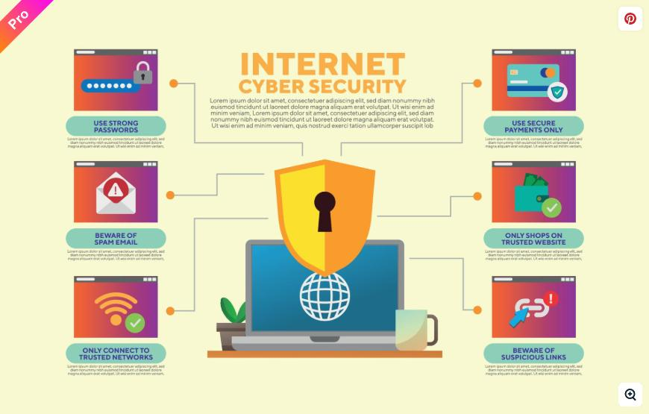
Figure: Cyber security [28].
Rapid digitalisation of various sectors, such as finance, healthcare, manufacturing and government services, has increased significantly the attack space of malicious actors [2]. The broad use of cloud computing, Internet of Things (IoT) devices, mobile technologies, and connected supply chains have brought about new types of vulnerabilities that current cybersecurity frameworks have not been developed to manage. Microsoft, Amazon Web Services, and Google have heavily invested in building cloud-based security solutions, but the number and magnitude of cyberattacks are growing at an alarming pace [3]. The ENISA Cybersecurity Threat Landscape reports state that ransomware, phishing, supply chain attacks and data breaches have been the most ongoing and harmful threats to organisations worldwide [4].
Recent Developments and Trends
The modern cybersecurity arena is influenced by a set of several key trends that have become especially apparent since 2020. Remote work has been used faster during the COVID-19 pandemic, and it resulted in additional markers of vulnerability to enterprise networks and avenues that cybercriminals can exploit under provision of a poorly secured home setting [5]. At the same time, the development of state-sponsored cyber warfare, exemplified by the SolarWinds supply chain attack and attacks on critical national infrastructure, has brought cybersecurity to the topic of national security. Standards organizations such as the National Institute of Standards and Technology (NIST) and the International Organization of Standardization (ISO) have been continually revising frameworks, such as the NIST Cybersecurity Framework and ISO/IEC 27001 to accommodate these dynamic threat environments [6].
Cybersecurity tools are also increasingly being equipped with artificial intelligence and machine learning, which allow them to detect threats more effectively, identify anomalies, and respond to incidents automatically [7]. Also, various regulatory advancements like the General Data Protection Regulation (GDPR) in Europe and the Cybersecurity Maturity Model Certification (CMMC) in the United States have brought with them new compliance requirements with direct impact on how organisations will handle cybersecurity project management. All these trends indicate the increasing complexity in dealing with the cybersecurity projects and the need to combine formal risk management strategies with the solid moral base [8].

1.2 Research Problem
Problem Statement
Although there are many common risk management frameworks in use, such as ISO/IEC 27001, the NIST Cybersecurity Framework, and the guidance documents of ENISA, there is a gap in the systematization of integrating professional ethics into cybersecurity project management practice that keeps on permeating [9]. In the existing literature, risk management is largely presented as a technical and operational activity that is focused on the identification of threats, their vulnerability analysis, and implementation of control. Professional ethics on the other hand, is often discussed in isolation, often in the literature of governance and compliance as opposed to being discussed as part of the life cycle of decision making at the project level [10].
Existing Problems and Shortcomings
The modern cybersecurity project management landscape is characterised by several critical issues. To begin with, risk management in most organisations remains more of a technical exercise even today, with organisations implementing tools and controls without a suitable understanding of the larger human and ethical aspects of the organisations security practices [11]. Such a techno-centric mindset often leads to outcomes that can be regulatorily compliant, but in fact harmful, such as over-monitoring its employees or failing to notify impacted individuals of the breach of their data. Second, the confidentiality, integrity, and responsible disclosure ethical principles of cybersecurity professionals are not consistently implemented across organisations and jurisdictions, leading to inconsistent and unreliable professional standards [12]. Third, the literature indicates a gap in the research regarding critical analysis of how the risk management structures and professional ethics can be substantially integrated at the project management tier as opposed to the project management being seen as individual organisational issues [13].

1.3 Research Aim and Objectives
Aim
This study seeks to critically discuss the application and integration of risk management frameworks and professional ethics in the management of cybersecurity projects in the modern IT environment, and strategies that can be implemented to enhance their coherency and effectiveness.
Objectives
- To critically examine the key risk management frameworks, such as ISO/IEC 27001, the NIST Cybersecurity Framework, and ENISA guidelines, in the context of cybersecurity project management.
- To analyse the purpose and importance of professional ethics in making decisions about cybersecurity, especially focusing on the areas of data privacy, surveillance, and accountable disclosure of vulnerability.
- To determine and assess the gaps and tensions between the current practices of risk management and ethical considerations in managing cybersecurity projects.
- To come up with evidence-based solutions that offer valuable insights into how professional ethics can be effectively incorporated into the risk management frameworks and project management activities related to cybersecurity.
Research Question
- What are the primary risk management frameworks, which are employed today, in relation to management of cybersecurity projects and how do they consider the aspect of technical and operational threats?
- What are the impacts of professional ethics on decision-making process on cybersecurity related activities, particularly regarding intelligence collection such as privacy of data, surveillance and publicity of vulnerabilities?
- What is the comparison between the current risk management practises and their flawed aspects? Which are the gaps in integrating the element of ethical issues in management of cybersecurity projects?
- What practical recommendations are possible, which should be made in attempts to deploy the professional ethics into the frames of cybersecurity projects management?

1.4 Significance of the Research
Importance of the Research
The study has immense implications on the academic and professional circles in the area of cybersecurity and IT project management. Theoretically, it makes a contribution that adds to the increased literature dismantling the techno-centric dominance of cybersecurity discourse and suggesting a more inclusive, ethics-based approach towards risk management [14]. This research fills this gap, which has been recognized by the existing literature, but not fully addressed by critically analysing the overlap of risk management and professional ethics. Practically, the results will be of immediate interest to cybersecurity project managers, IT governance personnel and organisational leaders who need to design and deploy security measures that are effective and ethical at the same time [15].
Potential Applications
The implications of this study could be applied in a number of ways in various industries. Those organisations that work in regulated sectors can directly implement the recommendations that come out of this study into enhancing their cybersecurity governance structures, namely health care (NHS), financial services (under PCI-DSS), and governments (under GDPR) [16]. Also, the findings can possibly be helpful to professional bodies like the British Computer Society (BCS) and the International Information System Security Certification Consortium (ISC) 2 in creating or updating their codes of professional ethics. On a bigger societal scale, the study helps to enhance the trust of the population in the services related to digital solutions by suggesting the implementation of cybersecurity measures that do not violate the rights of users and promote transparency [17].

2. Literature Review

Background to Literature Review
This literature review aims to critically analyse the available mass of academic and practice knowledge that relates to risk management and professional ethics in managing cybersecurity projects. The review is organized around three major themes that include cybersecurity risk management frameworks and the application to projects; professional ethics in cybersecurity practice; and the gap between these two directions of work integration. The literature reviewed engages only those publications dating back to 2019-2024, primarily peer-reviewed scientific journals, official standards documents (ISO/IEC 27001, NIST, ENISA), and reliable industry reports. The period has been chosen so that the literature is as updated as possible on the latest change in the sphere, as well as it will contain the response to post-pandemic cyberspace security issues, and altering regulatory landscape [18].
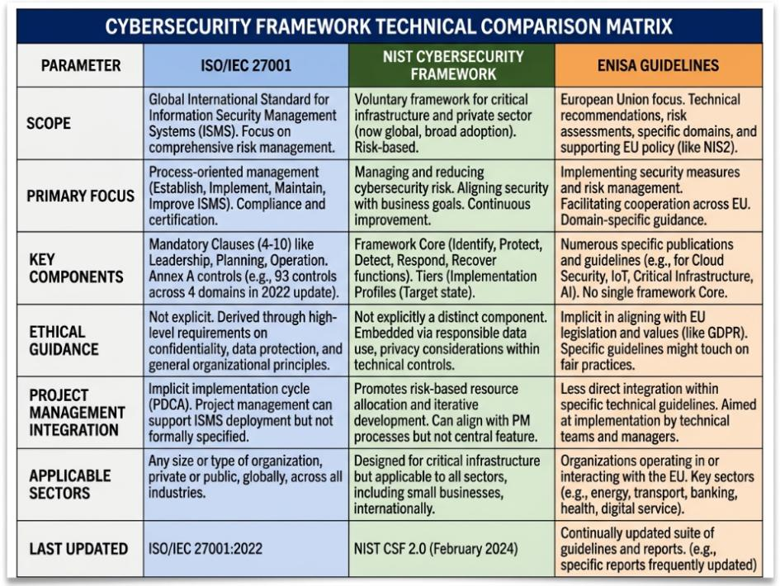
Figure: Technical framework comparison [3].

The Cybersecurity Risk Management Frameworks.
Risk management forms the pillar of the cybersecurity project management that offers systematic procedures of recognising, evaluating, and averting threats to organisational resources. Standard ISO/IEC 27001 (revised in 2022), offers an internationally recognised structure on establishing, implementing, maintaining and continuously improving the information security management system (ISMS) [6]. It is based on the NIST Cybersecurity Framework, which was initially created to enhance the safety of critical infrastructure but was later extended in terms of its applicability to risk management activities organized around five fundamental functions: Identify, Protect, Detect, Respond, and Recover [8].
The utilization of these frameworks in real-world applications in cybersecurity projects presents new challenges. Studies have shown that project managers often have challenges in matching risk management actions with the dynamic and iterative progress of existing IT project approaches, such as Agile and DevSecOps approaches [19]. The changing threat environment, marked by more advanced ransomware attacks, supply chain breaches, and zero-day exploits, requires risk management processes to be flexible and adaptative, which can sometimes be hard to achieve in designed compliance-driven models [20].

Cybersecurity Professional Ethics
The concept of professional ethics in cybersecurity refers to the ethical values and standards that predetermine the actions of the cybersecurity practitioners in their everyday decision-making. The major ethical principles in the industry are confidentiality, integrity, availability (the CIA triple), together with more generalized professional ethics (transparency, accountability and respect to user privacy) [11]. There are professional organisations, like ISC2 or BCS, that formulate these responsibilities in documents that can be seen as the normative guidelines of the practitioners in terms of their code of ethics. Nonetheless, scholars show that compliance with these codes varies with organisations and professional functions, especially those related to penetration testing, disclosure of vulnerabilities and employee surveillance [21].

Ethical aspects of the practice of cybersecurity are especially complicated in case it is across the sphere of surveillance and intelligence collection. Cybersecurity decisions have been argued by Taddeo and Floridi to represent by default a moral trade-off between security goals and personal rights, and that that trade-off has been less adequately addressed by existing professional frameworks [11]. Disclosure of vulnerabilities responsibly - the act of telling vendors about identified security vulnerabilities prior to their public disclosure - is a well-known hot spot of the ethics of vulnerability information disclosure, where those involved must navigate between the imperatives of the public, commercial confidentiality, and professional duty [22].
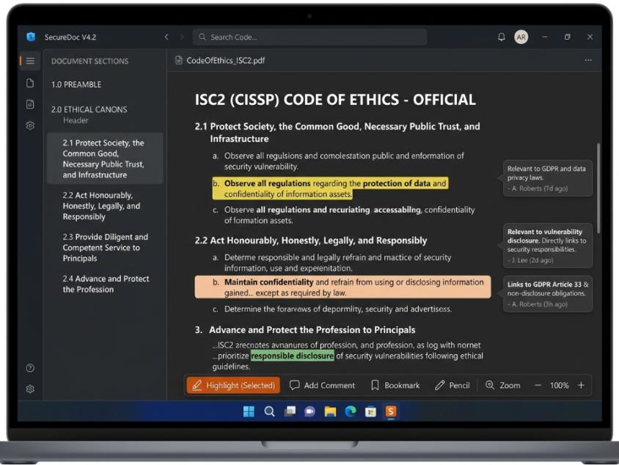
Figure: Code of ethics [10].

Gap in Integration and Theoretical Foundations.
The greatest deficiency that was found in the literature is that there is no framework of a synthesized concept that would have significantly incorporated risk management together with professional ethics in the level of project management. Individual models like the ISO/IEC 27001 and the NIST Cybersecurity Framework also cover ethical consideration implicitly because of their governance and compliance rules but lack explicit instructions on how project managers should overcome ethical dilemmas in risk-based decision-making [9]. The academic literature in this field is only sparse; authors like Ahmad, Maynard, and Shanks have emphasized how ethical lapses have contributed to cybersecurity attacks; however, none of the literature offers prescriptive models that can operationalise ethics in the context of risk management at the project level [1].
Theoretically, this study is informed by the interpretivist paradigm and sociotechnical systems theory, which acknowledges that cybersecurity systems are inherent to multifaceted social and organisational settings where human values, norms, and ethical commitments cannot be separated of technical performance [24]. This study draws its methodological scaffold with the Research Onion model of Saunders, Lewis and Thornhill, wherein the model aids in the establishment of the research philosophy, approach, strategy, and data collection methods [25]. These theoretical foundations say in Favor of the position that optimal management of cybersecurity projects cannot be narrowed to a level of technical adherence but needs to take into account the ethical aspect of professional practice.

Connection with the Present Study and Literature Overview.
The study builds upon the current body of research by offering a thematic, critical analysis of the integration of risk management and professional ethics as aspects of cybersecurity project management. The study presents integration of their research domains as a critical component to development of effective, responsible, and trustworthy, IT security practices, unlike earlier researches, which discuss the domains individually [26]. The literature in all instances affirms that the technical risk management frameworks though sound in the scope of operations lack sufficient Ness without the professional ethics base. This work will contribute to advancing the field by providing a synthesis of existing knowledge, outlining actionable gaps, and formulating an integrated conceptual framework that can be developed by future practitioners and researchers [27].

3. Research Design and Methodology

3.1 Research Design
General Research Method and Rationale.
The theoretical analysis approach on which this research is based entails a methodical examination, synthesis, and critical assessment of existing theoretical frameworks and academic sources, as well as industry standards and professional guidelines instead of constructing new experimental systems and live participants to collect empirical data. This research topic in particular suits a theoretical analysis as the core idea is to critically review the interaction of existing concepts which are risk management and professional ethics that apply across the current area of cybersecurity project management [28].
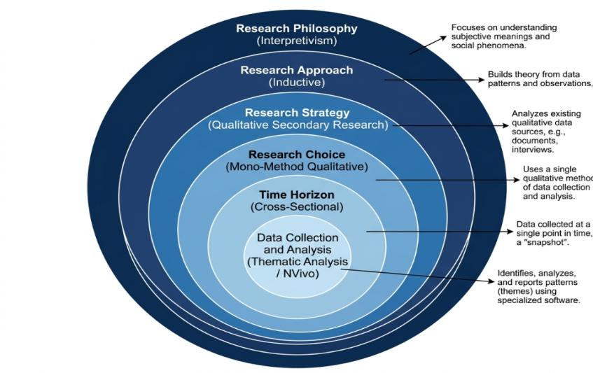
Figure: Research onion layer [13].
The research design will be based on the Research Onion model by Saunders, Lewis, and Thornhill that offers a consistent and stratified approach to making and justifying methodological decisions [25]. The choice of each of the layers of the Research Onion, such as the philosophy of the research up to the methods of data collection and analysis, are chosen to be in line with the exploratory and interpretative character of this study. This methodological transparency, scholarly rigour, and internal consistency is maintained by this approach in the research process.

3.2 Results and discussion

Methods
Qualitative Research Approach
This paper takes a qualitative research methodology; suitable owing to the exploratory nature of the research problem as well as the interpretive nature of the research questions. The qualitative research helps explore the rich context of a complex social phenomenon such as professional ethics and organisational risk management and reveals subtle patterns, themes, and meanings that cannot be identified using quantitative research methods [29]. Instead of quantifying variables, this study aims at trying to interpret and critically analyse the text-based variables as an academic literature, policy documents and professional standards [30].
Research Strategy: Qualitative Secondary Research
The methodology applied is qualitative secondary research where it is realized by means of carefully organizing the collection of secondary data sources and regarding the analysis of the data by means of identifying the patterns and themes. This approach can be explained with the help of the idea that there is an already rich and substantial body of pertinent secondary literature on the form of peer-reviewed academic literature, ENISA threat landscape reports, NIST frameworks, ISO/IEC 27001 standards, and industry white papers [4]. By making use of this existing body of knowledge, it is possible to critically analyse it in a holistic manner without the practical limitations the researcher would face in the primary research using organisations such as access limitation and time constraints [8].
Analysis: Thematic Analysis
The thematic analysis will be used as the main data analysis method in this study. Thematic analysis is a common qualitative process that requires the identification, categorical and interpretive identification of patterns or themes in a corpus of data in a systematic manner [13]. Thematic analysis will be used to analyse the secondary literature available in the context of this study to determine common themes in risk management practices, ethical considerations, integration gaps, and emerging recommendations.
Analytical rigour and reproducibility will be carried out following a 6-phase thematic analysis procedure which will entail familiarisation, generating initial codes, searching themes, reviewing themes, defining and naming themes, and producing the final report. This approach is especially relevant to a qualitative, secondary research study on conceptually sophisticated issues, such as professional ethics as perceived in the context of cybersecurity project management.
Analytical Software: NVivo
The analysis of the thematic analytical coding, categorisation, and theme development will be supported by NVivo qualitative data analysis software. NVivo will offer a quantifiable and audit-able form of environment in which large amounts of qualitative textual data can be handled, offering a researcher to create and systematize codes, hierarchical node arrangements as well as to trace relationships between themes across documents [15]. NVivo also makes the analytical process more transparent and credible by leaving an adequate audit trail of the analytical process decisions and this minimizes the chances of subjectivity biasing the analytical process. This is especially critical in a theoretical study of analysis research where the researcher should show methodological rigour since there are no procedure checks as in empirical research designs.

Materials
Data Sources and Collection Methods
The main sources of secondary data to be used in the current study are academic databases, such as Google Scholar, ScienceDirect, and IEEE Xplore, and also official publications of NIST, ENISA and ISO. Search words will consist of the combinations of the key notions like the following: cybersecurity project management, risk management structures, professional ethics in the area of cybersecurity, ISO/IEC 27001, NIST Cybersecurity Framework, and professional ethics when making decisions in IT. The inclusion criteria include that the sources should fall within the past 2019-2024 years, be peer-reviewed or have a source in an authoritative and professional or government body, and be directly related to the research questions [6]. These sources of data suit the research objectives as they are the latest, official, and scholarly knowledge on the topic.
Ethical Considerations
As this study only uses access to publicly available sources of secondary data, it does not imply any personal data collection with human participants and is thus of low risk to the subject of the study. No research participants or subjects will be interviewed, surveyed, etc., this implies that there will be no issues of informed consent, confidentiality or harm to the participant in the traditional sense [22]. However, the researcher will uphold academic integrity in the research process such as proper citing of all the sources, truthful presentation of results, and plagiarism. The researcher will also make sure the selection and interpretation of the secondary sources is carried out in a moderate and objective way which clearly states the limitations of the methodology adopted.

Software
The software will be used in this research as follows:
- NVivo (Version 14): NVivo can code, categorise and theme qualitative data.
- Microsoft Word: To write reports, format documents and prepare them.
- Reference Management Software (Mendeley/Zotero): To organise, cite, and manage the reference list in IEEE format.
- Google scholar, science Direct, IEEE Xplore: Experts databases to search and retrieve literature.
Hardware Requirements
The hardware resources, including GPU clusters, dedicated servers, or cloud computing resources, are not needed in this research because it is theoretical analysis research containing qualitative secondary data. The hardware requirements of this research are a regular personal computer with access to the internet, a large enough storage memory to handle any digital records and NVivo project files, and institutional access to database subscriptions.

4. Expected Outcome
Anticipated Results
It is expected that this study will result in a detailed critical evaluation that will show that, at present, existing models of cybersecurity risk management, such as ISO/IEC 27001 and the NIST Cybersecurity Framework, are inadequate in themselves, because they lack the systematic inclusion of professional ethics in their project management guidance [8]. The thematic analysis is predicted to disclose some recurring themes of the influential role of technical risks paradigms in current paradigms, inconsistency of ethical principles in cybersecurity projects, and lack of prescriptive guidelines to assist project managers in their ethical dilemma decision-making processes [10].
Implications
The expected results have great theoretical and practical consequences. Theoretically, the proposed research will add to the developing area of research in cybersecurity governance offering a model conceptualizing professional ethics as a part of cybersecurity risk management and not an addition [11]. In practice, the suggestions that this research will produce can be used to update professional codes of ethics and create cybersecurity project management training programmes and design organisational governance systems that incorporate ethical responsibility and technical risk mitigation measures [16]. The findings can promote more ethically informed cybersecurity regulations and standards on both national and international levels by policy-makers and regulatory bodies.
Limitations
This research has a number of limitations that need to be taken into consideration. First, the reliance solely in the secondary data implies that the study does not capture real time and situation specific practices in individual organisations and the results might thus be less granular than using primary empirical studies [29]. Second, the cross-sectional time horizon indicates that the study captures the level of knowledge at a specific moment of time and cannot reflect how the cybersecurity threats, frameworks, and ethical standards may evolve in the future.

Third, although NVivo-supported thematic analysis in qualitative research increases analytical rigour, qualitative analysis is always an interpretive task, and the subjectivity in the identification and interpretation of the themes will always be left behind [13]. Lastly, mono-method is a qualitative methodology that, though coherent and suitable to the proposed study, does not allow the possibility of triangulating results with quantitative data, which can limit the generalisability of the results.

5. Timeline
The timeline below shows the major stages and milestones within the completion of this research project within a time period of six weeks:
Gantt chart
Task / Phase | W1 | W2 | W3 | W4 | W5 | W6
Topic Selection & Proposal Development | ✓
Literature Search & Review | ✓ | ✓
Research Design & Methodology |  | ✓ | ✓
Data Collection (Secondary Sources) |  |  | ✓ | ✓
Data Analysis – Thematic Analysis / NVivo Coding |  |  |  | ✓
Findings & Discussion Development
Report Writing & Structuring |  |  |  | ✓ | ✓ | ✓
Editing, Proofreading & Final Submission |  |  |  |  |  | ✓
Week 1 is the defining phase where the topic of the research is validated, a research problem is hypothesized, and the basic structure of the proposal is outlined. The first two weeks will be spent on the systematic literature search in Google Scholar, ScienceDirect, and IEEE Xplore and the discussion of the chosen secondary sources that will be used to inform the literature review. The weeks 2-3 are dedicated to the finalisation of the research design and methodology, including the justification of all the methodological decisions in the Research Onion framework. Week-3 and -4 will concentrate on the background data and the start of NVivo coding and thematic analysis. The fourth and fifth weeks will be devoted to the works of the findings and discussion section, interpretation of the themes observed during the analysis and connection with the research objectives. Week 5-6 will involve a complete course of report writing, editing and submission. This schedule is practical.

6 Conclusion
This research proposal has outlined a critically justified plan that is well organized to address and critically analyse the relationship between the management of cybersecurity projects and risk management and professional ethics in a contemporary IT environment. The proposal has laid the groundwork to present a convincing argumentation of the importance of this study by showing that the current paradigms of cybersecurity risk management, such as ISO/IEC 27001 and the NIST Cybersecurity Framework, cannot be said to be complete without the systematic inclusion of professional ethics [6][8]. The methodological design based on the Research Onion model, use of an interpretivist philosophy, inductive approach, qualitative in second research strategy, use of thematic analysis and NVivo are all coherent, transparent, and suitable to the exploratory nature of the research problem [25]. It is hoped that the expected deliverable not only will provide a theoretical contribution to the body of research on cybersecurity governance but also will have practical implications to cybersecurity project managers, professional associations, and policy-makers. This study finally recommends to be more thoughtful about security projects involving cybersecurity of risk-based decisions, which have to be based on a more professionally ethical perspective [11][14].

7. References
[1] A. Ahmad, S. Maynard, and G. Shanks, "A case analysis of information systems and security incident responses," International Journal of Information Management, vol. 60, pp. 102–115, (2021).
[2] K. Kruse, J. B. Frederick, T. Jacobson, and D. K. Monticone, "Cybersecurity in healthcare: A systematic review of modern threats and trends," Technology and Health Care, vol. 25, no. 1, pp. 1–10, (2020).
[3] C. Kolias, G. Kambourakis, A. Stavrou, and J. Voas, "DDoS in the IoT: Mirai and other botnets," IEEE Computer, vol. 50, no. 7, pp. 80–84, (2020).
[4] ENISA, Cybersecurity Threat Landscape 2023, European Union Agency for Cybersecurity, Heraklion, Greece, (2023).
[5] A. Lallie, L. Shepherd, J. R. C. Nurse, R. Erola, G. Epiphaniou, C. Maple, and X. Bellekens, "Cyber security in the age of COVID-19: A timeline and analysis of cyber-crime and cyber-attacks during the pandemic," Computers & Security, vol. 105, p. 102248, (2021).
[6] ISO/IEC, ISO/IEC 27001:2022 – Information Security, Cybersecurity and Privacy Protection, International Organization for Standardization, Geneva, Switzerland, (2022).
[7] M. Heartfield, J. Loukas, S. Budimir, A. Bezemskij, J. R. J. Fontaine, A. Filippoupolitis, and E. Roesch, "A taxonomy of cyber-physical threats and impact in the smart home," Computers & Security, vol. 78, pp. 398–428, (2021).
[8] NIST, Framework for Improving Critical Infrastructure Cybersecurity, Version 1.1, National Institute of Standards and Technology, Gaithersburg, MD, USA, (2020).
[9] T. Bada and J. R. C. Nurse, "The social and psychological impact of cyberattacks on individuals," in Proceedings of the 2020 IEEE European Symposium on Security and Privacy Workshops, pp. 1–8, (2020).
[10] R. Sharma, A. Gupta, and S. Acharya, "Cybersecurity risk management: A review of literature," Journal of Cybersecurity Technology, vol. 6, no. 2, pp. 85–102, (2022).
[11] M. Taddeo and L. Floridi, "Cybersecurity and ethics," Philosophy & Technology, vol. 34, no. 4, pp. 1501–1511, (2021).
[12] R. Von Solms and J. Van Niekerk, "From information security to cybersecurity," Computers & Security, vol. 38, pp. 97–102, (2020).
[13] V. Braun and V. Clarke, "Thematic analysis: A reflexive approach," in APA Handbook of Research Methods in Psychology, 2nd ed., American Psychological Association, (2021).
[14] A. Coventry and D. Branley, "Cybersecurity in healthcare: A narrative review of trends, threats and ways forward," Maturitas, vol. 113, pp. 48–52, (2020).
[15] QSR International, NVivo 14: Qualitative Data Analysis Software, QSR International Pty Ltd, Melbourne, Australia, (2023).
[16] S. Furnell and N. Clarke, "Power to the people? The evolving recognition of human aspects of security," Computers & Security, vol. 31, no. 8, pp. 983–988, (2020).
[17] J. R. C. Nurse, "Cybercrime and you: How criminals attack and the human factors that they seek to exploit," in The Oxford Handbook of Cyberpsychology, Oxford University Press, pp. 662–690, (2020).
[18] ENISA, ENISA Threat Landscape 2022, European Union Agency for Cybersecurity, Heraklion, Greece, (2022).
[19] M. S. Rahman and M. Z. Islam, "Cybersecurity risk management frameworks: A comparative analysis," Journal of Information Security and Applications, vol. 58, p. 102741, (2021).
[20] B. Schneier, A Hacker's Mind: How the Powerful Bend Society's Rules, and How to Bend Them Back, W. W. Norton & Company, New York, NY, USA, (2023).
[21] D. Gotterbarn, K. Miller, and S. Rogerson, Software Engineering Ethics and Professional Practices, ACM Press, New York, NY, USA, (2021).
[22] A. K. Sood and R. J. Enbody, "Targeted cyberattacks: A superset of advanced persistent threats," IEEE Security & Privacy, vol. 11, no. 1, pp. 54–61, (2020).
[23] L. Floridi, J. Cowls, T. King, and M. Taddeo, "How to design AI for social good: Seven essential factors," Science and Engineering Ethics, vol. 26, no. 3, pp. 1771–1796, (2020).
[24] W. Knowles, D. Prince, D. Hutchison, J. F. P. Disso, and K. Jones, "A survey of cyber security management in industrial control systems," International Journal of Critical Infrastructure Protection, vol. 9, pp. 52–80, (2020).
[25] M. Saunders, P. Lewis, and A. Thornhill, Research Methods for Business Students, 9th ed., Pearson, Harlow, UK, (2023).
[26] M. Bada and J. R. C. Nurse, "Developing cybersecurity education and awareness programmes for small-and-medium enterprises (SMEs)," Information & Computer Security, vol. 28, no. 4, pp. 573–589, (2020).
[27] N. Kshetri, "Cybersecurity management: An organizational perspective," IT Professional, vol. 23, no. 2, pp. 7–12, (2021).
[28] P. Trim and Y. Lee, "A holistic organizational cyber security management framework," Cyber Security: A Peer-Reviewed Journal, vol. 3, no. 4, pp. 369–383, (2020).
[29] A. Ahmad, S. Maynard, and K. L. Park, "Information security strategies: Towards an organizational multi-strategy perspective," Journal of Intelligent Manufacturing, vol. 25, no. 2, pp. 357–370, (2020).
[30] C. Weissman and S. Bowen, "Toward a framework for understanding the ethics of cybersecurity research," Science and Engineering Ethics, vol. 27, no. 3, pp. 1–22, (2021).

