Digital Skills and Research Methods - BMSK4003
Task Two - Questionnaire Analysis
Iulian C. Tampau 1904938

This document is meant to analyse the findings from my business questionnaire regarding the lunch of a small nursing agency in Cardiff. My business questionnaire starts by analysing and dividing our potential customers by area of speciality, size and recruitment process. Through the middle section of the questionnaire I am looking to understand the trend and issues associated with using the services of a staffing solutions business particularly in the elderly care area. By the end of the questionnaire I will be researching what are the most demanded category of healthcare workers, placement fee process preferences and preferred settlement periods.

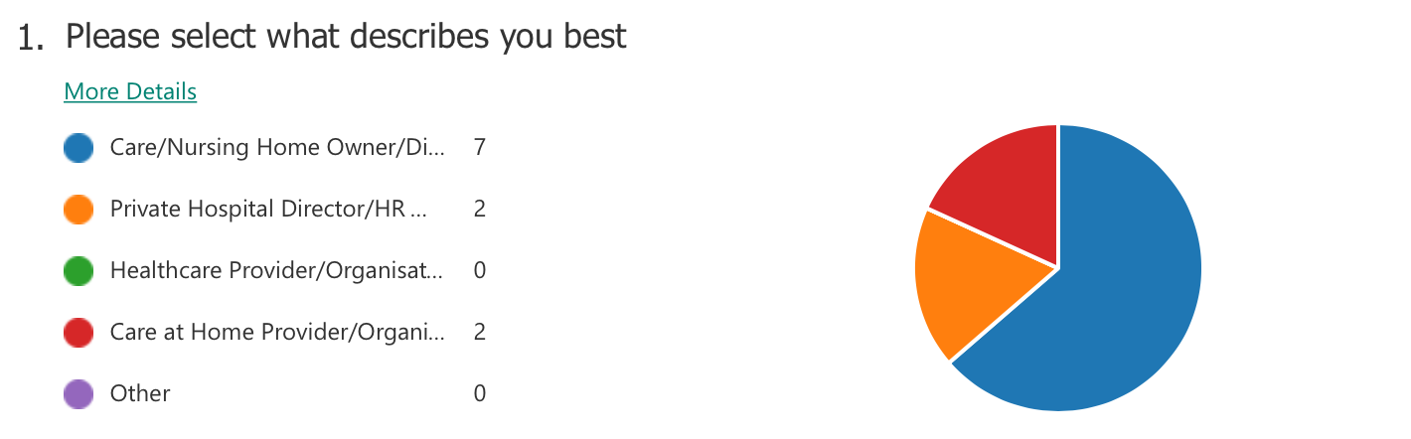

Analysing the first question which surveys the position of our targeted customers within their organisations will give us a better understanding of our market hot zones for placements. The survey has received response from various healthcare areas, but the leading gap are the parties around Care/Nursing homes organisations. This indicates that the main focus should be around this particular type of organisations but at the same time highlights interest from different care providers such as Private Hospitals Network or Care at home providers. While Care/Nursing homes has been identified as the main customer category the interest from Care at Home providers indicates the opportunities within the changing trend in the UK whereas the elderly prefer continuing living at home and receiving care through the services of the live-in healthcare workers. This indicates a good business opportunity and special addressed marketing campaign will be created.

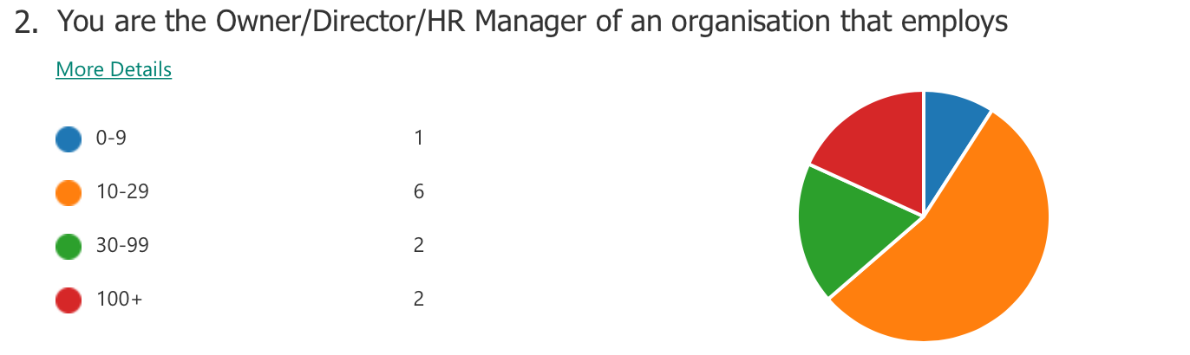

The second question of the survey is aimed at understanding the size of an organisation that we target as a potential customer. As a nursing agency our aim to build long lasting relationships with our customers and offer our services tailored for their needs. From the responses we received on our questionnaire we can see that small care setups employing up to 30 people are more often found, followed by small-medium sized and equally response from large organisations employing over 100 persons. While for a small organisation it wouldn’t be cost effective to use the services of an agency with larger size company there is opportunity for establishing working relationships with the purpose of offering part time and full-time staffing solutions.

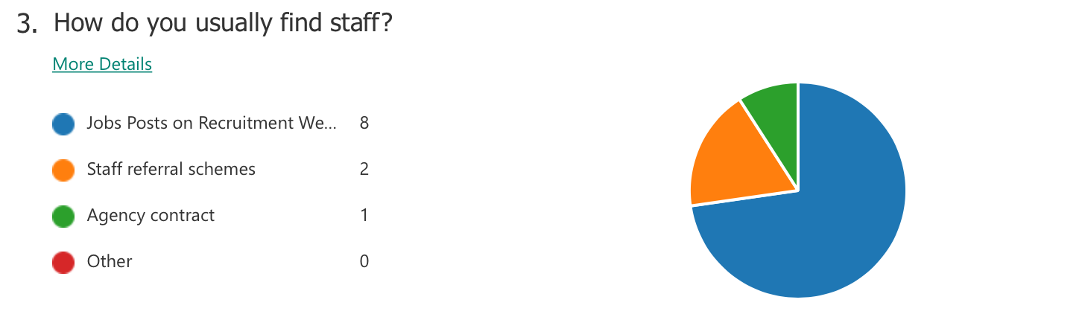

The third point of our questionnaire surveys the internal recruitment process/techniques that our potential customers use in-home. From the 11 organisations surveyed the majority of them have indicated that they are using Recruitment Specialist Website, Professional Networking Website such as LinkedIn and advertising openings on their website/Facebook page. Only 2 out of the 11 are having in place and relaying on staff referral schemes which is a great way to attract and help settle in new employees offering them access to the knowledge/experience insights from the referring employee. So far only 1 care setup out the 11 has taken on the services of an agency to secure staff which indicates that in order for the success of the new lunched agency to be ensured, a strong digital marketing campaign and simplified order service must be in place. This would make using agencies a strong alternative option for the ones that are currently relying on recruitment websites.

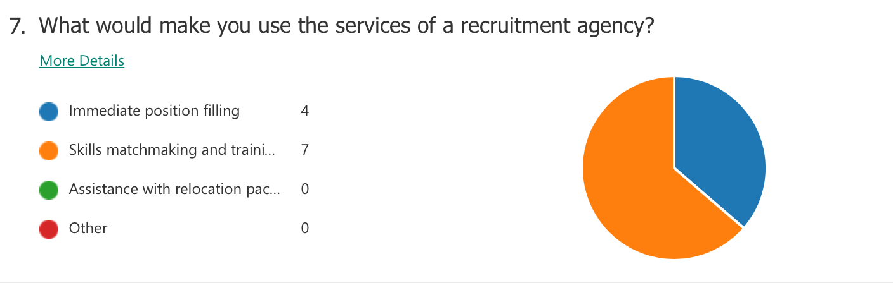

The 7th question of our survey is meant to identify what would make our potential clients use our services. I can see from the responses that the vast majority would prefer to take on our services in order to benefit of our experience in the elderly care business area. While interviews and skills matchmaking are time consuming, arranging trainings for staff while in employment has proved to be less efficient and cost-effective solution than outsourcing this part to a recruitment specialised agency. This indicates that employers would prefer to take on candidates that are ready and confident to carry out the work from their first day with the client. It has been noted that ‘Skill matchmaking and training’ needs to become a strong selling point and present in our marketing campaigns. Not surprisingly the rest of the attention has gone towards ‘Immediate position filling” as most care business struggle to fill positions (Fund, 2018).

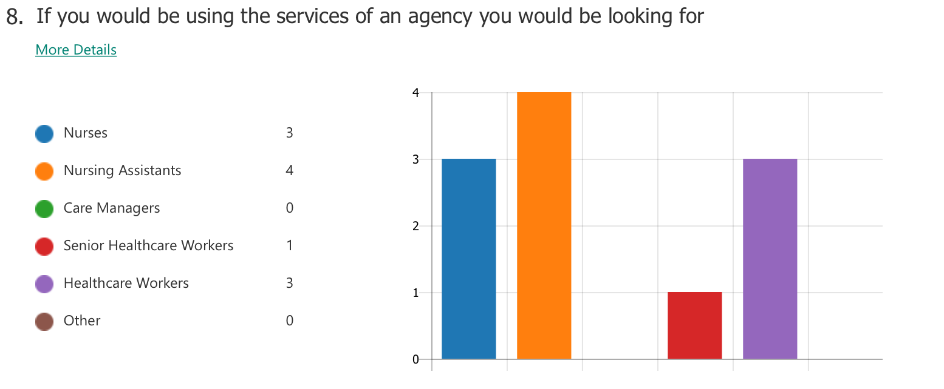

The eight question of our survey is addressing the most sought-after categories of healthcare workers. The graph reveals straight that healthcare workers are in demand at all levels of expertise. In the elderly care the lack of nurses and healthcare workers have been known over the past years (Library, 2020). What is interesting and creates a new market opportunity is the increased demand for Nursing Assistants. While the Nursing Assistant is a relatively new position in the current economic environment there are favourable conditions for a Healthcare Worker to progress Nursing Assistant position reducing the gap for required nurses. (RCN, 2019). The company has taken note and will investigate further in what type of training will be required for progression. There is also an indication that care providers would be interested in employing Senior Healthcare Workers which traditionally was an opportunity for progression offered to internal staff.

Conclusion

To conclude the findings of my survey related to the lunch of a new small size nursing agency that specialises in the elderly care area I would start by highlighting the importance of knowing your customers. For this to be possible through the survey I addressed and found out that company looking for staff in this business area are likely to be Nursing/Care Homes setups fallowed by Private Hospital Trusts and care at home providers. With the UK’s ageing population on the rise (statista, 2018) it is clear that more and more demand for healthcare workers will be needed on all levels of expertise. I took note that small-medium sized companies are more likely to use the services of a placement agency but there are opportunities with medium-large sized organisation to outsource contracts. The threats from the major established recruitment that every recruitment agency is facing (M Kerrin, 2003) have been expressed through this survey, with the findings that most organisations prefer to make use of the recruitment websites.
In terms of what attracts the organisation to use agencies has been found out that access to staff with matching skills and with valid trainings is the most sought-after detriment. Not surprisingly the fallowing category indicated that Immediate Position Filling would the factor that makes them appeal to the services of a nursing agencies which gives confidence that the demand for healthcare workers is out there and holding strong.

Bibliography
Fund, K., 2018. kingsfund.org.uk. [Online]
Available at: https://www.kingsfund.org.uk/press/press-releases/relentless-staff-shortage-leaves-home-care-sector-struggling [Accessed 16 June 2020].

Library, H. o. C., 2020. https://commonslibrary.parliament.uk. [Online]
Available at: https://commonslibrary.parliament.uk/social-policy/health/the-health-and-social-care-workforce-gap/ [Accessed 18 june 2020].

M Kerrin, P. K., 2003. e-Recruitment: Is it Delivering?, Brighton: Institute of Employment studies .
RCN, 2019. rcn.org.uk. [Online] Available at: https://www.rcn.org.uk/professional-development/become-a-healthcare-assistant-or-ap [Accessed 18 june 2020].

statista, 2018. Resident population projection of people in the United Kingdom (UK) for 2020 to 2050, by age group. [Online] Available at: https://www.statista.com/statistics/749078/elderly-population-of-the-uk-by-age-2017-2032/ [Accessed 17 june 2020].

Questionnaire:

Access link:

https://forms.office.com/Pages/ResponsePage.aspx?id=-REPTm4EBUWcuNshUjEeIWfBOzCJ8OxGuUP5vgqhPzBUMEozQlVIUThHSURONTFMVjRCSjMwSlFGSC4u

Summary of response link:

https://forms.office.com/Pages/AnalysisPage.aspx?id=-REPTm4EBUWcuNshUjEeIWfBOzCJ8OxGuUP5vgqhPzBUMEozQlVIUThHSURONTFMVjRCSjMwSlFGSC4u&AnalyzerToken=DWMyOYudnbFidjH1IeAUbXCw5BZZ56rY

