HTML AND CSS WEB DEVELOPMENT

Lecture Name: Suresh Shanmugasundaram
Student Name: Hamed Huffi
Student Number: 2528907
CertHE Computing Skills for Workplace: Group 1
Date: 14/08/2026
Kush-Kings Iron Fitness

Introduction to Web and Database Concepts Assessment 2 ACCA4023

Table of Contents
Introduction 2
Requirements 2
Implementation 3
Evaluation 10
Research 10
Website evaluation 12
Website Comparison 18
Conclusion 20
References, Validations, Auditor Links 20
Appendices 21

Introduction
In the second part of this assessment, I will elaborate on the three-page website I created, Kush-Kings Iron Fitness, a fictitious yet professional fitness centre for all levels of athleticism. I've included my design decisions, requirements, implementation, research and personal evaluations, and the SEO techniques used. I have also included screenshot illustrations with brief descriptions of the figures and validation for both CSS and HTML. Additionally, I checked the accessibility of my home page through an accessibility audit website, which assesses whether the accessibility guidelines are in line with my website. The last part of the report evaluates my website against two real-life websites for comparison and contrast.

Requirements
Kush-Kings Iron Fitness is a contemporary wellness centre. It was created to offer versatility, expertise, and accessibility and provide the community and people around the city of London with a performance-driven environment. Where members at any level, from beginners to veteran athletes, can train at their own pace and timetable and get into the best shape possible in a short time span.
The facility offers personalised programs such as martial arts, boxing, one-to-one training, high-intensity workouts, and strength conditioning, each crafted to enhance technical ability, build confidence, and physical development for continuous improvement.
Programme blocks are led by expert, accredited coaches and performance strategists, who bring specialised expertise to every session they coordinate. This means you’ll be guided through physical tasks with safe training protocols, a sequenced training plan, and individualised coaching. Irrespective of whether a Kush-Kings Iron Fitness member wants to strengthen striking effectiveness, boost core power, or burn calories, the centre accommodates your goals.
Elite-level equipment facilitates every training approach, from power training bags and sparring gear to free weights, gym machines, and conditioning apparatus. The centre's design promotes effortless flow between workout areas, giving members flexibility to mix training methods for a well-rounded exercise experience.
Adaptive membership plans with no joining fees make the premises accessible to all members. They offer options for occasional users (pay-as-you-go), committed performers (monthly), and members pursuing long-term performance training (annually). It is also open 24 hours a day, 7 days a week, all year round except on public holidays, enabling you to never postpone your fitness goals.
The fitness centre is located in West London, around the Maida Hill area, and administration staff are available from 07:00 am to 20:00 pm. However, the trainers are always rotating shifts, so you will never be alone while in the centre.
The website is also very user-friendly, and you can browse through it easily, as well as send a personalised electronic message to staff for all enquiries on the contact page.

Implementation
In the first image, we have the title, subtitle and logo of my modern fictitious website along with the three-page links for navigation.
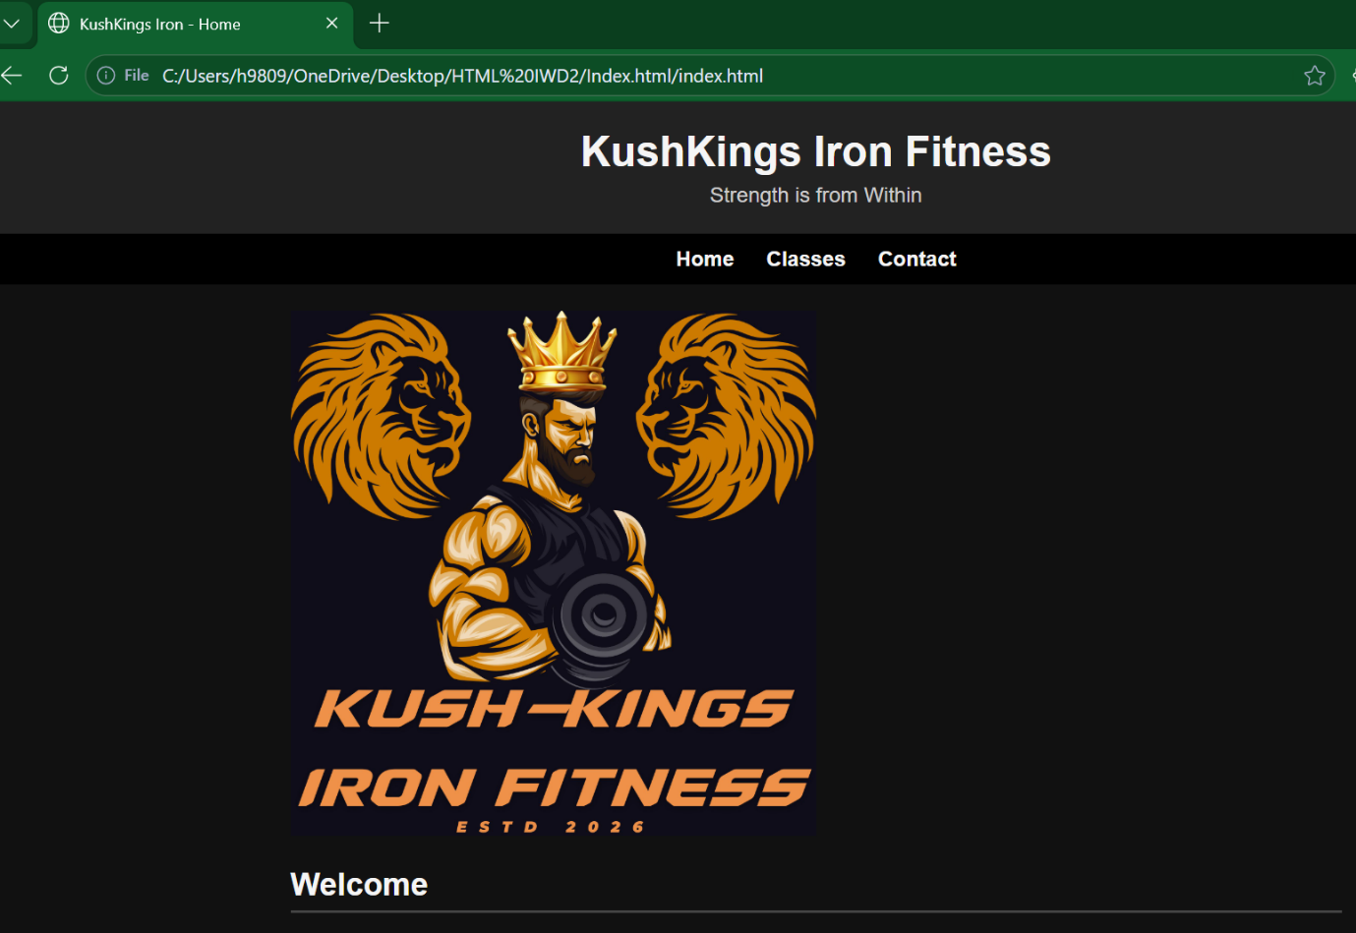Figure 1 Source index.html Home Page

The second image has a brief welcome paragraph, along with a reason why members should join, popular programs, and membership flexibility.
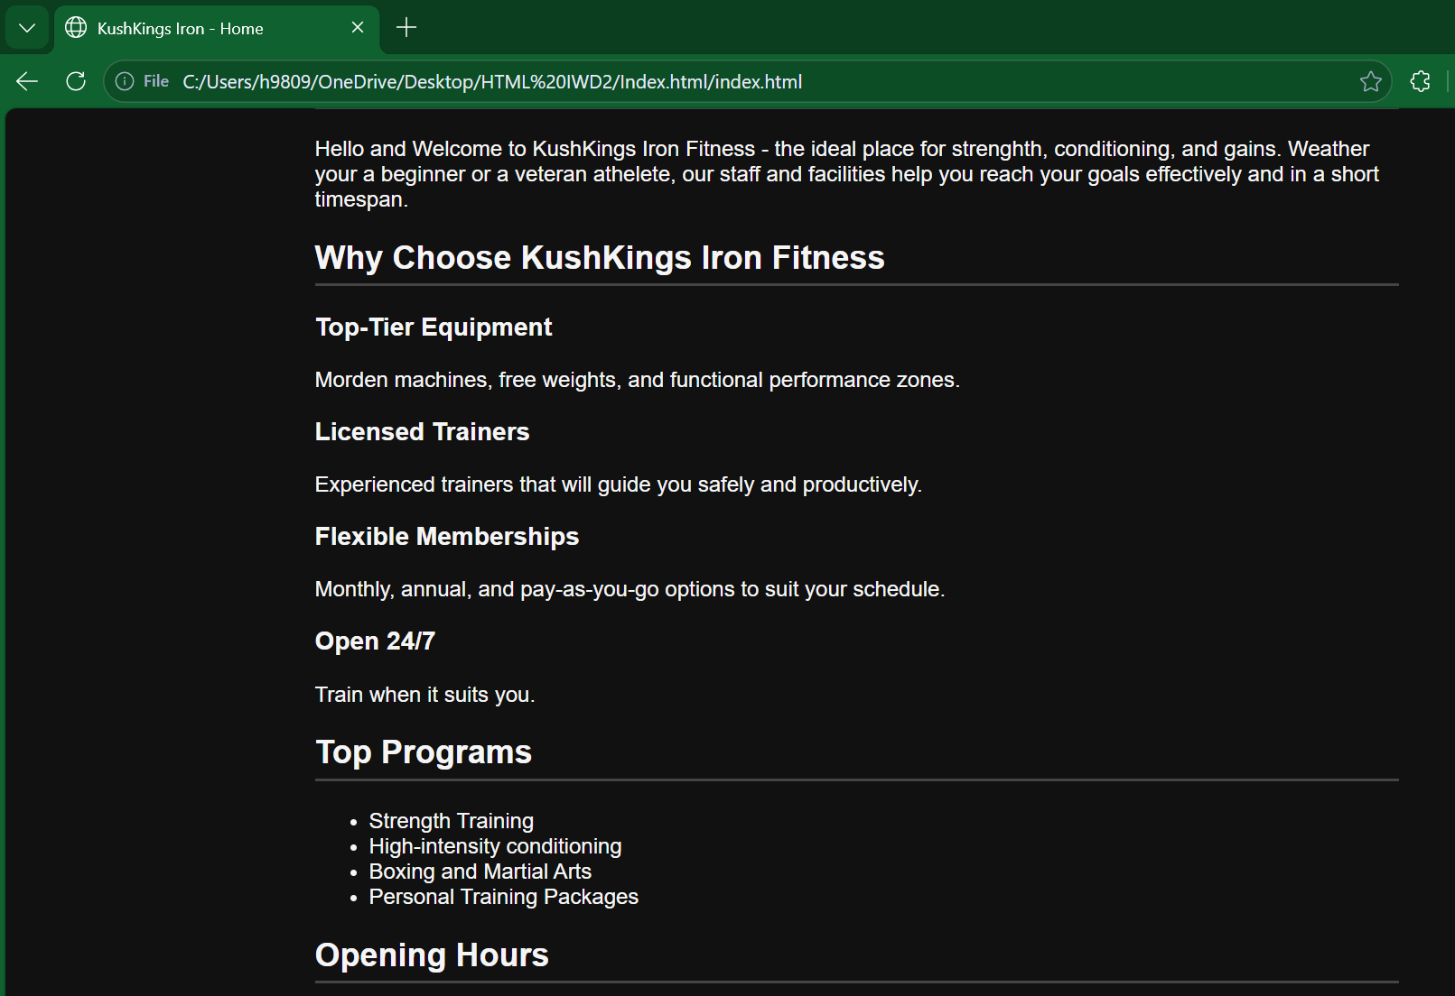

Figure 2 Source index.html Home Page

Here we have the opening hours.


Figure 3 Source index.html Home Page

Image four depicts the second page of the web page, detailing the first program that is operational along with its schedule, a brief explanation of what you can expect from strength and conditioning.

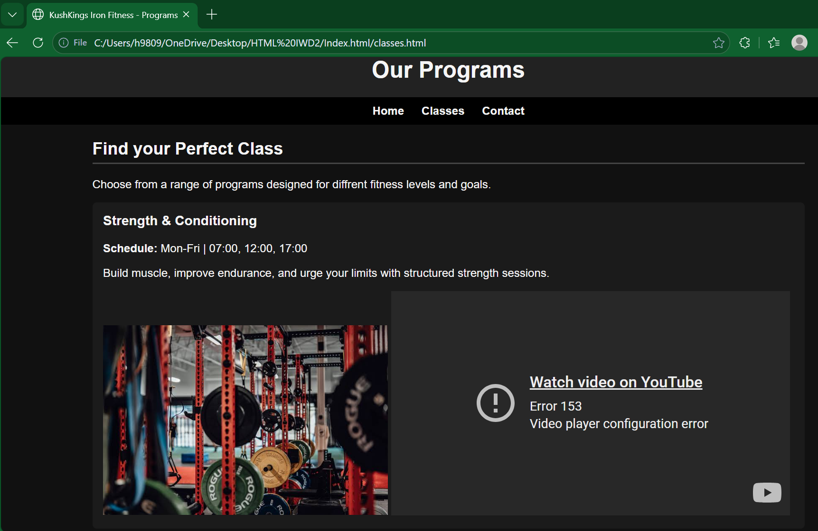

Figure 4 Source index.html Classes Page

The second active program is the high-intensity conditioning class, perfect for members who are targeting calorie burn and cardio, which has several sessions running every day.
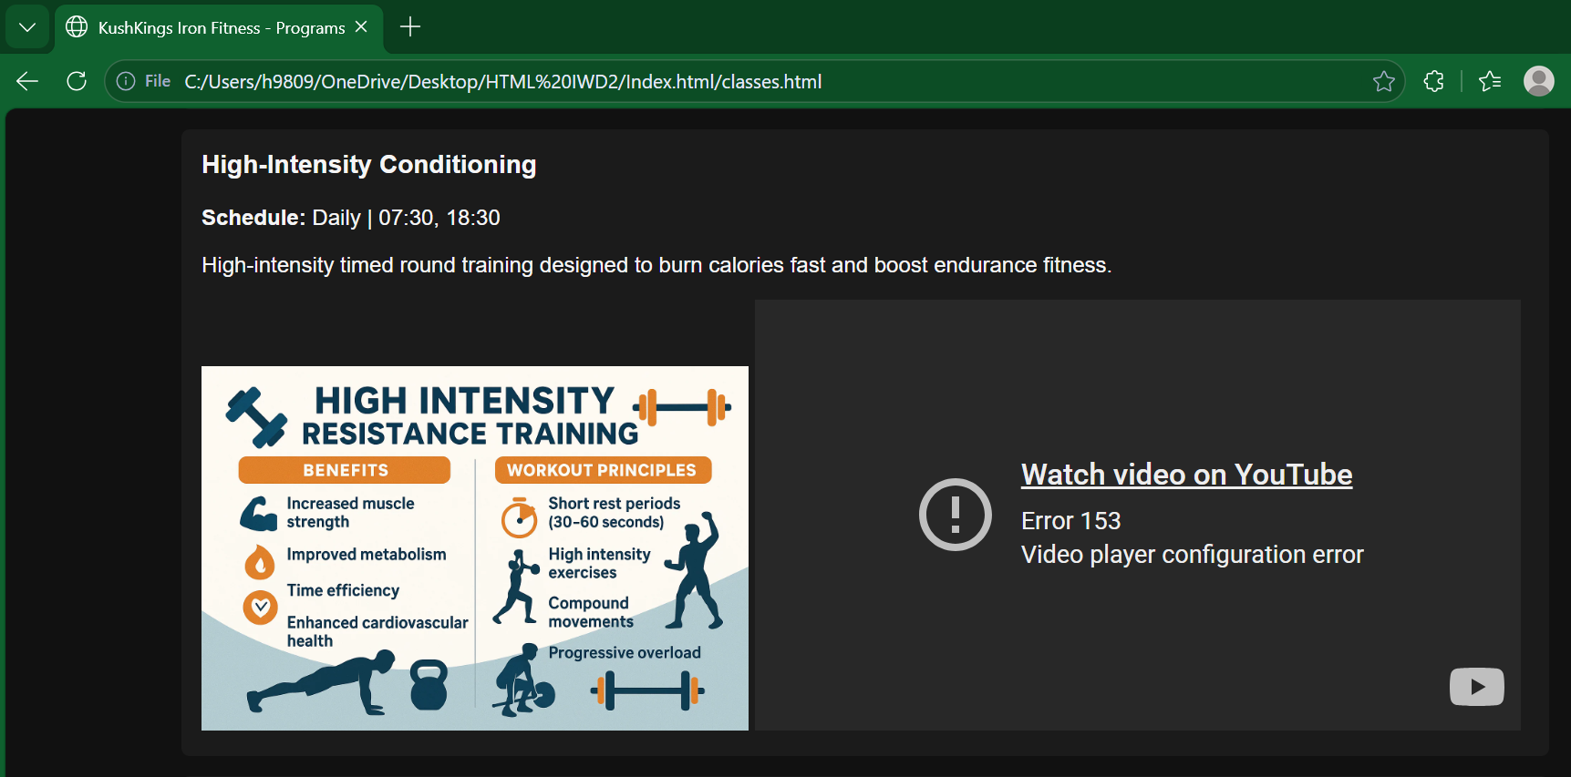

Figure 5 Source index.html Classes Page

Image six entails the combat programs available, boxing and martial arts, along with their schedule. You can attain the necessary skills for effective footwork, precise striking, and core essentials to become like your dojo instructors.
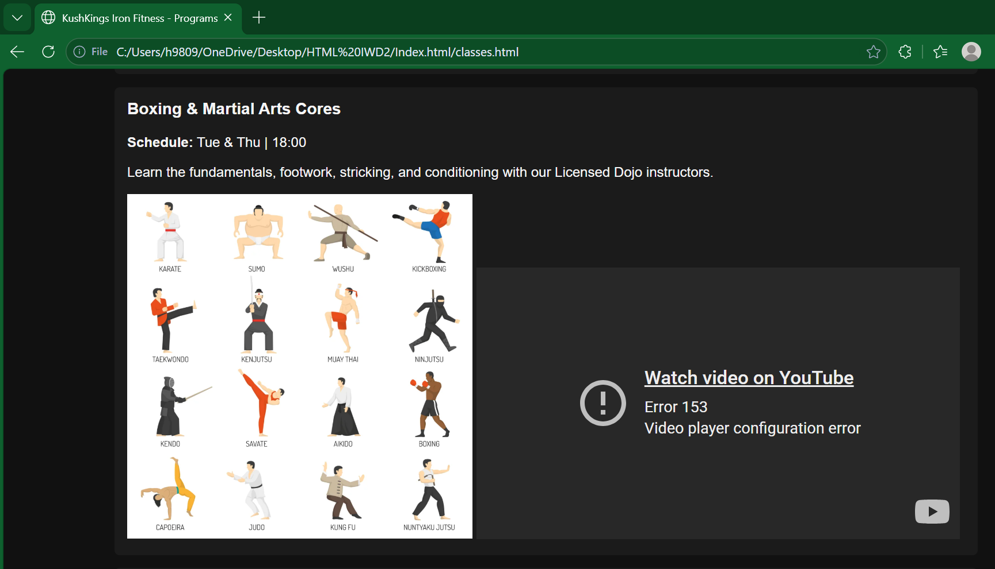

Figure 6 Source index.html Classes Page

The fourth program available is your one-to-one customizable personal training package. This is perfect for members wanting to hit their targets and put together a realistic, executable plan with a licensed professional for an effective result.
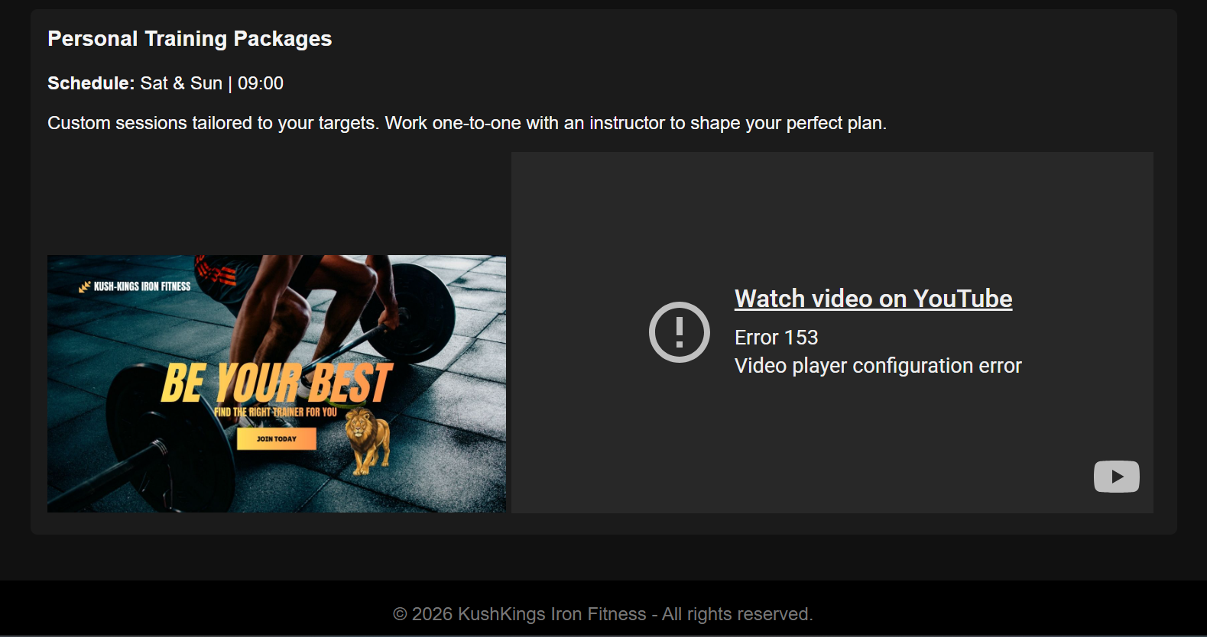

Figure 7 Source index.html Classes Page

The eighth image has the location, contact details, and staff operating hours.
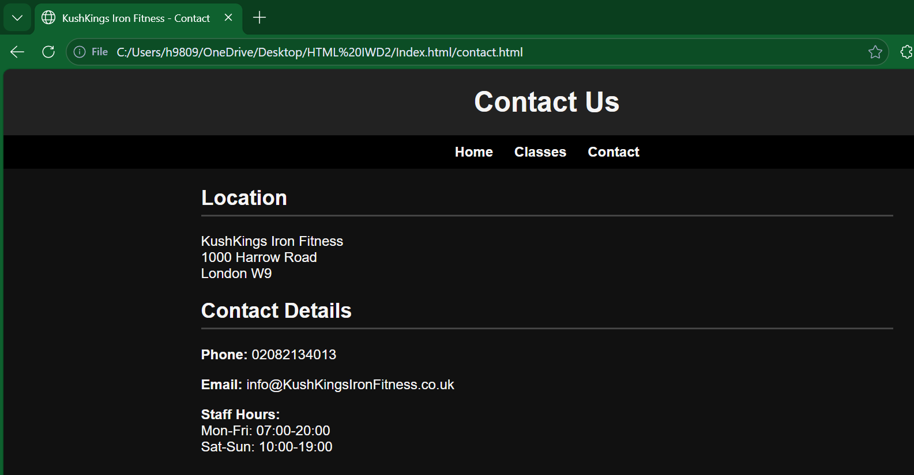

Figure 8 Source index.html Classes Page

The last screenshot illustrates a user inquiry form that allows clients to contact the fitness centre directly via email, a fast way for customers to communicate.
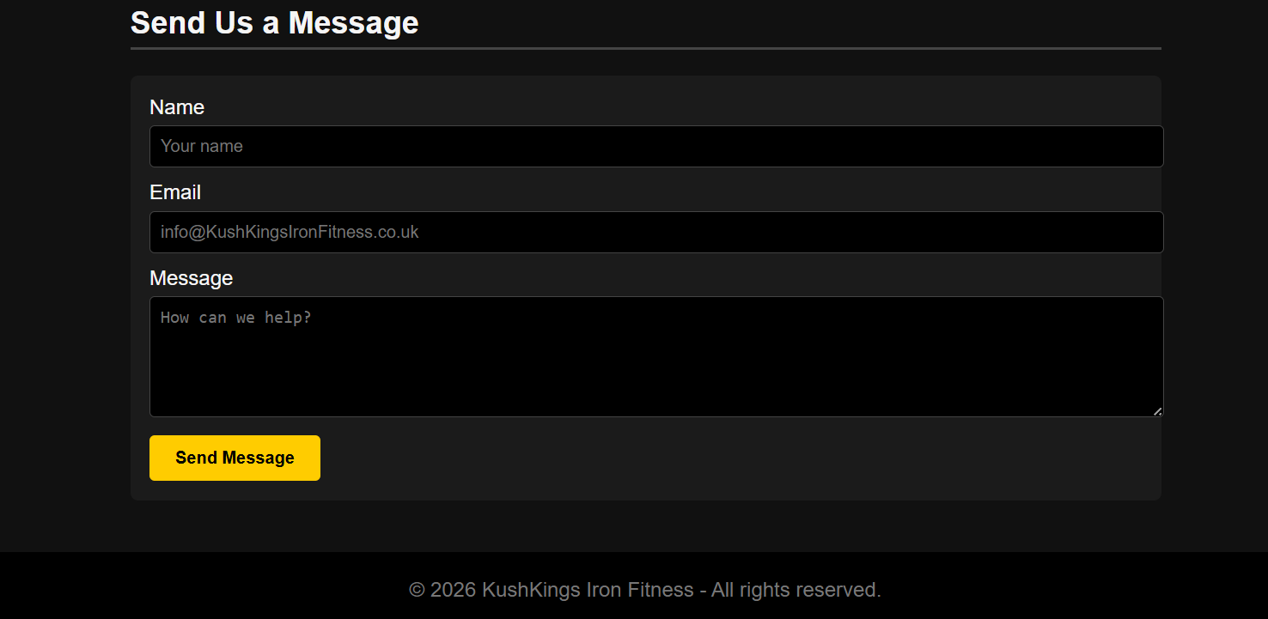

Figure 9 Source index.html Classes Page

HTML Validation Home Page:
I checked my home page HTML code on validator.w3.org, and the results returned 5 errors, which I corrected in Figure 12.
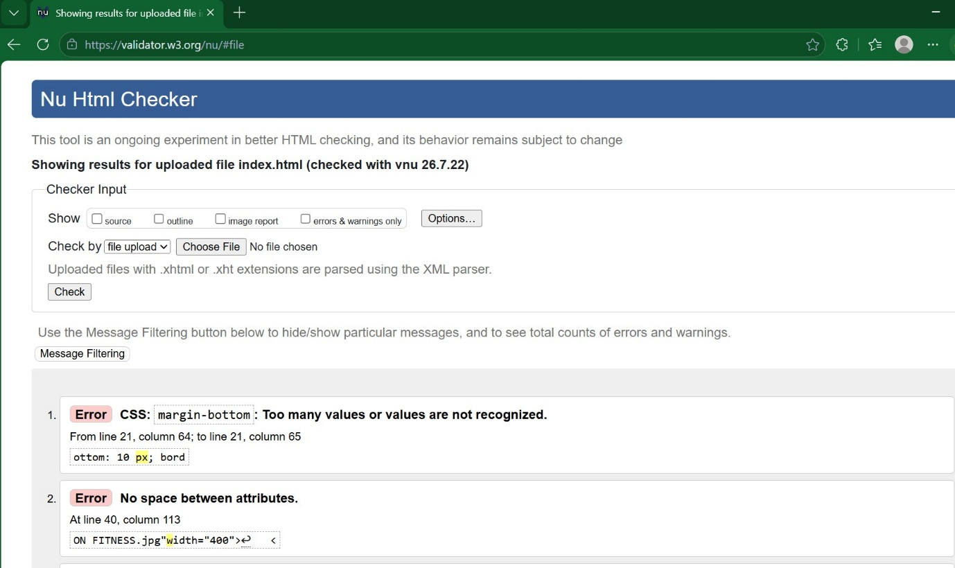Figure 10 Source http://validator.w3.org/
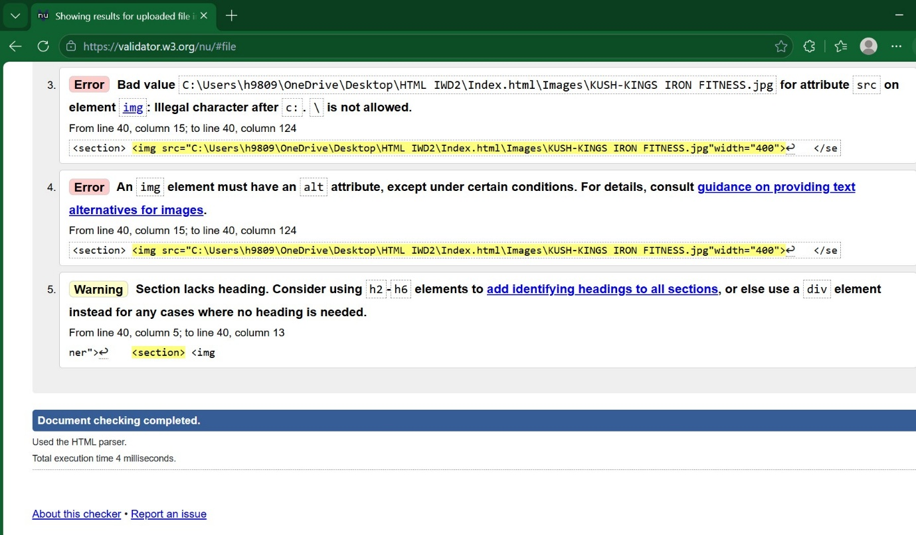

Figure 11 Source http://validator.w3.org/

Corrections:
Error 1 indicates either too many values or that the value is not recognised, so I removed the unit.
Error 2 states that there should be no spaces between attributes, so removed spaces.
Error 3 specifies that after C: a backslash (\) is not permitted. Thus, I removed the backslash.
Error 4 expresses that an img element must have an alt attribute. Therefore, I added it after the image code.
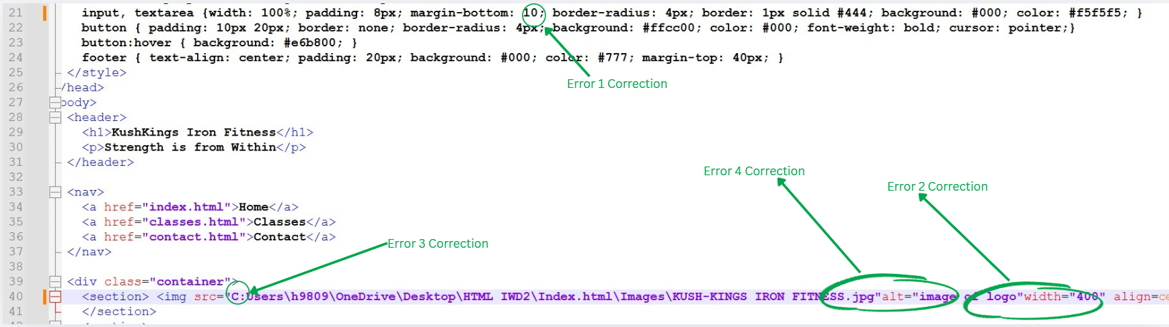

Figure 12 Source Notepad++

CSS Validation Home Page:
I tested my home page CSS code on jigsaw.w3.org/css-validator and came back with one error, which I corrected in Figure 14.
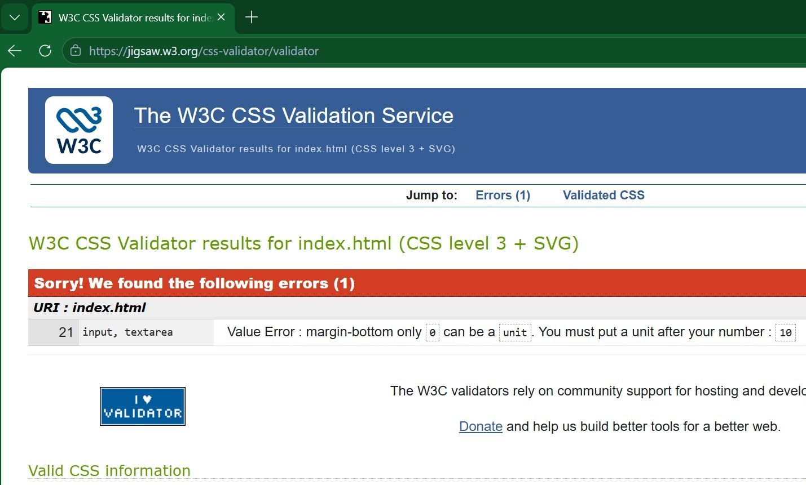

Figure 13 Source http://jigsaw.w3.org/css-validator/

Correction:
Error 1 indicates that a unit should follow the number.
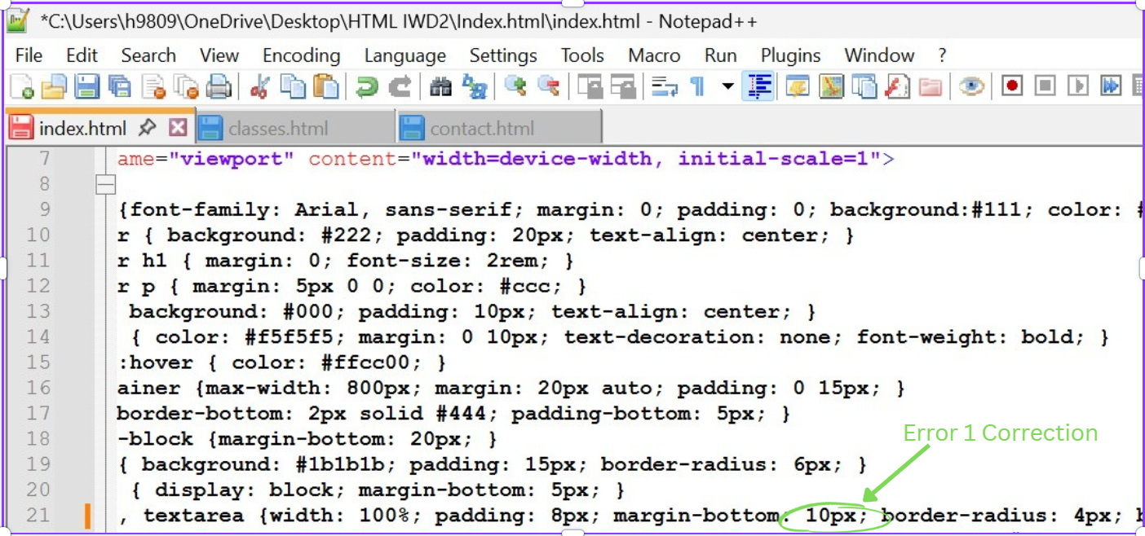

Figure 14 Source Notepad++

Evaluation

Research

A:
Usability of a website, also known as ease of website use, is a valuable characteristic that establishes itself with simplicity, productivity, and sufficiency, so that users are able to engage with the site with minimal effort [1]. Its main concentration is making sure website visitors can traverse through pages, comprehend the body of the site, and accomplish activities smoothly and with no difficulty [1]. A robust, user-friendly website heavily shapes repeat engagement with that website. On the other hand, as soon as you use a website that is complex to navigate through, you will discard it quickly and opt for a lucid, easier-to-grasp substitute.
Navigational simplicity is typically audited amid a quintet of fundamental building blocks. These are user onboarding ease, effectiveness, cognitive retention, fault recovery, and user approval [1]. These components help determine if participants are able to promptly interpret the way a website operates, execute activities with no or little obstructions, come back at a later stage without the need for re-familiarisation, steer clear of critical errors, and appreciate and engage with the site in an enjoyable way [1].
Given that usability is a quality property, it is vital for both customer-oriented websites and organisational platforms. Regarding e-commerce platforms, weak user experience deters users from sourcing products or making transactions [1]. As for enterprise networks, it hinders staff performance by delaying job execution [1]. When all is considered, usability plays a role in a web page’s broad effectiveness, consolidating interface usability to align with user requirements productively and optimally.

A1:
Accessibility, according to the World Wide Web Consortium (W3C), was established in 1994 by Tim Berners-Lee [2]. It is described as the universal organisation that produces and maintains web guidelines (WCAG) without requiring licensing fees and, most importantly, can be accessed by users who have different forms of disabilities [2]. Web Content Accessibility Guidelines are structured on four core principles. The material has to be noticeable, functional, comprehensible, and resilient [2].
In accordance with noticeability, sites are obligated to supply a written equivalent substitute for media content and guarantee data can be explained in a variety of ways while maintaining content accuracy. Regarding functionality, every operational capability has to be usable through a keyboard or mouse. Individuals need to have enough time to engage with materials. In addition, web pages have to refrain from implementing epileptic triggers. The comprehensible rule necessitates clear content, reliable interface passage, and measures that minimise mistakes. And to conclude, a resilient body certifies alignment with contemporary and upcoming supportive innovations [2]. In unison, these guidelines optimise usability for web users who have cognitive impairments.

A2:
Search Engine Optimisation (SEO) methods aid vital developments for a web page, exposure, ranking placement, and free user web flow [3]. A successful optimisation of a website commences with a solid SEO descriptor distribution and incorporating the keyword proactively in the data to help search engines perceive the connection to the web page. Constructing distinctive headlines and characterisations mitigates the chance of replicated material, which can bewilder or mislead search engines and weaken search visibility [3].
Performance-based SEO is similarly an important contributor, keeping the system in line with guidelines. This prevents content from being reproduced exactly and makes internal navigation stronger to assist search engines in analysing pages with a clearer understanding [3]. Making users interact more, making pages load faster, and matching with the required performance thresholds will sustain top positions when searched online [3].
Content effectiveness stays fundamental. Especially when matching with what the user is after, touching up older content, and sorting data for smooth AI extraction raise prominence across both standard search and automated outputs [3]. Crafting noticeable HTML title texts, easy-to-grasp web paths, and sharpened graphics additionally make the system more effective.
In conclusion, building gradual links and trademark acknowledgements solidifies credibility, raises the site’s ranking and earns reliability from both search engines and AI platforms [3].

Website evaluation

B:
Utility, Usability, and Content
Utility: Utility assesses how successfully the site meets its purpose and facilitates user needs. In examining my web pages, the results outline a clear purpose, which is a fitness centre offering an environment tailored for building endurance, health, strength, and combat skill. The classes page consists of schedules, descriptions, images and videos. The last page (contact page) contains the address of the facility, contact number, email address, and the hours admin staff are on site. This allows for rapid communication for members.
Usability: Usability reflects how smoothly users can traverse, comprehend and interact with your website’s features. In assessing my web pages, there is consistent navigation across all pages, clear headings (<h1>, <h2>, <h3>), and strong colour contrast, which illustrates a simple layout.
Content: The content benchmark covers clear communication, accurate info, precise relevance, and expert illustration of the content. When measuring my web pages, the content is clear, user-friendly, and aligned with the intended target market. The class descriptions are informative and simple to understand, and contact details are thorough and accurately presented.

B1:

SEO Techniques Used
Technique | Where applied in code
<header> | Lines 27, 29 of Contact.html Page
<nav> | Lines 33, 37 of Index.html Page
<section> | Lines 32, 35, 36, 68 of Classes.html Page
<div> | Lines 37 and 67 of Contact.html Page
<body> | Lines 27, 91 of Index.html Page

Screenshots of SEO techniques used
The first technique used (<header>) is a meaningful section. Meaning a section of content that groups related information together.
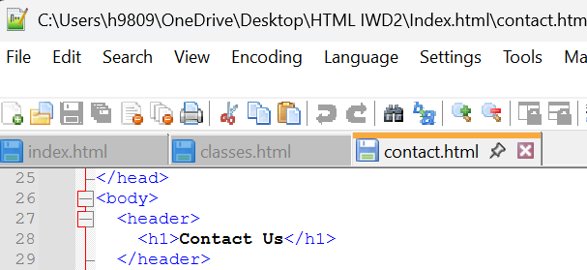

Figure 15 Source Notepad++

The second technique used (<nav>) can be described as a structured content unit. This allows for navigation links, which help users traverse the web page.
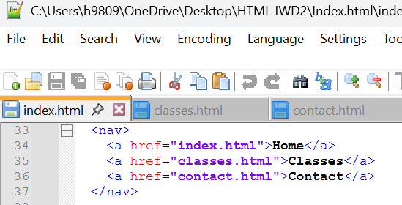

Figure 16 Source Notepad++

The third technique used (<section>) is also a meaning-based section like the first technique. However, the section technique is used to separate content by purpose, topic, or its own theme.
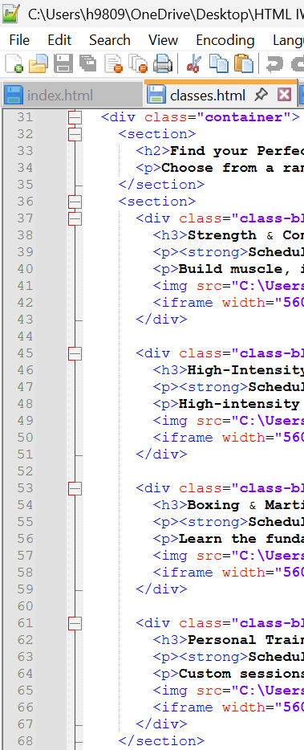

Figure 17 Source Notepad++

The fourth technique used (<div>) is an element used to structure variables of a code. Enabling you to style them with CSS, position them in a layout, and organise them for scripting.
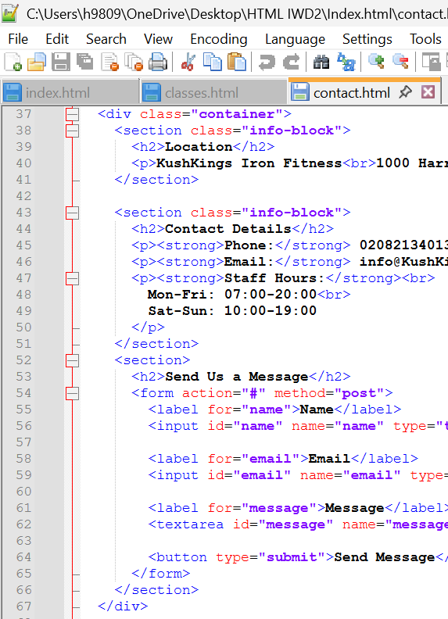

Figure 18 Source Notepad++

Finally, the last technique used (<body>) is the main content container of an HTML file. Everything the user can look at and interact with in the browser is inside the body tag.
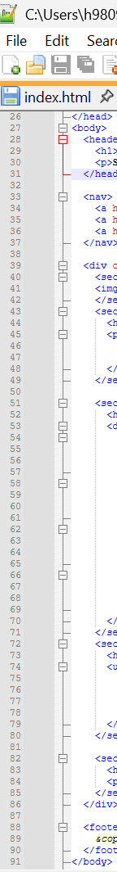

Figure 19 Source Notepad++

B2:

Accessibility

Principle | What it means | Example from a Website
Noticeable | Content must be presented in a way that users can interact with sight, sound, and assistive support tools [4]. | Images use alt text  Example from index.html (alt="image of fitness centre logo").
Functional | Users must be able to operate the website using keyboard and mouse [4]. | Navigation through pages can be accessed through mouse or keyboard.  Example from all HTML pages (<nav>  <a href="index.html">Home</a>  <a href="classes.html">Classes</a>  <a href="contact.html">Contact</a>  </nav>).
Comprehensible | Content has to be easy to comprehend [4]. | Same navigation menu appears on all pages.  Example on all HTML pages.
Resilient | Content must be compatible with existing and upcoming assistive support technologies [4]. | Meaningful HTML structure.  Example tags on all pages describe the meaning of content and are properly opened and closed. (<header>, <section>, <div>, <footer>).

Accessibility Website Auditor
I ran my home page (index.html) on Websiteaccessibilitychecker.com, and the tool identified several potential problems. I will be showcasing three.
Regarding the first possible issue (“248-visual lists may not be properly marked”), the checker flagged it as a reminder to make sure all lists use proper tags. However, this is a header section, not a list. In terms of the second and third likely concerns (“270-Unicode right-to-left marks or left-to-right marks may be required” and “271- dir attribute may be required to identify changes in text direction”), it is also a notification to use writing flow in case other languages are added later.
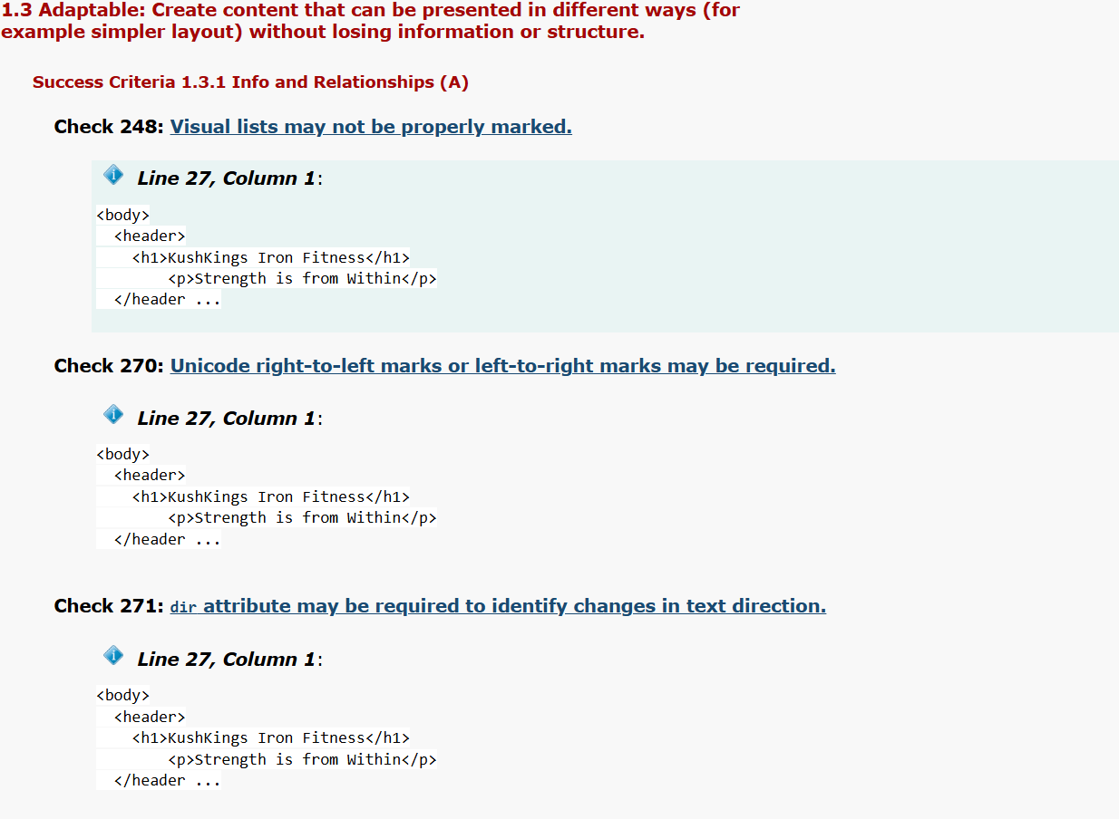
Figure 20 Source Web Accessibility Checker: Web Accessibility Checker

Website Comparison

C:

Compatibility
Below, I have compared my website with two well-established fitness brands. The first is Third Space and the second is Fight Zone London. I have compared them on a steady layout, blueprint information, informative headings, and understandable text. I also assessed content visibility, descriptive class details, and mobile adaptability. I have also included screenshots of the sites used.
Area | Third Space | Fight Zone London
Usability | Clear Information Blueprint | Consistent Layout
Accessibility | Meaningful Headings  h1, h2, h3 | Clear Text That is Understandable
SEO | Content Information is Very Noticeable | Descriptive Details on Different Types of Martial Arts
Mobile-Friendliness | Even distribution, margins, and padding reconfigure to mobile screens | Adaptive layout grid, adjusts to mobile screens

Site 1: Third Space
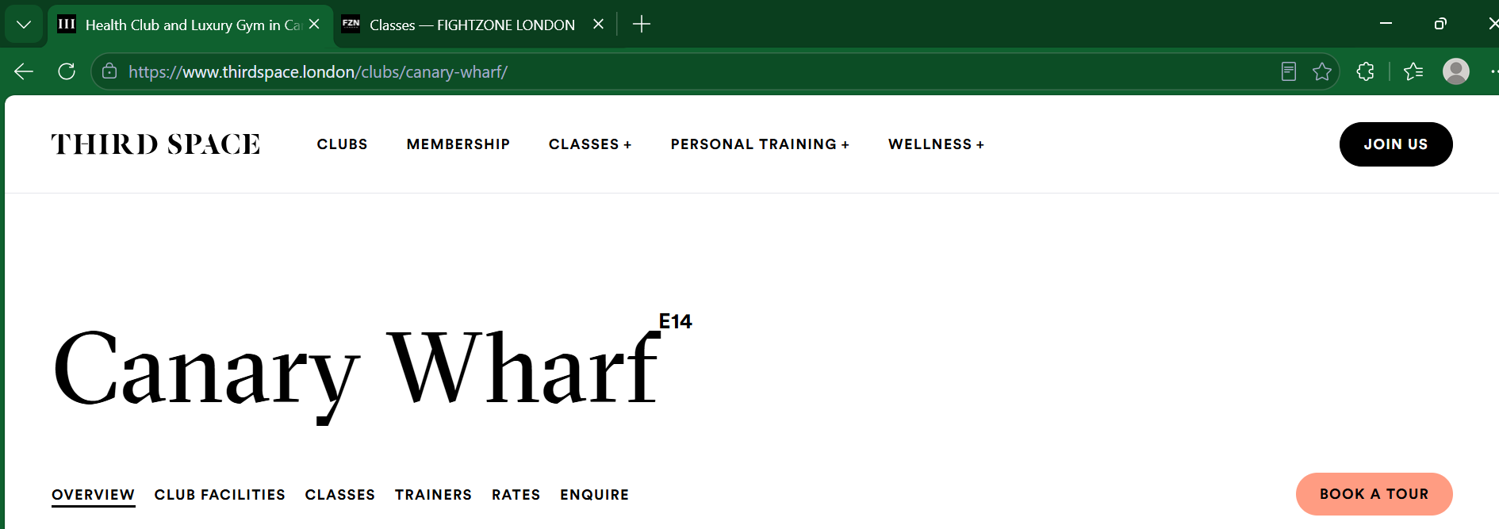

Figure 21 Health Club and Luxury Gym in Canary Wharf - Third Space

Site 2: Fight Zone London
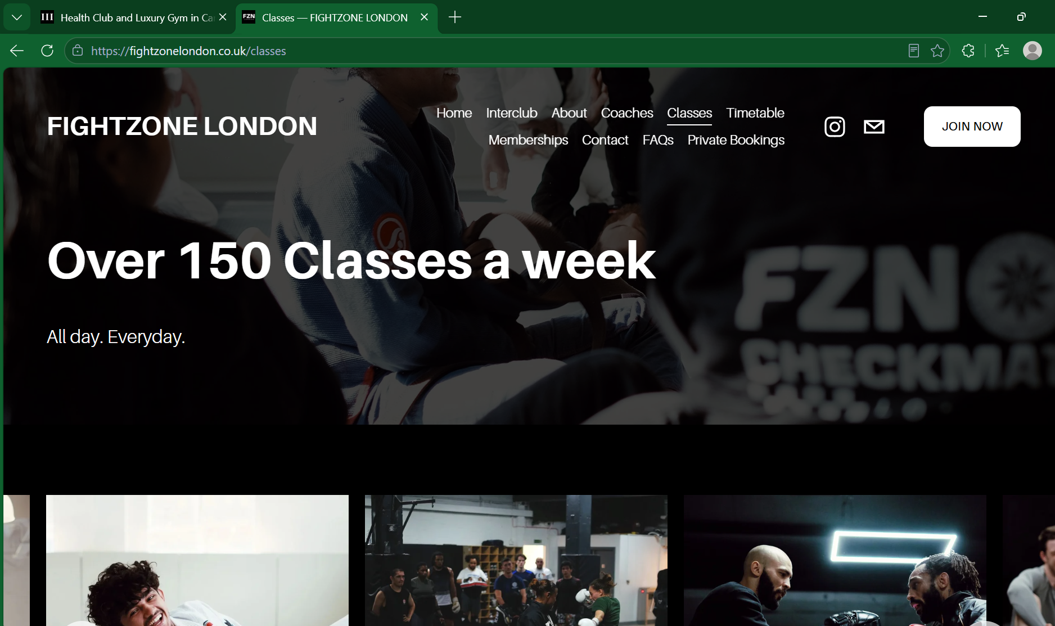Figure 22 Classes — FIGHTZONE LONDON

Conclusion
To wrap up this assessment, I want to be honest and say it was a challenge, as it was my first time learning these skills. However, I am always willing to go the extra mile to deliver results.
I have gained an understanding of the vital HTML and CSS markup and style languages to implement. From using syntax rules to create a layout that will be compatible with a web browser, for example, the building blocks, tags, nesting, and the document structure, to how styles must be written for an effective output.
When investigating and fact-finding the usability, accessibility, and SEO techniques to be implemented. I grasped that a website needs to be user-friendly, has an obligation to be in line with the Web Content Accessibility Guidelines (WCAG), and that embedded SEO techniques can have an impact on your classification, visibility, and the free, consistent, and meaningful user engagement. Finally, when I compared my website with two other fitness establishments, I cross-referenced the usability, accessibility, SEO techniques used, and mobile friendliness with my own website for a concise comparison.

References, Validations, Auditor Links
References
[1] R. Allison, C. Hayes, C. A. McNulty and V. Young, "A comprehensive framework to evaluate websites: literature review and development of GoodWeb," vol. 3, no. 4, pp.e14372, 2019,
[2] W3C (World Wide Web Consortium). "Web Content Accessibility Guidelines (WCAG) 2.0." Accessed: 29/07 2026. [Online]. Available: http://www.w3.org/TR/2008/REC-WCAG20-20081211 (w3.org in Bing)
[3] S. Gupta, N. Agrawal and S. Gupta, "A review on search engine optimization: Basics," vol. 9, no. 5, pp.381–390, 2016,
[4] N. Nussli and K. Oh, "Applying the POUR Model to Enhance Digital Accessibility in HyFlex Learning Environments Application du modèle PUCR pour améliorer l’accessibilité numérique dans les environnements d’apprentissage comodaux," Applying the POUR Model to Enhance Digital Accessibility in HyFlex Learning Environments

HTML Validation: http://validator.w3.org/ (Figures 10 and 11)
CSS Validation: http://jigsaw.w3.org/css-validator/ (Figure 13)
Accessibility auditor: Web Accessibility Checker: Web Accessibility Checker (Figure

Appendices

Index.html (Home Page 1)
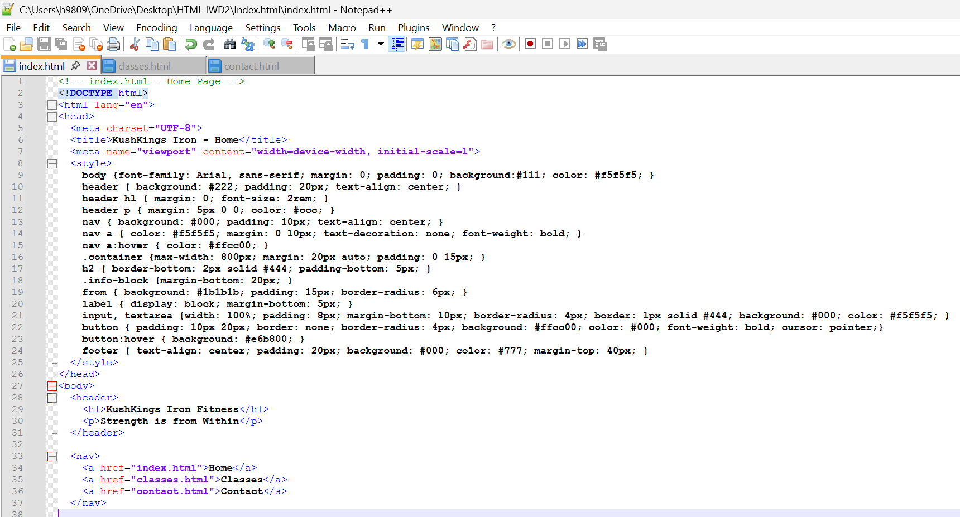
Figure 23 Source Notepad++

Index.html (Home Page 2)
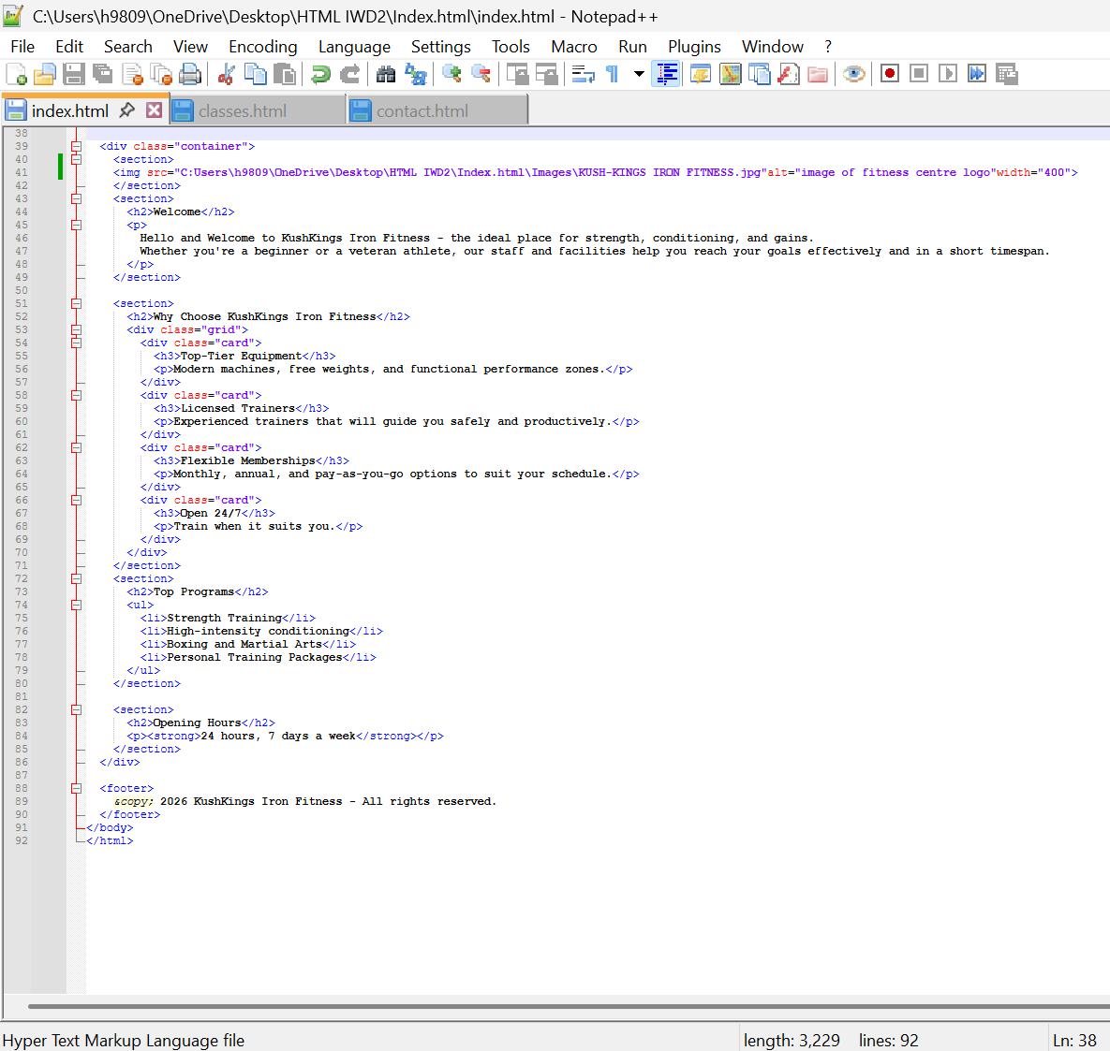Figure 24 Source Notepad++

Classes (Classes Page)
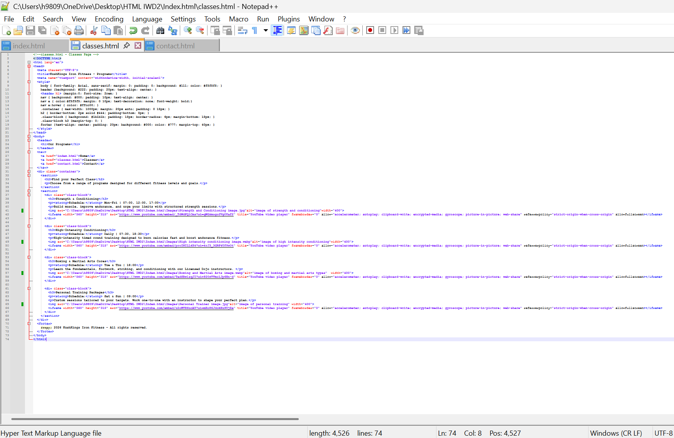Figure 25 Source Notepad++

Contact (Contact Page)
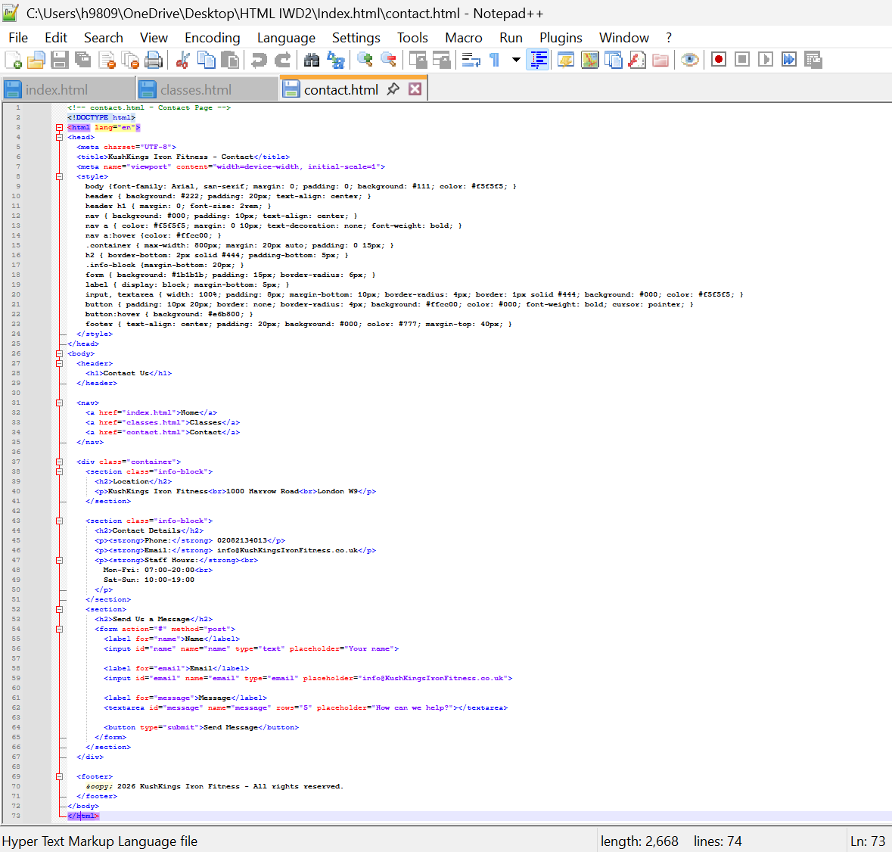Figure 26 Source Notepad++

