International Financial Management
LCBB6002

BA BUSINESS MANAGEMENT LEVEL 6
SEBASTIANA FRASINESCU
2021070

Executive Summary
The study has elaborated the concept of International Financial Management concerning the multinational corporation named Marks and Spencer. Firstly the report has stated the dividend distribution policy of the concerned company and then elaborated on the concept of efficient market hypothesis in the context. Moreover, the entities' different procedures for appraising the projects have been elucidated.

Table of Contents
Introduction 4
Outlining the overview of Marks and Spencer as well as portraying the indispensability of IFM 5
Highlighting the concept of the dividend policy and reflecting Marks and Spencer's policy of the dividend payout 8
Illustrating the concept of the efficient market hypothesis in the Marks and Spencer 10
Describing the methods used by the M & S for the assessment of projects or the investments 11
Conclusion 12
References 13

Introduction
International financial management is essential for companies since it enables them to better manage risks, make the most of their financial resources, and increase their revenues on international markets. The indispensability of the IFM about the MNC named Marks and Spencer will be elaborated on in this study. A company's dividend distribution strategy is crucial as it has an impact on the returns to shareholders, the financial flexibility, and the perception of the market. Also, the company's total worth, which has an impact on its capacity to draw in investors and raise money is included in this policy, its significance will be elucidated in the context. Moreover, the concept of the efficient market hypothesis for the M&S will be discussed along with the various methods that are utilised for evaluating different projects or investments will be completely described in this concerned report.

Outlining the overview of Marks and Spencer as well as portraying the indispensability of IFM
Overview of the Marks and Spencer
Michael Marks as well as Thomas Spencer established Marks and Spencer (M&S), a British global store, in 1884. With over 950 locations globally, M&S, which started as just a single market stall in Leeds, has expanded to become one of the biggest and most recognisable retailers in the UK. M&S boasts an extensive record of creativity and flexibility in the ever-changing retail sector and is renowned for its premium items and first-rate customer service. M&S is still evolving to satisfy the needs of current customers while also emphasising sustainability and moral corporate conduct. Located throughout the UK, Europe, Asia, and the Middle East. Marks and Spencer employed over 66,000 in the year 2022. M&S provides for its customers by operating in several markets, including those for clothing, food, and home goods. It runs about 900 outlets in the UK and 455 stores worldwide. In the UK retailing market, M&S has an overall market share of about 3% (Smith, 2022). Its yearly revenue increased by 1.9% to £9.2 billion in 2021 from the year before. To promote long-term sustainable growth, the company intends to increase online sales, broaden its global reach, and boost operational effectiveness.
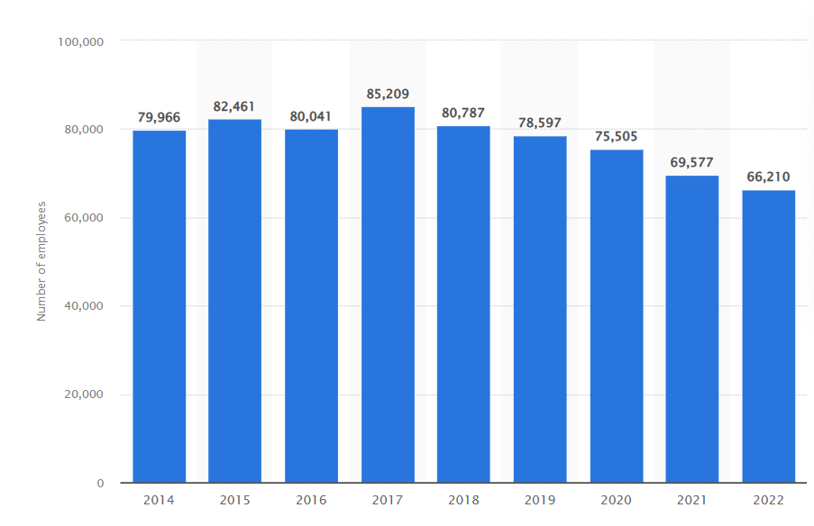
Figure: Number of employees of Marks and Spencer
Source: (Smith, 2022)
Importance of the International Finance Management for the entity
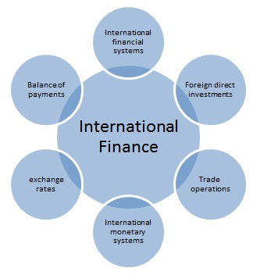
Marks and Spencer must prioritise international finance management since the company competes in a global market where changes in interest rates, currency exchange rates, and general economic conditions can have a big influence on its bottom line. Marks and Spencer may reduce currency risk exposure, efficiently manage cash flow, and improve capital structure with the use of effective international finance management (Shapiro and Hanouna, 2019). To secure its earnings and keep its prices competitive in global markets, it might protect against currency rate volatility. Additionally, Marks and Spencer can obtain finance from a variety of sources, such as capital markets worldwide, which can offer the funds required for expansion and growth. This can enable it to take advantage of international opportunities and reduce country-specific hazards.

Figure: Components of International Finance Management
(Source: Created by the learner)
Also, Marks and Spencer's performance in the foreign market depends on competent international financial management. It can aid the business with risk management, capital structure optimisation, and financing from a variety of sources of information, enabling it to capture opportunities and experience sustainable growth over the long term.

Highlighting the concept of the dividend policy and reflecting Marks and Spencer's policy of the dividend payout
Concept of Dividend Policy:
The term "dividend policy" describes the rules or methods that a business use to choose how much of its profits will be paid out as dividends to its shareholders. The dividend policy's primary goal is to strike a balance between the goals of the business and its stockholders by figuring out how much earnings should be preserved for future to grow and how much should be distributed as dividends (Barros et al., 2020) The purpose of the dividend strategy is to inform shareholders clearly and predictably regarding the company's intent to pay out dividends on its earnings. It also contributes to maintaining an ongoing dividend payment, which can improve the company's standing and draw in more investors. Furthermore, a company's dividend policy may indicate its financial viability and profitability, which may have an impact on the stock price. Overall, a company's dividend policy is crucial to its overall financial strategy since it helps to find a balance between the shareholders' need for income and the company's requirement for capital investment.
Marks and Spencer’s dividend pay-out policy:
The dividend policy of the business is made to offer a steady and regular return to shareholders while simultaneously preserving a sound balance sheet and promoting the long-term expansion of the company. The dividend payout policy of Marks & Spencer is determined by several elements, including the business's financial results, its cash and its reserves including its overall financial status. The business wants to distribute dividends to its shareholders equal to at least 20% of the company's post-tax earnings (corporate.marksandspencer, 2023). The actual dividend payment amount, however, may change from year to year based on the business's financial performance.
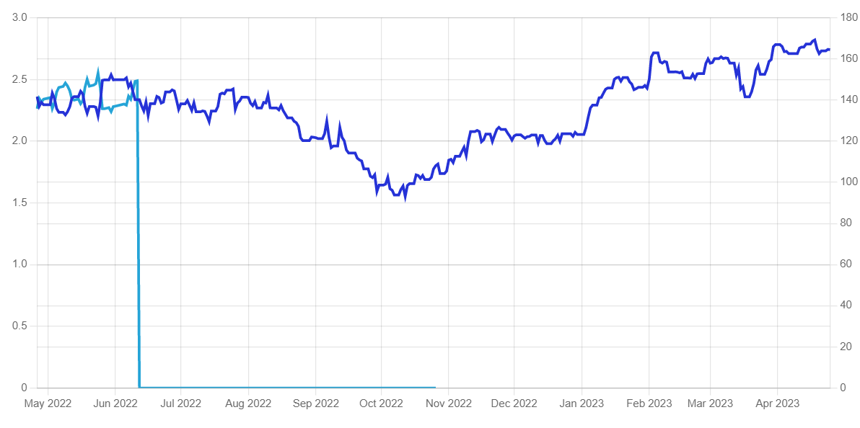
Figure: Marks and Spencer optimised chart of dividend
Source: (dividendmax, 2023)
Marks and Spencer maintains an established tradition of regularly distributing dividends to its shareholders throughout the years, and the business has a solid track record of doing so even during periods of economic turbulence. The dividend policy of the company is created to give shareholders a steady and predictable return while also enabling the business to make investments in growth and keep a sound balance sheet. The overall goal of Marks & Spencer's dividend distribution policy is to strike a balance between providing dividends to shareholders and preserving the company's long-term growth and stability.

Illustrating the concept of the efficient market hypothesis in the Marks and Spencer
Theory of Efficient Market Hypothesis
According to the effective market hypothesis (EMH), the securities markets are typically informationally effective, implying that asset prices accurately represent all available information. This suggests that it is difficult to regularly outperform the market with data that is already available to the general public. The EMH is predicated on the idea that market actors are logical as well as will make decisions in their best interest of themselves by incorporating all relevant information into their judgements (Chu et al., 2019). However, there is disagreement over the EMH's applicability because some contend that irrational behaviour and knowledge asymmetry prevent markets from being entirely efficient.
Stating the EMH theory with respect to M & S
According to the theory expressed as the Efficient Market Hypothesis, financial markets, especially the stock market, are effective and accurately represent all generally available information, making it difficult to regularly outperform the market. For Marks and Spencer, it would mean that the present stock price reflects all information that is currently accessible about the business, particularly its accounting records, market trends, and pertinent news (Vasileiou, 2021). Therefore, attempting to forecast the future share price of M&S using this knowledge would be fruitless. However, there is disagreement over the EMH's validity as some claim that it fails to take into account elements like irrational behaviour and information asymmetry. The EMH may therefore be a valuable framework for comprehending stock market behaviour, but it may not always be accurate in real-world situations.

Describing the methods used by the M & S for the assessment of projects or the investments
In accounting, a proposed project's financial feasibility is assessed as part of the project evaluation process. This entails evaluating the project's anticipated costs, advantages, risks, and returns to ascertain its future profitability and viability. Because they offer a quantitative framework for assessing various project possibilities and highlighting potential areas of concern, project appraisals are crucial in assisting firms in making wise investment decisions. Some of the appraisal techniques are as follows:
i. Net Present Value: For Marks & Spencer, the goal of Net Present Value (NPV) is to assess the prospective viability of a project of investment (accountingcoach, 2023). It is done by contrasting the present value of anticipated future earnings to the future value of its initial cost, while accounting for the time value of money.
ii. Payback period: Due to its ability to quantify both the risk and liquidity of an investment, the payback period is a crucial financial metric in accounting. A quicker payback time suggests that an investment is less hazardous and can return its initial cost more quickly, whereas a longer time frame for payback might suggest a higher risk level or lesser profitability (accountingcoach, 2023). Based on their expected revenue and time horizons, organisations can use this statistic to assess investment possibilities and decide which projects to pursue.
iii. IRR (Internal rate of return): The Company’s Internal Rate of Return (IRR), which offers a gauge of an investment project's prospective profitability (accountingtools, 2022). It aids Marks and Spencer in making investment choices based on projected returns, is a crucial financial parameter for the corporation.

Conclusion
The aforementioned study states that companies operating internationally have to concentrate on managing their finances as it has a significant effect on their functioning. Marks and Spencer being one of the major multinational retailers acquires a significant share in the marketplace. Furthermore, the study has discussed the dividend distribution policy being employed by the specific company and stated how it helped in maintaining a good brand image. Apart, from this, the report has discussed the concerned theory of the efficient market hypothesis in association with the effect on the functioning of the M&S. Three distinct methods such as the payback period, NPV as well as IRR, are illustrated in the context for appraising the projects or the necessary investments which are to be made by the respective investors.

References
accountingcoach, (2023). How do you calculate the payback period?. [Online] Available at: https://www.accountingcoach.com/blog/calculate-payback-period#:~:text=Definition%20of%20Payback%20Period,it%20invested%20in%20a%20project. [Accessed 24 April 2023].
accountingcoach, (2023). What is net present value?. [Online] Available at: https://www.accountingcoach.com/blog/what-is-net-present-value#:~:text=Definition%20of%20Net%20Present%20Value,by%20a%20specified%20interest%20rate. [Accessed 24 April 2023].
accountingtools, (2022). Internal rate of return (IRR) definition. [Online] Available at: https://www.accountingtools.com/articles/internal-rate-of-return-irr#:~:text=What%20is%20the%20Internal%20Rate,value%20of%20all%20associated%20costs. [Accessed 23 April 2023].
Barros, V., Matos, P.V. and Sarmento, J.M., (2020). What firm’s characteristics drive the dividend policy? A mixed-method study on the Euronext stock exchange. Journal of Business Research.
Chu, J., Zhang, Y. and Chan, S., (2019). The adaptive market hypothesis in the high frequency cryptocurrency market. International Review of Financial Analysis.
corporate.marksandspencer, (2023). Our year in review 2022. [Online] Available at: https://corporate.marksandspencer.com/investors/our-performance-updates/2022-annual-report [Accessed 22 April 2023].
dividendmax, (2023). Marks & Spencer Group. [Online] Available at: https://www.dividendmax.com/united-kingdom/london-stock-exchange/retailers/marks-and-spencer-group/dividends#:~:text=Dividend%20Summary,dividend%20cover%20is%20approximately%201.5.&text=Our%20premium%20tools%20have%20predicted,Spencer%20Group%20with%2078% [Accessed 22 April 2023].
Shapiro, A.C. and Hanouna, P., (2019). Multinational financial management. John Wiley & Sons.
Smith, P., (2022). Marks and Spencer - Statistics & Facts. [Online] Available at: https://www.statista.com/topics/3707/marks-and-spencer/#topicOverview [Accessed 25 April 2023].
Vasileiou, E., (2021). Behavioral finance and market efficiency in the time of the COVID-19 pandemic: does fear drive the market?. International Review of Applied Economics.

