


Data Security, Governance and Compliance

by
Yinjie Zhang
Lecturer: Dr. Nitheesh Kaliyamurthy

December 2022

Research Background
In the current information age, protecting the privacy, integrity, authenticity and reliability of information has become one of the highest priority demands of both people and enterprises. With the accelerating process of enterprise informatization construction, enterprise business relies more and more on IT and has higher and higher requirements for IT technical support service management. So, strengthening and improving the management of information technology services will play a vital role in the business operation and process management of enterprises, as well as the key for enterprises to win in the fierce market competition.

ITIL

History background
ITIL is a well-known best practice in the IT service management category. ITIL has been expanded and improved many times since its introduction. Up to now, there are five versions of ITIL, including ITIL v1, ITIL v2, ITIL v3, ITIL 2011 and ITIL4.

1.2 Characteristics and Advantages
ITIL provides a guiding framework that preserves the best of the existing IT management methods within an organization, adds the necessary technologies, and facilitates the exchange and coordination of information between different IT functions. However, it is not a set of theoretical models, but a customized sustainable improvement plan based on the best practical experience in the world, based on high-quality, reasonably defined, repeatable processes and other operations. By applying ITIL to IT service management, enterprises can effectively manage and improve IT service quality. Through ITIL process management modules, it can realize the improvement and optimization of business functions and business processes, so as to reduce costs, shorten time, improve efficiency and user satisfaction. Detailed advantages are as follows:
For the IT department, in terms of return on investment, if you look at IT investments against ITIL, you can easily define the expected return on investment and measure the return on investment. At the same time, it can more clearly create a multi-skilled, cross-departmental collaborative team with shared responsibilities and obligations. With the increase of mutual trust, users and IT operations personnel will not blame each other, but form a mutually reinforcing form of cooperation, and eventually improve their "fire brigade" appearance.
In terms of investment reporting, ITIL can measure returns and build a multi-skilled, cross-organizational team with shared responsibilities and obligations. Due to the deepening of mutual trust, users and IT personnel will no longer blame each other, 20 form a form of mutual promotion.
For enterprise managers, ITIL can make IT projects more efficient from planning to execution to operation and maintenance, and obtain higher IT service experience while reducing costs. And ensure that IT processes support business processes, thereby improving the quality of the company's overall business operations; At the same time, IT promotes the information exchange and integration between IT operation and maintenance and business departments, transforming IT operation and maintenance department from a cost center to a revenue center]; IT also reduces redundant and repetitive work, which improves productivity between IT operations staff and users.
For the heads of enterprise IT departments, using ITIL can master the leading IT service mode in the industry, enable the internal users of the company to have a more reasonable expectation of IT services, and enable the IT department to bring new strategic competitiveness to the enterprise, so as to become the MBA in the IT industry and develop towards the direction of managerial IT talents.
For the heads of enterprise IT departments, they can master the leading IT service mode in the industry, so that the internal users of the company can have a more reasonable expectation of IT services, so that the IT department can bring new strategic competitiveness to the enterprise, so as to become the MBA in the IT industry to the direction of management IT talents.
For the operation and maintenance personnel of the enterprise IT department, they can not only improve their IT skills, but also master more technical knowledge. For human resource directors, ITIL can improve the production efficiency, morale and job satisfaction of IT operation and maintenance staff, and make the management of the entire IT department more efficient and simple.
For the operation and maintenance personnel of the enterprise IT department, they can not only improve their IT skills, but also master more technical knowledge. For human resource directors, ITIL can improve the production efficiency, morale and job satisfaction of IT operation and maintenance staff, and make the management of the entire IT department more efficient and simple.
Although ITIL is advanced and authoritative, it is not perfect. Any thought or system with its advantages must have its corresponding shortcomings or limitations. The potential defects of ITIL can be summarized as follows:
Although ITIL is advanced and authoritative, it is not perfect. Any thought or system with its advantages must have its corresponding shortcomings or limitations. The potential defects of ITIL can be summarized as follows:
- The implementation of ITIL requires a strong communication and execution plan, as well as a large investment in costs and the world. It must be carried out only with a complete plan and ability, which to some extent needs to face various trade-offs and trade-offs
- As an IT operation and maintenance management system, it needs the full cooperation and support of all employees within the enterprise.
- IT is necessary to consider the actual situation of the enterprise, integrate IT processes and norms, and implement ITIL may take a long time, which is a process of continuous improvement and perfection.

1.3 The difference between each version
V1 is the earliest ITIL version, released at the end of 1980. IT mainly reflects the knowledge and experience accumulation of IT managers, covering more than 40 processes, including service support and service provision. V2 expands and enrichis the IT management process on the basis of V1, and establishes six modules, such as business management and service management, which basically cover every aspect of enterprise IT service management; V3 is on the basis of service management V2 put forward a higher standard of management requirements, added: service demand management, directory management, knowledge management and event access management and other processes, and highlights the life cycle cycle of IT management, including service strategy, service design, service transformation, service operation and service improvement five parts. The latest ITIL4 adds some agile, DevOps, lean, IT governance, leadership and other working methods on the previous version. IT integrates the operation and maintenance, research and development, testing within IT organization with the collaboration of business and users outside IT organization in a complete framework, creating a new management mode slot for digital services. Starting with a focus on the delivery of value in IT services, V4 incorporates the latest trends in technology and service management and provides a flexible foundation for enterprises to digitally transform and integrate digital technologies into all areas of their business. The service life cycle and 26 service life cycle processes imported in ITIL V3 were removed from ITIL V4.

ISO 27000
ISO27000 series of standards originated from the British Standards Association in 1995 developed BS7799 standard, and through the adoption of ISO standards formed after the ISO17799 standard improvement.
ISO27000 series standards by the International Association for Standardization (ISO) and the International Electronic Technology Association (IEC) jointly developed, to provide information security management system (ISMS) construction guidance. The standard covers issues such as information protection, confidentiality, and IT technology security, and is applicable to organizations of all sizes. This standard system makes new information security management-related standards every year, and currently mainly includes the following published standards.

Standard document number | content
ISO27000 | ISMS related terms and definitions
ISO27001 | Information security management system requirements
ISO27002 | Information security management system best practice
ISO27003 | Information security management system implementation guide
ISO27004 | Information security management measurement
ISO27005 | Information security risk assessment
ISO27006 | Entity requirements for performing ISMS audit and certification
ISO27007 | Information security management system audit guide
ISO/IEC TR 27008 | ISMS Control Implementation Auditor's Guide
ISO/IEC27010 | Information security management of enterprise internal communication
ISO/IEC27011 | Information security management Guide for telecommunication enterprises based on ISO27002
In many standards, ISO27001 standard first put forward the concept of information security management system, is the core of the whole ISO standard system.

COBIT
COBIT (Control Objectives for Information and related Technology) has been published by ISACA since 1996. COBIT (Control Objectives of Information and Related Technologies) is the international authoritative IT control framework, which can assist the management of IT governance, guide organizations to effectively use information resources, and effectively manage risks related to information. This standard system has been applied in important organizations and enterprises in more than one hundred countries in the world, especially the introduction of the Sarbanes-Oxley Act (referred to as SOX) of the United States and the related regulatory system of Chinese regulatory departments, which makes the internal control of listed companies more strict and standardized. In the process of establishing IT internal control in line with these regulatory systems, COBIT plays an important role. The five principles of COBIT are Meet the needs of stakeholders, Cover the enterprise end-to-end, Apply a single comprehensive framework, Implementation holistic approach, Separate governance from management.

4. System Design

4.1Company Background
Jamaica coffee is one of the best and most popular blended coffees in the world. CoffeeBlend sells the coffee. CoffeeBlend has a global presence, so the company needs the network to provide a range of services. Companies need important data such as media promotion, employee information registration and intellectual property storage on the Internet. Under the influence of interests, it is inevitable that many hackers launch attacks on the company's network, which makes the company in chaos.

4.2 Features and Information Security Management Issues
1) a large network company has many types and large amounts of data, and the electronic information exchange between internal and external networks is frequent. Since the company's primary business is online, it uses cloud services to provide an online business platform and a social media platform for customers and employees. The huge amount of data and the fluidity of information reduce the ability and efficiency of companies to estimate risks, and the information security challenges faced by companies are constantly increasing. In addition, improper use of frequent information from internal and external networks will lead to leaks of confidential data and attacks on internal networks, leading to large-scale internal paralysis.
2) In the era of evolving information security forms, some companies, especially network service companies, are faced with the constant updating of attack methods. This requires the enterprise to have a complete and practical electronic information security management system, electronic information security early warning mechanism, rapid response after attack loss control and data recovery system, the enterprise electronic information security management mechanism to have constant review, revision and review.

4.3 Significance
1) It is beneficial to protect the core secrets of enterprises and improve the competitiveness of enterprises. The key to enterprise competition lies in its unique competitive advantage, which can protect its core competitiveness. This is the importance of trade secrets. Preventing the disclosure of important information, such as design information, management knowledge, production techniques, customer lists, and market intelligence, can protect a company from loss of financial benefits and unnecessary legal problems. In view of the electronic information is easy to copy, easy to modify, easy to destroy the characteristics of strengthening the enterprise electronic information security management is particularly important.
2) By ensuring the operation of enterprise electronic information security management, it is helpful to enhance the enterprise's overall control ability and crisis response ability. In the information age, the more secure and comprehensive our grasp of electronic information, the better able we are to grasp the overall situation and win the competition. In order to prevent the company's internal information chaos, easy to leak, once the large-scale electronic information security incident, can not control the loss, leading to the destruction of the company's survival. Strengthening management, ensuring electronic information security and preventing competitors' influence and damage is a good strategy to improve the company's overall control ability and crisis response ability. The company designs electronic information security management mechanism according to its own characteristics, strengthens employees' awareness of information security and formulates effective crisis response plan, which is of great significance to ensure the safe operation of electronic information of the company.
3) It is beneficial to protect the privacy and rights of customers and establish a good reputation for the company. As we all know, the company is based on integrity and reliability. With the acceleration of the exchange of information, the frequency of cyber attacks, and the global personal privacy and security issues are intensifying. The security of basic customer information and specific electronic information is the key to the company's foothold. In today's frequent occurrence of personal information leakage, the company to strengthen information security management, to protect the privacy and rights of customers, has more special significance.

4.4 Method Design
As for ITIL related to COBIT, ITIL is process-oriented and customer-centric. While meeting actual business needs, ITIL also provides information technology service companies with rigorous, consistent and practical standards and norms. Other issues like benefit, implements and the guidelines of reviews are also mentioned, but they are better described in COBIT. COBIT is very powerful when it comes to management issues. When ITIL is benchmarked with COBIT, it is found that they largely correspond with each other, especially when the COBIT process is based on the latest version of ITIL. Although different words are used for the same issue, they cover the same issue. The comparation of ITIL and COBIT is shown in Table 1.
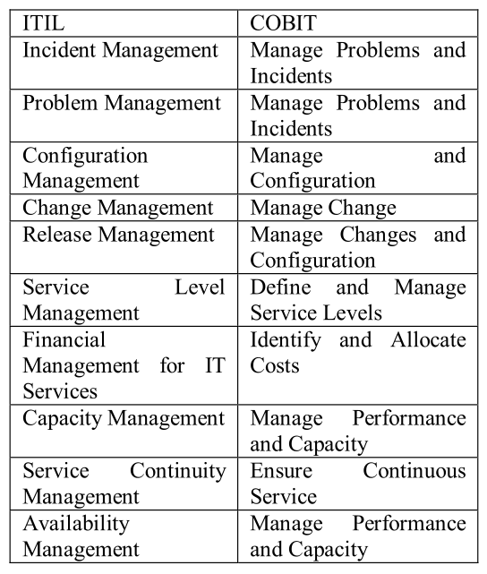
Table 1: Compare ITIL and COBIT
As mentioned above, ISO 27002 is used for information security and its’ main straight is to ensure the whole security of all levels in an organization. In ISO 27002 security framework, the characteristics of security are to preserve confidentiality, integrity and availability. It is only about risk management, that is to say, it can reduce risks to avoid costs.
So, designing a system security framework that combines ITIL, COBIT and ISO 27002 can meet the security and compliance requirements of the company's information system. Implementers can use ITIL to design modules and processes, then use COBIT for auditing and measurement, and use ISO 27002 for information security assessment and control.

4.4.1 ITIL
The IT service management system should be a fully automated system. The entire processing work should form a closed-loop workflow, which can facilitate timely feedback from service personnel and supervisory return visits by managers to improve work efficiency and service quality.
- Service Desk Management
The service desk is the access point for IT services. It conducts preliminary processing of service requests from users (such as by telephone, email) at first. When the service desk cannot effectively handle these requests or these requests exceed its’ ability, the service desk will transfer the event to the higher-line staff to process. In this way, it can save time and cost, as well as make service operations more efficient.
The main task of the service desk is to provide support for IT services by coordinating the relationship between users and IT departments, thereby improving user satisfaction. It is not only responsible for handling events and customer inquiries, but also to provide interfaces for other processes.
- Incident management
In CaribbeanCoffee's IT service management work, all event management users are required to submit service applications to the service desk. Incidents include failures, requests, consultations and complaints. All service applications are registered at the service desk and then enter the incident management process.
- Problem management
The fundamental purpose of the problem management process is to eliminate or reduce the occurrence of incidents. This process analyzes the incidents that occur in the production environment, determines the most frequently occurring or most impactful incidents, finds out the root causes, and then generates preventive measures to prevent the incident from happening again.
- Change management
Change management controls and manages all changes in the entire IT operating environment, and establishes an interface with configuration management. It should be supported by management tools, and the scope of management can include operation and maintenance level changes and R&D level changes. To truly prevent the recurrence of the incident or reduce the impact of the incident, certain changes must be implemented to eliminate the root cause of the incident.
- Release management
Release management refers to the management process of distributing and propagating new or modified configuration items imported into actual applications after testing. Through program design, approval, schedule planning, construction, testing, and launching, it is guaranteed that each change release can be executed efficiently, and the risk and impact on the application system is minimized.

4.4.2 COBIT
The COBIT5.0 framework is currently the most widely used, covering the three dimensions of IT process, IT resources and information standards.
From the COBIT framework diagram, we can see that the company’s information standards mainly include information quality and company reputation. Each level of the company includes: IT resources include personnel, application systems, data and technology. The IT process includes three aspects: domain, process, and activity. The domain includes four levels: planning and organization, acquisition and implementation, delivery and support, and monitoring and evaluation. In this way, the company can effectively ensure the consistency of control activities and internal control objectives, and ensure the smooth progress of corporate governance activities.

Quality
Reputation
Domain
Process
Activity
Personnel
Application System
Data and Technology
IT Process
Information Criteria
IT Resources
Graph 1: COBIT framework diagram
4.4.2.1 Information criterion dimension
Insufficient legal standards often bring new management problems for enterprises to introduce cloud services.
Risk management mechanism: The company may establish a layered management system for legal risks. The first layer is for small risks, and the accounting department and relevant business units shall deal with it in a timely manner. For major and difficult risks, the second and third layers of medium and large lines of defense should be established, and risks should be strictly controlled in advance and during the event. Establish a suitable internal control system and risk early warning management system within the scope permitted by law, so as to strictly manage the risk of information standards, and strive to make information transparent.
4.4.2.2 IT resource dimension
a) personnel
The use of the cloud may cause company employees to be unable to adapt to new jobs, resulting in insufficient human resources and risks of misuse.
Risk management mechanism: Firstly, improve the prevention awareness of managers in various departments. Secondly, it is necessary to focus on the training of business personnel to improve the ability of employees to identify and respond to the risks of changes brought about by new technologies to company management.
b) operating system
The possible risks are customer identity authentication, privacy protection and Information transmission security.
Risk management mechanism: Strengthen the key management of each application system and establish a password security level.
c）technology
It may lead to the intrusion of the management interface, the interception of customer information, the leakage of information during upload or download, the intrusion of the cloud service engine, the cloud service environment cannot meet customer security requirements and other risks
Risk management mechanism: The resources of the company’s various departments can be integrated with cloud configuration to enrich and improve the company’s internal control.
4.4.2.3 IT process dimension
- Planning and Organization
i）Management Company Structure
The company has a problem that the existing organization structure cannot meet the needs of cloud service management.
Risk management mechanism: The focus of company control activities is mainly in the cloud. The company should fully consider cloud storage software and the possibility of becoming a target of cyberattack when formulating its corporate risk management framework
ii）Management Service Agreement
Data leakage occurs in the process of formulating service agreements.
Risk management mechanism: The company should fully consider the possible risks of data leakage and service interruption before signing the agreement, and put forward clear liability regulations and risk handling methods for these emergencies in the agreement contract to reduce the loss caused by the emergencies to the enterprise.
iii）Manage suppliers
Assess how the cloud service provider manages the risks of the data mechanism, assess the risks of whether the provider has obtained information security certification (such as ISO27001), assess the risks of whether the provider provides relevant data access records. If the system operates abnormally, the cloud service provider should respond quickly.
Risk management mechanism: The company should regularly analyze the technical indicators and stability of the cloud system provided by the cloud supplier, and learn about the supplier from multiple perspectives such as the network and personnel exchanges.
- Acquire and Implement
The integrity, security, theft, backup and privacy of customer data are the most important issues. Cloud services must ensure that corporate privacy will not be leaked and financial security in the transaction process, as well as the integrity and confidentiality of cloud data.
Risk management mechanism: The company should ensure the security of information in the cloud, like using key technology to encrypt cloud data streams and changing the secret key regularly. This will prevent cloud information from being tampered with and leaked, threatening company information security.
- Delivery and Support
The company's continued operation is a key success factor in enterprise risk and management. In case of an accident, the enterprise may encounter the risk of sudden service termination in the cloud.
Risk management mechanism: The company should establish an internal information acquisition, processing and transmission mechanism to prevent the company from experiencing insufficient execution efficiency, unstable services, difficulties in the management of upper and lower departments, and poor communication between various departments.
- Monitoring and Evaluation
The company is at risk of difficulty in evaluating data transmission issues, performance assurance issues, and setting storage space limits.
Risk management mechanism: The company's monitoring of the cloud should run through the entire process, from the evaluation before the introduction of new technologies, to the formulation of service agreements, the selection of suppliers, and the subsequent organization and coordination of various departments of the company. These processes should have independent supervision departments and supervision feedback.

4.4.3 ISO 27002
ISO/IEC 27002 is the Code of Practice for Information Security Management. It defines 133 control measures from 11 areas to provide reference for the implementation of ISMS. Information security risk assessment occupies a large proportion in ISMS. It makes an estimate or evaluation of the confidentiality, integrity, availability, possibility of damage and the consequences of information in the process of generation, storage, transmission, etc. IS027002 points out that the results of the risk assessment will provide guidance for information security risk management and implementation of control measures, and determining appropriate management measures and priorities is a prerequisite for effective information security.
- The following figure shows the whole process of the establishment, implementation, operation and improvement of the entire ISMS system:

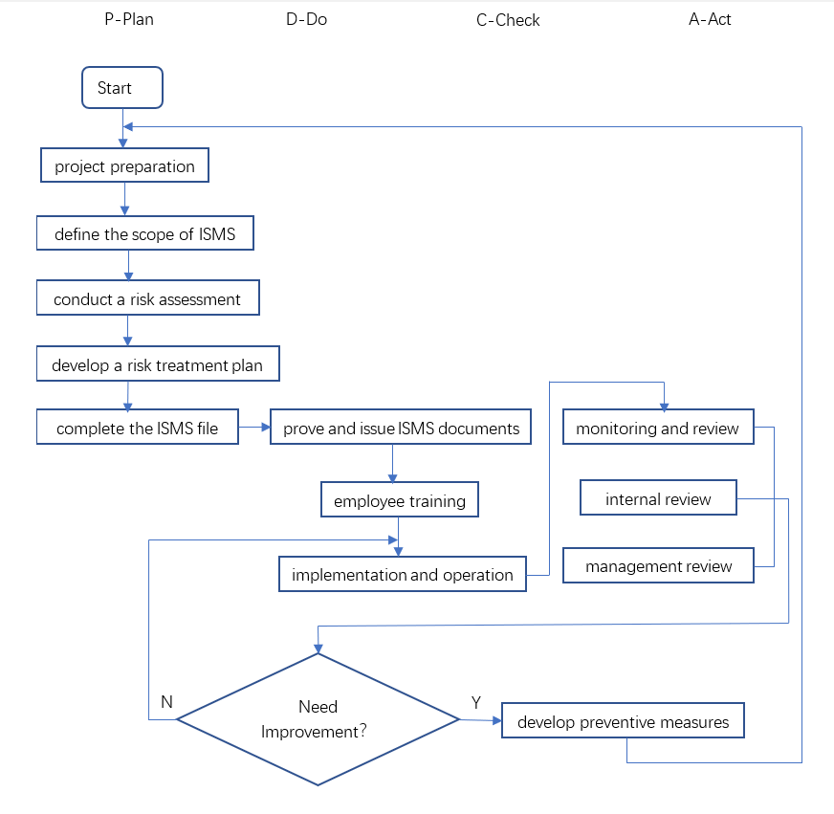
Graph 2: the process of the ISMS system
- The specific measures of ISO 27002 risk control are as follows：

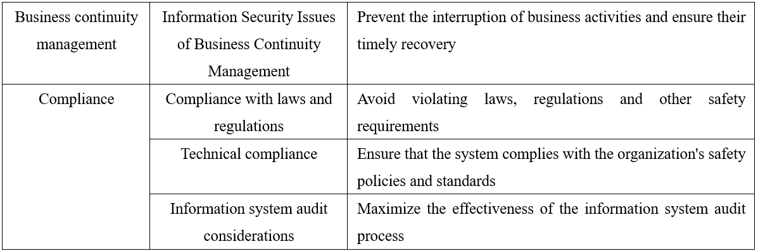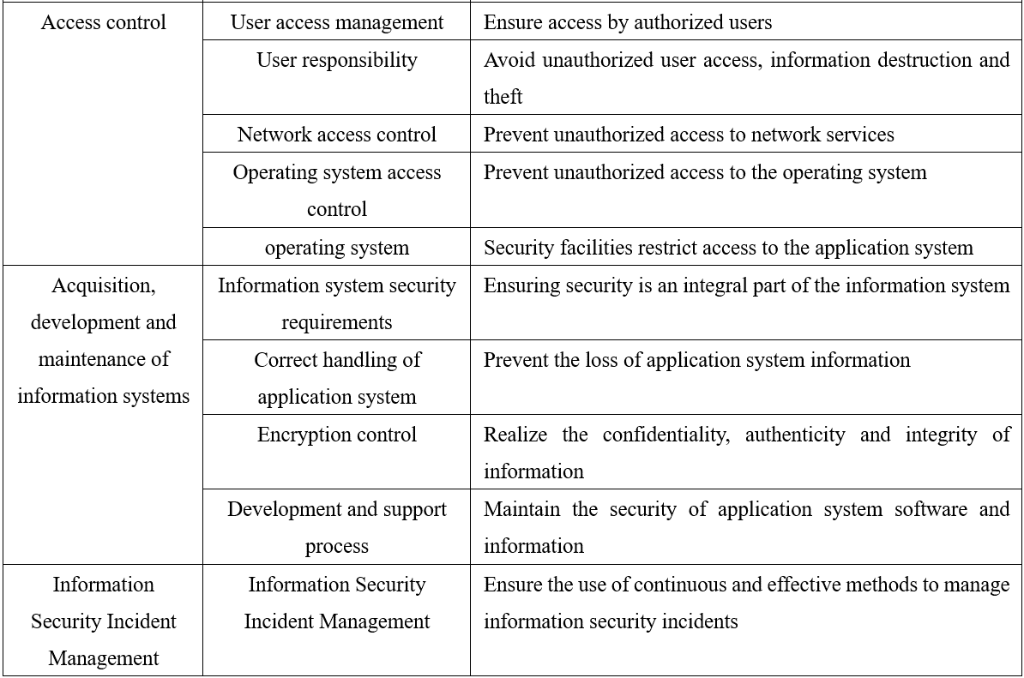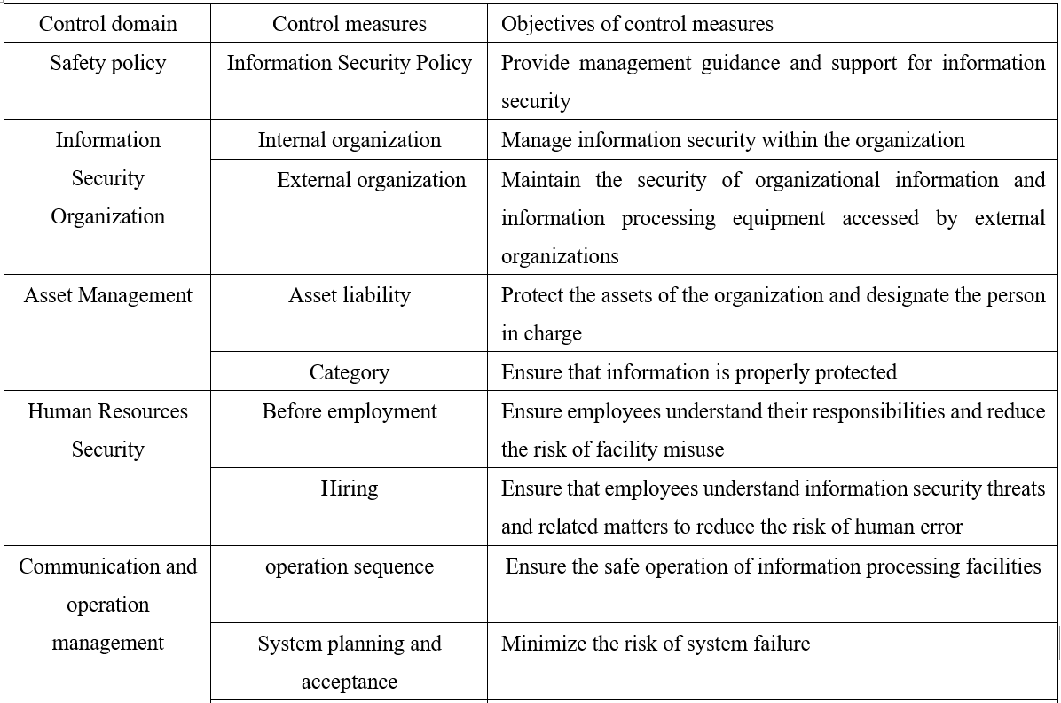

References
[1]Taylor Andy,Alexander David,Finch Amanda,Sutton David,Taylor Andy. Information Security Management Principles[M].BCS Learning &amp; Development Limited:2020-12-03.
[2]Malcolm Blumberg,Aileen Cater-Steel,Mohammad Mehdi Rajaeian,Jeffrey Soar. Effective organisational change to achieve successful ITIL implementation[J]. Journal of Enterprise Information Management,2019,32(3).
[3]T. R. Eikebrokk and J. Iden, "ITIL Implementation: The Role of ITIL Software and Project Quality," 2012 23rd International Workshop on Database and Expert Systems Applications, Vienna, 2012, pp. 60-64, doi: 10.1109/DEXA.2012.17.
[4]G G Prapenan, Prapenan G G, Pamuji G C. Information System Security Analysis of XYZ Company Using COBIT 5 Framework and ISO 27001:2013. 2020, 879(1):012047-.
[5]Stefan Fenz,Thomas Neubauer. Ontology-based information security compliance determination and control selection on the example of ISO 27002[J]. Information &amp; Computer Security,2018,26(5).
[6]Georg Disterer. ISO/IEC 27000, 27001 and 27002 for Information Security Management[J]. Journal of Information Security,2013,4(2).
[7]. A methodology for implementing an information security management system based on the family of ISO/IEC 27000 standards[J]. RISTI - Revista Ibérica de Sistemas e Tecnologias de Informação,2017,s/v(22).
[8]P. P. Roy, "A High-Level Comparison between the NIST Cyber Security Framework and the ISO 27001 Information Security Standard," 2020 National Conference on Emerging Trends on Sustainable Technology and Engineering Applications (NCETSTEA), Durgapur, India, 2020, pp. 1-3, doi: 10.1109/NCETSTEA48365.2020.9119914.
[9]Fatema Ebrahim Abdulrasool,Stephen J. Turnbull. Exploring security, risk, and compliance driven IT governance model for universities: applied research based on the COBIT framework[J]. International Journal of Electronic Banking,2020,2(3).
[10]S. J. Hussain and M. S. Siddiqui, "Quantified Model of COBIT for Corporate IT Governance," 2005 International Conference on Information and Communication Technologies, Karachi, Pakistan, 2005, pp. 158-163, doi: 10.1109/ICICT.2005.1598575.
[11]Ni Ren, Shuiqing Huang. Information Security Management of Digital Library under the New Version of ISO 27000 [J]. Books and Information,2015(06):38-46.
[12]Yajun Zhang, Jinlong Zhang, Jiangtao Chen. Review and Prospects of IT Service Management Research [J]. Information Magazine,2013,32(06):95-99.
[13]S. Sahibudin, M. Sharifi and M. Ayat, "Combining ITIL, COBIT and ISO/IEC 27002 in Order to Design a Comprehensive IT Framework in Organizations," 2008 Second Asia International Conference on Modelling & Simulation (AMS), Kuala Lumpur, 2008, pp. 749-753, doi: 10.1109/AMS.2008.145.
[14]S. Khou, L. O. Mailloux, J. M. Pecarina and M. Mcevilley, "A Customizable Framework for Prioritizing Systems Security Engineering Processes, Activities, and Tasks," in IEEE Access, vol. 5, pp. 12878-12894, 2017, doi: 10.1109/ACCESS.2017.2714979.
[15]Nur Kholis Gunawan, Kholis Gunawan Nur, Budiarto Hadiprakoso Raden, et al. Comparative Study Between the Integration of ITIL and ISO / IEC 27001 with the Integration of COBIT and ISO / IEC 27001. 2020, 852(1):012128-.

