INDIVIDUAL WRITTEN REPORT

Student Name: Marian Viorel Matei
Student ID:2123249
Lecturer: Abdi Rahman
Module code: BMSW5105

Table of Contents
Task 1 – Individual Written Report 3
Introduction 3
Main body 3
Impact of the environmental factors on the Culture of Sainsbury's 3
Ethical behaviour practised within Sainsbury's 7
Culture of Sainsbury's using appropriate Framework 9
Ethical dilemma likely to Influence Organisation’s Culture 10
Barriers to the effective functioning of the Organisation’s Culture 12
Recommendations 14
Conclusion 15
Task 2 – Individual practical (oral) performance 15
References 17

Task 1 – Individual Written Report

Introduction
Sainsbury's is a leading retail company in the UK that is mainly known for its "customer-centric approach" and focus on "sustainability". The culture of the organization is promoting trust, innovation, efficiency, and social responsibility. The company is valuing diversity and aims to adapt to fluctuating market dynamics and delivering extraordinary customer service. The present report includes a discussion on the impact of environmental factors on the culture of Sainsbury. Besides this, ethical behaviour practised within the organization, its culture and barriers associated with the effective functioning of the organizational culture is also identified. Based on this, certain recommendations are provided for improving the culture and efficiency of the organization.

Main body

Impact of the environmental factors on the Culture of Sainsbury's
Impact of External environmental factors
Factors | Analysis | Impact
Political | - Politically stable country  - Brexit has created political debates and uncertainties  - Political culture is vibrant | Political factors like Brexit and government policies, can affect the culture of Sainsbury. Changes in trade agreements and government regulations can influence the company's supply chain and operations, need a culture that is responsive and adaptable to political developments (Upadhyay et al., 2021).
Economical | - The current GDP rate of the UK is “7.5%”  - Inflation rate is “6.2%” (ons.gov.uk, 2023)  - Unemployment rate is “3.8 %” (statista.com, 2023)  - Current corporation tax rate is “25%” (blog.shorts.uk.com, 2023) | Economic conditions like unemployment, inflation, and consumer spending are directly influencing the culture of Sainsbury. During times of economic uncertainty, the company can embrace a more “cost-conscious culture” that is emphasizing efficiency, lean operations and cost control (Olabode et al., 2023). This can ultimately lead to a target of improving productivity, reducing waste, and encouraging a culture of accountability and performance.
Social | - Population growth rate of the UK is “0.4%” (datacommons.org, 2021)  - Education system of the UK is well-developed  - Healthcare system is progressing | Sainsbury is operating in a diverse society with advancing cultural and social norms as the company's culture is reflecting the values of diversity, inclusivity, and also social responsibility. Sainsbury is placing emphasis on developing a comprehensive work environment, encouraging community initiatives, and upgrading sustainable practices (Chowdhury, 2022). This culture can help in fostering customer loyalty, employee engagement, and a positive brand reputation.
Technological | - Technologically developed country  - Providing businesses with options to encounter new customers | Fast pace of advancements in technology in the retail industry is a crucial effect on Sainsbury's culture. The company is embracing technology for enhancing operational efficiency, improving supply chain management, and also providing flawless customer experiences (Lundgren et al., 2022). This needs a culture that is flexible, open to modification, and encourages employees to provide new technologies and grasp new skills.
Legal | - “Employment Act, 1996” is protecting employee's rights (lexisnexis.co.uk, 2023)  - “Equality Act, 2010” is protecting people from discrimination (gov. uk, 2023) | Legal framework, which mainly includes employment regulations and laws, influences the culture of Sainsbury. Compliance with regulations and laws is a core feature of the company's culture that ensures fair treatment of workers, ethical practices of business, and responsible sourcing. Sainsbury is also promoting a culture of safety and health to comply with the regulations of the workplace and assure employee well-being (Liang and Fu, 2022).
Environmental | - “Environmental protection act, 1990” is providing protection for the environment (gov. uk, 2022)  - Significant improvements in reducing the negative effect on the environment | With increasing considerations regarding sustainability and climate change, environmental factors are having a crucial impact on the culture of Sainsbury. The company has also set aspiring sustainability goals like decreasing carbon waste and emissions (Sharma et al., 2021). This operated an environmental consciousness culture, developing eco-friendly practices, and motivating employees to take part in sustainability efforts.
Table 1: PESTEL Analysis of Sainsbury's
(Source: Self-developed)

Impact of internal environmental factors
Strengths  - Strong reputation of the brand  - Large brand portfolio  - Focusing on providing effective service  - Powerful supply chain (sainsburys.co.uk, 2023) | Weaknesses  - Defined international presence  - Depending on physical stores  - Limited share in the market as compared to the opponent
Opportunities  - Increasing demand for online grocery  - Enhancing focus on stability  - Diversifying into new markets | Threats  - Intense market competition  - Changing preferences of consumers  - Uncertainty and economic downturn
Table 2: SWOT Analysis of Sainsbury
(Source: Self-developed)
Sainsbury is fostering a culture of loyalty and trust among customers and employees which can ultimately help in driving a sense of identity and pride within the organization. Encouraging a culture of innovation and diversity by providing a chance for employees to develop expertise in several product categories. The company is also emphasizing a culture of reliability, efficiency, and timely delivery by promoting coordination and collaboration among departments and teams. Nurturing a culture that is customer-centric by encouraging workers to go the extra mile for meeting customer expectations and needs (Xiao et al., 2021). It can limit exposure to distinct perspectives and cultures that can potentially affect the ability of an organization to create a global mindset. Shaping a culture that is focusing on experiences of in-store and face-to-face communication. Besides this, it may need adaptation to e-commerce trends and digital transformation. Encouraging a culture of innovation and continuous improvement to gain a greater market share by promoting agility and competitiveness in Sainsbury.
Company is encouraging a culture of innovation and digital transformation can help in providing opportunities for workers to advance new skills and adapt to developing technologies. Fostering a culture of environmental awareness and manageable business practices can help in driving the engagement of employees in sustainability initiatives. Promoting a culture of exploration growth, and adaptability needs adjustments of culture to cater to the specific preferences and needs of new markets. There is a need for a customer-centric approach for differentiating it from other competitors. Besides this, encouraging a market research culture and staying aware of customer needs can help in increasing working efficiency (Madhani, 2019). Developing adaptability and flexibility for meeting evolving preferences can result in creating a culture of cost-conscious within the company.

Ethical behaviour practised within Sainsbury's
Sainsbury's is considered to be the largest chain of supermarkets in the United Kingdom that is having a culture of promoting ethical behaviour among its workers. The company has exhibited a strong commitment to corporate social responsibility, sustainability, and ethical sourcing. Strong policies of ethical sourcing are implemented to make sure that the products it put on sale are acquired through responsible and fair means. The company is committed to operating attentively with its suppliers to make sure that human rights are admired, environmental standards are confirmed, and employees are treated equitably throughout the supply chain. By developing high standards for suppliers (Hąbek and Villahoz, 2020), Sainsbury's is promoting an ethical behaviour culture among its employees who are understanding the significance of these principles. Sainsbury's is also placing an emphasis on “corporate social responsibility (CSR)” and the company is actively engaged in community programs and charitable initiatives by focusing on issues like healthy living, food waste, and assisting local communities. By including employees in these actions, Sainsbury is encouraging a sense of ethical behaviour and social responsibility (Liu, 2023). This culture is strengthened through regular communication and training programs, making sure that employees know about the CSR efforts of the company and their function in upholding them.
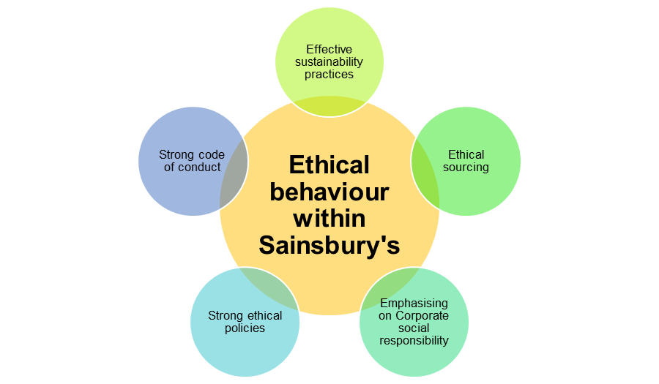
Figure 1: Ethical behaviour practised within the culture of Sainsbury's
(Source: Self-developed)
Sainsbury's has developed sustainability as a fundamental factor of its corporate strategy as the company has developed ambitious goals for reducing its environmental impact like decreasing carbon emissions, reducing waste, and encouraging sustainable sourcing. Implementing sustainability within its business practices company can motivate employees to embrace ethical behaviour in their daily functioning. This includes activities for promoting recycling, energy conservation, and also responsible consumption among its customers and employees. It has also implemented a “strong code of conduct and ethics policy” which outlines the employee’s behaviour (Tomić et al., 2022). The company is providing support and training to make sure that all employees adhere and understand to these ethical standards. Thus, this can help in promoting a culture of integrity, respect and honesty within the organization.

Culture of Sainsbury's using appropriate Framework
One framework that can be utilized for critically appraising Sainsbury's culture is the “ethical decision-making framework” proposed by “Lawrence Kohlberg”. This framework mainly includes “six stages” of moral development, ranging from “pre-conventional to post-conventional” which can help in evaluating the ethical culture and behaviour within an organization. In Sainsbury's, the culture of the company seems to be aligning with an elevated stage of moral development. It has developed policies of ethical sourcing and encourages practices of fair trade, providing concern for fairness and justice. This is indicating a move beyond the “pre-conventional stage” where decisions are solely driven by self-interest (Banks et al., 2022). The commitment of the company to work with suppliers for upholding environmental standards and human rights reflects an awareness of the effect of its measures on stakeholders beyond its profit.
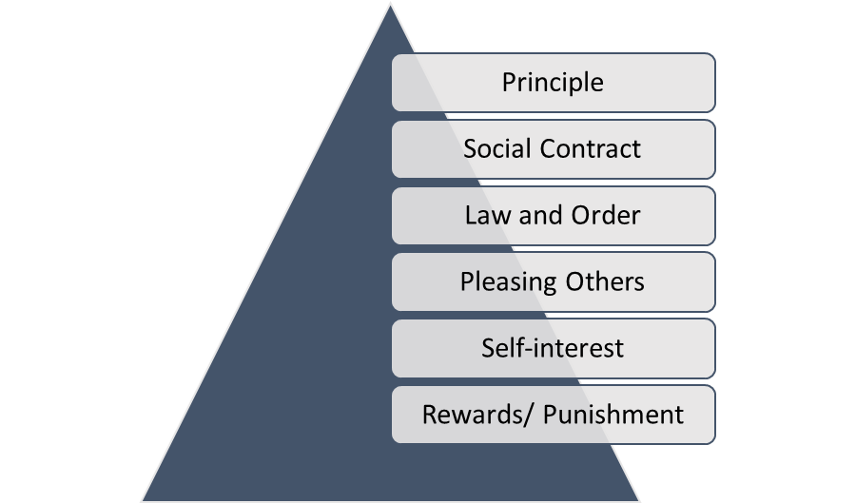
Figure 2: Ethical decision-making framework
(Source: Self-developed)
Sainsbury is also having a strong emphasis on “corporate social responsibility” that is indicating an advancement towards the “post-conventional stage” of moral development. By engaging actively in charitable initiatives and also promoting community programs, the company is showing a concern for society's well-being at large. This is suggesting that Sainsbury's is considered to be the broader impact of its measures and demonstrates a feeling of social responsibility. However, Sainsbury's culture critical appraisal also reveals possible areas for development. It has been observed that the company has done commendable efforts in sustainability and ethical sourcing, while there have been cases where its operations have fallen short. For instance, concerns are raised regarding the worker's treatment in the supply chain, specifically in relation to working conditions and fair wages. This designates a potential gap existing between the ethical aspirations of a company and the execution of those standards throughout its functioning. Furthermore, the efficacy of Sainsbury's ethical culture needs to be evaluated in terms of its effect on employee behaviour. While the company has also developed a “code of conduct and ethics policy” in place, it is crucial to analyze how skillfully these principles are implemented into the decisions of workers and daily actions (Kumar Krishnan Kutty, 2023). Without a powerful mechanism for monitoring and enforcing ethical behaviour, there is a chance that the provided ethical culture cannot transform into persistent practices across the organization.

Ethical dilemma likely to Influence Organisation’s Culture
One ethical dilemma that can influence Sainsbury's culture is the “tension between profitability and employee welfare” mainly in the context of working conditions and fair wages. Like several other retail companies, Sainsbury's faces the barrier of managing desirability in a competitive market which also ensures the employees' well-being. This problem is arising from the requirement to balance the financial interests of the company with its ethical responsibilities to its workforce. Sainsbury's is also having a responsibility to its investors and shareholders to develop profits and provide powerful financial performance. This often needs measures of cost-cutting, including managing expenses of labour. However, decreasing labour costs can have a negative impact on employees that can ultimately result in low wages, difficult working conditions and limited benefits. Ensuring effective working conditions and fair wages is an ethical command for any organization like Sainsbury's (Brennan et al., 2023). Employees are considered to be the company’s backbone and their well-being is directly impacting their job satisfaction, motivation, and overall performance. Furthermore, employees’ fair treatment is aligning with the commitment of the company to “corporate social responsibility” and its stated values of respect and integrity.
In order to address this ethical dilemma, Sainsbury's requires to encourage a culture that prioritizes the welfare of employees while also identifying the significance of financial sustainability. This needs a “multi-faceted approach” which is as follows:
Fair Compensation: Sainsbury's needs to strive for providing competitive benefits and wages that is enabling employees for meeting their basic requirements and maintain a satisfactory living standard. This includes continuous analysis of wage structures, benchmarking against standards of the industry, and considering the living cost in different regions (Lotfi et al., 2021).
Safe and Healthy Work Environment: Sainsbury's needs to prioritize the safety and health of its employees by making sure that there is compliance with relevant regulations, doing regular assessments of risk, and providing adequate resources and training. Efforts need to be made for addressing issues like long working hours, workplace stress and work-life balance.
Employee Voice and Engagement: Developing channels for employee feedback and open communication is important for encouraging a culture of inclusivity and respect. Sainsbury's needs to encourage the participation of employees in the processes of decision-making, develop mechanisms for concerns of reporting, and provide protection (Jones and Comfort, 2019).
Supplier Responsibility: The company needs to extend its commitment towards ethical practices all over its supply chain. This includes functioning with suppliers for ensuring fair treatment of employees, monitoring adherence to labour standards, and also conducting audits for addressing any ethical violations.
Ethical Leadership: The Sainsbury's culture needs to be driven with the help of ethical leadership which is setting an effective example and upholding the values of the company. Leaders need to consistently communicate the significance of employee welfare, holding themselves and others responsible for ethical behaviour, and creating a supportive and all-inclusive working environment (Thirusanku, 2021).
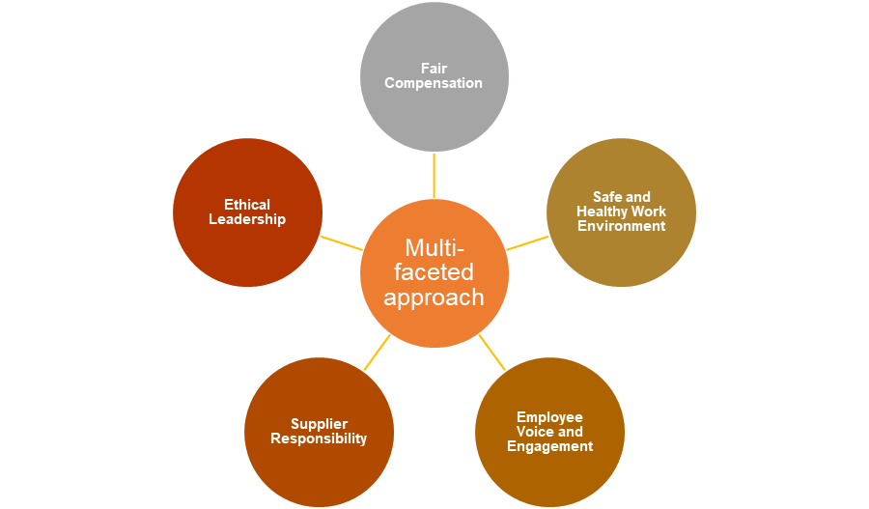
Figure 3: Multi-faceted approach for addressing an ethical dilemma
(Source: Self-developed)

Barriers to the effective functioning of the Organisation’s Culture
Sainsbury is striving to cultivate an inclusive and ethical culture and for achieving this various barriers can hamper its effective functioning. These barriers can obstruct the ability of the company to promote and maintain its desired culture. Some of the key barriers are as follows:
Communication Gaps: Effective communication is crucial for encouraging a positive culture and in a big organization like Sainsbury's there can be communication gaps between many different levels of departments, management, and even between store locations and headquarters. These communication gaps can ultimately result in a lack of clarity, misunderstandings, and disconnect between the values of the company and employees' consideration of them (Froese et al., 2023).
Lack of Engaged Employees: Engaging workers in processes of decision-making and providing them with a chance to voice and contribute their opinions is important for a powerful culture. However, in case employees are feeling excluded or disengaged from decision-making as it can result in a lack of commitment and ownership to the culture of the company. This can ultimately lead to decreased motivation, morale, and overall effectiveness.
Resistance to modifications: Developing and implementing changes in culture can face resistance, specifically from employees that are long-standing and may be habitual to the present culture. Change can be encountered with doubt, fear, or an unwillingness to support new values and practices (Payne et al., 2023). This resistance can prevent the assumption of a convenient culture and develop barriers to its productive functioning.
Lack of Responsibility: A culture that is promoting ethical behaviour mainly relies on accountability at each organizational level. In case there is an absence of clear assumptions, enforcement mechanisms, or consequences, employees may not feel responsible for their actions. This can ultimately result in divergence from the convenient culture, as employees may categorize engagement or self-interest in unethical behaviour without going through appropriate repercussions.
Organizational Silos: Big organizations such as Sainsbury is often having multiple business units or departments that can operate independently. These different departments can generate barriers to the effective functioning of culture as different units can create their own priorities and subcultures that may not line up with the overall culture of the organization (Ng et al., 2019). Silos can hinder communication, collaboration, and a collaborative approach to approving the desired culture.
Inadequate Development and Training: Providing workers with the required skills, resources and knowledge, to support the desired culture is crucial. Insufficient development and training opportunities can obstruct the understanding of employees to the company's values, expectations and ethics. Without actual support, employees may clash to range their behaviours with the culture that is desired.
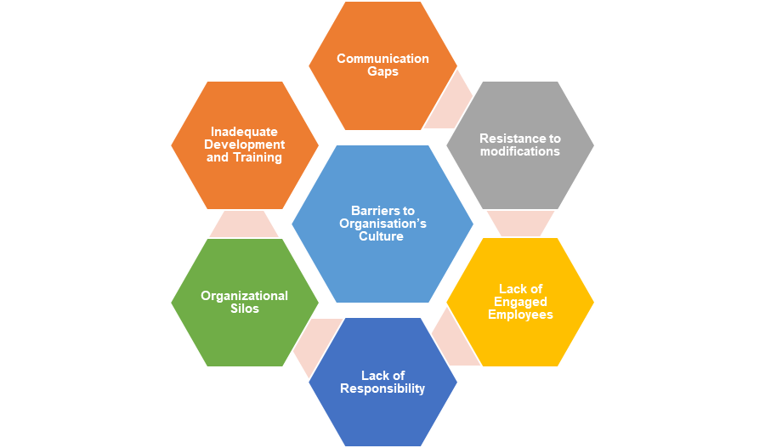
Figure 4: Barriers to the Culture of Organisation
(Source: Self-developed)

Recommendations
In order to enhance the workplace culture of Sainsbury's and positive impact on the efficiency of the organization, the following recommendations can be integrated:
Enhancing Internal Communication: Improving channels of internal communication is important for encouraging a positive culture. The company needs to implement transparent and regular methods of communication, like intranet updates, meetings at the town hall, and team huddles. This can help in making sure that employees are having knowledge regarding company values, news, and expectations (Lee and Kim, 2021). Consistent and clear communication can enhance employee engagement, understanding, and alignment with the goals of the organization which is positively affecting efficiency.
Encourage Employee Empowerment and Engagement: Sainsbury's need to prioritize the engagement of employees by including them in processes of decision-making, looking for their feedback, and also providing opportunities for their development and growth. This can be attained through mechanisms like employee surveys, suggestion boxes, and cross-functional teams. When employees are feeling empowered and valued, they become more productive, motivated, and invested in their work (Riyanto et al., 2021). Enhanced engagement can positively impact the efficiency of the organization by promoting a sense of ownership, innovation, and collaboration.
Develop Ethical Leadership: Developing ethical leadership is setting the tone for the whole organization as this can help in ensuring that leaders are consistently exemplifying and promoting ethical behaviour. Leaders need to actively communicate the company's values, expectations, and ethics while holding themselves responsible for the same standards (Kuenzi et al., 2020). This can encourage integrity, trust, and a positive culture all over the organization as when employees are observing ethical behaviour from their seniors, they are more likely to imitate those behaviours which can result in improved efficiency and decision-making.
Strengthen Programs for Employee Development: Sainsbury's needs to invest in all-inclusive development and training programs that is aligning with the company's goals and culture. These programs can mainly focus on the development of skills, ethical decision-making and leadership training. By providing workers with the required knowledge, resources and skills, they are going to be better equipped for contributing to the organization in an effective manner (Niati et al., 2021). Enhanced capabilities of employees can lead to higher outputs of quality, increased productivity, and enhanced organizational efficiency.
Integrating these recommendations within the workplace culture of Sainsbury's can enhance and positively affect organizational efficiency. Improving internal communication can help in facilitating a shared understanding of values and goals that can lead to better alignment and coordination. Employee empowerment and engagement can result in higher levels of collaboration, motivation, and commitment to the success of the organization. Ethical development programs and leadership can enhance the capabilities of employees and decision-making, promoting ethical behaviour and efficiency (Metwally et al., 2019). Reinforcing recognition and accountability can drive performance and a culture of high performance. Thus, these recommendations can help in promoting inclusion and diversity that can enhance a culture of adaptability and innovation, improving efficiency through different ideas and perspectives.

Conclusion
It can be concluded from the present study that the environmental factors are significantly impacting Sainsbury's culture which is characterized by inclusivity, adaptability, innovation, and a strong dedication to sustainability. By responding and understanding to environmental factors, Sainsbury's can develop its culture for remaining competitive, meeting customer expectations, and achieving success in the long-term in the retail industry. The company is practising ethical behaviour by exhibiting a strong commitment to corporate social responsibility, sustainability, and ethical sourcing. There are certain barriers that can obstruct the ability of the company to promote and maintain its desired culture. Recommendations are provided to enhance the workplace culture of Sainsbury's and positive impact on the efficiency of the organization.

Task 2 – Individual practical (oral) performance
During practical performance, the key points identified and explained while writing report on the Sainsbury’s are as follows:
Customer-centric approach: It has been observed that Sainsbury's is placing a strong focus on providing customer service that is exceptional. The report is highlighting that the organisational culture of Sainsbury's is revolving around meeting and understanding customer expectations and needs.
Focusing on sustainability: Sainsbury's has been also recognized for its devotion towards effective sustainable practices. While writing this report certain sustainable activities practised in the organization is identified that the culture of the company is promoting which are waste reduction, environmentally conscious practices, and responsible sourcing.
Efficiency and Trust: Trust has appeared to be a significant aspect of the culture of Sainsbury's. It is indicating that the company encourages a culture of trust among customers, employees, and other stakeholders. In addition, efficiency is determined to be a crucial cultural value and Sainsbury's is aiming to deliver services and products in an efficient manner and timely.
Innovation: Innovation is also considered to be a key aspect of Sainsbury's culture as it is encouraging continuous improvement, creativity, and a willingness for adapting to the changing dynamics of the market. This innovative culture can help Sainsbury's for staying competitive in the retail industry.
Ethical behaviour practices: Sainsbury's emphasis on strong ethical behaviour is also identified while writing this report. The organization has executed practices and policies for ensuring employees are treated fairly, responsible for product sourcing, and adhering to regulatory and legal requirements (Thirusanku, 2021).
Employee engagement: The report is uncovering that Sainsbury's is valuing the engagement of employees in ethical practices. As the organization is encouraging employees to participate actively in sustainability initiatives, processes of ethical decision-making, and determining any unethical behaviour they are witnessing.
Barriers to ethical behaviour: Certain barriers that can hamper the consistent ethical behaviour practice in Sainsbury's is also identified. These barriers mainly include time constraints, conflicting priorities, lack of training or awareness, and pressure for achieving financial targets. Addressing these issues is important for maintaining an effective ethical culture (Payne et al., 2023).

References
Journals
Banks, G.C., Knapp, D.J., Lin, L., Sanders, C.S. and Grand, J.A., 2022. Ethical decision making in the 21st century: A useful framework for industrial-organizational psychologists. Industrial and Organizational Psychology, 15(2), pp.220-235.
Brennan, L., Jackson, M., Kubacki, K., Parker, L., Garg, D. and Chorazy, E., 2023. Beyond the Dark Arts: Advancing Marketing and Communication Theory and Practice. In BEYOND THE DARK ARTS: Advancing Marketing and Communication Theory and Practice (pp. 1-9).
Chowdhury, M.S., 2022. INTER-CONNECTION OF EFFECTIVE WORKPLACE DIVERSITY WITH BETTER TEAM PERFORMANCE. Embracing Change in Business, Management & Social Sciences, p.23.
Froese, T., Richter, M., Hofmann, F. and Lüdeke-Freund, F., 2023. Degrowth-oriented organisational value creation: A systematic literature review of case studies. Ecological Economics, 207, p.107765.
Hąbek, P. and Villahoz, J.J.L., 2020. Socially Responsible Supplier Development. Practices of Automotive Industry. Multidisciplinary Aspects of Production Engineering, 3(1), pp.707-719.
Jones, P. and Comfort, D., 2019. Stories and Retailer Brands: A Study of the UK’s Leading Retailers. Indonesian Journal of Contemporary Management Research, 1(2), pp.65-77.
Kuenzi, M., Mayer, D.M. and Greenbaum, R.L., 2020. Creating an ethical organizational environment: The relationship between ethical leadership, ethical organizational climate, and unethical behavior. Personnel Psychology, 73(1), pp.43-71.
Kumar Krishnan Kutty, K., 2023. Establishing business ethics to insulate against scandals. Electronic Journal of Business Ethics and Organization Studies, 28(1).
Lee, Y. and Kim, J., 2021. Cultivating employee creativity through strategic internal communication: The role of leadership, symmetry, and feedback seeking behaviors. Public Relations Review, 47(1), p.101998.
Liang, X. and Fu, L., 2022. Practical Effects and Theoretical Significance of Enterprises' Human Rights Policies-Taking Fortune Global 500 as an Example. J. Hum. Rts., 21, p.600.
Liu, R., 2023. Multi-Perspective Analysis of the Sustainable Transformation of Multinational Companies. Journal of Progress in Engineering and Physical Science, 2(2), pp.59-65.
Lotfi, M., Walker, H. and Rendon-Sanchez, J., 2021. Supply chains’ failure in workers’ rights with regards to the SDG compass: A doughnut theory perspective. Sustainability, 13(22), p.12526.
Lundgren, C., Berlin, C., Skoogh, A. and Källström, A., 2022. How industrial maintenance managers perceive socio-technical changes in leadership in the Industry 4.0 context. International Journal of Production Research, pp.1-20.
Madhani, P.M., 2019. Building a customer-centric supply chain strategy: Enhancing competitive advantages. The IUP Journal of Business Strategy, 16(2), pp.28-42.
Metwally, D., Ruiz-Palomino, P., Metwally, M. and Gartzia, L., 2019. How ethical leadership shapes employees’ readiness to change: The mediating role of an organizational culture of effectiveness. Frontiers in psychology, 10, p.2493.
Ng, K.S., Yang, A. and Yakovleva, N., 2019. Sustainable waste management through synergistic utilisation of commercial and domestic organic waste for efficient resource recovery and valorisation in the UK. Journal of Cleaner Production, 227, pp.248-262.
Niati, D.R., Siregar, Z.M.E. and Prayoga, Y., 2021. The effect of training on work performance and career development: the role of motivation as intervening variable. Budapest International Research and Critics Institute (BIRCI-Journal): Humanities and Social Sciences, 4(2), pp.2385-2393.
Olabode, O.E., Hultman, M., Leonidou, C.N. and Boso, N., 2023. Disruptive market shift: Conceptualization, antecedents, and response mechanisms. Technological Forecasting and Social Change, 192, p.122577.
Payne, J., Lloyd, C. and Jose, S.P., 2023. ‘They tell us after they've decided things’: A cross‐country analysis of unions and digitalisation in retail. Industrial Relations Journal, 54(1), pp.3-19.
Riyanto, S., Endri, E. and Herlisha, N., 2021. Effect of work motivation and job satisfaction on employee performance: Mediating role of employee engagement. Problems and Perspectives in Management, 19(3), p.162.
Sharma, P., Sharma, S. and Schuetz, A., 2021. Supreme Creations and Wings of Hope: A symbiotic care of environment and society. In Pioneering Family Firms’ Sustainable Development Strategies (pp. 76-98). Edward Elgar Publishing.
Thirusanku, J., 2021. Equal Opportunity Within The Workplace. Economics and Business Quarterly Reviews, 4(3).
Tomić, V., Buljan, I. and Marušić, A., 2022. Perspectives of key stakeholders on essential virtues for good scientific practice in research areas. Accountability in research, 29(2), pp.77-108.
Upadhyay, A., Kumar, A. and Akter, S., 2021. An analysis of UK retailers’ initiatives towards circular economy transition and policy-driven directions. Clean Technologies and Environmental Policy, pp.1-9.
Xiao, B., Chen, Q. and Yu, Z., 2021, April. Research on the Investment Value of Sainsbury’s. In 2021 6th International Conference on Social Sciences and Economic Development (ICSSED 2021) (pp. 108-115). Atlantis Press.
Websites
datacommons.org, 2021, United Kingdom, Available at: https://datacommons.org/place/country/GBR/?utm_medium=explore&mprop=amount&popt=EconomicActivity&cpv=activitySource,GrossDomesticProduction&hl=en [Accessed on: 19.06.23]
statista.com, 2023, UK unemployment rate 2023, Available at: https://www.statista.com/statistics/279898/unemployment-rate-in-the-united-kingdom-uk/[Accessed on: 19.06.23]
blog.shorts.uk.com, 2023, Corporation Tax in the UK – Guide for 2023, Available at: https://blog.shorts.uk.com/corporation-tax-everything-you-need-to-know#:~:text=Corporation%20Tax%20in%20the%20UK%20is%20a%20corporate%20tax%20levied,Tax%20main%20rate%20was%2019%25. [Accessed on: 19.06.23]
datacommons.org, 2021, United Kingdom, Available at: https://datacommons.org/place/country/GBR/?utm_medium=explore&mprop=count&popt=Person&hl=en [Accessed on: 19.06.23]
gov.uk, 2022, Litter and refuse: code of practice, Available at: https://www.gov.uk/government/publications/code-of-practice-on-litter-and-refuse#:~:text=The%20Environmental%20Protection%20Act%201990,for%20which%20they%20are%20responsible. [Accessed on: 19.06.23]
lexisnexis.co.uk, 2023, Employment Rights Act 1996, Available at: https://www.lexisnexis.co.uk/legal/legislation/uk-parliament-acts/employment-rights-act-1996-c18#:~:text=legislation%20over%20time.-,Employment%20Rights%20Act%201996%20(1996%20c%2018),working%20and%20termination%20of%20employment. [Accessed on: 19.06.23]
ons.gov.uk, 2023, Consumer price inflation, UK: April 2023, Available at: https://www.ons.gov.uk/economy/inflationandpriceindices/bulletins/consumerpriceinflation/april2023#:~:text=The%20CPIH%20inflation%20rate%20is,down%20from%2012.7%25%20in%20March. [Accessed on: 19.06.23]
gov.uk, 2023, Equality Act 2010: guidance, Available at: https://www.gov.uk/guidance/equality-act-2010-guidance#:~:text=Print%20this%20page-,Overview,strengthening%20protection%20in%20some%20situations. [Accessed on: 19.06.23]
sainsburys.co.uk, 2023, Sainsbury's, Available at: https://www.sainsburys.co.uk/. [Accessed on: 19.06.23]

