EFFECTIVE TEAMWORK AND COMMUNICATION

Student Name: Daniela Rusu
Student Id:2133710
Module Name: Effective Team Working and Communication
Module Code:BMSW4002
Word Count: 2128.

Table of Contents
Introduction 3
Background 3
Business case 4
HRM Role 5
Employees Role 6
Conflict Management Training 7
Framework to Minimise Conflict 8
Effective Management 9
Careful Hiring 9
Fair Grievance Processes 9
Conclusion 10
Reference list 11

Introduction
Conflict in the workplace is unavoidable if individuals from diverse backgrounds and communication styles are brought together to achieve a same economic goal. The resolution of conflicts is controllable. Conflict in the workplace is more likely than ever since tensions and fears are at an all-time high due to the present political gulf and workplace debates about racial injustice (Liddle, 2017). This toolkit covers the reasons, ramifications, and justifications for employers to become involved in workplace conflicts. Employees who disagree with one another most commonly take the initiative to start looking for a solution when a problem at work emerges. Nevertheless, the business's role, which is played by managers and HR specialists, is crucial and is focused on creating a workplace where conflict among employees is, as far as possible, avoided.

Background
A culture of this kind is built on strong employee relationships, particularly ones characterised by respect, honesty, and trust at all levels. In addition to suggestions on how to create such a working culture, this toolkit offers methods for managing employee disputes and complaints. The conflict-resolution procedures used by an organisation are discussed in this toolkit along with how to communicate them and evaluate their effectiveness. The management of workplace conflict is under the purview of several HR experts (Van Eeden et al. 2018). The toolkit does not provide information on the nuances of dispute-resolution procedures. Conflict is a possibility when people with different origins and aspirations coexist in a workplace. Conflict may be expressed in a variety of ways, in addition to verbal abuse, defiance, bullying, and fury. There are several potential causes of this, including poor organisational management, miscommunication, and personality problems. Conflict at work may have negative effects on employees, including job disruptions, productivity losses, failed projects, absenteeism, attrition, and termination. Both the cause and the effect of workplace conflict can be attributed to emotional stress. Conflict at work usually stems from a worker's line manager and other employees. According to another poll result, employees are more likely to admit to disagreeing with a teammate who is more senior to them (Scott ,2010).
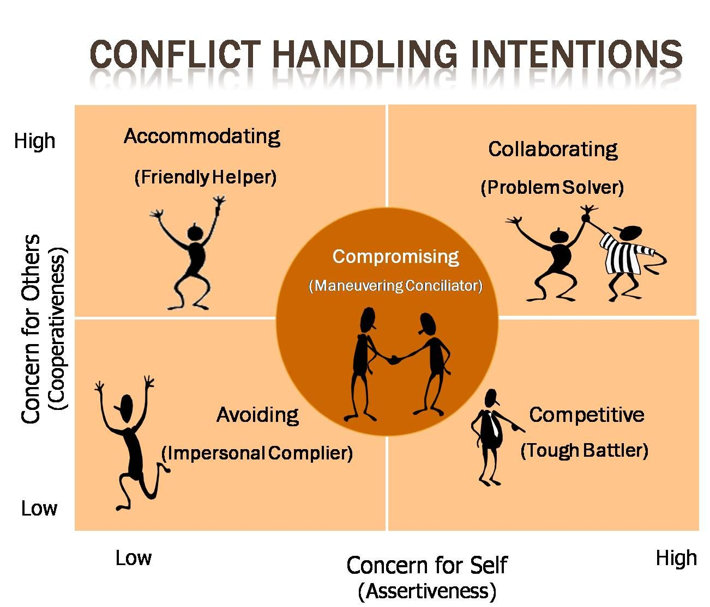
Figure 1: Managing Conflict in the workplace.
Sources: (Pinimg.com, 2022)

Business case
According to Annane et al. (2019) report, a productive workplace is one where employees respect one another regardless of their position, rank, or length of service, communicate nicely and without using improper language, and accept one another's differences. If a firm has procedures in place to resolve conflicts when they first arise, employees will typically perceive, their company will probably be more satisfied with their performance and will treat them fairly. Less employee friction can boost productivity, motivation, and loyalty in addition to reducing medical expenditures requests for workers' compensation and court fees. Unclear conflict and stress in the workplace, may cause employees to feel emotionally stressed. Additionally, politics may erupt in the workplace, which might divert attention from the organisation's goal (Andreoni and Chang, 2019). Once employers don't address conflicts, they can face additional complaints of harassment and discrimination, which might damage their reputation. Additionally, the following might happen if a workplace disagreement is not resolved:
- Absenteeism: Unplanned absences raise the cost of doing business for businesses since they force employers to pay benefits, hire substitute workers, increase employee stress levels, and reduce productivity.
- Turnover: Workers might be impacted by a lack of confidence in management or a feeling that the business is treating them unfairly. In addition to the costs associated with a performance drop while they are still getting the hang of their jobs, this might conduct to hiring and the cost of educating new workers (Wang and Liu, 2021).
- Litigation: A worker may seek outside legal assistance if he or she is unable to resolve a conflict at work. The corporation could have to launch a costly defence or consent to a pricey settlement as a result of this.
- Unionisation: Once workers feel their employers are treating them improperly, they are more likely to look for aid from outsiders, the same as a union, to stand up for them and engage in negotiations on their behalf over issues like employment, pay, and benefits.
Additionally, employers need to do something to stop the expanding cultures of rudeness and bullying in the workplace (Speights et al. 2020). Employers need to take these power conflicts seriously and seek to develop solutions in a proactive manner.

HRM Role
According to Owsiak (2019) discussion, the leadership of the human resources team is responsible for creating and implementing policies and procedures for handling workplace conflicts while also creating and overseeing programmes for conflict resolution. Apart from engaging in a conflict-resolution discourse with employees, human resources also maintains track of the costs and metrics related to such activities. Most Hr managers take conflict resolution courses as part of their professional development, and many of them are accustomed to either leading such courses themselves or using outside training resources for supervisors and managers. When employees and their supervisors are unable to come to an agreement during a workplace quarrel, HR specialists frequently step in to mediate the situation. A third-party neutral expert may be required if HR is unable to fix the problem (Durrah et al. 2018). Human Resources frequently learns about a problem at work after it has gotten out of hand. Managers should serve as the "warning system" for HR, alerting HR personnel to workplace disagreements before they turn into more serious issues. Conflicts in the workplace that can need legal action or the involvement of law enforcement, such as those involving harassment, racism, or other illegal activities, must always be documented to HR.
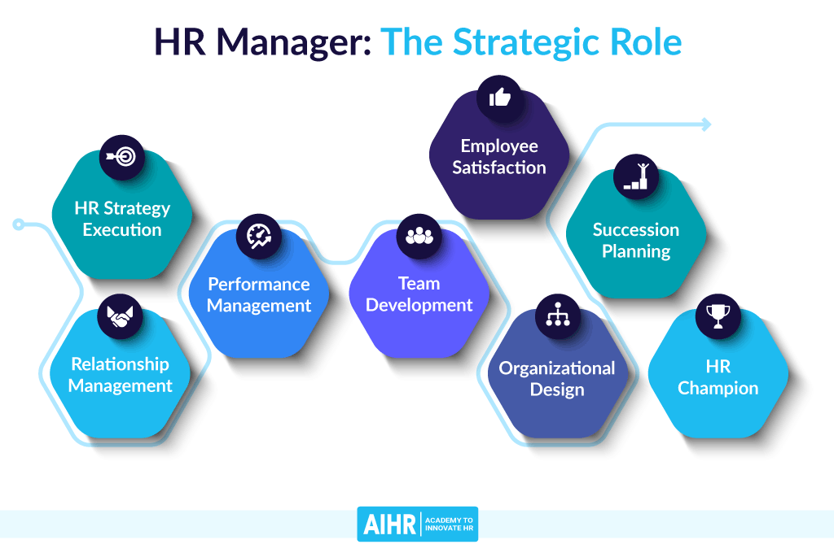
Figure 2: HR role in Manging Conflict.
Sources: (Aihr.com, 2022)

Employees Role
Many experts agree that individuals should initiate the process of resolving problems at work, even if managers and supervisors have a big part to play in this. According to Kelly Mollica, a specialist also with Centre Group, a Memphis-based HR management company, employees who have grievances about coworkers should be counselled to try to resolve such issues with those coworkers directly, Tennessee (Adamovic et al. 2020). She claims that this might lessen management interruptions while also assisting staff members in learning how to resolve disputes on their own. According to the writer, top-down actions are not necessary for resolving workplace disputes. A manager may be perceived as taking sides if they bring up an employee's grievances to another employee. If something happens regularly, it could raise concerns about the manager's authority since it might be interpreted as favouring specific employees. Worker reliance on managers should be limited as well. Organisations need staff individuals who are capable of managing daily affairs for themselves, while exercising independent judgement, problem-solving, and problem-analysis abilities (Caputo et al. 2018). These issues also involve issues with people and tasks. Eventually, everyone at work—not just the managers—will be seen as accountable for managing conflict. Educating staff on how to resolve conflicts may require some time on the part of management. Mollica provides the following suggestions for managers and supervisors:
- Specify exactly what the staff is to do in conflict situations by setting up clear regulations.
- Prioritise lesser-important issues above "urgent" employee-related circumstances. The troubles shouldn't always be viewed as their fault, but they should listen to and help employees who are having conflicts (Edo and Omunakwe, 2021).
- Let the workers know that they are counting on them to try their best to settle conflicts on their own without consulting management.
- It is important to offer staff ongoing conflict resolution training. Self-assessments are frequently the initial stage in such training, enabling participants to identify their own conflict-management preferences and consider the benefits and drawbacks of each alternative.

Conflict Management Training
Conflict management training is being used by certain managers and HR professionals to decrease or eliminate the effects of conflict. Numerous formats and subjects are addressed in this sort of training (Campbell et al. 2019). It can be imparted through one-on-one interactions, one-day seminars, or small-group facilitations. Depending on the kind of workplace conflict that must be resolved, HR experts should select a plan. Conflict management training may be advantageous for staff members who often face disciplinary action, exhibit intense rage, or engage in passive-aggressive behaviour, according to experts. Co-workers commonly complain about these people, and they are punished (Hofmann et al. 2018). Once they're angry, workers may speak inappropriately in meetings or even send out caustic emails. If they are the staff's supervisors, they may have extraordinarily high absence and turnover rates. But if an employee's actions entail hurting someone or raising the possibility that they may do so, they might need more assistance than what can be offered through training. Employers can consult their workplace safety policy for security deterrence and reaction techniques in instances where an employee demonstrates indicators of ferocious rage, such as shattering chairs or slamming fists (Monk et al. 2021). There should be policies in place for identifying, looking into, resolving, and handling violent incidents and threatening behaviour that happen at work.

Framework to Minimise Conflict
In order to promote a healthy workplace, there isn't a single, ideal strategy. To boost employee engagement and decrease conflict, a variety of tactics are used in different combinations. (Bahmani et al. 2019). However, there are a few vital resources HR experts may employ to encourage a pleasant work atmosphere.
CONTRACTS, POLICIES, AND RULES IN WRITING
Employees should be made aware of the procedure for resolving conflicts at work. The worker manual, human resources guidelines, and formal agreements and contracts with certain increased level personnel are frequently the means through which a corporation communicates its expectations (Mojarabi-Kermani et al. 2019). Written HR policies are essential so that managers and staff may obtain instructions on how to handle conflicts and other difficulties. These regulations address any formal conflict resolution mechanisms made available to staff members and also prohibitions on retaliation against individuals who raise issues.
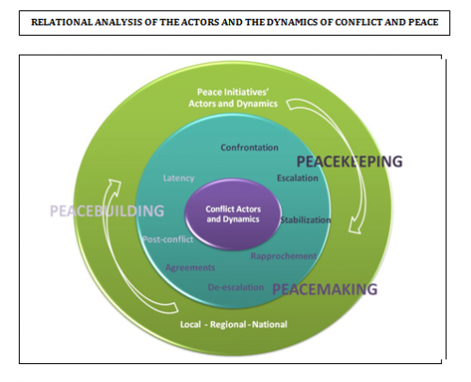
Figure 3: Conflict management framework.
Sources: (Irenees.net, 2022)

Effective Management
Conflicts are more likely to be handled swiftly and successfully in a firm when there are strong leadership teams in place. If a leader allows people to act in a disorderly manner or does nothing to combat bullying at work, employee relations will deteriorate (Einarsen et al. 2018). A productive management group is necessary to keep staff morale high and lower turnover.

Careful Hiring
Making sure that the organisation's hiring procedure includes efficient interviewing tactics, selection procedure, and pre-employment testing, which includes a background check, is an important strategy to avoid employee relations problems (Tanveer et al. 2019). Just as the required degree and experience are important recruiting criteria, an applicant's demeanour and communication style may suggest if they would be a "good match" for the business.

Fair Grievance Processes
Organisations should have language and written regulations related to dispute processes available inside the firm to provide both the employer and the employees with clear direction. The terms of each mechanism, together with their limitations and eligibility requirements, should be described in the policy (Duan et al. 2021). These terms should also include the frequency, decision-making processes, and necessary signoffs and approvals for problem resolution. Employers which use internal conflict resolution processes encourage employees to eschew time-consuming and expensive external litigation. Employees frequently use several techniques to settle disputes within or inside organisations. Once a grievance mechanism is in place, employees may feel more empowered to resolve conflicts, which might enhance their morale.
- That is the initial action. It promotes meetings between staff employees and their immediate supervisor for the goal of discussing and resolving issues relating to work. Employees should be informed that there will be no repercussions for filing a complaint (Duan et al. 2021).
- The upset worker selects a small group of co-workers and supervisors who have taken conflict resolution training to hear their side of the story. This strategy's effectiveness depends on employee participation in decisions that affect them. A review process could have unfavourable legal consequences for both parties, regarding the organization.
Conclusion
In order to lessen the negative effects that disputes, disagreements, and competing interests may have on individuals and the organisation, conflict management in the construction industry refers to the process of handling these situations. Conflict in the workplace has a cost in the form of presenteeism and absenteeism, which reduce productivity. Aside from that, there is the time dedicated to official activities including mediation. However, the costs involved in quitting a job were the most expensive. In the beginning of the struggle, there was not much money outlay. These findings underline the significance of early investments in problem-solving to increase employee welfare and lower overall organisational costs. Employers must thus ensure that managers have the necessary abilities to settle disputes peacefully wherever this is feasible.

Reference list
Journal
Adamovic, M., Gahan, P., Olsen, J.E., Harley, B., Healy, J. and Theilacker, M., (2020). Bringing the leader back in: Why, how, and when leadership empowerment behavior shapes coworker conflict. Group & Organization Management, 45(5), pp.599-636.
Aihr.com. (2022). HR Role in Managing Conflict. [online] Available at: https://www.aihr.com/wp-content/uploads/hr-manager-the-strategic-role.png [Accessed 14 Dec. 2022].
Andreoni, A. and Chang, H.J., (2019). The political economy of industrial policy: Structural interdependencies, policy alignment and conflict management. Structural change and economic dynamics, 48, pp.136-150.
Annane, D., Lerolle, N., Meuris, S., Sibilla, J. and Olsen, K.M., (2019). Academic conflict of interest. Intensive care medicine, 45(1), pp.13-20.
Bahmani, CHobbasti, A. and Seyedin, S.M., (2019). Structural Modeling the Effect of Librarians' Communication Skills on Interpersonal Communications and its Role in Conflict Management Strategies in the Libraries. Rahyaft, 28(72), pp.77-90.
Campbell, M.S., Wang, J., Cheng, Y., Cogen, F.R., Streisand, R. and Monaghan, M., (2019). Diabetes-specific family conflict and responsibility among emerging adults with type 1 diabetes. Journal of Family Psychology, 33(7), p.788.
Caputo, A., Marzi, G., Pellegrini, M.M. and Rialti, R., (2018). Conflict management in family businesses: A bibliometric analysis and systematic literature review. International Journal of Conflict Management, 29(4), pp.519-542.
Duan, Y., Jiao, Y. and Tam, K., (2021). Conflict of interest and proxy voting by institutional investors. Journal of Corporate Finance, 70, p.102089.
Durrah, O., Allil, K., Gharib, M. and Alhamoud, A., (2018). How different styles of conflict management determine creativity? Exploring petrochemical companies in Oman. Journal of Economics and Business, 1(4), pp.455-463.
Edo, B.L. and Omunakwe, C., (2021). Principals’ conflict resolution strategies on effective management of secondary schools in Port Harcourt Metropolis. International Journal of Innovative Education Research, 9(3), pp.100-107.
Einarsen, S., Skogstad, A., Rørvik, E., Lande, Å.B. and Nielsen, M.B., (2018). Climate for conflict management, exposure to workplace bullying and work engagement: a moderated mediation analysis. The International Journal of Human Resource Management, 29(3), pp.549-570.
Hofmann, H., Schleper, M.C. and Blome, C., (2018). Conflict minerals and supply chain due diligence: an exploratory study of multi-tier supply chains. Journal of Business Ethics, 147(1), pp.115-141.
Irenees.net. (2022). Conflict Management Framework. [online] Available at: http://www.irenees.net/local/cache-vignettes/L500xH406/Cinep3-82651.png?1611906919 [Accessed 14 Dec. 2022].
Liddle, D., (2017). Managing Conflict, A Practical Guide to Resolution in the Workplace.[ebook]. Kogan Page Limited, Available at: https://www.google.co.uk/books/edition/Managing_Conflict_at_Work/xRneuiXfiPkC?hl=en&gbpv=0. [Accessed 19 Dec. 2022].
Mojarabi-Kermani, A., Shirangi, E., Bordbar, A., Kaman Bedast, A.A. and Masjedi, A., (2019). Stochastic optimal reservoir operation management, applying group conflict resolution model. Water Resources Management, 33(8), pp.2847-2865.
Monk, J.K., Ogolsky, B.G., Rice, T.M., Dennison, R.P. and Ogan, M., (2021). The role of family-of-origin environment and discrepancy in conflict behavior on newlywed marital quality. Journal of Social and Personal Relationships, 38(1), pp.124-147.
Owsiak, A.P., (2021). Conflict management trajectories: theory and evidence. International Interactions, 47(1), pp.23-55.
Pinimg.com. (2022). Managing Conflict. [online] Available at: https://i.pinimg.com/originals/19/63/7f/19637ffd6d127d239efe1826e3f45b0b.jpg [Accessed 14 Dec. 2022].
Scott, V., (2009). Conflict Resolution at Work For Dummies. 1st ed. [ebook] Hoboken: Wiley. Available at: https://www.google.co.uk/books/edition/Conflict_Resolution_at_Work_For_Dummies/2VmWAAAAQBAJ?hl=en&gbpv=0, [Accessed 20 Dec. 2022].
Speights, S.L., Bochantin, J.E. and Cowan, R.L., (2020). Feeling, expressing, and managing emotions in work-family conflict. Journal of Business and Psychology, 35(3), pp.363-380.
Tanveer, Y., Tariq, A., Akram, U. and Bilal, M., (2019). Tactics of handling interpersonal conflict through emotional intelligence. International Journal of Information Systems and Change Management, 11(3-4), pp.211-227.
Van Eeden, L.M., Crowther, M.S., Dickman, C.R., Macdonald, D.W., Ripple, W.J., Ritchie, E.G. and Newsome, T.M., (2018). Managing conflict between large carnivores and livestock. Conservation Biology, 32(1), pp.26-34.
Wang, D. and Liu, Y., (2021). The effect of political skill on relationship quality in construction projects: The mediating effect of cooperative conflict management styles. Project Management Journal, 52(6), pp.563-576.

