
Applied Computing
Wales Institute of Science and Art (WISA)

Network Programmability (ACCB5029)

Lab 1:
Task 1: Install Virtual Machine
Task 2: Explore DevNet Resources
Task 3: Linux Review


Task 1:
Objectives
- Prepare a Computer for Virtualization
- Explore the DEVASC VM GUI
- Create Lab Environment Accounts
- Install Webex Teams on your Device
Required Resources
Host computer with at least 4 GB of RAM and 15 GB of free disk space
High-speed internet access to download Oracle VirtualBox and the DEVASC VM
Instructions
- Prepare a Computer for Virtualization
In this Part, you will download and install desktop virtualization software and the DEVASC VM. The link for DEVASC VM file is available in Moodle under Module Essentials section.
Note: The following instructions are for Windows 10 using VirtualBox v6.1.4. Your steps may differ slightly. Regardless of the operating system or VirtualBox version, be sure you locate and select the options specified in the following steps.
  - Open VirtualBox.
  - Import the DEVASC VM.
    - Login to Moodle and download DEVASC VM under Lab section.
    - In VirtualBox, select File > Import Appliance. The source of the appliance is Local File System. Browse to the location of the downloaded DEVASC VM and click Open.
    - Click Import to continue. The import process will take several minutes.

- Explore the DEVASC VM GUI

  - Start the DEVASC VM. This will take a few minutes as the Ubuntu image boots.
  - The DEVASC VM contains Packet Tracer. You must agree to the Cisco Packet Tracer EULA to continue starting the VM. When you see the license agreement, use the arrow keys to scroll the text. Press the Right Arrow key to select <OK> when you are finished. Press the Space Bar to move to the Agreement screen. Press the Left Arrow key to select <I Agree> when you are finished.
  - The Ubuntu image will continue to load. Close any popup messages.
  - In the later labs, you will use the terminal, VS Code, Packet Tracer, Chromium Browser, and Postman. Open these applications and explore them.
  - Click the Menu button and explore the Places, System, and All applications.
Note: Remember that this is a virtual machine and is completely separate from the computer on which it is installed. You can make any changes you like. If you make a mistake, or break something, you can simply remove the VM from VirtualBox, and import a fresh copy from the file you downloaded. This is a great way to experiment with programs without affecting your real computer. Don't be afraid to explore!
- Create Lab Environment Accounts
There are many tools that you will need to use to complete the labs in this Module. Some of these require you to have your own account. These are easy to set up and can be done for free. In this Part, you will create the accounts you will need for the rest of the Module.
  - Create a DevNet account.
    - Open the Chromium browser and navigate to developer.cisco.com.
    - Click SIGN UP FREE.
You can choose any of the Login types for which you already have an account. This allows for easy association with other accounts. If you do not wish to associate your DevNet account with any other apps, Choose Login with a Cisco ID. Follow the instructions to complete the account creation.
  - Create a GitHub account.
    - Navigate to github.com.
    - Fill in the fields for Username, Email, and Password, and then click Sign up for GitHub.
    - Perform any verification to ensure you are human.
    - Click Join a free plan and Complete Setup.

  - Create a Webex account.
    - Navigate to webex.com. Click Start for Free or Sign up now, it's free. Enter the Email address you wish to use.
    - Click Sign Up. Follow the instructions to complete the account creation.
    - Shut down the VM.
Note: When you are done with the VM, you can save the machine state of the VM for future use or shut down the VM.
- Install Webex Teams on your Device
  - Search and find appropriate link to download the Webex Teams.
    - Download Webex Teams based on your OS.
    - Open the installation file and follow the instructions to finish the installation.
    - Launch Webex Teams.

  - Open Webex Teams.
    - Create your own Team. In the left panel, click the Teams button. Then click the plus button to Create a team. A Team is required for the next step.
    - Add a user to Webex Teams.
    - In Webex Teams, search for a user in the Search field. You may search by username or email. The user must be a member of your team.
    - Click the user in the list of search results to open a space.
    - Type a message to the user. They will be notified of your message and can now return a message to you.

Task 2:
Objectives
- Find and Navigate a Learning Lab
- Explore more resources
Required Resources
1 PC with operating system of your choice, Internet access, Active DevNet Account
Note: Although you can use your DEVASC VM to complete this lab, it is not required.
Instructions
- Find and Navigate a Learning Lab
  - Go to developer.cisco.com and log in. All the learning tools can be found here such as Learning Labs, Video course, Code Exchange, among others.
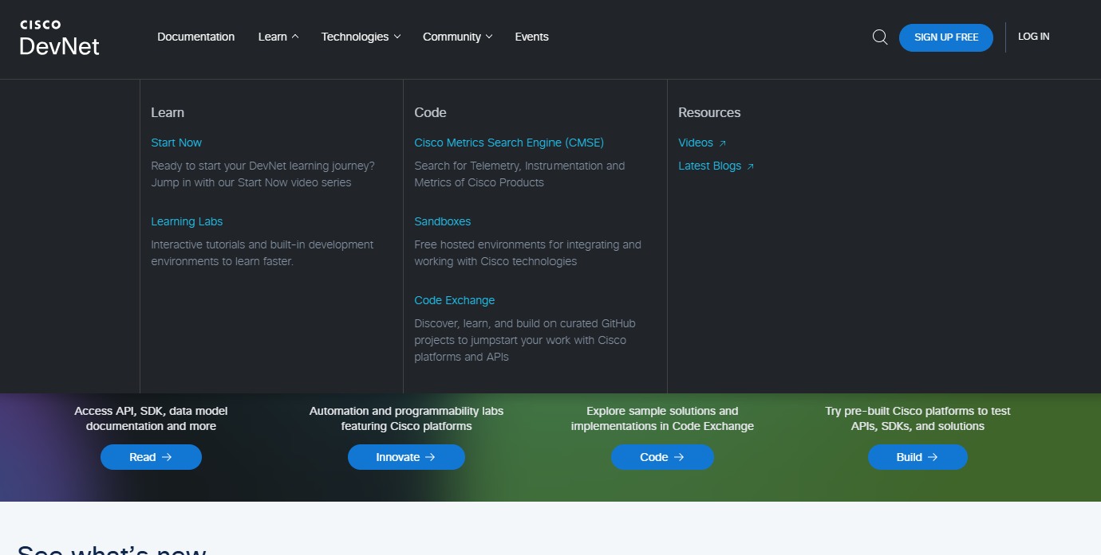
  - Click Learning Labs. It will show you All Learning Tracks.
    - For this example, scroll down and click Introduction to Python through a use case. This is a beginner's track which covers some fundamentals. These skills will be necessary for success in this Module. This is a great place to start.
    - Similarly, you could search and find many useful resources here. Explore.
    - Navigate to and read each page.
Note: In addition, these content in the DevNet learning tracks are beyond the scope of this module. However, consider these for your Independent Learning. You will learn more about Git and using Python to make API requests later in this Module.
- Explore More Resources
In this part, you spend some time looking through all the available resources at developer.cisco.com.
  - Explore the Start Now page.
The DevNet home page has many ways to find content. As a beginner, the Start Now link is a great way to get started.
    - From the DevNet home page, click Start Now.
This part of the site links you to entry level content in small chunks based on a common technology area.
    - Click What’s A Virtual Environment.

- Explore the Sandbox page.
One of the greatest things about DevNet is the Sandbox. This is a place where you can run your code against real equipment! There are virtualized environments, simulators, and real hardware available for free! Some labs are always running while others require a reservation.
    - From the DevNet home page, click Sandbox.
    - Where can you go for help if you have difficulty or wish to ask a question about the Sandboxes?
    - Click CICD Pipeline. A new tab will open with the details about the lab.

  - Explore the Code Exchange page.
The Code Exchange page allows you to work with all kinds of code related to Cisco technologies. These are GitHub projects that help you build and collaborate on projects. You can search for a specific repository or browse by technology.
    - From the DevNet home page, click Code Exchange
    - Click Explore repos and choose any repo.
This page tells you all about the project including how to install it, how to use it, and how to download the repository. The link to the GitHub location will tell you much more about the project and show the contents of the different branches.

Task 3:
Objectives
- Review command syntax Navigation
- Review File management
Required Resources
1 PC with operating system of your choice, Virtual Box or VMWare, DEVASC Virtual Machine
Instructions
- Open a terminal in the DEVASC-LABVM
  - Use the ls command to display a listing of the current directory. Remember that commands are case-sensitive.
devasc@labvm:~$ ls
  - Use the ls command with the labs argument to display the contents of the labs folder.
devasc@labvm:~$ ls labs
  - Use the ls command with the -l option to display a "long display" of the contents of the current directory.
devasc@labvm:~$ ls -l
  - Use the ls command with the -r option to display the contents of the current directory in reverse alphabetical order.
devasc@labvm:~$ ls -r
  - Multiple options can be used at the same time. Use the ls command with both the -l and -r options to display the contents of the current directory both in long and reverse order.
devasc@labvm:~$ ls -lr
  - There are many more options that can be used with the ls command. Use the man command with the argument ls to see all of the possibilities in the manual. The man command can be used to look up any command within the system. Use the space bar to advance to subsequent screens. Press q to quit.
devasc@labvm:~$ man ls
What happened? Recap on the Linux commands to make yourself better in this course.
  - You can also use --help argument after most commands to see a shorter summary of all the available command options.
devasc@labvm:~$ ls --help
  - Use the pwd command to display the current working directory.
devasc@labvm:~$ pwd
  - Use the cd command to change the directory to /home/devasc/Documents.
devasc@labvm:~$ cd Documents
devasc@labvm:~/Documents$
  - Use the cd command with the / symbol to change directories to the root directory. Use pwd again to see that you are now in the root directory.
devasc@labvm:~/Documents$ cd /
devasc@labvm:/$ pwd/
  - Return to the /home/devasc/Documents directory. Tip: You can move one directory at a time or all the way to a destination. To quickly enter the command, type the first few letters of the directory name and press Tab for the system to automatically enter the rest of the name. Remember that names are case-sensitive.
devasc@labvm:/$ cd /home/devasc/Documents/
devasc@labvm:~/Documents$
  - Use the .. characters to move up a single directory. Use pwd again to see you are back in the user’s home directory.
devasc@labvm:~/Documents$ cd ..
devasc@labvm:~$ pwd
/home/devasc
  - Use super user commands for administrative access.
Use the sudo command to issue a single command as the root user. A new terminal will not be created. Use the sudo apt-get update command to update to refresh the list of available packages installed on the VM. This command will not work without using the sudo command.
Note: If your output is different, it is ok. Check if you are understanding the purpose of those commands. You will be using linux in more advanced modules as well.
devasc@labvm:~$ sudo apt-get update

- Review File Management
Review file permissions.
  - Use the ls Desktop -l to display the contents of the Desktop folder.
devasc@labvm:~$ ls Desktop -l
Answer the following questions about the output you got. If necessary, search the internet for information of Linux file permission shown in the output of the ls command.
Reflections
    - What does the initial dash represent in the permission information?

    - What would be in the place of the dash if the item was a directory?

    - What do the next three letters or dashes represent in the permission information?

    - What do the middle three letters or dashes represent in the permission information?

    - What do the last three letters or dashes represent in the permission information?

    - What does the first instance of "devasc" in the permission information indicate?

    - What does the second instance of "devasc" in the permission information indicate?

    - What does a permission type of "r" mean?

    - What does a permission type of "w" mean?

    - What does a permission type of "x" mean?

  - Change file permissions and ownership.

    - Use the command cd to change to the Documents directory.
devasc@labvm:~$ cd Documents/
    - Use the command echo to create a shell script file, that will have the command ls ../Desktop inside the file. Remember that the greater than (>) character redirects command output to a file.
devasc@labvm:~/Documents$ echo "ls ../Desktop" > myfile.sh
    - The myfile.sh script is stored in the /Documents directory. Use the cat command to view the only command in the script. This file will be used as an example to modify permissions and ownership.
devasc@labvm:~/Documents$ cat myfile.sh
    - Use the command ./myfile.sh to run the script. Access is denied because you must set the permission of executable on the file.
devasc@labvm:~/Documents$ ./myfile.sh
bash: ./myfile.sh: Permission denied
    - Use the command ls -l myfile.sh to view the current file permissions.

devasc@labvm:~/Documents$ ls -l myfile.sh
-rw-rw-r-- 1 devasc devasc 14 Apr 16 12:46 myfile.sh

    - Use the command chmod +x myfile.sh to allow you to execute the file.
devasc@labvm:~/Documents$ chmod +x myfile.sh
devasc@labvm:~/Documents$
    - Use the command ./myfile.sh to run the script.
devasc@labvm:~/Documents$ ./myfile.sh
    - Use the command sudo chown root myfile.sh to change the ownership of the file to "root".
devasc@labvm:~/Documents$ sudo chown root myfile.sh
    - Display the permissions of the myfile.sh file.
devasc@labvm:~/Documents$ ls -l

  - Use the move files command.

    - Use the command mv to move the myfile.sh file to the desktop.
devasc@labvm:~/Documents$ mv myfile.sh /home/devasc/Desktop/
devasc@labvm:~/Documents$
    - Display the contents of the Desktop folder.
devasc@labvm:~/Documents$ ls ../Desktop/
    - Return the file to the Documents folder.
devasc@labvm:~/Documents$ mv ../Desktop/myfile.sh myfile.sh
    - Use the command mv to rename myfile.sh to myfile_renamed.sh.
devasc@labvm:~/Documents$ mv myfile.sh myfile_renamed.sh

  - Use the copy files command.

    - Use the command cp to make a copy of the myfile_renamed.sh file.
devasc@labvm:~/Documents$
cp myfile_renamed.sh myfile_renamed_and_copied.sh
  - Use the remove files command.

    - Use the rm command to remove the myfile_renamed_and_copied.sh file.
devasc@labvm:~/Documents$ rm myfile_renamed_and_copied.sh
devasc@labvm:~/Documents$ ls
  - Use the standard output redirect.

    - Use the redirect (>) to place text into a new file called linux.txt.
devasc@labvm:~$ echo "Linux is AWESOME!" > linux.txt
    - Use the command cat to redirect the contents of linux.txt to another file.
devasc@labvm:~$ cat linux.txt > linux2.txt
    - Use the command cat to view the contents of linux2.txt.
devasc@labvm:~$ cat linux2.txt
Linux is AWESOME!
    - Use the echo command to append text to the linux2.txt file.
devasc@labvm:~$ echo "I LOVE Linux!" >> linux2.txt
    - Use the cat command to view the contents of the linux2.txt file.
devasc@labvm:~$ cat linux2.txt
Linux is AWESOME!
I LOVE Linux!
    - Use the echo command to overwrite the contents of a file using the single angle bracket.
devasc@labvm:~$ echo "Linux is POWERFUL!" > linux.txt
    - Use the cat command to view the contents of the linux.txt file. Notice that the previous state “Linux is AWESOME!” was overwritten.
devasc@labvm:~$ cat linux.txt
Linux is POWERFUL!
  - Use the vi text editor.

    - Use the following command to start the vi text editor & open a text file.
devasc@labvm:~$ vi linux2.txt
The following content is shown in the editor window:
Linux is AWESOME!
I LOVE Linux!
    - Use the text editor to change the content to the following:
Linux is Linux
I am AWESOME!
The a key will allow you to enter edit mode, appending after the cursor’s position, while the i key will allow you to enter edit mode, inserting at the cursor’s position. You will need to use the Esc key to enter command mode to move around. Remember that d will delete (cut), y will yank (copy), and p will put (paste) the current line with the cursor.
    - Save the text to a new file called "linux3.txt". Remember that you will need to be in the command mode and type a colon ( : ) to enter ex mode so that you can write (save) the document ( :w linux3.txt). You can then use the quit (exit) command ( :q) to exit the vi editor.

    - Use the cat command to view the contents of the linux3.txt file.
devasc@labvm:~$ cat linux3.txt

End of document.
Linux review continued in next part. Refer to the next document.

