FINANCIAL MANAGEMENT

STUDENT NAME: PATEL HANIBEN RAJESHBHAI
STUDENT ID: 2323021
COURSE NAME: FINANCIAL MANAGEMENT
LECTURER NAME: JIA MIAO
SUBMISSION DATE: 21 AUGUST 2024

Table of Contents
Part A: Introduction 3
Brief History of the Company 3
Recent Events Encountered by the Company 3
Part B: Financial Performance Review 4
Calculation and Critical Evaluation of Key Financial Ratios 4
Comparison with Major Competitors 10
Recommendations for Improving Financial Management 14
Part C: Methods of Investment Appraisal 15
Payback Period, Accounting Rate of Return and Net Present Value 15
Recommendations for Choosing Relevant Investment Project 17
Investment Appraisal Techniques Benefits and Shortcomings 17
Non-Financial Factors to be Considered 18
Conclusion 19
References 20

Part A: Introduction

Brief History of the Company
Financial management is a comprehensive strategic procedure that ascertains organising, monitoring, controlling, analysing and reporting financial resources of a company. It involves several activities to manage the movement of economic sources that can assist in achieving organisational goals and objectives. The goal of this job is to do a thorough financial analysis of Unilever Plc, a British multinational company that works in the fast-moving consumer goods sector around the world. The company has been around since 1929 and has more than 128,000 employees who serve millions of customers in over 190 countries. The British soap company Lever Brothers and the Dutch margarine company Margarine Unie merged to form Unilever, which was then traded on the London Stock Exchange. The company follows a definite Growth Action Plan which consists of three strategic pillars: faster growth, productivity & simplicity and performance culture (Unilever, 2024). According to faster growth, the company is focused on 30 power brands to maintain organisational superiority and enhance its investment to continue portfolio optimisation. Productivity and simplicity define the company’s concern towards increasing gross margin and driving sustainable goals (Unilever PLC, 2024). As per the business model, performance culture promotes reward out performance and team integrity. The marketplace of Unilever can be evaluated as business-to-business and business-to-consumer where both traditional and e-commerce platforms are utilised. The primary focus of Unilever for strengthening its marketplace is to establish a balanced e-commerce business model to foster e-retailers and D2C businesses. One of the major competitors of Unilever is Tesco and Procter & Gamble, serving a similar customer base.

Recent Events Encountered by the Company
The strategic decisions of Unilever to capture the maximum market advantages can be observed with the organisational merging with K18, a renowned biotech haircare brand. The main aim of proposing the business merger with the company is to capture the customer base achieved by the company in less than 2 years after its market commencement. However, Unilever has proposed investment for merging K18 for showing its interest in biotechnology and expansion of hair-care products as well as gaining interest among consumers regarding bond repair technology. The official merging of Unilever and K18 was proposed in 2023 which impacted its revenue positively. It has been recorded that Unilever generated the maximum amount of revenue of 12.47 billion euros from its beauty and well-being products at the end of 2023 (Statista, 2022). Moreover, the business merging strategy of Unilever has efficiently affected its financial performance, representing the reason behind its stability in the competitive market environment.
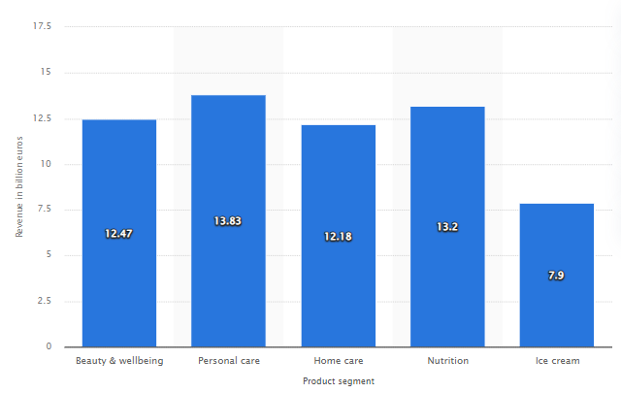
Figure 1: Revenue Generated by Unilever in 2023 as per Product Segments
(Source: Statista, 2022)
Recommendations will be also given here to improve the financial management of the company. Investment appraisal techniques will be applied here for Unilever to identify the profitability between two projects A and B by calculating the accounting rate of return, payback period and net present value.

Part B: Financial Performance Review

Calculation and Critical Evaluation of Key Financial Ratios
Ratio analysis is a significant accounting approach that helps in evaluating the optimal financial health of a business over a specific period. It involves the computation and interpretation of information obtained from financial statements such as income statements, cash flows and balance sheets to determine the effective allocation of assets, equities and liquid funds (Purnama, et al., 2020). Ratio analysis helps in understanding the actual operational health of a business by measuring companies’ liquidity, profitability, solvency and stock market engagement. In this section, five major accounting ratios which are profitability, liquidity, efficiency, gearing and stock performance have been calculated for Unilever to measure its performance for the prior five financial years.
Profitability ratios are crucial financial metrics that assist in observing the economic ability of a business to generate revenue by meeting expenses and allocating resources for a particular period. The main goal of figuring out profitability ratios is to show how well a business can make money after paying for things like taxes, fees, and other costs. Gross profit margin, net profit margin, working profit margin, return on assets, and return on equity have all been calculated to show how well Unilever can make money (Olayinka, 2022).
 | 2023 | 2022 | 2021 | 2020 | 2019
Earnings per share | 2.58 | 3 | 2.33 | 2.13 | 2.15
Dividend payout ratio | 66 | NIL | NIL | NIL | NIL
Table 1: Profitability Ratios of Unilever Plc
(Source: Excel)
Gross profit margin has defined the amount of profit generated by the company after covering the amount of cost of sales from the total revenue. The calculation of the operating profit margin has helped in getting the percentage of operating profit generated over revenue considering operational expenses (Nariswari and Nugraha, 2020). Similarly, the net profit margin has shown the actual earnings gained by the company after meeting necessary costs, interest and taxes from the revenue. From the percentages of gross profit margin for the five years, it can be observed that Unilever has efficiently controlled its cost of sales and managed to collect higher gross profit. A slight change can be identified in its operating profit margin, showing the decline due to dynamic operational costs. On the other hand, changes in the net profit margin affirm the absence of the company in controlling all expenses, taxes and interests that decline its overall profitability. Return on assets comprises the ability of the business to allocate its total assets and gather net income. Calculation of return on assets has shed light on the efficient asset management practices of Unilever where the percentage of ROA has increased in 2023 compared to prior years 2019 and 2020. However, the decline in the return on equity in 2023 confirms less engagement of equity to generate income.
Liquidity ratios help in identifying the financial liquidity of a company to cover its short-term borrowings. There are three kinds of liquidity ratios such as current, quick and cash. These ratios assist in comprehending the liquidity of the assets that can be easily converted into cash to meet short-term liabilities (Markonah, et al., 2020). Similarly, working capital should be also measured to observe the differences between current assets and current liabilities.
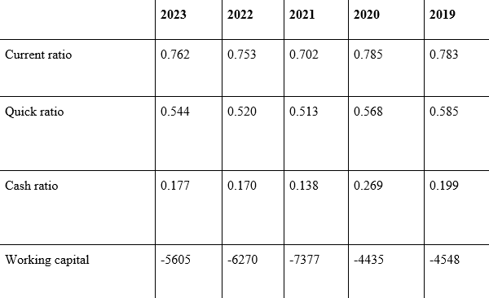Table 2: Liquidity Ratios of Unilever Plc
(Source: Excel)
The current ratio shows how much money a business has between its current assets and current liabilities over a certain time period. The quick ratio, on the other hand, shows how easily assets can be turned into cash, excluding inventories. When talking about financial liquidity, the cash percentage shows exactly how much cash is available to pay off short-term debts. Working capital also shows the difference between assets and debts (Sari, et al., 2022). Based on the above estimate, it's clear that Unilever is trying to minimize its debt by increasing its current assets, which has led to a higher current ratio in 2023 compared to 2021 and 2022. In 2021, the current ratios dropped quickly compared to 2020 and 2019. This could be because of changes in accounts payable and bills, which caused current liabilities to rise. Similarly, the quick ratios have gone up in 2023 compared to 2021 and 2022 when current assets other than stocks are taken into account. This shows that the company can handle short-term borrowing without having to worry about its inventory. The cash ratio for Unilever in 2023 was 0.177, which shows that the company isn't doing a good job of using its cash and cash equivalents to meet its present obligations. The ratio was higher in 2020 (0.269) and 2019 (0.199). Based on the amount of working capital, it's clear that Unilever has more debt than assets, which is not a good sign for its financial health.
Efficiency ratios are a way to figure out how well a company is using its assets and inventories to make sales. They are linked to the idea of activity performance. By showing how well the company manages its inventory, deals with suppliers, and moves cash from customers, these numbers give you a deep understanding of how well the business runs (Patin, et al., 2020). This inventory turnover ratio tells you how long it takes for a business to sell its stock and get new stock in a certain amount of time. How long it takes to get money back from customers is shown by the debt turnover ratio. On the other hand, the accounts payable ratio shows how long it will take the company to pay its bills. To find out the average number of days it takes to sell an inventory, days sales of inventory are added up. Day’s sales unpaid, on the other hand, show how long it takes to get paid for credit sales (Gôa̺, 2020). The average number of days it takes for a business to pay its creditors is shown by days payable outstanding.
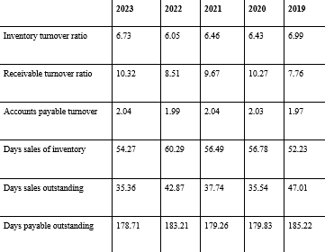

Table 3: Efficiency Ratios of Unilever Plc
(Source: Excel)
From the above calculations for efficiency ratios, it can be observed that the inventory turnover ratio has increased in 2023 compared to the prior years which indicates strong sales for Unilever. The company has also successfully gained a higher receivable turnover ratio showing its aggressiveness in collecting payments. It also underpins extensive operational practices of the company done on a cash basis rather than performing credit sales. Similarly, the increase in the accounts payable ratio indicates the effectiveness of Unilever in collecting payments from its suppliers by offering them taking advantage of early payment discounts. The above calculation also demonstrates a significant decrease in days sales inventory, defining that the company is effectively selling its inventories as well as replenishing it smoothly. Similarly, the constant decrease in the days sales outstanding represents that Unilever is collecting its payment quickly without creating any disruption in cash flows. The company is also focused to minimising days payable outstanding to avoid delays in repaying suppliers.
Gearing ratios are the most significant accounting ratios for business entities that help in assessing the optimisation of the source of finance by comparing debt and equity. Ratios such as equity, debt and debt-to-equity are considered as gearing ratios that indicate the overall financial solvency of a company (Nukala and Prasada Rao, 2021). Generally, higher ratios interpret the overdependency of debt while emphasising returns and risk maximisation. The equity ratio defines the active utilisation of shareholders’ equity to generate assets whereas the debt ratio comprises dependency on debts for financial total assets. On the other hand, the debt-to-equity ratio differentiates the proportion of debts and equities used for generating total assets (Alvian and Munandar, 2020).
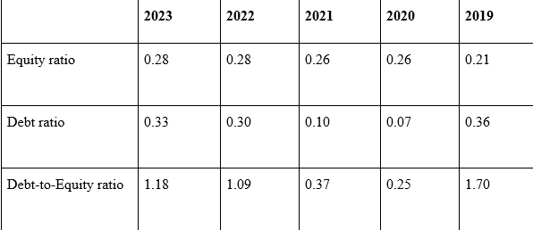Table 4: Gearing Ratios of Unilever Plc
(Source: Excel)
The computation of equity ratios for the five financial years has determined that Unilever has been efficiently optimising shareholders’ equity to generate funds for assets which pose lower economic risks. However, the debt ratio has also increased immensely in 2023 compared to other financial years, showing the collection of long-term and short-term debts for maximising assets. The constant increase in the debt-to-equity ratio thoroughly determines that Unilever is collecting further capital from the market for conducting its operations rather than proceeding with equity market performance. The immense increase in the debt-to-equity ratios indicates an adverse financial condition for the company where it can face severe economic risks and avoid in taking immediate actions can raise the chances of insolvency.
Stock market ratios are core financial metrics that can be used for evaluating the share practices of a company. These ratios help in determining overvaluation, undervaluation or fair stock performance by which is stakeholders can gain a clear overview of the company’s financial stability (Arsal, 2021). In this section, two major stock performance ratios such as earnings per share and dividend payout ratio have been calculated for Unilever. Earnings per share helps in contemplating the profitability of the company to be earned from the outstanding share of common stock. On the other hand, the dividend payout ratio has been computed to reflect the dividend paid by the company to shareholders from the net income (Arsyad, et al., 2021).
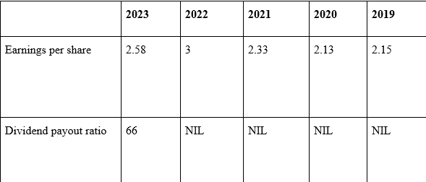Table 5: Stock Performance of Unilever Plc
(Source: Excel)
The above-mentioned calculation has represented the increase in earnings per share provided by Unilever to its stakeholders that can attract future investors by showing its ability to generate higher profits over its share price. The company has not provided any further information on the dividend payout ratio other than financial year 2023.

Comparison with Major Competitors
Tesco and Procter & Gamble are Unilever Plc's two main rivals. They both work in the same industry. In this part, accounting ratios were used to compare Unilever's financial success with that of its competitors.
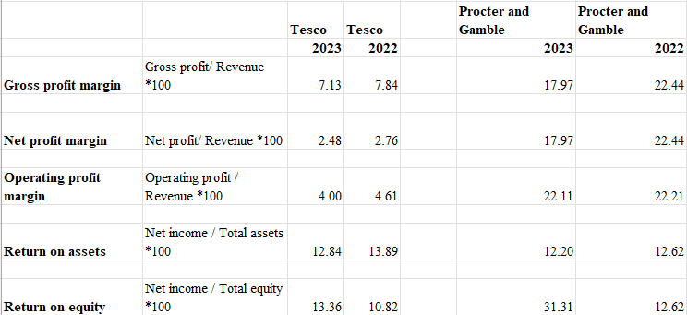
Figure 2: Profitability Ratios of Tesco Plc and Procter & Gamble
(Source: Excel)
Key profitability ratios have been calculated above for Tesco and P&G. Analysing the gross profit margin, it can be identified that Unilever holds economic advantages over Tesco and P&G. As per GP margin 2023, Unilever has a higher margin of 42.24 while Tesco and P&G have the margins of 7.13 and 17.97. Comparing the net profit margin, it can be found that Unilever poses a higher percentage than Tesco hence, lower than P&G. Similarly, the operating profit margin is also higher in P&G being compared to Tesco and Unilever, posing effective control on expenses and costs. However, Unilever has been generating lower returns on assets than its competitors which evaluates its poor strength in managing asset allocation.
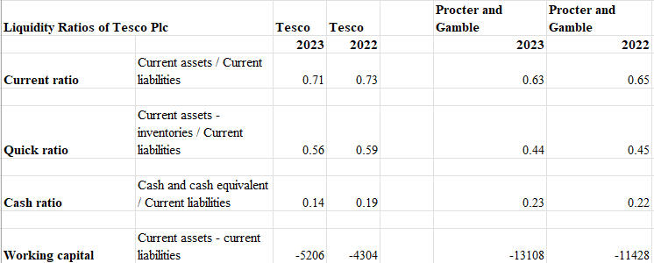
Figure 3: Liquidity Ratios of Tesco Plc and Procter & Gamble
(Source: Excel)
From the above computation, the liquidity of Unilever has been distinguished from Tesco and P&G where cash ratios, quick ratios, current ratios and working capital have been calculated. Comparing the results of the current ratios, it can be observed that Unilever has achieved higher ratios than Tesco and P&G due to having higher assets than liabilities. However, the percentage of quick ratio for Tesco is comparatively higher for Tesco which defines the competitive lesser liquidity of Unilever after deducting the number of inventories. On the other hand, the cash ratios of P&G are higher than Unilever's that reflects the sufficient cash and cash equivalent present to cover current liabilities. The computation of working capital has shown the difference between current assets and current liabilities for the company where Tesco has lower distinguished in the amounts than Unilever. Hence, the company holds a lower difference with P&G, underpinning positive competitive financial performance.
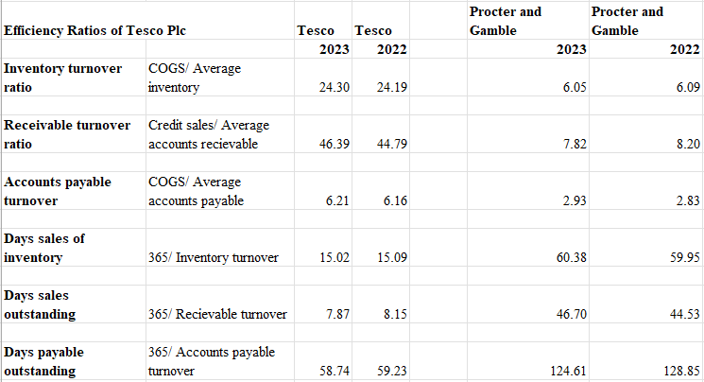
Figure 4: Efficiency Ratios of Tesco Plc and Procter & Gamble
(Source: Excel)
Computation of efficiency ratios has helped in examining asset management, inventory management and cash movement efficiency among Unilever, Tesco and P&G (Kadim, et al., 2020). From the calculation, it can be observed that Tesco in controlling its inventory movement more fluently than Unilever which indicates its sales performance. Similarly, receivable turnover and payable turnover are also higher for Tesco, comprising better cash flows than Unilever. However, the company is upholding higher operational advantages over P&G affirmed by efficient days sales inventory, days sales outstanding and days payable outstanding.
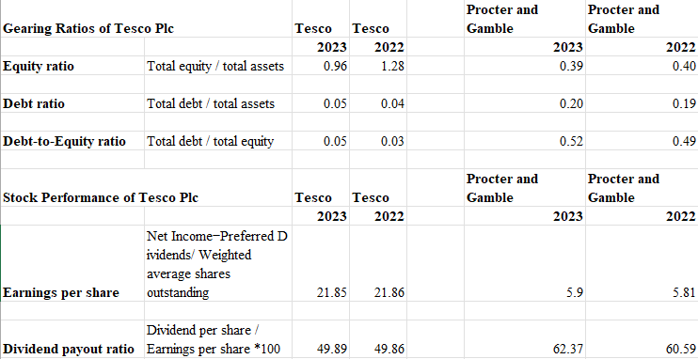
Figure 5: Gearing Ratios and Stock Performance of Tesco Plc and Procter & Gamble
(Source: Excel)
The computation of gearing ratios has aimed to investigate the insolvency situations between the companies by focusing on their debt and equity performance (Jakubik and Moinescu, 2023). As per equity ratios, it can be observed that Tesco possess lower financial risks compared to Unilever and P&G due to the optimisation of equities to generate assets. Both P&G and Tesco have lower debt ratios as they avoid financial risks by not being overdependent on debts for financing their assets. In this term, Unilever holds a higher chance of becoming insolvent as well as attracting less investors than its competitors. From the results of debt-to-equity ratios, it can be found that the ratios are higher for Unilever which can attract fewer future shareholders due to showing the financial risks and insolvency. For this reason, the company should take efficient actions and gather new stakeholders to generate sufficient funds for financing total assets.
Execution of the stock performance ratios such as earnings per share and dividend per share has helped in evaluating the share market activities of Unilever, Tesco and P&G. From the results, it can be found that Tesco and P&G have been providing its stakeholders with higher earnings per share. Though Unilever has provided the dividend payout ratio of 66% in 2023 which is comparatively higher than Tesco, the percentage is comparatively lower than P&G provided 62.37% in 2023. Therefore, it can be comprised that Unilever should focus on strengthening its overall performance by implementing necessary actions to gain competitive advantages.

Recommendations for Improving Financial Management
Unilever can adopt different strategies to enhance its financial management which has been described below.
Efficient cost management and pricing strategies: Unilever should imply directive cost management to minimise unrequired expenses present in supply chains and administrative overheads. The company can also focus on reviewing its pricing techniques such as value-based pricing and tiered pricing models that can help in improving net profit margins (Raja, et al., 2020). For executing better profitability, Unilever can also intend to diversify its revenue streams by which it can identify market demands, commence new products and propose further investment in sales.
Enhancement of cash flow management and inventory management: For improving liquidity performance, Unilever should maintain close monitoring of its cash flow and implement stricter credit control policies. Implementation of just-in-time inventory management system can also assist it to avoid excess stock (Balkhi, et al., 2022).
Optimisation of debt management and capital structure: The company can strengthen its solvency performance by evaluating its debt structure and avoiding overdependency on high-interest short-term debt. In order to upgrade its capital structure, it should promote better control of its cost of capital as well as resource allocation.
Implementation of technology and process management: Advancement of efficiency performance can be achieved by accomplishing lean management techniques which will ensure better cash cycle times and workflow. Unilever should also invest in technology and business automation to enhance its productivity and lowering operational costs (Baiyer, et al., 2020). Similarly, investment should be also made in employee training and development initiatives to achieve better performance.
Improvement in investor relations and corporate governance: In order to enhance stock market performance such as earnings per share and dividends payout, Unilever should attract new stakeholders by maintaining transparent communication. It can also reinforce its corporate governance by including strong leadership and risk assessment tactics.

Part C: Methods of Investment Appraisal

Payback Period, Accounting Rate of Return and Net Present Value
Investment appraisal is the process of using analysis to figure out how profitable an investment will be over a certain amount of time. This can show how affordable it is and how well it fits with your overall strategy. The main goal of investment appraisal is to figure out possible returns, lower economic risks, and get potential partners involved in making smart choices (Magni and Marchioni, 2020). Different types of investment evaluation tools can be used by people and companies. These include net present value, internal rate of return, accounting rate of return, payback period, and profitability index. Three types of investment evaluation were used to find out which of Project A and Project B would make Unilever more money.
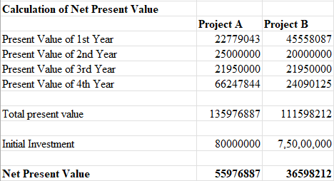
Figure 6: Net Present Value for Project A and Project B
(Source: Excel)
Net present value is a general accounting method that is often used to figure out how profitable a purchase is. It involves figuring out the difference between the present values of cash flows coming in and going out so that extra money flow can be observed that have to cover the cost of the original investment (Illés, 2020). Net present value can also help to choose between two or more business projects so that best option can be explored. By looking at its cash flows, this method has helped Unilever figure out which of Project A and Project B is more profitable. Based on the above math, it is clear that Project A needs a bigger starting investment of £80,000,000, while Project B only needs £75,000,000. It is known that Project A will have better cash flows than Project B, even when the cost of capital is taken into account. The results show that Project A will make the most money after the original costs is paid for. This is shown by the net present value of £55,976,887.
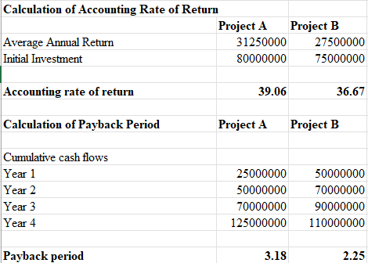
Figure 7: Accounting Rate of Return and Payback Period for Project A and Project B
(Source: Excel)
Accounting rate of return is another vital investment appraisal method that can help the business to observe the revenue-generation ability of a project. At the time of calculating this metric, the estimated amount of average annual accounting profit should be divided by the cost of the initial investment (Vipond, 2023). This particular technique promotes a definite measurement of a projected percentage of return to be generated by an investment rather than depending on their cash flows. Based on the above computation, it can be implied that the estimated average annual return for Project A is comparatively higher than Project B due to its maximum investment scale. Though having a lower investment cost, Project B is incapable of generating an elevated annual profit which declined its percentage of accounting rate of return. The calculation effectively shows that Project A holds the capability of generating an average annual return of 39% as a higher ARR is expected by project stakeholders.
On the other hand, the payback period can be also utilised by an organisation to compute a particular time period projected to be taken by a project to recover its initial investment. This technique focuses on the estimated amount of cash flows for generating cash movement to recover the investment cost (Dai, et al., 2022). For the two projects, the payback period has been computed by optimising cumulative cash flows where it can be identified that Project A will generate a higher cash movement than Project B. However, due to having an excessive initial cost, Project A will take a longer time to recover its primary investment. Project B will efficiently generate sufficient cash flows to recover its costs. Moreover, it can be underpinned that Project A will cover £80,000,000 within 3.18 years while Project B will take 2.25 years to meet £75,000,000.

Recommendations for Choosing Relevant Investment Project
From the above discussion of the investment appraisal techniques, the comparison has been made between Project A and Project B regarding their capability in generating profitability. According to the results of the net present value, it can be found that Project A will efficiently cover its initial investment by optimising its cash flow and generating excess profit compared to Project B. Similarly, computation of the accounting rate of return shows that Project A will gather average annual profit by 39% to meet primary investment amount. However, the payback period has implied that Project B will take 2.25 years to recover initial costs while the payback period for Project A is estimated to be 3.18 years. A lower payback period does not indicate less profitability for Project A as the company can gain higher profit in the long run. For this reason, it can be evaluated that Unilever should propose further investment for Project A rather than Project B which will administrate profitability in future.

Investment Appraisal Techniques Benefits and Shortcomings
One of the biggest benefits of net present value is that it considers the real-time value of money by utilising the estimated cash flow including the cost of capital. This strategy also helps in determining the worth of currencies in cash flows to promote better accuracy in measuring profitability (Huang, et al., 2022). This process helps in observing decision-making for investment projects as a positive rate of NPV is highly expected by companies while a negative rate indicates financial loss. The computation technique of net present value is immensely flexible which ensures the accommodation of projected cash flows indicating the liquidity performance of the business for capital budgeting. NPV also indicates the sensitivity of a project where a lower amount is less desirable and heightens the chance of financial risks. However, significant shortcomings are also present in this technique. Due to its overdependency on cash flows, the effectiveness of this technique lowers for poor cash flow projection. Similarly, net present value does not include the changes in the market such as economic downturns, currency fluctuations and changes in exchange rates. Along with that, the utilisation of NPV for proposing capital budgeting may be disrupted by constraints which can impact the return on investment.
Accounting rate of return is a straightforward investment appraisal method which interprets the profitability of a project (Shagiakhmetova, et al., 2020). It defines the excess of the required return percentage and or the cost of capital, making the project acceptable for business entities. The results of the ARR method are reflected in a percentage format that helps in understanding the financial suitability of the investment by comparing it with others. Similarly, it focuses on interpreting the efficiency of a project by highlighting the return to be gained on capital per unit. However, shortcomings can be also found in this method where it does not consider the liquidity performance of the company which affirms its ineffectiveness due to poor estimation. This technique does not consider the financial risks present for a project for not identifying changes in interest rates and cash overvaluation or undervaluation.
The advantages of the payback period are interrelated with its simplicity in identifying capital projects to observe the time needed for an investment to cover its initial cost (Dobrowolski and Drozdowski, 2022). Being a prominent investment appraisal method, the payback period can be effectively adapted for maintaining cash flow management. This technique also promotes a quick measurement of the liquidity of a project where it poses the ability to generate sufficient cash movement to recover initial investment. In this regard, less payback period is expected, hence it can also indicate higher profitability for large-scale and long-term projects. Therefore, a company should optimise various appraisal techniques before making any decisions for an investment.

Non-Financial Factors to be Considered
Unilever should understand several non-financial factors before making any decisions towards future investment projects. The company should focus on observing the current nature of market trends and estimate future changes by comprehending consumer preferences and market demographics. Regulatory compliances in the market must be identified also such as laws and trade protocols including political and economic stability. Unilever should also attract potential stakeholders for completing social and environmental responsibilities. This strategy can also help the company in maximising sales performance and gathering more revenue regarding the investment. The proposition of innovation and technological development are also crucial non-financial factors which can affect the completion of organisational goals for the investment.

Conclusion
From the above discussion, it can be concluded that Unilever Plc has been successfully operating in the fast-moving consumer goods industry by serving millions of customers and stock market performance on the London Stock Exchange. The organisational growth strategy is efficiently based on a growth action plan as well as business merging that ensures its constant growth in the competitive market landscape. Ratio analysis is a vital financial management method which has helped in exploring the optimal financial gaining of the company. Computation of major ratios such as profitability, liquidity, gearing, efficiency and stock market performance has proposed an in-depth analysis of the economic achievements and capability of the firm to generate revenue. However, conducting a detailed comparison with major competitors, Tesco and P&G, has highlighted the importance of strengthening the overall performance of Unilever. Optimisation of net present value, accounting rate of return and payback period has evaluated the profitability of Project A where non-financial factors are needed to be considered. Therefore, it can be contemplated that Unilever must aim to enhance its performance to achieve competitive advantages in the market environment.

References
Alvian, R. and Munandar, A., 2022. The influence of debt to equity ratio, net profit margin, and cash ratio on firm value. Fair Value: Jurnal Ilmiah Akuntansi dan Keuangan, 4(7), pp.2682-2690.http://journal.ikopin.ac.id/index.php/fairvalue/article/view/1204
Arsal, M., 2021. Impact of earnings per share and dividend per share on firm value. ATESTASI: Jurnal Ilmiah Akuntansi, 4(1), pp.11-18.https://jurnal.feb-umi.id/index.php/ATESTASI/article/view/158
Arsyad, M., Haeruddin, S.H., Muslim, M. and Pelu, M.F.A., 2021. The effect of activity ratios, liquidity, and profitability on the dividend payout ratio. Indonesia Accounting Journal, 3(1), pp.36-44.https://ejournal.unsrat.ac.id/index.php/iaj/article/view/30119
Baiyere, A., Salmela, H. and Tapanainen, T., 2020. Digital transformation and the new logics of business process management. European journal of information systems, 29(3), pp.238-259.https://www.tandfonline.com/doi/abs/10.1080/0960085X.2020.1718007
Balkhi, B., Alshahrani, A. and Khan, A., 2022. Just-in-time approach in healthcare inventory management: Does it really work?. Saudi Pharmaceutical Journal, 30(12), pp.1830-1835.https://www.sciencedirect.com/science/article/pii/S1319016422002699
Dai, H., Li, N., Wang, Y. and Zhao, X., 2022, March. The analysis of three main investment criteria: NPV IRR and payback period. In 2022 7th International Conference on Financial Innovation and Economic Development (ICFIED 2022) (pp. 185-189). Atlantis Press.https://www.atlantis-press.com/proceedings/icfied-22/125971510
Dobrowolski, Z. and Drozdowski, G., 2022. Does the net present value as a financial metric fit investment in green energy security?. Energies, 15(1), p.353.https://www.mdpi.com/1996-1073/15/1/353
Gołaś, Z., 2020. Impact of working capital management on business profitability. Agricultural Economics/Zemědělská Ekonomika, 66(6).http://www.agriculturejournals.cz/pdfs/age/2020/06/05.pdf
Huang, J., Tong, J., Wang, P. and Zheng, X., 2022, March. Application and Comparison of NPV and IRR Methods in the Company Investment Decision. In 2022 7th International Conference on Financial Innovation and Economic Development (ICFIED 2022) (pp. 71-78). Atlantis Press.https://www.atlantis-press.com/proceedings/icfied-22/125971679
Illés, M., 2020. Scientific problems of modern approach of net present value.http://193.6.1.32/bitstream/handle/20.500.12795/373/4839.pdf?sequence=1&isAllowed=y
Jakubik, P. and Moinescu, B.G., 2023. What is the optimal capital ratio implying a stable European banking system?. International Finance, 26(3), pp.324-343.https://onlinelibrary.wiley.com/doi/abs/10.1111/infi.12438
Kadim, A., Sunardi, N. and Husain, T., 2020. The modeling firm's value based on financial ratios, intellectual capital and dividend policy. Accounting, 6(5), pp.859-870.http://m.growingscience.com/beta/ac/4052-the-modeling-firms-value-based-on-financial-ratiosintellectual-capital-and-dividend-policy.html
Magni, C.A. and Marchioni, A., 2020. Average rates of return, working capital, and NPV-consistency in project appraisal: A sensitivity analysis approach. International Journal of Production Economics, 229, p.107769.https://www.sciencedirect.com/science/article/pii/S092552732030150X
Markonah, M., Salim, A. and Franciska, J., 2020. Effect of profitability, leverage, and liquidity to the firm value. Dinasti International Journal of Economics, Finance & Accounting, 1(1), pp.83-94.https://dinastipub.org/DIJEFA/article/view/225
Nariswari, T.N. and Nugraha, N.M., 2020. Profit growth: impact of net profit margin, gross profit margin and total assests turnover. International Journal of Finance & Banking Studies (2147-4486), 9(4), pp.87-96.https://www.ssbfnet.com/ojs/index.php/ijfbs/article/view/937
Nukala, V.B. and Prasada Rao, S.S., 2021. Role of debt-to-equity ratio in project investment valuation, assessing risk and return in capital markets. Future Business Journal, 7(1), p.13.https://link.springer.com/article/10.1186/s43093-021-00058-9
Olayinka, A.A., 2022. Financial statement analysis as a tool for investment decisions and assessment of companies’ performance. International Journal of Financial, Accounting, and Management, 4(1), pp.49-66.https://goodwoodpub.com/index.php/ijfam/article/view/852
Patin, J.C., Rahman, M. and Mustafa, M., 2020. Impact of total asset turnover ratios on equity returns: Dynamic panel data analyses. Journal of Accounting, Business and Management (JABM), 27(1), pp.19-29.https://journal.stie-mce.ac.id/index.php/jabminternational/article/view/559
Purnama, O., Hanitha, V. and Angreni, T.A., 2020. Financial Statement Analysis to Assess Company Financial Performance. ECo-Fin, 2(3), pp.168-174.https://jurnal.kdi.or.id/index.php/ef/article/view/537
Raja, J.Z., Frandsen, T., Kowalkowski, C. and Jarmatz, M., 2020. Learning to discover value: Value-based pricing and selling capabilities for services and solutions. Journal of Business Research, 114, pp.142-159.https://www.sciencedirect.com/science/article/pii/S0148296320301910
Sari, W.N., Novari, E., Fitri, Y.S. and Nasution, A.I., 2022. Effect of Current Ratio (Cr), Quick Ratio (Qr), Debt To Asset Ratio (Dar) and Debt To Equity Ratio (Der) on Return On Assets (Roa). Journal of Islamic Economics and Business, 2(1), pp.42-58.https://journal.uinsgd.ac.id/index.php/jieb/article/view/20173
Shagiakhmetova, E., Borovskikh, O., Nizamova, A. and Kazymova, T., 2020, July. Multivariate model of construction project operational efficiency. In IOP Conference Series: Materials Science and Engineering (Vol. 890, No. 1, p. 012113). IOP Publishing.https://iopscience.iop.org/article/10.1088/1757-899X/890/1/012113/meta
Statista., 2022. Revenue of the Unilever Group worldwide 2005-2019, by product segment. [online] Statista. Available at: https://www.statista.com/statistics/269200/revenue-of-the-unilever-group-worldwide-by-product-segment/. [Accessed on 25th July, 2024].
Unilever., 2024. Our strategy and Growth Action Plan. [online] Unilever. Available at: https://www.unilever.com/our-company/strategy/. [Accessed on 25th July, 2024].
Unilever PLC., 2024. Unilever global company website | Unilever Global. [online] Unilever. Available at: https://www.unilever.com/. [Accessed on 25th July, 2024].
Vipond, T., 2023. ARR - Accounting Rate of Return. [online] Corporate Finance Institute. Available at: https://corporatefinanceinstitute.com/resources/accounting/arr-accounting-rate-of-return/. [Accessed on 25th July, 2024].

