Module Title – Distinctiveness and Regeneration
Module Code - BMSP4005
Assignment Number - Assignment 1
Name - Glyn Gainard
Student ID – 2114234
Word Count - 1099

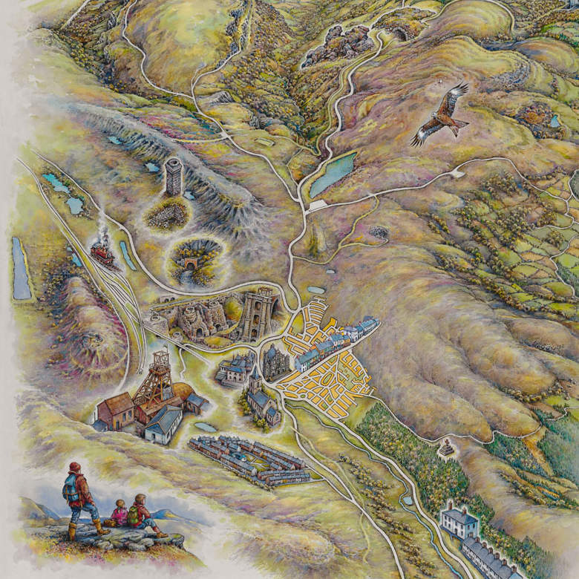

(Visit Blaenavon, n.d.)

Blaenavon has progressed from small farming community in the Welsh Valleys to being designated a UNESCO World Heritage and one of Wales top tourist attractions (Museum Wales, n.d.).

Blaenavon

The first coal and Ironstone mines were sunk on the Blorenge in 1325 (Knight, 2016), the Blorenge is the mountain that overlooks what would one day become Blaenavon. It was soon established that this area was rich in natural resources according to (Visit Blaenavon, n.d.). The area surrounding Blaenavon is rich with beds of Coal and Ironstone, this was first exploited 1584 when Richard Hanbury started digging for Ironstone on the Blorenge, local people were employed to perform what was an early form of open-cast mining whilst other were used for woodcutting to help power the furnaces in Pontypool (Visit Blaenavon, n.d.). Although some metal work was carried out in Blaenavon until 1780’s the main industry in the region was agriculture (Knight, 2016).
In the late 18th Century Wales followed the rest of the Great Briton into the Industrial Revolution with being produced on mass by machines in purpose built factories (History.com, 2019). The first factory of the Great Briton was by Richard Arkwright in 1769 on Cromford near Derby, this new concept was to become to catalyst for a dramatic shift in industry (Trueman, 2015). By 1786 the Hanbury lease on the land at Blaenavon was due to end and with the onset of the Industrial Revolution Iron and Coal became highly sought after with a number of potential suiters looking to negotiate a new lease (Knight, 2016). In 1987 Lord Abergavenny agreed a lease with Thomas Hill and Benjamin Pratt two businessmen. Hill and Pratt did not have previous experience in Ironworking so they enlisted on a third partner Thomas Hopkins (Knight, 2016).
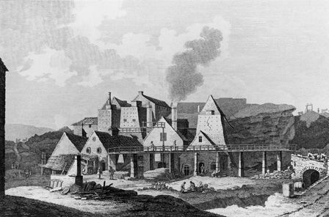
The Ironworks opened in 1789, it is suggested by (Visit Blaenavon, n.d.) that this was a risky venture with initial costs of £40,000. Upon opening the ironworks had 3 blast furnaces employing approximately 300 men. By the time the works open the community of Blaenavon had a population of over 1,000 (Knight, 2016). With Great Briton fighting many wars during the next 20-30 years the nations thirst for Iron would increase with Blaenavon producing over 14,000 tons of pig iron a year by 1812 (Visit Blaenavon, n.d.) soon furnaces 4 and 5 were added to the site, then in 1959 the site had expanded to 6 blast furnaces as production thrived.
(Museum Wales, n.d.)

By 1870 Blaenavon was being repurposed as a steel works following to collapse of the Blaenavon Iron and Coal company, however by 1880 the Blaenavon Iron and Steel company was again replaced by the Blaenavon Company. During this period Steel was in demand, however due to the high phosphoric content of the steel it became brittle, this meant that more expensive non-phosphoric ores needed to be imported. In the 1870’s a challenge was laid down “the man who eliminates phosphorus by mean od the Bessemer converter will make his fortune” (Visit Blaenavon, n.d.). That man was Chemist Percy Gilchrist, through experiments conducted at Blaenavon was able to revolutionise the Steel production industry in what would become known as the Thomas-Gilchrist Process.

By 1904 the Ironworks at Blaenavon were closed, briefly reopening during the first and second World Wars (Knight, 2016). By the 1960’s the Ironworks closed their doors for the last time and by 1976 the original works moved into state care. Although Blaenavon had lost the Ironworks the coal mines at “Big Pit” knowns as this due to it unusually large shaft employed 1,300 at its height in the 1920’s.
Big Pit continued to improve its facilities with the most notable being the opening of the pithead baths in 1939, helping to reduce illness amongst the workers who would no longer need to walk home in their damp and wet clothes (Visit Blaenavon, n.d.). However by 1980 the pit was closed, at the time of closing Big Pit still employed 250 workers (Knight, 2016).

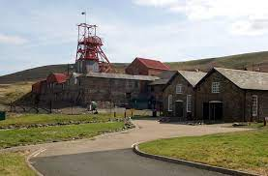
In 1983 the doors of Big Pit were once again open to the public, long before its closure plans were already afoot to reopen the pit as a National Museum (Visit Blaenavon, n.d.). Then in 2000 Big Pit was designated a UNESCO world heritage site (UNESCO, n.d.). according to UNESCO Blaenavon “provides one of the prime areas in the World where the full social, economic and technological process of industrialisation through iron and coal production can be studied and understood” (UNESCO, n.d.). (Lowe, 1982)
(Museum Wales, n.d.)

Housing

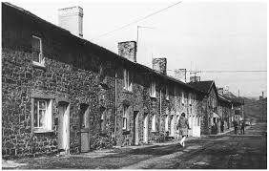
Once the Ironworks opened it was important to have housing close to the site, during the first half of the nineteenth century rows of housing we build in the general vicinity of the works as the population grew (Knight, 2016). According to (Matthews, 2008) during this period there was an amount of social segregation with many the differing workforces tending to be housed together.
(Lowe, 1982)
By the early 20th century many of Blaenavon’s poorer community was living in slums, this lead to Blaenavon’s first “Council Estate” Elgam (Knight, 2016).

Religion and Language

In 1799 Capel y Graig (Rock Chapel) was opened in Blaenavon by the start of the 20th century Blaenavon had eighteen chapels and churches and a population of nearly 11,000 people up from just 1,469 in 1801 (Torfaen County Borough Concil, 2018).
According to (Matthews, 2008) with new communities growing all over Wales at this time the Anglican church was quite slow to open new churches and parishes, this lead to many in Blaenavon to follow a more nonconformity approach to religion. By the 1850’s 80% of the community attending Chapel rather than the more traditional religious offerings of the time.
Before the influx of English speaking workers during the 1820’s Blaenavon was a Welsh speaking area with Welsh street names and most religious services were conducted in through the medium of Welsh (Knight, 2016). By the 1850’s the English language had become part of the ‘Welsh Chapels’, this was partly due to the chapel wanting to reach out to the new English-speaking portions of the community. By the late 1870’s most services were bilingual with the traditional morning service being in Welsh and the evening service in English (Knight, 2016). By the early 20th century (Knight, 2016) suggests that only 5.6% of the local population of Blaenavon considered themselves to be Welsh Speaking, it goes on to further suggest that almost all of them would be bilingual.

Conclusion

Over the years Blaenavon has had many different roles to play, however its current guise as the National Coal Museum of Wales means that it will be preserved for many years to come for future generations.

REFERENCE LIST

History.com. (2019, September 9). Industrial Revolution. Retrieved from History.com: https://www.history.com/topics/industrial-revolution/industrial-revolution

Knight, J. (2016). Blaenavon From Iron Town to World Heritage Site. Herefordshire: Longston Press.

Lowe, J. (1982). Housing as a Source for Industrial History: A Case Study of Blaenafon, A Welsh Ironworks Settlement, from 1788 to c1845. IA. The Journal of the Society for Industrial Archeology, 8(1), 13-36.

Matthews, N. A. (2008). Religion in Blaenavon. Retrieved from Visit Blaenavon: https://www.visitblaenavon.co.uk/en/Publications/Blaenavon-Story/Religion-in-Blaenavon.pdf

Museum Wales. (n.d.). Big Pit National Coal Museum. Retrieved from Museum.wales: https://museum.wales/bigpit/learning/

The Dorman Museum. (n.d.). The Introduction of the Gilchrist Thomas Process - 1879. Retrieved from Cleveland & Teesside Local History Society: http://ctlhs.co.uk/golden-jubilee/fifty-interesting-events/the-introduction-of-the-gilchrist-thomas-process-1879/

Torfaen County Borough Concil. (2018). Blaenavon Townscape Heritage Programme: The Historical Context. Retrieved from Visit Blaenavon: https://www.visitblaenavon.co.uk/en/Publications/Education/The-Blaenavon-Townscape-Story.pdf

Trueman, C. N. (2015, March 31). Factories in the Industrial Revolution. Retrieved from history Learning Site: https://www.historylearningsite.co.uk/britain-1700-to-1900/industrial-revolution/factories-in-the-industrial-revolution/

UNESCO. (n.d.). Blaenavon Industrial Landscape. Retrieved from UNESCO: https://whc.unesco.org/en/list/984/

Visit Blaenavon. (n.d.). BLAENAVON AND THE 'GILCHRIST-THOMAS' PROCESS. Retrieved from Visit Blaenavon: https://www.visitblaenavon.co.uk/en/Publications/Blaenavon-Story/Gilchrist-Thomas.pdf

Visit Blaenavon. (n.d.). Blaenavon Ironworks: A Brief History. Retrieved from Visit Blaenavon: https://www.visitblaenavon.co.uk/en/Publications/Blaenavon-Story/Blaenavon-Ironworks.pdf

Visit Blaenavon. (n.d.). Blaenavon Ironworks: A Brief History. Retrieved from Visit Blaenavon: https://www.visitblaenavon.co.uk/en/Publications/Blaenavon-Story/Blaenavon-Ironworks.pdf

