3/23/2026
University of Wales Trinity Saint David
London campus
Module Name: Introduction to Web and Database Concepts
Module Code: ACCA4023_LON
Student Name: Dzhenifer Oleksandra Safutina
Student ID: 2514100
Group: 2
Lecturer’s Name: Anum Paracha
Assessment 1
Introduction to Web and Database Concepts
Contents
Introduction…………………………………………………………………………………………………. 2
Task 1…………………………………………………………………………………………. 2
1. Scenario Analysis………………………………………………………………………………………. 2
2. Entity-Relationship Diagram………………………………………………………………………… 3
3. Data structure Development……………………………………………………………………….. 11
4. Normalization Compliance………………………………………………………………………….. 14
5. Sample Data Population……………………………………………………………………………… 15
6. Query Development……………………………………………………………………………………. 17
7. Validation and Testing…………………………………………………………………………………. 21
References……………………………………………………………………………………………………. 22

Introduction
This project is based on developing and implementing a database system in a pharmacy. A database system is important in managing and organizing large amounts of information in a proper manner. In a pharmacy, a database system may be helpful in automating various operations such as managing medicines, sales, and customer service.
The database system in a pharmacy will be used to manage important information about medicines, prescriptions, customers, and medicines in stock. With a database system, various information about medicine, such as names, active ingredients, and availability, can be accessed by the employees of the pharmacy.
Besides, it would be helpful in managing various activities more effectively in this regard, it may be noted that the database system will be helpful in updating the quantity of medicines in stock when medicines are sold or received from suppliers. In this way, it will be helpful in maintaining accurate and reliable information in a database system.
Generally, it may be noted that a database system in a pharmaceutical sector will be helpful in managing various operations in a more efficient manner.
Task 1
1. Scenario Analysis
The scenario describes how to create a database for a pharmacy. The purpose of this system is to effectively manage medicines, customers, prescriptions, and sales. Currently, manual systems have become inefficient because it can lead to data errors. Therefore, to improve the quality of storage, search and general management of pharmacy databases, a solution for a structured database is required.
Based on the scenario, the following main objects were identified:
- Medicines
- Suppliers
- Customers
- Prescriptions
- Sales
1. Medicines
The Medicines entity stores information about all medicines that are available in the pharmacy. This includes the name of medicines, category, price, quantity of the product in stock and its expiry date. This entity is important for managing stocks and ensuring the availability of medicines if necessary.
2. Suppliers
The supplier entity contains information about the companies that supply all medicines to the pharmacy. It includes the names of these suppliers, contract details and email addresses. This helps the pharmacy to manage orders and be able to keep in touch with suppliers.
3. Customers
The customers entity stores all the information they need about pharmacy customers. Customer names, contact numbers and addresses are listed here. This data is useful for tracking purchases and managing prescriptions.
4. Prescriptions
The Prescriptions entity records information about prescriptions issued to customers. It contains such data as the name of the doctor, the date of issue and the prescription of the necessary medicines. This ensures that the pharmacy complies with all proper medical procedures.
5. Sales
The Sales entity stores information about all completed transactions in the pharmacy. It includes the medicines sold, the quantity of medicines sold, the date of their sale and the total price of the product. It helps to track revenue and track business efficiency.
2. Entity-Relationship Diagram
Attributes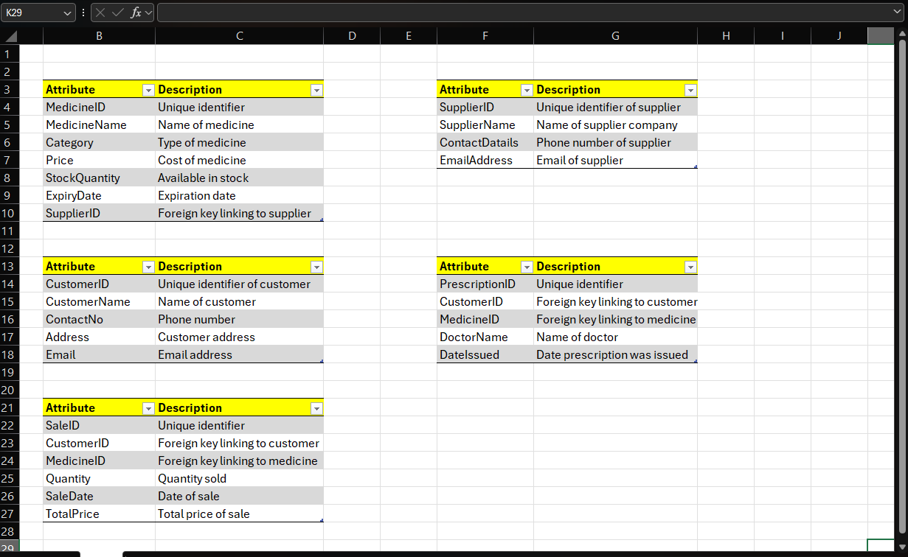
1. Screenshot: Medicines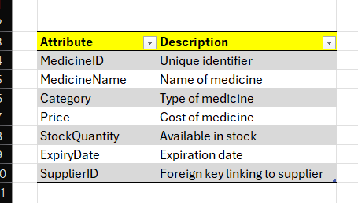
2. Screenshot: Suppliers
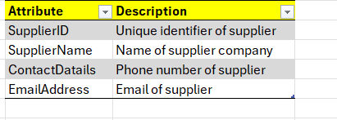
3. Screenshot: Customers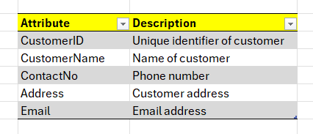
4. Screenshot: Prescriptions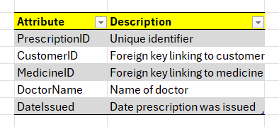
5. Screenshot: Sales
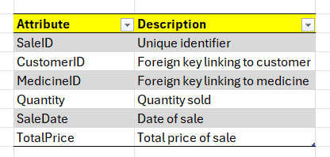

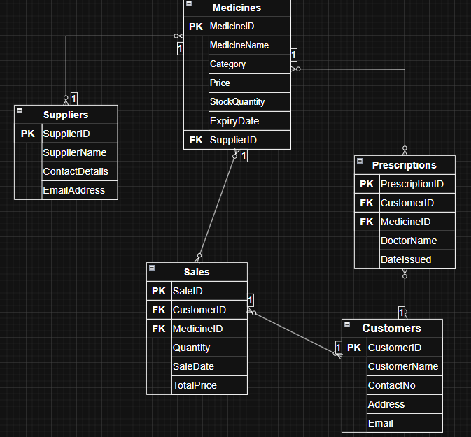
- SuppliersMedicines
One-to-Many (1:M)
One supplier can supply many medicines for the pharmacy, but each medicine is supplied by only one supplier.
- Suppliers.SupplirID Medicines.SupplierID
- CustomersSales
One-to-Many (1:M)
One customer can make many purchases, but each sale is associated with only one customer.
- MedicinesSales
One-to-Many (1:M)
One medicine can appear in many sales deals.
- CustomersPrescriptions
One-to-Many (1:M)
One customer can have several prescriptions.
- MedicinesPrescriptions
One-to-Many (1:M)
One medisine can be prescribed several times.
Relationships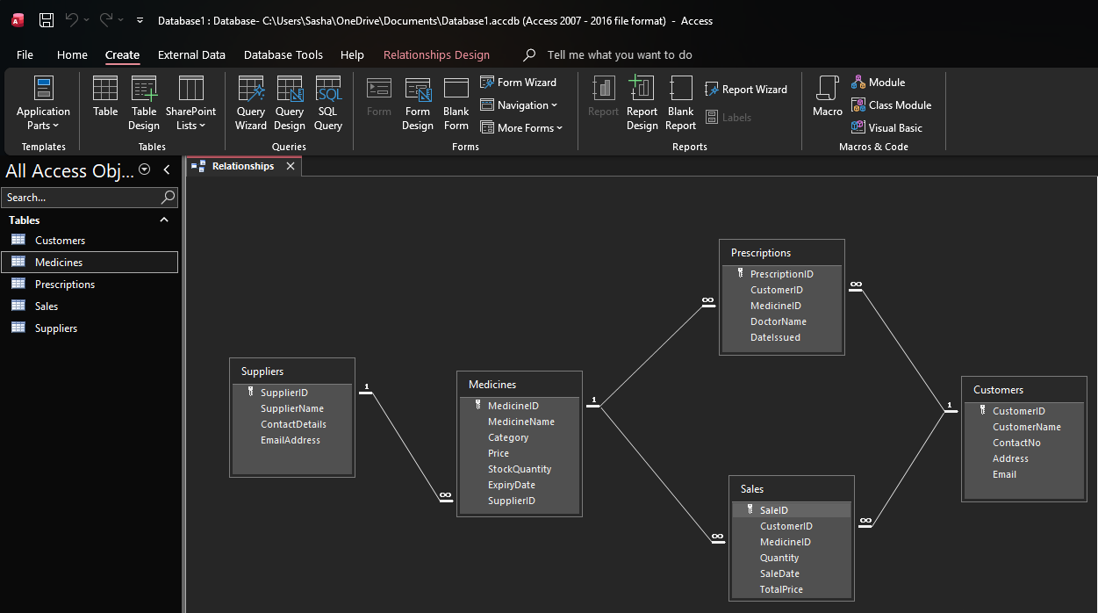
1. Screenshot
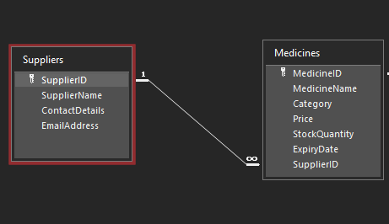
Database entities are linked through relationships to ensure effective data management and integrity. There is a relationship between suppliers and medicines (one-to-many), when one supplier can supply several medicines, but each medicine is associated with one supplier.
2. Screenshot
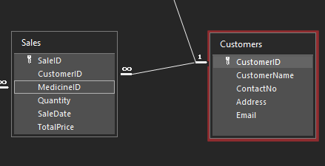
In the same way, there is a relationship between customers and sellers (one-to-many), since one customer can make several purchases. Each sale is associated with only one customer.
3. Screenshot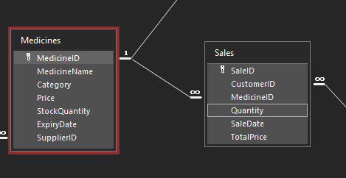
In addition, medicines are linked to sales through relationships (one-to-many), since one medicine can be included in several sales transactions.
4. Screenshot
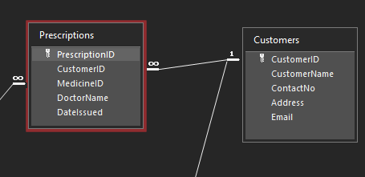
The customers and prescriptions entities also have a relationship (one-tomany), where the client can have several prescriptions. Each prescription is associated with a specific customer.
5. Screenshot
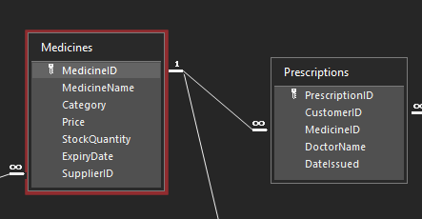
Furthermore, medicines are linked to prescriptions, since one medicine can be prescribed several times.
These relationships are realised using primary keys and foreign keys to maintain reference integrity in the database.
Primary and Foreign Keys
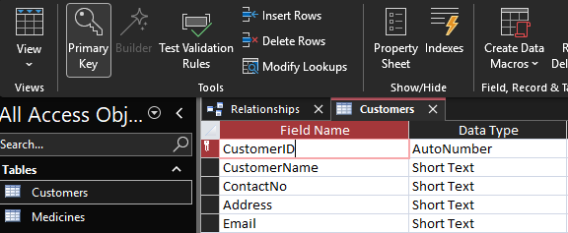Primary keys

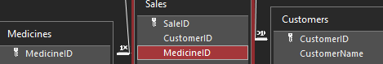
Foreign Keys
All tables have a primary key, which makes sure that all the information stored in the table is unique. The external keys are used in the process of joining two or more tables. In this case, the SupplierID, which serves as a key to identify the information stored in the table of medicines, is a foreign key that joins the table with the Suppliers table.
3. Data structure Development
Introduction
The structure of the database for the pharmacy system has been developed according to the Entity Relationship Diagram, which was designed in the previous stage. The ER approach gave a comprehensive view of the entities, their attributes, and their relationship, which has been implemented in Microsoft Access (Microsoft, 2023). The objective of this stage is to create a workable database by defining tables with appropriate data types and their relationship with constraints (Connolly and Begg, 2015).
Table Design

Medicine Table
This table is intended to store information relating to all the medicines available in the pharmacy. The information includes MedicineID, MedicineName, Category, Price, StockQuantity, ExpiryDate, and SupplierID. The primary key is defined for MedicineID in this table to uniquely identify each medicine. The SupplierID is defined as a foreign key to relate it with the Suppliers table.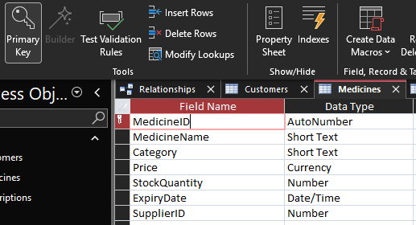
Suppluiers Table
This table will store the information regarding the suppliers of the medicine to the pharmacy. The columns and data in this table will be as follows: SupplierID,SupplierName, ContactDetails, and EmailAddress. SupplierID is to be defined as the primary key for this table. This table is useful in managing the suppliers of the medicine.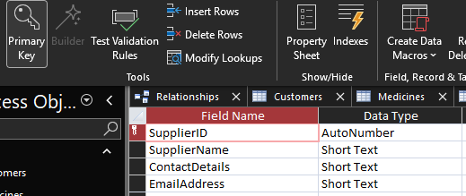
Customers Table
The table for the customers has been created with the objective of storing information regarding the customers, including their CustomerID, CustomerName, ContactNo, Address, and Email. In the table above, it is noted that the field name CustomerID has been defined as the primary key. The table is significant in managing the customers with reference to their interaction, sales, and prescriptions.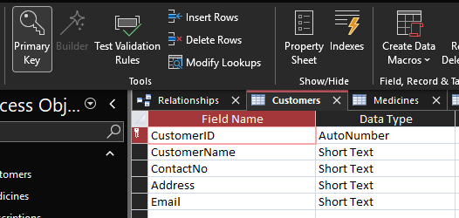
Prescriptions Table
Prescriptions is a table used to hold information on the prescriptions of medicines provided to the customers. The columns in this table contain information on the PrescriptionID, CustomerID, MedicineID, DoctorName, and DateIssued. The rows of information in this table contain a single prescription issued to a customer.
PrescriptionID is used as a primary key in this table. This means that it uniquely identifies a prescription in the table. The columns of CustomerID and MedicineI are
used as foreign keys.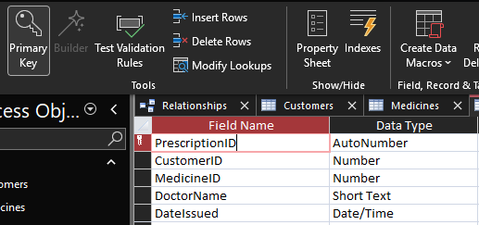
Sales Table
The table named Sales is used to store the data related to the information of sales data. The columns of this table contain Customer ID, Medicine ID, Quantity, Sale Date, and Total Price. The column name ‘Sale ID’ of the above table is defined as a primary key column. Customer ID and Medicine ID of the above table are defined as foreign key columns.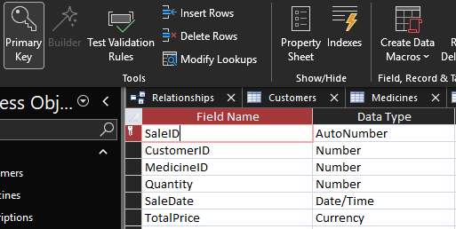
Data Types
In order for everything to be accurate and efficient, the appropriate types of all data were assigned to each field (Microsoft, 2023). Text fields such as Names and Addresses have been added to the Short text data type. Values with numbers, such as Identifiers and Quantities, are preserved using the Number data type. The Price and TotalPrice fields were assigned a Currency data type for registration of monetary values. Date-related fields, such as ExpiryDate and SaleDate, were saved using the Date/Time data type.
Relationships
Relationships were labelled between the tables to ensure the effective use of data (Connolly and Begg, 2015). A relationship (one-to-many) has been created between Suppliers and Medicines, where one Supplier can supply many Medicines. In the same way, a relationship (one-to-many) was established between Customers and Sales, as well as between the Medicines and Sales Department. In addition, Customers and Prescriptions, as well as Medicines and Prescriptions were connected through relationships (one-to-many). All these relationships were realised using Primary and Foreign keys.
Constraints and Data Integrity
Several restrictions have been made to maintain data integrity. Primary keys have been added to all tables to ensure that each record has a unique identity capability. External keys were used to link linked tables and ensure link integrity. Reference integrity was to prevent invalid data entry, ensuring that all foreign keys match the existing values of the primary key. This helps to maintain consistency and accuracy in the database.
Conclusion
In conclusion, I want to say that the structure of the database was developed using Microsoft Access. Tables, relationships and constraints were made using an ER diagram made to ensure a well-organised and efficient system without data. This structure supports accurate storage, retrieval and data management for the pharmacy system.
4. Normalization Compliance
1. First Normal Form (1NF)
Rule:
- No dublicate data
- Each field= one value
The database corresponds to the First normal form (1NF), since all fields contain anatomic values and there are no repeating groups. Each record is uniquely identified using the primary key. For example, in the Medicine table, each created field, such as MedicineName and Price, contains only one value, and there are no repeating groups.
2. Second Normal Form (2NF)
Rule:
- All fields depend on Primary Key
The database fully complies with the requirement of the Second normal form (2NF), since all non-key attributes depend on the primary key. Each table has a primary key, which uniquely means records. For instance, in the Customers table, attributes such as CustomerName and Address depend on the CustomerID.
3. Third Normal Form (3NF)
Rule:
- No unnecessary dependencies
- Data is not duplicated
The database is in the Third normal form (3NF), as there are no transitive dependencies. All attributes depend only on the primary key, and the associated data is stored in separate tables so that there is no redundancy. For example, all this information about supplier is stored in a separate Supplier table, and not repeated in the Medicines table, which reduces redundancy.
Conclusion
In general, the database made complies with all the rules up to the Third Normal Form (3NF). This reduces redundancy, improves data integrity and the efficiency of data management.
5. Sample Data Population
The sample data was entered into all the tables in the database to test the functionality of the database. The database was created based on the assumption that there would be a minimum of five entries in each table. This is a practical assumption for a pharmacy environment. The database was created by the use of Microsoft Access.
The reason for the addition of the sample data into the database was to test the functionality of the database. The addition of the data into the database was to create a practical scenario, which would be used to test the functionality and accuracy of the database.
Data was successfully added to the following tables:
- Medicines
- Suppliers
- Customers
- Prescriptions
- Sales
The data which it stores includes realistic data such as the name of the medicine, type of medicine, price of the medicine, quantity of the medicine available, supplier details, customer details, prescription details, and sales details. For example, under the Medicines table, information such as data related to Paracetamol medicine, data related to Ibuprofen medicine, data related to Amoxicillin medicine, and so on is available. All these medicines have their respective suppliers.
The data which is inserted into the tables also contains information about the relationship between the tables. For example, under the Medicines table, information about the relationship with the Suppliers table is available in the column named SupplierID. Under the Sales table, information about the customer and the medicine which they have purchased is available.
In conclusion, it can be stated that the data which is inserted into the database is such that it is ready to use.
Figure 1: Suppliers Table with Sample Data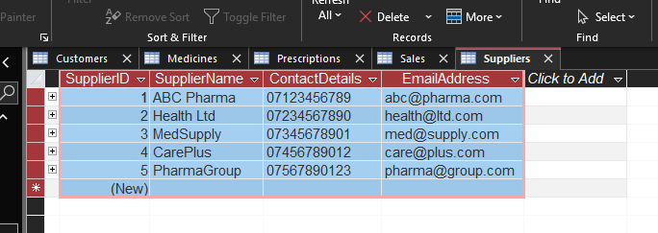
Figure 2: Medicines Table with Sample Data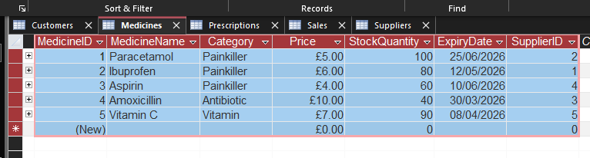
Figure 3: Customers Table with Sample Data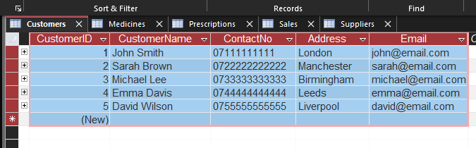
Figure 4: Prescriptions Table with Sample Data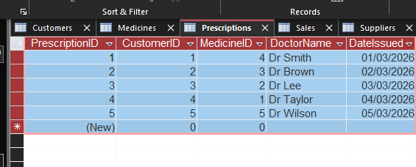
Figure 5: Sales Table with Sample Data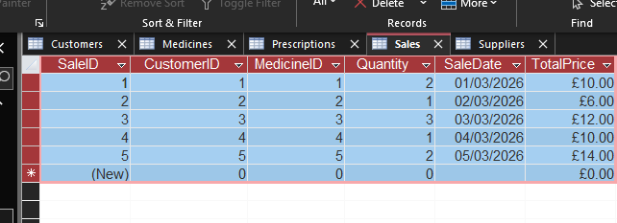
6. Query Development
Many queries have been made in Microsoft Access to show how the database can be used to obtain and analyse data (Microsoft, 2023). These requests help to improve the process of making all decisions, control the level of inventory, maintain communication and track customer activity.
Query 1: All Medicine
Purpose:
This request displays all medicines available in the Pharmacy.
Explanation:
The query shows all the entries from the medicine table, including such points as the name of medicines, category, price and quantity.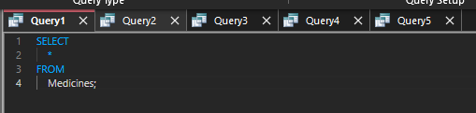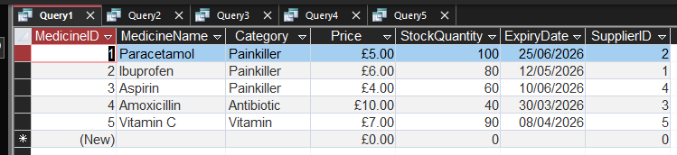
Query 2: Low Stock Medicines
Purpose:
Show medicines that are running out of stock.
Explanation:
This query filters medicines that have a supply of less than 50. This helps the Pharmacy to replenish stocks of products before they run out.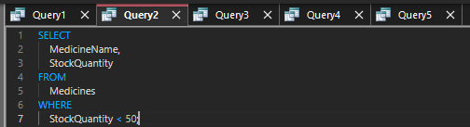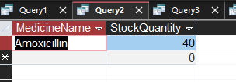
Query 3: Sales by Customer
Purpose:
To view sales deals for each customer.
Explanation:
This query combines data from two Sales and Customers tables to display customer names, purchased medicines, quantity and total price.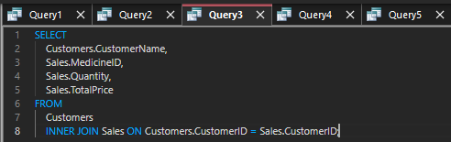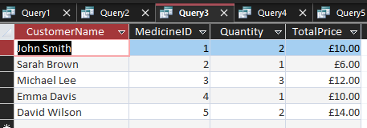
Query 4: Prescription Records
Purpose:
Displays all the information about the Prescriptions.
Explanation:
This query extracts data from the Prescriptions and Customers tables, showing which client received which prescription and from which doctor.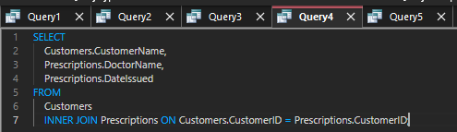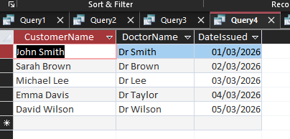
Query 5: Total Sales Revenue
Purpose:
Calculate the total sales revenue.
Explanation:
This query uses the SUM function to calculate the total income received from all sales transactions.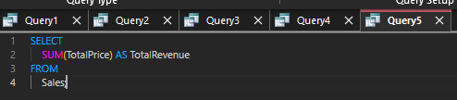
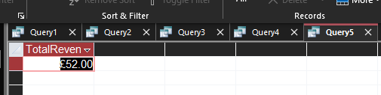
Conclusion:
The queries created show how this database can be utilized to retrieve useful information from it. They can be utilized to monitor stocks, analyze sales, and manage customer and prescription data, among other tasks. This shows that the database is indeed useful and functional in a real-world scenario in a pharmacy setting.
7. Validation and Testing
Validation and Testing
Validation and testing were carried out to make sure that the database works correctly and maintains data accuracy. These processes help prevent any errors and ensure that the system meets user requirements.
Validation
Validation rules have also been implemented to ensure that only the right and appropriate information is entered into the database. For instance, the type of data has been carefully selected (IBM, 2022). When entering text information like names and emails, the data type selected has been Short Text. When entering numerical information like stock quantity, the selected data type has been Number. When entering prices, the selected data type has been Currency. When entering dates, the selected data type has been Date/Time.
Moreover, primary keys have been implemented to ensure that each entry in the database is unique. In addition, foreign keys have also been implemented to ensure that there are relationships in the database. Referential integrity has also been implemented to ensure that no invalid information is entered into the database. This ensures that all information in the foreign keys matches the information in the primary keys.
Other validation rules that could have been implemented include limiting negative numbers in stock quantity and ensuring that no information in the required fields is left blank.
Testing
Testing was done to confirm that the database works as required. Sample data was inserted in all the tables, and queries were executed to confirm that data was being retrieved as required.
Several tests were done to confirm that the database worked as required. These included testing to confirm that:
- Data was being stored in the respective tables
- Table relationships were working as required
- Queries were returning accurate and relevant data
- Sales were being calculated as required
- Queries for low stock were returning accurate results
The results from these tests confirmed that the database was functional and worked as required for the pharmacy system.
Cunclusion
In conclusion, validation and testing proved that the database is reliable, accurate, and ready to be utilized. This is because the implementation of validation rules and testing of queries and relationships ensures that the system works efficiently in managing pharmacy data.
Task 2: Course Work Written Elements
Contents
Introduction…………………………………………………………………………………………………. 2
Task 1…………………………………………………………………………………………. 2
1. Scenario Analysis………………………………………………………………………………………. 2
2. Entity-Relationship Diagram………………………………………………………………………… 3
3. Data structure Development……………………………………………………………………….. 11
4. Normalization Compliance………………………………………………………………………….. 14
5. Sample Data Population……………………………………………………………………………… 15
6. Query Development……………………………………………………………………………………. 17
7. Validation and Testing…………………………………………………………………………………. 21
References……………………………………………………………………………………………………. 22
Scenario Explanation
The report provides an explanation of the design and implementation of a database system in a pharmacy. The main purpose of designing the database system was to ensure efficient management of medicines, suppliers, customers, prescriptions, and sales transactions. This helps in providing more accurate information, reducing errors, and improving efficiency in service delivery.
The database system was developed to store structured data in a pharmacy. This helps in accessing key information such as stock levels, customers, and sales transactions. This enables efficient management of a pharmacy.
Figure1: ERD Diagram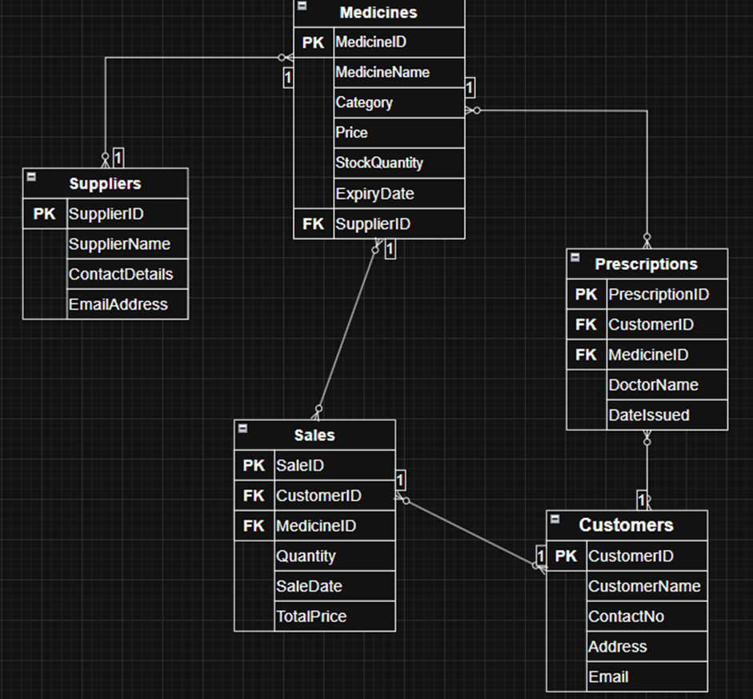
Figure 2: Medicines Table
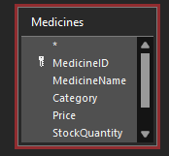

Figure 3: Suppliers Table
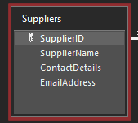
Figure 4: Customers Table
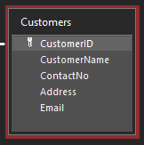
Figure 5: Relationships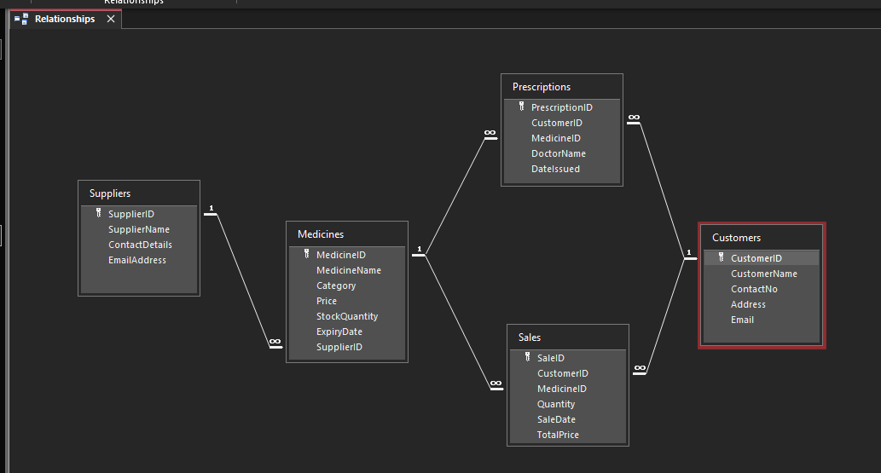

Figure 6: Queries
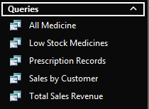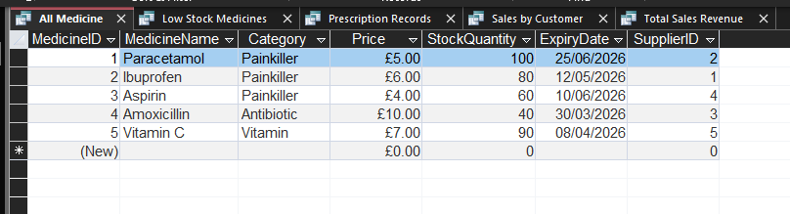
Design Decisions
There were a number of decisions that were made during the process of designing the database. The first decision was that the database was divided into a number of different tables such as the Medicines table, Suppliers table, Customers table, Prescriptions table, and the Sales table in order to eliminate the possibility of redundancy.
Primary keys were assigned to the database tables in order to eliminate the possibility of duplication of data. Foreign keys were also used in the database in order to relate the data with each other.
The appropriate data types were selected for the data in the database in order to eliminate the possibility of errors in the data. For instance, the prices were selected as Currency, the quantities were selected as Number, and the dates were selected as Date/Time.
The database was also normalized to Third Normal Form (3NF) in order to eliminate the possibility of redundancy and to store the data in an efficient manner.
Challenges and Improvements
During the development process, there were a number of challenges that were encountered. One of the challenges involved ensuring that there were proper relationships between the tables as well as ensuring that there was referential integrity in the system. Another challenge that was encountered during the development
process involved ensuring that the appropriate data type for each field in the system was used.
In the future, there are a number of improvements that can be made to the system. One of the improvements that can be made to the system in the future is the addition of a user interface as well as automated reporting features in the system. Other improvements that can be made to the system.
References
1. Microsoft (2023) Microsoft Access support. Available at: https://support.microsoft.com (Accessed: 24 March 2026).
2. Connolly, T. and Begg, C. (2015) Database Systems: A Practical Approach. Harlow: Pearson.
3. IBM (2022) Introduction to databases. Available at: https://www.ibm.com/uk-en (Accessed: 24 March 2026).

