Name:_chahir_bentrad__________________________

Student Number: 2223851________________________
__________________________________________________________

WORKSHEET 1 – TESTING (Using Variables)

- Original code:
[Copy and paste your original code from Moodle into this box. Do not change it.]
print("please enter your surname")
surname=input()
print ("national insurance Number")
number=input()
print("Enter age")
age= int(input("enter your age"))
print("valid age great then 25")
print("number of working hours per week")
hours=input()

- Code Testing

For each test below, run your code and enter the values provided. Present a screenshot of the programme running. Did the programme behave correctly or did it do something unexpected, and if so, why?

Surname:
- Enter JONES
- Leave blank
- Enter A
- Enter 123

National Insurance Number:
- Enter PE534121B
- Leave blank
- Enter AB11223344556677 (ie too long for National Insurance number format)
- Enter 22PE4088A (ie wrong format)

Age
- Enter 34
- Enter 150
- Enter -4
- Enter a letter

Number of working hours per week:
- Enter 37.5
- Enter 150
- Enter 0
- Enter -2

Fill in a box for each test above. You should present 16 separate boxes, 1 for each test. (Note: the first two boxes are provided as a template)

Test: i
Surname i. Enter JONES

Screenshot(s) of output:
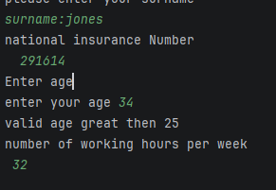
Result: Did the programme behave as expected ie syntactically and logically correct?
YES
If NO, what went wrong?
If YES, comment on what happened
It responded as expected without any errors

Test: ii
Surname ii Leave blank

Screenshot(s) of output:
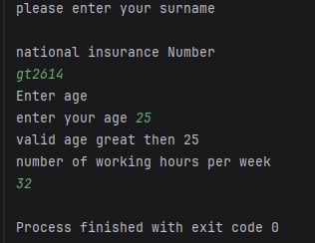
Result: Did the programme behave as expected ie syntactically and logically correct?
NO
If NO, what happened
It did work but you cant have no surname as an answer
If YES, comment on what happened

Continue the rest of the tests below. (Copy and paste a box for each one)

Test: iii
Surname enter A

Screenshot(s) of output:
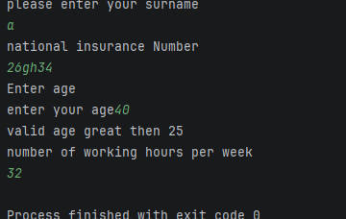
Result: Did the programme behave as expected ie syntactically and logically correct?
NO
If NO, what went wrong?
It did respond correctly but logically there isn’t a surname called “A”
If YES, comment on what happened

Test: iv
Surname enter 123
Screenshot(s) of output:

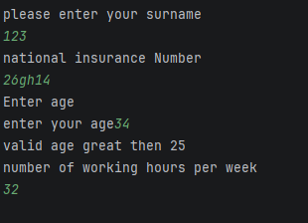
Result: Did the programme behave as expected ie syntactically and logically correct?
/NO (delete as appropriate)
If NO, what went wrong?
The program incorrectly accepted the surname 123 , a surname should contain letters not only numbers
If YES, comment on what happened

Test:

Test: i
National insurance number pe534121b
Screenshot(s) of output:

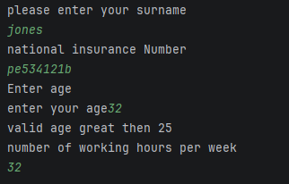
Result: Did the programme behave as expected ie syntactically and logically correct?
YES/
If NO, what went wrong?
If YES, comment on what happened

The program correctly accepted the national insurance number pe534121b, the input was validated successfully and the program continued to process the remaining inputs without errors

Test ii
National insurance number leave blank

Screenshot(s) of output:
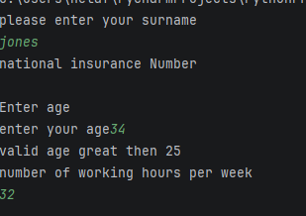

Result: Did the programme behave as expected ie syntactically and logically correct?
/NO (delete as appropriate)
If NO, what went wrong?
The program accepted a blank national insurance number instead of asking the user to enter a valid national insurance number
If YES, comment on what happened

Test iii
National insurance number enter -4

Screenshot(s) of output:

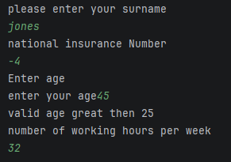
Result: Did the programme behave as expected ie syntactically and logically correct?
/NO (delete as appropriate)
If NO, what went wrong?
The program accepted -4 as a national insurance number even htoughbit is not a valid format, it should have rejected the input and asked for a valid insurance number
If YES, comment on what happened

Test IV
National insurance number enter 22PE4088A ( wrong format)

Screenshot(s) of output:
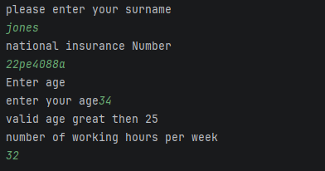

Result: Did the programme behave as expected ie syntactically and logically correct?
/NO (delete as appropriate)
If NO, what went wrong?
It accepted the invalid input and continued to ask other questions instead of asking the user to enter the national insurance number again
If YES, comment on what happened

Test i

Age enter 34
Screenshot(s) of output:

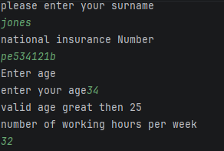
Result: Did the programme behave as expected ie syntactically and logically correct?
YES (delete as appropriate)
If NO, what went wrong?
If YES, comment on what happened
The program behaved as expected. the program is syntactically and logically corrected for this test.

Test: ii
Age enter 150

Screenshot(s) of output:

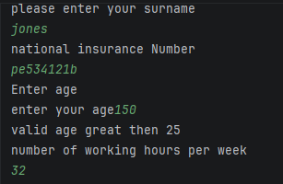
Result: Did the programme behave as expected ie syntactically and logically correct?
/NO (delete as appropriate)
If NO, what went wrong?
The program accepted the age 150 as valid and displayed
“ valid age greater than 25”. However 150 is an unrealistic age and should have been rejected.
If YES, comment on what happened

Test iii
Age -4

Screenshot(s) of output:

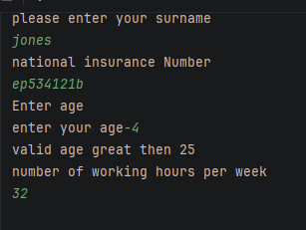
Result: Did the programme behave as expected ie syntactically and logically correct?
/NO (delete as appropriate)
If NO, what went wrong?
The program accepted the age -4 and displayed “ valid age greater than 25 “, wish is incorrect. A negative age is invalid and should have been rejected and it should of asked the user to enter a valid age
If YES, comment on what happened

Test: iv
Age enter a letter

Screenshot(s) of output:
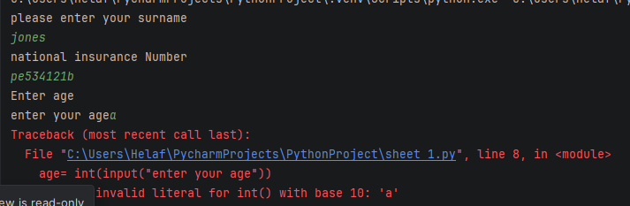

Result: Did the programme behave as expected ie syntactically and logically correct?
/NO (delete as appropriate)
If NO, what went wrong?’
The program crashed with a valueError because it tried to convert the letter a into an intoger. Instead of crashing, the program should have ASKED THE USER TO ENTER A VALID NUMERIC age
If YES, comment on what happened

Test: i
Number of working hours per a week enter 37.5

Screenshot(s) of output:

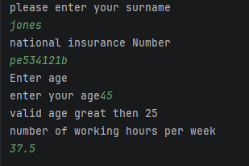
Result: Did the programme behave as expected ie syntactically and logically correct?
YES(delete as appropriate)
If NO, what went wrong?
If YES, comment on what happened
The program behaved as expected, it accepted 37.5 as the number of working hours per a week without any errors. The output was correct and logically matched the input

Test ii
The number of work hours per week enter 150

Screenshot(s) of output:
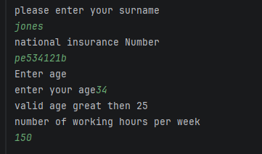

Result: Did the programme behave as expected ie syntactically and logically correct?
NO (delete as appropriate)
If NO, what went wrong?
The program accepted 150 as valid working hours, even though it is an unrealistic value. It should validate the input and reject the values outside the reasonable range by asking the user to enter a valid nnumber
If YES, comment on what happened

Test: iii
Working hours per week enter 0

Screenshot(s) of output:

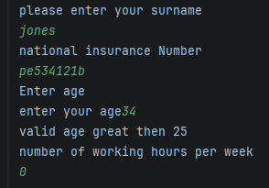
Result: Did the programme behave as expected ie syntactically and logically correct?
YES (delete as appropriate)
If NO, what went wrong?
If YES, comment on what happened
It reacted as expected , it accepted 0 as a valid number of work hours per a week

Test: iv
Number of working hours per week enter -2

Screenshot(s) of output:
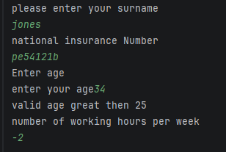

Result: Did the programme behave as expected ie syntactically and logically correct?
/NO (delete as appropriate)
If NO, what went wrong?
No because -2 is not a logical answer yet the program excepted it
If YES, comment on what happened

[Copy and paste your revised code here – note, do not use a screenshot]
print("please enter your surname")
while surname.isalpha()==false:
print("Invalid surname. please enter letters only.")
surname=input("please enter your surname again: ")
surname=input()
print ("national insurance Number")
number=input()
while age <= 25:
print("age must be greater than 25.")
age= int(input(please enter your age again:))
print("Enter age")
age= int(input("enter your age"))
print("valid age great then 25")
print("number of working hours per week")
hours=input()
hours= float(hours)
while hours < 0 or hours > 80
print("working hours must be between 0 and 80.")
hours= float(input("please enter your working hours again:"))

