THE GLOBAL BUSINESS ENVIRONMENT
LCBB4005

Environmental Analysis of an Industry

Syed Jaffery
Cornelia Carpen 1905632

GLOBAL BUSINESS ENVIRONMENT
VOLVO ELECTRIC CARS

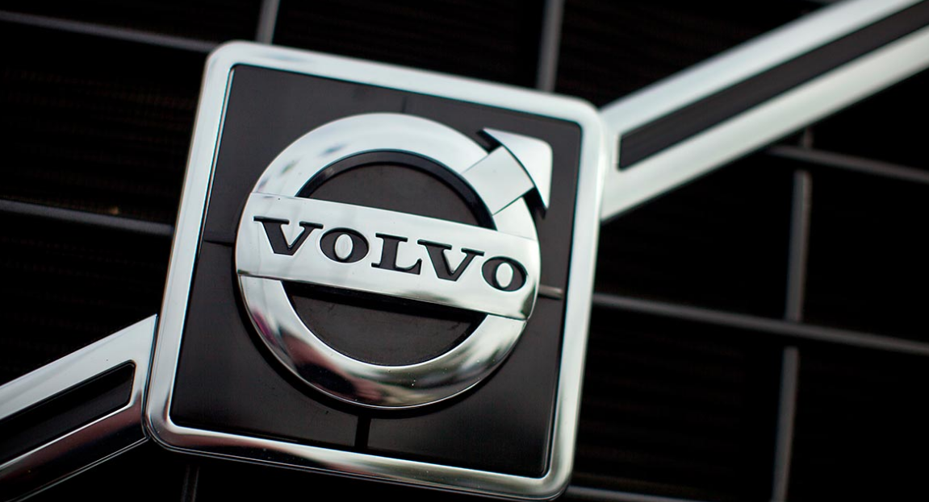
TABLE OF CONTENTS

INTRODUCTION 4
MAJOR FORCES SHAPING THE GLOBAL BUSINESS ENVIRONMENT OF ELECTRIC CARS 5
HOW CAR MANUFACTURING INDUSTRY HAS CHANGED SINCE LAST FEW YEARS 9
FUTURE OF ELECTRIC CARS 13
CONCLUSION 15
REFERENCES 16

INTRODUCTION
It’s been more than 120 years since the IC engine was commercialized and since its invention, it became a huge global industry for automated transportation. Due to the increasing population and a high number of vehicles on the road, the emission, the price of these cars, the technology used, the emission levels and various other such factors gave birth to the rise of new demand for a better alternative for vehicles technology (Sperling, 2013). In the past few years, various countries around the world have started to embrace the EVs (Electronic Vehicles) as the future of transportation.
This report will develop an understanding of the current market and future trend of EVs in the context of Volvo, which is a Sweden based multinational automobile manufacturing company headquartered at Gothenburg (Volvo Group, 2020). The company has launched its range of electric cars in 2019 and penetrated the market of the future, by putting the technology at the centre of its future business (Volvo group, 2020). This report will use frameworks and models to evaluate the current trend of adoption of electric cars and discuss the future of the industry.

MAJOR FORCES SHAPING THE GLOBAL BUSINESS ENVIRONMENT OF ELECTRIC CARS
PESTLE ANALYSIS
The PESTLE analysis is a framework which comprises of the major microenvironment factors to evaluate the environmental factors affecting the businesses. It helps in developing an understanding of how these macro-environmental factors are affecting or affect the business so that effective strategies can be made to deal with them (Ho, 2014). PESTLE analysis is vital for the success of any business because these factors are not controllable by the business and hence all the decision-making must be done according to these aspects. In the context of Volvo electric cars, the PESTLE analysis is given below:
Political: Political factors are the ones which demonstrate how the business is being affected due to political or governmental bodies. The European Commission has come forward to support the adoption of EVs and proposed directions for the development of alternative fueling methods. The change happened in 2013 for supporting clean energy (Avci et al. 2015). There is a regulatory pressure on automobile companies for reducing their fleet emissions, which brings a good scope for EVs of Volvo in the European market and all around the world (Sierzchula et al. 2012). The CO2 reduction target for automobiles is higher in the EU as compared to China, Japan and the US. They aim for the limit of 95g CO2/km cap by the end of 2020 and the regulations may tighten further (Mckinsey & Company, 2014). This is represented in the graph below:
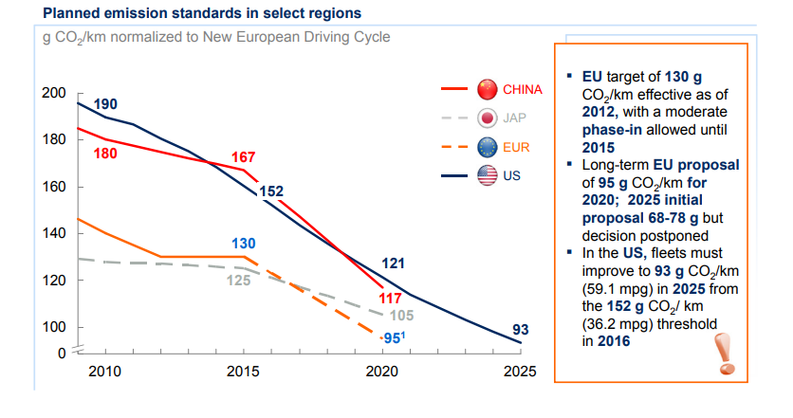
Figure 1: Ambitious targets set by global governmental bodies for CO2 emissions of light vehicles
Source: [Mckinsey & Company, 2014]
Economic: In Europe, several regions such as Norway is significantly showing a rapid growth in EVs sales. In 2013, the total sales of EVs were 6.2% of all and the new sales share of EVs reached 12% by November (Holland et al. 2016). As the governmental bodies show support to the adoption of EVs, the business for Volvo will significantly add to the economy and continue to grow in the upcoming global markets.
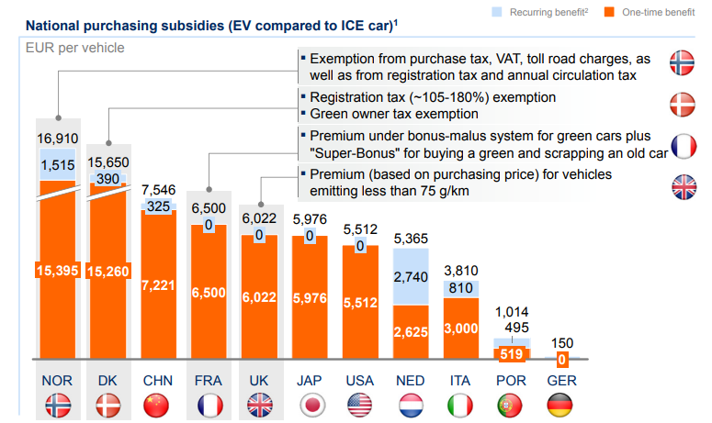
Figure 2: Stimulation of EV demands by the government
Source: [Mckinsey & Company, 2014]
Social: The main three forces driving the adoption of electric mobility are the industry developments, the customers' demands and the stimulus of governments. The early adopters of EVs in mega-cities such as Paris, New York and Shanghai suggested that these people usually have high purchasing power (Wesseling et al. 2015). Customers all around the world are now more aware of the adverse impacts of vehicle emission and are now demanding companies to be more responsible for environmental health.
Technological: Technology is now being more focused on reducing the carbon footprint for the organization due to the increasing demands for companies to adopt better CSR policies. The speed with which EVs are embraced by the customers depends upon the innovations made to reduce the total cost price of the products and various other factors (Kristoffersen et al. 2011). In EVs, the type of battery pack used is a critical technological component as most of them are Li-ion technology but now small formats cells are also introduced by Tesla which is better than the li-ion (Kristoffersen et al. 2011).
Environmental: This is the most essential aspect which is forcing the automobile industry and other organizations to change their products to be easier on environmental health. EVs are embraced by the customers not only because they are cheaper or more efficient in the coming future, but also because those who have high purchasing power also care about the environmental impacts (Serra, 2013). Customers are ready to pay a premium price for zero-emission standard vehicles. According to Serra (2013), 29% of EVs in Norway stated "environment" as the main reason to purchase.
Legal: With the governmental support and green flag to EVs all around the world, the government is also providing better business opportunities in their areas to encourage the production of EVs, which is an advantage for Volvo to start their ventures and grab the market of the future of the automobile. There are lower legal restrictions as the demand for adoption of safer transportation alternative is urgent as environmental health is critical, for example, the climate change (San Román et al. 2011).
PORTER’S FIVE FORCES MODEL
Bargaining power of suppliers: moderate
The Company has a long term history in the automobile sector and great brand loyalty of customers. For R&D, the company is more dependent on house capabilities for bringing innovation in products. Due to a new segment, the supplier power is moderate because the previous suppliers won’t be useful for the EVs manufacturing, and the EVs industry is still in its initial phase, with comparatively have very less number of reliable suppliers, such as for batteries (Bohnsack et al. 2014).
Bargaining power of customers: Moderate
The bargaining power of customers is moderate because there are a large number of automobile manufacturers who are experts in the field and have already launched vehicles. For Volvo to overcome this force, their offerings must be unique by bringing more efficiency through innovation, to gain a monopoly in the market (Tuttle and Baldick, 2012).
The threat of new entrants: low
The major and esteemed automobile companies such as Ford, Audi, TESLA, Toyota, etc. have realized the potential of the future market of EVs due to which they are rapidly launching and improvising their range of EVs (Yang et al. 2015). Due to this, it is difficult for any new venture to maintain its competitiveness among these players and hence this force is low.
The threat of substitute: Very low
The possibilities with EVs are already under-minded and the technology has a lot to see yet. The scope for such electric vehicles for personal and commercial use is still being projected and the threat of substitute as of now is very low. The EVs itself is not the substitute for automobiles but a substitute of engine for ICs to Electronic (Sadek, 2012).
Rivalry among competitors: High
This force is high as esteemed automobile manufacturing companies such as Audi, Totoya, Mercedes, Ford and many other companies are already working in the field of EVs. Tesla is currently among the market leaders when it comes to innovation in electronic vehicles. In 2013, Nissan sold 100,000 units of EVs and TESLA has already sold 25,000 units of the S-model. Also, only TESLA is using the OEM (Original Equipment Manufacturer) of small format cells which are said to be better than the usual Li-ion batteries as it signed a contract of four years, for manufacturing 2 billion cells (Mckinsey & Company, 2014). Thus, this force is high.

HOW CAR MANUFACTURING INDUSTRY HAS CHANGED SINCE LAST FEW YEARS
Automobile manufacturing companies such as Volvo have realized the potential of EVs in satisfying future needs. Volvo is a premium car maker which have announced its penetration in the EVs industry through all of its productions after 2019 (Pelliccione et al. 2016). The car manufacturing industries have changed over the past few years when they realized that there is already a good demand. The car-making company has announced the gradual end of cars with IC only as a part of their strategy over the past few years. Pelliccione (2016) stated it as one of the most significant moves for embracing the EVs and demonstrated how electrification of vehicles is paving its way as a new chapter of automobiles after over a century of the invention of IC driven ones.
The past few years was a period of maturation of EVs which was also supported by the governmental bodies (Svahn et al. 2017). The president and chief executive of Volvo stated that they have noticed an increasing demand for electrified cars and they are redesigning their strategy and supply chains to meet them. According to him, the customers will be allowed to choose and pick from a range of electrified cars as per their wish. Talking about the European regions, the automotive powertrains are yet to be diversified which will produce a diverse portfolio of powertrains with alternatives of electrically driven vehicles as a successor of IC engines driven vehicles (Netland and Aspelund, 2013). The graph below represents the sales figures of EVs in the European country, which shows a clear rise in the demand and a fall of LVs (Light Commercial Vehicles).
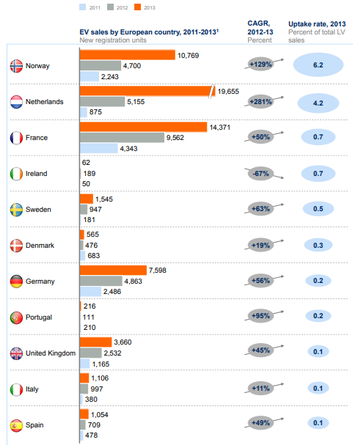
Figure 3: EV sales by European country, 2011-2013
Source: [Mckinsey & Company, 2014]

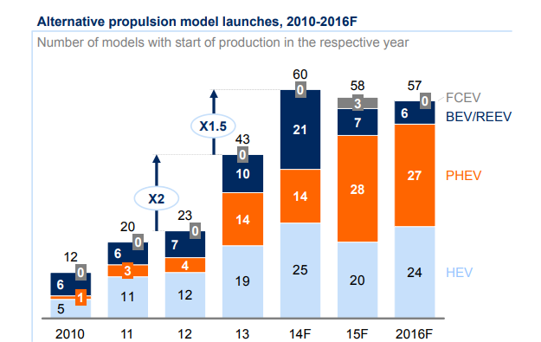
Figure 4: the trend of the launch of EVs
Source: [Mckinsey & Company, 2014]
FCEV: fuel cell electric vehicles BEV/REEV: battery electric vehicle/range-extended electric vehicles PHEV: plug-in hybrid electric vehicles HEV: hybrid electric vehicles

FUTURE OF ELECTRIC CARS
The electric vehicle has a long-term history since its first use was demonstrated by Nikola Tesla but due to the high demand and convention of IC driven vehicles, it failed to gain popularity and recognition. A modern problem such as increasing pollution, lower efficiency, high fuel prices, adoption on a large scale and many other reasons; the EVs market are growing rapidly (Van Vliet et al. 2011). The rate of its adoption depends upon various factors such as fuel prices, emission regulation and battery pack efficiency. The most frequently used measure is TCO and the key cost driver is the battery pack used (Vikström et al. 2013). Economies of sales have reduced battery prices and are expected to reduce further to gain competitiveness. Innovations such as lightweight carbon fibre for reducing the weight have improved the EV's proposition.
According to Kahlen and Ketter (2015), a lot of improvisations are yet to be made such as standardization of slow/fast charging, lightweight vehicles, and so on. OEM and suppliers will also invest more in platforms for EV productions which will be different from the cars with ICE technology. Over a longer-term in future, electric mobility will be intensively used for personal and industrial transportation all around the world and will begin with megacities, slowly spreading its reach in smaller cities with a better pricing strategy for holistic adoption. By the end of 2020, ICEs with optimized performance will already dominate the European market and by the end of 2030, it will be globally embraced as the primary mode of transportation (Dijk et al. 2013). However, the experts and various scholars suggest that the speed with which Evs will be adopted globally is still difficult to determine and depends upon a range of factors such as regulatory environment, oil prices and infrastructure of charging (Mckinsey & Company, 2014).
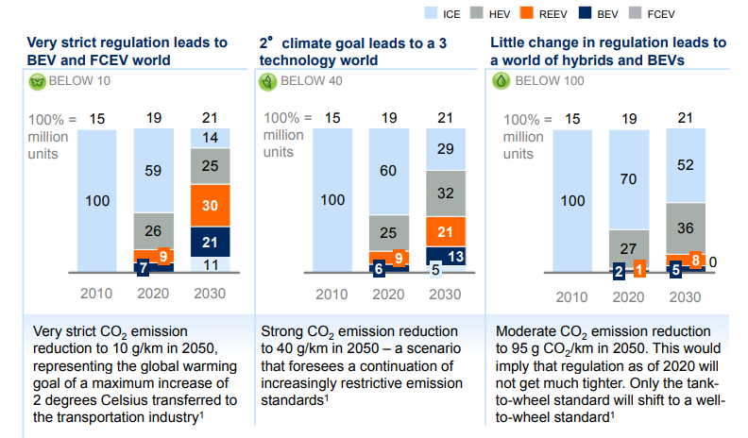
Figure 5: factors affecting EVs adoption in future (demonstrating sales of the vehicle as per powertrain technology used in per cent of sales across emissions)
Source: [Mckinsey & Company, 2014]

CONCLUSION
From the above analysis, it can be concluded that EVs have a great scope in future as with the development of a lifestyle of people, there will be more demand of transportation to boost the development and aid lifestyle of people. Satisfying this need through IC driven vehicles has been proven dangerous for the health of the planet and human due to which EVs are already in high demands in European regions. For Volvo, the important driver of the TCO of their cars is the battery pack cost, which is already being addressed by TESLA. It can also be concluded the short term adoption of EVs depends upon the consumers’ willingness to pay more for them and the demand incentives such as tax breaks and subsidies, as it is still in its initial phase and yet to see a lot of developments and improvements before it could compete with the traditional alternatives. And for the long term adoption, Volvo has to focus on reducing the cost of batteries and consecutively the price of their cars for penetrating successfully and establish a significant market.

REFERENCES
Avci, B., Girotra, K. and Netessine, S., 2015. Electric vehicles with a battery switching station: Adoption and environmental impact. Management Science, 61(4), pp.772-794.
Bohnsack, R., Pinkse, J. and Kolk, A., 2014. Business models for sustainable technologies: Exploring business model evolution in the case of electric vehicles. Research Policy, 43(2), pp.284-300.
Dijk, M., Orsato, R.J. and Kemp, R., 2013. The emergence of an electric mobility trajectory. Energy policy, 52, pp.135-145.
Ho, J.K.K., 2014. Formulation of a systemic PEST analysis for strategic analysis. European academic research, 2(5), pp.6478-6492.
Holland, S.P., Mansur, E.T., Muller, N.Z. and Yates, A.J., 2016. Are there environmental benefits from driving electric vehicles? The importance of local factors. American Economic Review, 106(12), pp.3700-3729.
Kahlen, M. and Ketter, W., 2015, February. Aggregating electric cars to sustainable virtual power plants: The value of flexibility in future electricity markets. In Twenty-Ninth AAAI Conference on Artificial Intelligence.
Kristoffersen, T.K., Capion, K. and Meibom, P., 2011. Optimal charging of electric drive vehicles in a market environment. Applied Energy, 88(5), pp.1940-1948.
Mckinsey & Company, 2014. Electric vehicles in Europe: Gearing up for a new phase? (Online) Available at: https://www.mckinsey.com/featured-insights/europe/electric-vehicles-in-europe-gearing-up-for-a-new-phase (Accessed on 5 May 2020)
Netland, T.H. and Aspelund, A., 2013. Company-specific production systems and competitive advantage: a resource-based view on the Volvo production system. International Journal of Operations & Production Management, 33(11-12), pp.1511-1531.
Pelliccione, P., Knauss, E., Heldal, R., Ågren, M., Mallozzi, P., Alminger, A. and Borgentun, D., 2016, April. A proposal for an automotive architecture framework for Volvo Cars. In 2016 Workshop on Automotive Systems/Software Architectures (WASA) (pp. 18-21). IEEE.
Sadek, N., 2012. Urban electric vehicles: a contemporary business case. European Transport Research Review, 4(1), pp.27-37.
San Román, T.G., Momber, I., Abbad, M.R. and Miralles, A.S., 2011. Regulatory framework and business models for charging plug-in electric vehicles: Infrastructure, agents, and commercial relationships. Energy policy, 39(10), pp.6360-6375.
Serra, J.V.F., 2013. Electric vehicles: technology, policy and commercial development. Routledge.
Sierzchula, W., Bakker, S., Maat, K. and Van Wee, B., 2012. The competitive environment of electric vehicles: An analysis of prototype and production models. Environmental Innovation and Societal Transitions, 2, pp.49-65.
Sperling, D., 2013. Future drive: Electric vehicles and sustainable transportation. Island Press.
Svahn, F., Mathiassen, L. and Lindgren, R., 2017. Embracing Digital Innovation in Incumbent Firms: How Volvo Cars Managed Competing Concerns. Mis Quarterly, 41(1).
Tuttle, D.P. and Baldick, R., 2012. The evolution of plug-in electric vehicle-grid interactions. IEEE Transactions on Smart Grid, 3(1), pp.500-505.
Van Vliet, O., Brouwer, A.S., Kuramochi, T., van Den Broek, M. and Faaij, A., 2011. Energy use, cost and CO2 emissions of electric cars. Journal of power sources, 196(4), pp.2298-2310.
Vikström, H., Davidsson, S. and Höök, M., 2013. Lithium availability and future production outlooks. Applied Energy, 110, pp.252-266.
Volvo Group, 2020. About us. (Online) Available at: https://www.volvogroup.com/en-en/about-us.html (Accessed on 5 May 2020)
Wesseling, J.H., Niesten, E.M., Faber, J. and Hekkert, M.P., 2015. Business strategies of incumbents in the market for electric vehicles: Opportunities and incentives for sustainable innovation. Business Strategy and the Environment, 24(6), pp.518-531.
Yang, W., Zhou, H., Liu, J., Dai, S., Ma, Z. and Liu, Y., 2015, September. Market evolution modeling for electric vehicles based on system dynamics and multi-agents. In 2015 International Symposium on Smart Electric Distribution Systems and Technologies (EDST) (pp. 133-138). IEEE.

