Business Plan
Carousel Confiserie



Business Owner: Tanasa Andra acting as sole trader
Contents:

Business Plan for Carousel Confiserie………………………………… … …… 1
Business Owner Andra Tanasa acting as sole trader………………. …… ………1
Carousel Confiserie………………………………………………. ………. ….….3
Mission Statement………………………………………………. ………. ……....3
Vision Statement………………………………………………………. …. … ….3
Aims of the Business………………………………………………. ……. ………3
SMART Objectives………………………………………………… ……. … ...4
Introduction………………………………………………………………. ……...5
Products…………………………………………………………………. . ………6
Marketing Analysis………………………………………………………. ……. ...7
Competitor Analysis………………………………………………… …. ……….9
Marketing Strategy……………………………………………………. ………..10
Resources……………………………………………………………. ………….13
Physical Resources……………………………………………………… …… 13
Financial Resources…………………………………………………… ……… 13
Human Resources……………………………………………………… ………..13
SWOT Analysis…………………………………………………… …… ………14
Cash Flow………………………………………………………………… …….14
Conclusion……………………………………………………………… ……….15
Appendices…………………………………………………………………… …16
Appendix 1……………………………………………………………………….16
Appendix 2……………………………………………………………………. .17
Appendix 3……………………………………………………………………….18
References………………………………………………………………………..23

Carousel Confiserie

The business will be owned by Tanasa Andra operating as a Sole Trade, the reason for choosing sole trader was the simplicity of its structure, it is inexpensive to setup because there are few legal and tax formalities, as owner I will be entitled to all profits that are made and have complete control of any business decisions.

Mission Statement

The company mission is to educate local customers and diversity the options they have when it comes to choosing tasty and quality desserts.
The products portfolio will include products based on the best ingredients, a baby friendly product; all created especially for children between 1-5 years old.

Vision Statement

There is an increased attention of child on a healthy lifestyle, more precisely on a quality product with less sugar. I anticipate that in the space of 12-24 months, our desserts will become one of the first options for local consumers to buy a tasty, refined and balanced dessert. The competitive advantages of our social enterprise are that we introduce products that are made with substitutes of sugar, flour and artificial colours. Fresh fruit, dried fruits, honey, maple, and other healthy ingredients will be promoted in appropriate proportion.

Aims of the business

- Provide high quality products;
- Provide excellent services and attention to the finest details of the business and personal forex needs of its targeted customers;
- Have sustainable profit;
- Create a business whole value, exceed the client’s expectations;
- Continue to grow our customers year after year;
- Employ more staff as the business grows;
- Have an office to run business;
- Have another brand of my business and to be a well-known;
- Get feedback from the customers;
- Sale in a good way and have harmonious relationship with customers.

SMART Objectives

Specific
Run a successful company and continually extending our list of clients,
I will publish at least one blog post weekly on my website for four consecutive weeks.

Measurable
Monitoring and increasing the number of clients each year,
Sales progress will be tracked on a spreadsheet with the dates of each week labeled,
Each Sunday morning, I will record on the spreadsheet if I have reached the weekly goal.

Achievable/Attainable
Increase staff,
Have a good work ethics,
On Sunday mornings, I will schedule time on my weekly calendar to ensure all blog post components can be completed within the week posting and also a repeat reminder on my phone.

Relevant/ Realistic
Company achieving a profit enabling,
Return of the personal investment put in,
Share more feedback for future developing.

Timed
Business grows with 38% in the first year,
Increase customers until 2023. (2015)

Introduction- Why choosing dessert business?

Be a mom since last year, I decide that is the time to change something in my life, and I start to cook more natural and without so many colorants or sugar.
Most of the children and not only children have big problems with their health because they eat uncontrolled and use a lot of sweet that is made wrong.
So, I decided that I need to change this situation cooking a different dessert that can be tastier and look nicer than what we found on shops.

I introduce products that are made with substitutes of sugar, flour and artificial colors. Fresh fruit, dried fruits, honey, maple, and other healthy ingredients will be promoted in appropriate proportions. Healthy desserts mean a better life.

Products

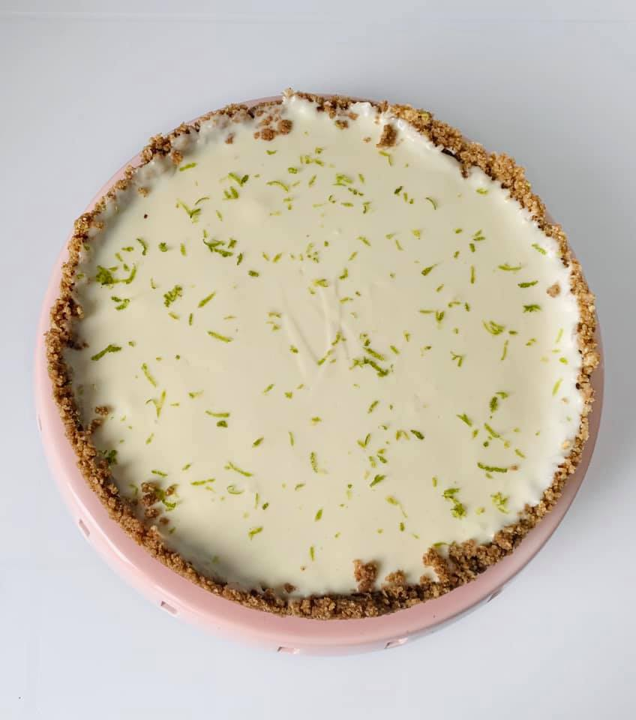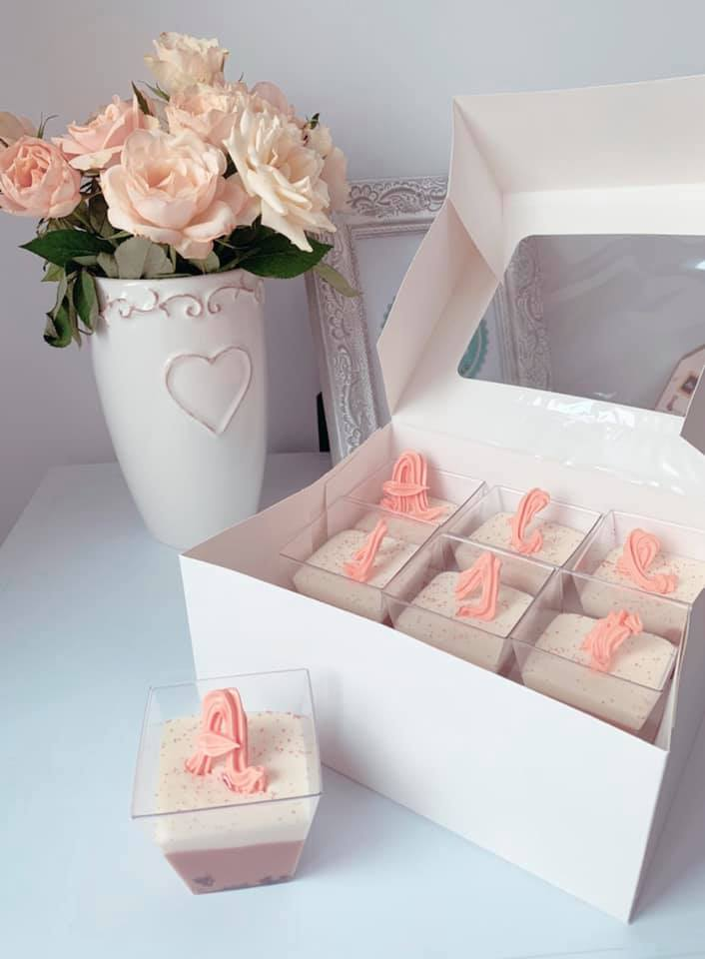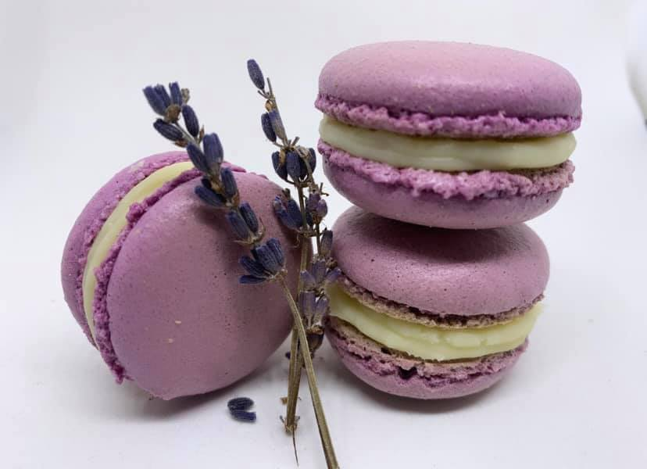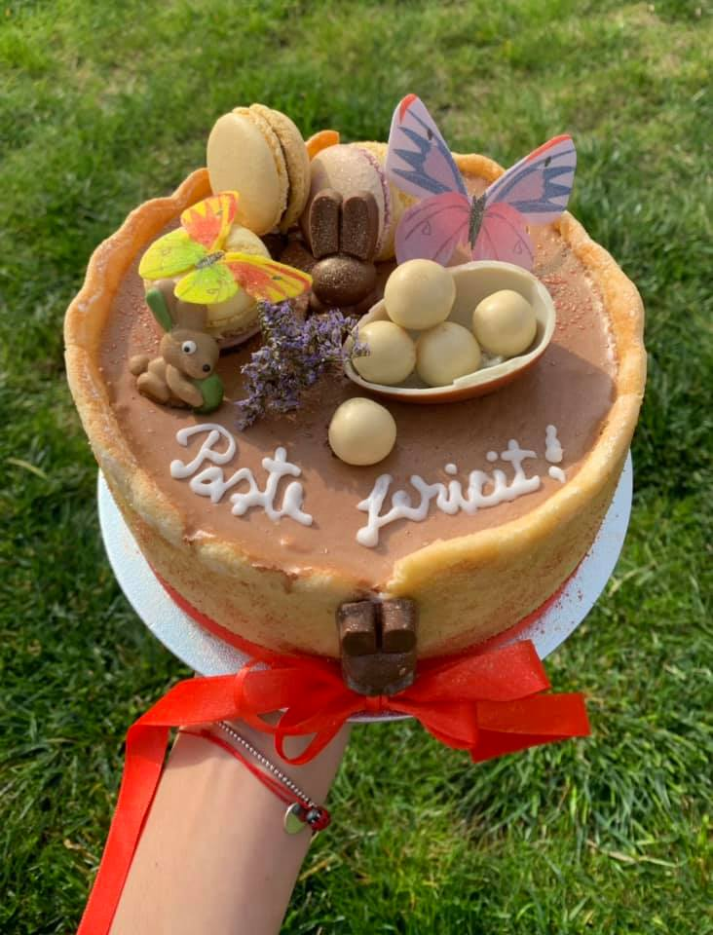
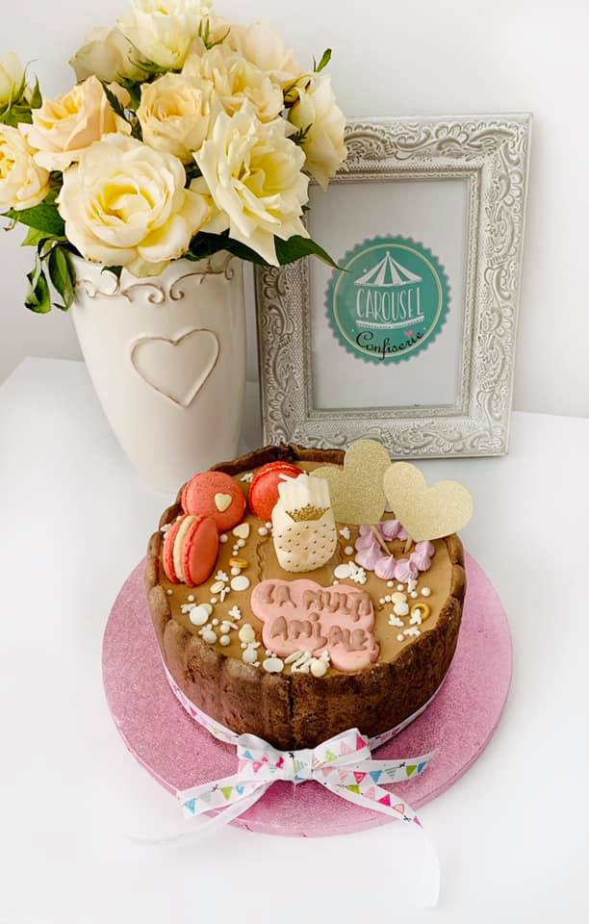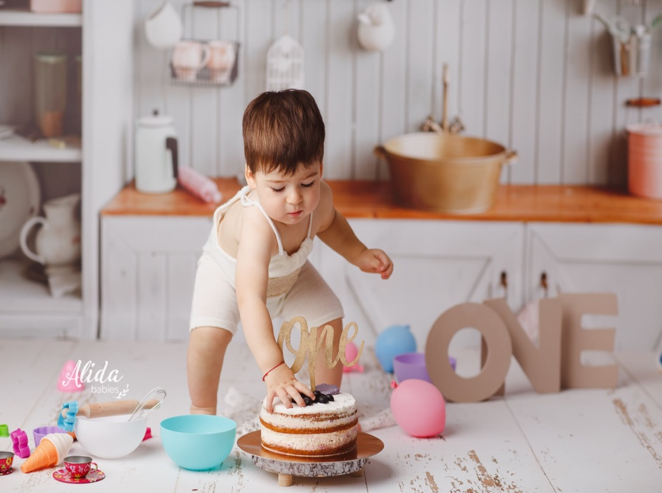
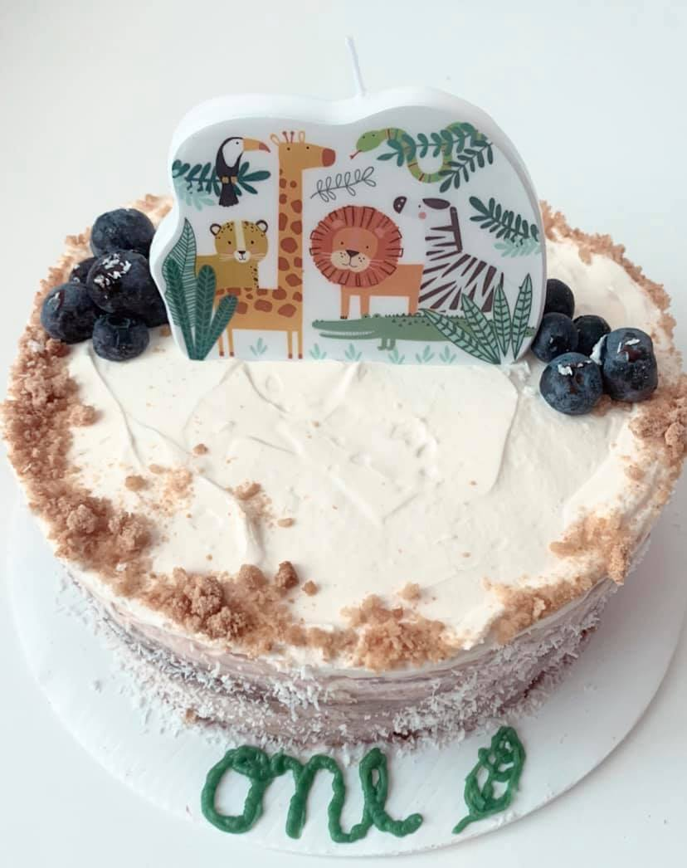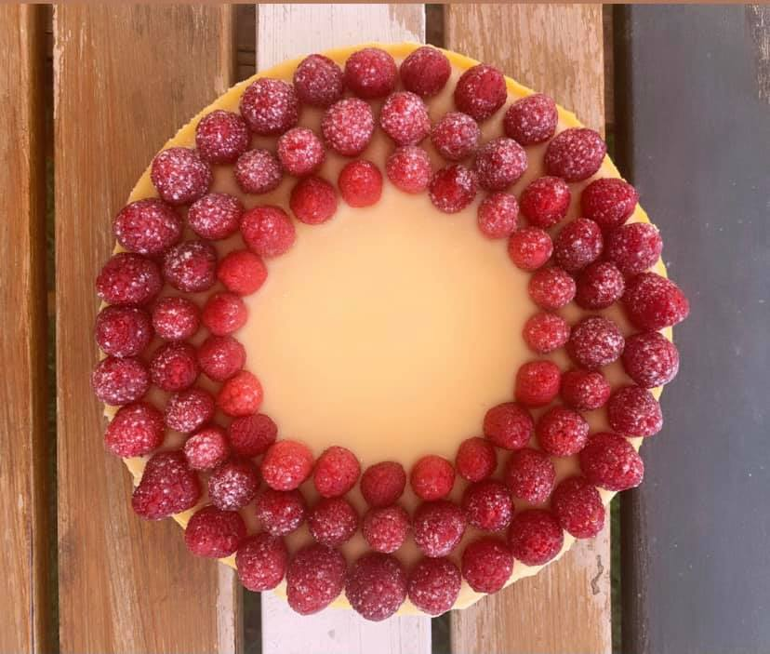
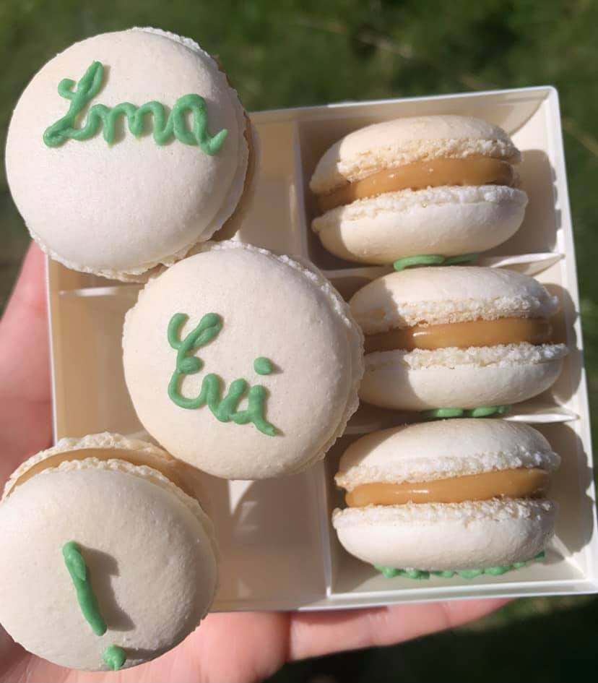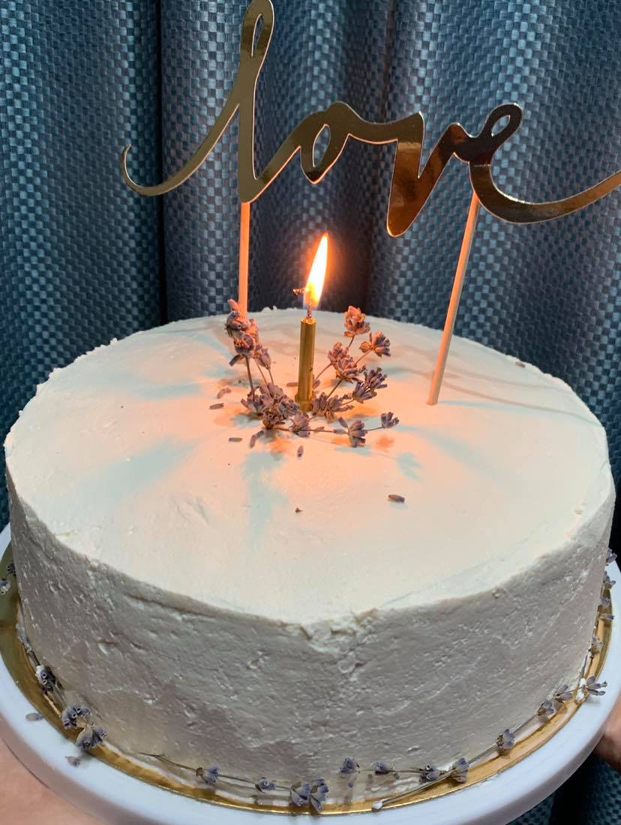

Marketing Analysis

For all the businesses, the voice of the customers is very important because if they are happy, we are happy because this will be show on sales and directly into company profit.
Pandemic comes in the same time when Nathalia, my daughter was born and was a difficult period for all the market segmentations. More of the shops was closed and ordering online becomes the best thing that you can do.
Ordering online means saving time and stay long with the family.
Primary research is important for businesses because it helps them to gather first-hand info about the needs of the market. Provide great insights and they usually inform product development and the changes into organisation policies.
Primary research gives us all the info that we need from the market, so we don't need to wait until we will receive feedback from the customers. This gives us a real dialog with our target audience, gathering customers intelligence and transpose this intelligence into actions.
Now we can carry it out directly with our customers and check also what are our competitors. Primary research gives more Accuracy because we can have the information’s first hand, deeper insight that means is directly recording the feelings of primary data, what practically the clients saying. Give more control for how to collect the data results because we can see if the results can be relied and ownership, because the research it belongs to us.( Kuligowski, 2020)
For my business, healthy desserts, I made primary research to see exactly what are the customer requirements, and I create a questionnaire when I practically ask directly the feedback.

80% of the people shows that is a good idea to start the business, for the rest of 20% will be my future goal to prove that those desserts are very important for healthy.

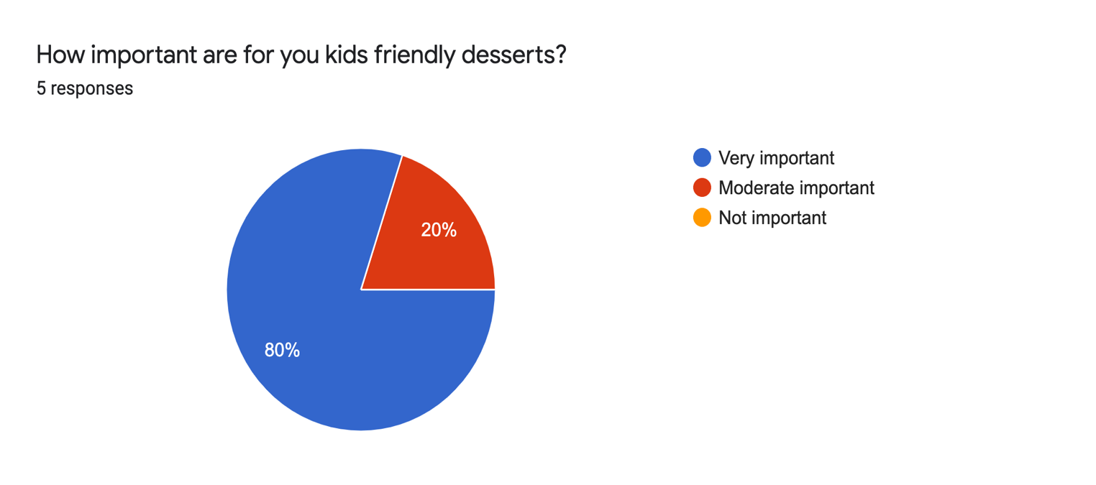

Secondary research refers to the use of existing data to answer to the questions that still we have.
There are many situations where taking this approach can be of benefit.
In this situation, the secondary research show that the young people buy more times desserts than the oldest, and also the price is a big criterion when they want to order sweets.
Some of them will have the future focus to improve the health of their children and also their live, so they will pay more for these high-quality desserts.

Questionnaire added into Appendix 3.

Competitor Analysis

Building a strategy for my business is hard and understanding that of our competitor’s is even harder, but is not impossible.
Exist many shops that sell a lot of desserts but the desserts are not healthy. Our desserts come with a lot of variants and all customers can personalize themselves the desserts using our web site.
The price is not cheap, but our business is not addressed to everybody, is addressed to people that have a high education and culture and understand that eating well they will feel well.
Our fresh products comminated with a lot of desserts from Europe will be definitely one of most important business in the area. Because we have also delivery, come in and collect, try the taste for every product first, is definitely something that add the company in the top of the competitors.
We have also a good understanding for any modification of the orders and this will just help us to build relationships with the customers and why not a lot of recommendation.(Lloyd,2021)

Marketing Strategy

A marketing strategy refers to a business's overall plan that helps reaching pconsumers and turning them into customers of their products or services.
A marketing strategy contains the company’s value proposition, key brand messaging, data on target customer demographics, and other high-level elements.
We will use a clear marketing strategy that should revolve around the company's value proposition, which communicates to consumers what the company stands are, how it operates, and why it deserves their business.
A good marketing strategy is to achieve and communicate a sustainable competitive advantage against to other companies by understanding what the customer wants and try the best to achieve this.
A thorough marketing strategy covers minimum "the four Ps" of marketing—product, price, place, and promotion. (Adam, 2021)
A target market is a segment of the market to which a company intends to sell its products and services, and it consists of a specific group of customers to whom the company devotes its marketing efforts. For my Company, the target market will be first to kids 1-5 years old but also to the parents, to everybody.

Using Website reviews, using promotions, using face-to-face feedback we will be in the right position to achieve the target and increase year by year the sales.

Because we want to be the number one in the top of customer preferences we will build a complete marketing strategy, using the 7P’s model. (Brooks, 2022)
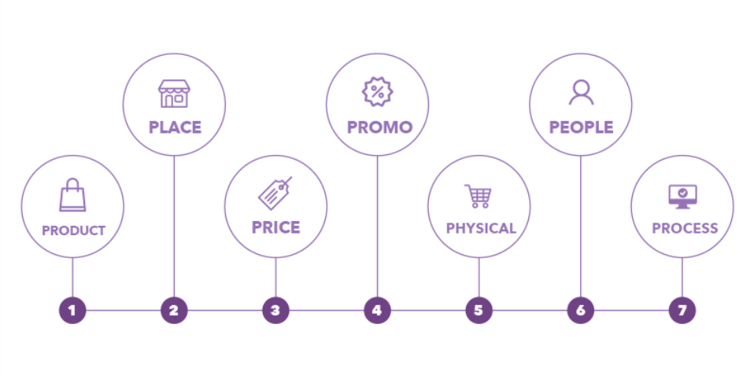
Product, we are using a high level of quality, a lot of variants, personalise desserts, mix.

Place, trade channels, actual house in the middle of the town.
Price, discount for old customers, discount for the new customer if they buy minimum 3 desserts.
Promotion, marketing communication like flyers, using Website, using face-to-face questions, sales promotions, buy 2 desserts get 1 free, 10% for the next 3 order for payment that reach 500£.
Physical evidence, product personalise packaging, staff with experience in online.
People, individuals on marketing activities, uniform with Carousel Confiserie.
Process, customer focus, design features, research and develop the best ingredients. (Brooks, 2022)

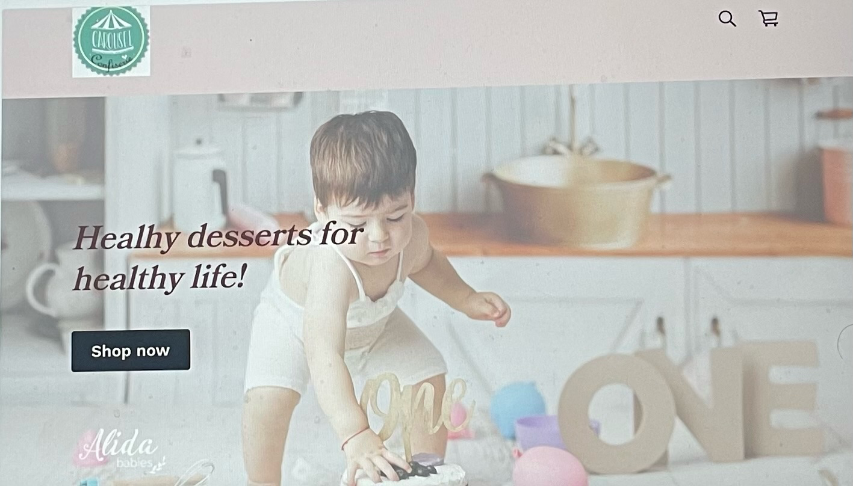

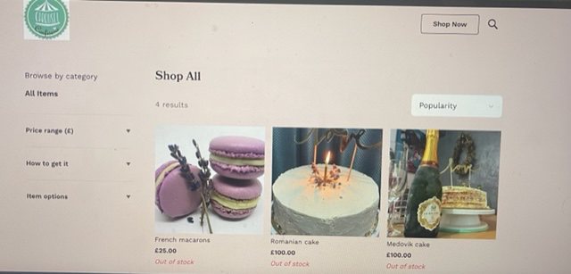

Resources
Physical Resources
Carousel Confiserie business will run from the residence of Andra Tanasa and the kitchen will be the place when we will store all food ingredients.
The start-up cost for run the business will be the rent of the house, the equipment we will have and only buy the fresh products according with customer orders.
We already have a car for transport and we will decorate with our Company motto.
Financial Resources
A personal investment of 50,000£ savings will be used to start the company up acting as a sole trader, and for any risks, we still have 10,000 for the family like fix loan.
If the sales will be increased and the orders also, don’t need to do anything else for cover our daily costs.
Human Resources
Myself, that I’m the owner of this company I will take care about orders, buy ingredients, booking session when the customers can come and try different desserts by free. Because I have experience in finance, is not needed to recruit any other people, I can do the calculation, pay the tax by myself.
If after one year the Company will have profit more than 50%, will be possible to recruit another people to help me to deliver on time the products if the customer asks for this and not for come and collect alone the desserts.
Making a search on Gov.co.uk, I will need to take into considerations more items before recruitment: if the people is eligible to work in the UK, DBS checks, inform HM Revenue and Customs, etc

SWOT Analysis

A SWOT Analysis is a great way to recognize the company’s strengths and weaknesses and identify the threats and opportunities, with improved business awareness and adaptability it can prepare you for change and enable you to react accordingly. (Reading, 2019)
A SWOT Analysis can be found on Appendix 1.

Cash flow

Cash flow is the amount of cash that comes into and out of the business in a particular period of time.
If you have positive cash flow, this means that you have more cash coming into your business than you have leaving it.
When you have negative cash flow, the opposite is valuable. A sustained period of negative cash flow can make it increasingly hard to pay the bills and cover other expenses from the business. This is because your cash flow affects the amount of money available to fund your business’ day-to-day operations, otherwise known as working capital.
Is very important to have a clear view of the business working capital because this help to have a strong position when decisions must to be make.
Every business is unique, depending on how the money is make, with sure exist some way to improve the cash flow. Some of the measures that can be take it into consideration is to agree for the beginning payments term in advance, rent some of equipment, etc
There are important differences between cash flow and profit.
Cash flow is the money that flows in and out of your business throughout a given period that all the companies are set.
Profit is whatever remains from your revenue after deducting costs. Is exactly the money that remains after to make all payments; while profit is usually taken to indicate the immediate success of a business, cash flow is a very good way to determine the business’ overall health.
This is because it’s possible for a business to be profitable while having a poor cash flow. For example, for a small electronics manufacturer selling wholesale products to large companies, a late payment could result in it being unable to pay its suppliers.
Even if you have a successful product with rising sales, you could end up facing cash flow issues and, despite reaching profitability, your business might be unable to meet its financial obligations. (2021, British Business Bank)
A Cash Flow Analysis can be found on Appendix 2.
Conclusion
Carousel Confiserie will be a profitable business, providing healthy and tasty desserts for all kids but also for everybody that want to live in a beautiful body.
For future, we will want to increase the business and prepare some delicious desserts or pets too, because most of them are part of our like.
Checking the cash flow and because we have a lot of friends that like desserts, we assume that this business will be the best option in my life.

Appendix 1

SWOT Analysis

Strengths:
Good characteristic,
Good quality products,
Products innovative and personalized,
Wide range of products,
Not concern for healthy,
Customers are expanding through word of mouth of social media postings.

Weaknesses:
Dominated by personal feedback,
New in the market,
Company is not strategically located.

Opportunities:
Unique healthy desserts on the market,
No competitors,
Tie up with party organizers to widen their market.

Threats:
Because is a new dessert, people may lead to reject,
Not so cheap price,
Increasing number of competitors.

Appendix 2

Cash Flow Forecast

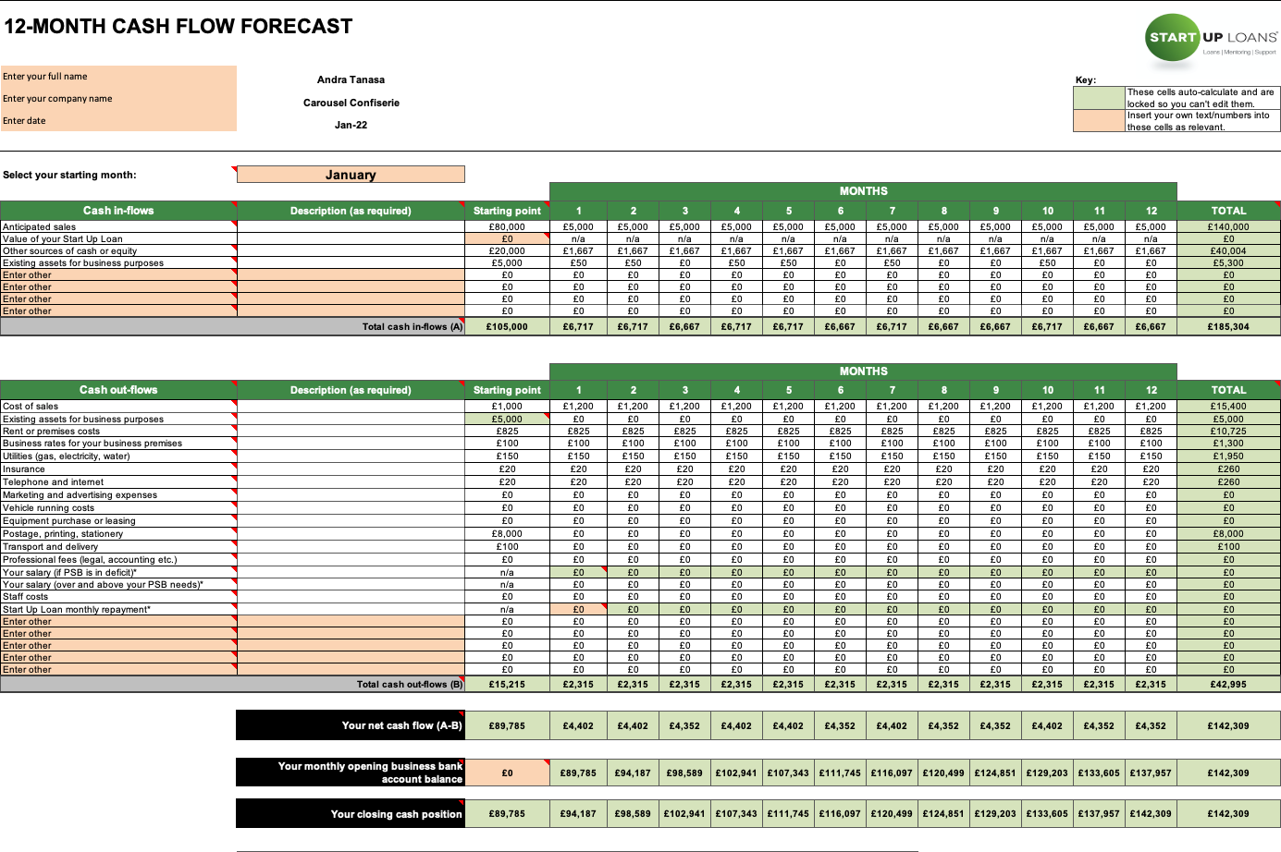

Appendix 3

Questionnaire

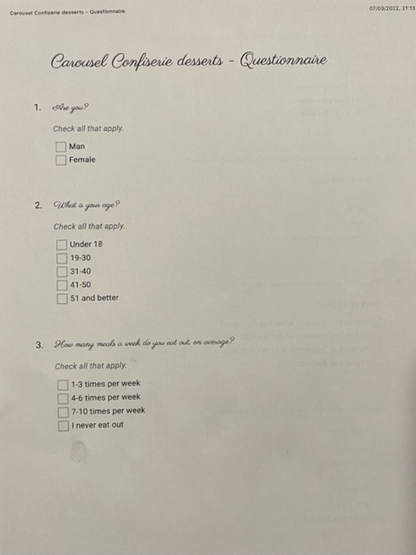
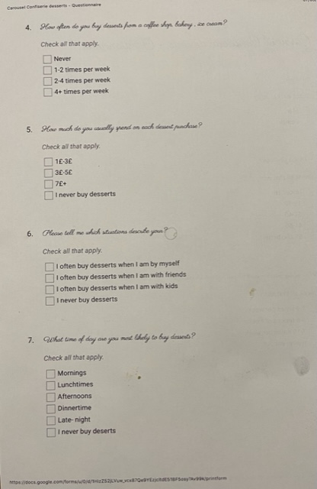
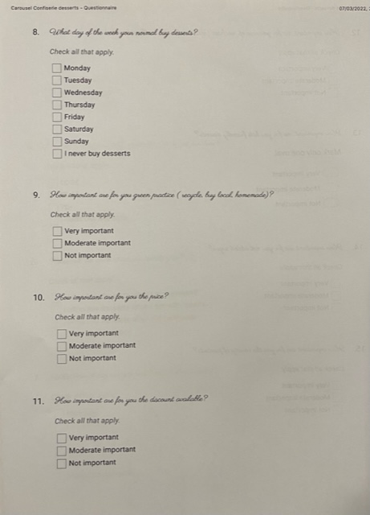
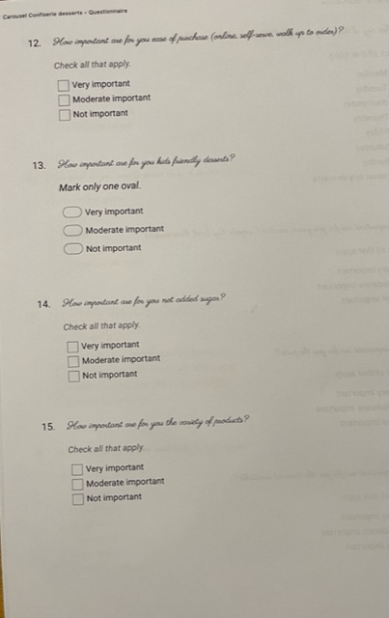
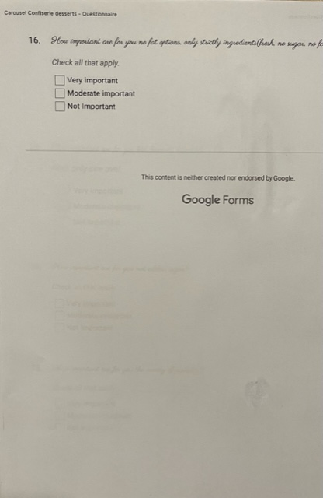
References

- Albright College/Lion, 2021, Statistic and Research: Qualitative and Quantitative, EDU510,
https://library.albright.edu/education;

- Alicia Tuovila, 2020, Cash Flow from operating activities (CFO),
https://www.investopedia.com/terms/c/cash-flow-from-operating-activities.asp;

- Alicia Lloyd, 2021, The importance of a Competitor Analysis and how to conduct one,
https://kayo.digital/news/the-importance-of-a-competitor-analysis;

- BBC,2020, The Marketing Mixt,
https://www.bbc.co.uk/bitesize/guides/zw9877ty/revision/1;

- Head Office GCL, 2020, 5 Reasons Why Primary Market Research is Essential;

- Kiely Kuligowski, 2020, How to conduct a market analysis for business,
https://www.businessnewdaily.com;

- Reading D., 2020, Importance of SWOT analysis,
https://www.businesswest.co.uk/members/blog/importance-swot-analysis;

- Tim Tobierski, 2020, Cash flow versus profit: What’s the difference? Harvard Business School,
https://online.hbs.edu/blog/post/cash-flow-vs-profit;

- University of Arkansas Grand ham,2019, A guide to organisational resources and how to manage them;

10.US Small Business Administration, 2018, 5 Reasons you need a business plan,
https://www.sba.gov.

