DS 1 – First submission

Screenshot/Photo 1
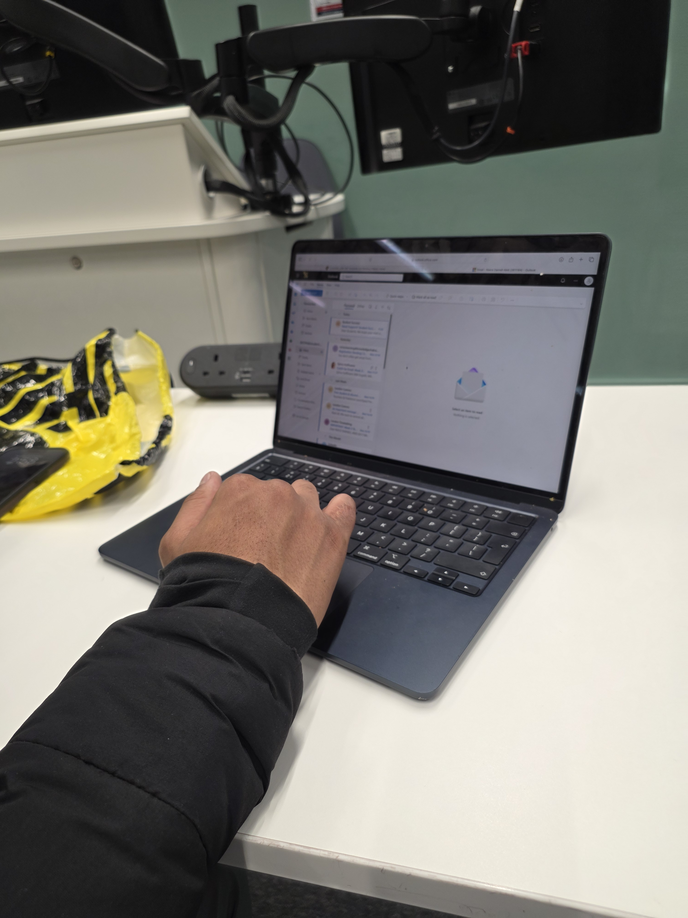
This photo shows me using my laptop for schoolwork and completing digital assignments. It represents how I use technology to learn, access information, and stay organised with my studies.

Screenshot/Photo 2

Social media i.e. WhatsApp represents my digital life because it allows me to communicate with friends and family instantly. I use it to share messages, photos and important information, helping me stay connected with people wherever they are.

Screenshot/Photo 3
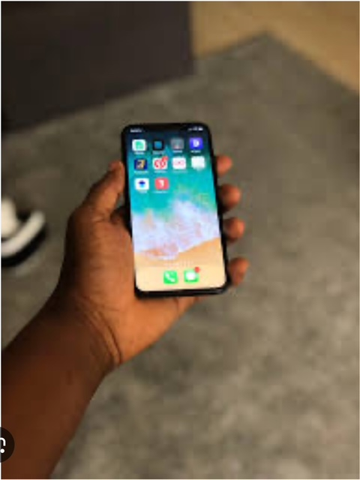
This photo shows me using my mobile phone and also how my digital life helps me stay connected and organized. I use my phone to communicate with others, access apps, and find information. It shows how technology is part of my everyday life and makes many tasks easier

Screenshot/Photo 4
[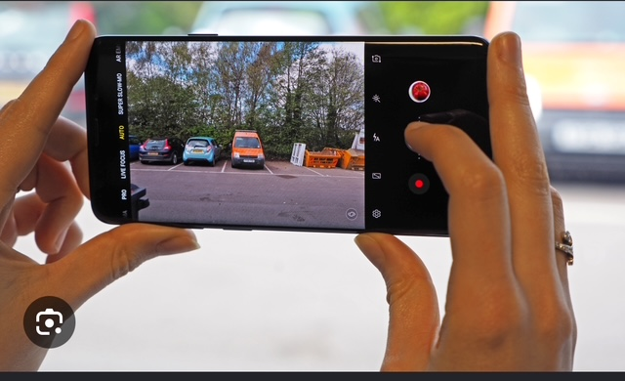
I use my phone to take photos and save memories of important moments. Digital photos allow me to look back at experiences and share them with others.

My Short Reflection
- I use my phone and laptop every day.
- I use the internet to find useful information.
- I communicate with friends and family online.
- I use social media to stay up to date.
- I do some of my work and studies online.
- I try to balance my digital life with my real life.

