28/03/2025
Ana-Maria Ifrim
ID:2412153
UNIVERSITY OF WALES TRINITY SAINT DAVIDS
Problem Solving and Innovation (BMSW4014_CARD)
Table of Contents

1. Introduction 2
2. Main findings 2
2.1. PESTLE Analysis 2
2.2. Key Factors analysis 5
3. Conclusion 9
4. Recommendations 10
6. List of Figures 14

A critical analysis of external factors impacting
UK High Street retailers

Introduction
High street retailers in the UK operate in a complex environment influenced by a variety of external factors. The present report provides a critical analysis of the current circumstances of High Street retailers in the UK through an evaluation of external factors using the PESTLE framework. By examining the political, economic, social, technological, legal, and environmental factors that shapes retail operations, the challenges and opportunities that businesses are facing can be understood. The findings highlight how macroeconomic changes, shifts in consumer behaviour, and the evolving digital marketplace can significantly impact retailers, their stakeholders, and overall market dynamics.

Main findings

PESTLE Analysis
A PESTLE analysis is a strategic management tool that helps businesses understand and assess external factors which influences the organisation (CIPD, 2025). The main goal of PESTLE analysis is to identify critical macroeconomic changes that could significantly affect the development of a company (Marmol et al., 2015). For High Street retailers in the UK, these are classified into six categories as follows:
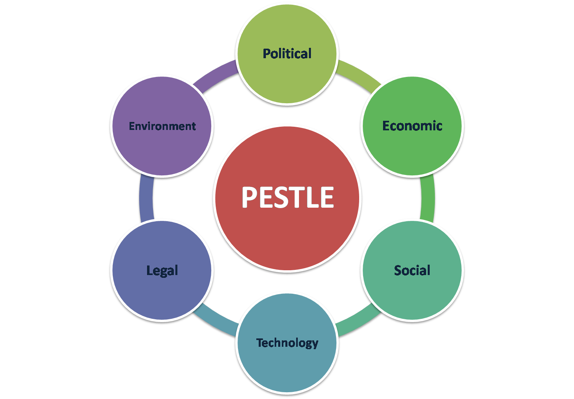
Figure 1. PESTLE Model

2.1.1. Political Factors (Ward, 2025), (Fresen, 2024), (Otto, 2024):
- Government policies: changes in policies regarding retail regulations, trade policies and minimum wage laws impacts operational costs and pricing strategies.
- Brexit: Post-Brexit trade agreements affected UK retailers, resulting in supply chain disruptions, rising costs and changes in regulation that influence customer access and retail operations.
- Taxation: Changes in VAT or business rates has direct impact on profit.
- Restrictions and Lockdowns: also impacted high street retailers resulting in a permanent closure of some businesses.
- Political instability: leads to decrease of customer confidence and spending.

    - Economic Factors (Ward, 2025), (RSM, 2025), (Fresen, 2024), (Michael, 2024):
- Consumer Spending Power: Financial condition with influence over income, such as inflation or wage growth, impacts the consumer purchasing power.
- Interest Rates: High interest rates affects both business and consumer credit availability which is reflected in the final price resulting in less spending on non-essential items.
- Increased cost of living: pressures household budgets and discourages consumer spending, leading to decreasing sales.
- Market Competition: Discount retailer, e-commerce and discount retailers affect traditional retail sales.

    - Social Factors (Ward, 2025), (Local Government Association, 2022):
- Consumer Behaviour: trends towards online shopping, ethical consumption and sustainability changes the products demand.
- Household changes: the increase in single-person household changes the demand for certain products.
- Full time working women also impacts shopping preferences.
- Demographics: values and shopping preferences of ageing people are different from young consumers which influence High Street retailers.
- Health awareness: the increasing concern about health and wellness influences the consumer preferences and the product offerings in food, clothing, and lifestyle sectors.

    - Technological Factors (Munnery, 2023), (Fresen, 2024), (Pearse, 2025):
- E-commerce: forces retailers to adapt to the rise of online shopping with new strategies integrating online and offline offers.
- Digital Marketing: the increased use of social media and digital advertising gives the retailers the opportunity to reach and engage effectively with consumers.
- Automation: the advanced technology benefits retailer with inventory management and customer service (e.g. self-checkouts).
- Data Analytics: The ability to analyse consumer behaviour gives retailers the opportunity to offer personalized experiences and targeted advertising.

    - Legal Factors (Pearse, 2025), (Izard, 2024), (Floris, 2024):
- Consumer Protection Laws: Retailers must comply to regulations around consumer rights, trading and safety.
- Employment Laws: Labour laws influencing working hours, wages and employee rights affects operational cost.
- Data Protection Regulations: Retailers must adhere to GDPR regulations to avoid penalties and maintain customer trust.
- Intellectual Property Laws: In a competitive market is essential for retailers to protect their brands.
- Health and safety regulations: retailers must ensure the health and safety of customers and employees.

    - Environmental Factors (Munnery, 2023), (British Business Bank, 2025):
- Sustainability: Retail operations are affected by customer trend towards eco-friendly products and practices.
- Regulations on Waste Management: Packaging and waste regulations impose operational changes and costs.
- Climate: Weather condition can affect retail supply chain and operations leading to fluctuating availability of products.
- Corporate Responsibility: Company ethics and social responsibility has considerable impact over customer loyalty and brand reputation.

Key Factors analysis
The factors with the higher impact over High Street retailers in UK are Economical and Social factors. To gain an insight of how these external factors affects retailers, it is crucial to analyse both positive and negative effects along with their impact on stakeholders. The tools developed by De Bono (2000), known as the Six Thinking Hats, and the Mendelow Stakeholder Matrix (1991) can assist in conducting this analysis as follows:

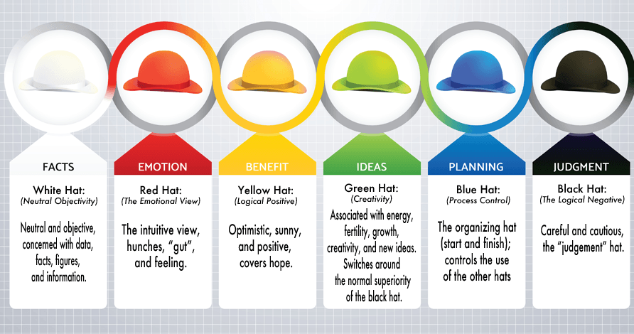
Figure 2. Six Thinking Hats

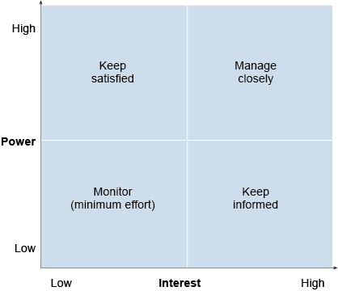
Figure 3. Mendelow Matrix

2.2.1 Economic Factor
Positive Impact:
- Resilience in Retail Adaptation:
Many retailers have embraced technology and alternative business models to diversify offerings (e.g., click-and-collect, in-store experiences).
Stakeholder Impact:
- Customers (High Interest, High Power): Enjoy greater shopping flexibility and service innovations.
Negative Impact:
- Reduced Consumer Spending Power:
Cost of living crisis diminishes disposable income, leading consumers to prioritize essentials over discretionary spending.
Stakeholder Impact:
- Suppliers, Shareholders (High Interest, High Power): Experience reduced income.
- Employees (High Interest, High Power): Risk job insecurity as businesses downsize in response to declining sales.

- Intense Competition from E-commerce:
Retailers must invest heavily in technology and omnichannel strategies to compete, which strains resources.
Stakeholder Impact:
- Shareholders (High Power, High Interest): Concerns over declining profits can lead to shareholder discontent.
- Employees (High Power, High Interest): Potential job losses or restructuring as companies streamline operations to focus on digital channels.

- Rising Operational Costs:
Increased costs for materials, energy, and labour put additional pressure on profit.
Stakeholder Impact:
- Shareholders (High Power, High Interest): Are financially affected.
- Customers (High Interest, High Power): Experience higher prices, which might lead to reduced spending or shifting to discount retailers.

2.2.2 Social Factor
Positive Impact:
- Enhanced Customer Engagement:
Retailers that adapt to changing consumer preferences can create more engaging and personalized shopping experiences.
Stakeholder Impact:
- Customers (High Interest, High Power): Benefit from offers that better meet their needs and values.
- Employees (High Interest, High Power): Enjoy a more dynamic and fulfilling work environment, leading to better morale and job satisfaction.

- Focus on Sustainability:
A growing demand for eco-friendly and ethically sourced products can lead to stronger brand loyalty.
Stakeholder Impact:
- Customers (High Interest, High Power): Preference for sustainable products increases satisfaction and loyalty.
- Employees (High Interest, High Power): Work for companies that align with personal values, enhancing morale and retention.

- Opportunities for Innovation:
Health and wellness trends provide opportunities for retailers to diversify products.
Stakeholder Impact:
- Customers (High Interest, High Power): More choices in healthy products increases satisfaction.
Negative Impact:
- Pressure for Ethical Practices:
Consumers expect brands to uphold ethical standards, which can pressure retailers to change their practices rapidly.
Stakeholder Impact:
- Employees (High Interest, High Power): May face pressure to align with evolving company practices, causing workplace stress.
- Inconsistent Consumer Behaviour:
Rapid shifts in trends can create challenges for retailers in inventory management and product offers.
Stakeholder Impact:
- Customers (High Interest, Low Power): Could experience frustration if desired products are out of stock or not aligned with their preferences.

- Digital Dependence:
Increased digital connectivity means that negative reviews or social media can quickly influence public perception.
Stakeholder Impact:
- Shareholders (High Power, High Interest): financial affected by the negative public image leading to decreasing sales.
- Employees (High Interest, High Power): May feel the stress of being in the public eye, impacting workplace morale and job security.

Conclusion
This report has provided an analysis of the various external factors influencing High Street retailers in the UK, utilizing the PESTLE framework to uncover political, economic, social, technological, legal, and environmental elements. Through this examination, arises that both economic and social factors play critical roles in shaping the dynamics of retail, with significant implications on stakeholders.
Economic pressures, such as inflation, rising operational costs, and strong competition from e-commerce, challenge retailers to adapt quickly to maintain profitability. These factors can reduce consumer spending power and require price increases, which may drive away price-sensitive customers and lead to job insecurity for employees. Conversely, opportunities for resilience and innovation exist, particularly through embracing technology, which can enhance customer satisfaction and engagement.
Social factors further presents both opportunities and challenges. Enhanced customer engagement and a growing focus on sustainability can foster brand loyalty and drive innovation, while pressures for ethical practices and constant changes in consumer preferences pose ongoing challenges for inventory management and brand reputation.
To navigate these complexities, High Street retailers must adopt proactive strategies that align with consumer values and market demands while addressing the concerns of various stakeholders’ interests to foster trust and long-term success.

Recommendations
- Invest in Technology and Omnichannel Strategies:
Retailers should enhance digital potential and integrate online and offline experiences to offer consumers improved experience. This investment should focus on user-friendly e-commerce platforms, mobile applications, and data analytics tools that allows personalized customer interactions. Hereby retailers can engage customers more effectively and capture a broader market share, mitigating the impact of declining foot traffic in physical stores.
- Emphasize Sustainable Practices and Ethical Sourcing:
High Street retailers should commit to sustainable business practices by prioritizing ethical sourcing, reducing waste, and offering eco-friendly products. Not only does this align with increasing consumer demand for sustainability, but it also enhances brand loyalty among customers who value corporate social responsibility. Retailers should promote these practices transparently and foster partnerships with ethical suppliers, thereby improving their market positioning and long-term viability.
- References
British Business Bank (2025), How to become a more sustainable retailer, Available at: https://www.british-business-bank.co.uk/business-guidance/guidance-articles/sustainability/how-to-become-a-more-sustainable-retailer#:~:text=Small%2C%20online%20retailers%20also%20contribute,for%20additional%20guidance%20and%20help. (Accessed 24 March 2025).
Chartered Institute of Personnel and Development [CIPD] (2025), PESTLE analysis, Available at: https://www.cipd.org/en/knowledge/factsheets/pestle-analysis-factsheet/#:~:text=A%20PESTLE%20analysis%20studies%20the,managers%20in%20strategic%20decision%20making (Accessed 24 March 2025).
De Bono, E. (2000) Six thinking hats. London: Penguin.
Floris, S. (2024), 10 regulations every retailer must follow, Available at: https://www.retailsector.co.uk/650743-10-regulations-every-retailer-must-follow/#:~:text=The%20Health%20and%20Safety%20at,equipment%2C%20and%20conduct%20staff%20training. (Accessed 24 March 2024).
Fresen, N. (2024) Is online shopping killing the High Street? Available at: https://www.theretailbulletin.com/general-merchandise/is-online-shopping-killing-the-high-street-20-05-2024/#:~:text=The%20toll%20on%20high%20street%20businesses&text=More%20than%20one%20in%20every,the%20new%20consumers'%20shopping%20habits. (Accessed 24 March 2025).
Fresen, N. (2024) Election 2024: Potential impacts on the UK retail market, Available at: https://www.theretailbulletin.com/general-merchandise/election-2024-potential-impacts-on-the-uk-retail-market-24-05-2024/ (Accessed 20 March 2025).
Izard, V. (2024) Retailing in 2024 – liability considerations for UK retailers, Available at: https://kennedyslaw.com/en/thought-leadership/article/2024/retailing-in-2024-liability-considerations-for-uk-retailers/ (Accessed 24 March 2025).
Local Government Association, (2022) Creating resilient and revitalised high streets in the ‘new normal’ Available at: https://www.local.gov.uk/publications/creating-resilient-and-revitalised-high-streets-new-normal#:~:text=of%20daily%20life.-,Challenges%20for%20high%20streets,term%20impact%20of%20new%20technology.&text=On%20the%20horizon:%20Technological%20advancements,healthcare%20and%20social%20services%20too. (Accessed 24 March 2025).
Marmol, T. del et al. (2015) PESTLE analysis. Translated by C. Probert. Namur: Lemaitre Publishing.
Mendelow, A.L. (1991) ‘Stakeholder strategy: Profiting from the power of stakeholders’, Managing as a Frontier Activity. London: Adair Publishing.
Michael, S. (2024), Retail Forecast Report 2025, Available at: https://www.bdo.co.uk/getmedia/0cd1abdf-c5b6-4149-bf36-9bcdb126cada/RET-Report-Retail-Forecast-Report-2025-BDO.pdf?utm_campaign=retail-forecasts-report&utm_medium=website&utm_source=body-copy&utm_term=2025, (Accessed 20 March 2025)
Munnery, J. (2023) What does 2024 hold for the future of the British high street? Available at: https://www.begbies-traynorgroup.com/news/commentary/what-does-2024-hold-for-the-future-of-the-british-high-street (Accessed 24 March 2025).
Otto, A. ( 2024) Brexit’s Impact On Retail And The Marketplace Opportunity To Thrive, Available at: https://www.imrg.org/blog/brexits-impact-on-retail-and-the-marketplace-opportunity-to-thrive/#:~:text=Varying%20impact%20on%20retail%20categories&text=The%20value%20of%20non%2Dfood,2023%E2%80%93%20almost%20two%2Dthirds.(Accessed 20 March 2025).
Pearse, J. (2025) Decline and fall? The impact of digital on the UK high street Available at: https://newdigitalage.co/retail/decline-and-fall-the-impact-of-digital-on-the-uk-high-street/#:~:text=Primark%20is%20the%20perfect%20example,t%20a%20viable%20approach%20anymore. (Accessed 24 March 2025).
RSM (2025), What consumers are looking for in 2025, Available at: https://www.rsmuk.com/insights/consumer-outlook/retail-industry-outlook, (Accessed 24 March 2025).
Ward, M. (2025), Retail sector in the UK, Available at: https://researchbriefings.files.parliament.uk/documents/SN06186/SN06186.pdf (Accessed 24 March 2025).

List of Figures

Figure 1. PESTLE Model

Figure 2. Six Thinking Hats

Figure 3. Mendelow Matrix

