Watch these videos to learn more about phonics

Before you really get into thinking about English phonics, it’s worth noting that phonics are very different in Welsh and English.
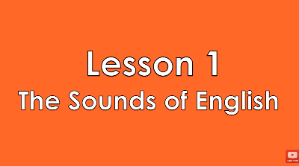

https://www.youtube.com/watch?v=NzHVmX1pnc8
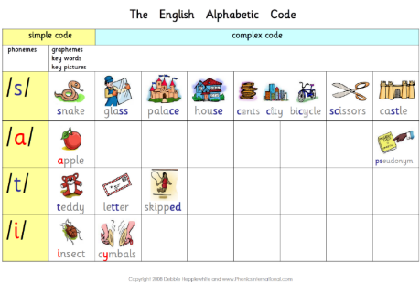

The English Alphabetic Code - complete picture chart.pdf

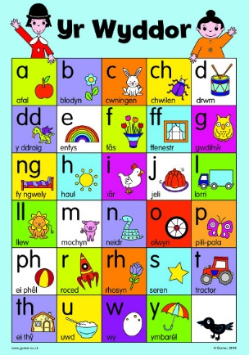

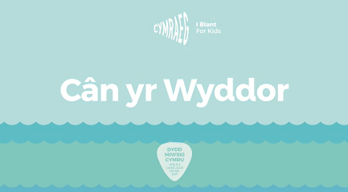

https://www.youtube.com/watch?v=vn_hrOAKTaM

Here is a video that will help you understand some of the terms you have read about. This video is part of a series you may want to watch.


https://www.youtube.com/watch?v=sB2-mFb_O0E&app=desktop

These videos show you how phonics are taught in the classroom.
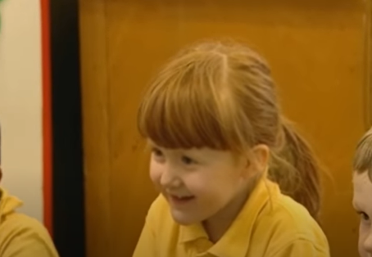

https://www.youtube.com/watch?v=141Rj_-uHX4

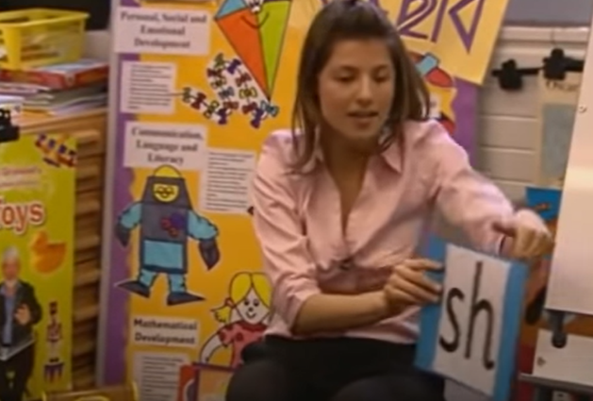

https://www.youtube.com/watch?v=8aljylvCBzc&app=desktop

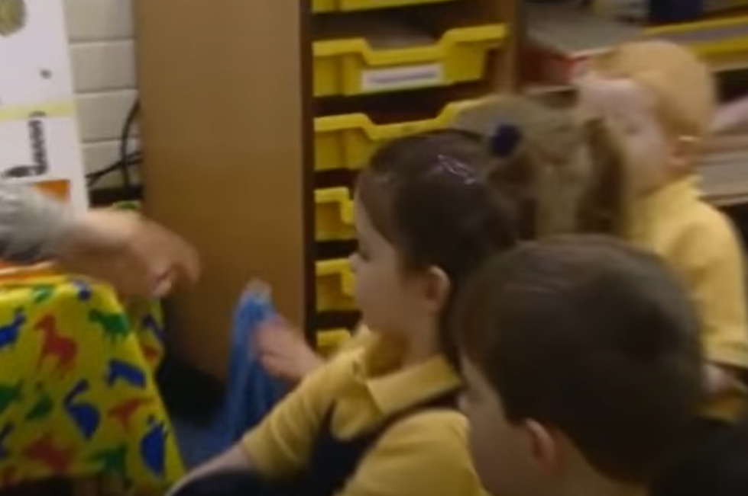 https://www.youtube.com/watch?v=m5v35_jYJYw
Happy viewing!

