
Creativity and Value Creation
Assignment 2: Iteration and Development

Andrew Davis
2220233

Contents
TASK E: Iterative development
TASK F: Reference images / Orthographic projections
TASK G: A Final Design
TASK H: A 500-word critical evaluation
References and Bibliography

TASK: E Iterative development
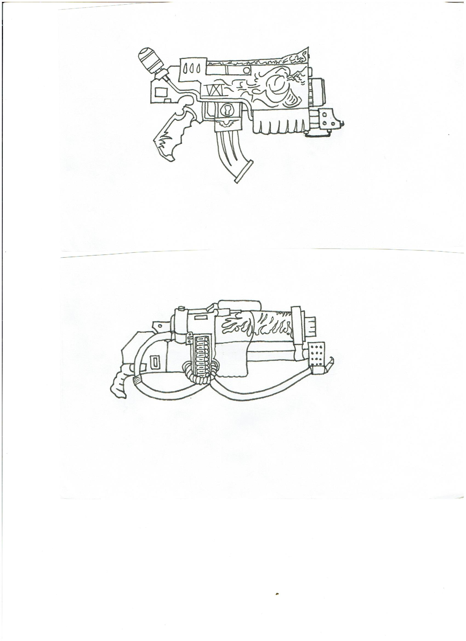
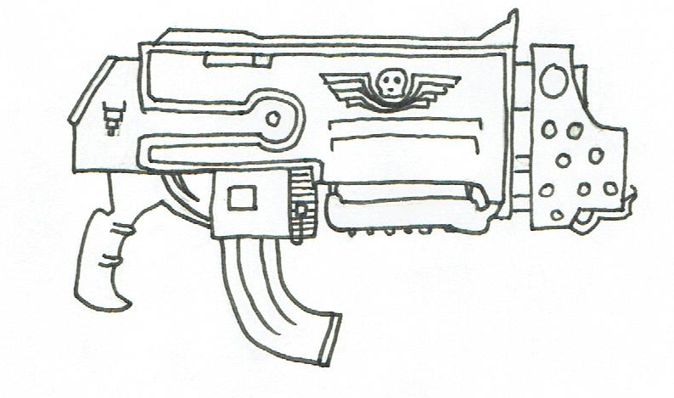
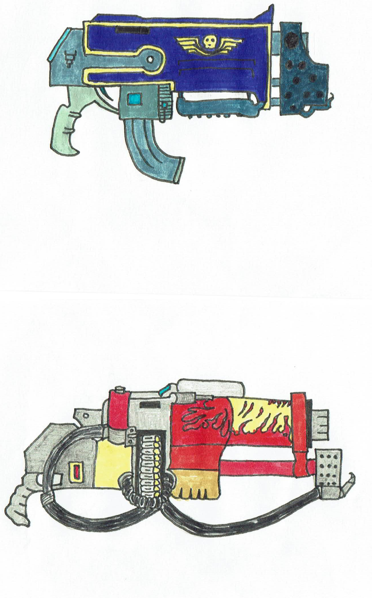
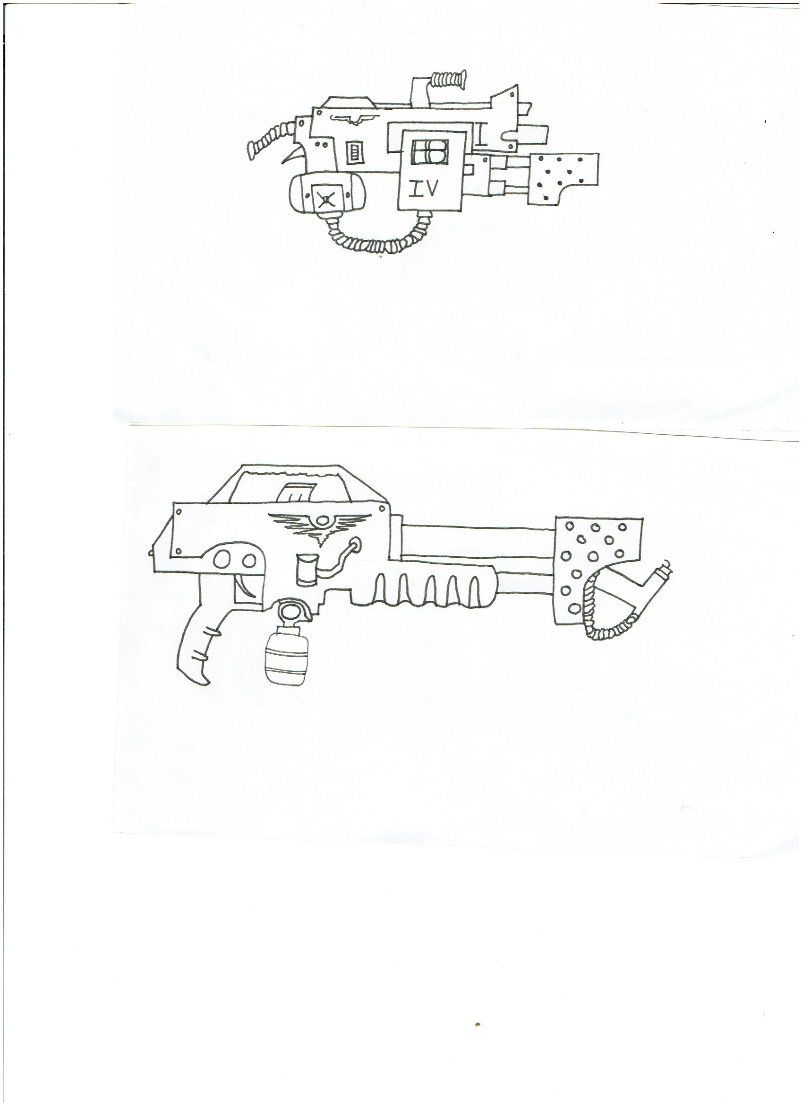
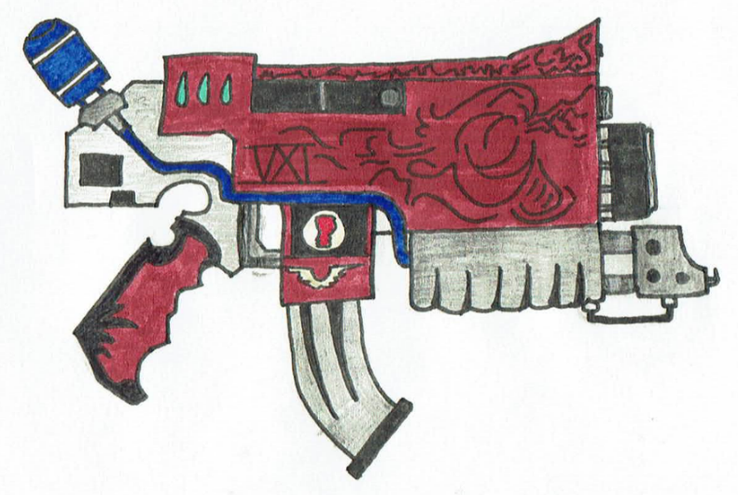
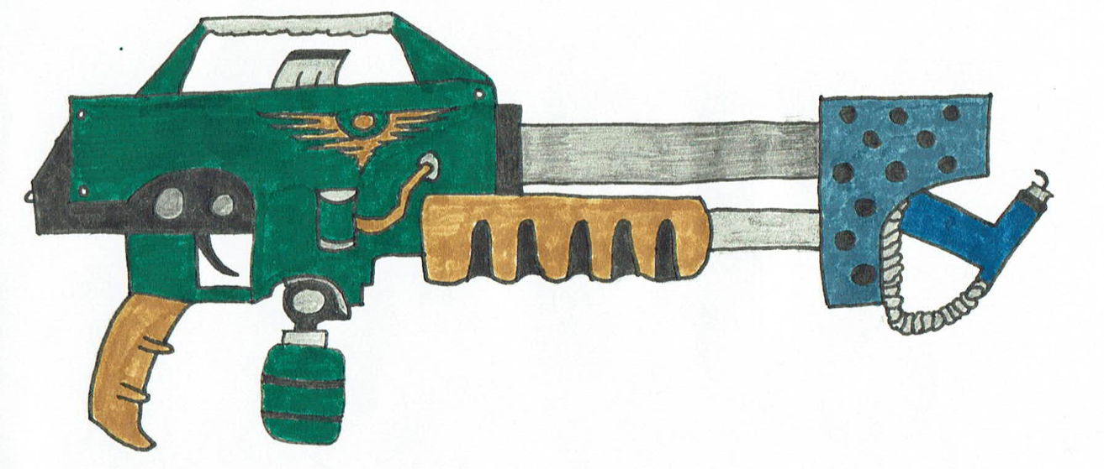
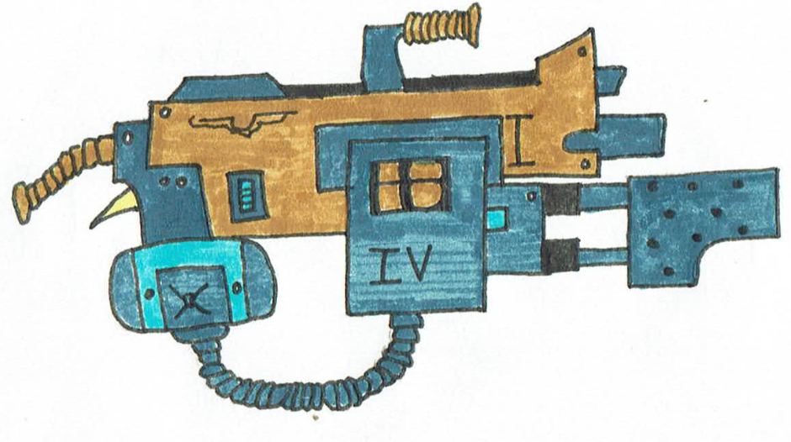
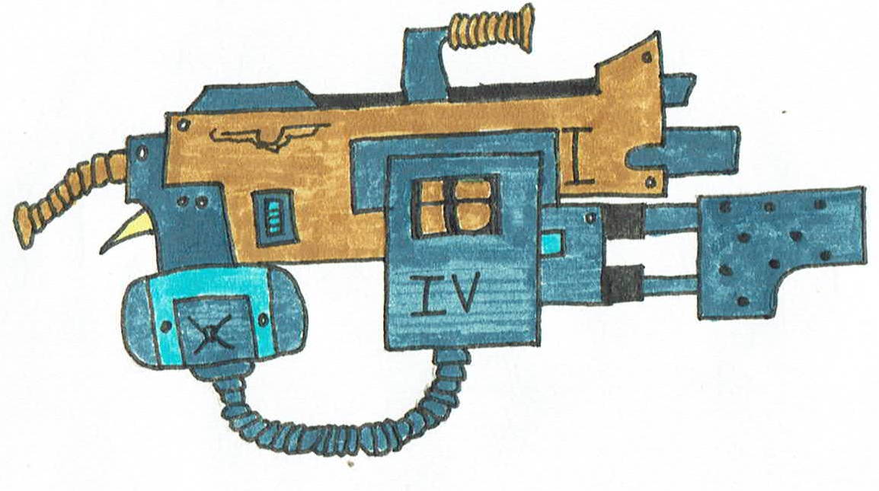
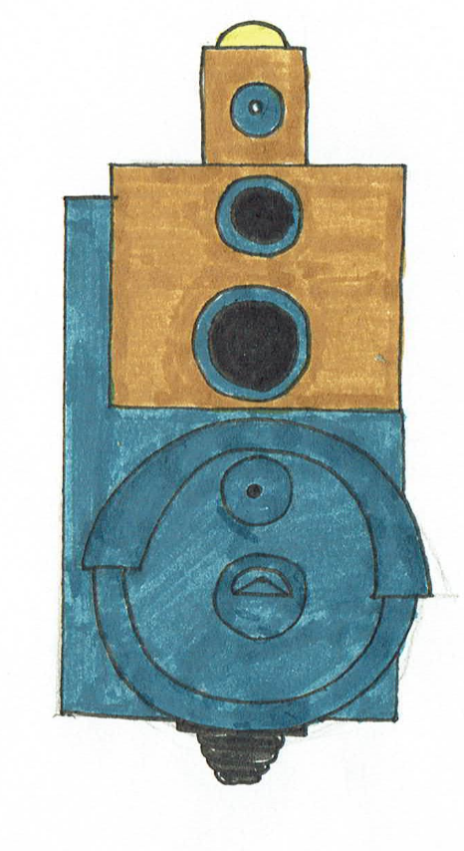
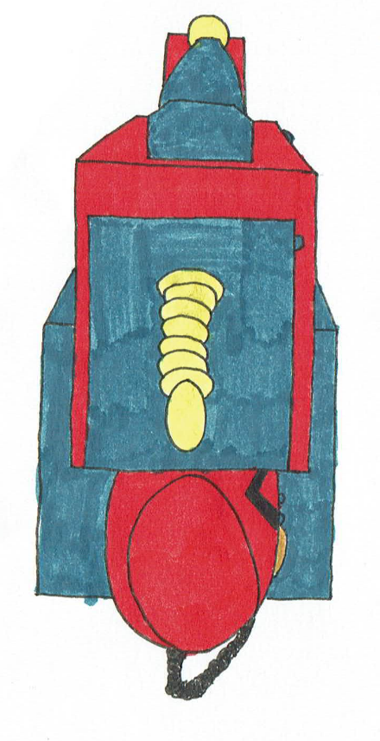
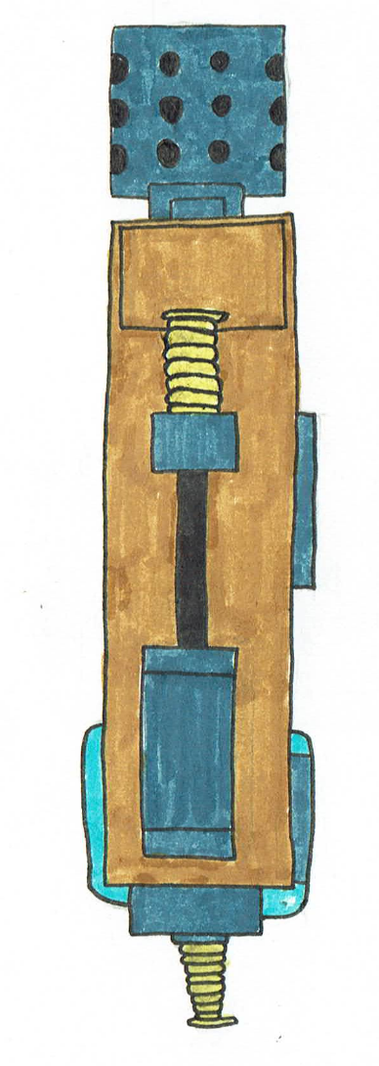
TASK F: Reference images / Orthographic projections

TASK G: A Final Design
FlameBolterComboMark1: Rendered Images and a link to the 3d model.
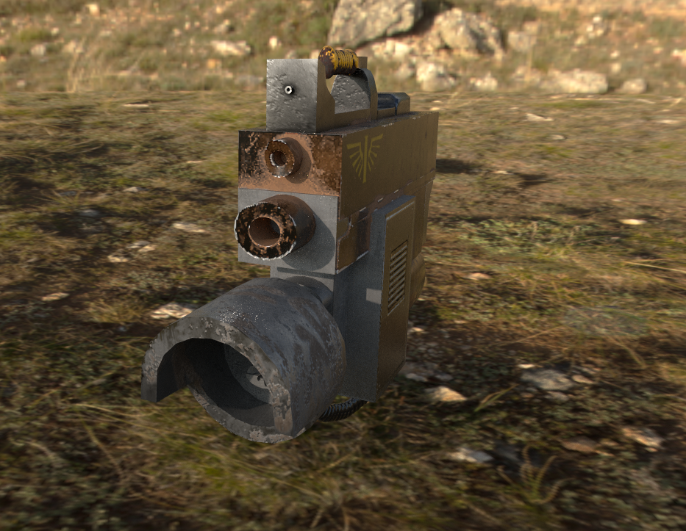
https://sketchfab.com/3d-models/fmcmark1-4f9f3f831ecf4334a532193b66d47d66
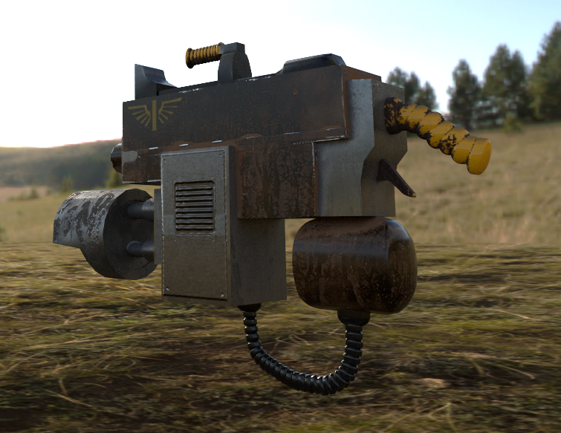
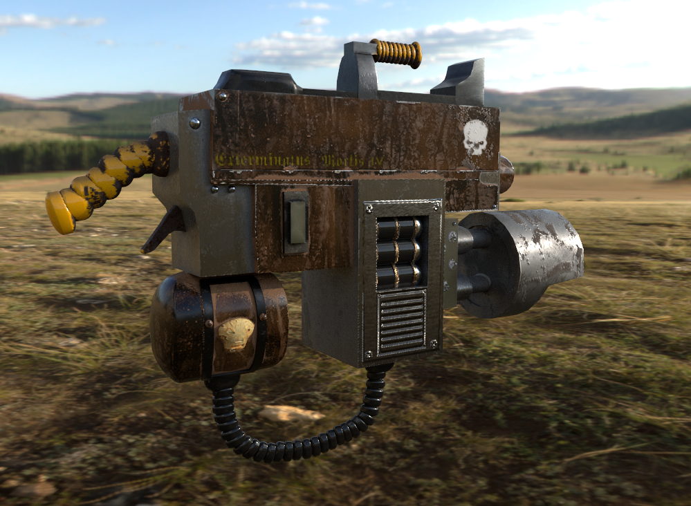
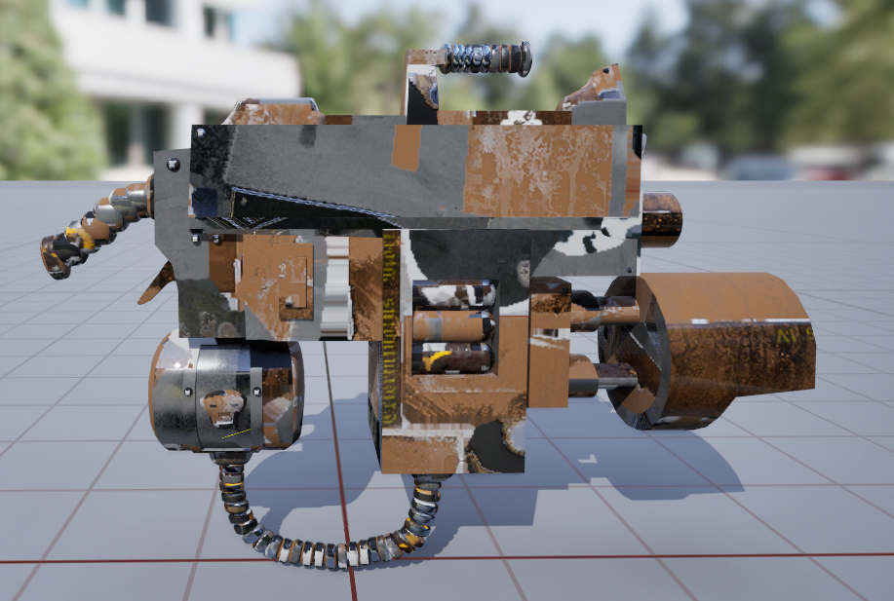
TASK H: A 500-word critical evaluation
Having developed several ideas in the first assignment, the main theme of a dual weapon combined with that of a sci-fi military background meant selecting from the initial designs ended up being quite an easy selection, due to functionality and personal choice [1]. Settling on what is now called an FBCmk1 (FlameBolterComboMark1) five more iterative designs were created for development and research purposes.
During the development phase, placement was carefully considered regarding ammunition storage, grip handles, sights, and weapon functionality. Different variations were considered with calibre rounds and injection of chemicals, checked and compared to see how the design would be most functionable [1][2][3][4][5].
From these developed ideas you can see that having the chemical storage underneath the weapon helps with increasing visibility compared to other designs where it was centred on the top, whilst the weight distribution is more evenly spread.
After completing several design iterations based on the previous development criteria the final design was settled on as the most practical in use and application. The use of maya to model out a basic block-out helped to gain a greater understanding of the size and bulk of the weapons design. The orthographic projections combined with the block-out ensured greater accuracy [6].
Experimenting with different colour schemes from current urban combat to fantasy-Warhammer units like such as Space Marines. The final design idea was to incorporate both to make an aesthetic that had a feel of active battle. The colour scheme reflects use in a built-up urban environment [2][3][4].
Adobe substance painter allowed for effects such as rust and weathered metal paint by utilizing smart materials and photoshopped textures. The ability to fine tune the parameters of smart materials mean for greater manipulation, an example of this being the weapons reflectiveness on the steel barrel and the dullness on the flamer’s Cast-Iron turret. Most impressive was the ability to create depth with a flat surface with the best example of this being the vent system on the ammunition box [7].
When modelling the FBCmk1 a few mistakes were made, however these were not realised till after exporting the mesh into 3D Substance painter where they became a lot more obvious to spot. After reexporting the amended FBX file the back plate for the flamer was now no longer see-through and the correct UV had been imported. This would later again cause an issue when trying to import into Unreal for the final render, due to having multiple save files and importing the incorrect FBX file into Unreal with the textures resulting in the last image [8]. This was corrected for the final rendered image with the correct UV. The last issue was implementing the height map in the unreal blueprints, with the addition of bump offset and changing the vector of the pixels I was able to add the height information, this is an example of additional research conducted [9].

Reference and Bibliography
[1] A. Davis, “Innovation & Research,” Behance, https://www.behance.net/gallery/191753827/Innovation-Research
[2] C. to W. 40k Wiki, “Laser weapons,” Warhammer 40k Wiki, https://warhammer40k.fandom.com/wiki/Laser_Weapons
[3] C. to W. 40k Wiki, “Flamer Weapons,” Warhammer 40k Wiki, https://warhammer40k.fandom.com/wiki/Flamer_Weapons?so=search
[4] C. to W. 40k Wiki, “Sniper rifle,” Warhammer 40k Wiki, https://warhammer40k.fandom.com/wiki/Sniper_Rifle?so=search
[5] C. to W. 40k Wiki, “Bolter ammunition,” Warhammer 40k Wiki,https://warhammer40k.fandom.com/wiki/Bolter_Ammunition
[6] “Autodesk maya 2025.” Autodesk, San Rafael, CA, 2006
[7] Z. J. Shah, “Realistic Asset Creation with Adobe Substance 3D: Create Materials, textures, filters, and 3D models using substance 3D painter, designer, and stager.”
[8] The most powerful real-time 3D creation tool - unreal engine, https://www.unrealengine.com/en-US (accessed Apr. 27, 2024).
[9] NeamuMa-tii, “How do you add a height map to your material ?,” Epic Developer Community Forums, https://forums.unrealengine.com/t/how-do-you-add-a-height-map-to-your-material/683525

