
UNIVERSITY OF WALES TRINITY SAINT DAVID
School of Business
London Campus
PROBLEM SOLVING AND DECISION MAKING
BMSW4004_LON
Mr. Mushfiqur Rahman

SAMANTHA ESTEFANIA MONCAYO CASANOVA
1907363
Table of Contents
1. INTRODUCTION 2
2. DECISION MAKING TECHNIQUES AND TOOLS TO EVALUATE THE RISE OF SOLUTIONS. 2
3. ANALYSIS AND DISCUSSION 2
3.1. Description of the problem 2
3.2. Fishbone Diagram 4
3.3. SWOT Analysis 5
3.3.1. SWOT Analysis explanation 5
3.4. PESTLE Analysis 7
3.4.1. PESTLE Analysis explanation 7
3.5. Description of solutions 8
3.6. What solution I think is the best? 9
4. CONCLUSIONS 10
5. REFERENCES 10

INTRODUCTION
As we know, problem solving and decision-making skills are very important abilities we need in our professional life. Problem solving frequently encompasses decision making, and decision making is really important for management and leadership. Problem solving and decision making are thoroughly connected and each requires originality in recognising and developing possibilities.
Problem solving is a logical procedure used to find the possible resolutions to the situation at hand and decision making is a choice made by using one’s judgement.
(Changeboard Team, 2019)

DECISION MAKING TECHNIQUES AND TOOLS TO EVALUATE THE RISE OF SOLUTIONS.
The following report describes a problem related with the lack of communication in my current workplace. In addition, I will show different solutions for this situation making use of the recognised problem-solving tools and techniques that I learned during this term. First of all, I will make use of the SWOT, PESTLE analysis and Fishbone of the company I´m working at the moment, then I will analyse the problem and write about the scope and the impact that the lack of communication brings to the workers. After that, I will show a list of solutions for the problem and I will choose the one I think is the best for give a resolution to the lack of communication.

ANALYSIS AND DISCUSSION

Description of the problem
Lack of communication or poor communications skills is when there is an impossibility of being able to convey a clear and concise message to a person. There are factors that prevent communication from being correct, such as language differences, fluency when speaking, incorrect use of words, bad body language or weak listening skills.
The actual problem in my workplace, is the poor communication between the manager and the employees. In my case, the problem begins when I start working. I came from another country and my first language is Spanish so I have some problems at the beginning with English and the way of communicate with other people was a little bit bad. The first factor that affects this was the difference between languages. The second problem came when I realise that my manager has weak listening skills and a very poor body language, so I have difficulties to understand what she was saying. Most of the time, she didn’t listen what the employees were saying and ignore some of our requests and the effect that this caused was the complications to work without the material that was requested and that our manager did not provide it to us.
The scope of the problem occurs only in the city of London, specifically in the spa located in Primrose Hill, where the failure is made by our manager who doesn’t know how to express correctly his ideas and instructions. This cause confusion in the workers on issues related to work schedules, wages and sometimes the lack of equipment necessary to work.
The impact that this situation generates is that the lack of communication prevents the good understanding of the message sent by our manager, in addition this causes that the workers have a absence of confidence towards our superior and that they cannot communicate any situation that occurs in their workplace or any inconvenience that happens in the spa. Also, there have been occasions when beauty therapists haven’t known what to do and the manager has not been helpful in solving doubts, in addition, this problem has sometimes caused some kind of discussion between therapists and that is not correct because all the members are there to help and not to disturb the customers. The last thing that occurs is the effect called “the grapevine”, also known as the telephone game. If one person miscommunicates information, that information can simply be passed along through the workplace. Of course, the diffusion of misinformation can lead to create confusion, fear and overall disaster in the office.

Fishbone Diagram

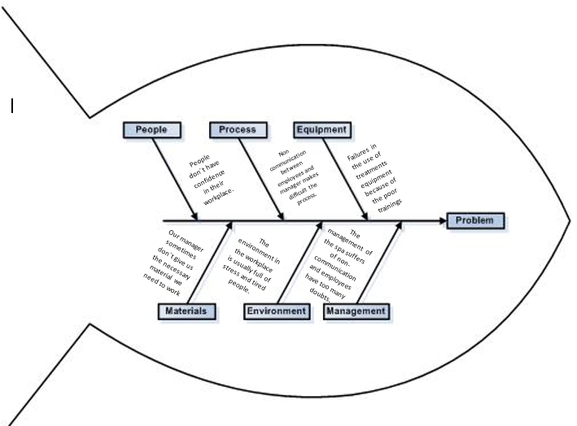

SWOT Analysis

SWOT Analysis explanation
In strengths we have excellent customers service, this is because our clients always have the best spa treatments with professionals that knows exactly what to do and this gives our clients the confidence and security of being in good hands. Also, we have a very good location in Primrose Hill, near Camden Town where there is always a good transit of people. The last strength we have is strong knowledge about body and face treatment, this is because our beauticians are in constant learning about spa treatments.
In weaknesses we have flexibility of staff working hours, this is because some difficulties with the schedule and the lack of communication between the manager and the employees. Also, we have lack of capacity, before Covid-19 we have a small place to work with people and always have some big demands. Now, because of the same reason and to maintain the correct social distancing, we have to reduce our capacity for attending people. Is known that social distancing is now necessary but it represent a little problem because the high demand of people that want a beauty treatment in our spa.
In opportunities, we have stock organic products, this is because we have COWSHED treatment brand that are produce with organic materials and are 100% natural. Also, we have strong market growth because we are a spa located as well in other countries of the European union. The last opportunities we have is local business partnerships, this is because nowadays we are working with Skin Ceutical brand to have better results in our customers beauty and health treatments.
In threats we have the new opening of different spa in the area like Lavender on the hill Spa, that are offering new discounts for the customers. The last threat we have is the impact of the global economic actual situation because of Covid-19 that affects all countries around the world. Covid-19 represent a change in the economy and everybody is trying to maintain their own economy correct. Our spa in not different, because of the pandemic, we had to close our services for people and now, we are following all the rules that the government gives us to the correct management of the spa and be Covid-19 free and keep safe our clients.

PESTLE Analysis

PESTLE Analysis explanation
In the political factors we have the changing of the government rules and regulations for business related to health and beauty industry with a little of employment limitations and prices to be worried about. Also, there is the introduction of new instructions for beauty cultural field.
In economic factors we have the increasing inflation rates that influence people to cut down on their consumption patterns.
In social factors we have that in the beauty industry is a growing request for health spa amenities because of the needing of have a better health. Also, we have the petition from older individuals for health spa treatments because they want to have a younger appearance. The last social factor is an growing capability by people to be able to pay for treatments.
In technological factors we have a growing need for spa´s to ensure that the members of staff have the necessary trainings to use the different equipment for the body and face treatments.
In the legal factors we have that all practitioners will have to be appropriate capable, which will have the influence of growing staff prices. Also, we have that the insurance will have to be preserved and all necessary service regulation requirements obeyed with.
In the environmental factors we have that there is a dangerous relation in the different substances such us massage oils and cleaning chemicals that can affect to the customers or employees in the spa. Also, we have that the environment might carry chances to the spa company with a rising demand for organic and natural products.

Description of solutions
Last but not least, I will describe some of the possible solutions I think they could apply in my workplace to avoid the poor communication between the members of staff and the manager.
The first solution that I am going to propose is establishing a baseline of communication standards in which the members of the company have to create brand guidelines applying conduct communication training. This will build a strong foundation where the communication will be the base of the relation employee-manager.
The second solution that I propose is the creation of a safe place where the employees can communicate to each other, with this, everybody will gain confidence and they will start to share ideas, giving opinions about any situation that occurs in the spa, report issues or asking questions about any doubt they have.
The third solution that I propose is the application of monthly surveys to get the feedback of the employees. With surveying all workers, the manager can collect all the information and compile into the data needed to keep an eye on problems, upgrade workplace culture, and improve employee engagement. But surveys are not the only way to obtain feedback, also we can have individual meetings between the team members and the manager to talk about any kind of doubts. In both cases, the manager has to collect the information from employees and create strategies to the better functioning of the spa.
The fourth solution I propose is to get the control of the new technologies and make use of it. The manager can create a group in a social network like WhatsApp, with all of the spa members of staff. This type of group chat, helps everybody to create a good friend relationship, also, improves communication and everybody can give their opinion.

What solution I think is the best?
For the lack of communication problem, I think the best options to give a solution is to apply the second and third options that I describe before. The second one explains about the creation of a safe place where the employees can talk about anything and improve their communication skills and their team working abilities. Because of this, I think that our manager should consider this option, where all workers will have the option of giving their points of view and giving their opinion on the different aspects to be considered in the workplace. If there is the possibility, I think that the third option is also a good option to solve the lack of communication in the spa. I think every manager need a feedback to know if they are doing a correct job. In my workplace case, my manager needs to hear from the employees that there are some failures in the type of communication that she is using in the spa. She needs to know that we don’t understand some of the instructions of what we have to do. A bonus for these solutions can be certain rest intervals where workers can have a moment to relax and socialize with the rest of their colleagues.
Because of these reasons, I feel that we need urgently to apply any type of resolution. All we want is that the management and maintenance of the spa, keeps correct and doesn’t affect to our customers and the way we work every day.

CONCLUSIONS
In conclusion, the lack of communication can be caused by excessive work on both parties, workers and managers, which does not allow creating a relationship between co-workers due to the constant pressure demanded towards them. The fundamental problem is that this causes little trust among staff members and consequently, a lack of communication between them and a poor work team relationship.
I also conclude that write about the problem we have in the spa, with an analysis of the factors that can have influence in the decision making and the description of some of the possible solutions that the workers can apply in their workplace, is a good way of solving a problem in a company and helps a lot in the improving of communication skills between all the members of the spa.

REFERENCES

Changeboard Team (2019) Changeboard. [Online]
Available at: https://www.changeboard.com/article-details/16960/problem-solving-vs-decision-making-what-is-the-difference-/
[Accessed 26 August 2020].

