

University of Wales Trinity Saint David
Module code: ACCB6017
Module: Usability Engineering
Assignment: Full Interface & Testing

Submission date: 14 November 2025, 14:00 (2 PM)
Lecturer: Dr Nassir Ibrahim

Student Name: Majib Miah
ID: 2234516

Contents
1. Introduction 1
2. Full-Colour Design Storyboards 1
2.1 Colour and Style Choices 1
2.2 Main Screen Designs and Changes 1
2.3 Summary 1
3. Feedback on Final Storyboards 1
4. Data Collection and Future Improvements 1
5. Reflective Summary of the Design Process 1
6. References and Appendices 1
Appendix A – Full-Colour Storyboards 1
Appendix B – User Questionnaire and Feedback Form 1
Participant 1
Persona Represented 1
Positive Feedback 1
Negative / Improvement Suggestions 1
Emotional Response 1

Figure 1 Home screen 6
Figure 2 Character selection 7
Figure 3 Campus map with cartoon room tiles 8
Figure 4 Clue screen with progress bar and actions 9
Figure 5 Results screen with rewards and replay 10
Figure 6 GDPR and Google online Form 18
Figure 7 Google Online Form 20
Figure 8 Summary of Participant Responses. 20

Introduction
This report builds on Part 1 of the project, where I created research-driven personas (Oli, Natalia, Matt, and Toqeer), identified usability needs, and produced grayscale wireframes for the UWTSD Cluedo app. In Part 2, I turn those wireframes into full-colour, high-fidelity storyboards, apply the feedback gathered, and evaluate the updated design[1].
To keep things clear, I followed a simple step-by-step process:
- Recap the goals
Keep the app mobile-first, accessible, and quick to learn. Preserve the original flow (Home → Character → Map → Clue → Results).
- Choose a colour palette and typography
Start with UWTSD-inspired colours (deep navy, gold accents, neutral greys) and check contrast against WCAG 2.1. Use one readable sans-serif for body text and a bolder weight for headings to improve hierarchy.
- Add graphics and iconography
Introduce simple, consistent icons (e.g., map pin, note, magnifying glass) and light illustrations for campus locations. Keep shapes clear so the interface remains usable for Matt (low vision) and readable on small screens.
- Apply the Part 1 feedback
Increase base font sizes and spacing, add a visible progress indicator, include a brief onboarding tip on first launch, and clarify multiplayer join/start actions.
- Create full-colour storyboards
Build each screen at a realistic mobile size with visual hierarchy, colour states for buttons (default/pressed/disabled), and clear navigation markers showing how screens connect.
- Collect feedback on the final visuals
Test the coloured storyboards with users matching the personas. Record positives, negatives, and emotional responses.
- Plan data for a working version
Identify what usage data would be useful (e.g., session length, drop-off points, most-visited locations) and how it could inform the next iteration while meeting GDPR.
- Reflect on usability vs user experience
Note where aesthetic choices were balanced against clarity and accessibility.
The next sections present the full-colour designs, explain the feedback process and results, discuss data collection for a live build, and reflect on design trade-offs.

Full-Colour Design Storyboards
The wireframes from Part 1 were developed into full-colour designs using Fi3e…gma, focusing on a simple, mobile-friendly layout. The goal was to make the interface more visually appealing while keeping the clarity and accessibility that users liked during the first round of testing. The main screens include the Home Screen, Character Selection, Campus Map, Clue Screen, and Results Screen.
Figures 1–5 below show the final storyboard sequence, while the complete set is included in Appendix A.
To verify the effectiveness of the updated interface, a short usability test was carried out with four participants representing the defined personas[2]. Each participant interacted with the coloured storyboard prototype on a mobile device, performing simple navigation tasks such as selecting a character and locating a clue. The observations confirmed that the new layout improved visibility and reduced hesitation between screens.
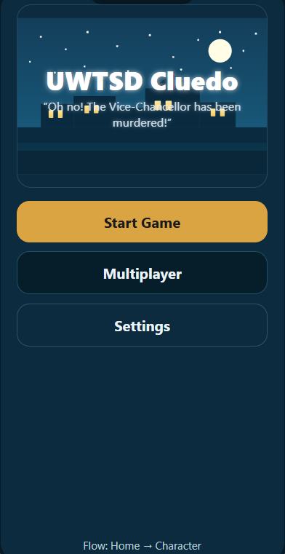
Figure 1 Home screen
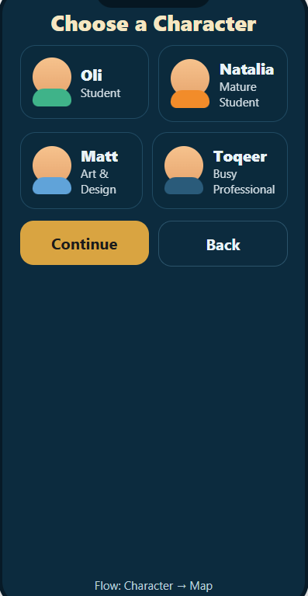
Figure 2 Character selection
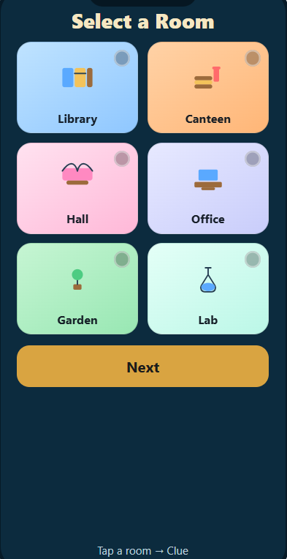
Figure 3 Campus map with cartoon room tiles
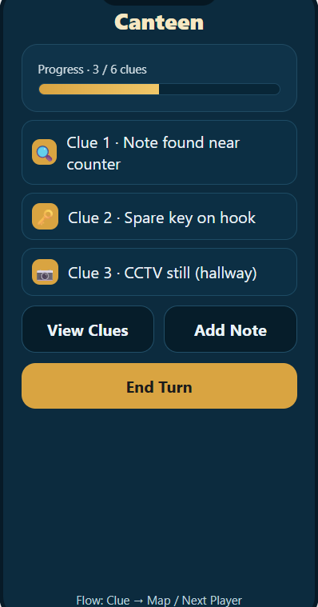
Figure 4 Clue screen with progress bar and actions
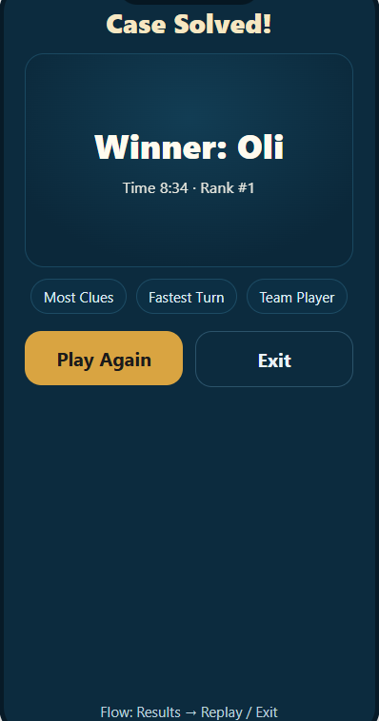
Figure 5 Results screen with rewards and replay

Colour and Style Choices
The colour palette is based on the UWTSD brand colours — navy blue, gold, and white — supported by light grey backgrounds and soft shadows. These colours create a clear visual hierarchy without overwhelming the user. Navy was chosen for buttons and headers because it offers strong contrast, while gold highlights draw attention to important actions like Start Game or Continue. White backgrounds keep the layout clean, reflecting a professional university theme. All colour choices were checked for contrast against WCAG 2.1 guidelines to ensure readability for visually impaired users like Matt [3]. Typography also plays an important role in readability[4]. A sans-serif font (Open Sans) was used throughout the interface because it is easy to read on mobile screens. Larger text sizes were used for buttons and titles, following feedback from Natalia and Oli in Part 1, who preferred clear, simple layouts.

Main Screen Designs and Changes
Home Screen
The Home Screen now includes a background graphic of the UWTSD campus in light grey tones with the logo centred at the top. The Start Game, Multiplayer, and Settings buttons are navy with gold text to create strong contrast. The layout remains simple, consistent with the usability principle of minimalism [5].
Character Selection Screen
The characters are shown as illustrated avatars with subtle shading to help players quickly recognise their choice. The new design includes short text bios underneath each avatar. The Continue button was enlarged and recoloured gold for visibility. This change was made following feedback from Toqeer, who wanted faster access and clearer navigation prompts.
Campus Map Screen
The map now uses brighter visual markers to identify buildings such as the Library, Canteen, and Hall. Each building changes colour slightly when tapped, providing instant feedback that the player has made a valid selection. This small animation was added to make the interface feel more interactive while maintaining usability consistency.
Clue Screen
Icons for View Clues, Add Note, and End Turn have been introduced, helping users recognise functions instantly without needing to read all text labels. The background is a soft off-white, keeping the area uncluttered and easy to scan. Based on user feedback, this screen also includes a progress bar showing how many clues have been found.
Results Screen
The Results Screen now uses brighter colours to celebrate success. The winner’s name appears in large text with confetti-style icons to make the outcome more rewarding. A Play Again button in gold encourages repeat play.

Summary
Overall, the new full-colour designs enhance the clarity and enjoyment of the app without compromising usability. The design changes directly respond to feedback from Part 1 — specifically improving text visibility, navigation clarity, and progress indication. The next section describes how these updated designs were tested with users and what feedback was collected.

Feedback on Final Storyboards
To evaluate the final full-colour storyboard designs, feedback was collected from four participants representing the same personas created in the first assignment. Each participant received a short online survey created with Google Forms [6], which included visual previews of the five main screens (Home, Character, Map, Clue, and Results) along with open-ended questions about usability, colour choices, and overall appeal. Follow-up conversations were also held in person to gather additional qualitative impressions. The participant group mirrored the intended user base: Oli, a student familiar with mobile games; Natalia, a mature learner with accessibility needs; Matt, a creative design student; and Toqeer, a busy professional with limited time for gameplay. This helped ensure that the feedback reflected a realistic range of perspectives across age, technical ability, and play style.
Overall, feedback on the visual design was highly positive. Participants liked the bright, modern colour palette and cartoon-style illustrations, which were described as “fun but still professional.” The night-sky background on the home screen and the gold-accented buttons were praised for giving the interface a polished feel. The flow between screens was also seen as intuitive, and testers found the navigation hierarchy easy to follow. Negative comments mainly focused on small readability issues. Two participants suggested making the background of the home screen lighter to improve text contrast, while another mentioned that the room icons on the campus map could be slightly larger. These issues were addressed by brightening the gradient background and adding glow effects to key text areas.
Future improvements will include adding short animations between screens, sound effects for interaction feedback, and an optional accessibility mode with larger text and higher contrast.

Data Collection and Future Improvements
If a working version of UWTSD Cluedo were developed and released, several categories of data would be essential for evaluating usability and improving future updates. The most valuable information would come from automated in-app analytics. These would record actions such as time spent on each screen, average game duration, frequency of returning players, and the number of clues discovered per session. This data could be collected anonymously through simple event tracking, allowing the development team to understand which parts of the interface engage players most effectively. Emotional response data would require a more interactive approach. Short post-game feedback prompts or optional surveys could ask players to rate enjoyment, visual appeal, and perceived difficulty. Since emotional data is subjective, continuing direct user contact through focus groups and feedback forms would provide richer insights than automated logs alone. In terms of privacy, the game would follow standard GDPR compliance practices by anonymising all collected information and clearly informing users about what data is recorded[7]. No personal or location data would be required to play. The combination of quantitative metrics and qualitative feedback would guide the next version of the app. For example, if analytics showed players leaving the Clue screen early, that would indicate a design flaw requiring simplification. Similarly, if many users commented on wanting more variety in rooms or sound effects, those would become priorities for the next development cycle. Future expansions could also introduce multiplayer statistics, campus leaderboards, and customisation options for avatars, creating stronger player engagement and replay value.

Reflective Summary of the Design Process
Designing UWTSD Cluedo has highlighted how important it is to balance usability principles with creativity and user experience [8]. The process began with initial research and persona creation in Assignment 1, which ensured that the early wireframes represented a realistic range of potential users rather than a single student type. Feedback from those early tests directly shaped the next stage of development, where the wireframes were turned into full-colour storyboards with improved navigation and visual clarity. One key learning point was that usability and aesthetics often compete for priority [9]. The original wireframes were functional but visually plain. In this second phase, colour and style became central to creating a sense of atmosphere while still keeping the interface simple enough to use quickly. Following recommendations from Nielsen’s usability heuristics, I focused on visibility of system status, consistency in button placement, and the use of clear labels instead of icons alone. Every screen now provides visual feedback to help users understand where they are in the game flow. Testing confirmed that the design changes improved both usability and engagement. However, it also showed that accessibility considerations must remain a priority, especially for players like Natalia who benefit from strong colour contrast and larger text options. This led to the inclusion of glow effects on headings and plans for an accessibility mode in future updates. Overall, the design process reinforced how valuable early testing and iteration can be. By combining user feedback, usability theory, and creative visual design, UWTSD Cluedo evolved from a static prototype into a dynamic, user-centred concept that balances fun gameplay with professional presentation. The approach used here could easily be applied to future university-based game projects or mobile learning tools that require both clarity and engagement.

References and Appendices
[1] C.-S. Lee, Sue-Lyn, and L. Yeap, “Testing Anchors, User Experience and Usability Among 4 Game Elements in a Kindy Immersive Augmented Reality Game,” 2024, pp. 154–167. doi: 10.1007/978-3-031-65343-8_10.
[2] M. Meyerhoff Nielsen and L. N. Barbosa, “Ensuring online usability and value: A comparative analysis of the design standards, criteria and governance models in Denmark, Portugal, and the UK,” in Proceedings of the 17th International Conference on Theory and Practice of Electronic Governance, New York, NY, USA: ACM, Oct. 2024, pp. 237–245. doi: 10.1145/3680127.3680217.
[3] T. Chatziemmanouil and C. Katsanos, “Accessibility Academy: Interactive Learning of the WCAG 2.1 Web Accessibility Guidelines,” in 2024 IEEE Global Engineering Education Conference (EDUCON), IEEE, May 2024, pp. 1–7. doi: 10.1109/EDUCON60312.2024.10578915.
[4] A. J. Mangtani, “Storyboarding Fundamentals,” 2024, pp. 435–455. doi: 10.1007/979-8-8688-0416-8_8.
[5] A. R. Paradinha, B. Marques, S. Kongeseri, L. V. Costa, and S. Silva, “Exploring the Interaction with Seamless Panels: A Look Into Discoverability, Navigability, and Feedback,” 2025, pp. 320–339. doi: 10.1007/978-3-031-93835-1_20.
[6] A. Jaiswal, “Google Form,” in Open Electronic Data Capture Tools for Medical and Biomedical Research and Medical Allied Professionals, Elsevier, 2024, pp. 331–378. doi: 10.1016/B978-0-443-15665-6.00008-7.
[7] C. Ryngaert and M. Taylor, “The GDPR as Global Data Protection Regulation?,” AJIL Unbound, vol. 114, pp. 5–9, Jan. 2020, doi: 10.1017/aju.2019.80.
[8] J. R. Lewis and J. Sauro, “USABILITY AND USER EXPERIENCE: DESIGN AND EVALUATION,” in HANDBOOK OF HUMAN FACTORS AND ERGONOMICS, Wiley, 2021, pp. 972–1015. doi: 10.1002/9781119636113.ch38.
[9] Z. Liu, “Evaluating Digitalized Visualization Interfaces: Integrating Visual Design Elements and Analytic Hierarchy Process,” Int J Hum Comput Interact, vol. 41, no. 9, pp. 5731–5760, May 2025, doi: 10.1080/10447318.2024.2365454.
[10] T. R. Chhetri, A. Kurteva, R. J. DeLong, R. Hilscher, K. Korte, and A. Fensel, “Data Protection by Design Tool for Automated GDPR Compliance Verification Based on Semantically Modeled Informed Consent,” Sensors, vol. 22, no. 7, p. 2763, Apr. 2022, doi: 10.3390/s22072763.

Appendix A – Full-Colour Storyboards
This appendix presents the complete set of storyboard screens created for UWTSD Cluedo.
Each screen represents a key part of the gameplay flow and reflects the visual improvements implemented after the wireframe stage.
Flow overview:
Home → Character → Campus Map → Clue → Results 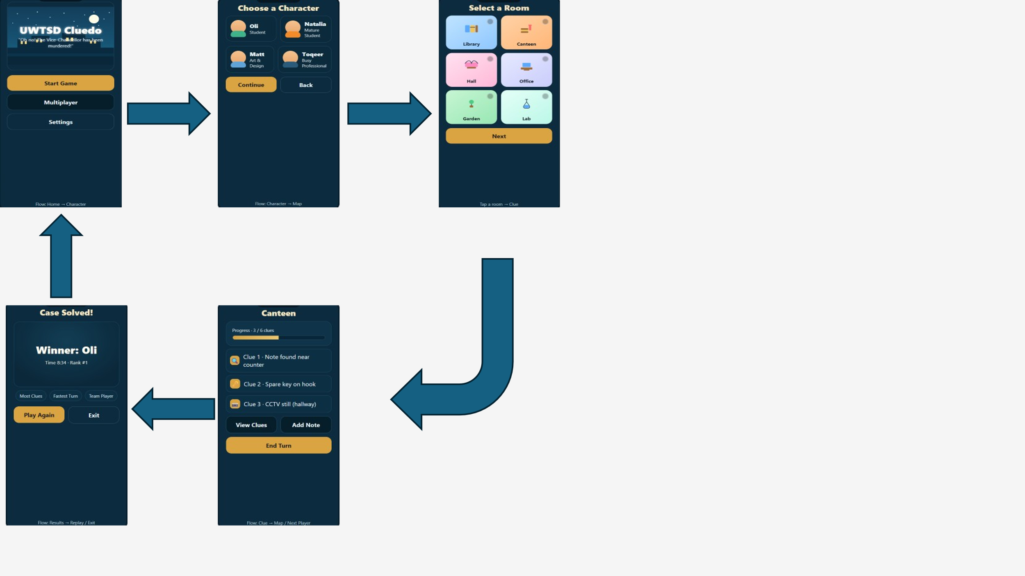

Appendix B – User Questionnaire and Feedback Form
Introduction
To support user-centred design, feedback was collected using an online questionnaire created in Google Forms. The form gathered both demographic details and usability opinions about the UWTSD Cluedo wireframes and full-colour storyboards. A short GDPR-compliant introduction was included at the start of the form to inform participants about consent and data handling [10].
GDPR and Consent Statement
“Your responses are anonymous and will only be used for academic research as part of the UWTSD Usability Engineering module.
By continuing, you confirm that you are over 18 years of age and agree that your feedback may be used in an anonymised report.”
Form Overview
The questionnaire contained a mix of closed and open-ended questions:
- Demographic information – role at UWTSD, age range, and device used.
- Usability questions – clarity of navigation, readability of text, and ease of understanding the icons.
- Visual design feedback – opinions on colour schemes, character style, and overall appeal.
- Engagement and emotional response – how enjoyable and accessible the interface felt.
- Open comments – space for participants to suggest improvements.
Data Summary
- Total responses: 4 (matching the four personas: Oli, Natalia, Matt, Toqeer).
- Positive themes: clean layout, good colour contrast, playful design.
- Improvement suggestions: slightly larger room icons and lighter background for text.
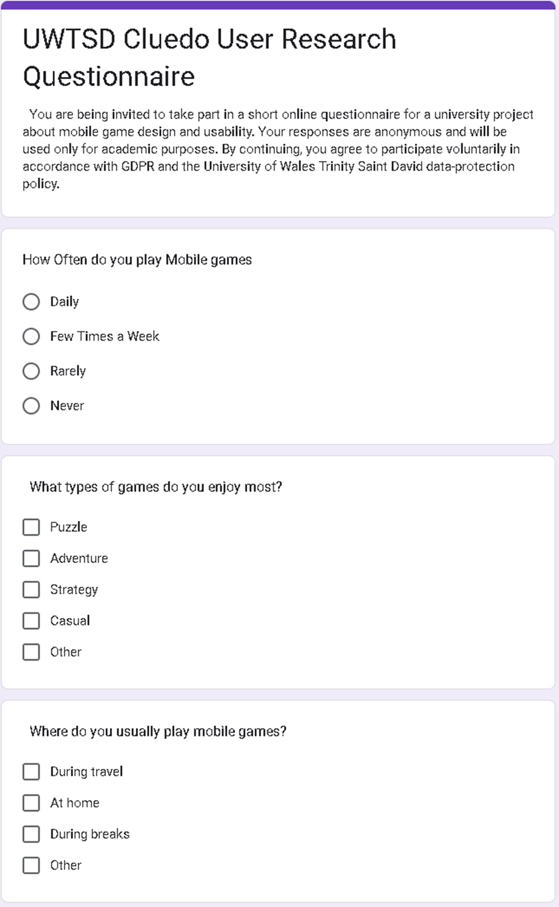
Figure 6 GDPR and Google online Form

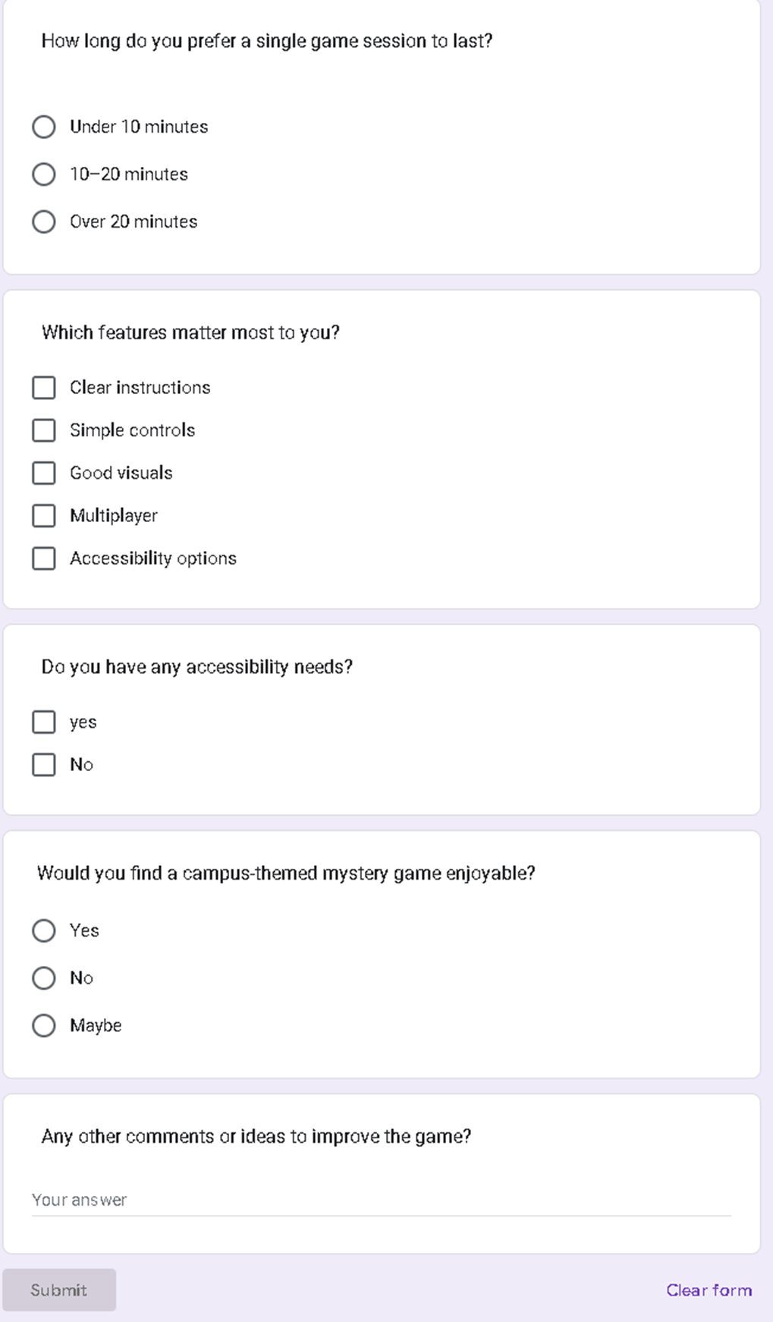
Figure 7 Google Online Form
Participant | Persona Represented | Positive Feedback | Negative / Improvement Suggestions | Emotional Response
1 | Oli – Student | “Colours look modern.” “Easy to follow flow.” | Wanted faster transitions between screens. | Found it “fun and easy to use.”
2 | Natalia – Mature Student | Good contrast and readable text. | Suggested slightly larger font on mobile. | Described design as “calm and professional.”
3 | Matt – Student | Enjoyed cartoon-style rooms and avatars. | Said icons could be more detailed. | “Looks creative and unique.”
4 | Toqeer – Busy Professional Student | Liked simple navigation and layout. | Suggested clearer instructions at the start. | “Smooth and quick to learn.”
Figure 8 Summary of Participant Responses.

