

Assessment 1 – Reading Task Template
PART 1: Upload your photo of your A3 in-class notes here:
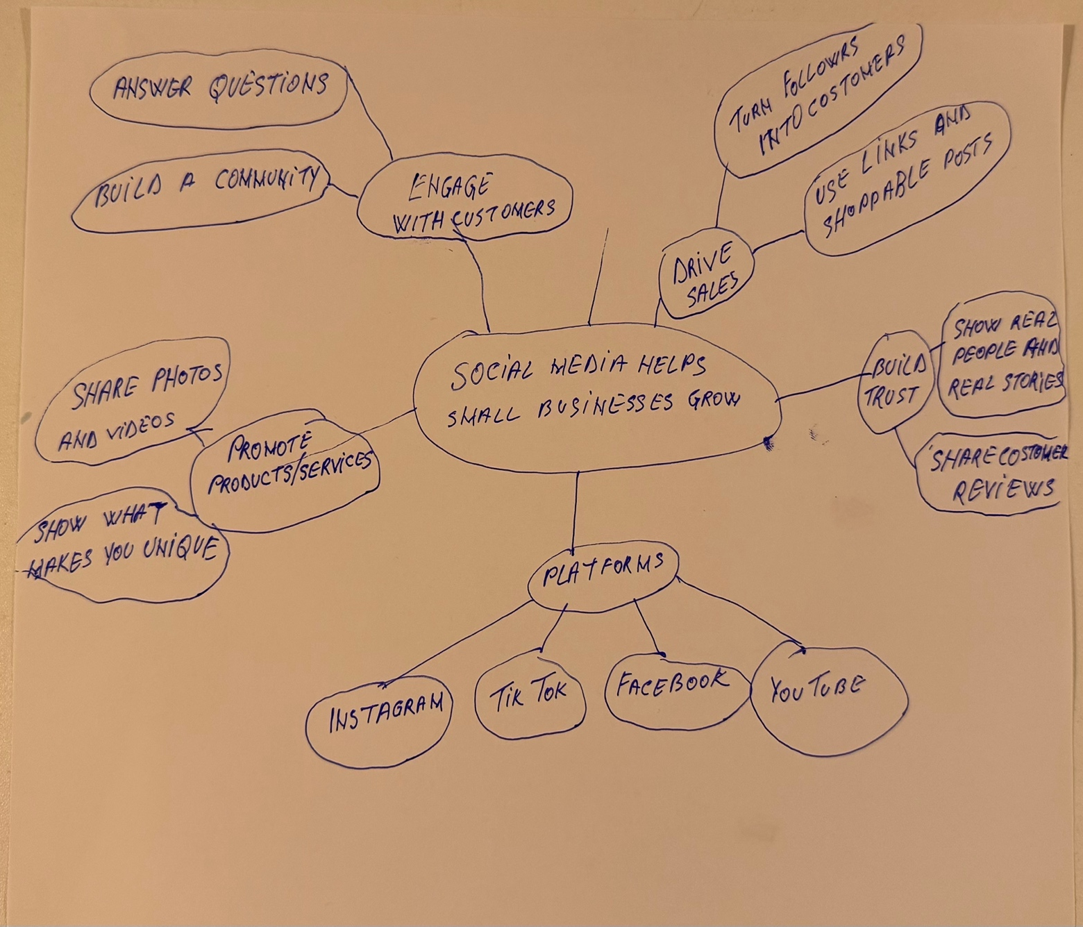

PART 2:
- Answer every question below in 1-3 full sentences.
- Use your own words. Do not use generative AI to answer these questions.
- Include a specific detail from the text when asked.
REMINDER
- The main idea is the overall message of the whole text.
- A key point helps to explain the main idea.
- A specific detail or example from the text shows that the key point is true.

- What is the main idea of the whole text?

The main idea in this text is that the social media can help small businesses to become more popular. Also using platforms like Instagram and TikTok they can attract new customers and increase their sales and turn that into real business success.

- What is one key point that supports the main idea, and which specific example from the text shows this?

The key point is that a viral post on social media can bring customers from far away. The example in the text is that customers can travel three hours to visit Honeywood Sandwich Shop just to try the chicken burger.

- What is a different key point that supports the main idea, and which specific example from the text shows this?

Another key point is that the social media can make a business more popular and increase sales. The example in the text that is familiar to me is Binley Mega Chippy, because I have also seen online how social media had a positive impact on it.

- Which part of the text do you think is most important, and why?

The most important part of the text I think is the examples of small businesses becoming successful through social media. They show that online popularity can lead to more customers and higher sales.

Reflection:
- What did you find difficult in this task (including in-class components), and why was it difficult?

I found it difficult to choose the main idea because the article gives many different examples and it was a bit hard. I had to think about what all the examples had in common.

- What helped you with this difficulty, and how did it help you?

Reading the text a few times and highlighting the important details helped me. I could see that the main thing that helped all the businesses become successful was social media.

