REPORT ON SECURITY ANALYSIS TECHNIQUES AND PROCEDURES
Word count: 5192

Table of Contents
Part 1 3
Introduction 3
Contingency policy 3
Choice of Penetration testing framework 5
Choice of Penetration testing tools 6
Types of mounted attacks 6
Recommendation for threat mitigation 9
Cost of Solution 11
Timetable for execution of solution 14
Part 2 15
1. knowledge gain from the Security Analysis Techniques and Procedures 15
Nature of penetration testing 15
2. HPC with a professional forensics 16
Forensic report 16
3. Invoice for the professional service 17
Reference list 19

Part 1

Introduction
Ethical hacking is a process of detecting vulnerabilities in an application, system, or organization's infrastructure that an attacker can use to exploit an individual or organization. They use this process to prevent cyberattacks and security breaches by lawfully hacking into the systems and looking for weak points. The present report provides an evaluation of “Healios Pharmaceutical Company” (HPC) to identify technical flaws, design weaknesses and vulnerabilities.

Contingency policy
Pen testing, another term for penetration testing, is a type of ethical hacking in which "white hat" penetration testers intentionally execute simulated cyberattacks using tactics and tools meant to access or exploit computer systems, networks, websites, and apps. Security experts can utilize penetration testing techniques and specialized testing tools to check the stability of an association's security policies, its compliance with regulations, its workers' security awareness, and the company's capacity to recognise and respond to cyber security concerns and incidents. Ethical hacking tactics serve as a simulated cyberattack for security professionals to assess the efficiency of security protocols within their organizations (Ghanem and Chen, 2020). The pen test aims to penetrate an organization's cyber defenses, looking for exploitable flaws in networks, web applications, and user security. The goal is to detect vulnerabilities in systems before they are exploited by attackers.
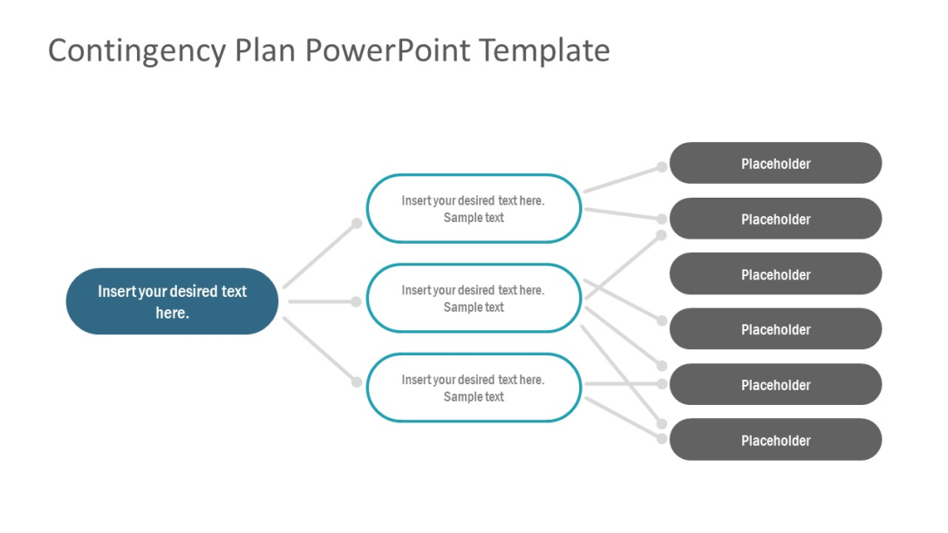

Figure 1: Contingency policy
(Source: Ghanem and Chen, 2020)
Before delving into penetration testing, it is essential to develop policies and guidelines using a contingency plan. As per the views of McKinnel et al. (2019), simulated pentesting based on planning can provide substantially more test coverage than manual pentesting. However, a crucial task for the attack planning is to replicate human hackers to the greatest extent possible. Generally, the policy is developed on the basis of planning, scanning, accessing, maintaining the access and thorough analysis.
Planning- The planning stage helps to decide the scope of the test, the testing methodologies to be used, and any data to be provided to the tester (Duppa and Surantha, 2019). Both the tester and the target need to go through this process to get an idea of expectations from the ethical hacker and what data the tester might have access to.
Scanning- The scanning stage helps to search for any flaws in the system through either static scanning or dynamic scanning. The code of the application or some other target is subjected to static scanning at a specific point in time to determine the behavior of the app and decide the appropriate test that needs to be performed on it. Dynamic scanning helps the tester to operate over the target in real time (Dieber et al. 2020). In order to decide a better target for the testing, dynamic scanning seems to be a more effective way to go since it does not just take a single snapshot.
Obtaining Authorization- After the scanning process is complete, the tester will use any discovered vulnerabilities to try to breach the security of the system or app. As the scanning process reveals, several tools and procedures may be employed.
Preserving Ease of Use- It is one thing to gain access to the system, but it is another to keep that access for long enough to steal data or cause other harm to the system (Svilicic et al. 2019). It will be determined at this step of testing whether the vulnerabilities provide the attacker enough time to obtain information or to install a more serious security risk on the computer system. It is possible for hackers to acquire access for short periods of time, but only long enough to install some form of backdoor that allows them to gain more access in the future (Abukari and Bankas, 2020).
Analysis- It is the fifth step wherein the data is evaluated to see what vulnerabilities were found, how much data was exposed while the tester had access to it, and for how long. To prevent "actual" attackers from exploiting these vulnerabilities, your security staff should be armed with this information.

Choice of Penetration testing framework
Ethical hacking tactics serve as a simulated cyberattack for security professionals to assess the efficiency of security measures within their organizations. The pen test aims to penetrate an organization's cyber defenses, looking for exploitable flaws in networks, web applications, and user security. The goal is to detect vulnerabilities in systems before they are exploited by attackers (Saleem and Hammoudeh, 2018). High-level network security objectives include shutting unused ports, debugging services and calibrating firewall rules, as well as closing any remaining security gaps that may exist.
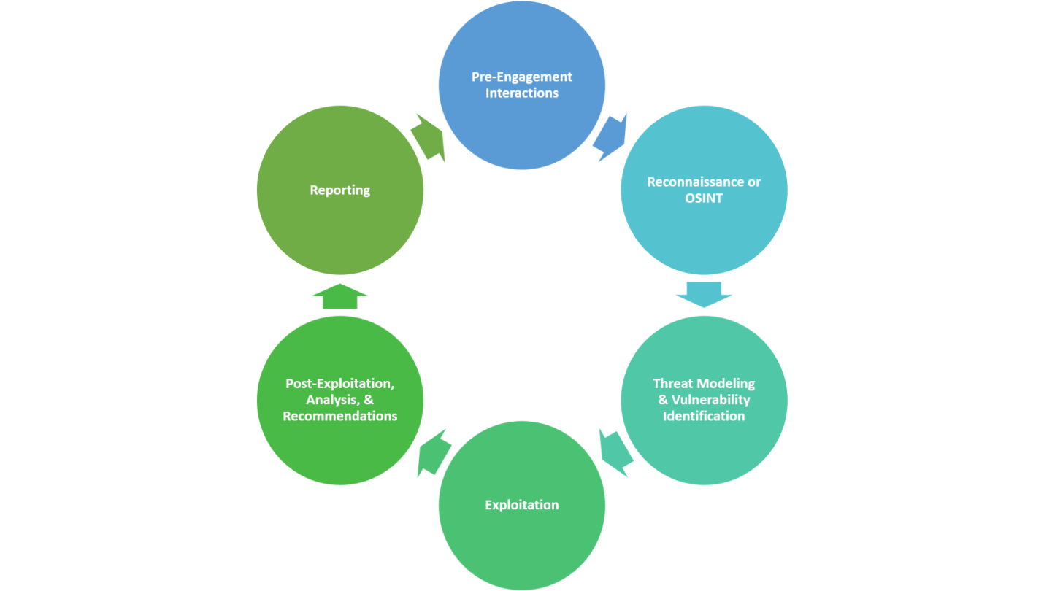

Figure 2: Penetration testing framework
(Source: Saleem and Hammoudeh, 2018)
In the case of web applications, pen testing is aimed to find, analyze, and report on typical web application vulnerabilities such as buffer overflow, SQL injection, and cross-site scripting. This can be done by gaining privileges or stealing data from an otherwise secure system through pen testing as well. Penetration testing is frequently performed in conjunction with a web application firewall to enhance the security of web applications (WAF).

Choice of Penetration testing tools
Pen testing can be carried out either manually or automatically. Automated penetration testing technologies save time and money by automating some aspects of the testing process, allowing for continuous and unattended vulnerability detection. Security weaknesses that allow attackers to gain access to user, system, protocol, or application systems must be discovered during penetration testing in order to help the organization improve its security procedures and patch discovered vulnerabilities (West, 2018). It begins with gathering information about potential targets, discovering possible access points, threatening to break in – whether virtual or physical – and reporting discoveries to the organization's security staff.

Types of mounted attacks
1. Injection
Injection occurs when an attacker exploits insecure code to insert (or inject) their own code into a programme. Injection attacks allow attackers to gain access to sensitive areas and confidential information by pretending to be trusted users. This is because the programme cannot tell the difference between inserted code and its own (Kareem et al. 2021). Examples of injection include SQL injections, command injections, CRLF injections, and LDAP injections. SQL injection attacks are particularly dangerous for the HPC website since it relies on data.
Application security testing can discover injection problems and recommend remedial approaches such as removing special characters from user input or developing parameterized SQL queries.


Figure 3: Types of mounted attacks
(Source: Goel and Mehtre, 2018)

2. Broken Authentication
Authentication and session management calls that have been implemented incorrectly can pose a significant security risk (Srinivas et al. 2019). Attackers may be able to simply assume the identities of genuine users if they discover these vulnerabilities.
Multifactor authentication is one technique to mitigate faulty authentication. Implement scans for FAST and SCA to find and fix implementation flaws prior to deploying any new code.
3. Sensitive Data Exposure
APIs, which allow developers to connect their programme to third-party services like Google Maps, are excellent time-savers (WAHYUDI, 2018). Although insecure data transfer methods can be exploited by hackers to get access to sensitive data, certain APIs rely on them.
Protecting sensitive information can be as simple as implementing data encryption, tokenization, and proper key management.
4. XML External Entities
Insecure programming, integrations, or dependencies allow attackers to upload or add hostile XML content. An SCA scan can detect hazards in third-party components with well-documented vulnerabilities and alert you to them (Sommer et al. 2019). Disabling the processing of XML external entities also minimizes the risk of an XML entity intrusion.
5. Broken Access Control
If authentication and access limitations are not correctly established, it's easy for attackers to grab anything they want. Unauthorized or unauthenticated users may get access to sensitive data and systems due to weaknesses in the access control mechanism.
Configuration mistakes and unsafe access control methods are hard to discover as automated systems cannot always test for them. Penetration testing can discover missing authentication, but other approaches must be employed to determine setup errors. Weak access controls and concerns with credentials management are preventable using secure coding techniques, as well as preventative steps including locking down administrative accounts and controls and implementing multi-factor authentication.
6. Misconfiguration of the security system
In the same way that incorrectly configured access controls put sensitive data and site regions at risk, more general security configuration issues also pose a significant threat (Goel and Mehtre, 2018). Misconfigured security in your application might be discovered through dynamic testing.
7. Cross-Site Scripting (XSS)
It is possible for an attacker to send commands or data from one site into another via cross-site scripting. Because of the increased attack surface that cross-site scripting creates, malicious actors are now able to take over user accounts, view browsing histories, distribute Trojans, worms, and more (Umrao et al. 2018).
Data encoding and input validation are two best practices that developers should be taught. The best way to make sure your data is safe is to make sure it's what you expect for each field, and to encode it for the "endpoint" as an extra layer of protection.
8. Insecure Deserialization
Deserialization, or recovering data and objects that have been written to discs or otherwise preserved, can be used to remotely execute code in your application or as a door to additional attacks. Common serialization technologies like JSON and XML use binary or structured text to serialize an item. This issue arises when an attacker utilizes untrusted data to modify an application, conduct a denial of service (DoS) attack, or execute unanticipated code to affect the behavior of the application.
Although it is difficult to exploit deserialization, penetration testing or the usage of application security tools can further reduce the risk (Ibrahim and Kant, 2018). As a further precaution, don't utilize functions that only accept primitive data types or serialize objects from untrusted sources
9. Using Components with Known Vulnerabilities
Attackers can abuse APIs, dependencies, and other third-party components if they are not secure themselves, regardless of how safe the code itself is. Insecure parts of your programme can be found and eliminated with the help of a static analysis and a software composition analysis. Veracode’s static code analysis tools can assist developers detect such unsafe components in their code before they publish an application.
10. Logging and Monitoring
Failing to log errors or assaults and inadequate monitoring techniques might inject a human element to security issues. In order to carry out their attacks before you notice or react, threat actors rely on a lack of monitoring and longer turnaround times for repair (Qasaimeh et al. 2018).
To prevent issues with insufficient logging and monitoring, make sure that all login failures, access control failures, and server-side input validation failures are documented with context so that you can identify suspicious activity. Penetration testing is an excellent technique to uncover portions of your application with insufficient logging too. Establishing appropriate monitoring procedures is also necessary.

Recommendation for threat mitigation
a. The configuration changes that could be made to the web servers
- Adopting policies and practices that reduce exposures is the preventative measure against injection attacks. Scripting languages, operating systems, and content management systems all provide security issues and challenges (Fathurrahmad and Ester, 2020). In order to avoid SQL injection attacks, any database query needs to be avoided that contains unfiltered data from an HTTP query string. Rather than using raw HTTP query string input, you should parameterize it instead.
- To mitigate the issues of broken access control, implementing multi-factor authentication (MFA) is essential. A combination of small and large letters, capital letters, alphanumeric symbols and special characters can be used to make passwords more difficult to crack. Don't allow more than three failed login attempts in a row (Wang et al. 2021). Notify the system administrator if you find an attack, such as brute force, credential stuffing, or any other sort of assault.
- In order to avoid the leakage of confidential information, security procedures such as Defining the level of accessibility and encrypting the data. Irrespective of whether the information or data is stored or transmitted, it is essential to encrypt it. To a hacker, material in plain text is a virtual open invitation.
- It is possible to protect against XSS assaults using a web application firewall (WAF). WAFs are capable of detecting and blocking harmful bots and other online activities that can point to an impending assault (Hassan et al. 2018). Before any scripts are run, attacks can be prevented.
- OWASP claims that apps and APIs are vulnerable if they deserialize hostile or modified objects supplied by an attacker. Introduce digital signatures and other integrity checks to prevent malicious objects from being created or other data from being interfered with in order to prevent these attacks (Satria et al. 2018). Make use of low-privilege contexts when deserialization code is run, and keep a log of any deserialization failures or errors.
- A patch management method should be implemented to remove unused dependencies, redundant features, elements, directories, and documentation in order to avoid the use of such components (Liu and Wang, 2018). Monitoring, resourcing, and implementing updates and software updates should be a continuous process throughout the life of the application or business.
- In order to thwart attempts of logging and monitoring, begin by creating a baseline of logs required for business, including system logs, rejected logins, suspected or anomalous activity, network, gateways, cloud and so on.
b. Defense strategy to avoid this type of attack succeeding in the future
- Data quality and parameterized queries, including prepared statements, are the only safeguards against SQL Injection attacks in the future. The input should not be used directly by the application code. Input from any source, rather than only user accesses inputs such as login forms, must be inspected by the developer.
- In order to avoid assaults on the website based on invalid authentication credentials, it is necessary to safeguard user credentials (Rak et al. 2020). Password cracking or encryption should be used to protect user authentication processes when they are stored on a computer. No session identifiers should be made public in the URL.
- Standard algorithms and keys need to be robust, and adequate key management needs to be in place. In order to protect passwords, ensure that they are saved in an algorithm that is specifically intended for this purpose Autocomplete should be disabled on forms gathering personal information, as should caching.
- Server-side code or serverless APIs are the only places where access controls can be imposed without the attacker being able to change them or alter their information. By default, block access to features (Deepa et al. 2018). Use technologies such as authentication and authorization and role-based validation to regulate who has accessibility to what information.
- Eliminate serializing sensitive data and instead go for simpler configurations such as JSON. All XML processors and libraries used by the programme or the underlying operating system should be patched or upgraded at the same time.
- Server-side code or serverless APIs are the only places where access controls can be imposed without the attacker being able to change them or alter their information. Access control unit and integration tests must be included in the development process to avoid assaults on the system (Akbulut, 2018).
- It is possible to avoid network misconfigurations by managing the network configuration. Network device configuration backups can be updated, archived, and accessed. Execute security audits on the network Using an automated tool to avoid security misconfigurations.

Cost of Solution
a. Cost of replacing software or Hardware (if required)
Embedded software differs from desktop software in that it has a strong link with the hardware. This has always seemed evident to me. When it comes to custom-built embedded devices, the hardware platform is a mystery. As a result, it's obvious that hardware and software development should be done in concert. In the past, the relationship between hardware and software teams has been more like "we vs them." Things are looking well, but I've observed a few little quirks that have an impact on their relationship: Hardware is not something that can be put off (Čisar et al. 2018). Stable hardware has always been the prerequisite for software development. With lengthier development cycles and faster time-to-market, work has to begin considerably earlier in today's industry (Fischer et al. 2020). The next hurdle is gaining access to the blueprints of the hardware so that software developers may work on it.
Developers of software and hardware do not share the same set of toolsets. It's unrealistic to hope for a shift on the part of any party. If you ask a software developer to work with hardware design tools, it's like having an electrician do the work of installing your sink with a pair of wire-cutting scissors (Upadhyay et al. 2020). An oscilloscope is an excellent tool for analyzing time delays in real-time operating systems, and I often recommend it in presentations. Engineers are apprehensive about employing such a tool. There are a variety of ways to calculate the costs. The EDA salesman said he couldn't grasp our pricing list, and I remember that "Debugging software requires complex tools, and this debugger just costs $5K? Why aren't you charging $50K?" Because many software engineers expect their tools to be provided for free, he was stunned into silence.
Everything is altered by those in positions of power. Aside from CPU selection, the hardware was traditionally developed, constructed, and delivered to the software team without any previous consultation. Software development has evolved to a point where it is possible for developers to offer direction – rather than relying just on the resources they are provided. Software-driven hardware design is becoming the standard as power management becomes more crucial in the design process (Sun et al. 2020). It's critical to know the distinction between price for named users and pricing for concurrent users. Using named user pricing, all users may use the product at the same time, and each user has their own unique login. Only a certain number of users may be simultaneously logged in at the same time with concurrent user pricing. The named user price for 20 users is the best option if you have a team of 20 persons who will be using the product at the same time. Concurrent user pricing for five users may be less expensive if only five of your twenty users need to use the product at the same time (Fauzan and Syukhri, 2021). In most circumstances, you'll have no choice but to go with a subscription plan for the product. There aren't many software providers that provide both a perpetual license and a subscription model. Users should still examine the benefits and drawbacks of each model to decide which is best for your company when you have the option to do so or when comparing a perpetual product with a subscription product.
b.Cost of implementing the fix, including your hourly rate
In a cost-benefit analysis, the cost component might be linked to your budget or to the efficiency of your processes. Small businesses may not be able to afford the financial burden of installing the most effective internal controls (Mateo Tudela et al. 2020). Replacement of expensive but ineffective measures is now a need. Internal controls, such as the separation of roles, are crucial. Adding more staff to maintain this level of control, on the other hand, isn't necessarily the most cost-effective option. An option is to perform unannounced internal audits or randomly chosen transaction reconciliations to examine the work of your employees. In order for an internal control system to be effective, both management and workers must work together. As a result, a cost-benefit analysis must take into account the potential consequences of non-compliance (Mateo Tudela et al. 2020). Internal controls, such as authorisation and verification, may have a negative impact on operational efficiency and a propensity to search for methods to speed up everyday routines if they are included into manual systems.
Automated accounting and stock management systems may help reduce the inclination of workers to circumvent rules, as well as boost productivity and improve internal controls. Choosing how to effectively utilize limited resources is a frequent cause of frustration for small-business owners (OSWAP, 2017). This necessitates weighing the advantages of both preventative and detective measures before making a final decision. Aside from the fact that both are important, preventative controls are usually superior to investigative controls. Because they are proactive rather than reactive, preventative controls aim to avoid problems before they arise. In addition, preventing fraud and employee theft is preferable than detecting illicit activity after the fact. It's not only about the money when it comes to putting in place internal controls; the possible legal consequences are also important to take into account. OSHA and HIPAA, for example, have obligatory compliance rules that must be met (Sun et al. 2020). According to the impact vs. cost criteria, complying with federal and state requirements should outweigh the expenses.
The true question is not whether you can afford to install controls, but rather whether you can afford not to establish robust internal controls. Budgetary restrictions and the need to maintain effective internal controls must be balanced in a small company owner's mind. The need of a good internal control system cannot be overstated, yet the expense of certain controls makes it imprudent to include them in your system. An internal control system for small businesses should weigh the expenses against any direct or indirect advantages that they may provide. Internal controls may have a significant impact on your yearly budget.
When it comes to securing your company's data, you can't always afford the up-front expenditures of adding more workers or automating business processes. Consequently, small company owners are often forced to use less expensive and ineffective controls and to make concessions for improvements in the efficiency of their own operations (Wang et al. 2021). A few examples include conducting surprise internal audits and establishing clear, explicit information storage policies. Alternatively Internal control implementation might have a negative impact on productivity and efficiency because of the expenses connected with it.
It is possible that your staff may devise ways to circumvent manual cash management controls such as transaction verification, payment authorisation, and account reconciliation processes. Internal control systems must include both direct and indirect costs when planning their design and implementation. When selecting how to spend limited financial resources, make a distinction between preventative and detective controls and take their relative costs into account. Preventive controls, on the other hand, are proactive procedures that work to avoid fraud, waste, and misuse of company resources.
Preventive controls have fewer negative consequences and are more cost-effective than reactive investigative controls in the vast majority of circumstances. For example, a permanent electronic inventory system that reconciles inventory in real time is more successful than a manual inventory system that includes a monthly physical inventory count in discouraging employee theft (Goel and Mehtre, 2018). Direct financial costs might make it seem impossible to establish some internal controls. You should also think about the indirect costs of ignoring or installing restrictions that are less effective. You may ask whether you can afford not to establish robust internal controls after doing a comprehensive cost-benefit analysis. Because of the high costs of noncompliance with federal and state standards, as well as the expense of repairing a company's damaged image, investing in preventative measures is typically the wiser choice.

Timetable for execution of solution
During plan timetable planning for the execution w have faced many different kinds of issues such as:
- A lack of common understanding
- Uninvolved sponsors
- Misalignment with strategic project objectives and goals
- Poor change management processes
- Ineffective corporate governance
As per the results, researchers understood that it is possible to hack computers, online applications, servers, and networks using a variety of tools and scripts. There is a wide range of these instruments on the market (Satria set al. 2018). Hacking tools for ethical hacking may be downloaded quickly and simply. Some of these solutions are free to use, while others are for sale. Automated ethical hacking solution Acunetix replicates a hacker to stay one step ahead of invaders. The web application security scanner is capable of scanning HTML5, JavaScript, and single-page apps. It's capable of auditing complicated, authenticated web apps and generating compliance and management reports on a broad variety of web and network vulnerabilities.

Part 2

1. knowledge gain from the Security Analysis Techniques and Procedures
Software systems are always under assault, and cyberattacks are becoming more common as technology improves. Software vulnerabilities exploited by malicious software increased by 151 percent in the second quarter of 2018. An internal or external source might cause a security breach, which can lead to catastrophic results. Data loss is a real possibility if an assault results in the disclosure of confidential information or the full shutdown of the system.However, there are many different kinds of procedures will be presented below such as:

Nature of penetration testing
A black box penetration test has been used in this testing. This testing is one in which the tester has no access to any data. An unprivileged attacker's first steps include gaining access, running commands, and executing code, and then moving on to the exploit phase. If you're looking for the most realistic example of how an outsider would attack and compromise a company, this is it. However, it is also the most expensive alternative (Alanda et al. 2021). Using black box pen testing, a system's security is examined against external factors that could be exploited by an external attacker. The inputs and outputs of the software are the focus of a black box test. The tester through this type of pen test does not have access to or knowledge of the software's source code or implementation details (Qasaimeh et al. 2018). It is necessary to write the test cases to match the needs of the application. Customers' interfaces or external interfaces, which allow many computers and processes to connect to the application under test, are the only methods available for breaking into the software.
No prior knowledge of the target system is given to a security expert in black-box penetration testing. For the most part, it's just like an end-user except for one thing: access to the destination URL. Before the testing, the tester is not given access to the application's source code (other than publicly available code), the application's internal data, its structure, or its design. The term "black-box" alludes to the test's initial gloomy, information-free state (Satria et al. 2018). A black-box penetration test has been helpful to conduct real-time, on-the-fly assessment of the application. As a result, it is often referred to as Dynamic Application Security Testing (DAST). Testing your external assets such as web-apps, network security (firewall/router/VPN/IDS/IPS), web servers (Application and Database), etc. can be done using a black-box pentesting technique.
Testing the application from the perspective of a hacker or end-user is not an alternative to a full security evaluation, although black-box penetration testing can help. Validation issues, information leakage through error messages, server misconfigurations, and more can all be detected by this tool (Sun et al. 2020). Penetration testing using only a black box does not uncover all of a system's security flaws. However, when paired with source code review and other security tests, it provides a complete picture of the system and network's security condition.

2. HPC with a professional forensics
- This technique of testing is appropriate in this case because it simulates a hacker's perspective on the application (Alanda et al. 2021). In a real sense, it identifies the flaws in your network and applications.
- It can help to find implementation and configuration errors because it tests the programme while it is running.
- A product build error detector such as old or missing modules and files is included.
- It employs social engineering approaches to detect security flaws in humans (Upadhyay et al. 2020).
- Security concerns that occur from the interaction with the underlying environment can be detected using this technology (e.g., improper configuration files, unhardened OS, and applications)
- Input/output validation mistakes, information leakage in error messages, and other problems are among the things it can catch.
- Compared to gray and white box penetration testing, a black box test may be more cost-effective.

Forensic report
In computer forensics, the primary purpose is to conduct a thorough examination of a computer in order to determine what occurred or who was accountable for what happened, while keeping a correct chain of evidence in a formal investigative report as the following is the report's syntax or template. An investigation's objectives section serves as a list of all the tasks it intends to accomplish. When evaluating media information, forensics examinations may not be able to conduct a complete investigation in all circumstances. A legal council, decision makers, and clients must review and accept the established plan list before any forensic study may begin. At the conclusion of the report, an examiner should include a list of all the tasks he or she has completed, along with the technique they used to do them.
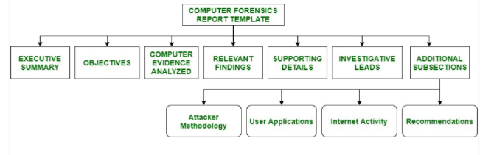

Figure : Digital forensic report procedures
(Source: Upadhyay et al. 2020)
In the case scenario, it has been observed that all the data got deleted from the overall system. In order to mitigate and avoid such instances in the future, the following steps have been followed-
• Application used and protocols involved-
• Tools used-
• How the attack was launched. The forensics methodology used-
• Restricted access to the necessary site-

3. Invoice for the professional service
BILL TO: Manger
Company Name - Healios Pharmaceutical Company (HPC)
INVOICE #
DATE
01/17/22
INVOICE DUE DATE
01/17/22

________________________________________

ITEMS DESCRIPTION QUANTITY PRICE TAX-Am.
ITEM 1 Description 1 $000.00 1% $000.00
ITEM 2 Description 1 $000.00 1% $000.00
ITEM 3 Description 1 $000.00 1% $000.00
ITEM 4 Description 1 $000.00 1% $000.00
ITEM 5 Description 1 $000.00 1% $000.00
ITEM 6 Description 1 $000.00 1% $000.00

An accurate, full, and properly produced forensic report is critical to enabling the report's readers, whether they are management for correcting cultural and control gaps, to implement actions against suspects or make educated judgments. In order to stand up to scrutiny and cross-examination in conflict resolution venues, a professionally crafted report is essential as well. This written report will highlight that Dr. Nera Star is a research scientist employed at the Healios Pharmaceuticals Company (HPC). The firm was developing a vaccination for Covid-19 therapy for humans. For six months, Nera worked on the project. Research materials must be saved in MS Word or Rich Text Format in order to comply with business policy. To avoid manipulation, important papers were saved as PDFs. Therefore, A week after she departed the firm, Nera was found guilty of this crime. Because the enterprise's central backup system was being repaired, her computer was not backed up during a routine backup cycle. In her most recent paper, which included the final formula, she did not provide any proof. It may have resulted in a loss of USD 3 million in different contracts with suppliers if the data had not been recovered.

Reference list
Abukari, A.M. and Bankas, E.K., 2020. Some cyber security hygienic protocols for teleworkers in COVID-19 pandemic period and beyond. International Journal of Scientific & Engineering Research, 11(4), pp.1401-1407.
Akbulut, A., 2018. VinJect: Toolkit for Penetration Testing and Vulnerability Scanning. Düzce Üniversitesi Bilim ve Teknoloji Dergisi, 6(4), pp.779-790.
Alanda, A., Satria, D., Ardhana, M.I., Dahlan, A.A. and Mooduto, H.A., 2021. Web Application Penetration Testing Using SQL Injection Attack. JOIV: International Journal on Informatics Visualization, 5(3), pp.320-326.
Čisar, P., Cisar, S.M. and Fürstner, I., 2018. Security Assessment with Kali Linux. Bánki Közlemények (Bánki Reports), 1(1), pp.49-52.
Deepa, G., Thilagam, P.S., Praseed, A. and Pais, A.R., 2018. DetLogic: A black-box approach for detecting logic vulnerabilities in web applications. Journal of Network and Computer Applications, 109, pp.89-109.
Dieber, B., White, R., Taurer, S., Breiling, B., Caiazza, G., Christensen, H. and Cortesi, A., 2020. Penetration testing ROS. In Robot Operating System (ROS) (pp. 183-225). Springer, Cham.
Duppa, G.I.P. and Surantha, N., 2019. Evaluation of network security based on next generation intrusion prevention system. TELKOMNIKA, 17(1), pp.39-48.
Fathurrahmad, F. and Ester, E., 2020. Automatic Scanner Tools Analysis As A Website Penetration Testing: Automatic Scanner Tools Analysis As A Website Penetration Testing. Jurnal Mantik, 4(2), pp.1138-1144.
Fauzan, F.Y. and Syukhri, S., 2021. Analisis Metode Web Security PTES (Penetration Testing Execution And Standart) Pada Aplikasi E-Learning Universitas Negeri Padang. VoteTEKNIKA: Jurnal Vocational Teknik Elektronika dan Informatika, 9(2), pp.105-111.
Fischer, M., Langer, F., Mono, J., Nasenberg, C. and Albartus, N., 2020. Hardware penetration testing knocks your SoCs off. IEEE Design & Test, 38(1), pp.14-21.
Ghanem, M.C. and Chen, T.M., 2020. Reinforcement learning for efficient network penetration testing. Information, 11(1), p.6.
Goel, J.N. and Mehtre, B.M., 2018. Vulnerability assessment & penetration testing as a cyber defence technology. Procedia Computer Science, 57, pp.710-715.
Hassan, M.M., Bhuyian, T., Sohel, M.K., Sharif, M.H. and Biswas, S., 2018. SAISAN: An automated Local File Inclusion vulnerability detection model. International Journal of Engineering & Technology, 7(2-3), p.4.
Ibrahim, A.B. and Kant, S., 2018. Penetration testing using SQL injection to recognize the vulnerable point on web pages. International Journal of Applied Engineering Research, 13(8), pp.5935-5942.
Kareem, F.Q., Ameen, S.Y., Salih, A.A., Ahmed, D.M., Kak, S.F., Yasin, H.M., Ibrahim, I.M., Ahmed, A.M., Rashid, Z.N. and Omar, N., 2021. SQL injection attacks prevention system technology. Asian Journal of Research in Computer Science, 13, p.32.
Liu, M. and Wang, B., 2018. A Web second-order vulnerabilities detection method. IEEE Access, 6, pp.70983-70988.
Mateo Tudela, F., Bermejo Higuera, J.R., Bermejo Higuera, J., Sicilia Montalvo, J.A. and Argyros, M.I., 2020. On Combining Static, Dynamic and Interactive Analysis Security Testing Tools to Improve OWASP Top Ten Security Vulnerability Detection in Web Applications. Applied Sciences, 10(24), p.9119.
McKinnel, D.R., Dargahi, T., Dehghantanha, A. and Choo, K.K.R., 2019. A systematic literature review and meta-analysis on artificial intelligence in penetration testing and vulnerability assessment. Computers & Electrical Engineering, 75, pp.175-188.
OSWAP, 2017. A9:2017-Using Components with Known Vulnerabilities. Available at: https://owasp.org/www-project-top-ten/2017/A9_2017-Using_Components_with_Known_Vulnerabilities [Accessed on 12th January, 2022]
Qasaimeh, M., Shamlawi, A. and Khairallah, T., 2018. Black box evaluation of web application scanners: standards mapping approach. Journal of Theoretical and Applied Information Technology, 96(14), pp.4584-4596.
Qasaimeh, M., Shamlawi, A. and Khairallah, T., 2018. Black box evaluation of web application scanners: standards mapping approach. Journal of Theoretical and Applied Information Technology, 96(14), pp.4584-4596.
Rak, M., Salzillo, G. and Romeo, C., 2020. Systematic IoT Penetration Testing: Alexa Case Study. In ITASEC (pp. 190-200).
Saleem, J. and Hammoudeh, M., 2018. Defense methods against social engineering attacks. In Computer and network security essentials (pp. 603-618). Springer, Cham.
Satria, D., Alanda, A., Erianda, A. and Prayama, D., 2018. Network Security Assessment Using Internal Network Penetration Testing Methodology. JOIV: International Journal on Informatics Visualization, 2(4-2), pp.360-365.
Satria, D., Alanda, A., Erianda, A. and Prayama, D., 2018. Network Security Assessment Using Internal Network Penetration Testing Methodology. JOIV: International Journal on Informatics Visualization, 2(4-2), pp.360-365.
Sommer, F., Dürrwang, J. and Kriesten, R., 2019. Survey and classification of automotive security attacks. Information, 10(4), p.148.
Srinivas, J., Das, A.K. and Kumar, N., 2019. Government regulations in cyber security: Framework, standards and recommendations. Future Generation Computer Systems, 92, pp.178-188.
Sun, J., Cao, Y., Chen, Q.A. and Mao, Z.M., 2020. Towards robust lidar-based perception in autonomous driving: General black-box adversarial sensor attack and countermeasures. In 29th {USENIX} Security Symposium ({USENIX} Security 20) (pp. 877-894).
Sun, J., Cao, Y., Chen, Q.A. and Mao, Z.M., 2020. Towards robust lidar-based perception in autonomous driving: General black-box adversarial sensor attack and countermeasures. In 29th {USENIX} Security Symposium ({USENIX} Security 20) (pp. 877-894).
Svilicic, B., Kamahara, J., Celic, J. and Bolmsten, J., 2019. Assessing ship cyber risks: a framework and case study of ECDIS security. WMU Journal of Maritime Affairs, 18(3), pp.509-520.
Umrao, S.A.C.H.I.N., Kaur, M.A.N.D.E.E.P. and Gupta, G.K., 2018. Vulnerability assessment and penetration testing. International Journal of Computer & Communication Technology, 3(6-8), pp.71-74.
Upadhyay, D., Sampalli, S. and Plourde, B., 2020. Vulnerabilities’ Assessment and Mitigation Strategies for the Small Linux Server, Onion Omega2. Electronics, 9(6), p.967.
WAHYUDI, E., 2018. Analisis Keamanan WPA2-PSK Dan RADIUS SERVER Pada Jaringan Nirkabel Menggunakan Metode Wireless Penetration Testing. Journal Ilmiah Rinjani: Media Informasi Ilmiah Universitas Gunung Rinjani, 6(1), pp.199-206.
Wang, L., Abbas, R., Almansour, F.M., Gaba, G.S., Alroobaea, R. and Masud, M., 2021. An empirical study on vulnerability assessment and penetration detection for highly sensitive networks. Journal of Intelligent Systems, 30(1), pp.592-603.
West, J., 2018. A prediction model framework for cyber-attacks to precision agriculture technologies. Journal of Agricultural & Food Information, 19(4), pp.307-330.

