
How to use teamwork theories to improve the performance of a team in the workplace
Effective Team Working and Communication

December 4, 2020
University of Wales Trinity Saint David

Catalin Ionel Mirica 1920075
UWTSD
04.12.2020
Word count (excluding executive summary, references and appendices): 2166

Executive Summary

This report highlights the importance of teamwork theories such as Belbin and Tuckman at the workplace. It starts with an effective presentation of the theories, and the difference between them, while using workplace examples.
It continues with an analyse of a team, what makes it different from a group, then what makes a team to be effective, and why it is important that a team to be affective at the workplace. It is also shown how the theories can improve the manager’s perspectives about the team and how it can help to provide the best strategies that will make the team to be productive. The report ends with the importance of delegation and conflict handling.

Table of Contents
Executive Summary 1
Terms of Reference 3
Procedure 3
Introduction 4
Findings 5
Teamwork Theories 5
Difference between group and team 10
Characteristics of effective team and its importance 11
Conflict handling and delegation 13
Conclusion 14
Bibliography/References 15
Appendices 18

Terms of Reference

The report was requested by Melanie Squire on 4th of December 2020, with the purpose to evaluate the knowledge obtained during the course Effective Teamwork and Communication.
This report was completed by Catalin Ionel Mirica 1920075 on 2nd of December 2020.

Procedure

The procedures used for this report were websites and journals.

Introduction

In general, theories are used mostly as a guideline, because it is important to have a model about what certain things should be, and they can be easily demonstrated in practice, as well as adapted to different needs (Costley, 2006). This is also the case of the teamwork theories, represented by Tuckman’s Stages of Development and Belbin’s Team Roles. These theories are guidelines for organisations that want to improve their productivity, but they need to improve the employees first.
This report will focus on the teams, and how the theories already mentioned can improve the performance of a team. The topics discussed will be regarding the difference between group and team, because this often is considered the same thing, then the journey will continue with the need for an effective team in any organisation, then the characteristics of effective team, group dynamics, and finally, delegation and conflict handling. Every topic will be supported by theories, as well as workplace examples, to highlight how the theory is representative in practice.

Findings

Teamwork Theories
Among the many theories regarding teamwork, there are two that are considered to be the most accurate, even nowadays, these being Tuckman’s Stages of Development and Belbin’s Team Roles. According to Keeler (2017), Tuckman’s theory is based on his observations from the formation of a team to completion of a task, while Belbin’s theory was focus on how individuals work in a team and what type of team members exist.
Tuckman’s Stages of Development
Bruce Tuckman developed in 1965 and completed in 1977 the well-known model which described the phases that teams tends to go through their inception to the completing of a project. This model was meant to give an idea of the path that every team must undertake in order to become productive and successful, but it also highlights the areas that might cause difficulties within that team (Wilson, 2010). There are 5 important stages that a team must complete:
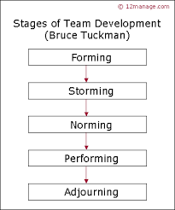
Figure 1. Stages of Team Development
- Forming
This is the first stage, where the first impressions are made, people are sceptical with each other and they usually need a leader that will show them around, tell them what to do and answer any type of questions the team members might have (Wilson, 2010). For example, on the first day at work, the team is getting to know each other, and sometimes there are ice breakers created by the leader to relax the atmosphere and make every person feel more comfortable.
- Storming
The second stage is considered to be the tensest, because everyone is starting to have an opinion about everyone, and disagreement usually happen. The conflicts in this stage can impact the team in a negative way, if it is ignored or poorly handled (Keeler, 2017). For example, a person might not agree with someone, so then a competition might start, in order to prove who is right or wrong, and depending on the person, this confrontation might have serious consequences, like making a person leave the company.
- Norming
This stage might come gradually, once the team members are starting to solve their issues, accept the differences between them and agree to cooperate towards the same goal, while they will start to feel more comfortable around each other (MindTools, 2020). An example of the Norming stage is when, after a few weeks of working together, every member is feeling more relaxed and more confident to ask questions, to ask for help and to seek advice from other colleagues.
- Performing
This stage is represented by the team members that are able to do their job efficiently, without too much management supervision. At the same time, it is important to note that even thought conflicts might still arise, at this stage, unlike the Storming stage, the team already has experience in dealing with conflict and potential strategies developed to ensure that every difficult situation is managed correctly (Plex, 2020). For example, every team member starts to achieve the targets monthly, by working together.
- Adjourning
This stage represents the end of the initial team, where people are realising how much they achieved as a team, how close they are, and they will realise the fact that things will not be the same as usual. This stage might be harder for certain team members than other (Wilson, 2010). For example, a team member is promoted, and someone else must replace him.

Belbin’s Team Roles

Belbin (2020) argued that the Team Roles can help individuals to have a better understanding of themselves, their strengths, weaknesses and how they work within a team. This theory can also be used by managers or team leaders that want to have a deeper knowledge about the members of the team so that they can implement strategies that will be suitable for each team, depending on its composition. The Team Roles can be easily discovered, only by completing The Belbin Questionnaire. The Team Roles are:
- Resource Investigator
This person had great communication skills, it is good at negotiation, but sometimes it can be over talkative or lose focus if they are not working in a fast-paced environment (Belbin, 2020).
- Team Worker
This person is the most supportive person from the entire team, always there to help everyone. It is usually popular and tries to avoid conflict at any costs (Belbin, 2020).
- Coordinator
This person is mostly in a leadership position, delegates the work based on the skills of the team, but sometimes it can also delegate its own work and take credit for things that were not made by him (Belbin, 2020).
- Plant
Being the most creative person in the team, the Plant can often be a little bit more independent. This person enjoys working alone, has trouble communicating with its colleagues and is not a fan of bureaucracy (Belbin, 2020).

- Monitor Evaluator
This person is the best at taking decisions, due to its critical thinking, but it can be sceptical to new, creative ideas. As well, it can bring conflict in a team due to its cynical way to respond to innovative ideas, but also due to the time it spends analysing the pros and cons of an idea (Belbin, 2020).
- Specialist
This person is devoted to a certain field which can be beneficial for the company and likes to be updated in his domain. This can also be seen as a minus, because being so focused on its own field, it might lose sight of all the other things that matter as well (Belbin, 2020).
- Shaper
The Shaper is the most dynamic person in the team and is focusing its entire energy in getting the things done. Sometimes, it can be too involved in the process, that might neglect the feelings of its colleagues and start conflicts (Belbin, 2020).
- Implementer
The Implementer is that person that gets things done and loves a systematic way. He is always developing a routine, but that makes him to not be so keen to try something new, and once his routine is broker, it can become a source of conflict (Belbin, 2020).
- Complete Finisher
The Complete Finisher is mostly excited to work in an environment in which he must pay attention to details and have a high level of concentration. While this is a good thing for companies, it has the potential to become a source of conflict if the Complete Finisher develops an obsessive behaviour (Belbin, 2020).

Difference between group and team

While these theories are important for a good team working, it is important that they are applied to teams, and not groups. Even though they are often confused, due to their similarity regarding the number of members (Prachi, 2019), the group and the team are different. While a group is considered to be ‘a collection of individuals who coordinate their individual efforts’ (Sisson, 2013), a team is mostly focusing on a mutual goal where all the members are working together to achieve it (Prachi, 2019).
The group is mostly characterised by individuality, which can be seen in every action of every member of the group. At the same time, they do not depend on each other is any way, and there is not place for meaningful relationships (Prachi, 2019).
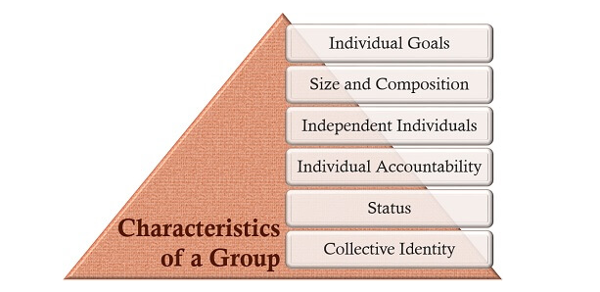
Figure 2. Characteristics of a Group

The team is characterised by teamwork, since every member is participating in every action that must be taken in order to complete an objective. There are many feelings involved in a team, and every member is relying to each other (Prachi, 2020).
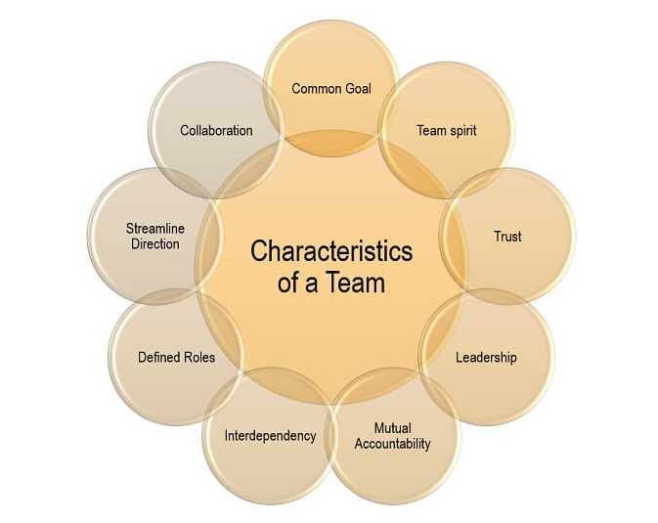
Figure 3. Characteristics of a Team
For example, in every workplace, the managers are trying to develop teams, because they need more people to work for the same goal, to bring profit. By having groups instead of teams, they will not have people working to the same goal, because there will be competition, conflict, which translates by a poor productivity.

Characteristics of effective team and its importance

Even though teams are considered to be enough for a workplace, it is important that those teams to be effective. Using this principle, Rose (2019) created a list of a few characteristics of an effective team:
- Team members are dependent on each other, and this is beneficial because individuals will not waste time on achieving personal goal, because they will focus on achieving the team goals, which will save the company a lot of money, time and effort. For example, a person that was hired for a few weeks decides to leave the company, it will be a waste of time, money and effort from the company and the rest of the team, since that person wasn’t reliable.
- There is a work atmosphere of trust, and this is beneficial because everyone is encouraged to ask questions and come up with ideas. This will also help at problem solving and will increase the communication within the team. For example, during a brainstorming session, it is important that every member share his ideas.
- Team members take ownership for their tasks, meaning that they are more involved in the work and recognise that their actions will have an impact on the entire team, either positive or negative. For example, if someone will not complete a task in time, it will affect the entire team, because they will lose time and potentially, money.
- Team members are encouraged to develop new skills, because this affects the overall performance of the team. For example, there are companies that offers extensive trainings or even pay for their employees’ education.
The effective team working is important because it will increase the productivity, reduce the costs, increase the profit, can create a healthy competition between the members, while being a great source of learning and developing (BrightHR, 2020).
The teamwork theories can be used here by adapting them to each particular team, in order to discover its strengths, weaknesses, and the most efficient working strategy.

Conflict handling and delegation

Delegation represents the sharing of the task within a team. This is important because, by being done correctly, it can increase productivity, can make each team member equally participating on the path to achieve the common goal and can save money by not having to do the same thing twice (Prachi, 2015).
The teamwork theories Tuckman and Belbin can help any manager to delegate better their work, and to attribute the task to the right person from the first time, based on the skill set.
On the other hand, by not having a good delegation in the organization, there are high chances that the conflict will appear.
The conflict is represented by a disagreement that can bring tension in the team. There are lots of causes to conflict, but the most frequent reason for the conflict to start is the poor delegation. There is no right way to handle the conflict, but it is important that the managers possess Conflict Management Skills, that will make the managers ‘communicating clearly, empathetically, and patiently leads to favorable outcomes and keeps professional relationships strong’ (Doyle, 2020).

Conclusion

In conclusion, there are a lot of things that makes a team effective, but it is important that managers apply different strategies to analyse the team’s skills set, weakness and potential threats. By doing so, using Tuckman and Belbin, the managers will have an accurate idea about their team, and they will be more prepared in case that there any issues or conflicts. At the same time, the managers that apply Tuckman and Belbin to their team will then have the knowledge about what to do to make the team effective, maximise the productivity, save money and time.

Bibliography/References

- 12Manage (2020) Stages of Team Development [Photo]. Available at: https://www.12manage.com/methods_tuckman_stages_team_development.html (Accessed: 30 November 2020).
- Belbin (2020) Team Role Spotlight: Complete Finisher. Available at: https://www.belbin.com/about/team-role-spotlight-completer-finisher/ (Accessed: 30 November 2020).
- Belbin (2020) Team Role Spotlight: Co-ordinator. Available at: https://www.belbin.com/about/team-role-spotlight-co-ordinator/ (Accessed: 30 November 2020).
- Belbin (2020) Team Role Spotlight: Implementer. Available at: https://www.belbin.com/about/team-role-spotlight-implementer/ (Accessed: 30 November 2020).
- Belbin (2020) Team Role Spotlight: Monitor Evaluator. Available at: https://www.belbin.com/about/team-role-spotlight-monitor-evaluator/ (Accessed: 30 November 2020).
- Belbin (2020) Team Role Spotlight: Plant. Available at: https://www.belbin.com/about/team-role-spotlight-plant/ (Accessed: 30 November 2020).
- Belbin (2020) Team Role Spotlight: Resource Investigator. Available at: https://www.belbin.com/about/team-role-spotlight-resource-investigator/ (Accessed: 30 November 2020).
- Belbin (2020) Team Role Spotlight: Shaper. Available at: https://www.belbin.com/about/team-role-spotlight-shaper/ (Accessed: 30 November 2020).
- Belbin (2020) Team Role Spotlight: Specialist. Available at: https://www.belbin.com/about/team-role-spotlight-specialist (Accessed: 30 November 2020).
- Belbin (2020) Team Role Spotlight: Team Worker. Available at: https://www.belbin.com/about/team-role-spotlight-teamworker/ (Accessed: 30 November 2020).
- Belbin (2020) What's Belbin All About? Available at: https://www.belbin.com/ (Accessed: 30 November 2020).
- BrightHR (2020) The importance of teamwork. Available at: https://www.brighthr.com/articles/culture-and-performance/teamwork/the-importance-of-teamwork-in-the-workplace/ (Accessed: 30 November 2020).
- Costley, K.C. (2006) Why Do We Have Theories? Available at: https://files.eric.ed.gov/fulltext/ED491769.pdf (Accessed: 29 November 2020).
- Doyle, A. (2020) Conflict Management: Definition, Skills and Examples. Available at: https://www.thebalancecareers.com/conflict-management-skills-2059687 (Accessed: 1 December 2020).
- Keeler, J. (2017) Belbin and Tuckman. Available at: https://www.trainingzone.co.uk/community/blogs/belbin/belbin-and-tuckman (Accessed: 29 November 2020).
- MindTools (2020) Forming, Storming, Norming, and Performing. Available at: https://www.mindtools.com/pages/article/newLDR_86.htm (Accessed: 30 November 2020).
- Plex (2020) Tuckman's Stages Of Group Development. Available at: https://plex.page/Tuckman's_stages_of_group_development (Accessed: 30 November 2020).
- Prachi, J. (2015) Importance of Delegation. Available at: https://www.managementstudyguide.com/importance_of_delegation.htm (Accessed: 1 December 2020).
- Prachi, M. (2019) Group vs. Team. [Photo] Available at: https://theinvestorsbook.com/group-vs-team.html (Accessed: 30 November 2020).
- Prachi, M. (2019) Group vs. Team. Available at: https://theinvestorsbook.com/group-vs-team.html (Accessed: 30 November 2020).
- Rose, D. (2019) 8 Characteristics of an Effective Team. Available at: https://skillpath.com/blog/8-characteristics-of-an-effective-team- (Accessed: 30 November 2020).
- Sisson, J. (2013) The difference between a group and a team. Available at: https://www.bizjournals.com/bizjournals/how-to/growth-strategies/2013/06/the-difference-between-a-group-and-a.html (Accessed: 30 November 2020).
- Wilson, C. (2010) BRUCE TUCKMAN’S FORMING, STORMING, NORMING & PERFORMING TEAM DEVELOPMENT MODEL. Available at: http://www.sst7.org/media/BruceTuckman_Team_Development_Model.pdf (Accessed: 30 November 2020).

Appendices

Belbin’s Questionnaire


