Module: Research Methods / Presentation PowerPoint
Student: Luciana Stafi
Student ID: 2130653
Submission date: 05 June 2026 10:00 pm

Topic: The Role of Leadership and Management in Implementing Work Procedures and Improving Employee Performance in Logistics Operations.

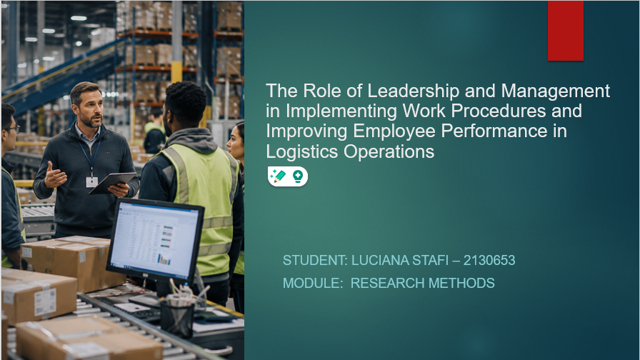
GHGHG

SLIDE 1

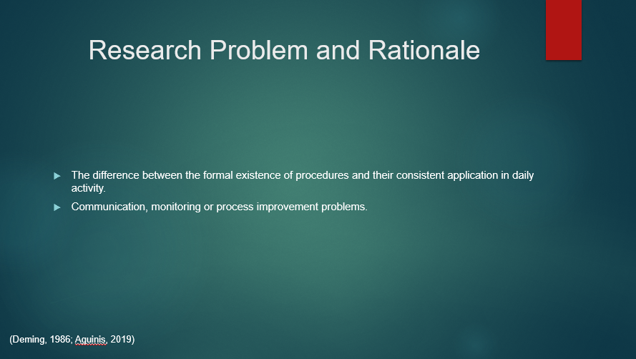

Slide 2

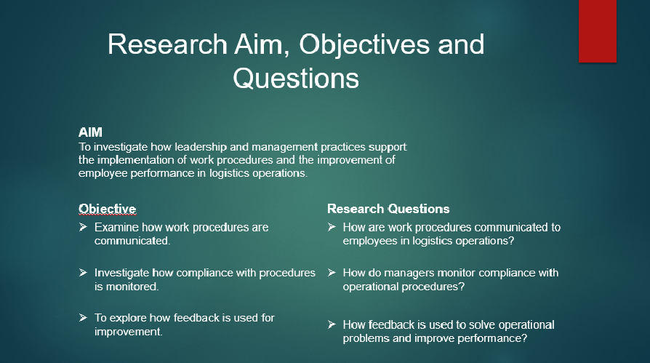
Slide 3

Slide 4

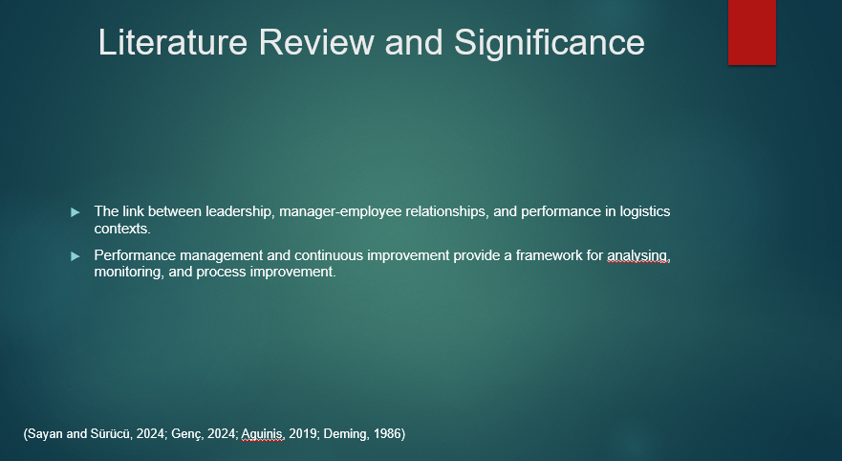

Slide 5

Slide 6

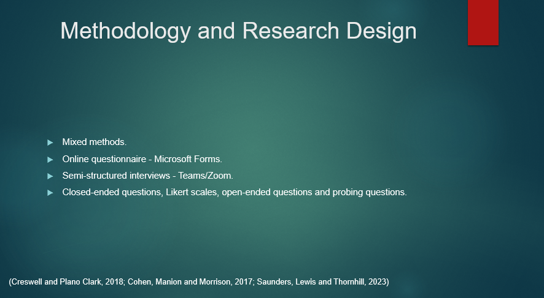

Slide 7

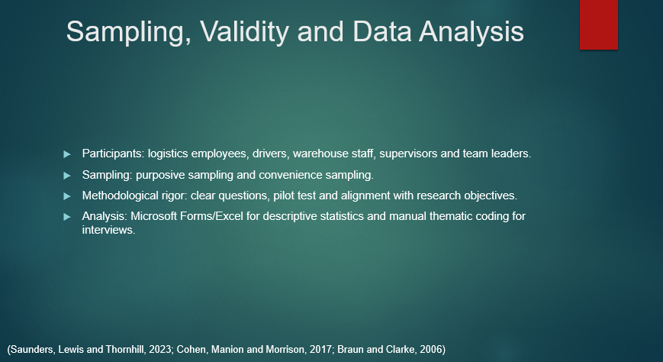

Slide 8

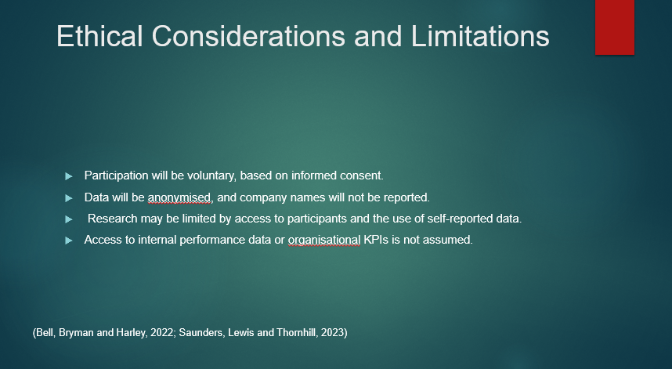
Slide 9

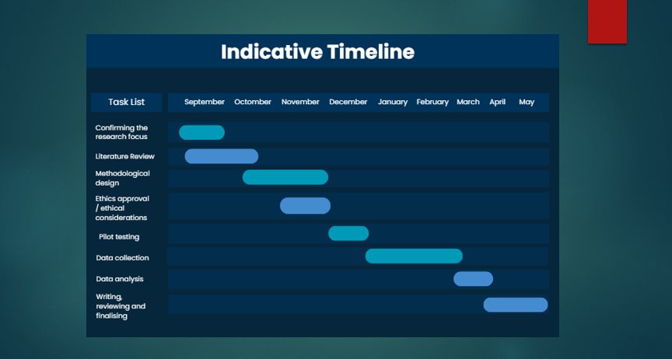

Slide 10

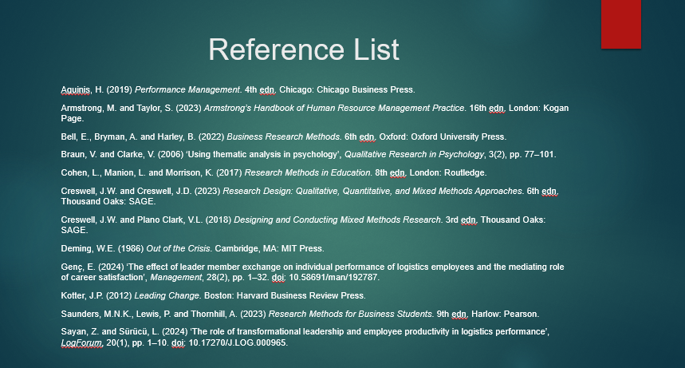

Slide 11

