

LEVEL 5 ASSESSMENT SPECIFICATION
Programme: | BSc Health and Social Care
Module: | Changemakers: Creativity and Value Creation
Student Name: | Munaza Sakindar
Student ID: | 2419348
Module code: | BMHP5014 | Contribution to Overall Module Assessment (%): | 50%
Lecturer: | Tomy Adattu Chacko | Internal Verifier: | Dr Eleni Koutsogeorgou-Andreou
Assignment Title: | Component 2: Written Assignment (Report) | Word count (or equivalent): | 2,000 words (+/- 10%)

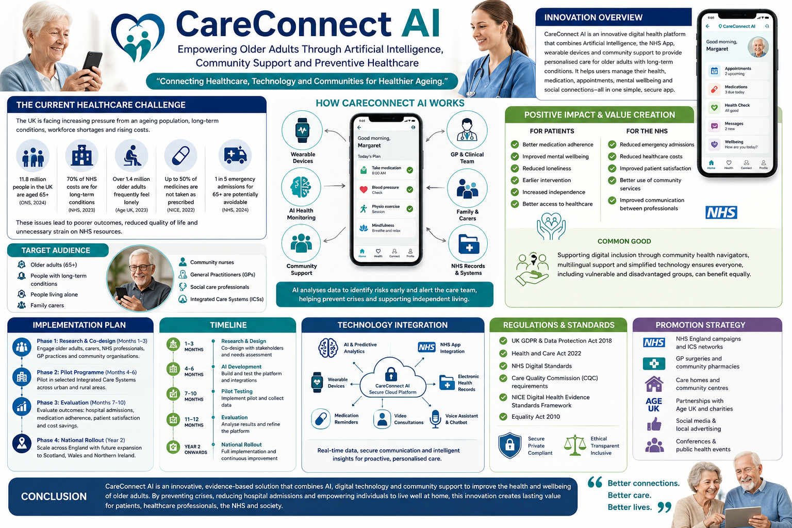
CareConnect AI
Innovative Technology to Empower Aging Individuals Through the use of Community Support, Artificial Intelligence, and Preventive Health Services - an overview of innovation.
How CareConnect AI Works

INNOVATION OVERVIEW
CareConnect AI is a ground-breaking digital healthcare solution that aims to enhance the experience and quality of life for older adults (age 65+) in the UK who suffer from at least one long term health condition. By using wearables, the NHS app and a trained Navigator (called a clinical Health Coach), CareConnect AI will assist with individualized wellness plans with personalized assistance through AI tools for managing both medical and non-medical requirements such as medications, appointment scheduling and mental health resources to help them with their overall physical and mental health.
CareConnect AI brings together these three components - Artificial Intelligence (AI), the NHS app, and a trained navigator - to create one digital integrated solution, allowing the individual to live independently and reduce the likelihood of future emergency department visits due to non-compliance with their medical instructions.

THE CURRENT HEALTHCARE CHALLENGE
There are numerous difficulties that the aging population and patients with multiple chronic illnesses face in the UK, including increased healthcare costs and a shortage of health professionals. Many of the older adults experience loneliness, not adhering to their medications, delayed access to healthcare and through poorly-coordinated services leading to preventable hospitalizations, and thus impacting their quality of life.
The evidence suggests that an integrated digital solution for healthcare could lead to better patient outcomes while making effective use of NHS resources (NHS England, 2023; WHO, 2023)

.

POSITIVE IMPACT
AI analyses data in order to spot risks ahead of time and notify the care team, thereby averting crises and promoting independent living.
Benefits to Patients
- Better medication compliance
- Improved mental well-being
- Reduction of home isolation
- Earlier access to interventions
- Greater continued independence
- A simplified method of obtaining access to the health service.
Benefits to NHS
- Reductions in unscheduled emergency admissions
- Reductions in overall healthcare costs
- Improved patient / client satisfaction
- More appropriate use and maximising availability of community health services
- Improvements in communication and co-ordination of care between professionals.

COMMON GOOD
By providing all older adults and digitally exempt individuals with personalised community health navigation support, various forms of language interpretation, and using technology which is easily explained and understood, CareConnect AI provides long-term benefits of equity to all vulnerable populations.

.

IMPLEMENTATION
Phase 1
Conduct research and design (consult) in partnership with:
- NHS England
- Older adults
- Nursing Homes
- GP Practices
- Community organisations

Phase 2
Implement pilot projects across selected NHS Integrated Care Systems.

Phase 3
Evaluation through client and patient satisfaction, and rates of hospitalisation for more than one or more prescribed medications.
Phase 4
Evaluation throughout England with consideration of future applicability to Scotland, Wales and Northern Ireland.

.

INTENDED AUDIENCE
CareConnect AI is intended for use by:
- Older adults aged 65 years and older
- Individuals with long term (chronic) health conditions
- Individuals who live alone
- Carers
- Community, nurse practitioners
- General practitioners
- Social care professionals
- Integrated Care Systems (ICS).

.

TIMELINE
Stage | Duration
Research & Design | Months 1–3
AI Development | Months 4–6
Pilot Testing | Months 7–10
Evaluation | Months 11–12
National Rollout | Year 2

.

TECHNOLOGY INTEGRATION
CareConnect AI is an integrated approach to healthcare technology through:
- Utilization of Artificial Intelligence
- NHS App
- Wearable health devices
- Electronic Health Records
- Predictive analysis
- Secure cloud-based storage
- Voice assistant
- Medication reminders
- Video consultations

As Artificial Intelligence analyses a patient's health data, it can assist in the early identification of issues which enables healthcare professionals to provide preventative interventions before health issues escalate.

.

REGULATIONS AND STANDARDS
The CareConnect AI innovation meets the following regulatory and policy requirements:
United Kingdom General Data Protection
Regulation (UK GDPR)
Data Protection Act (2018)
Health and Care Act (2022)
NHS Digital Standards
Care Quality Commission (CQC) Standards
National Institute for Health and Care Excellence (NICE) Digital Health Evidence Standards Framework
Equality Act (2010)

.

PROMOTIONAL STRATEGY
CareConnect AI will be marketed through:

NHS England Campaigns
GP Practices and Community Pharmacies
Residential Care Facilities
Age UK and Community Events
Social Media and Local Government
Health Care Conferences

.

CONCLUSION
CareConnect AI is an integrated technology, community and patient-centric model that will improve the lives of older adults by providing support to reduce the number of hospital admissions, enhance their wellbeing and support the sustainability of the NHS, providing significant value to individuals and healthcare providers as well as society as a whole.

.

Written Pitch: CareConnect AI – Transforming Healthcare for Older Adults through Artificial Intelligence and Community Support

Introduction
The UK’s health and social care system is under enormous strain as a result of: (1) the growing number of older people; (2) the increasing numbers of people with long-term illnesses; (3) the lack of sufficient staff to provide care; and (4) rising costs of providing health and social care services to people in the UK. According to NHS England (2024), more people than ever are living with more than one chronic (or long-term) illness, which puts an ever-growing burden on hospitals, general practice and community-based health services. Elderly individuals above the age of 65 years tend to feel lonely, suffer from medication non-compliance issues and lack integrated care resulting in unnecessary hospitalization and health problems (World Health Organization, 2023).
CareConnectAI has been established as a new form of digital health application that combines the power of artificial intelligence (AI), wearable devices, the NHS app, and community navigators, to provide integrated and individualised healthcare. The application seeks to empower people aged 65 years or older to manage their own health needs, while also creating a better way to communicate between patients, health care providers and community-based organisations. CareConnectAI, through creativity and value creation, successfully provides a sustainable way to support the NHS Long Term Plan through improved patient outcomes, reduced healthcare costs and improved aged care.

Why is this Innovation Necessary?
The UK is experiencing rapid growth in its older population, creating a corresponding increase in demand for health and social care services. Many older adults have multiple chronic conditions, like diabetes, hypertension, heart disease and arthritis, which require considerable ongoing monitoring and co-ordination of care (NHS England, 2024), and still, many current healthcare systems operate in a fragmented manner making it difficult for patients to co-ordinate appointments, medications and communications across multiple providers.
Loneliness is a growing concern for older adults’ health and well-being. Age UK (2023) states that prolonged periods of loneliness can increase an older person’s chance of suffering with depression, developing cognitive decline, or having a physical illness. Medication non-compliance is another major issue, which contributes to hospital admissions due to preventable complications (NICE, 2023).
Digital healthcare technologies have grown significantly since the COVID-19 pandemic began; however, most of the technology available today focuses on appointment scheduling and/or accessing medical records. CareConnect AI is a digital healthcare technology that provides integrated health, mental well-being, community engagement, and preventative care into one intelligent platform, providing a comprehensive solution to supporting older adults.

Evidence Supporting the Problem
The evidence strongly supports the need for integrated digital healthcare innovations. According to NHS England (2024), approximately 70% of NHS expenditure is spent on caring for people living with long-term conditions. Older adults continue to enter hospital emergency rooms at a growing rate due to preventable complications and delays in receiving appropriate care.
As pointed out by the World Health Organization (2023), Digital Health Technology (DHT) is a crucial component of Universal Health Coverage since it improves the accessibility of healthcare, continuity of healthcare provision, and involvement of patients in their healthcare. By using technology combined with community-based services, The King’s Fund (2024) states that significant improvements can be made to healthcare efficiency and a reduction in acute hospital pressures can be made.
According to research into digital innovation, as outlined in the article by Kaihlanen, Hietapakka and Heponiemi (2020), it has been proven that patient engagement will be enhanced when digital innovation is combined with person-centred care and sufficient professional support. As a result, CareConnect AI uses AI technology integrated with community-based health navigators to ensure that all users will be digitally included and provided with equitable access to these technologies.

Creativity and Value Creation
Creativity is defined as the generation of unique ideas that seek to resolve a current issue, while innovation concerns the successful implementation of such ideas to establish or create value (Tidd & Bessant, 2021). CareConnect AI is an example of both creativity and innovation by using previously established technologies such as; artificial intelligence (AI), wearable devices and electronic health records within a unified platform, specifically designed for older persons.
From the perspective of value creation; the CareConnect AI innovation aims to create value for multiple stakeholders rather than only on a financial basis. Older persons will have access to personalised avenues of support to better manage their own health and increase their independence; support for professionals to improve communication and early detection of deterioration in patient's health; improvement in the financial position of the NHS through decreasing number of emergency admissions and providing a better allocation of resources.
CareConnect AI reflects the principles of social entrepreneurship since it emphasises both the social impact of its activities and the advancement of technology. CareConnect AI provides an additional service to a patient without replacing the current work of healthcare professionals by creating a cooperative relationship among patients, clinicians, and community organisations through technology.

Implementation and Technology
There will be four phases of implementation of the CareConnect AI platform. In the first phase, the platform is developed using a co-design process involving older adults, NHS organisations, ICSs, family carers, and voluntary organisations to ensure that the platform meets the needs of users with respect to what they actually need. In the second phase, software developers will build the AI platform and integrate it with NHS digital systems, such as electronic health records and wearable devices.
The third phase would have pilot testing within selected ICSs, with key performance indicators being intended to show reduced hospital admissions, improved adherence to medications, patient satisfaction with the use of CareConnect AI, and reduced costs of care for healthcare systems. After evaluation of this, in the fourth and final phase, the CareConnect AI platform would be rolled out across England gradually before expanding to Wales and Scotland.
CareConnect AI contains the technology of artificial intelligence at its core. The system uses machine learning algorithms to process data collected from patients’ wearable devices and electronic health records to anticipate deterioration in health. Additionally, the CareConnect AI platform will allow for personalized reminders for medication; scheduling of appointments; mental health support; secure messaging; video consultations; and voice-assisted navigation for users with limited digital skills.

Policy, Legislation and Professional Standards
The successful implementation of digital health technology requires full compliance with UK legislation and the standards of the various professions involved in health and care. All patient health information will be managed according to the UK General Data Protection Regulation (UK GDPR), as well as the UK’s Data Protection Act 2018, to maintain confidentiality, transparency and to enable secure handling of sensitive information.
The Health and Care Act 2022 funds innovation to facilitate collaboration and integration of care between physical and mental health services, and the Care Quality Commission (CQC) has set out standards for providing safe, effective, responsive and people-centred digital services.
CareConnect AI, alike other digital health technologies, has been aligned to the NICE Evidence Standards Framework for Digital Health Technologies by demonstrating clinical effectiveness, patient safety, and continuous improvement in quality.
The principles of the Equality Act 2010 will be included in the project design for CareConnect AI, through the use of multi-lingual interfaces, adhering to the universal design of the application, and providing community health navigators to ensure that any potential barriers to accessing CareConnect AI via digital means do not prevent access from all those groups in society who face digital exclusion, particularly vulnerable populations.

Stakeholders, Benefits, Risks and Limitations
Key stakeholders involved in the implementation of CareConnect AI include NHS England, Integrated Care Systems, GPs, community nurses, social workers, pharmacists, local authorities, volunteer groups (e.g. Age UK), technology developers, older adults, and their family members. Actively engaging these stakeholders throughout the design and implementation stages will increase the likelihood of successful adoption and sustainability of the program.
There are various advantages of this invention. First, there is improvement in self-management, mental well-being, and independence among patients. Second, early detection of clinical deterioration and better multidisciplinary communication for health professionals. Third, fewer emergency admissions, reduced costs, and improved efficiency for the NHS. Fourth, healthy aging, fewer inequalities, and improved community support within society.
Although there are many advantages to this innovation, there are also many risks that need to be addressed, including limited digital literacy among some older adults, which may hinder their initial use of the system; concerns about cybersecurity and data privacy; and algorithmic bias. All these risks will be mitigated by establishing strong systems of governance, conducting routine system audits and having transparent decision-making processes when using artificial intelligence. While the initial development and implementation costs for this innovation may be high, the long-term cost reductions associated with avoiding unnecessary hospital admissions and increased quality of preventive care will justify the investment.

Conclusion
CareConnect AI is an innovative, evidence-based solution that will help solve some of the most critical issues in the UK health and social care systems. This innovative use of artificial intelligence, community support and integrated healthcare services will provide older adults the tools to manage their health care better while allowing healthcare professionals to communicate effectively with one another and reduce the number of patients who are unnecessarily reliant on the NHS.
This innovation will demonstrate how creativity and value creation can deliver real social benefits, while aligning with the objectives of national health care. When implemented properly, in collaboration with stakeholders and in accordance with applicable laws and standards, CareConnect AI will have a lasting impact on the way healthcare is delivered, promote healthy aging and significantly benefit the public good.

Reference List (Harvard Style)
Age UK (2023) The State of Health and Care of Older People, 2023 (abridged). London: Age UK. Available at: https://www.ageuk.org.uk/siteassets/documents/reports-and-publications/reports-and-briefings/health--wellbeing/age-uk-briefing-state-of-health-and-care-july-2023-abridged-version.pdf [Accessed: 26 June 2026].
Department of Health and Social Care (2022) Health and Care Act 2022. London: HMSO. Available at: https://www.legislation.gov.uk/ukpga/2022/31/contents [Accessed: 26 June 2026].
Kaihlanen, A.M., Hietapakka, L. and Heponiemi, T. (2020) 'Increasing cultural awareness: Qualitative study of nurses' perceptions about cultural competence training', BMC Nursing, 19(1), pp. 1–9.
King’s Fund (2024) Mental Health 360: Workforce. London: King’s Fund. Available at: https://www.kingsfund.org.uk/insight-and-analysis/long-reads/mental-health-360-workforce [Accessed: 26-6-2026].
National Institute for Health and Care Excellence (NICE) (2022) Evidence Standards Framework for Digital Health Technologies. London: NICE. Available at: https://www.nice.org.uk/corporate/ecd7 [Accessed: 26 June 2026].
National Institute for Health and Care Excellence (NICE) (2023) We produce useful and usable guidance for the NHS and wider health and care system. London: NICE. Available at: https://www.nice.org.uk [Accessed: 26 June 2026].
NHS England (2023) NHS Long Term Workforce Plan. London: NHS England. Available at: https://www.england.nhs.uk/wp-content/uploads/2023/06/nhs-long-term-workforce-plan-v1.2.pdf [Accessed: 23-6-2026]
NHS England (2024) Primary care.. London: NHS England. Available at: https://www.england.nhs.uk/primary-care/ [Accessed: 26 June 2026].
Office for National Statistics (2024) Ageing. Newport: ONS. Available at: https://www.ons.gov.uk/peoplepopulationandcommunity/birthsdeathsandmarriages/ageing [Accessed: 26 June 2026].
Tidd, J. and Bessant, J. (2021) Managing Innovation: Integrating Technological, Market and Organisational Change. 7th ed. Chichester: John Wiley & Sons.
UK Government (2018) Data Protection Act 2018. London: HMSO. Available at: https://www.legislation.gov.uk/ukpga/2018/12/contents [Accessed: 26 June 2026].
UK Government (2021) The UK's data protection legislation. Available at: https://www.gov.uk/data-protection [Accessed: 26 June 2026].
World Health Organization (2021) Global Strategy on Digital Health 2020–2025. Geneva: World Health Organization. Available at: https://www.who.int/publications/i/item/9789240020924 [Accessed: 26 June 2026].
World Health Organization (2023) Ageing and Health. Geneva: World Health Organization. Available at: https://www.who.int/news-room/fact-sheets/detail/ageing-and-health [Accessed: 26 June 2026].

