

UNIVERSITY OF WALES TRINITY SAINT DAVID
Swansea Business School
BMMB7003: Dissertation - Level 7 MBA

TO WHAT EXTENT HAS REMOTE WORKING IMPACTED ON EMPLOYEE WELL-BEING, ENGAGEMENT AND RETENTION IN THE UK?

Md Mujibur Rahman
Student Number: 2504300
Programme: MBA
Supervisor: David Greenshields

Academic Year: 2025-2026

A dissertation submitted in partial fulfilment of the requirements for the degree of Master of Business Administration

Declaration
This work has not previously been accepted in substance for any degree and is not being concurrently submitted in candidature for any degree.
Signed: __________ Md Mujibur Rahman_____ (candidate) Date: _____25/09/2026__

Statement 1
This work is the result of my own investigations, except where otherwise stated. Other sources are acknowledged by footnotes giving explicit references. A bibliography is appended.
Signed: __________ Md Mujibur Rahman_____ (candidate) Date: _____25/09/2026__

Statement 2
I hereby give consent for my work, if accepted, to be available for photocopying and for inter-library loan, and for the title and summary to be made available to outside organisations.
Signed: __________ Md Mujibur Rahman_____ (candidate) Date: _____25/09/2026__

Acknowledgements
I would like to express my gratitude to my dissertation supervisor David Greenshields for his guidance, patience and constructive feedback throughout the research process, from the research proposal to the completion of this dissertation.
I also owe thanks to the 150 people who took the time to complete the survey that allowed for this research to be undertaken, and to the University of Wales Trinity Saint David, Swansea Business School, for their support during the MBA course.
Lastly, I would like to express my appreciation to my family and friends for their encouragement and support throughout this degree.

Abstract
Since 2020, remote and hybrid working has been a permanent aspect of employment in the UK, but there is still a lack of consensus on the extent of flexibility to be provided, and previous studies have typically looked at one aspect of the experience rather than all three (well-being, engagement, retention). This dissertation aims to fill that gap by exploring how the working arrangement (fully remote, hybrid or predominantly office-based) is related to these three outcomes, using the lens of Self-Determination Theory and Job Demands-Resources Model.
We conducted a cross-sectional online survey with employees in the UK in financial services, consultancy, technology and education and got 150 valid questionnaires. Each construct was assessed with a composite scale that included 4 or 5 items, and had internal reliabilities ranging from .738 to .817 (Cronbach's alpha). Multiple regression was used to analyse the data, controlling for sector, seniority and organisation size, and one-way ANOVA with Tukey post-hoc comparisons were performed across the three groups of working arrangements.
All three outcomes were significantly predicted by working arrangement. Those who primarily work in an office-based environment had significantly worse well-being, engagement and intention to stay than those who work completely remotely and those who work in a hybrid setting, with no significant differences between the two groups who work remotely and hybrid. This trend remained when the factors of sector, seniority and organisation size were taken into account, none of which were significant predictors.
The findings indicate a non-linear (threshold) relationship between the working arrangement and employee outcomes, such that some flexibility (full remote/blended working) is correlated with a significantly positive impact on outcomes that is not observed with no flexibility. The dissertation concludes that this is a measurable cost to well-being, engagement and retention which should be taken into account by UK organisations when deciding on a full return to the office, and that policy should focus on the importance of maintaining flexibility rather than favouring one particular flexible arrangement.

Keywords: remote working; hybrid working; employee well-being; employee engagement; employee retention; Job Demands-Resources Model.

Table of Contents
Declaration 2
Acknowledgements 3
Abstract 4
Table of Contents 5
List of Figures 8
List of Tables 9
1 Introduction 10
1.1 Background to the Study 10
1.2 Research Focus 11
1.3 Research Aim and Objectives 13
1.4 Definitions of Key Terms 13
1.5 Scope and Boundaries 14
1.6 Structure of the Dissertation 14
2 Literature Review 16
2.1 The Changing Landscape of Work in the UK 16
2.2 Theoretical Foundations: Self-Determination Theory and the Job Demands-Resources Model 17
2.3 Remote Working and Employee Well-being 18
2.4 Remote Working, Engagement and Organisational Belonging 20
2.5 Remote Working and Employee Retention 22
2.6 The Research Gap and Conceptual Framework 24
3 Methodology 26
3.1 Aims and Objectives 26
3.2 Research Rationale 26
3.3 Research Design and Philosophy 26
3.4 Data Collection 28
3.5 Population and Sample 30
3.6 Data and Analysis 30
3.7 Reliability and Validity 31
3.8 Limitations of the Research 32
3.9 Research Ethics 32
3.10 Summary 33
4 Data Analysis and Findings 34
4.1 Data Screening and Response Profile 34
4.2 Demographic Profile of Respondents 35
4.3 Reliability of the Composite Scales 37
4.4 Descriptive Statistics 38
4.5 Correlations Between the Composites 39
4.6 Multiple Regression Analysis 40
4.7 One-Way ANOVA and Group Comparisons 42
4.8 Chi-Square Test of Association 46
4.9 Summary of Findings 47
5 Recommendations and Conclusions 50
5.1 Conclusions 50
5.2 Recommendations for Managerial Practice 51
5.3 Contributions to Theory 53
5.4 Limitations of the Study 54
5.5 Areas for Further Research 55
6 References 57
Appendix A: Survey Instrument (Participant Information, Consent and Questionnaire) 62
Appendix B: Research Ethics and Supervisor Approval 65
Appendix C: Collected Data & Analysis Files 66

List of Figures
Figure 3.1 The Research Onion, showing the choices adopted in this study (adapted from Saunders, Lewis and Thornhill, 2023) 27
Figure 4.1 Mean Well-being score by working arrangement 44
Figure 4.2 Mean Engagement score by working arrangement 45
Figure 4.3 Mean Retention Intention score by working arrangement 45
Figure 4.4 Estimated marginal means plot - Well-being by working arrangement 46
Figure 4.5 Estimated marginal means plot - Engagement by working arrangement 46
Figure 4.6 Estimated marginal means plot - Retention Intention by working arrangement 46

List of Tables
Table 4.1 Data screening funnel 35
Table 4.2 Demographic and organisational profile of respondents (N=150) 36
Table 4.3 Reliability statistics for the composite scales 38
Table 4.4 Descriptive statistics for the composite scores (N=150) 39
Table 4.5 Correlations between the composite scores (N=150) 39
Table 4.6 Multiple regression predicting Employee Well-being 40
Table 4.7 Multiple regression predicting Employee Engagement 41
Table 4.8 Multiple regression predicting Retention Intention 41
Table 4.9 Group means and ANOVA results by working arrangement 43
Table 4.10 Tukey HSD post-hoc pairwise comparisons 43
Table 4.11 Chi-square test - Working arrangement by Seniority level 47
Table 5.1 Summary of recommendations linked to findings 52

Introduction

Background to the Study
The working pattern in the United Kingdom has become forever altered since 2020. The UK workforce has been forever changed by the COVID-19 pandemic, and it seems that the shift is here to stay. Between January and March 2025, 28 per cent of working adults in Great Britain worked on a hybrid basis (ONS, 2025), combining working from home and a workplace. In a slightly later study, the House of Lords Home-based Working Committee (2025) found that 13 per cent of working adults were working from home all of the time in the second quarter of 2025 and a further 26 per cent were working a hybrid working pattern. Work from home and remote working is not just a coronavirus catch-up. They have now become a regular part of the working lives of people in the UK, and are unlikely to end up going back to pre-pandemic routines.
This has put employers in a difficult position. Three-quarters (74%) of UK organisations now have some hybrid working arrangements in place, with a small number of employers wanting more working from the office (CIPD, 2025). The same report identified approximately 1.1 million workers in the UK who left their job due to not being offered flexible working policies in the year to 2025 (particularly pronounced among those aged less than 35 years), and over half of workers felt pressured by their senior colleagues to attend more frequently, with a majority of firms specifying that employees must be in the office at least a certain number of days each week. Employer policy and employee preference are therefore going in opposite directions, and have direct implications for three outcomes that are important to any organisation: how employees feel at work, how engaged they are, and whether they stay.
The CIPD (2025) found that flexible working has gained wider traction, underscoring the significance of this tension. Eight in 10 of those staff who do have access to flexible working have said it has had a beneficial impact on their quality of life, with numbers of those who feel it has had a positive effect on their career prospects increasing from 22 per cent in 2022 to 33 per cent in 2025. Because of this, flexible and remote working has now become more than a bonus for employees, but is considered a valuable part of the career and wellbeing support they receive in the workplace. Flexibility that is viewed as reversible is a risk that organisations may not be aware of, as flexibility has become an integral part of the overall employee perception of their employer, and therefore an integral part of whether the employee chooses to stay or not.
There is no single sector which faces this tension. Distributed working is now used to a greater or less extent in each of the financial services, professional consultancy, higher education and technology sectors and in each of these sectors, there is an underlying question of how much flexibility to afford, and at what cost if it is denied. The repercussions for an organisation of making this wrong decision is quantifiable. The cost of recruitment and induction is high and when a good employee walks out the door as a result of a policy on working arrangements that could have been modified, it is a loss of organisational knowledge and capability that is avoidable. This is the real world context for the present work: a policy debate which is still open and being considered by UK employers, and in which the evidence base is still incomplete, largely restricted to a single sector, firm or pandemic disruption period, as fully explored in Chapter 2.

Research Focus
As described in detail in the literature review in Chapter 2, previous studies on remote working have focused almost exclusively on either well-being or engagement or retention, and have typically been conducted within a single organisation, sector or within a specific time period of the pandemic disruption. Research examining all three outcomes concurrently, in more than one sector, and with consistent and comparable measures is lacking. This is a significant identified gap as the link between well-being and engagement and retention are closely related in practice. An employee is less likely to be engaged when they feel sick at work and an employee is more likely to leave when they are disengaged. With these outcomes being treated separately it will be challenging to see the big picture around a change in working arrangement's impact on an employee's overall relationship with their employer.
This study will fill that gap. It examines the relationship between remote and hybrid working and employee well-being, engagement and retention in UK organisations, and utilises employees from a variety of knowledge-work sectors where remote and hybrid working is prevalent, such as financial services, consultancy, technology and higher education. The aim is not just to capture the current landscape but to provide insights to assist organisations considering how much remote or hybrid working to allow.
The study is guided by two theoretical frameworks: Self-Determination Theory (Deci and Ryan, 2000), which focuses on well-being and motivation as a result of meeting the needs for autonomy, competence and relatedness, and Job Demands-Resources Model (Bakker and Demerouti, 2007, 2017), which focuses on engagement and retention as a result of the balance between demands and resources faced by an employee. Both approaches indicate that the impact on employees of working remotely is not predetermined, but rather a function of the advantages and disadvantages involved, such as having more autonomy and not commuting as much, while at the same time having less face-to-face contact with co-workers.
The literature review (Chapter 2) ends with the identification of three main research questions that will guide the research instrument employed in this research: what is the relationship with working arrangement (and its intensity) and employee well-being; what is the relationship between working arrangement and employee engagement; and what is the relationship between working arrangement and intention to stay with the employer? The results of the multiple regression and group comparison analyses presented in Chapter 4 address these three questions directly: does working arrangement predict each of the three outcomes; and if so, do the prediction relationships hold true and how strong are they, once other explanatory factors are controlled for, such as sector, seniority and organisation size?
The aim of this study is to make both a practical and an academic contribution. The bulk of the studies examined, detailed in Chapter 2, were conducted in a single organisation, or in countries outside the UK, or within the atypical context of the pandemic when the forced remote working experience of those employees meant they were unable to choose how they worked. A recent UK-wide research study, which sees well-being, engagement and retention as three interdependent outcomes, not merely three distinct research questions, addresses a gap that is relevant and significant in today's HR and people management decisions for UK organisations, as well as in their future policies on office attendance by the end of 2026.
For the purposes of this study, working arrangement is treated as a three-category variable, with the following categories: fully remote, hybrid, predominantly office-based. This is in keeping with the general literature where it seems that the extent to which an employee is remote and how much choice is granted to them in their remote working is as important as if they work remotely or not. This study was designed to assess the relationship between the amount of remote working and the three outcomes of interest, but to also test if a graded relationship exists between the amount of remote working and the three outcomes of interest, or if there is another pattern of relationship between the amount of remote working and the three outcomes of interest that would better describe the UK data collected here.

Research Aim and Objectives
The purpose of this research is to explore the effect these remote and hybrid work arrangements have on wellbeing, engagement and retention of employees in UK organisations, and to provide evidence-based recommendations for managing distributed employee populations.
The objectives of this study are to:
- Define the key aspects of employee psychological well-being, engagement, and retention as they are represented in the remote and hybrid literature.
- Examine the connection between remote working and employee engagement and organisational belonging, specifically with regards to social connectedness, motivation and institutional identification.
- Analyse well-being, engagement and retention data on a cross-sectional level for fully remote, hybrid and office-based workers to assess if working modality has a meaningful impact.
- Examine the relationship between remote working and employee retention, specifically employees' intention to remain with their organisation.
- Propose evidence-based organisational recommendations for improving employee well-being, engagement and retention in distributed work environments.
The objectives are aligned with the research aim and to the research question set out in the proposal: to what extent has remote working impacted on employee well-being, engagement and retention across UK organisations? The first objective is addressed mainly in the literature review in Chapter 2, the second, third and fourth objectives are addressed in the survey instrument, the analysis of the instrument and the results reported in Chapter 4, while the fifth objective is addressed in the concluding chapter of the dissertation in Chapter 5.

Definitions of Key Terms
The following are a few terms that are used consistently throughout this dissertation without definition, the definitions of which are provided here. A fully remote working arrangement is one that allows a worker to work away from an employer workplace for effectively all of the hours in their contract, and does not include a regular expectation of attendance at an employer workplace. Hybrid working is a pattern of work which involves an employee splitting their time between the employer's workplace and a different place of work, usually their home, on a regular basis. Office-based working is where an employee works at the employer's workplace for the majority or all of the time, but rarely or not regularly works at home.
When it comes to employee well-being, this study adopts the framework of Self-Determination Theory (Deci and Ryan, 2000), which refers to a psychological state that is influenced by the meeting of the needs for autonomy, competence and relatedness, and is defined by a sense of calm, rest and confidence in one's working life. Based on Kahn (1990), employee engagement is defined as the extent to which an employee brings their whole self (physically, cognitively and emotionally) to their job, as evidenced by showing energy, enthusiasm and absorption in tasks. Retention intention was measured as how likely a person is to continue working for a company, as well as whether he has thought about leaving or plans to look for a new job, based on the turnover model proposed by Mobley (1977).

Scope and Boundaries
This study is bounded in a number of intentional ways. It is based on people working in a UK organisation, not on trying to compare to other countries as there are many differences between countries in terms of norms for working arrangements, employment law and expectations. It attracts respondents from mainly knowledge-work/ professional-service industries, financial services, consultancy, technology and higher education where remote/hybrid working is commonplace, but not manufacturing or retail where remote working is generally not possible. It reflects how things are at the moment of the survey and is based on employees' self-reported perceptions of their well-being, engagement and retention intention, not on organisational data like turnover or absence. The notion of these boundaries and their implications are addressed in the limitations sections in Chapters 3 and 5.

Structure of the Dissertation
The rest of this dissertation is structured in four chapters. The literature review in Chapter 2 covers remote working, well-being, engagement and retention, gives the theoretical framework based on Self-Determination Theory and Job Demands-Resources Model and provides the background for this study. Chapter 3 outlines and justifies the research design, survey instrument, sampling, statistical methods and ethical considerations. The findings are presented in Chapter 4, starting with data screening and the demographic profile then followed by the reliability, descriptive, correlational, regression and group comparison. Each finding was related to the research objectives. Chapter 5 offers conclusions for each objective, practical recommendations, theoretical contribution of the study and limitations and further research recommendations.

Literature Review

The Changing Landscape of Work in the UK
How people work in the UK has transformed since 2020. What began as an emergency response to the COVID-19 pandemic has become a permanent part of working life. The data reveals that 28 per cent of working adults in Great Britain worked in a hybrid way between January and March 2025 (ONS, 2025). However, this is not the case for all workers, as hybrid working is significantly more prevalent among older, higher paid and more highly qualified workers than among those aged under thirty (ONS, 2024). The House of Lords Home-based Working Committee (2025) estimated that 13 per cent of working adults worked from home every day (April-June 2025) and a further 26 per cent had a hybrid working system. Remote and hybrid working is therefore not a short-term solution, but an integral aspect of the UK labour market. The legal landscape has followed suit: the Employment Relations (Flexible Working) Act 2023 increased the rights to request flexible working, meaning this is a day-one right from April 2024 (UK Parliament, 2023) and is echoed in the revised statutory guidance on how to deal with flexible working requests by Acas (2024).
The transition leaves a clear problem for employers and policy makers. 74 per cent of organisations now provide some kind of hybrid working, down from 84 per cent in 2023 (CIPD, 2025). The same report revealed that flexible working was the biggest reason for job loss, with approximately 1.1 million UK workers quitting their positions in the past 12 months for this reason, with younger workers most likely to have left, at 24%. Meanwhile, over half of workers say they feel pressured to work more hours at the office; and a majority of employers have an expectation that employees are going to work at least a certain number of days each week. This concern of employers and employees about flexibility is at the heart of the current debate and has implications on three of any organisation's most important outcomes: the sense of belonging of employees, the level of engagement they display, and their intent to remain.
This tension is also expressed in various ways around organisations. Generally, larger organisations, with more well-established HR practices, have been able to formalise hybrid policies quicker than smaller employers, and in some cases, sectors with high levels of in-person collaboration, such as parts of financial services, have introduced tougher office attendance rules than technology and consultancy, where remote-first working models were likely to be the first to be adopted (CIPD, 2025). Equity is also part of the picture, and not just confined to a particular sector; disabled workers are much more likely to benefit from the flexibility of becoming involved in both a job and home office than to be deterred by the lack of one, as argued by Taylor et al. (2022) for whom a well-designed hybrid arrangement can expand labour-market participation. This variation is important for the design of this current study as it indicates that sector, organisation size and seniority are all potential influences on the outcomes of interest and should therefore be considered along with working arrangement and not ignored.
This review pulls together literature on these three related outcomes well-being, engagement and retention in the context of remote and hybrid working. It starts with theoretical underpinnings on why working arrangement may impact these outcomes. It then examines the empirical evidence on each outcome sequentially, extracting from the studies the commonalities and inconsistencies between studies and then highlights the gap this research will address and the questions it will inform to guide the research instrument.

Theoretical Foundations: Self-Determination Theory and the Job Demands-Resources Model
There are two frameworks that are useful in comprehending the relationship between remote work and employee outcomes, both of which have a strong theoretical grounding, dating back over many decades, and which have influenced occupational psychology over the years.
According to the Self-Determination Theory (Deci and Ryan, 2000), these three basic needs for psychological well-being and motivation are autonomy (feeling of choice and ownership over actions), competence (feeling of mastery and effectiveness), and relatedness (feeling connected with others). The three needs are impacted differently by working from home, making the theory relevant for the research of remote working. As autonomy increases, so does employees' control over their work schedule and workplace, with relatedness decreasing as informal interactions with co-workers are more difficult to sustain. The tension helps to explain mixed findings around remote working and well-being; one benefit could come with one cost and the overall impact would rely on which need is most important to the individual. Evidence of this can be seen in studies which put the theory directly to the test in the context of telework: Brunelle and Fortin (2021) compared teleworkers with workers in the office and concluded that satisfaction with autonomy, competence and relatedness better accounted for differences in job satisfaction than location itself.

The Job Demands-Resources Model developed by Bakker and Demerouti (2007) (later extended by Bakker and Demerouti, 2017) has a complementary perspective: the model posits that both demands and resources are important, and that the specific demands and resources taken together predict and influence motivation and strain over time (Bakker, Demerouti and Sanz-Vergel, 2023). It differentiates job demands, components of work in which a sustained effort is required that can result in exhaustion, from job resources, components that enable employees to complete their goals and to ward off strain. Digital overload, blurred work-home boundaries and reduced informal supervision are demands that have been identified in remote and hybrid working and are valid strains as constant connectivity can lead to technostress, even though it supports collaboration (Bondanini et al., 2025). Flexibility, decreased commute and sometimes increased task control are all resources. In the absence of adequate resources to meet demands, the outcome is exhaustion, disengagement and increased attrition rates; when demands are met, the outcome is engagement. A known antecedent for withdrawal is resource depletion (Bakker and Demerouti, 2017), which is relevant to the retention strand of this research.
These two are not explanatory alternatives, but different lenses to be used at different levels. The level of Self-Determination Theory is the individual's psychological needs, and the level of the Job Demands-Resources Model is the objective characteristics of the work environment. When used together, they account not only for the positive or negative impact that working remotely may have on employees but also the different results of various studies and even different outcomes for various individuals. They both share the same underlying message: The type of work arrangement doesn't have a single definitive effect. Its impact will be contingent on the gains, like autonomy and decreased requirements, and losses, like relatedness and informal support. This balance is the conceptual thread which follows throughout the rest of this review.

Remote Working and Employee Well-being
The initial findings related to remote work and well-being are not as promising as might be assumed. Based on the findings of the UK Skills and Employment Survey, Felstead and Henseke (2017) reported that being a remote worker was linked to an increase in organisational commitment, job satisfaction and wellbeing at work. The same study, however, revealed that these advantages had a downside: the remote workers reported more intensification of work and less ability to disconnect from work. The discovery is significant because it suggests that the idea that working remotely is always positive for well-being is not so easy to accept. It proposes that the trade-off between flexibility and control over boundaries has shifted in the context of remote work, not that it has gone away. This was corroborated by another evidence-based review, which found that remote work can have a positive impact on well-being when conditions and processes within the organisation are conducive, and a negative effect when these are not (Ferrar et al, 2022).
This is corroborated by broader meta-analytic data, although the specific point of transition from benefit to cost is subject to debate. Gajendran and Harrison (2007), in a meta-analysis of 46 studies and almost thirteen thousand employees, found telecommuting had small but largely positive effects on autonomy and work-family conflict, with no general negative effect on relationships with managers or colleagues except where employees worked away three or more days a week. A similar finding was published by Allen, Golden and Shockley (2015): the higher the percentage of time worked at home and the better the arrangement is managed, the higher the job satisfaction and the lower the stress. Both agree that, while remote working is present, the outcome is determined by the intensity of the remote working, but have different ideas regarding what constitutes the cut point. This ambiguity continues in the post-pandemic literature, as hybrid schedules are generally linked to more positive well-being impacts than either all-remote or all-office schedules (Lyzwinski, 2024).
The COVID-19 pandemic resulted in another set of data, some of which is less positive, but it is different from the studies mentioned above. In a study of employees in China who were forced to work entirely remotely, Wang et al. (2021) found four common problems: interference between work and home life, less effective communications, procrastination and loneliness that were found to be the most severe when social support, autonomy, monitoring and workload were low. This confirms the importance of Self-Determination Theory as a determinant of strain, as the absence of relatedness, not autonomy, seems to be the more uniform cause of strain. The remote working Wang et al. (2021) studied was compulsory and not voluntary, which may also be a reason for their results being more negative than the largely voluntary setups of Gajendran and Harrison (2007) and Allen, Golden and Shockley (2015); choice over working arrangement may act as a psychological resource. Longitudinal data further highlights the role of context: After having tracked employees across five European countries, Kornadt et al. (2025) found that during the initial, more turbulent, months of the pandemic, WFH was negatively associated with well-being, but was not associated in later months, indicating that some of the negative effects reported in early pandemic studies were due to the context of lockdown rather than to remote working.
Another factor to consider is the demarcation between work and home. Felstead and Henseke (2017) note that the lack of cues to signal the end of the working day can create a boundary-management problem in the context of the demands-resources balance as well as the physical separation between the working day and the home environment; in other words, the absence of a physical boundary between home and work leaves fewer cues to indicate the end of the working day, which extends the workday informally even when hours of work stay the same. This is one of the more explicit ways in which remote working becomes a demand for resources, flexibility, and that's why well-being is measured with items that reflect the capacity to switch off, not with just one single question. Presenteeism is another related boundary issue, as it is not as strict at home as it is in the workplace, hence workers may still work when they are ill instead of taking time to rest and recover, with this tendency being stronger among remote than in-office workers (Schmitz, Bauer and Niehaus, 2023).
All together this evidence suggests that the relationship between remote working and wellbeing is contingent, rather than causal, and varies based on the amount of remote time, the level of choice, and the level of social support. The relationship between home working and mental health changed throughout the pandemic, not remaining constant, as was seen in UK populations by analysing seven longitudinal surveys throughout the pandemic (Wels et al., 2023). This mechanism has since been described as a dual pathway whereby relaxation and exercise of resources on the one hand and strain on the other through working from home operate simultaneously, with the final impact depending on the relative strength of the two for a specific employee (Dong et al., 2025).

Remote Working, Engagement and Organisational Belonging
The term employee engagement is most often used as part of the seminal work of Kahn (1990), who defined it as the extent to which employees physically, cognitively and emotionally bring themselves to their work roles; and highlighted meaningfulness, psychological safety and availability as the three conditions that enable employee engagement. This is the basis of the Utrecht Work Engagement Scale by Schaufeli and colleagues, which defines work engagement as a state of vigour, dedication and absorption (Schaufeli et al., 2002). Schaufeli and Bakker (2004) directly connected engagement with the Job Demands-Resources Model and across various samples found job resources to be the best predictor of engagement and job demands to be the best predictor of burnout. More contemporary research has returned to Kahn's conditions, reconfirming meaningfulness, safety and availability as the states in which job resources can manifest as engagement (Albrecht, Furlong and Leiter, 2023). One of the most obvious of these theoretical connections is the combination of Kahn's model with the Job Demands-Resources framework, a psychological perspective about the causes of engagement and an environmental perspective about the causes of engagement.
This is a particular concern in relation to remote and hybrid working. Many factors that Kahn (1990) found to be essential for engagement, including interpersonal trust and trust-based shared identity, rely on frequent contact with colleagues and managers; this can be diminished when the interaction is limited to online or digital communication. This aligns with the above well-being results, in which loneliness and a diminished social support system proved to be the most harmful effects of remote work (Wang et al., 2021), and also UK studies showing that remote working more often is linked with an increase in loneliness, especially when digital interaction is replacing physical contact (Chen, Wang and Yan, 2026). It is also an extension of Self-Determination Theory, as relatedness is a need for well-being as well as a precondition for engagement. This is borne out by empirical evidence: Basit and Nauman (2023) determined that workplace loneliness resulted in lower work engagement and subsequently job dissatisfaction, while the interpersonal foundations needed to sustain this are more difficult to maintain at a distance, as trust and psychological safety that forms the basis of them, is greatly established through informal interactions that are minimised in virtual work circumstances (Hao et al., 2022).
Organisational belonging (the feeling of being valued, included and identified as an employee) may be considered as a result of engagement and a factor that helps engagement. The best bridge from this to retention is provided by Allen and Meyer (1990), who identify three forms of commitment: affective, which is based on feelings towards the organisation; continuance, which is based on cost of leaving; and normative, which is based on duties. Belonging most directly influences affective commitment, which relies on the feelings of individual attachment among colleagues and to the organisation's identity. Organisations that use remote or hybrid working may need to create new ways of achieving belonging, as the aspects of belonging and affective commitment that rely on frequent interactions and touching base are not as easy to achieve through remote or hybrid working. Across nearly two thousand workers in over two hundred companies, Petitta and Ghezzi (2025) have found that a sense of belongingness protected from the impact of work stressors on performance and distress, and that this protection was less pronounced for employees who spent time away from the workplace.
One more thing in the hybrid working research literature is relevant here. While not directly assessing engagement, Bloom, Han and Liang's (2024) experimental results that a moderate (two-day) hybrid schedule improved retention without negatively impacting performance align with the theoretical account developed in this section, which suggests that a hybrid pattern that maintained some regular in-person contact would retain some of the conditions that Kahn (1990) describes as necessary for engagement, including psychological safety and availability, while also delivering the autonomy benefits of remote work more broadly. Given that this is the case, one would expect engagement to be maintained better with hybrid arrangements than with those that involve little or no face-to-face interaction at all, which this study is well positioned to test directly, as all types are compared using the same instrument.

Remote Working and Employee Retention
A relationship between working conditions and the likelihood of leaving an organisation has been established in management literature for years. Mobley (1977) introduced a model that was influential in explaining that job dissatisfaction does not directly cause turnover, but instead it goes through a series of intermediate steps: thoughts of quitting, assessment of the potential benefit of a job search, an actual job search, and finally, a turnover decision. This model continues to have considerable use due to the linkage between dissatisfaction and turnover, but not a complete one. Employees may be unhappy for a while before they have to decide to act because they are faced with circumstances or alternatives, and Allen and Meyer (1990) note that the affectivity of the commitment an employee has towards an organisation buffers or accelerates this progression, especially when the commitment is weak. Recent assessments of the turnover field have improved but not superseded this sequence, combining the traditional withdrawal models with new research on pros and cons of alternatives and attachments before the employees quit their jobs (Hom and Kiazad, 2025).
This is reflected in the contemporary UK data for flexible working, specifically. According to the CIPD (2025), approximately 1.1 million UK workers changed jobs over the past year due to the lack of flexible working and 80 per cent of those who have access to flexible working believe that it has had a positive impact on their quality of life, with 33 per cent stating that it had positively affected their prospects for a career, up from 22 per cent in 2022. The numbers reflect that flexible working is one of the intermediate variables in Mobley's model, a factor that will take away the dissatisfaction and push employees towards the active choice to leave. Bermudez-Gonzalez, Lucia-Casademunt and Padilla-Angulo (2024) directly tested the commitment mechanism in a remote-work environment, revealing that involuntary remote work negatively influenced organisational commitment among information-technology workers, thus establishing a causal relationship between the affective commitment as described by Allen and Meyer (1990) and the desire to stay.
The best causal evidence is from a randomised controlled trial by Bloom, Han and Liang (2024). They randomly selected 1,612 employees at a Chinese tech firm to work a two-day hybrid work schedule or strictly at the office and followed them for two years. Hybrid working led to a third fewer workers leaving their jobs, and workers were more satisfied with their job, with no measurable impact on performance, and this reduction in quitting rates was greatest for non-managers, females and those with long commutes. The study also overcomes a drawback of many of the studies cited above: that participants were not self-selected, so that they could not be different from the other employees in the office, which might also influence retention. It is thus more evidence of a direct causal effect of a moderate, two day hybrid schedule on the decision to stay. A second randomised field experiment, independently conducted in a different national context, came to a similar conclusion, namely that a schedule of approximately two office days a week would be an optimal balance for retention and output (Choudhury et al., 2026), giving the two-day pattern a special significance in this literature.
This experimental result can be explained by the Job Demands-Resources Model. Continuous resource depletion has been documented as a precursor to withdrawal, such as intentions to turn over one's job (Bakker and Demerouti, 2017). When a remote/hybrid work is used as a resource, limiting it increases the overall demand that the employee feels, along with the chances of disengagement and turnover. This is why the current trend for mandatory attendance to the workplace (CIPD, 2025) will increase a measurable retention risk even if rates of pay are not adjusted, and why the hybrid working effect of Bloom, Han and Liang (2024) was greater among employees with lengthy commutes, where commuting is a clear sign of a job requirement and is removed by hybrid working. Two additional threads of recent evidence There are two additional threads of recent evidence that link these mechanisms to the decision to remain: The study of job embeddedness suggests that employees stay because they feel connected to their organisation, and see significant costs to leaving, while hybrid and remote working arrangements are changing the nature of these connections which are only starting to be understood (Sang, 2025). Research on required return-to-the-office policies, in turn, reveals that such policies can increase the feeling of lack of control that flexible work affords and in so doing increase the odds for disengagement and turnover (Lezcano et al., 2026).

The Research Gap and Conceptual Framework
When these three outcomes are read together with the two frameworks, a pattern is evident which is not always clearly visible in any individual study. Gajendran and Harrison (2007) determined that the effects of telecommuting are negative after about three days at home; Bloom, Han and Liang (2024) determined two days a week create the highest retention gain without any negative impact on performance; and Wang et al. (2021), who analyzed the impact of mandatory full-time home work on the well-being of employees, found the most negative well-being effects of any study reviewed here, with loneliness dominating all of them. Taken together, these depict a dose-response relation: moderate, voluntary remote working serves as a job resource for well-being, engagement, and retention, whereas very high intensity or involuntary working are job demands that threaten well-being, engagement, and retention. It extends the Self-Determination Theory, as it indicates that the relatedness need allows some reduction in the face-to-face dimension, and the Job Demands-Resources Model because it demonstrates that this can be a resource or a demand, depending on how intense the need is and how much choice is involved in the arrangement.
Three observations follow. First, the well-being relationship is contingent; it is dependent on the amount of remote work conducted (see Gajendran and Harrison 2007), and the boundary control and support provided (see Felstead and Henseke 2017), rather than location per se (see Allen, Golden and Shockley 2015). Second, the interpersonal conditions that support engagement and belonging are conditions that are also diminished through intensive remote working, which combine the engagement conditions of Kahn (1990), the relatedness need of Deci and Ryan (2000) and the affective commitment of Allen and Meyer (1990). Third, current UK evidence demonstrates that flexible working is a measurable driver of retention and turnover (CIPD, 2025), in line with Mobley's (1977) turnover model and the evidence of Bakker and Demerouti (2017), the resource-depletion mechanism and evidence of Bloom, Han and Liang (2024).
What is currently lacking is a single study that measures the three outcomes together, across a UK sample of organisations, not just one sector, one organisation or a short period of a pandemic disruption, and using validated psychometric scales. The most compelling causal evidence by Bloom et al. (2024) is from one technology company in China and does not quantify engagement or well-being. The best account of mechanism, from Wang et al. (2021), represents mandatory, not selected, remote work in one country and period. Current practice in the UK is described by the CIPD (2025) and the ONS (2025) but they do not employ validated measures and do not test the association between arrangement and these outcomes. These findings are reinforced by recent direct comparisons between the three, even if neither of them investigated all three arrangements or included a UK sample: Walczak (2026) found that basic psychological need satisfaction was a more effective differentiator among the groups than location was; and Rosander (2026), who sampled a national probability sample, was able to show association between different arrangements and distinct, but not identical, patterns of satisfaction and health.
This is a research that fills in that gap. It is based on Self-Determination Theory, which outlines the well-being and engagement implications of alterations in autonomy and relatedness, and the Job Demands-Resources Model, which states that the relationship between demands and resources of the various working arrangements, including the intensity of the demands and the degree to which these are chosen, affect engagement and, consequently, retention. This construct is directly related to the design of the research instrument. It highlights three key questions which the survey needs to address: the relationship between working arrangement including intensity and employee well-being, as measured by a validated scale; the relationship between working arrangement and relatedness and social resource aspects as shown in this review and discussed in relation to affective organisational commitment as a measure of intention to leave an organisation; the relationship between working arrangement and intention to stay with an organisation. The following methodology is based on these three questions.
This framework also has an immediate methodological implication that is further explored in Chapter 3. The dose-response relationship found in this review relied on intensity of remote working, so the research instrument had to measure working arrangement beyond a binary of working remotely or in the office. This three-category classification, fully remote, hybrid and predominantly office-based, is a direct operationalisation of this reasoning, and in Chapter 4 the analysis reported tests to see if this same pattern suggested by Gajendran and Harrison (2007) and Bloom, Han and Liang (2024) is also found in a UK cross-sector sample, or if some other pattern, such as a simpler threshold between having some flexibility and having none, describes the relationship between working arrangement and the three outcomes under study better.

Methodology

Aims and Objectives
The purpose of this study was to examine the effect of remote and hybrid working arrangements on employee well-being, engagement and retention in organisations in the United Kingdom (UK), to inform the development of evidence-based recommendations for the management of distributed workforces. This chapter describes and justifies the research design, philosophy, data collection instrument, sampling approach and analysis methods used to meet this aim and the five research objectives outlined in Section 1.3 and reports the actual methodology that was used.

Research Rationale
A methodology was needed that would both reveal the strength and direction of the relationship between working arrangement with three outcome variables, as well as have a sample size sufficiently large to facilitate group comparison. Each outcome can be assessed within constructs which are based upon known and validated scales, and the research question concerns the strength of an effect, but not a rich understanding of the experience of individuals. A quantitative approach was thus considered more suitable than a qualitative approach, in order to allow for the measurement of these variables in a numerical way, the relationships proposed by the theories in this context (Self-Determination Theory and Job Demands-Resources Model) to be tested, and the results to be generalised within a defined population (Bryman and Bell, 2007; Bell, 2005; Veal, 2011); also relevant to this study is the fourth objective of comparing outcomes between different groups, which would be better accomplished through a quantitative approach. A mixed methods design with qualitative interviews was explored but not implemented to maintain feasibility of the study within the time and resources of the dissertation while also providing an opportunity for comparison of the data with the research question in mind, a compromise that is explored in further detail in Chapter 5.

Research Design and Philosophy
Saunders, Lewis and Thornhill (2023) describe the 'research onion' as a visual aid which depicts the various layers of decisions involved in a research design, from the outer surface indicating the research philosophy, through to the approach to theory, the methodological choice, and then to the research strategy, the time frame of the research and finally to the specific techniques used for data collection and analysis. This is illustrated in Figure 3.1 below, with the option(s) that were selected within this study highlighted.
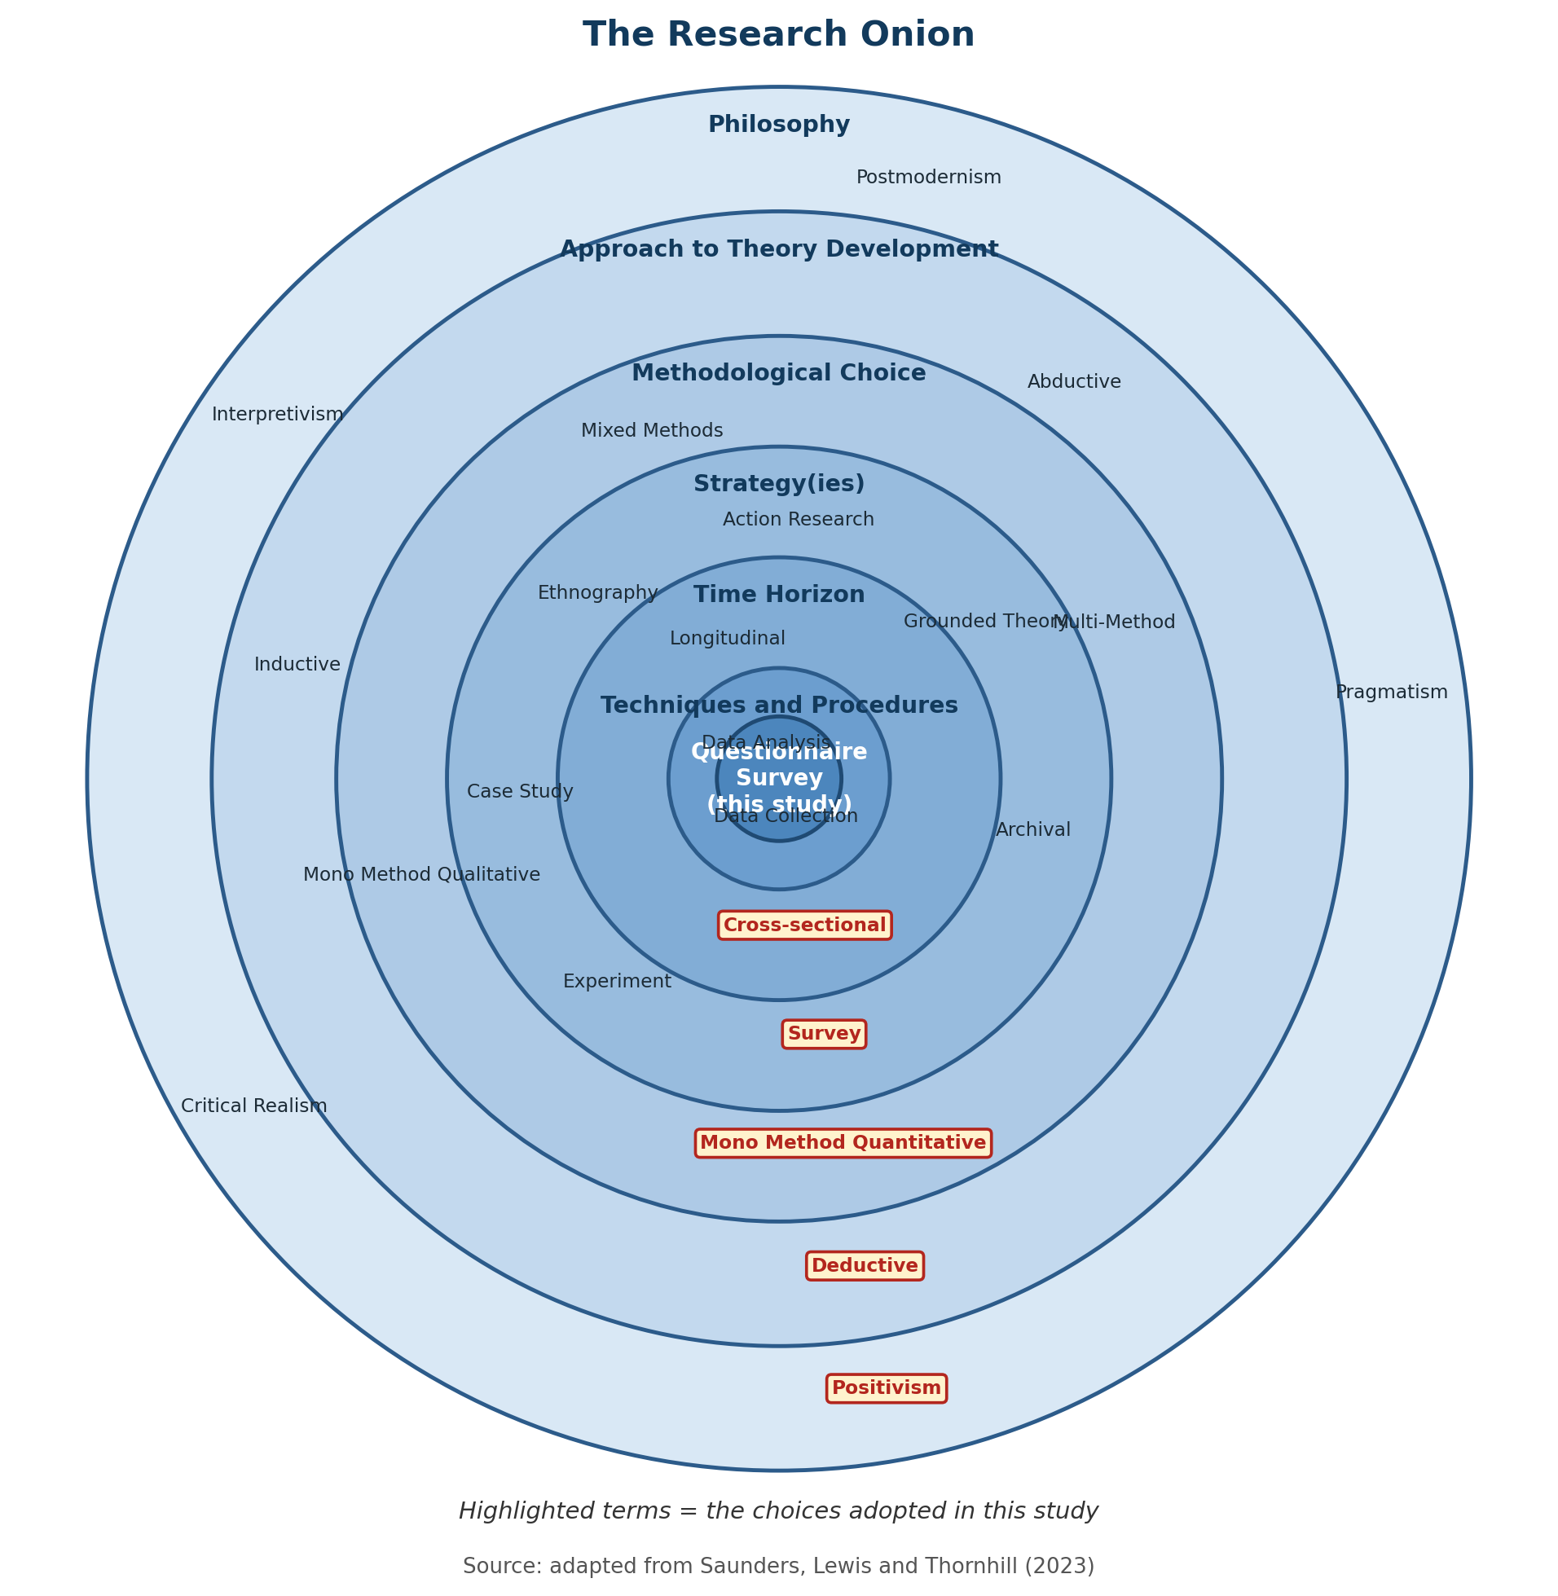
Figure 3.1 The Research Onion, showing the choices adopted in this study (adapted from Saunders, Lewis and Thornhill, 2023)
The research philosophy used in this research was positivist. Positivism states that social reality such as the well-being of employees, employee engagement and retention can be objectively observed and measured and that relationships between variables can be tested by using quantifiable data (Saunders, Lewis and Thornhill, 2023). It was the aim of the study to test relationships predicted by theory, as opposed to developing new theory from the participants' perceptions, that was consistent with the use of psychometrically-derived scales.
Based on the philosophy, the study used a deductive model for theory development. The literature review of the SST and the Job Demands-Resources Model clearly highlighted expectations regarding the relationship between working arrangements and well-being, engagement and retention. The intention of the research was to use the data gathered to test these expectations, not to construct new theory inductively from the qualitative accounts (Saunders, Lewis and Thornhill, 2023).
Methodologically, the study adopted a mono-method quantitative design, where quantitative data was the only form of evidence collected and analysed using one method which is structured questionnaire (Saunders, Lewis and Thornhill, 2023). The research method adopted was a survey, involving a single structured questionnaire, sent to employees in various organisations in the UK. A survey strategy is appropriate for obtaining standardised data from a relatively high number of participants and then statistically comparing the data from different groups based on working arrangement (Saunders, Lewis and Thornhill, 2023). The data were cross-sectional, meaning that data were collected from each respondent at one time, rather than from the same respondents over a long period of time. A cross-sectional design was felt to be the most suitable design for the dissertation because of the time constraints, as will be discussed in Section 3.8, the conclusions that could be reached regarding cause/effect were limited.
At design stage, alternative ways of research were thought of and neglected. The study had four aims and would have been stronger and more contextualised if it had been a case study of one organisation which had changed their working policy, but would not have enabled comparison across the three working-arrangement groups that was required, and would have restricted the generalisability of any findings to the context of that one organisation. It would not have been possible to design an experiment, like Bloom, Han and Liang (2024) did, within the scope of a scale of a dissertation that depended on randomisation with direct cooperation from an employer who was prepared to randomise their staff into various working conditions. The methodology for the survey adopted here was thus the most realistic option for ensuring a statistically meaningful comparison across a broad range of organisations in the UK that could be achieved within the limitations of the dissertation.

Data Collection
The main data collection tool used was a structured, self-administered online questionnaire, designed and disseminated via Google Forms, with six sections. In Section A, the respondents were screened for three eligibility criteria: current employment in the UK, age 18 and over, and duration of current employment arrangement of at least 6 months. Information for the purposes of group comparison is collected in Section B and includes classification, age band, gender/identity, sector, organisation size, seniority, highest qualification, and current working arrangement. The well-being items of Section C were based on five items of the Warwick-Edinburgh Mental Wellbeing Scale (Tennant et al., 2007), the engagement items of Section D were based on five items of the Utrecht Work Engagement Scale (Schaufeli et al., 2002) covering vigour, dedication and absorption, and the retention intention items of Section E were based on four items of the established turnover research of Mobley (1977). There was one optional open text comment in Section F. The complete questionnaire can be found in Appendix A.
The response format for all scale items was the five-point Likert scale (strongly disagree to strongly agree) that was used in the source constructs and facilitates statistical analysis described in Chapter 4. To analyse two items from each of the four scales included in the well-being and engagement, and retention scales, each of these was worded in a negative direction, and was reverse-scored prior to the analysis, such that a higher score on each item across the four scales indicated a more positive outcome.
The research proposal included an ethical safeguard that the questionnaire was reviewed and approved by the dissertation supervisor before it was distributed. It was distributed via LinkedIn professional groups relevant to remote working and human resources (with moderator permission) and via UWTSD working students currently working remotely or in a hybrid setting (as per e-research principles of Anderson and Kanuka (2003)). The written Participant Information Sheet described in Section 3.9 was presented to the respondents before the first question was asked, outlining the purpose of the study, participants' rights to confidentiality and the voluntary nature of participation.
The pilot exercise involved a small group of working professionals who were administered the questionnaire before it was widely distributed, and engaged in three checks: (1) the wording of each item was clear and unambiguous, (2) that the five point response scale seemed appropriate for each construct and, (3) that the questionnaire could be feasibly completed within the timeframe indicated in the participant information (5-10 minutes). The length and structure of the survey did not change for full distribution and no item wording difficulties were identified during the piloting. This would be a small-scale step, consistent with Cottrell's (2014) advice to pilot a dissertation-level survey, even if this is not an option for larger, formal pilot studies.

Population and Sample
The target population consisted of employees in knowledge work and professional service jobs, who were currently working in a remote and hybrid or office-based setting, and are based in the United Kingdom. Because a full random sample of UK employees within the resources available for this dissertation was not practically achievable a multi-channel purposive-convenience sampling approach was used, utilising LinkedIn professional groups, sector based outreach and UWTSD working students (Brown, 2006).
To ensure the responses aligned with a settled experience and not a recent transition, the inclusion criteria included current full-time or part-time employment, and at least six months of the respondent's current working arrangement. The study focused on the employment relationship between an employee and an employer, excluding those who are self-employed, but not affiliated with any organisation. The information provided by Veal (2011) on the minimum sample size required for reliable inferential comparison between groups was followed, setting a target of 200 completed responses at the design stage and confirming a minimum of 150. The final sample of 150 valid and eligible responses The screening and cleaning procedure which yielded 150 valid and eligible responses is fully described in Section 4.1 and falls within the minimum sample size pre-determined for the study.

Data and Analysis
IBM SPSS Statistics, version 27, was used to analyse the data. The classification variables and the scale scores were first summarised using descriptive statistics such as frequencies, percentages, means and standard deviations. These cross tabulations were then created to analyse trends within the demographic groups. For the second and third aims comparisons between the different types of work arrangements (fully remote, hybrid, and office-based) were completed using independent samples comparisons and one-way ANOVA, respectively. In order to test the fourth objective, multiple regression was applied to test working arrangement as a predictor of well-being with classification variables such as sector, seniority and organisation size (Bryman and Bell, 2007) controlled for. For the nominal variable working arrangement, the three categories were converted into two dummy variables to incorporate into the regression models, with hybrid working as the reference category as it was the largest single group in the achieved sample. Specifically, the analyses performed, and the rationale for each analysis, are described with the results in Chapter 4.
Assumptions of all parametric tests were checked before moving to inferential analysis. Skewness and kurtosis statistics were examined for each composite scale to assess approximate normality; Levene's test was used to check the assumption of homogeneity of variance ahead of each ANOVA; and variance inflation factors were examined for each regression model to check for problematic multicollinearity among the predictor variables. The results of each of these tests are discussed with the corresponding analysis in Chapter 4 and in all tests the assumption was found to be sufficiently satisfied to justify use of the parametric tests listed above, compared with the non-parametric alternatives.

Reliability and Validity
According to Bryman and Bell (2007), reliability is an indication of whether a measure yields consistent results and validity is an indicator of whether the measure measures what it is supposed to measure. Construct validity was achieved by the use of item sets with a conceptual foundation in scales with a proven history of use in workplace studies. Although, as mentioned in the following section (3.8), the exact wording of the items that comprised the constructs differed from the validated instruments. After the data was collected, the internal consistency reliability of each scale was measured with Cronbach's alpha, with all three scales having an alpha of more than 0.7, which is the established threshold for determining good reliability; complete Cronbach's alpha results are reported in Section 4.3. The instrument was pre-piloted with a small number of working practitioners before finalising the instrument for full distribution to identify and correct any unclear items or those that could affect the reliability of the scales as suggested by Cottrell (2014).
Common method bias, which has been documented when all measures are administered using the same instrument (self-report) (Podsakoff et al., 2024), was mitigated by the use of different item wording across different sections and by assuring the anonymity of respondents (also intended to reduce socially desirable responding); these are among the procedure recommendations to reduce socially desirable responses when all measures are self-report (Polas, 2025). The content validity of the instrument in terms of the extent to which items covered the construct they were designed to measure was substantiated by having the instrument checked the content by the supervisor before it was distributed to the participants, which is an independent check on content of the items on the instrument other than the researcher's judgement.

Limitations of the Research
There are some caveats that should be noted. This cross-sectional design does not allow for causal inferences to be made, therefore, the conclusions made about the relationships do not imply a cause and effect relationship between the working arrangement and any observed differences in well-being, engagement or retention. Self-report methods may engender a degree of response bias, such as social desirability response biases in particular when reporting on wellbeing measures. The use of a purposive-convenience sample of LinkedIn groups and UWTSD students may not be representative of the wider UK working population as those recruited may not be representative of all sectors or seniority within those groups. The number of sectors included, which is essential for a sufficient sample size, also brought in some variance between sectors, although this was somewhat counteracted by including sector as a control variable (Alvesson and Skoldberg, 2009). Lastly, the well-being, engagement and retention items were conceptually similar to previously validated items, but they did not mirror the exact language of these other scales-this choice and its impact on comparisons with other published research are discussed in Chapter 5.

Research Ethics
Ethical approval was requested and received from the relevant UWTSD process following the research proposal and the ethics documentation having been reviewed by the dissertation supervisor (a copy of the proposal form approved is attached as Appendix B) with participation being entirely voluntary and informed consent being obtained at the beginning of the online questionnaire, participants were informed that they could withdraw at any time, without giving a reason or without facing repercussions but a specific response would not be withdrawable once they had been submitted, due to the anonymity of responses. Personally identifiable information was not obtained, but instead each response was given a unique identifier to maintain anonymity. Data was stored in the University's Office 365 system on the cloud and was protected by a password that was only accessible to the researcher and supervisor and maintained only for the period of the project as outlined by the General Data Protection Regulation (GDPR) and the Data Protection Act 2018 (UK Parliament, 2018). The survey instrument and all item wording was pretested and approved by the supervisor prior to distribution.

Summary
The chapter has followed and argued for a mono method quantitative survey design, based on a positivist philosophy and a deductive approach, which was used to test the relationships between working arrangement and three employee outcomes, within a sample of employees in the United Kingdom. It has explained the instrument used in data collection, sampling method, the plan for data analysis, measures taken to ensure reliability and validity of the data, limitations of the design used, and ethical considerations that were followed in conducting the study. The minimum number of responses required to be collected as specified in Section 3.5 was 150, which was achieved during the data collection process. First, the results of the data screening process are reported in full in the next chapter, and then the demographic profile of the data achieved sample and the above described statistical analysis are presented.

Data Analysis and Findings
The outcomes of the survey data collected for this study are presented in this chapter. As in the methodology chapter, screening of the data, the demographic profile of the respondents, reliability of the three composites, descriptive statistics, correlations between the composites, use of multiple regression to test the effect of working arrangement, one-way ANOVA and post-hoc comparisons between the three working-arrangement groups, and a chi-square check for confounding by seniority is followed. The results of each are related to the research objectives in Chapter 1 and the literature reviewed in Chapter 2.
Data was analysed using IBM SPSS Statistics version 27 and the analysis methods outlined in Chapter 3. As promised in Section 3.6, the assumptions underlying the inferential tests were checked prior to the analysis of each. In the case of skewness and kurtosis, they were used as a check for approximate normality before each inferential test was run; variance inflation factors were checked for each regression model; and Levene's test was used as a check of homogeneity of variance before each ANOVA test was performed. The results of these checks are presented in the below analysis and in each case the assumption was met to a sufficient degree.

Data Screening and Response Profile
150 responses were obtained. All 150 answered the three screening questions (are currently employed in the UK, are aged 18 or over, and have been in the current working relationship for at least 6 months). A pattern of careless straight-lining was not observed in the answers of any respondent as all 14 Likert items were answered differently by each one; a pattern of multivariate outlier was not observed with regard to the response pattern of the respondents as the Mahalanobis distance threshold value was not exceeded (critical value=36.12, df=14, p<.001). There were no cases excluded and all subsequent analyses listed below used N=150.

This is something that is noteworthy, as a survey of this size usually drops off a few at the screening and/or cleaning phase. Two characteristics of the process could account for this: Because the Google Forms branching logic prevented those who did not meet the screening questions from continuing, it is likely that the workers who responded were those who did meet the criteria, and not otherwise eligible, and, because the form was distributed via targeted LinkedIn working student groups, but not an open public link, a relatively engaged and relevant pool likely was reached, explaining the lack of straight-lined or extreme responses.
Table 4.1 Data screening funnel
Stage | Cases removed | N remaining
Responses collected | - | 150
Failed screening questions | 0 | 150
Straight-lining (near-zero variance across items) | 0 | 150
Multivariate outliers (Mahalanobis distance, p<.001) | 0 | 150
Final sample used in analysis | - | 150
Note: no cases were excluded at any stage; the final analytic sample is equal to the number of responses collected.

Demographic Profile of Respondents
The respondents' demographic and organisational characteristics are summarised in Table 4.2. The composition of the sample is fairly representative in terms of gender, age bands, sector, organisation size and seniority. In this study, the primary independent variable is the working-arrangement variable with 48 respondents (32.0%) working remotely full time, 67 respondents (44.7%) working hybrid, and 35 respondents (23.3%) predominantly in the office.
The proportions of hybrid and fully remote work respondents are broadly comparable to the overall mix of UK respondents found in Chapter 1, who indicated hybrid or fully-remote work, depending on whether they had access to any flexibility at work (House of Lords Home-based Working Committee, 2025). The sample is also reasonably senior and size ranged from entry level to executive/director, and from less than 50 employees to more than 1,000 employees, allowing for this range in these variables to be used as statistical controls in the regression models reported in Section 4.6.

Table 4.2 Demographic and organisational profile of respondents (N=150)
Variable | Category | n | %
Age band | Under 25 | 10 | 6.7
 | 25-34 | 43 | 28.7
 | 35-44 | 48 | 32.0
 | 45-54 | 28 | 18.7
 | 55-64 | 19 | 12.7
 | 65 or over | 2 | 1.3
Gender/identity | Man | 68 | 45.3
 | Woman | 70 | 46.7
 | Non-binary | 6 | 4.0
 | Prefer not to say | 6 | 4.0
Sector | Financial services | 30 | 20.0
 | Consultancy | 24 | 16.0
 | Technology | 36 | 24.0
 | Higher education | 34 | 22.7
 | Other | 26 | 17.3
Organisation size | Under 50 | 29 | 19.3
 | 50-249 | 38 | 25.3
 | 250-999 | 42 | 28.0
 | 1,000 or more | 41 | 27.3
Seniority level | Entry-level | 54 | 36.0
 | Middle management | 55 | 36.7
 | Senior management | 25 | 16.7
 | Executive/Director | 16 | 10.7
Qualification | Below degree level | 19 | 12.7
 | Undergraduate degree | 56 | 37.3
 | Postgraduate degree | 50 | 33.3
 | Professional qualification | 25 | 16.7
Working arrangement | Fully remote | 48 | 32.0
 | Hybrid | 67 | 44.7
 | Predominantly office-based | 35 | 23.3
Tenure in arrangement | 6-12 months | 46 | 30.7
 | 1-2 years | 51 | 34.0
 | More than 2 years | 53 | 35.3

Reliability of the Composite Scales
Internal reliability of each composite scale was examined with Cronbach's alpha, before testing relationships between variables. The coefficient value of more than .70 is considered acceptable (Bryman and Bell, 2007). All three scales fulfilled the criterion of meeting the required number of items, with each set being averaged to create a composite scale for each of the three measures: well-being, engagement and retention intention.
The scale with the best reliability was the well-being scale (α=.817), followed by engagement (α=.769) and retention (α=.738). Retention has a relatively low alpha but still good, which is also in line with the fact that it is constructed with the least number of items (4, compared to 5 for the other two scales) because Cronbach's alpha is somewhat sensitive to the length of the scale. None of the items when removed would have raised the alpha above that reported by a significant amount, and they were therefore kept in as originally designed.
Table 4.3 Reliability statistics for the composite scales
Composite scale | Number of items | Cronbach's alpha
Employee Well-being | 5 | .817
Employee Engagement | 5 | .769
Retention Intention | 4 | .738

Descriptive Statistics
Descriptive statistics for the three composite scores are reported in Table 4.4. On average, respondents reported moderately positive well-being, engagement and intention to remain, as all three are above the midpoint of the scale (3). Skewness and kurtosis of the three are within the "normal range" of ±1 typically used to indicate that there is not a significant departure from normality, and thus are not problematic for the parametric tests (ANOVA and multiple regression) used below.
The ordering of retention intention, engagement and well-being is not strong, because the means are close together and the standard deviations similar (from .665 to .700), but the informative comparisons are those that are made between working-arrangement groups, presented in Sections 4.6 and 4.7.
Table 4.4:
Table 4.4 Descriptive statistics for the composite scores (N=150)
Composite | Minimum | Maximum | Mean | SD | Skewness | Kurtosis
Well-being | 2.00 | 5.00 | 3.664 | .700 | -.214 | -.690
Engagement | 1.80 | 5.00 | 3.704 | .665 | -.232 | -.471
Retention Intention | 2.00 | 5.00 | 3.785 | .690 | -.216 | -.561

Correlations Between the Composites
Table 4.5 shows the Pearson correlations between the three composite scores. The positive significant correlation among all three pairs is at the level of p<.001. The strongest relationship is between well-being and engagement (r=.849), which is consistent with the Job Demands-Resources Model, which states that a balance of demands and resources that benefits well-being also benefits engagement (Bakker and Demerouti, 2017; Schaufeli and Bakker, 2004). There is a similar relationship between retention intention and well-being (r=.736) and retention intention and engagement (r=.729), which is also consistent with resource depletion harming engagement, and subsequently, the chance of staying (Bakker and Demerouti, 2017).
Table 4.5 Correlations between the composite scores (N=150)
 | Well-being | Engagement | Retention
Well-being | 1 | .849** | .736**
Engagement | .849** | 1 | .729**
Retention Intention | .736** | .729** | 1
** Correlation is significant at the 0.01 level (2-tailed).

Multiple Regression Analysis
Multiple regression was employed to assess whether working arrangement is a significant predictor of each outcome once sector, seniority and organisation size have been controlled for. Two dummy variables were entered: 'Fully remote (vs Hybrid)' and 'Office-based (vs Hybrid)' for working arrangement with the reference category being Hybrid. This is directly related to Research Objectives 2, 3 and 4, which are related to the impact of working arrangement on well-being, engagement and retention.
Table 4.6 Multiple regression predicting Employee Well-being
Predictor | B | SE | Beta | t | p | VIF
(Constant) | 3.745 | .205 | - | 18.296 | <.001 | -
Fully remote (vs Hybrid) | -.075 | .133 | -.050 | -.563 | .574 | 1.255
Office-based (vs Hybrid) | -.454 | .142 | -.275 | -3.188 | .002 | 1.173
Sector | .049 | .042 | .097 | 1.179 | .240 | 1.064
Seniority | -.062 | .058 | -.087 | -1.066 | .288 | 1.041
Organisation size | .010 | .053 | .015 | .184 | .854 | 1.069
Model: R=.293, R²=.086, Adjusted R²=.054, SE=.680, F(5,144)=2.700, p=.023. Dependent variable: Well-being composite mean.
Office-based working arrangement also significantly correlates with lower well-being compared to hybrid (B=-.454, p=.002), and there is no significant difference between fully remote and hybrid working (p=.574). The control variables (sector, seniority, size of the organisation) are not significant. The VIF for all the predictors is below the usual limit of 5, suggesting that there is no significant multicollinearity among the predictors.
The model is statistically significant, but only accounts for a small amount of variance in well-being (R²=.086). That is not uncommon with any model with a single predictor of interest for a psychological outcome and it suggests that most variance in the wellbeing scores is from other factors not included in this study such as personality, home environment or job satisfaction. The practical implications are in the size and stability of the office-based effect rather than on the overall explanatory power of the model.
Table 4.7 Multiple regression predicting Employee Engagement
Predictor | B | SE | Beta | t | p | VIF
(Constant) | 3.950 | .192 | - | 20.536 | <.001 | -
Fully remote (vs Hybrid) | -.041 | .125 | -.029 | -.326 | .745 | 1.255
Office-based (vs Hybrid) | -.482 | .134 | -.307 | -3.605 | <.001 | 1.173
Sector | .003 | .039 | .006 | .075 | .940 | 1.064
Seniority | -.087 | .055 | -.128 | -1.591 | .114 | 1.041
Organisation size | .017 | .050 | .028 | .350 | .727 | 1.069
Model: R=.328, R²=.108, Adjusted R²=.077, SE=.639, F(5,144)=3.477, p=.005. Dependent variable: Engagement composite mean.
The pattern of engagement is similar to well-being, with lower engagement with office-based arrangement compared to hybrid (B=-.482, p<.001), which has the largest standardised effect in this model (Beta=-.307), but not significantly different from hybrid for fully remote. This aligns with Kahn's (1990) theory that engagement is achieved through frequent interpersonal interactions, which are best maintained through arrangements that leave some flexibility.
Table 4.8 Multiple regression predicting Retention Intention
Predictor | B | SE | Beta | t | p | VIF
(Constant) | 3.886 | .200 | - | 19.396 | <.001 | -
Fully remote (vs Hybrid) | .013 | .131 | .009 | .101 | .920 | 1.255
Office-based (vs Hybrid) | -.444 | .139 | -.273 | -3.186 | .002 | 1.173
Sector | -.014 | .041 | -.027 | -.334 | .739 | 1.064
Seniority | -.064 | .057 | -.092 | -1.134 | .259 | 1.041
Organisation size | .064 | .052 | .101 | 1.235 | .219 | 1.069
Model: R=.314, R²=.099, Adjusted R²=.067, SE=.666, F(5,144)=3.153, p=.010. Dependent variable: Retention composite mean.
Office-based arrangement predicts lower intention to stay relative to hybrid (B=-.444, p=.002), but there is no significant difference between fully remote and hybrid (B=.013, p=.920). This aligns with the Job Demands-Resources Model of withdrawal behaviour, as resource depletion (linked to a fully office-based arrangement) increases the risk of withdrawal and intention to leave (Bakker and Demerouti, 2017), and the CIPD (2025) finding that flexibility is a measurable factor of staff turnover in the UK.
In each of the three regression models, office working is linked with significantly poorer outcomes while working fully remotely and hybrid working are not significantly different from each other on any outcome. As noted in the literature review, the dose-response relationship was not as clearly defined as the pattern that was anticipated in this study, where a moderate, predetermined amount of remote work (Bloom, Han and Liang 2024 two-day hybrid model) would be expected to perform better than either 100-percent presence in the office or 100-percent remote work (Gajendran and Harrison 2007). The data, however, indicate that fully remote and hybrid work are similar, while there is a clear outlier, office-based work, on the low performance side.

One-Way ANOVA and Group Comparisons
In order to address Research Objective 4, one-way ANOVA was used to compare well-being, engagement and intention to remain across the three groups without adjusting for any other variables. However, Levene's test was not significant for any of the three outcomes well-being F(2,147) = .830, p = .438; engagement F(2,147) = .058, p = .943; retention F(2,147) = .447, p = .640, indicating that homogeneity of variance was confirmed and the standard ANOVA and Tukey HSD post-hoc test could be used.

Table 4.9 Group means and ANOVA results by working arrangement
Outcome | Fully remote (n=48) | Hybrid (n=67) | Office-based (n=35) | F(2,147) | p
Well-being M (SD) | 3.729 (.730) | 3.791 (.662) | 3.331 (.636) | 5.594 | .005
Engagement M (SD) | 3.779 (.653) | 3.839 (.625) | 3.343 (.645) | 7.425 | .001
Retention M (SD) | 3.901 (.723) | 3.888 (.636) | 3.429 (.638) | 6.556 | .002

All three ANOVAs are significant, indicating that the working arrangement significantly contributes to well-being, engagement and intention to remain. Tukey HSD post-hoc comparisons (Table 4.10) reveal a similar pattern: the office-based workers have significantly lower scores on all three outcomes compared to both fully remote and hybrid workers, and there are no significant differences between fully remote and hybrid workers on any of the outcomes.
The ANOVA results further support the results of the regression analysis presented in Section 4.6, both of which point to the factor office-based working arrangement as being the significant driver of poorer outcomes, albeit in different ways. With the ANOVA, the three groups are compared directly without assuming any linearity; with the regression the three groups are compared, accounting for sector and size of the organisation, and seniority at the same time. The fact that both come to the same conclusion adds to the confidence in a finding than either one alone would.
Table 4.10 Tukey HSD post-hoc pairwise comparisons
Outcome | Comparison | Mean difference | SE | p
Well-being | Fully remote vs Hybrid | -.062 | .128 | .880
 | Fully remote vs Office-based | .398* | .151 | .025
 | Hybrid vs Office-based | .460* | .142 | .004
Engagement | Fully remote vs Hybrid | -.060 | .121 | .874
 | Fully remote vs Office-based | .436* | .142 | .007
 | Hybrid vs Office-based | .496* | .133 | .001
Retention | Fully remote vs Hybrid | .013 | .126 | .994
 | Fully remote vs Office-based | .472* | .148 | .005
 | Hybrid vs Office-based | .459* | .139 | .003
* Mean difference is significant at the 0.05 level.
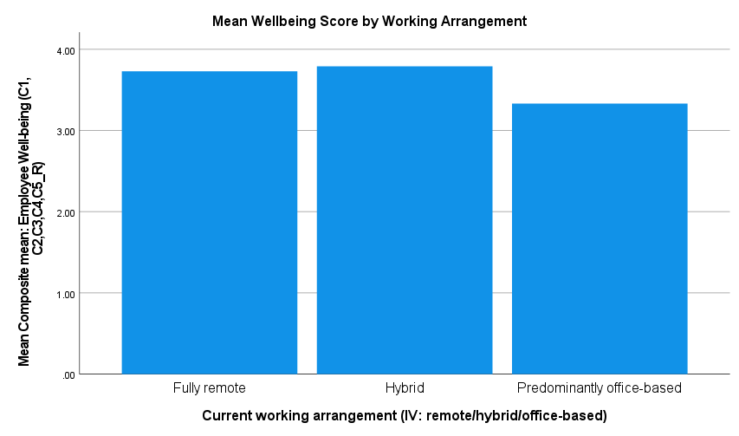
Figure 4.1 Mean Well-being score by working arrangement

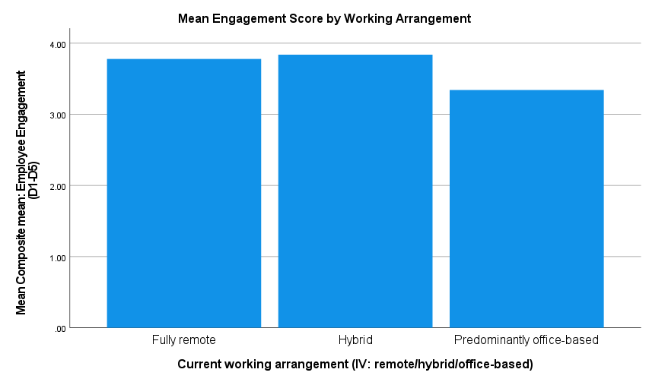
Figure 4.2 Mean Engagement score by working arrangement
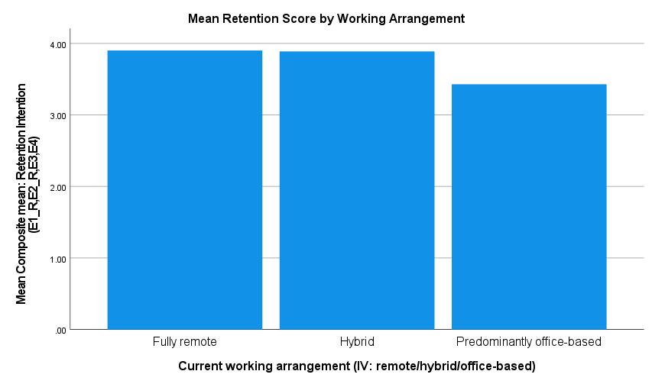
Figure 4.3 Mean Retention Intention score by working arrangement
The pattern of the groups is more apparent when plotted as bar charts in Figures 4.1 to 4.3 and as line plots in Figures 4.4 to 4.6: the fully remote and hybrid groups are more similar to each other at the top and more distinct from the office-based group, which is lower. This aligns with some degree of flexibility being a job resource when compared to 100% working from home, but the data do not support the idea that hybrid specifically outperforms 100% working from home, as the dose-response account predicted (Gajendran and Harrison, 2007; Bloom, Han and Liang, 2024).
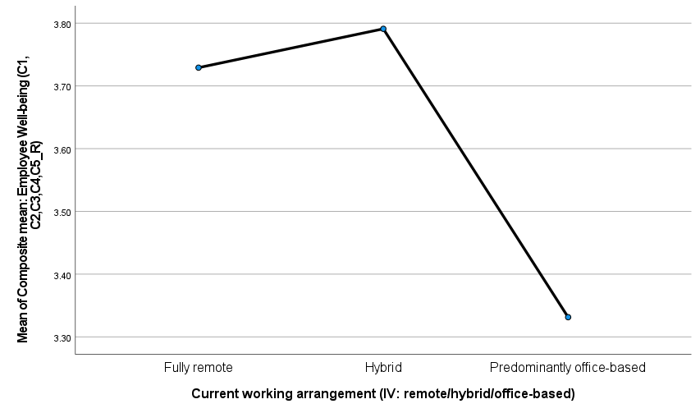
Figure 4.4 Estimated marginal means plot - Well-being by working arrangement
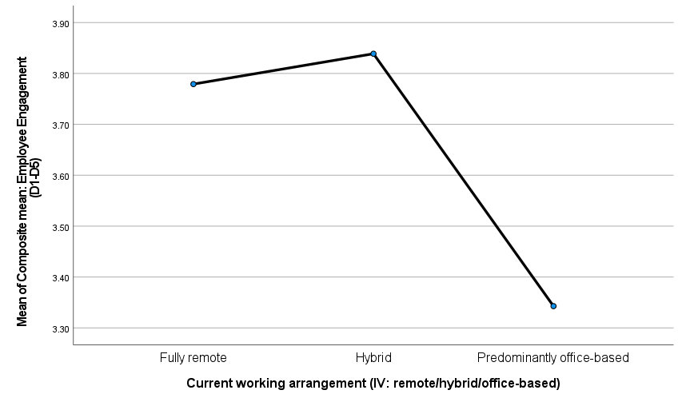
Figure 4.5 Estimated marginal means plot - Engagement by working arrangement
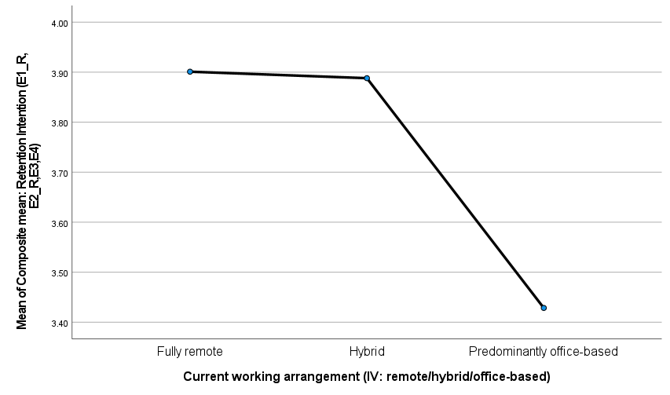
Figure 4.6 Estimated marginal means plot - Retention Intention by working arrangement

Chi-Square Test of Association
To ensure that the above group comparisons were not confounded by systematic differences in the composition of the seniority level in each of the three working-arrangement groups, a chi-square test of independence was performed between working arrangement and seniority level. The association was not significant, χ²(6, N=150)=4.177, p=.653 (likelihood ratio 4.210, p=.648). The test result is considered reliable as the expected count of one cell (8.3%) is below the guideline of no more than 20% of cells having an expected count below 5.
Table 4.11 Chi-square test - Working arrangement by Seniority level
Test | Value | df | p
Pearson Chi-Square | 4.177 | 6 | .653
Likelihood Ratio | 4.210 | 6 | .648
This is a positive outcome as the three groups do not differ significantly on seniority profile, meaning that the differences in well-being, engagement and retention indicated above is not likely to be due to the uneven distribution of junior and senior employees. This check does not eliminate all potential extraneous factors, and as mentioned above, sector and organisation size and qualification were checked as control variables in the regression models in Section 4.6, however, other unmeasurable factors, such as personal circumstances or the reason why an employee joined in a specific arrangement cannot be ruled out by this design and is discussed in Chapter 5 as a limitation.

Summary of Findings
This section relates the findings of the research to the research objectives outlined in Chapter 1. A note on framing: The following summary is organised by objective, as was the original proposal and Chapter 1, following the framing of the study.
However, it is important to reiterate the one over-arching pattern that exists in each of the analyses that follow in this chapter. The result is consistent across the different types of tests examined (correlation, regression, and direct comparison of the fully remote and hybrid groups against the office-based group using ANOVA and Tukey post-hoc tests): that no significant differences in well-being, engagement and retention intention can be found between the fully remote and hybrid groups, which both have significantly better scores than their colleagues in the office. The consistency of these four analysis approaches on the same 150 respondents is noteworthy, as is the fact that this pattern was not seen to be an artefact of any one analytical approach.
Objective 2 was whether the employee well-being is impacted by working 100% from home. The regression and ANOVA results indicate that there is no significant difference between fully remote and hybrid employees in terms of well-being, but the scores are significantly higher for fully remote employees than for office-based employees (Tukey p=.025). The dose-response account of the literature is only partially supported: fully remote working is linked to improved well-being, while the association of hybrid working to well-being is limited, suggesting that the latter does not have an advantage or disadvantage over the former.
Objective 3 queried the link between remote working and employee engagement and organisational belonging. There is a significant prediction of office-based working in the regression model (p<.001), and this is supported by the ANOVA, which shows significant differences between the office-based group and the remote and hybrid groups. This objective is supported in the sense that working arrangement is clearly linked to engagement, even if the link is in the opposite direction to some strands of the literature focusing on isolation in remote settings: it is office-based as the disadvantaged group, rather than fully remote (Wang et al., 2021).
Objective 4 was to determine if well-being, engagement and retention outcomes varied meaningfully based on the setting (fully-remote, hybrid, or office-based). The objective is supported with all three ANOVAs being significant with Tukey post-hoc tests showing significant difference between the scores of the office-based and both other groups on each of the outcomes; and no significant difference between the fully remote and hybrid groups.
Overall, the results confirm the Job Demands-Resources Model, which predicts that unfavourable outcomes in terms of well-being, engagement and retention are associated with lack of flexibility as a job demand (Bakker and Demerouti, 2017; CIPD, 2025). They do not, however, align with the more specific dose-response model, which would suggest that hybrid working would be more effective than fully remote working (Gajendran and Harrison, 2007; Bloom, Han and Liang, 2024). Rather, it seems there is a more straightforward threshold effect: Some flexibility, be it hybrid or full-remote, is correlated with improved outcomes than none. This mirrors the recent large-scale findings where remote and hybrid employees reported similar levels of well-being, connection and retention from office-based workers, and little to distinguish the two groups in these flexible scenarios (Lezcano et al., 2026). This distinction and its implications are developed in the discussion and conclusion chapters.

Recommendations and Conclusions

Conclusions
The aim of this study was to examine the relationship between remote and hybrid working arrangements and employee wellbeing, engagement and retention within organisations in the UK, and to provide evidence-based guidance to managing distributed workforces. This aim was to be achieved through five objectives which are discussed in turn below.
The first step of identifying the primary dimensions of well-being, engagement and retention from the literature was completed through the literature review which identified two models, namely, Self-Determination Theory (Deci and Ryan, 2000) and the Job Demands-Resources Model (Bakker and Demerouti, 2007, 2017) that adequately explained how working arrangement could influence these outcomes.
To answer the second and third aims around the impact of extended home working on wellbeing, and working arrangement and engagement, the regression analyses and ANOVA were used. The results were more specific than expected: fully remote workers showed no significant differences from hybrid workers in either measure, while the hybrid workers performed significantly better than office-based workers. As a result, it is not so much that working remotely is good or bad in itself; when flexibility is present or absent, that's what matters.
The fourth goal: analyse results for three working arrangement groups, was definitely met. All three outcomes were significantly different by working arrangement with a consistent pattern: office-based employees reported lower well-being, lower engagement and lower intention to stay compared with fully remote and hybrid working employees, who did not differ significantly from each other on any of the outcome measures.
In Section 5.2 below, the fifth aim of making recommendations to the organisation based on evidence is covered.
This study's main finding is that the impact of the working-arrangement on employee outcomes in this sample is most likely a "threshold" effect rather than a "dose-response" effect. There is a clear connection between some level of flexibility (full-time remote or hybrid) and meaningfully improved well-being, engagement and retention when compared to a predominantly in-office environment. The data, however, do not support a specific comparison to find that hybrid working is actually superior to fully remote working, which is less clear cut and extensive a finding than some previous literature have suggested (Gajendran and Harrison, 2007; Bloom, Han and Liang, 2024).
The conclusion is based upon the research objective formulated in Chapter 1 because the study was not formulated with numbered hypotheses. This form of statement can, in some ways, serve as an answer that is quite successful; it provides a clear answer, derived in a statistically valid manner to the research question, albeit it may be more specific and even simpler, than the literature review had foreseen. The evidence doesn't suggest that every part of the curve is going to have a gradual improvement as people move from having some choice where they go to work to full-time working from home; instead, it is one that's defined by a single dividing line.

Recommendations for Managerial Practice
The subsequent recommendations stem from the trend of the findings found in Chapter 4 and are directed at those UK organisations that are currently making decisions about the amount of remote or hybrid working they are allowing their staff to do. Each recommendation is carefully formulated, and only as a product of the data presented in this study, not to go beyond what this study was designed to test.
- Do not impose blanket return to office orders. The evidence does not indicate any benefits of an office arrangement compared to remote or hybrid working on any of the three outcomes measures and a clear disadvantage on all three. Organisations looking for a complete move to the office should take this into account along with the measurable impact of the study on employee well-being, engagement and intention to leave which has already found a link by the CIPD (2025) with a significant increase in voluntary employee turnover in the UK as a result of less flexibility.
- Maintain true flexibility as opposed to preferring a certain arrangement over another. The findings of this research suggest that there is no difference between fully remote and hybrid working in terms of the outcomes, so organisations should not assume that hybrid working is superior to fully remote working, or vice versa. What should be the priority based on these findings is that employees must have some meaningful level of choice in where they work, instead of a pre-determined number of days in the office.
- For certain roles or teams where attendance at the office is operationally required, make a specific investment in engagement and well-being support for these employees as they have been shown here to be at highest risk on all three outcomes. This may involve more conscious focus on social and psychological factors that Kahn (1990) links with engagement, including the opportunity to have meaningful interpersonal contact, as opposed to assuming that just being in an office will provide this benefit.
- Ensure flexible-working policy is applicable across the board and does not require a lot of customisation on a sector-by-sector, senior-by-senior, size-by-size basis. None of these three variables significantly predicted well-being, engagement or retention when working arrangement was controlled for in the regression models, indicating that the advantages of flexibility found in this study are not limited to a specific type of organisation, industry or employee group.
- Pay attention to retention risk factors, especially those associated with those with less flexibility in their working arrangement, as there was a strong link between office-based working and lower intention to stay. For this population, early-warning indicators consistent with the withdrawal models (e.g., Mobley 1977) such as decreases in engagement scores or in the voluntary participation in optional activities may serve as useful indicators to monitor.
These recommendations collectively suggest a relatively straightforward policy message: while organisations do not need to pursue a single ‘best practice' approach to working, they should be aware of the dangers of losing any flexibility completely, as this study links this to poorer employee outcomes, not the particular working patterns.
Table 5.1 Summary of recommendations linked to findings
Finding (Chapter 4) | Recommendation
Office-based employees scored significantly lower on well-being, engagement and retention than remote or hybrid employees | Avoid mandating full-time office attendance where not operationally necessary
Fully remote and hybrid employees did not differ significantly on any outcome | Do not treat hybrid as inherently superior; prioritise flexibility itself over a specific arrangement
Sector, seniority and organisation size were not significant predictors | Apply flexible-working policy broadly rather than restricting it to particular teams or levels
Office-based arrangement significantly predicted lower retention intention | Track retention risk closely among employees with limited flexibility

Contributions to Theory
The study adds to the theoretical field of remote working in two ways: First, it provides empirical support for the Job Demands-Resources reading of working arrangement, where lack of flexibility is viewed as a job demand, and flexibility (in either remote or hybrid) is considered a job resource (Bakker and Demerouti, 2017; Schaufeli and Bakker, 2004). The recurring disadvantages for office-based workers in all three outcomes are well accounted for by this framework because when the locus of work is not under one's control, there is a lack of buffer to protect against the stressors of everyday work.
Second, the results indicate that the emphasis of the Self-Determination Theory (Deci and Ryan, 2000) on autonomy is a more appropriate explanation for the pattern of results than a dose-response explanation. If the psychological benefit of flexible working is more about the autonomy that workers enjoy over where they work, rather than the proportion of their time spent away from the office, then fully remote and hybrid would provide a similar autonomy benefit whereas an arrangement that would allow no such choice would not, which is why fully remote/hybrid employees reported statistically indistinguishable outcomes to office-based employees and office-based employees did not. This autonomy-based interpretation is in line with the latest research indicating that satisfaction with basic psychological needs, not working location per se, differentiates between office-based, hybrid and remote workers (Walczak, 2026).
This contrasts somewhat with the earlier measure of the telecommuting-employee relationship that was more linear and curvilinear (Gajendran and Harrison, 2007) as well as the more recent work that linked the two-day hybrid pattern with the curvilinear relationship (Bloom, Han and Liang, 2024). The present findings do not contradict that literature completely; this study was not specifically designed to test a dose-response relationship and measured working arrangement as three broad categories and not as a number of office days as a continuous number. At present, however, there is no measurable difference between fully remote and hybrid respondents, so autonomy or choice over working arrangement might be a better lens with which to view, at least for outcomes and population studied here.
The retention results may also relate to previous studies on the withdrawal behaviour. Mobley's (1977) model views job dissatisfaction as a process that leads to an employee's intention to leave the current job and ultimately to turnover, with resources and constraints of the employee being a key driver in that process. This is consistent with this model, as the absence of flexibility could be interpreted as one of these constraints, which in turn, would decrease the job resources in the Job Demands-Resources sense, increasing the risk of retention (Bakker and Demerouti, 2017). This corroborates the idea that engagement and retention are not distinct but intertwined processes, as suggested by the significant correlations among all three composites in Chapter 4.

Limitations of the Study
It should be noted that a number of restrictions were imposed as described in greater detail in the methodology chapter. Because it is a cross-sectional design, the relationships found are associational rather than causal. It is not possible to draw any conclusions about the impact of a particular type of working on a particular type of well-being, engagement or retention - it might just be that employees who are less satisfied or engaged in the first place are more likely to be placed in office roles, for example, but not that office working itself is a cause of low satisfaction. This is a reverse causality scenario that was not addressed in the study, and therefore the reported disadvantage of being in the office (as summarised in Chapter 4) must be interpreted as a strong association rather than as an indication of a causal pathway.
Common method bias and social desirability effects may arise due to the use of self-report data for all three outcome measures, especially for the well-being items. The findings may not be representative of the UK working population more broadly, as the sample was drawn from a purposive-convenience sampling approach, and may not be representative of all sectors, seniority or organisation types, due to the working relationships between the UWTSD staff and the people who were sampled. However, expanding the recruitment base to a number of sectors was a necessary step in obtaining a sufficient sample size, but led to a certain amount of variation across the sectors, which was only partially accommodated by the inclusion of sector as a control variable in the regression models.
Another constraint is the instrument for measuring. The well-being, engagement and retention items in the survey were constructed to capture the same constructs as other validated items, but not the same language of these validated items. In the present sample, the internal reliability of each of the composite scales was acceptable (Cronbach's alpha ranging from .738 to .817), lending confidence to the assumption that each set of items measured a coherent underlying construct. However, due to some differences in wording from the original validated scales, only the comparisons that can be confidently made within this data set, between the working-arrangement groups, can be compared with published norms or other studies using the original scales.
Lastly, this study was not intended to account for the specific poorer-reported outcomes of office-based workers; the intent was simply to determine whether a difference exists, and it does. It is uncertain whether this distinction is due to the nature of the working arrangement itself, the nature of the person who ends up in such an arrangement, or a combination of these, so this study cannot differentiate.

Areas for Further Research
Based on the above finding and limitations, four ideas for further study are recommended. First, a longitudinal design, which follows the same employees before and after a change in working arrangement, such as the switch from a fully-remote to a hybrid arrangement, would enable much greater causal inference than the cross-sectional design used here, and would help answer the question of whether the disadvantage of working from the office, observed in this study, is a real effect of the working arrangement itself, as longitudinal studies of transitions between fully-remote and hybrid arrangements have started to indicate (Casely-Hayford et al., 2026).
Second, qualitative research, including semi-structured interviews with specific office-based respondents, may help explain the reasons why this group of respondents report consistently lower outcomes across all three measures. It would help to separate between a few possible explanations this study is not able to do so: that office-based working itself impacts well-being, engagement and intention to stay; that people who were already less well were more likely to be offered the opportunity to work in the office; or that there is some third factor not captured in this study which affects the working arrangement and the outcome.
Third, future research could use a larger sample (than used in this study) generated using a purposive-convenience method to determine if the threshold pattern identified in this study is evident across a wider and more representative number of UK industries, company size and level of seniority.
Finally, additional studies can test potential moderators not included in the current research, such as commute time, job autonomy apart from place of work, or actual choice of working arrangement for the employee. The findings and theoretical discussion above suggest that autonomy and choice are likely to be the best explanation, and therefore a study that directly measures perceived choice, instead of a broad category of working arrangements, would be a more direct test of this explanation than the present study has been able to provide.
In closing, this study was designed to quantify the level of a relationship and it has done just that, reasonably well. But the evidence to date does not suggest that hybrid working is an advantage over working from home, rather it suggests that the key difference is whether workers have some real flexibility around where they work or not. If there is a mechanism for removing flexibility that is not yet clear, the practical implications for organisations considering attendance at the workplace or not are clear enough, even in the absence of a clear mechanism: it has been shown here, and in other comparable studies, that removing flexibility in itself has measurable and statistically significant negative implications for well-being, engagement and retention, which seems to be outweighed by the mix of remote and hybrid working.

References
Acas (2024) Code of Practice on Requests for Flexible Working. London: Acas.
Albrecht, S.L., Furlong, S. and Leiter, M.P. (2023) 'The psychological conditions for employee engagement in organizational change: Test of a change engagement model', Frontiers in Psychology, 14, 1071924.
Allen, N.J. and Meyer, J.P. (1990) 'The measurement and antecedents of affective, continuance and normative commitment to the organization', Journal of Occupational Psychology, 63(1), pp. 1-18.
Allen, T.D., Golden, T.D. and Shockley, K.M. (2015) 'How effective is telecommuting? Assessing the status of our scientific findings', Psychological Science in the Public Interest, 16(2), pp. 40-68.
Alvesson, M. and Skoldberg, K. (2009) Reflexive Methodology: New Vistas for Qualitative Research. 2nd edn. London: Sage Publications.
Anderson, T. and Kanuka, H. (2003) E-Research: Methods, Strategies and Issues. Boston: Allyn and Bacon.
Bakker, A.B. and Demerouti, E. (2007) 'The Job Demands-Resources model: state of the art', Journal of Managerial Psychology, 22(3), pp. 309-328.
Bakker, A.B. and Demerouti, E. (2017) 'Job Demands-Resources theory: taking stock and looking forward', Journal of Occupational Health Psychology, 22(3), pp. 273-285.
Bakker, A.B., Demerouti, E. and Sanz-Vergel, A. (2023) 'Job Demands-Resources Theory: Ten Years Later', Annual Review of Organizational Psychology and Organizational Behavior, 10, pp. 25-53.
Basit, A.A. and Nauman, S. (2023) 'How workplace loneliness harms employee well-being: A moderated mediational model', Frontiers in Psychology, 13, 1086346.
Bell, J. (2005) Doing Your Research Project. 4th edn. Maidenhead: Open University Press.
Bermudez-Gonzalez, G., Lucia-Casademunt, A.M. and Padilla-Angulo, L. (2024) 'What can talent management do about involuntary remote working in the post-COVID-19 era? Spanish IT employees' organizational commitment', Humanities and Social Sciences Communications, 11(1), 1239.
Bloom, N., Han, R. and Liang, J. (2024) 'Hybrid working from home improves retention without damaging performance', Nature, 630(8018), pp. 920-925.
Bondanini, G., Sanchez-Gomez, M., Mucci, N. and Giorgi, G. (2025) 'Digital Connectivity at Work: Balancing Benefits and Risks for Engagement, Technostress, and Performance', Administrative Sciences, 15(10), 398.
Brown, R.B. (2006) Doing Your Dissertation in Business and Management. London: Sage Publications.
Brunelle, E. and Fortin, J.-A. (2021) 'Distance Makes the Heart Grow Fonder: An Examination of Teleworkers' and Office Workers' Job Satisfaction Through the Lens of Self-Determination Theory', SAGE Open, 11(1), 2158244020985516.
Bryman, A. and Bell, E. (2007) Business Research Methods. 2nd edn. Oxford: Oxford University Press.
Casely-Hayford, J., Tinnerholm Ljungberg, H., Aboagye, E., Bjorklund, C., Kwak, L., Toivanen, S., Bergstrom, G. and Jensen, I. (2026) 'Entering the new normal - psychosocial work environment and health during the transition from full remote to a hybrid work arrangement in a higher education context', PLOS ONE, 21(7), e0353162.
Chen, D., Wang, Q. and Yan, Y. (2026) 'Remote work frequency and loneliness among United Kingdom employees: the moderating role of active and passive social media use', Frontiers in Psychology, 17, 1930871.
Choudhury, P., Khanna, T., Makridis, C.A. and Schirmann, K. (2026) 'Is Hybrid Work the Best of Both Worlds? Evidence from a Field Experiment', The Review of Economics and Statistics (advance online publication).
CIPD (2025) Flexible and Hybrid Working Practices in 2025. London: Chartered Institute of Personnel and Development. Available at: https://www.cipd.org/en/knowledge/reports/flexible-hybrid-working/ (Accessed: 22 June 2026).
Cottrell, S. (2014) Dissertation and Project Reports: A Step by Step Guide. Basingstoke: Palgrave Macmillan.
Deci, E.L. and Ryan, R.M. (2000) 'The "what" and "why" of goal pursuits: human needs and the self-determination of behavior', Psychological Inquiry, 11(4), pp. 227-268.
Dong, J., Tan, Z., Zhang, Y., Sun, Y. and Huang, Y. (2025) 'Work from home and employee well-being: a double-edged sword', BMC Psychology, 13, 748.
Felstead, A. and Henseke, G. (2017) 'Assessing the growth of remote working and its consequences for effort, well-being and work-life balance', New Technology, Work and Employment, 32(3), pp. 195-212.
Ferrara, B., Pansini, M., De Vincenzi, C., Buonomo, I. and Benevene, P. (2022) 'Investigating the Role of Remote Working on Employees' Performance and Well-Being: An Evidence-Based Systematic Review', International Journal of Environmental Research and Public Health, 19(19), 12373.
Gajendran, R.S. and Harrison, D.A. (2007) 'The good, the bad, and the unknown about telecommuting: meta-analysis of psychological mediators and individual consequences', Journal of Applied Psychology, 92(6), pp. 1524-1541.
Hao, Q., Zhang, B., Shi, Y. and Yang, Q. (2022) 'How trust in coworkers fosters knowledge sharing in virtual teams? A multilevel moderated mediation model of psychological safety, team virtuality, and self-efficacy', Frontiers in Psychology, 13, 899142.
Hom, P.W. and Kiazad, K. (2025) 'New Directions for Theories for Why Employees Stay or Leave', Annual Review of Organizational Psychology and Organizational Behavior, 12, pp. 185-213.
House of Lords Home-based Working Committee (2025) Is Working from Home Working? HL Paper 196 of session 2024-26. London: House of Lords.
Kahn, W.A. (1990) 'Psychological conditions of personal engagement and disengagement at work', Academy of Management Journal, 33(4), pp. 692-724.
Kornadt, A.E., Bowen, C.E., Lepinteur, A., D'Ambrosio, C., Ratti, L. and Vogele, C. (2025) 'Working from home and well-being during the pandemic and beyond: a longitudinal analysis in five countries', BMC Public Health, 25, 1183.
Lezcano, A.M., Zajac, S.A., Johnson, S.K. and Holladay, C.L. (2026) 'Rethinking return-to-office: the positive impact of remote work on well-being, connection, and employee retention', Frontiers in Psychology, 17, 1848857.
Lyzwinski, L.-N. (2024) 'Organizational and occupational health issues with working remotely during the pandemic: a scoping review of remote work and health', Journal of Occupational Health, 66(1), uiae005.
Mobley, W.H. (1977) 'Intermediate linkages in the relationship between job satisfaction and employee turnover', Journal of Applied Psychology, 62(2), pp. 237-240.
Office for National Statistics (2024) Who Are the Hybrid Workers? Available at: https://www.ons.gov.uk/employmentandlabourmarket/peopleinwork/employmentandemployeetypes/articles/whoarethehybridworkers/2024-11-11 (Accessed: 21 September 2026).
Office for National Statistics (2025) Who Has Access to Hybrid Work in Great Britain? Available at: https://www.ons.gov.uk/employmentandlabourmarket/peopleinwork/employmentandemployeetypes/articles/whohasaccesstohybridworkingreatbritain/2025-06-11 (Accessed: 22 June 2026).
Petitta, L. and Ghezzi, V. (2025) 'Remote Work and Psychological Distance: Organizational Belongingness as a Resource Against Work Stressors and Employee Performance Impairment and Distress', Sustainability, 17(4), 1342.
Podsakoff, P.M., Podsakoff, N.P., Williams, L.J., Huang, C. and Yang, J. (2024) 'Common Method Bias: It's Bad, It's Complex, It's Widespread, and It's Not Easy to Fix', Annual Review of Organizational Psychology and Organizational Behavior, 11, pp. 17-61.
Polas, M.R.H. (2025) 'Common Method Bias in Social and Behavioral Research: Strategic Solutions for Quantitative Research in the Doctoral Research', Journal of Comprehensive Business Administration Research (advance online publication).
Rosander, M. (2026) 'Working from Home: Hybrid and Predominantly Home-Based Work in Relation to Work Environment, Job Satisfaction, and Health', International Journal of Environmental Research and Public Health, 23(4), 524.
Sang, W. (2025) 'Employee Retention Dynamics: A Systematic Review Mapping the Knowledge Evolution of Embeddedness Theory in Human Resource Management (1995-2025)', Administrative Sciences, 15(12), 499.
Saunders, M.N.K., Lewis, P. and Thornhill, A. (2023) Research Methods for Business Students. 9th edn. Harlow: Pearson.
Schaufeli, W.B. and Bakker, A.B. (2004) 'Job demands, job resources, and their relationship with burnout and engagement: a multi-sample study', Journal of Organizational Behavior, 25(3), pp. 293-315.
Schaufeli, W.B., Salanova, M., Gonzalez-Roma, V. and Bakker, A.B. (2002) 'The measurement of engagement and burnout: a two sample confirmatory factor analytic approach', Journal of Happiness Studies, 3(1), pp. 71-92.
Schmitz, H., Bauer, J.F. and Niehaus, M. (2023) 'Working Anytime and Anywhere - Even When Feeling Ill? A Cross-sectional Study on Presenteeism in Remote Work', Safety and Health at Work, 14(4), pp. 375-383.
Taylor, H., Florisson, R., Wilkes, M. and Holland, P. (2022) The Changing Workplace: Enabling Disability-Inclusive Hybrid Working. Lancaster: Work Foundation, Lancaster University.
Tennant, R., Hiller, L., Fishwick, R., Platt, S., Joseph, S., Weich, S., Parkinson, J., Secker, J. and Stewart-Brown, S. (2007) 'The Warwick-Edinburgh Mental Well-being Scale (WEMWBS): development and UK validation', Health and Quality of Life Outcomes, 5(63).
UK Parliament (2018) Data Protection Act 2018, c. 12. London: The Stationery Office.
UK Parliament (2023) Employment Relations (Flexible Working) Act 2023, c. 33. London: The Stationery Office.
Veal, A.J. (2011) Research Methods for Leisure and Tourism. 4th edn. Harlow: Prentice Hall.
Walczak, R.B. (2026) 'Differences in work satisfaction among remote, hybrid, and on-site workers: the role of core self-evaluations and fulfilment of basic psychological needs', International Journal of Occupational Medicine and Environmental Health, 39(2), pp. 149-162.
Wang, B., Liu, Y., Qian, J. and Parker, S.K. (2021) 'Achieving effective remote working during the COVID-19 pandemic: a work design perspective', Applied Psychology, 70(1), pp. 16-59.
Wels, J., Booth, C., Wielgoszewska, B., Green, M.J., Di Gessa, G. et al. (2023) 'Home working and social and mental wellbeing at different stages of the COVID-19 pandemic in the UK: evidence from 7 longitudinal population surveys', PLOS Medicine, 20(4), e1004214.

Appendix A: Survey Instrument (Participant Information, Consent and Questionnaire)
This appendix includes the accurate wording used for the survey that was sent to the respondents through Google Forms, consisting of the participant information and consent text prior to the first question.
Participant Information and Consent
University of Wales Trinity Saint David, Swansea Business School, Remote Working Impact on Employee Wellbeing, Engagement and Retention in the UK.
You are invited to participate in this academic research study as part of a Masters of Business Administration (MBA) dissertation (BMMB7003) at Swansea Business School, University of Wales Trinity Saint David. This survey aims to examine the relationship between remote and hybrid working and employee well-being, engagement and retention in the UK workforce in organisations.
This research has been undertaken for academic purposes only. All your answers will be protected and anonymous, in accordance with the ethics and GDPR standards. No identifiable information will be captured, each response will be given a unique identifier within the data set. All data will be stored on password protected cloud storage within the University's Office 365 system which is only accessible to the researcher and the supervisor under the General Data Protection Regulation, Data Protection Act 2018 and University Policies.
There is no formality for participating and you must be at least 18 years old. You can get no right or wrong answers; be honest and answer according to your own experience. It only takes about 5-10 minutes to fill out the questionnaire. You can withdraw without specifying a reason, and without any consequences; however, data is anonymous and may not be possible to withdraw responses after they have been submitted.
If you proceed with this survey you acknowledge that you understand the purpose of the study and agree to participate. Thank you for your involvement!
Section A: Screening Questions
Please answer honestly. If you answer "No" to any of the below, you are not eligible to continue.
- A1. Are you currently employed (full-time or part-time) in a UK-based organisation? (Yes / No)
- A2. Are you aged 18 or over? (Yes / No)
- A3. Have you been in your current working arrangement (fully remote, hybrid or office-based) for at least 6 months? (Yes / No)
Section B: Background Information
- B1. What is your age band? (Under 25 / 25-34 / 35-44 / 45-54 / 55-64 / 65 or over)
- B2. What is your gender/identity? (Man / Woman / Non-binary / Prefer to self-describe / Prefer not to say)
- B3. Which sector best describes your organisation? (Financial services / Consultancy / Technology / Higher education / Other, please specify)
- B4. Approximately how many employees does your organisation have? (Under 50 / 50-249 / 250-999 / 1,000 or more)
- B5. Which best describes your seniority level? (Entry-level / Middle management / Senior management / Executive/Director)
- B6. What is your highest qualification level? (Below degree level / Undergraduate degree / Postgraduate degree / Professional qualification)
- B7. Which best describes your current working arrangement? (Fully remote / Hybrid / Predominantly office-based)
- B8. How long have you worked in this arrangement? (6-12 months / 1-2 years / More than 2 years)
Section C: Employee Well-being
For each statement below, please select one option per row (1 = Strongly disagree, 2 = Disagree, 3 = Neutral, 4 = Agree, 5 = Strongly agree). These items relate to how you have generally felt over the past two weeks.
- C1. I have generally felt calm and able to cope with my workload.
- C2. I have felt able to switch off from work at the end of the day.
- C3. I have felt physically and mentally rested.
- C4. I have felt optimistic about my working life.
- C5. I have felt isolated from the people I work with. (reverse-scored)

Section D: Employee Engagement
For each statement below, please select one option per row (1 = Strongly disagree, 2 = Disagree, 3 = Neutral, 4 = Agree, 5 = Strongly agree).
- D1. I feel full of energy when I am doing my job.
- D2. I am enthusiastic about the work that I do.
- D3. Time passes quickly when I am absorbed in my work.
- D4. I feel a strong sense of connection to my colleagues.
- D5. I feel that I truly belong to my organisation.
Section E: Retention Intention
For each statement below, please select one option per row (1 = Strongly disagree, 2 = Disagree, 3 = Neutral, 4 = Agree, 5 = Strongly agree).
- E1. I often think about leaving my current organisation. (reverse-scored)
- E2. I intend to actively search for a new job within the next 12 months. (reverse-scored)
- E3. I would recommend my organisation as a good place to work.
- E4. My current working arrangement is an important reason for staying with my organisation.
Section F: Optional Comment
- F1. In your view, what changes to working arrangements (remote, hybrid or office-based) would most improve employee well-being, engagement or retention in your organisation? (open text, optional)
Closing statement shown to respondents: "Thank you for taking the time to complete this questionnaire. Your responses will contribute to a better understanding of how remote and hybrid working arrangements relate to employee well-being, engagement and retention in UK organisations. The information you provide will be used for academic purposes only and will be treated confidentially

Appendix B: Research Ethics and Supervisor Approval
This study has been formally approved in terms of ethics by the UWTSD Level 7 Dissertation research proposal process. The completed proposal with ethics and sampling and the ethics section, was sent to and approved by the supervisor of the dissertation, David Greenshields and was signed by him on 27 June 2026 as appropriate. The contents of that approved proposal which relate to ethics are summarised below.

Appendix C: Collected Data & Analysis Files

Response Collected

Form Questions

SPSS Analysis Output

