
foreign languages &cultural awareness (BMIH5003)
Intercultural Competence Report

lECTURER`S NAME: LISA-MARIE bassler
Student id: 2234369
sTUDENT NAME : RAMONA BARNA

EXECUTIVE SUMMARY
This report has discussed about the importance of communication and cultural awareness in a 5- star Inclusivity Hotel & Spa in London. The key differences and comparison between the Italy and England have been done in the report. The challenges related to intercultural leadership in the hotel operating under the hospitality industry of the United Kingdom have been discussed. Some recommendations have also been provided to improve the overall functioning of the business.

Contents table
EXECUTIVE SUMMARY 1
INTRODUCTION 3
MAIN BODY 3
Differences between the countries 3
Comparison of the countries 7
Challenges of intercultural leadership 8
RECOMMENDATIONS 9
CONCLUSION 9
REFERENCES 11

INTRODUCTION
Cultural awareness is highly crucial in the businesses operating under the hospitality industry. In this report, the cultural awareness of a 5-star Inclusivity Hotel & Spa headquartered in London, England will be discussed (Nazarian and et.al., 2021). In this report, the differences between England and Italy in terms of customs and cultures will be described. The comparison of these two countries will be done and the challenges of intercultural leadership in the hospitality sector will also be provided. Some recommendations will be given to the team of hotel management to overcome these challenges.

MAIN BODY

Differences between the countries
The key differences between England and Italy in terms of their customs and cultures are described as follows:
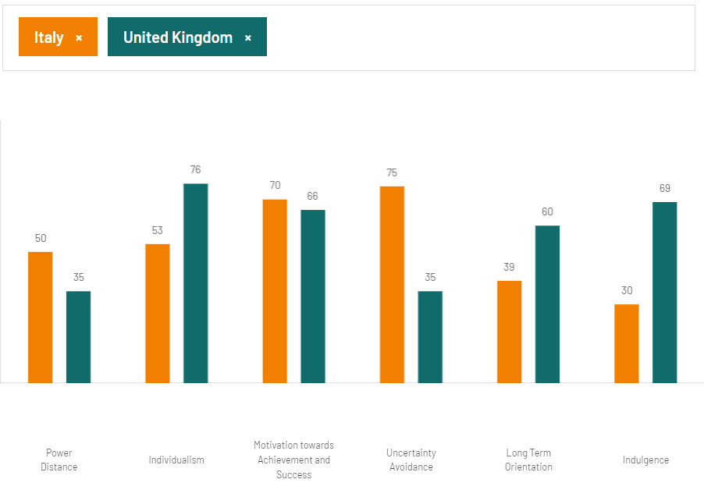
Figure 1: Comparison between England and Italy
(Source: The Culture Factor, 2024)
Power Distance: Power distance shows the cultural attitudes towards the inequalities among the country. England has a lower ranking of power distance index as compared to Italy. This means England believes in a society in which inequalities can be minimised and this research of lower index is among the higher class of Britain as compared to the working class. The score of Italy is 50 and the country preferred decentralisation of decision making and power and equality. The younger generation also dislikes control and supervision.
Individualism: The United Kingdom is a more individualist society as compared to Italy. Children begin to move at an early stage and become individuals to find their purpose in life (Yang, Cheung and Li, 2022). Italy has a score of 53 which means they have the individualist attitude but not more than the United Kingdom. The people in Italy have the objectives that their happiness is through personal fulfilment.
Motivation for Success and Achievement: The Society of Italy is more decisive as compared to the United Kingdom and people of Italy are highly success driven and success oriented. (Addis and et.al., 2024) Children are taught to stay competitive and winner from a very early age and competition between colleagues for making a strong career is also preferred more.
Uncertainty Avoidance: Italy highly controls the fact that they have to control the future which brings more anxiety. The United Kingdom has a lower score of uncertainty avoidance. England does not bother about what is coming in the future and they are comfortable in unclear situations as well.
Long Term Orientation: Britain is a culture in which people highly depend on situation, time and context and they show their ability for adapting traditions easily (Shehawy and et.al., 2024). Italy has a low score which means people show great respect to traditions and do not save money for the future because they want to achieve quick results.
Indulgence: The indulgence score of the United Kingdom is high as compared to the score of Italy. The people of the United Kingdom are willing to enjoy life and have fun whereas Ital people are restrained by social norms and have a perception regarding their actions.
Culture Visualization –
England:
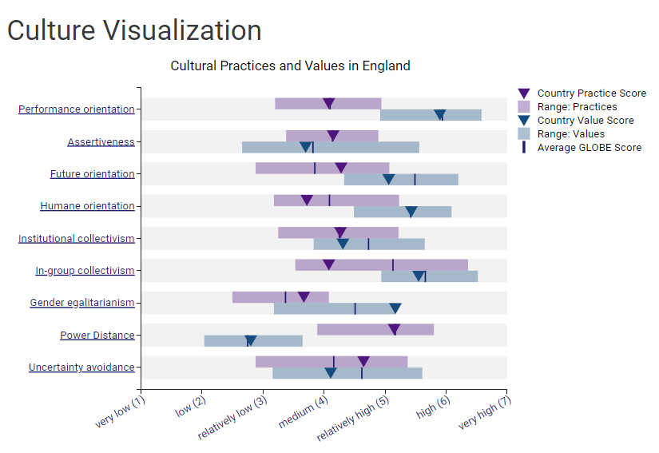
Figure 4: Cultural Practices and Values in England
(Source: GLOBE, 2020)
Italy:
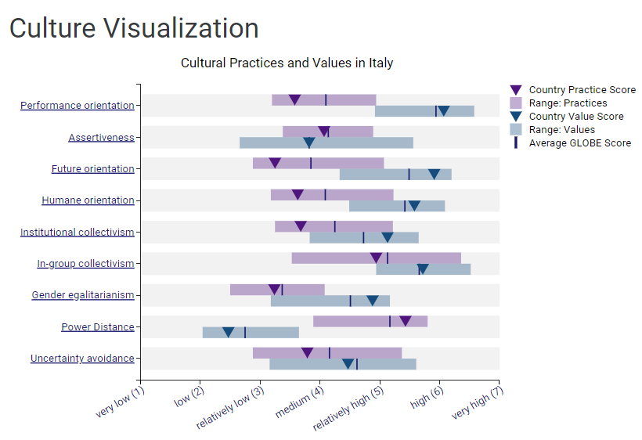
Figure 5: Cultural Practices and Values in Italy
(Source: GLOBE, 2020)

Comparison of the countries
The comparison of England and Italy is done by using GLOBE Project’s culture and leadership study. The Globe study has extended Hofstede analysis by adding some dimensions that are mentioned below:
Human orientation: The significance of human orientation has increased drastically and it has transformed into an accepted rule which states that every individual has different rights and if they have failed some abuse then they have the rights to question the abuse (Agag and et.al., 2024). The importance of human orientation in society and the cultures as well as traditions has increased. The culture of the workplace has also started to follow human orientation so as to bring equality within their work.
Performance orientation: This dimension states the extent through which rewards of innovation, encouragement of community improvement in performance and high standards in the performance are valued (Oriade and et.al., 2021). These cultures value only those individuals who attain and produce greater results. Hence, this is also an important parameter in the lives of leaders.
Assertiveness: Assertiveness are the beliefs through which people are encouraged to stay assertive, tough, non-aggressive and available for social relationships. Assertiveness is a crucial dimension of the culture and the leaders have to stay assertive for operating effectively in the hospitality organisations.
Leadership Visualization –
England:
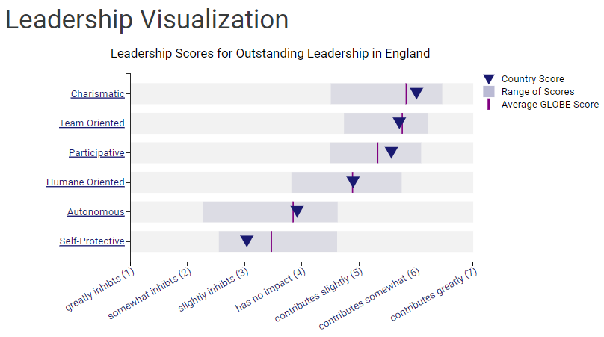
Figure 2: Leadership Scores for Leadership in England
(Source: GLOBE, 2020)
Italy:
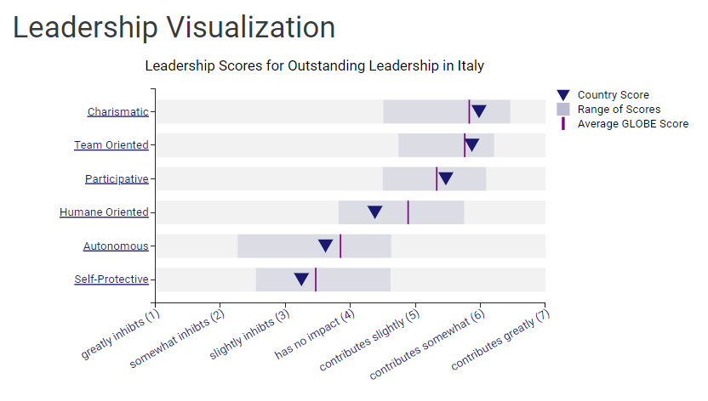
Figure 3: Leadership Scores for Leadership in Italy
(Source: GLOBE, 2020)

Challenges of intercultural leadership
The challenges faced by the hotels due to intercultural leadership are described below:
Communication barriers: The difference in styles of communication and language leads to ineffective communication and misunderstandings among the team.
Decision-making: Different people have different perspectives regarding culture and these perspectives influence the leaders regarding creating decisions (Hossain and et.al., 2022). This also brings difficulty for the leaders to manage the team effectively.
Training and development: Effective development and training programmes are highly needed for catering to the requirements of employees which have different cultures.
Cultural differences: The difference in the practices, values and norms of the team influence on how employees interact with the guests. This enhances the need of leaders to become more adaptable and sensitive.

RECOMMENDATIONS
To improve the overall effectiveness of leaders in the hotel, the management team is advised to do certain things:
- Providing continuous training to the leaders and employees for increasing the knowledge of different behaviours, cultures and communication styles will be helpful.
- Using simple and clear language and encouraging open communication among the members of the teams will be better for the hotel (Chawla, Lugosi and Hawkins, 2024).
- The company must foster an inclusive culture in which all the employees feel respected and valued irrespective of their cultural backgrounds.
- Regularly seeking feedback from the guests and team for identifying the improvement areas will help in improving the overall approach of leadership.

CONCLUSION
From this report, it has been concluded that cultural awareness is a key for overall success and growth of the organisation. Cultural awareness has helped the hospitality organisations to engage large numbers of visitors and enhance their turnovers. In this report, the cultural awareness in a five star hotel headquartered in London has been described and their challenges related to intercultural leadership have also been provided. The recommendations have also been stated to the management team for overcoming these challenges. The differences between culture and customs of England and Italy have also been analysed and compared.

REFERENCES
Books and Journals
Addis, G. and et.al., (2024). The artification of hospitality: Art hotels as the new frontier of sustainable cultural tourism. In Tourism Planning and Destination Marketing, 2nd Edition (pp. 175-196). Emerald Publishing Limited.
Agag, G. and et.al., (2024). Understanding the link between net promoter score and e-WOM behaviour on social media: The role of national culture. Journal of Business Research 170. 114303.
Chawla, G., Lugosi, P. and Hawkins, R., (2024). Evaluating localized conceptions and embedded applications of the Food Waste Hierarchy in luxury hotels. Current Issues in Tourism, pp.1-14.
Hossain, M.S. and et.al., (2022). Determinants of sustainable competitive advantage from resource-based view: implications for hotel industry. Journal of Hospitality and Tourism Insights 5(1). pp.79-98.
Nazarian, A. and et.al., (2021). Organizational justice in the hotel industry: revisiting GLOBE from a national culture perspective. International Journal of Contemporary Hospitality Management 33(12). 4418-4438.
Oriade, A. and et.al., (2021). Sustainability awareness, management practices and organisational culture in hotels: Evidence from developing countries. International Journal of Hospitality Management 92. 102699.
Shehawy, Y. M. and et.al., (2024). Cross-national differences in consumers’ willingness to pay (WTP) more for green hotels. Journal of Retailing and Consumer Services 77. 103665.
Yang, H., Cheung, C. and Li, W., (2022). Intercultural communication competency practices in the hotel industry. Journal of China Tourism Research 18(1). pp.162-184.
Online
GLOBE, (2020). [Online] Accessed through < https://globeproject.com/results/countries/GBR%3Fmenu=list.html#list >
GLOBE, (2020). [Online] Accessed through < https://globeproject.com/results/countries/ITA%3Fmenu=list.html >
The Culture Factor, (2024). Country Comparison Tool, [Online] Accessed through < https://www.hofstede-insights.com/country-comparison-tool?countries=italy%2Cunited+kingdom >

