Harveer Singh (1912321)
1912321@student.UWTSD.ac.uk

Manufacturing systems and simulation
First assignment

Table of Contents

List of figures and tables 2

Introduction 3

Lean manufacturing 3

The current process 3

Potential wastes 6

Value/ nonvalue adding 8

Leaner process 9

Underlying problems with improvements 10

Conclusion 11

References 11

List of figures and tables

Figure 1 – Image of component ………………………………………………………………………………………………………4
Figure 2 – Value stream map example …………………………………………………………………………………………….5
Figure 3 – Value stream map before implementations ……………………………………………………………………6
Figure 4 – Image of CNC machine used …………………………………………………………………………………………..7
Table 1 – Workholding ……………………………………………………………………………………………………………………7
Table 2 – Program …….…………………………………………………………………………………………………………………….8
Table 3 – Tools ………….…………………………………………………………………………………………………………………….8
Table 4 – Machining ….…………………………………………………………………………………………………………………….8
Table 5 – After machining ……………………………………………………………………………………………………………….9
Table 6 – Workholding (Value/ nonvalue) ……………………………………………………………………………………….9
Table 7 – Programming (Value/ nonvalue) ……………………………………………………………………………………..9
Table 8 – Tools (Value/ nonvalue) …………………………………………………………………………………………………..9
Table 9 – Machining (Value/nonvalue) ………………………………………………………………………………………….10
Figure 5 – Value stream map after implementations …………………………………………………………………….11
Figure 6 – Image of part catcher ……………………………………………………………………………………………………11
Figure 7 – Image of bar puller ……………………………………………………………………………………………………….11
Figure 8 – Image of part counter …………………………………………………………………………………………………..12

Introduction

“The most dangerous kind of waste is the waste we do not recognise”- Shigeo Shingo (2018). Waste is a common occurrence throughout the manufacturing industry. There is a variety of factors which can contribute towards this. Within FSG Tool and Die Limited there are a number of batch work processes carried out to achieve products made predominantly of metal. This report will focus onto one of the batch work processes carried out with the purpose of making it leaner. Interviews will be used throughout to attain information related to the organisation and current processes. Waste, cost, and other underlying issues will be considered.

Lean manufacturing

In order to make something leaner, the process needs to be identified. The text states “Lean uses a systematic approach to eliminating non-value-added activities throughout a production system.”, Tetteh & Uzochukwu (1972). This implies that lean can be used to improve manufacturing systems to benefit the organisation through the means of reducing time. “Many organisations improved their ability to provide added customer value to their products.”, Tetteh & Uzochukwu (1972). This suggests further benefits to lean manufacturing, furthermore the added value could also have a positive impact on customer satisfaction. This would create more loyal customers towards the organisation, therefore more orders. As a result, more annual turnover.

The current process

The process to make leaner is based around a set of components for a long-term customer of FSG Tool and Die Limited. Due to confidentiality, the name of the company cannot be used. There is one set in particular which have been ordered a number of times within the time they have been a customer, furthermore, known as blaster screws.
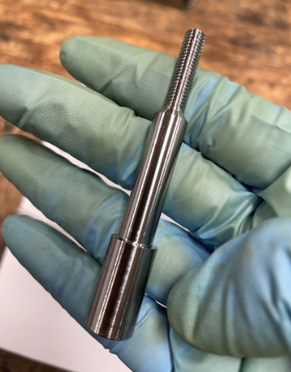
From looking at the image, blaster screws are a small component, consisting of multiple diameters and a thread.
In order for the process to be improved, an overview is needed. The blog states “Value stream mapping (sometimes called VSM) is a lean manufacturing technique to analyse, design, and manage the flow of materials and information required to bring a product to a customer.”, Mukherjee (2022). This infers that a value stream map can help depict work streams and information flows. This allows for more a more accurate breakdown of the process compared to simpler methods such as a flow chart.
- Value Stream Mapping: Definition, Steps, and Examples - Tallyfy
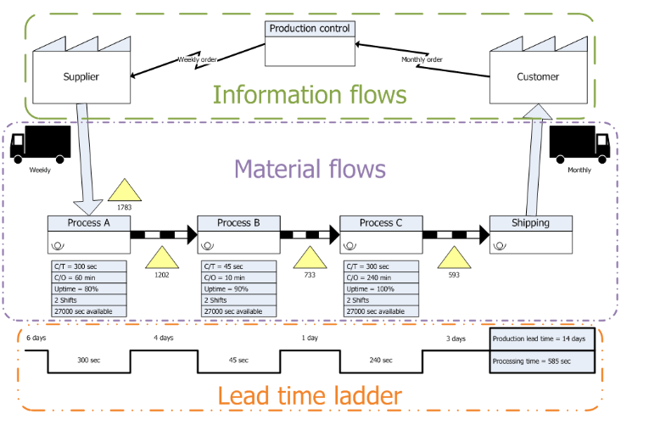
From looking at the above diagram, it can be seen that a value stream map is split into three sections. The first section consists of information being communicated between the customer, production, and the supplier in preparation for the next phase. This is known as ‘material flow’. The diagram shows the different processes involved in manufacturing the component requested for the customer. Finally, the bottom section shows how long each process took, with a total amount of time at the end.
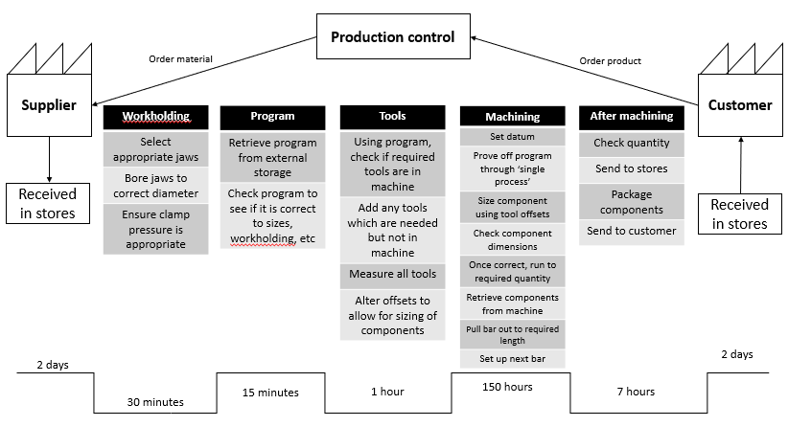
Processing time
158.75 hours
Production lead time
10.6 days

This is what a value stream map would look like for the blaster screws. As there is only one manufacturing process they need to go through before being sent to the customer, it is possible to go into further detail through the setting up of the components. This will allow for a more in-depth view of how the process is carried out.
The first section of the value stream map is very similar to the example which was provided in the sense that a customer orders a product, which is processed by customer control. This allows for the material to be ordered. There is then a set amount of time for the material to be transported to the stores within the workplace, which in this scenario is two days.
For materials flow, the component takes 30 minutes to program, as well as another 30 minutes to prepare the workholding. Preparing and measuring tools took one hour as the machine was empty before the beginning of the set up. Next, the machining time is heavily dependent on the quantity stated on the order. For this scenario, 800 were ordered, giving a time of 150 hours.
“FSG Tool and Die Limited charge £60 per hour on each order.” (Heath, B. interview 10th May 2022). From this interview with the team leader of the turning section, it can be confirmed that the current cost to manufacture the blaster screws is £9,525 based on the processing time. Finally, there are tasks consisting of retrieving the components from the machine, as well as setting up the next bar. The components need to be checked once more and packaged so they can be sent to the customer.
“Lead time is the time between a confirmed customer order and its scheduled pick up or delivery.”, Lester (2017). This infers that lead time is the amount of time between process initiation and completion. The lead time ladder also shares similarities to the example shown as it shows the times taken for production, also the time taken for the order to be completed.
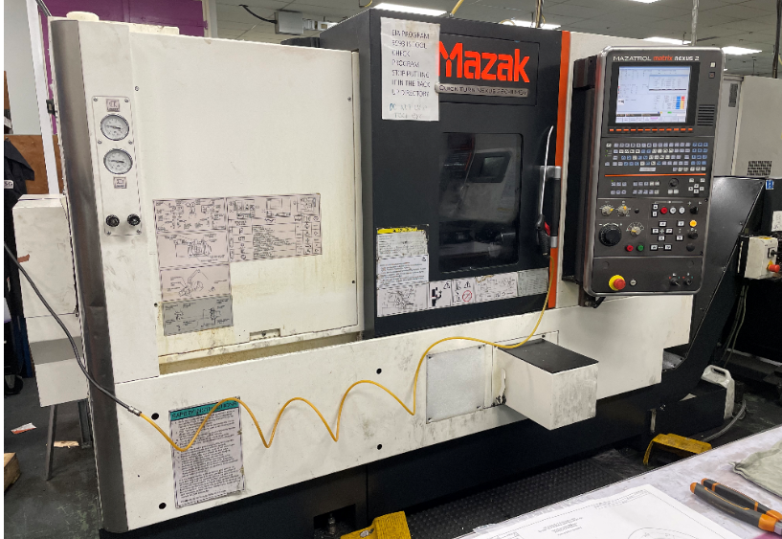
What also needs to be taken into understanding is the type of equipment used to manufacture the components. The machine used is a CNC lathe. The blog states “CNC stands for computer numerical control.”, Velling (2020). As it also is a computer, it may be able to show more information than a manual machine.

Potential wastes

Waste within manufacturing can be defined further. The article states “Any potential sources of wastes are identified and eliminated to achieve and maintain high quality and low-manufacturing costs.”, Shah & Ward (2003). This infers that eliminating waste has the potential to bring a number of benefits to an organisation. A result of this could be better flowing processes.
“The seven types of wastes that have to be eliminated by lean implementation include over-production, waiting, transportation, over-processing, inventory, motion and defects.”, Yichalewal (2019). Within FSG Tool and Die Limited, some of these wastes can be identified within multiple sections. An example of this is tools being found in a number of locations instead of one place, which can waste time through a lot of motion.
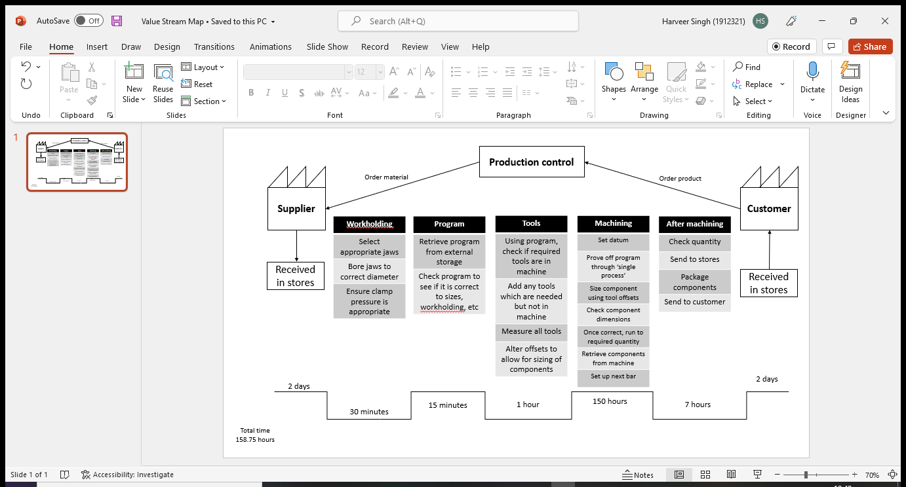
The value stream map used earlier in the report can be used to help determine what sort of wastes could be occurring within the manufacturing process as each part has been broken down.
The first part of the manufacturing process consists of preparing the workholding device for the material. In this scenario a chuck is used to hold a cylindrical bar, therefore a set of jaws is to be selected to accommodate for the material shape. They are all found in one place, however it may not always be the case of finding jaws quickly. “Jaws are regularly machined to accommodate different sizes of material. It is rare to find jaws that hold to the smaller diameters for this reason.” (Heath, B. interview 20th May 2022). The potential wastes here could be waiting and transportation due to it taking time to get new jaws from the stores, which is away from the section.
Secondly, the jaws are machined to suit the diameter of the bar being held. The bar is a smaller diameter than most materials machined corresponding to the interview, therefore they do not need to be bored out as much compared to other sized diameters. The only part of this which could contain potential waste is looking for a tool to machine the jaws, resulting in a waste of motion.
The third part to this process is to ensure the clamp pressure is appropriate to the material to prevent it from moving. This is done by checking a dial and altering if necessary. There is no potential waste here as it is a very small yet important task.
As the program can be accessed electronically on the machine, it does not require any movement or storage. With that being said, there is still a chance of the program being wrong through the means of human error. The text states “It is necessary to determine optimal cutting conditions for workpieces machined.”, Čuš & Balič (2001). Optimal cutting conditions allow for maximum tool life, furthermore any incorrect cutting conditions has the potential to create more wastes for future processes. Another potential waste here may be waiting as the machine is a computer, it is liable to performance issues.
Next, the tools will need to be selected for the component being manufactured. Assuming there are no tools in the machine, all the tools will need to be found and assigned accordingly. As mentioned as an example earlier in the report, the workplace is organised in a way that tools can be found in multiple places. This is not beneficial as it results in a waste of transportation, as well as inventory and motion.

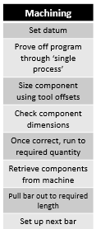
The fourth part of the process involves machining the components. Waste of motion could be present while setting up a new bar. Another type of waste involved with machining could be defects, which can be defined as “An unacceptable deviation from specified requirements.”, Parsloe et al (1998). A component out of the specified tolerance is considered a defect.
On the contrary, over production is also a waste as it defies the amount requested by the customer. For this scenario, this is commonly occurred through ordering too much material.
Another potential waste can come from retrieving the components and constantly having to pull the bar out, which is motion.
Another potential waste which can occur during the ‘machine’ phase ties back into the ‘program’ phase. If the cutting conditions are not appropriate for the material, tool life can be cut short easily. This leads to over processing as tools will need to be changed more regularly due to excessive damage.

Finally, there is the ‘after machining’ phase, where the components are checked and packaged to be sent to the customer. The only potential waste here could be transportation as there is a large number of components, therefore it may take multiple trips back and forth to stores to move all of the components.

Value/ nonvalue adding

The tasks involved can be categorized in a different way to give beneficial information towards a leaner process. “Value is defined from the view point of the customers, with the capability to deliver exactly the customer needed product or service with minimal time.”, Shou et al (2019). This infers that ‘value’ can be used to help determine which tasks are more important towards carrying out the service, or in this scenario, manufacture the correct amount of components.
“As a company value to us would mean to receive our products as asked, within the timeframe discussed.”, (Jones, Z. interview 1st Jun 2022). This reinforces the definition found from the research conducted. Using information from the interview, the process steps can be broken down into a form that shows value and nonvalue adding activities.
Workholding
Process step | Value/ non value adding?
Select appropriate jaws | Value adding
Bore jaws to correct diameter | Value adding
Ensure clamp pressure is appropriate | Value adding

For the first part of the process, all of the tasks are value adding as they fit into the definition mentioned earlier.
Program
Process step | Value/ non value adding?
Retrieve program from external storage | Value adding
Check program to see if it is correct to sizes, workholding, etc. | Value adding

The same can be said for the program.
Tools
Process step | Value/ non value adding?
Using program, check if required tools are in the machine | Value adding
Add any tools which are needed but not in the machine | Value adding
Measure all tools | Value adding
Alter offsets to allow for sizing of components | Value adding

So far all of the tasks carried out are all contributing to creating the product for the customer.
Machining
Process step | Value/ nonvalue adding?
Set datum | Value adding
Prove off program through ‘single process’ | Value adding
Size components using tool offsets | Value adding
Check component dimensions | Value adding
Take component out of machine | Nonvalue adding
Pull bar out to required length | Nonvalue adding
Run components until quantity is achieved | Value adding

During the ‘machine’ phase, there are some tasks which can be considered as nonvalue adding. They were identified during another interview with one of the employees on the section. In an interview with an employee, they stated “Every time a component is finished, we need to open the door and take it out of the machine. This is done for every part.”, (Smith S. interview 15th Jun 2022). In this scenario, 800 blaster screws were ordered by the customer. Having to take them all out of the machine individually has the potential to be very time consuming. This goes against the definition of value adding mentioned earlier in the report. The same can be said for repeatedly having to pull a bar out to length. These glaring issues would have to be eliminated in order to make the process leaner.

Leaner process

Now that the potential wastes have been identified, furthermore the value and nonvalue adding steps, a leaner process can now be made. A trial of the new process can be seen below.
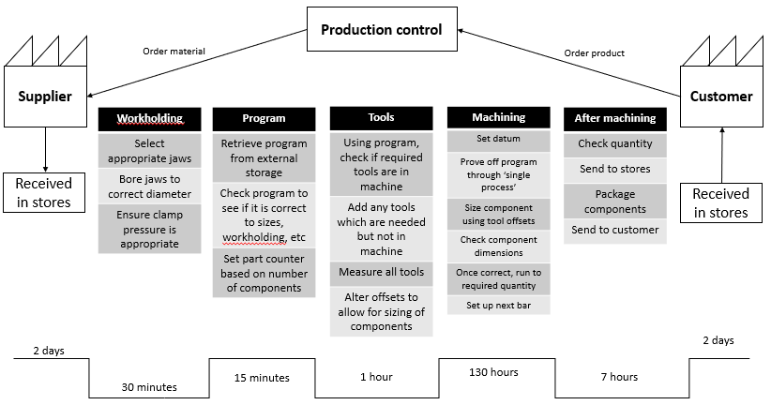
Production lead time
10 days
Processing time
138.75 hours
From all of the information gathered, it has been found that there are implementations in place which can reduce the processing time of the components. The production lead time has been reduced by one day, whilst the processing time has reduced by 20 hours.
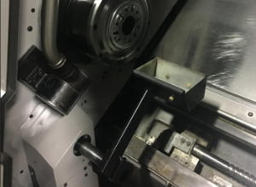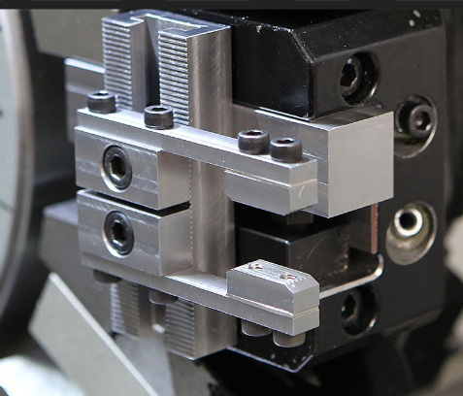
From looking at the above images, it can be seen that a part catcher has been implemented to eliminate the task of constantly having to go into the machine to retrieve each component. This also reduces the wastes of motion and transportation. This removes five hours from the total processing time.
Another way motion can be reduced is through the next application. A bar puller has been implemented inside of the machine. This disregards the task of pulling the bar out to length after each component. A total of 15 hours was saved by doing this.

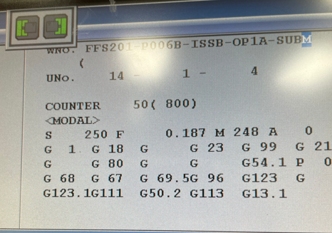
A task added into the programming is the part counter. This can be set up on the machine which can make the employees aware of a quantity of components in a given moment. This has the potential to reduce the waste of over production.
Finally, using the processing time, the new cost to manufacture the components is £8,325. The applications will save FSG Tool and Die Limited £1,200.

Underlying problems with improvements

The first problem which comes to mind when taking into consideration the changes is that there may be employees who are not informed about the new process. This may add a lot of unnecessary time onto the components as the process is now leaner. For this scenario it could mean that the £1,200 potential savings could be lost. To overcome this, a solution could be to give all of the employees on the section training on the new process implementations to reduce chance of human error.
Another issue is based around the part counter implemented, furthermore it does not take into account any defects or components which cannot be finished, e.g. the end of the bar being too small to make one more. The inaccuracies have the potential to mislead the employees in terms of the number of components made, leading to underproduction. This can be compensated for by the employees recording the number of components made on each shift through manual means such as a tally chart.
A final interview with the section leader provided information about the costs of the implementations. “The part catcher will cost £400, and the bar pullers start at £200.”, (Heath B. interview 3rd Jul 2022). In total it is going to cost £600 to acquire the apparatus in order to make the process leaner. The full effects will be seen after the first order to compensate for the money spent.

Conclusion

To conclude, the current process has a number of opportunities where it can be made leaner. The wastes identified consisted of motion, transportation, inventory, over-processing, and overproduction. This had the majority being in the ‘machine’ phase of the process, which made sense at the time as it had the most tasks. An interview with the customer allowed for defining value and non-value adding, where an analysis was made on the tasks carried out. Using this information, a leaner process was made. Some benefits consist of reducing multiple wastes, as well as reducing overall processing time and production lead time. £1,200 was the potential savings for the implementations after the first order. Finally, any underlying problems were discussed, furthermore potential solutions to them, with cost being taken into further contemplation.

References

- Zeeman A. (2018). Shigeo Shingo. Retrieved 03/03/20 from Toolshero. https://www.toolshero.com/toolsheroes/shigeo-shingo/

- Tetteh & Uzochukwu (1972). Lean six sigma approaches in manufacturing, services, and production. Retrieved 28/06/2022.

- Mukherjee (2022). Value stream mapping. Retrieved 28/06/2022 from Atlassian.
Value Stream Mapping | Atlassian

- Lester (2017). What is Lead Time, why is it important, and how do you reduce it?. Retrieved 28/06/2022 from Linkedin.
What is Lead Time, why is it important, and how do you reduce it? (linkedin.com)

- Shah & Ward (2003). Lean manufacturing as a vehicle for improving productivity and customer satisfaction. Retrieved 28/06/2022.

- Velling (2020). What is CNC Machining? Working Principles & Available Methods. Retrieved 28/06/2022 from Fractory.
What is CNC Machining? Working Principles & Available Methods (fractory.com)

- Čuš & Balič (2001). Selection of cutting conditions and tool flow in flexible manufacturing system. Retrieved 28/06/2022.

- Parsloe (1998). Engineering Defects- Costs and Sustainability. Retrieved 28/06/2022.
Session-18-Paper-1-Engineering-b.pdf (ljmu.ac.uk)

- Shou et al (2019). Value adding and non-value adding activities in a turnaround maintenance process: classification, validation, and benefits. Retrieved 28/06/2022.
Full article: Value adding and non-value adding activities in turnaround maintenance process: classification, validation, and benefits (tandfonline.com)

