Python Exercises 3d – Input and Calculations

1a We are going on a trip (hooray!)

Prompt the user to enter whether they are going, how far it is, and how fast they are going to travel.

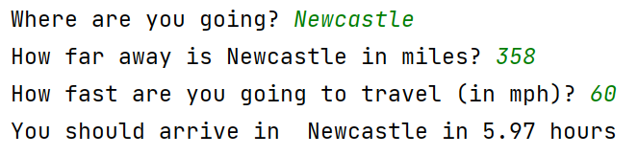

1b Extend the exercise to show how long the trip is in minutes.

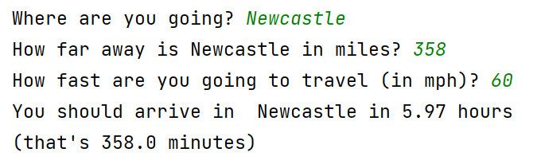

Solution:
# Ex 1a
destination = input("Where are you going? ")
print("How far away is", destination, "in miles? ", end="")
distance = float(input())
speed = float(input("How fast are you going to travel (in mph)? "))
total = distance / speed
print("You should arrive in ", destination,"in", round(total, 2), "hours")
# Ex 1b
total2 = total * 60
print("(that's", round(total2, 2), "minutes)")

2. Box set

I am watching a box-set of my favourite show

Ask the user to enter:
- How long is each episode in minutes?
- How many episodes left?

- How many minutes will it take to watch the rest of the box set?

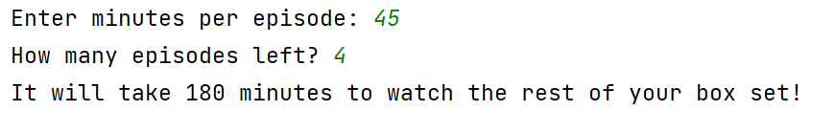

- I pause the TV for 5 minutes per complete hour for a break. What is the new total?

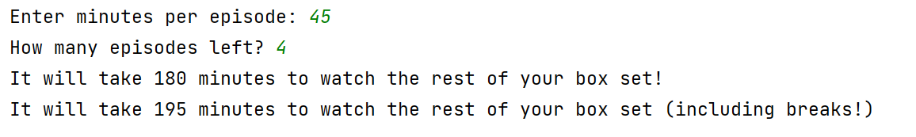

Solution:

# Ex 2a
minutesPerEpisode = int(input("Enter minutes per episode: "))
episodesRemaining = int(input("How many episodes left? "))
totalRemaining = minutesPerEpisode * episodesRemaining
print("It will take", totalRemaining, "minutes to watch the rest of your box set!")
# Ex 2b
noBreaks = totalRemaining // 60 # find complete hours
breakMinutes = noBreaks * 5
finalTotal = totalRemaining + breakMinutes
print("It will take", finalTotal, "minutes to watch the rest of your box set (including breaks!)")

3. The moon goes around the earth in 29.53 days (“synodic month” for those interested in astronomy!) The moon travels at approximately 2,288 miles per hour.

Write a program to work out how far the has moon travelled after:

- 29.53 days (one orbit)
(Hint: first work out how many hours it takes for the Moon to complete its orbit)
- 7 days
- days of the user’s choice

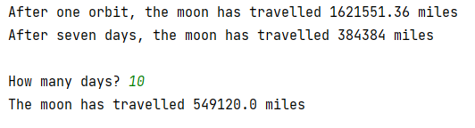

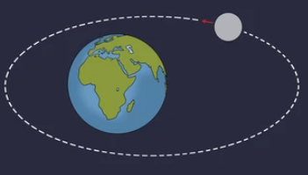

Solution:

speed = 2288
# Ex 3a
oneOrbit = speed * (29.53 * 24) # speed * time (day*24=hours)
print("After one orbit, the moon has travelled", oneOrbit, "miles")
# Ex 3b
sevenDays = speed * (29.53 * 24) * 7
print("After seven days, the moon has travelled", sevenDays, "miles")
# Ex 3c
userChoice = float(input("\nHow many days? "))
userDistance = speed * (userChoice * 24)
print("The moon has travelled", userDistance, "miles")

