Identifying the Anaerobic Threshold

Anaerobic (or Lactate) Threshold:

‘The highest oxygen uptake (VO₂) at which arterial lactate does not show a systematic and sustained rise above resting levels’ (Levett et al, 2017)

- Measured during a ramp test by taking blood lactate readings
- Can be estimated non-invasively by measuring expired gas (termed Ventilatory Threshold 1 (VT1)

Criteria for determining VT 1

- Criterion 1 - ‘Excess’ VCO₂ identified by the V-slope method

As lactate starts to accumulate at a faster rate than it is cleared due to the increased rate of anaerobic glycolysis above the Anaerobic Threshold, it is buffered by bicarbonate. The buffering reactions generate CO₂ that is additional to the metabolic CO₂ produced by oxidative phosphorylation. When we see a plot of VO₂ to VCO₂, we see a steepening of this relationship due to the extra CO₂ that is produced by buffering once above the Anaerobic Threshold. The inflection point that denotes the AT can be determined by either the v-slope method or the modified v-slope methods as illustrated below:

    - V-slope Method

In the early stages of an incremental protocol (ramp test) the VC02 and VO2 values rise linearly, and a linear regression line can be created. Similarly, above the AT a linear regression line can be created. Where these two lines intersect indicates the AT as illustrated below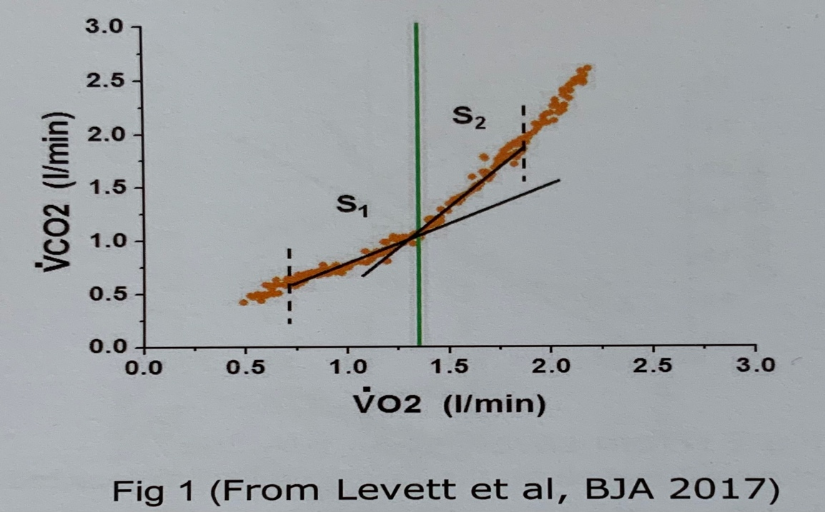:

    - Modified V-slope method

Sometimes there are not clear linear sections (S₁ and S₂ in Figure 1 above). In this instance, an assumption can be made that the RER (ratio of VCO₂ to VO₂) below the AT will be less than 1 (since the max ‘aerobic’ RER is 1) and that the RER above the AT will be more than 1 (due to the excess CO₂ from buffering of lactate from anaerobic glycolysis). An RER of 1 would be represented by a 45° line, therefore if we ‘run in’ a 45° line from the right, the AT will be the first point that it contacts the VCO₂-VO₂ relationship. As shown below:

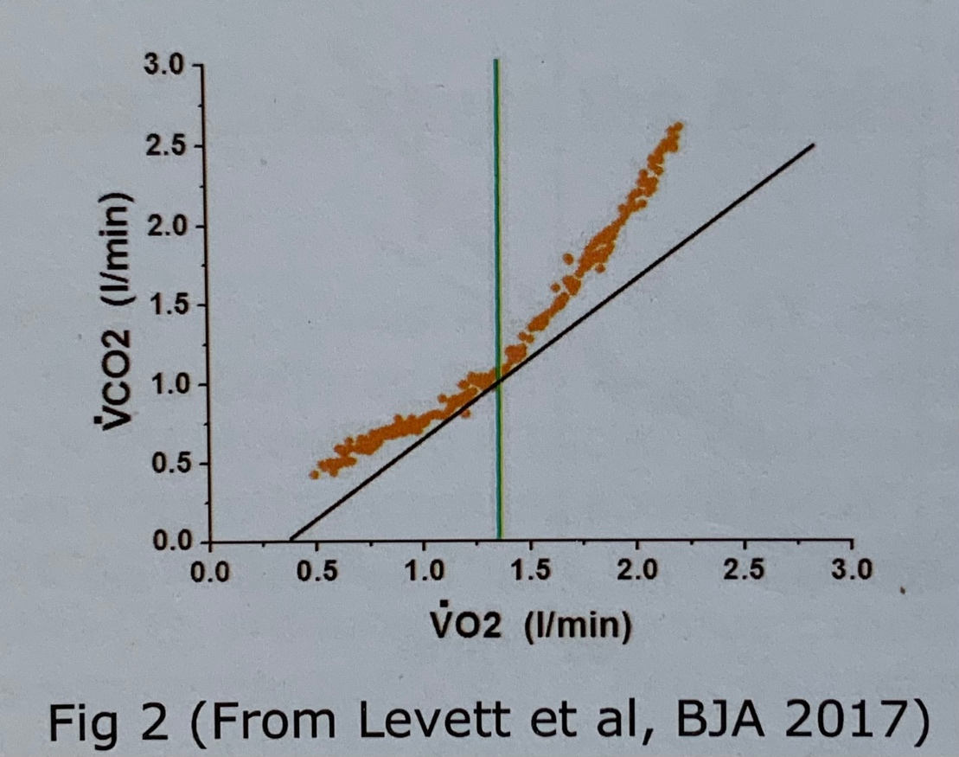

- Criterion 2 - Hyperventilation relative to O₂

Since minute ventilation (VE) is driven mainly by VCO₂, the increase in VCO₂ at the AT results in a proportional increase in VE, however there is no equivalent increase in VO₂. This is reflected in VE/VO₂ and alveolar end-tidal PO₂ (P_{ET}O₂) both starting to increase at AT.
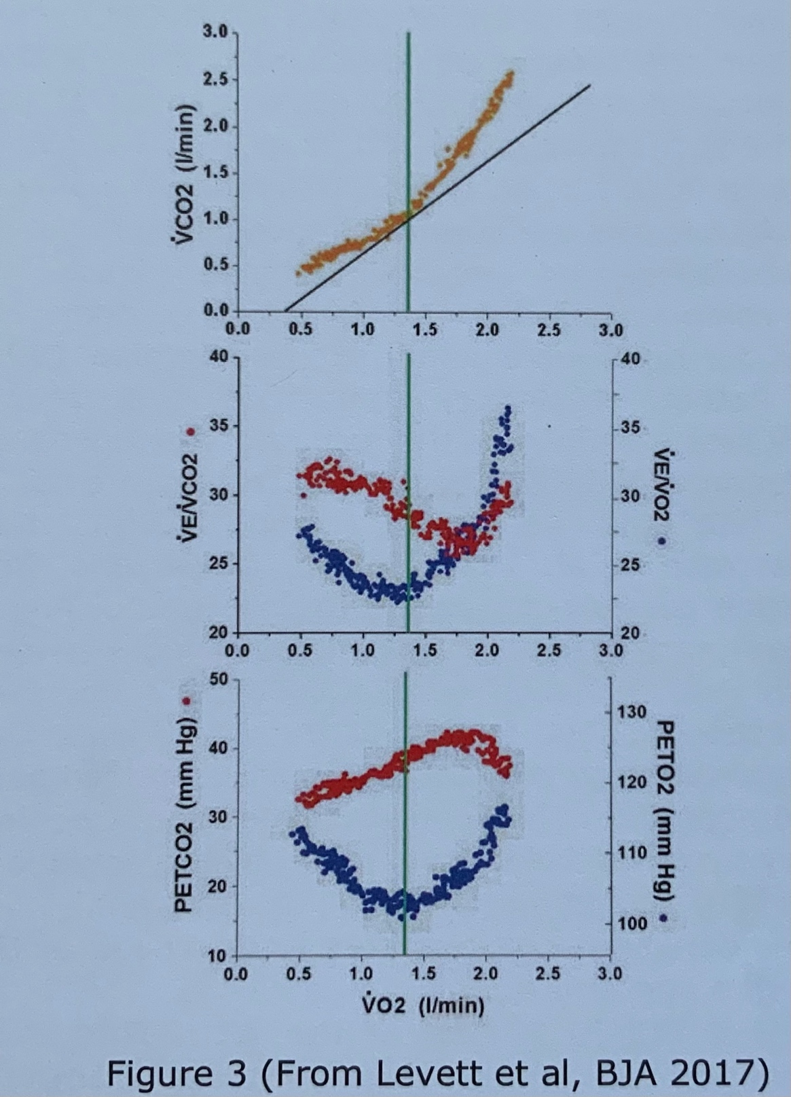
- At AT VE/VO₂ (blue dots middle graph) having been flat or declining, starts to increase.
- At AT the P_{ET}O₂-VO₂ (blue dots bottom graph) having been flat or declining starts to increase.

- Criterion 3 – No hyperventilation relative to CO₂

To ensure that the hyperventilation relative to oxygen outlined above is accurately indicating the AT, and is not due to non-specific hyperventilation due to factors such as anxiety or pain, it is important to confirm that there is no hyperventilation relative to VCO₂. In order to do this we must ensure that:

- The VE/VCO₂ (red dots in middle graph above) remain constant or continue to decrease after the AT as the VE/VO₂ (blue dots) start to rise.
- The P_{ET}CO₂ (red dots in third graph above) do not start to decrease at AT (they will decrease later at the Respiratory Compensation Point (RCP) but should not decrease at the AT).

