Author: | Charles Gill | Student Number: | 0250767
Module: | Changemakers: Creativity and Value Creation | Programme: | BSc (Hons) Software Engineering
Reference: | ACCA5033 | Lecturer: | Gareth Jones
Date: | 26th June 2023

Changemakers: Creativity and Value Creation

Assignment 2:

Contents
Section 1. Overview 3
1.1 General 3
1.2 Purpose 3
1.3 Report Sections 3
Section 2. Changemakers: Creativity & Value Creation 4
2.1 Quantitative analysis 4
2.2 There’s a Theme Here 6
2.3 Project Management 7
2.3.1 Poster 7
2.3.2 Planning management 8
2.3.3 Mapping 8
2.4 Reflection 9
References 10
Section 3. Appendix – Moodle Task Completion 12

Overview

General
This report details the Changemakers: Creativity & Value Creation module, underpinning the knowledge required to undertake the Emerging Trends & Independent Project modules in my final year of study. The module identifies opportunities, develops ideas, undertakes research analysis & critical thinking to generate value in society. It realises connections between the practice of design thinking and research, recognising when used together they can give rise to insights that generate value for individuals and society.

Purpose
To create a report about the processes of the creation of new ideas, the research that has to go alongside those ideas and present them in an e-portfolio.

Report Sections
The sections are laid out as follows:
Section 2.1 relates to Unit 4 Q1: All in the numbers.
Section 2.2 relates to Unit 4 Q2: There’s a theme here
Section 2.3 relates to Task 2: Project Management, Poster, Planning Management and Design.
Section 2.4 relates to Task3: Reflection

Changemakers: Creativity & Value Creation

Quantitative analysis

The stats for domestic abuse have been collated by the Office for National Statistics (ONS) and some basic statistics are provided from the ONS below:

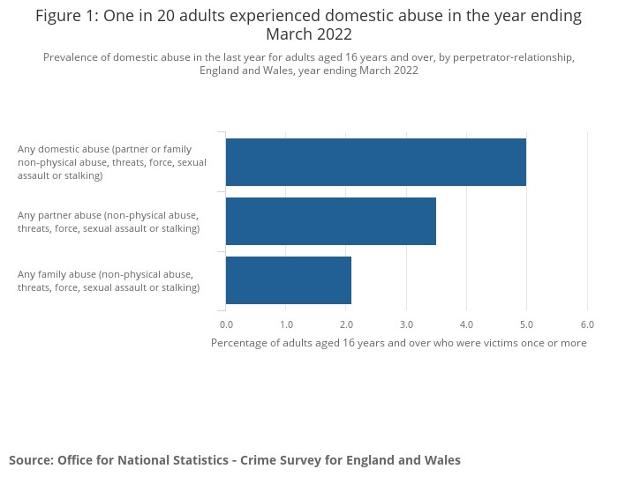

The aim of this project is to provide victims with an added layer of safeguarding once the initial threat has been dealt with. Restraining orders are placed upon offenders but it is unfortunately the case that these are not always adhered to. I have searched online for figures to detail what the prevalence of this type of re-offending is but have not been able to locate any locally relevant data.
The chart would look something like the following though. Please be aware that the figures for re-offending are fictitious. These would be found through local Officers from their casework. This would provide real-world, locally relevant figures.

Harrassment: www.statista.com Stalking: www.ons.gov.uk DA: www.ncdv.org.uk
The local figures for offenders that are managed could then be visited and the numbers of instances where this project would be of benefit could be gathered. For example the local data could look something along the lines of the following:

We would have good data about these cases and the Officers involved would be able to provide good metrics about how effective this technology could be.
Some example questions would be:
Frequencies of restraining order breaches?
How often are initial warnings ignored?
Is there a pattern or trigger to the events?
How often does the offender have access to the home Wifi?
The likelihood of the offender having their phone with them during an offence?
Do the officers have the ability to respond if the alarm is raised?
Should the alarm be covert or overt?
Whether other technologies such as ‘Ring’ -style doorbells could be used, is there a need for extra access points to be setup to widen the capture area.
This research would mostly be qualitative with the view to determine the value of the project and its viability.

There’s a Theme Here
The theme here may be that as domestic abuse is largely within the household, it is likely that the offender’s mobile technology, phones/tablets/laptops will have connected to the household’s Wifi. This also applies to some stalking and harassment cases also, but obviously far less. As these devices will then automatically connect to the Wifi when back in range, this can be an effective way to capture the arrival of an offender at an address and report them, if for example they have a restraining order or have been warned by Police not to attend at that address. The figures for how useful this tech would be would be gleaned from the quantitative data above (section 2.1). The value of the project would come from the qualitative data captured here by speaking with the victims.
The types of questions asked could be:
What’s the likelihood of the offender carrying mobile device,
Has access to router previously been given,
How would they feel about this tech being implemented, would it help their mental health, would they feel safer?
Would they want the alarm covert or overt? Ie would they rather the offender be caught or warned off by an alarm.
How do they feel about other tech such as ‘Ring’ style doorbells?
Would they want access points at the perimeter to provide a wider capture or just within their home confines?
If extended there is a chance that their network would be picked up more readily by other individuals, although this may be masked. It would not be the only tech used but one of a suite of protection technologies.
The relating of events during interview would provide aspects of the crimes committed that could then be analysed to provide a qualitative thematic review, which could look something like the following:
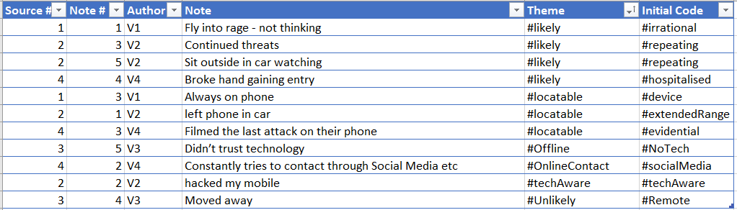
The themes being that the four scenarios 3 offenders are likely to have mobile devices with or near them. One is unlikely to attend the address. This would make the project worthwhile, but it has to be remembered that the above is fictitious.

Project Management

Poster
See poster.pptx attached
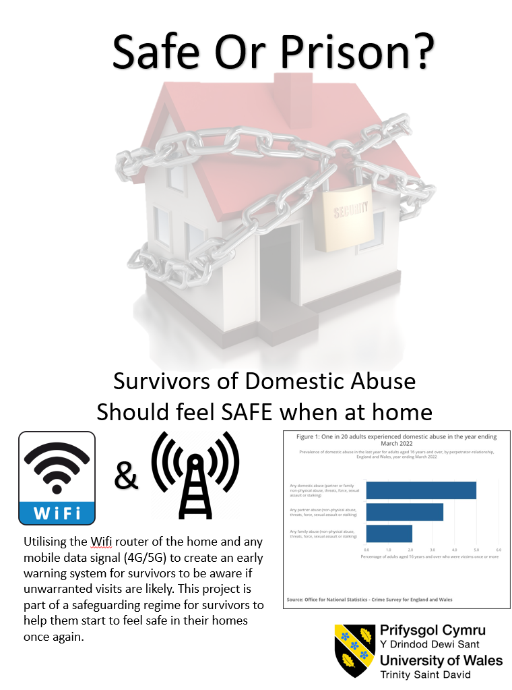

Planning management
Gantt chart
A Gantt chart such as the below would be utilised to track the project’s different aspects and to see where the project is staying on track.
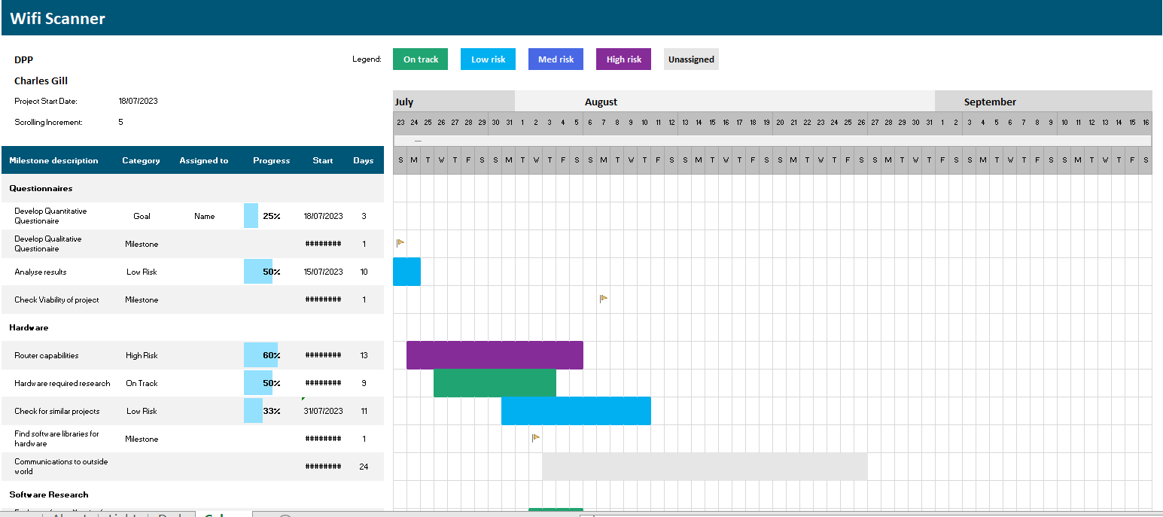

Mapping
The different aspects of the WiFi watcher or scanner are listed below as a mindmap.
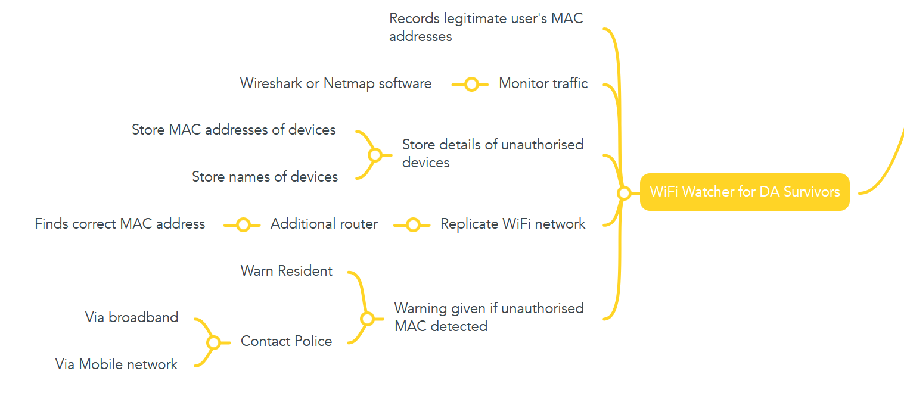

Reflection
This project will allow me to further my programming which I find is one of my greatest creative outlets. I also enjoy the fact that it relates to an actual physical warning rather than just activating further code.
The contribution to society is one that could be of great importance to survivors of domestic violence and hopefully help them feel safer.
The main challenges now are that many mobile devices now use MAC tumbling in the bid to maintain privacy for their users. However, in this project there are ways to attempt to circumvent that aspect and still provide this service.

References

[1] | Wikipedia, “Six degrees of separation,” Wikipedia, 21 06 2023. [Online]. Available: https://en.wikipedia.org/wiki/Six_degrees_of_separation. [Accessed 09 07 2023].
[2] | Oracle, “What is Big Data?,” Oracle UK, 2023. [Online]. Available: https://www.oracle.com/uk/big-data/what-is-big-data/. [Accessed 09 07 2023].
[3] | J. Fernando, “Cambridge Analytica: Overview, History, Example,” Investopedia, 30 10 2021. [Online]. Available: https://www.investopedia.com/terms/c/cambridge-analytica.asp#:~:text=Cambridge%20Analytica%20was%20a%20political%20consulting%20company%20that,as%20well%20as%20Donald%20Trump%E2%80%99s%202016%20presidential%20campaign.. [Accessed 09 07 2023].
[4] | Wikipedia, “History of Algebra,” 14 06 2023. [Online]. Available: https://en.wikipedia.org/wiki/Timeline_of_algebra.
[5] | H. Editors, “Neolithic Revolution,” History.com, 12 01 2018. [Online]. Available: https://www.history.com/topics/pre-history/neolithic-revolution. [Accessed 14 06 2023].
[6] | L. Boroditsky, “How Language Shapes Thought,” Scientific American, 01 02 2011. [Online]. Available: https://www.scientificamerican.com/article/how-language-shapes-thought/. [Accessed 14 06 2023].
[7] | BBC News, “Vote Leave's targeted Brexit ads released by Facebook,” BBC, 26 07 2018. [Online]. Available: https://www.bbc.co.uk/news/uk-politics-44966969. [Accessed 18 06 2023].
[8] | Forbes, “What Joe Biden’s And Donald Trump’s Facebook Ads Reveal About Their Campaign Strategies,” Forbes, 02 11 2020. [Online]. Available: https://www.forbes.com/sites/martyswant/2020/11/02/what-joe-bidens-and-donald-trumps-facebook-ads-reveal-about-their-campaign-strategies/?sh=4b66fd3e5c83. [Accessed 18 06 2023].
[9] | E. P. a. T. Wood, “The global effectiveness of fact-checking: Evidence from simultaneous experiments in Argentina, Nigeria, South Africa, and the United Kingdom,” PNAS, 10 09 2021. [Online]. Available: https://www.pnas.org/doi/10.1073/pnas.2104235118. [Accessed 18 06 2023].
[10] | M. Gleiser, “Our language is inadequate to describe quantum reality,” BugThink, 04 01 2023. [Online]. Available: https://bigthink.com/13-8/quantum-uncertainty-language/. [Accessed 18 06 2023].
[11] | Wikipedia, “Double Slit Experiment,” 09 06 2023. [Online]. Available: https://en.wikipedia.org/wiki/Double-slit_experiment. [Accessed 18 06 2023].

Appendix – Moodle Task Completion
Task3 Section 1
Reflect on the importance of networks:
It is often quoted that we are only 6 degrees of separation from anyone, the history of this concept is detailed by Wikipedia as:
‘The concept was originally set out in a 1929 short story by Frigyes Karinthy, in which a group of people play a game of trying to connect any person in the world to themselves by a chain of five others. It was popularized in John Guare's 1990 play Six Degrees of Separation.
The idea is sometimes generalized to the average social distance being logarithmic in the size of the population.’ [1]
However, it is very difficult to randomly work out the paths through your friends network to a particular individual. And so it is with markets. For any idea or product to reach its intended audience, the marketing has to be specific and targeted but also it has to propagate through the necessary online channels to be effective.
This re-iterates what was discussed in the first part of this report, where the details of vast amounts of money spent by politicians and parties in reaching their audience. This is also where ‘Big Data’ is becoming possibly the start of the 4th Industrial Revolution. Big Data is defined by Oracle as
Put simply, big data is larger, more complex data sets, especially from new data sources. These data sets are so voluminous that traditional data processing software just can’t manage them. But these massive volumes of data can be used to address business problems you wouldn’t have been able to tackle before. [2]
According to Oracle it concerns the 3 Vs –
- Volume – How much data there is,
- Velocity – How fast the data is being produced
- Variety – How many different types of data there are.
The benefits are listed as being able to gain more complete answers as there is more information leading to more confidence in the answers providing a different approach to tackling problems.

Companies such as Cambridge Analytica have utilised data for political ends and Investopedia record this activity as follows:
- Cambridge Analytica was a political consulting company that infamously attempted to use the psychological profiles of roughly 90 million Facebook users to influence their political decisions.1
Facebook. "An Update on Our Plans to Restrict Data Access on Facebook." Accessed Aug. 31, 2021.
- The firm was active in the Leave-EU Brexit campaign, as well as Donald Trump’s 2016 presidential campaign. [3]
The story of this activity, although highlighting the nefarious use of data, does demonstrate the power and money that is available through this technology.
Networking is intrinsic to our online presence and anyone who has a social media account is feeding the markets with data. To some degree, we have to be happy that we get more relevant adverts, that when we search for activities, resources, services, we will get the most relevant and most local results. So there is obvious good that comes from these technologies.
The power of networks is vast but as the video states, we all too often close our network to those around us, not expanding into other areas, or not believing that stranger networks could offer anything to our ‘niche’ worldview. However, as stated in the video, it is these stranger networks that could help revolutionise the industry or network that you are in.
We are in a niche industry in my place of work, and it is through links with other departments that we learn and grow, My manager has had to recently build a project for a centre of excellence within our field. This was achieved to a high standard by visiting other similar dpeartmnets but also by talking with educational organisations, companies that supply the unit and through names in the industry.
Types of network (video):
Active or Latent
Reciprocity – Give and take mutually beneficial possibly someone at work – Active
- Latent – one sided
Intimacy Trust – Friend confide in for work or personal. – Active
- Latent m- low level of trust – maybe works for competitor
Frequency – in active – regular contact within last six months.- Active
- Latent - Sporadic more than six months ago former boss check in with occasionally.
Networks should be Open Diverse and Deep

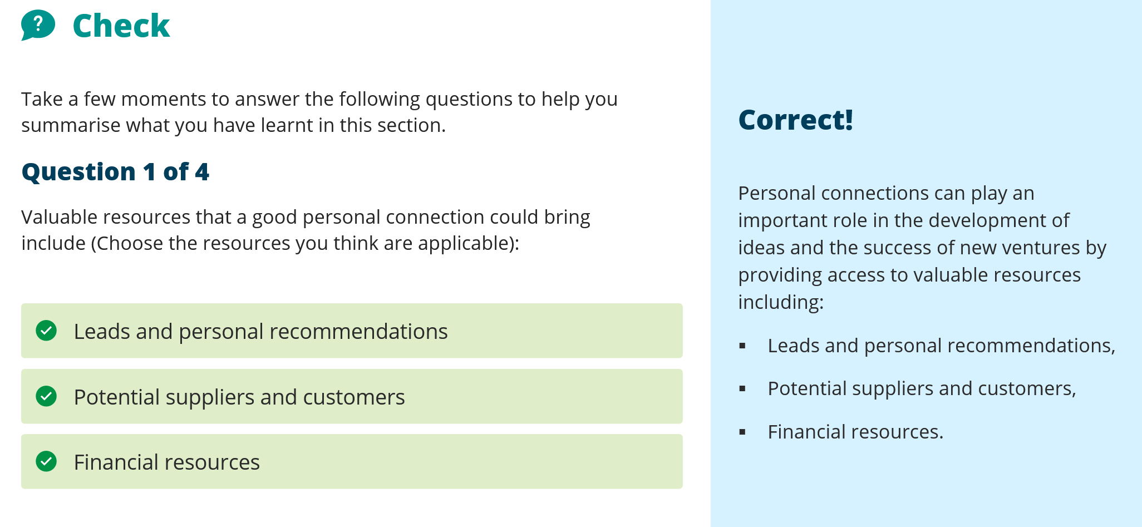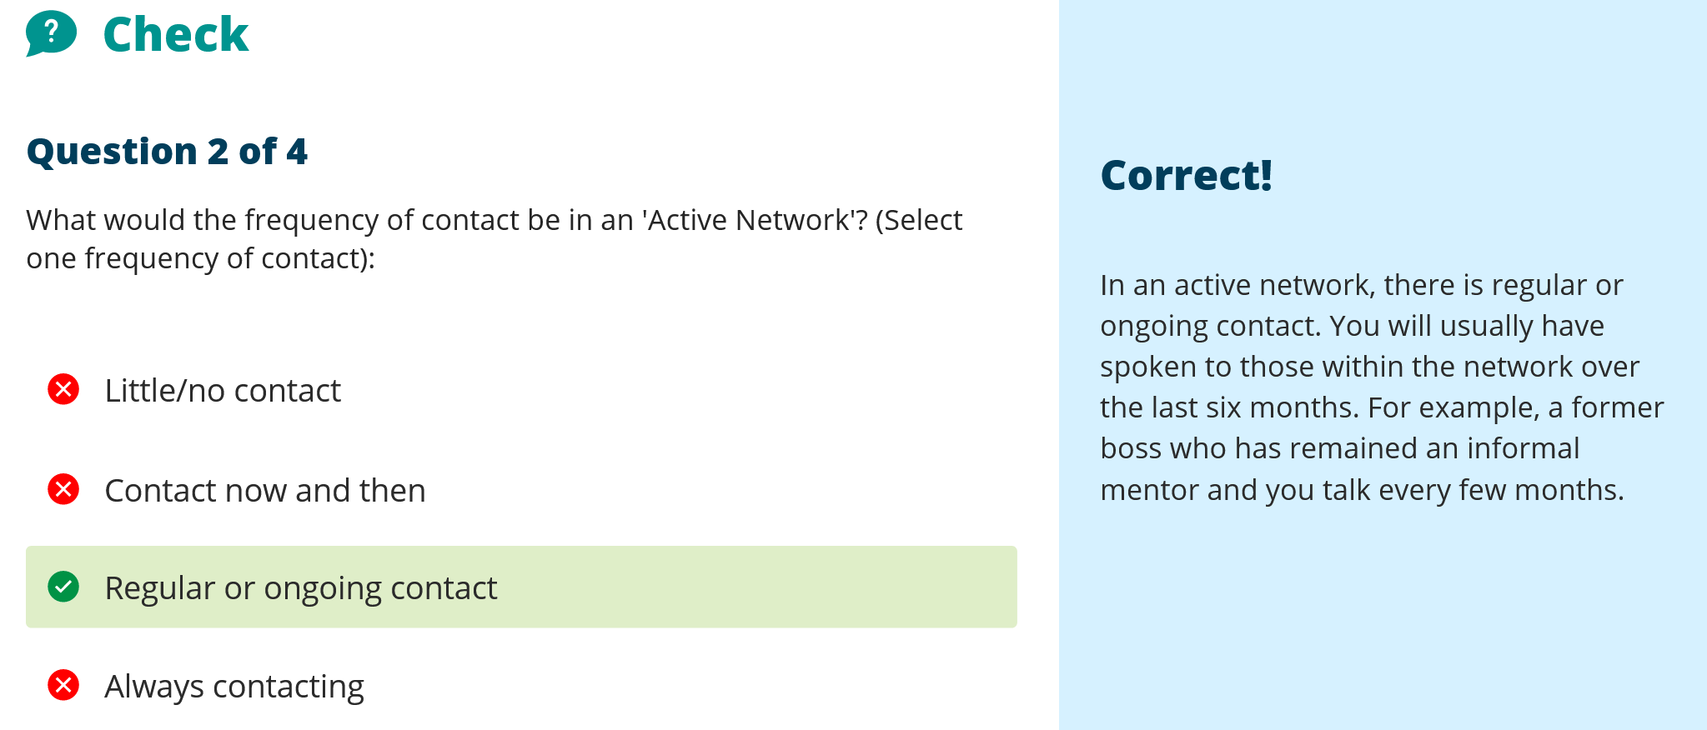

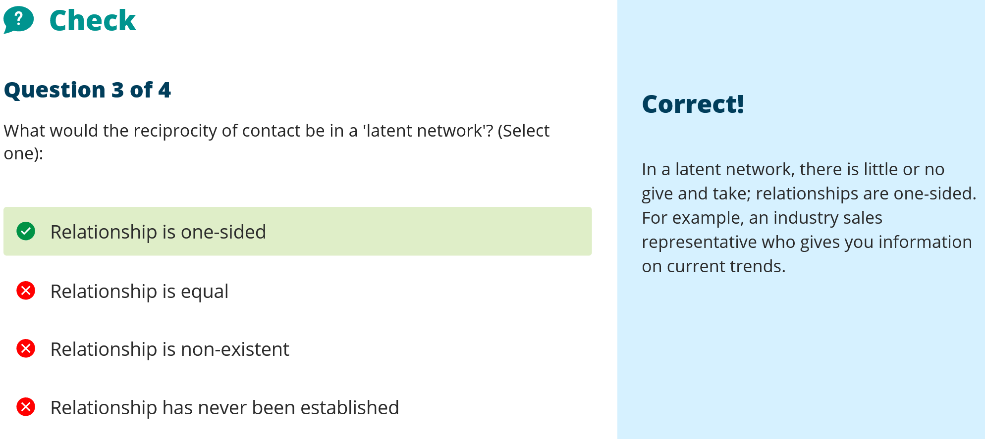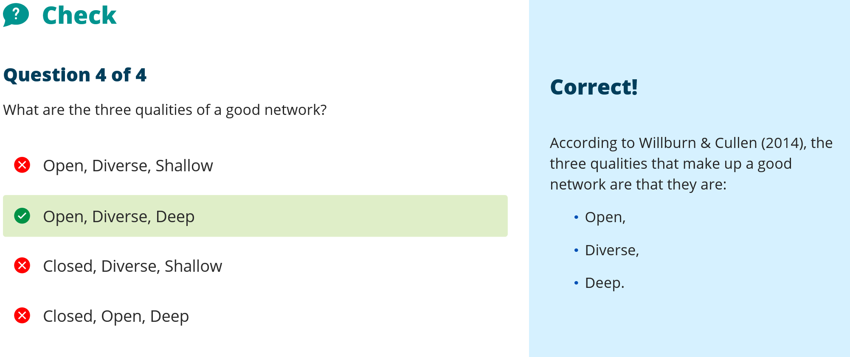

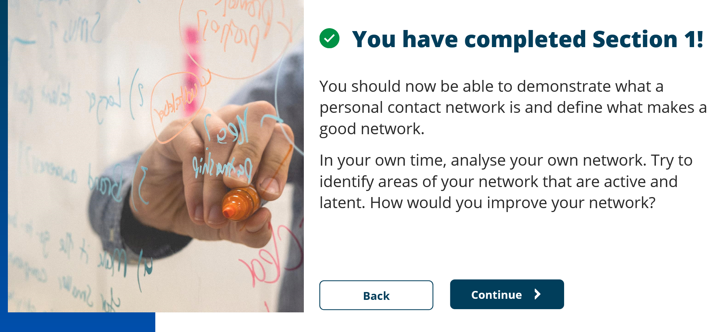

Unit 3 – Section 2 Who’s at stake

Value creation – Harmonisation – Noble cause
Stakeholder analysis who they are interests andf beliefs/
For Uber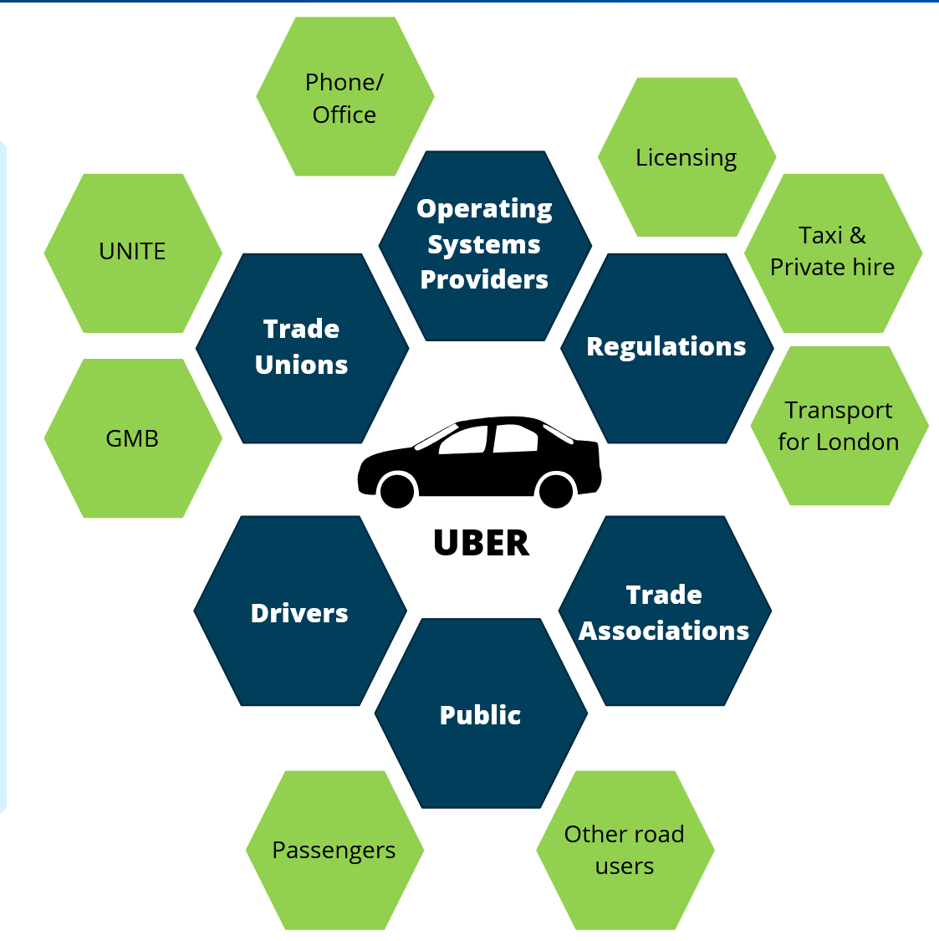
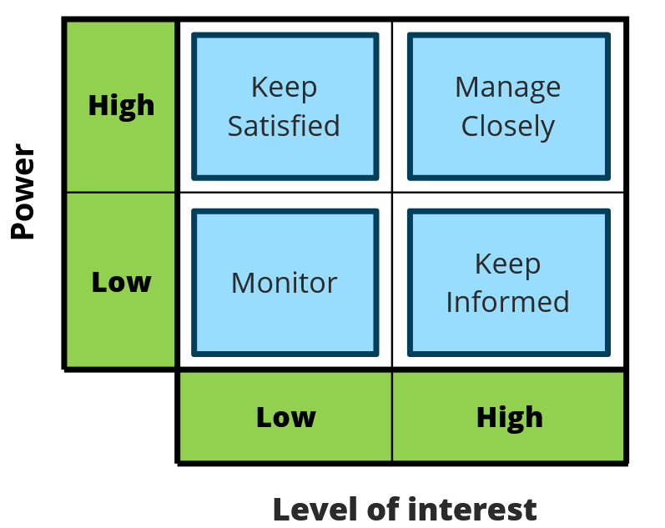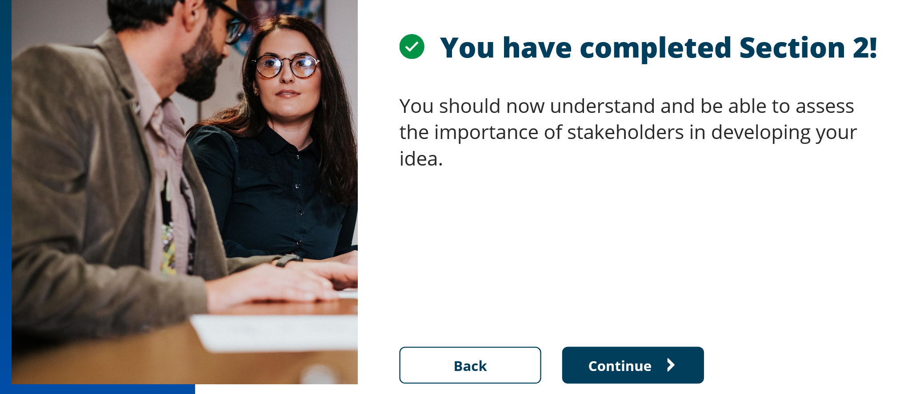

Unit 3 section 3 – Map it out
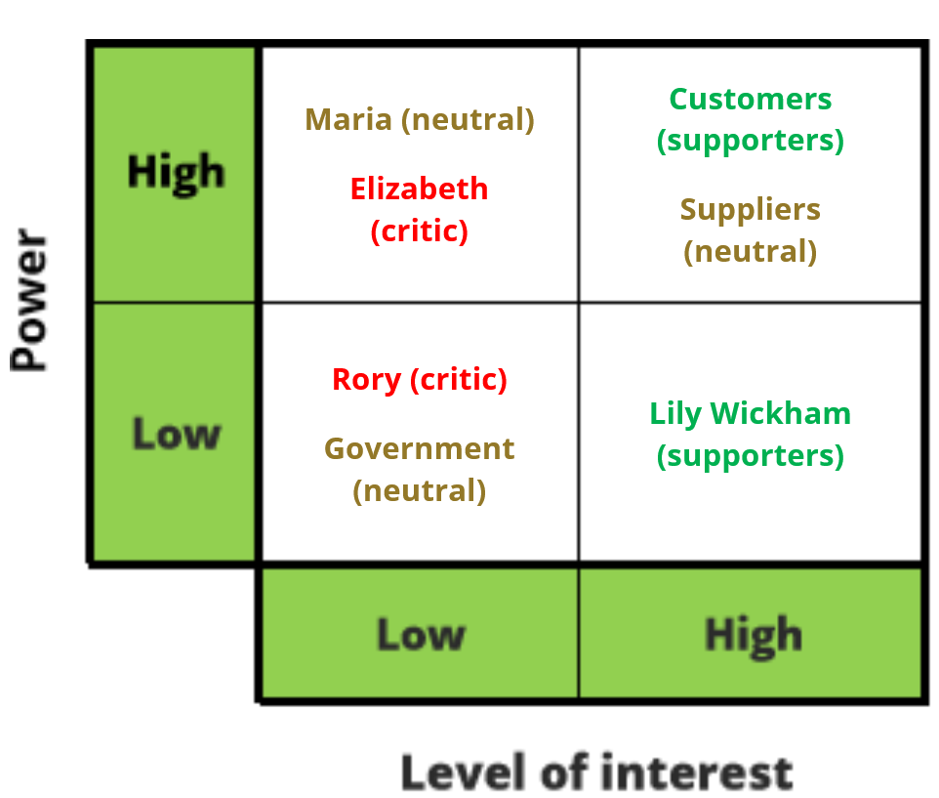
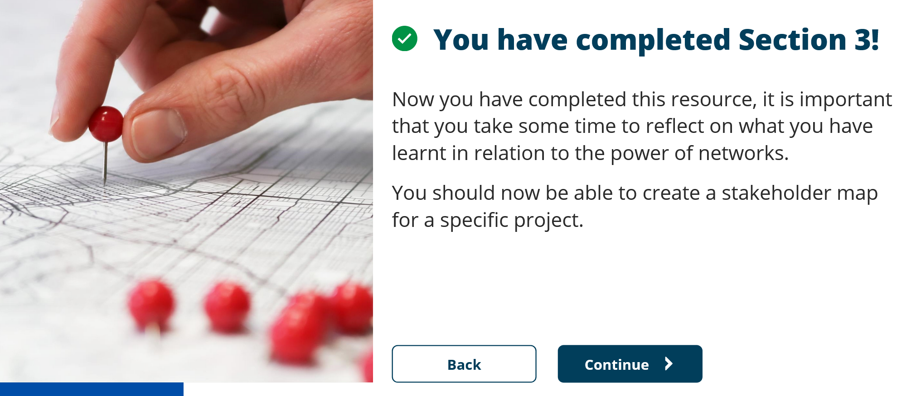

Topic 2 – Show me the money
Reflect about who did you approach, why choose them over someone else.
UK Research councils

GOVt Depts

Non-dept public bodies
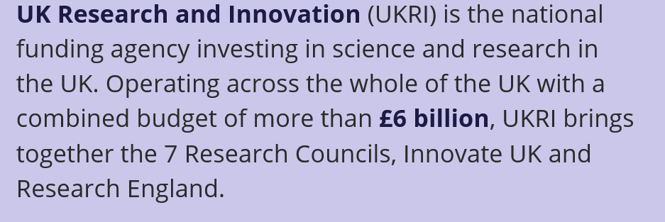
UK charities
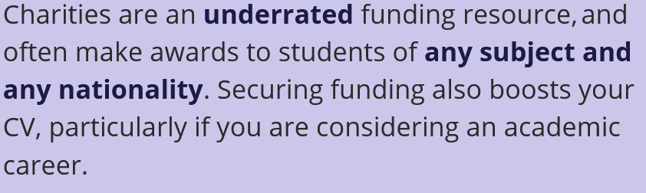

Unit 1 Section 4

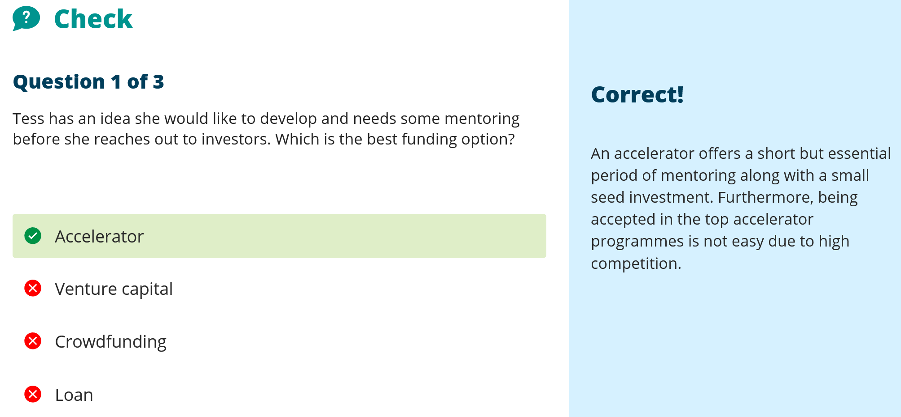

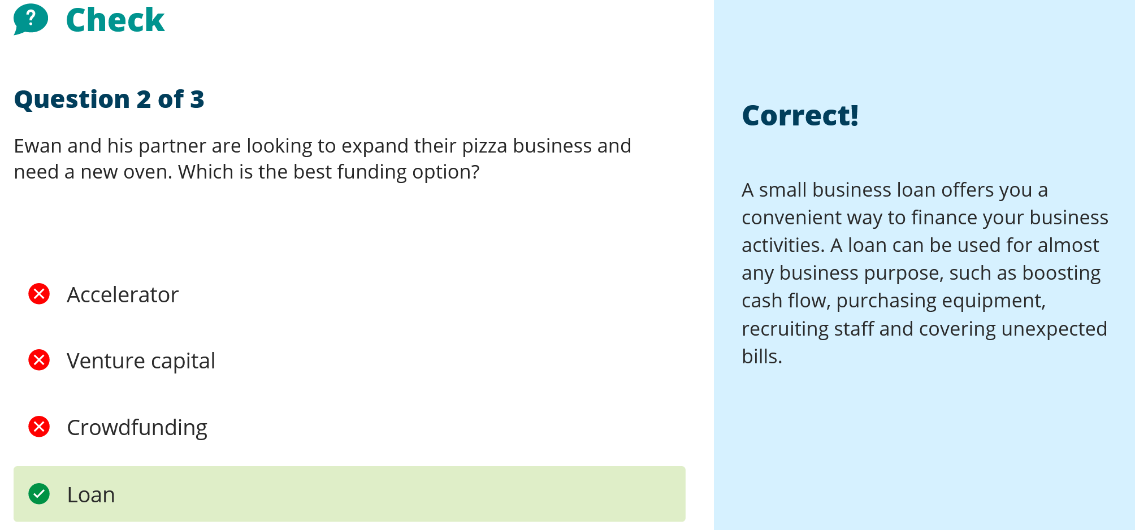

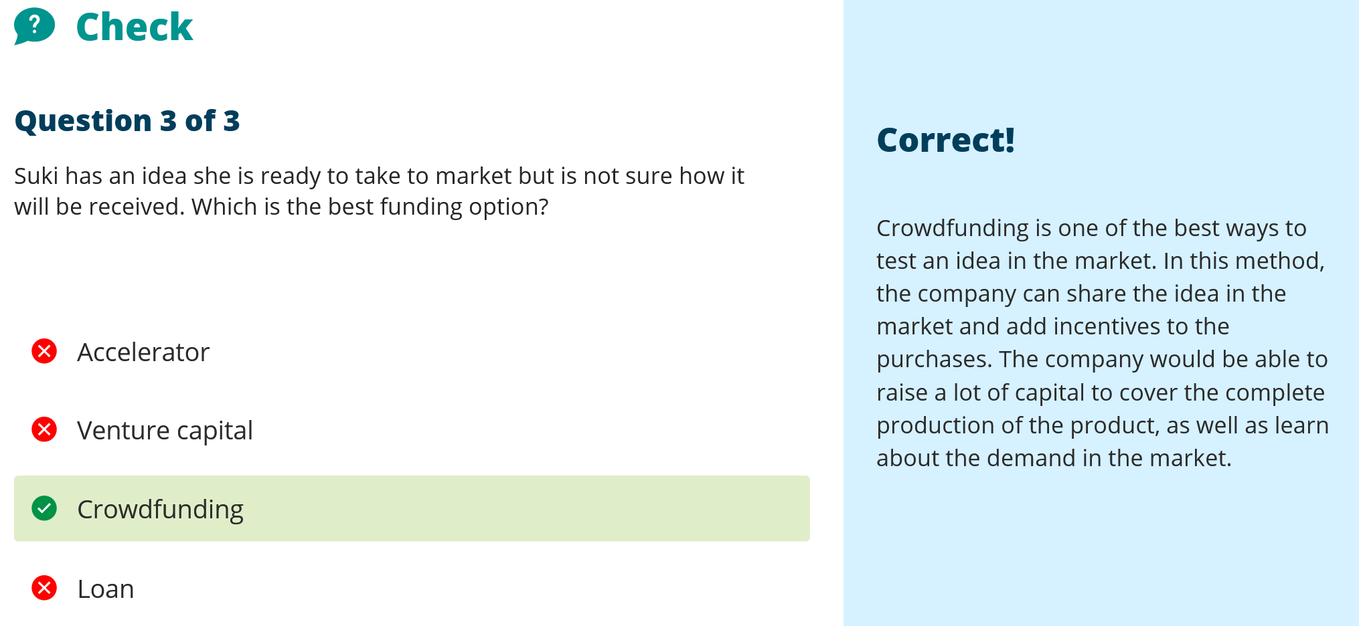

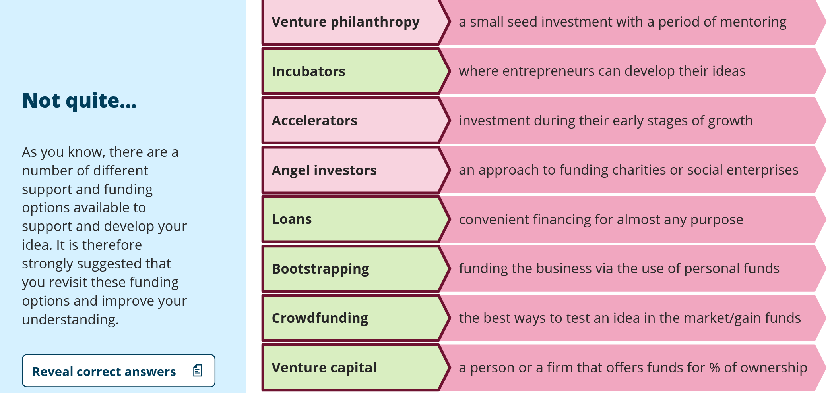



Section 2 Adding Value

Reflect how does networking fit with adding value.
Sharing knowledge between teams has added value in that there has been no monetary advantage but there has been cohesion between procedures and policies. This has shared knowledge and provided a stable base to work from. So the value there is one of almost solidarity and being on the curve rather than feeling we have to keep changing for the sake of it. There is not the budget time or money for continual change. Although much of this course is designed to drive change, we have also found value in a period of no change to provide stability whilst other areas get the priority in change. This may seem counter-intuitive but it has to be realised, in a pragmatic fashion, that there is a cost to the benefits of change. Sometimes in a fast moving industry, you cannot continually change all of your processes, and that sometimes by the time a project is designed, built, signed off for procurement and then started; by the time these things are completed, the initial problem has also changed, become irrelevant, or another solution has become available. This means that areas of change have to be decided and other areas should remain relatively stable to allow the areas best placed for change to be concentrated on. This is not to say that change is not required, just that sometimes through our networking we have realised that some processes are not worth continually updating.

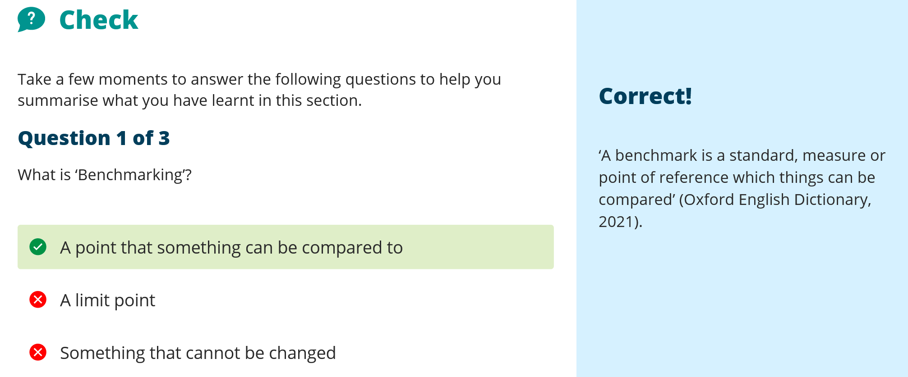

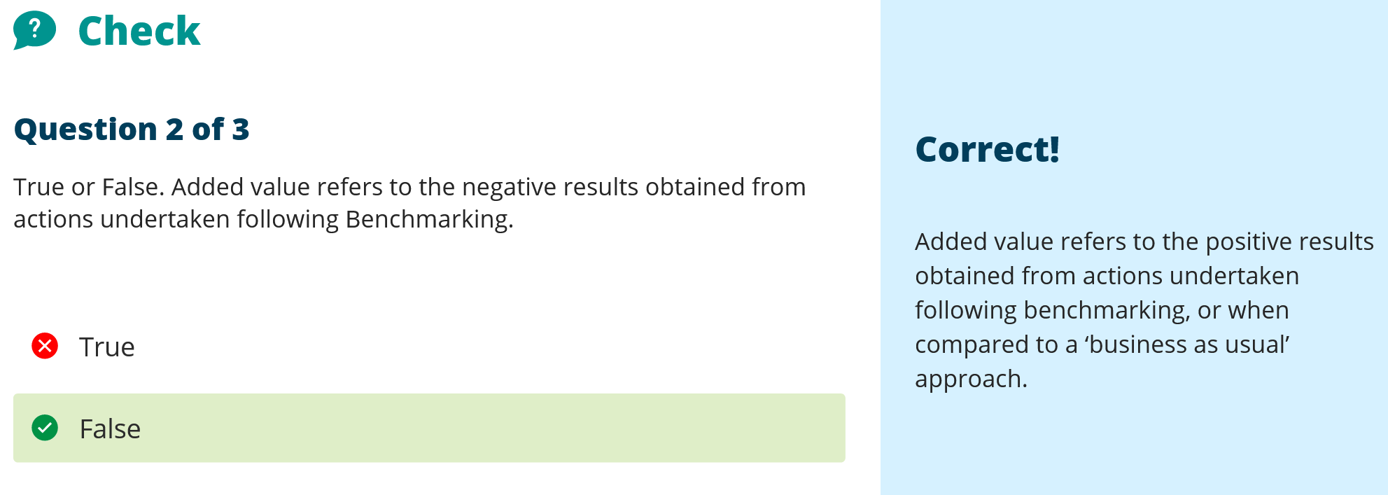

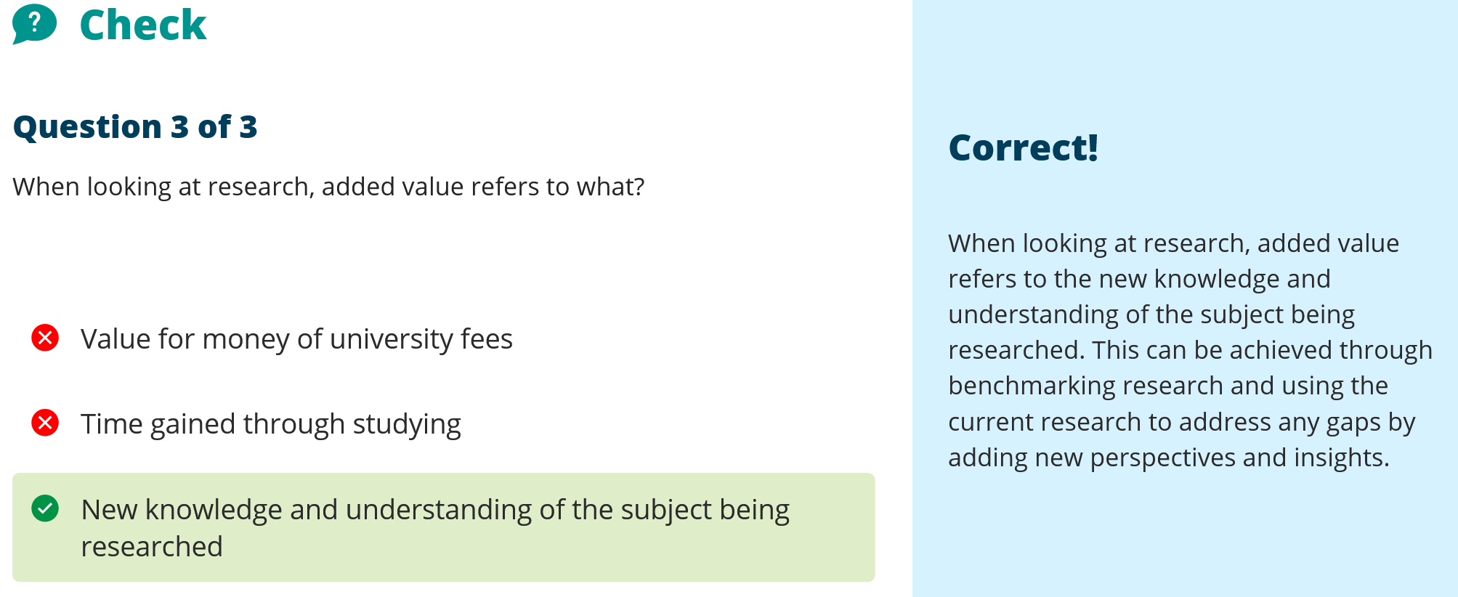



Section 3 Crowdfunding
No video created – there is an element of sensitivity around the project I have selected and within the timescales and covert nature of its deployment I would not be able to create something of worth.



Whats the story

The campaign for safety for DV survivors is one that I have had to deal with – although in a limited capacity. But there is a compelling reason for protecting the vulnerable. I believe that this could be transformed into a powerful story that would be both truthful and compelling.

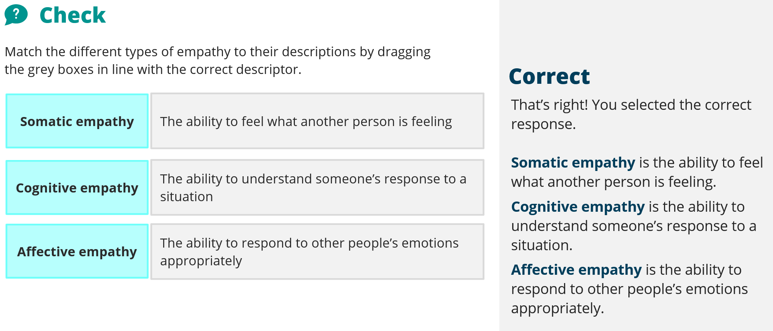
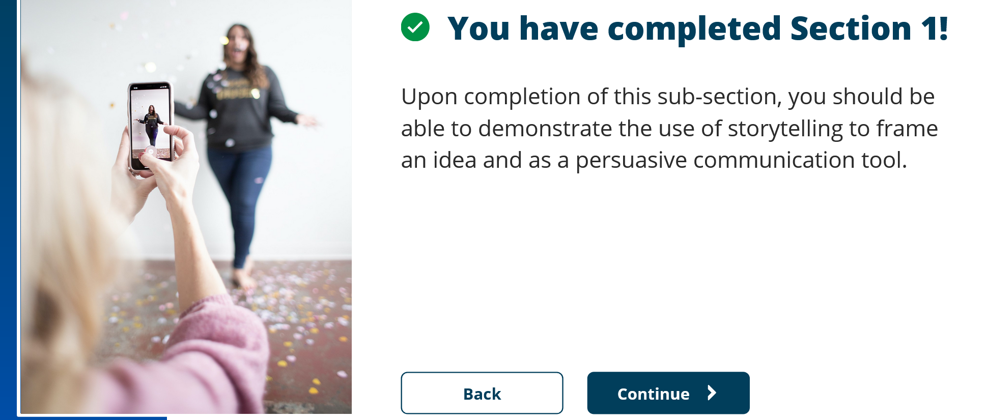

Unit 2 Section 2 Self Confidence/authenticity

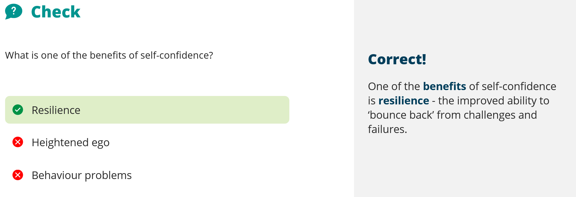

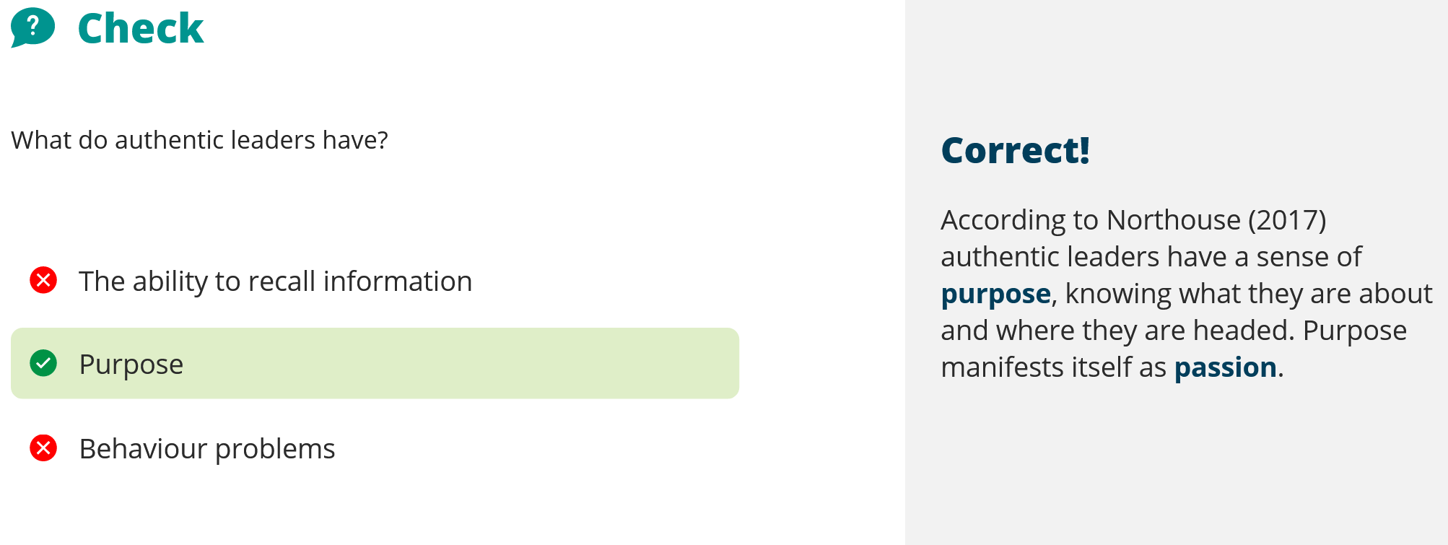


Unit 2 Section 3 presentation
3 act structure
Presenter not star of show? Audience is the star. Presenter is the one that moves audience into the story. Likeable hero, encounters roadblock, emerges transfomed.
Fraytags dramatic story structure Exposition, rising action, climax, falling action, denouement. Beginning middle end. What is to what could be (as big as possible). Middle goes between those two with your idea as the possible. At end describe world as new bliss.
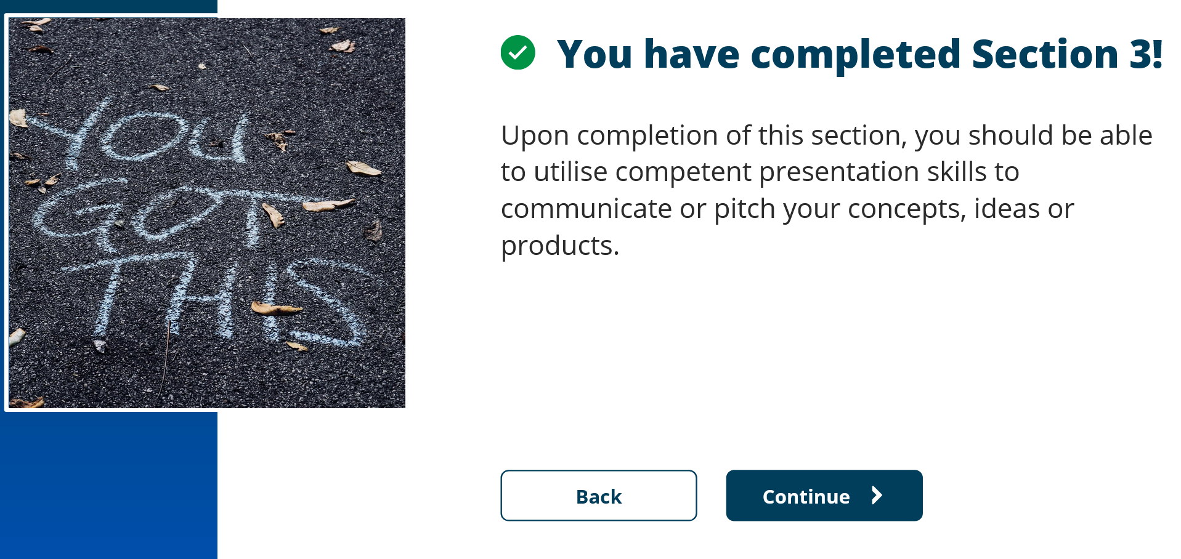

Prototyping is the conversation you have with your ideas. Means to me that you are discussing around the idea and usually a conversation has two participants, the participants here could be the idea or item talking back at you about how it sees itself, or it could be an imaginary user extolling the virtues or describing its shortcomings. These discussions should have both a positive and a negative aspect to round out issues and to be realistic or pragmatic. However, sometimes these conversations should be without negativity to maybe ignore limitations and describe a utopia. This sometimes is described as blue sky thinking. The conversations should have a point and these points should be noted and perhaps organised into groups such as utopia, limitations, difficulties, solutions, Then each of these points can form part of the project to help it be successful.
We may have to be cognisant that in some areas of research, such as quantum theory, that language has not developed enough to describe the ideas being put forward.

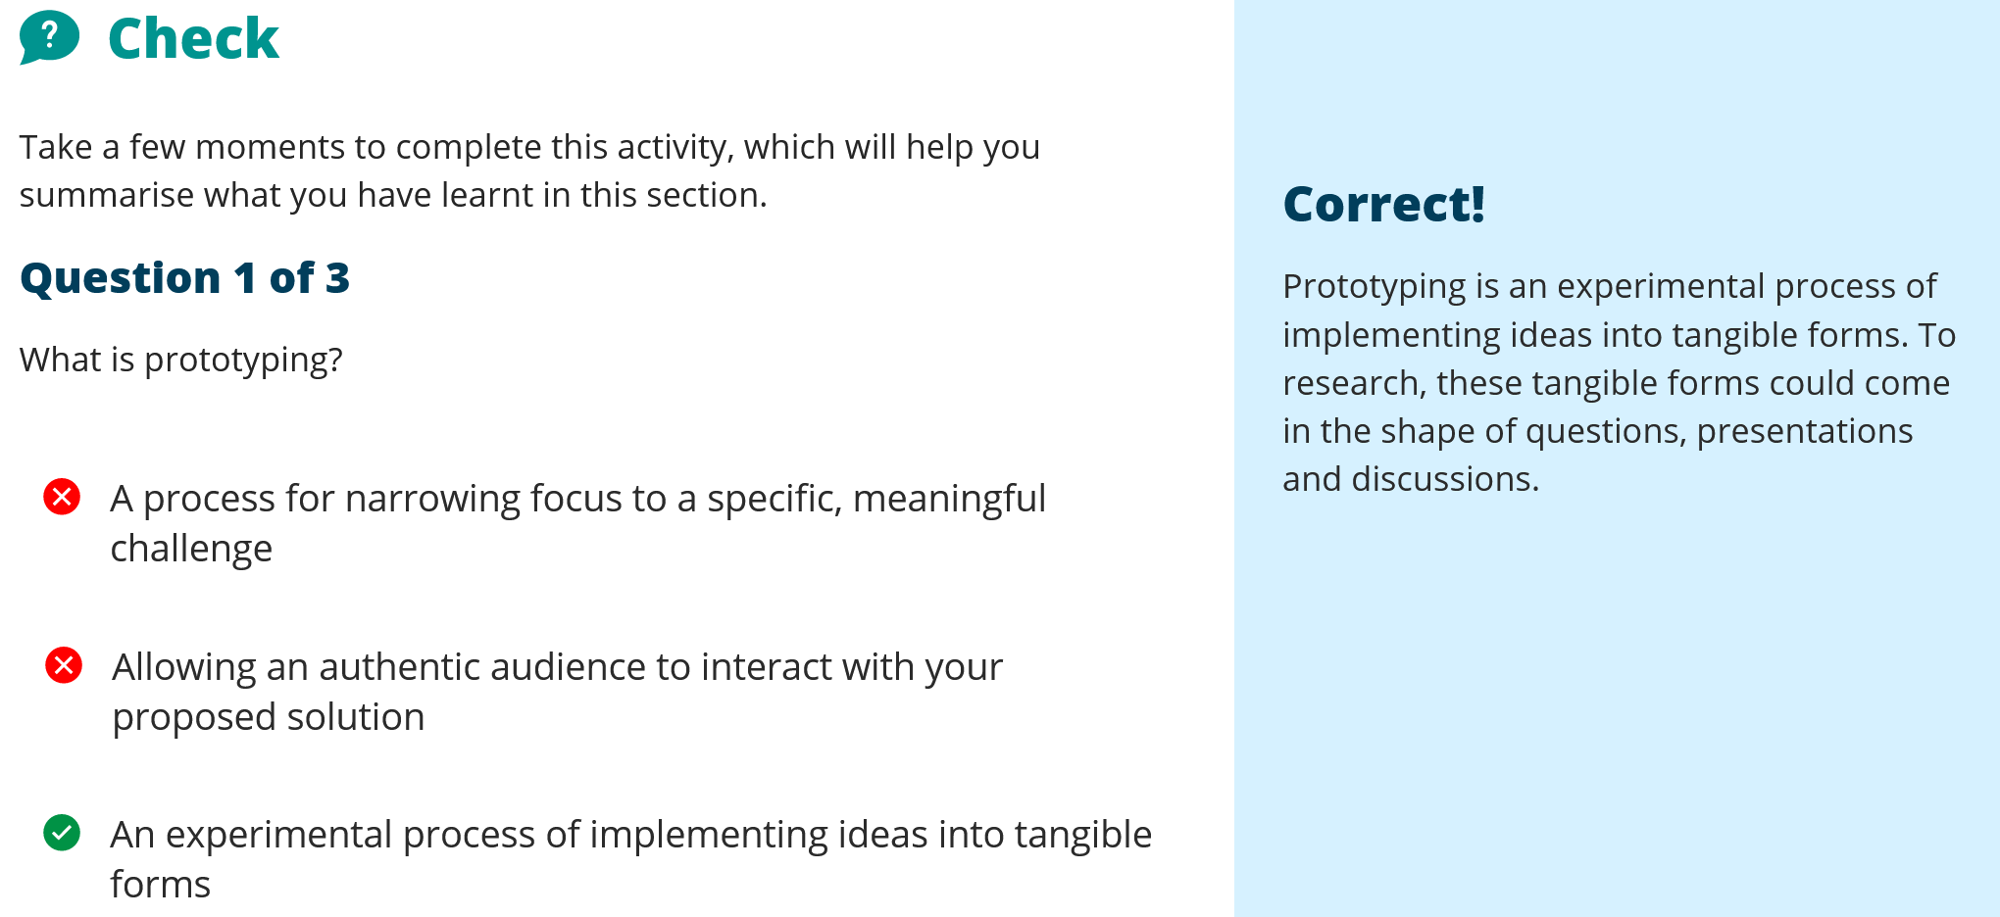

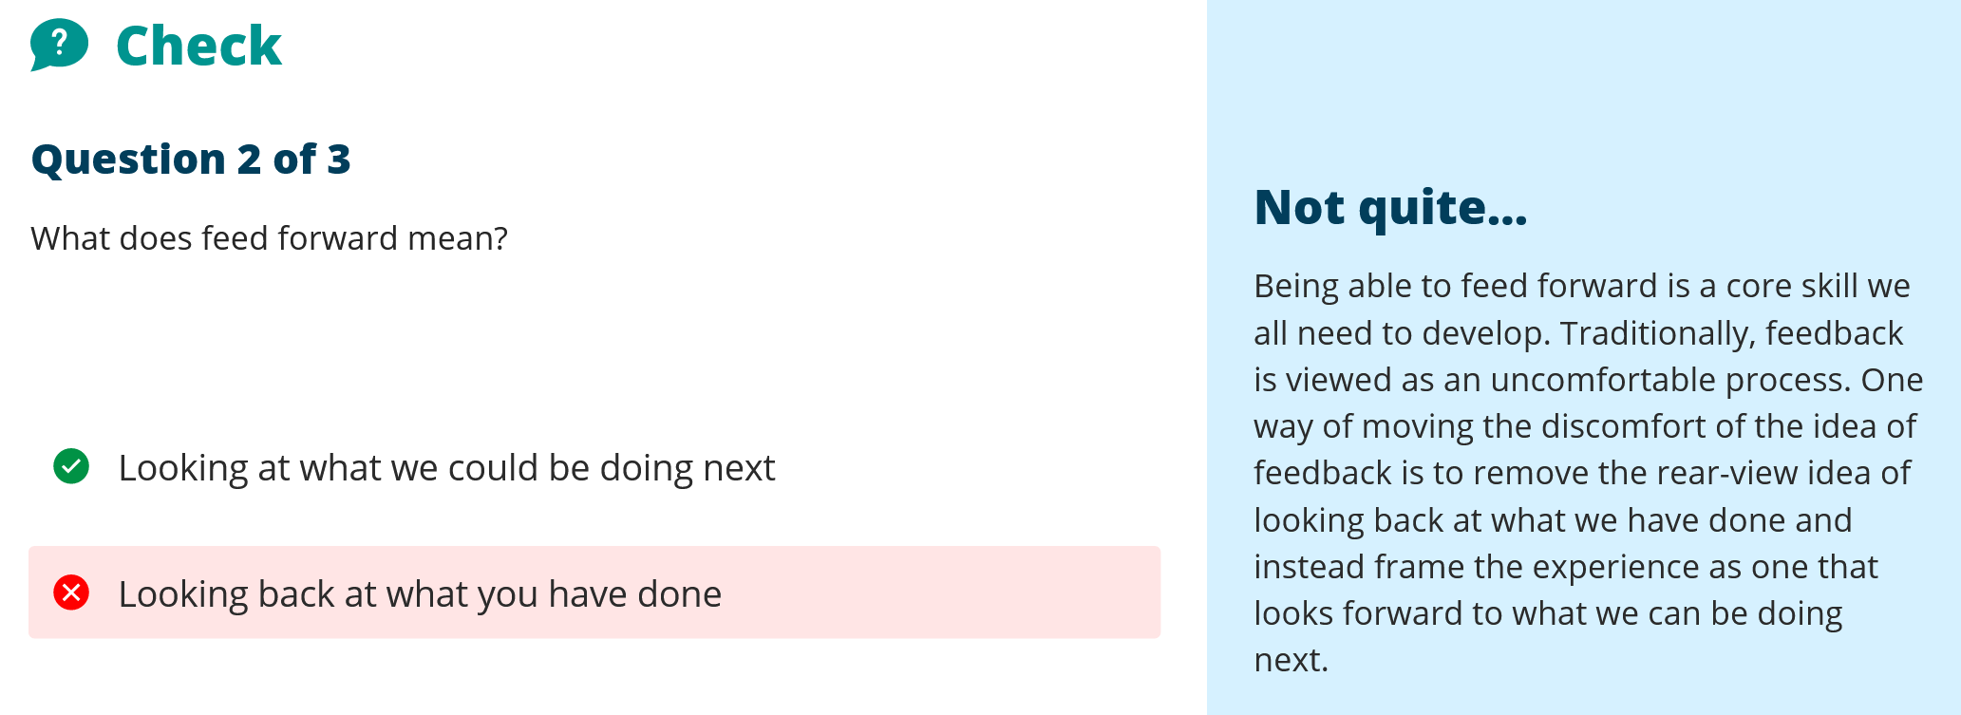
But what is being fed forward, you are feeding forward from what you’ve done surely? Looking at what could be done next is not feeding forward, if you are feeding you are providing sustenance which has to come from previous experience, not just looking at what could be done – that’s exploratory and without sustenance and therefore not fed. Apologies but I did not see this in the slides.

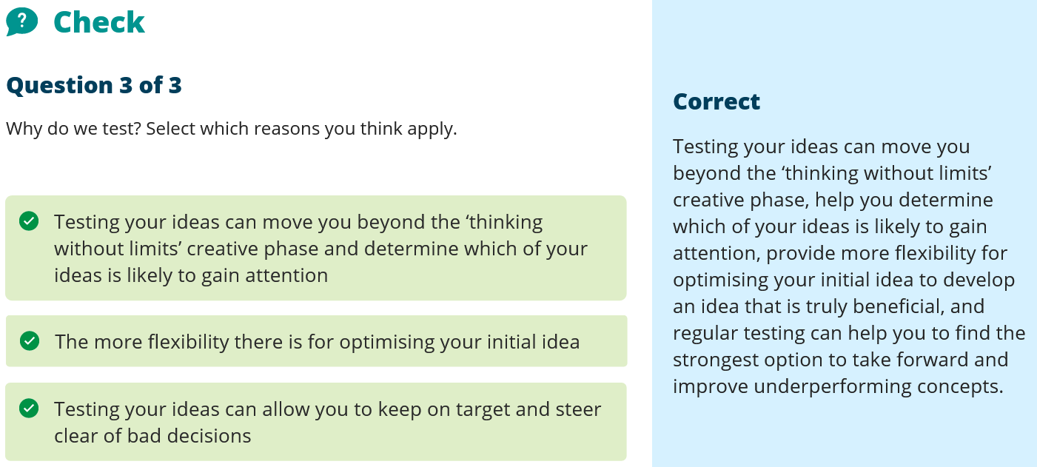
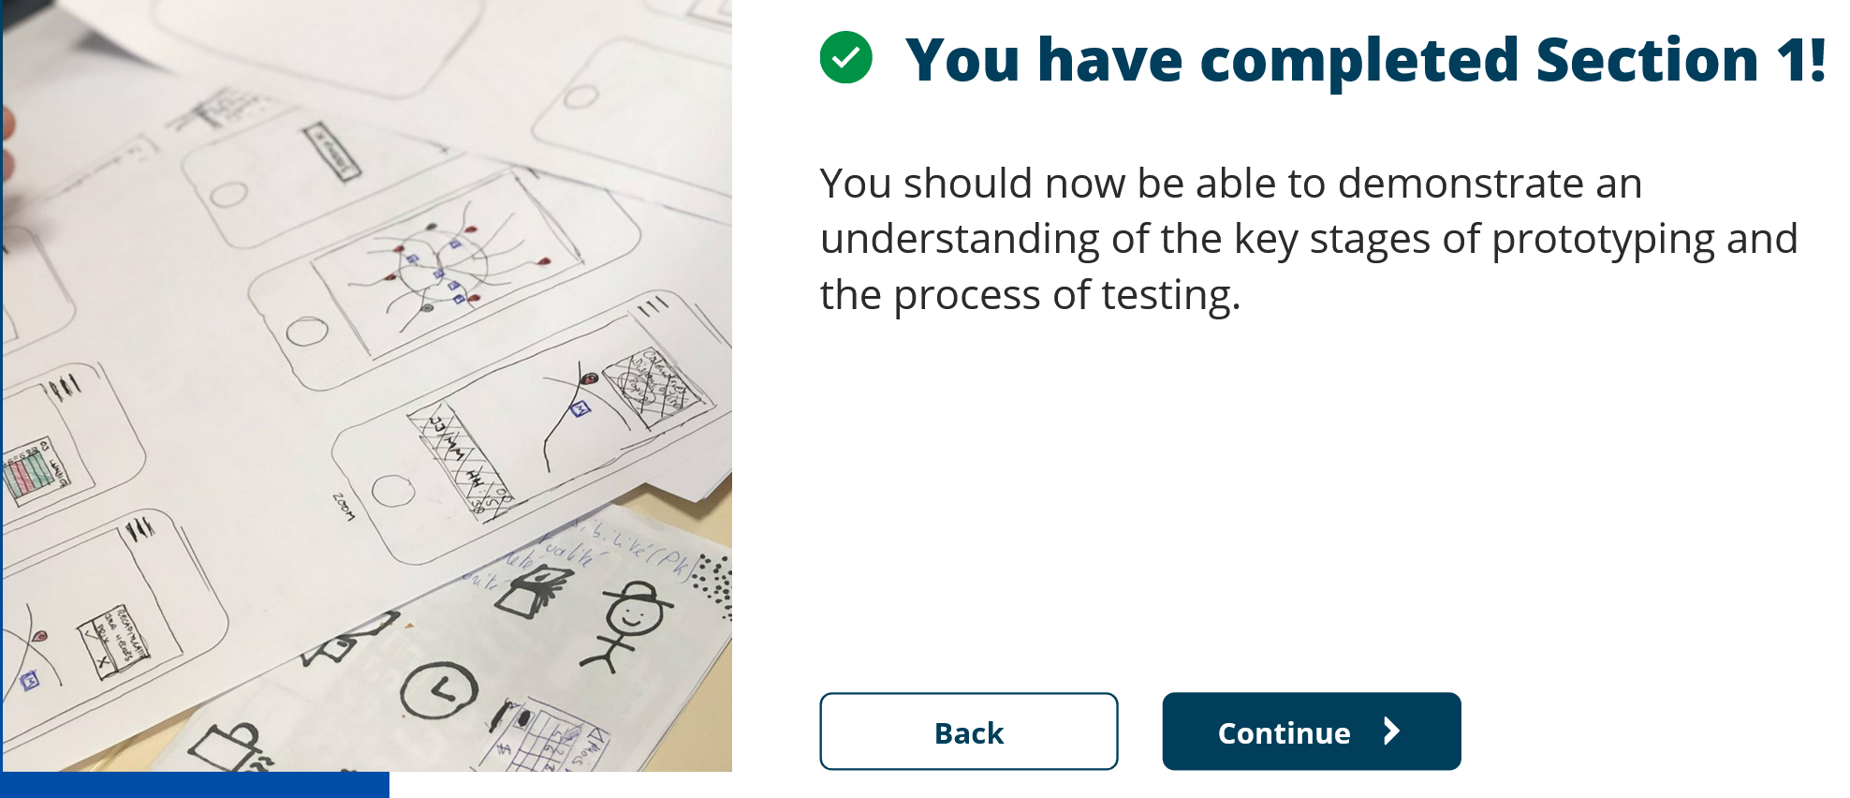

Thinking Agile:

Reflect:
The Maths library code was a good piece of work but one where I found that I was performing prototyping with small bits of code to check they worked before amalgamating them in, also, with some of the routines there were multiple ways to solve the equation and I used something akin to Agile in creating all the different versions of the code that worked and then selected the one with the least code and memory locations required.

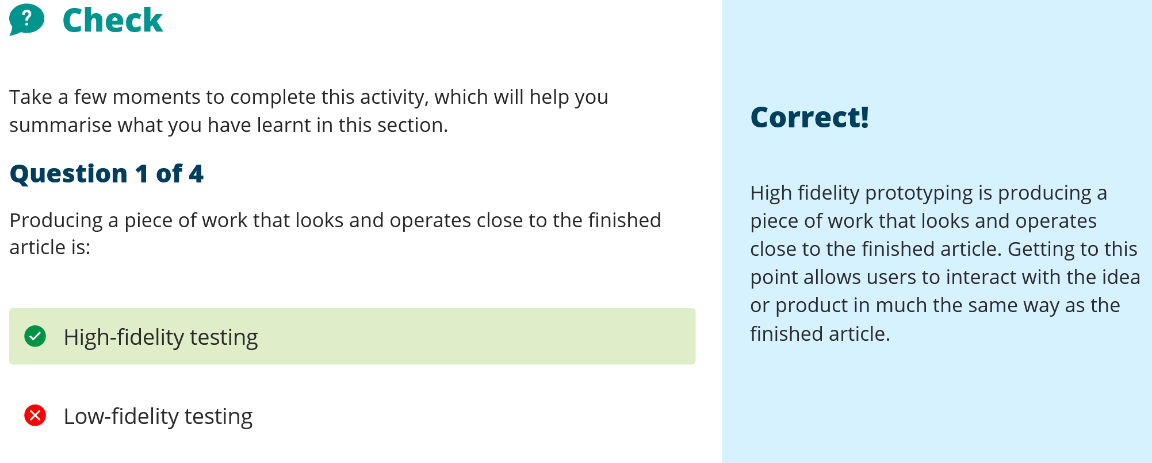

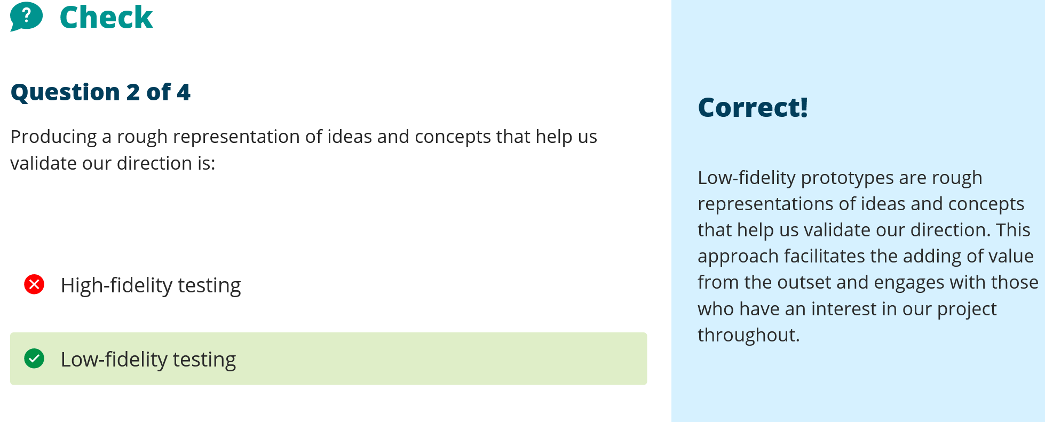
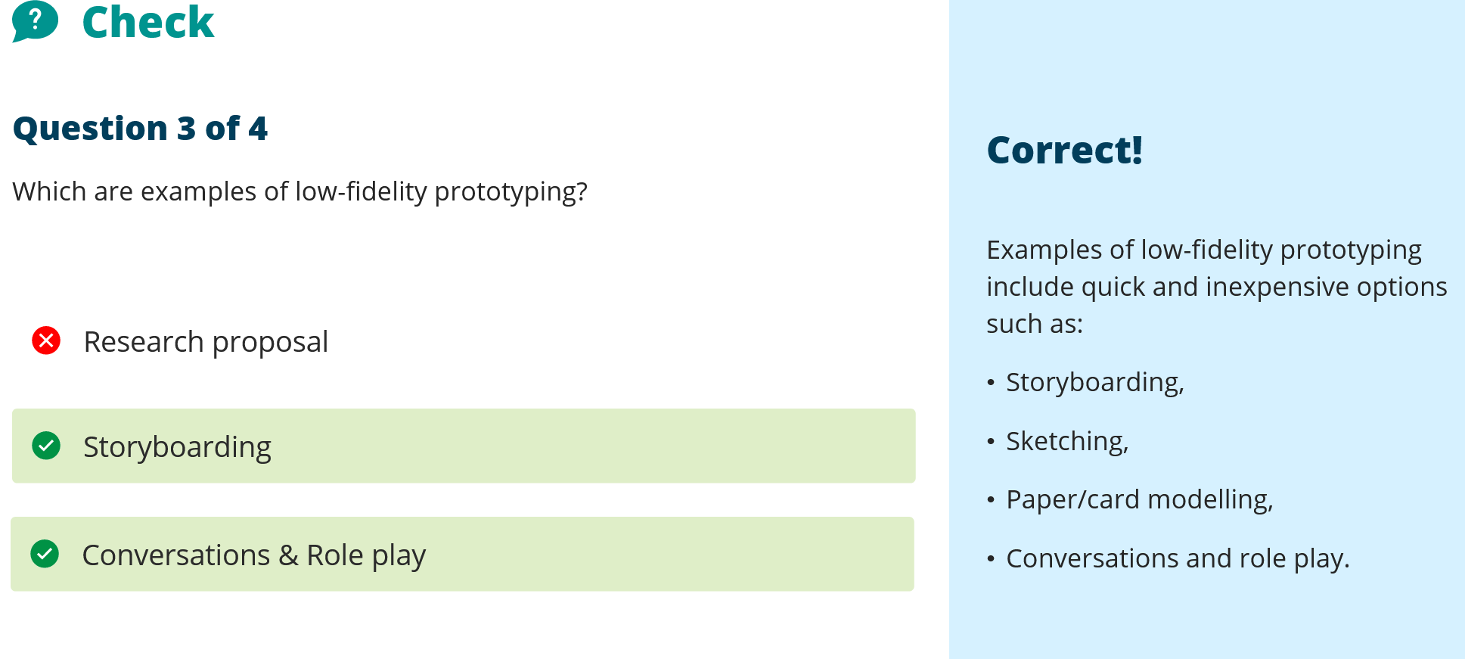

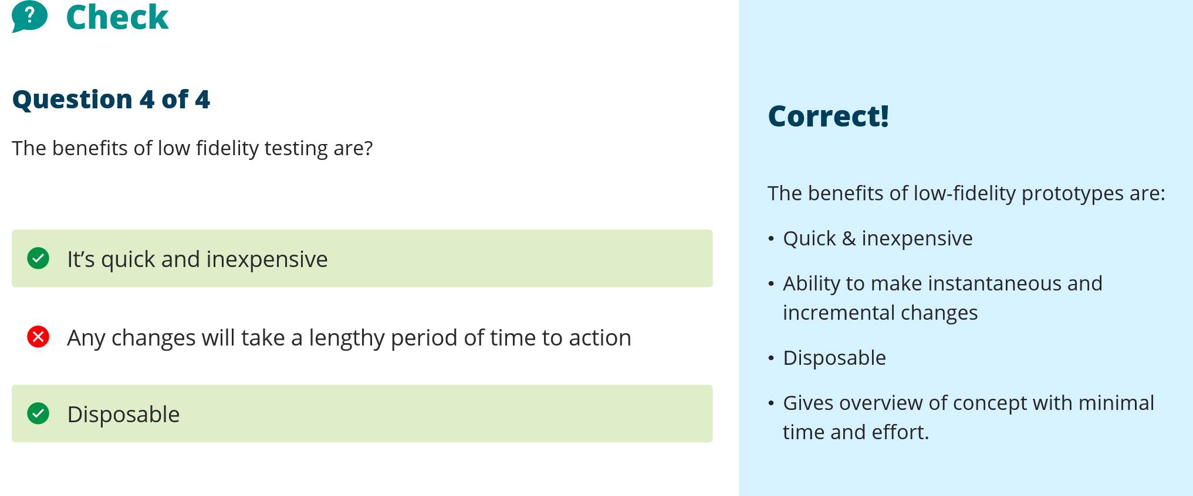


Topic 4:
Google search for qualitative research domestic violence – following screenshot:
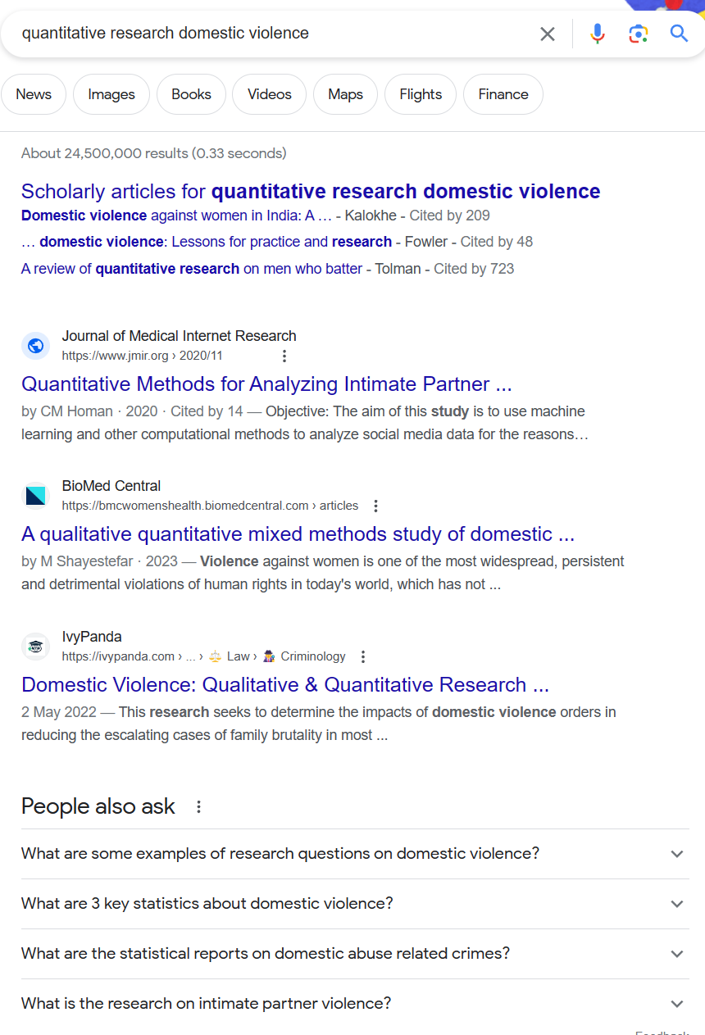
And:
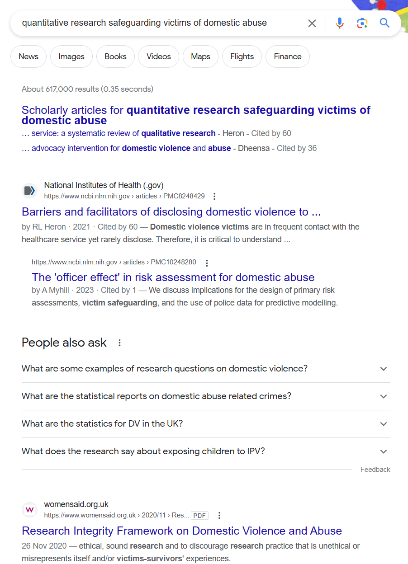

One entry on the National centre for Domestic Violence mentions that women are more likely to experience repeat victimisation as below:
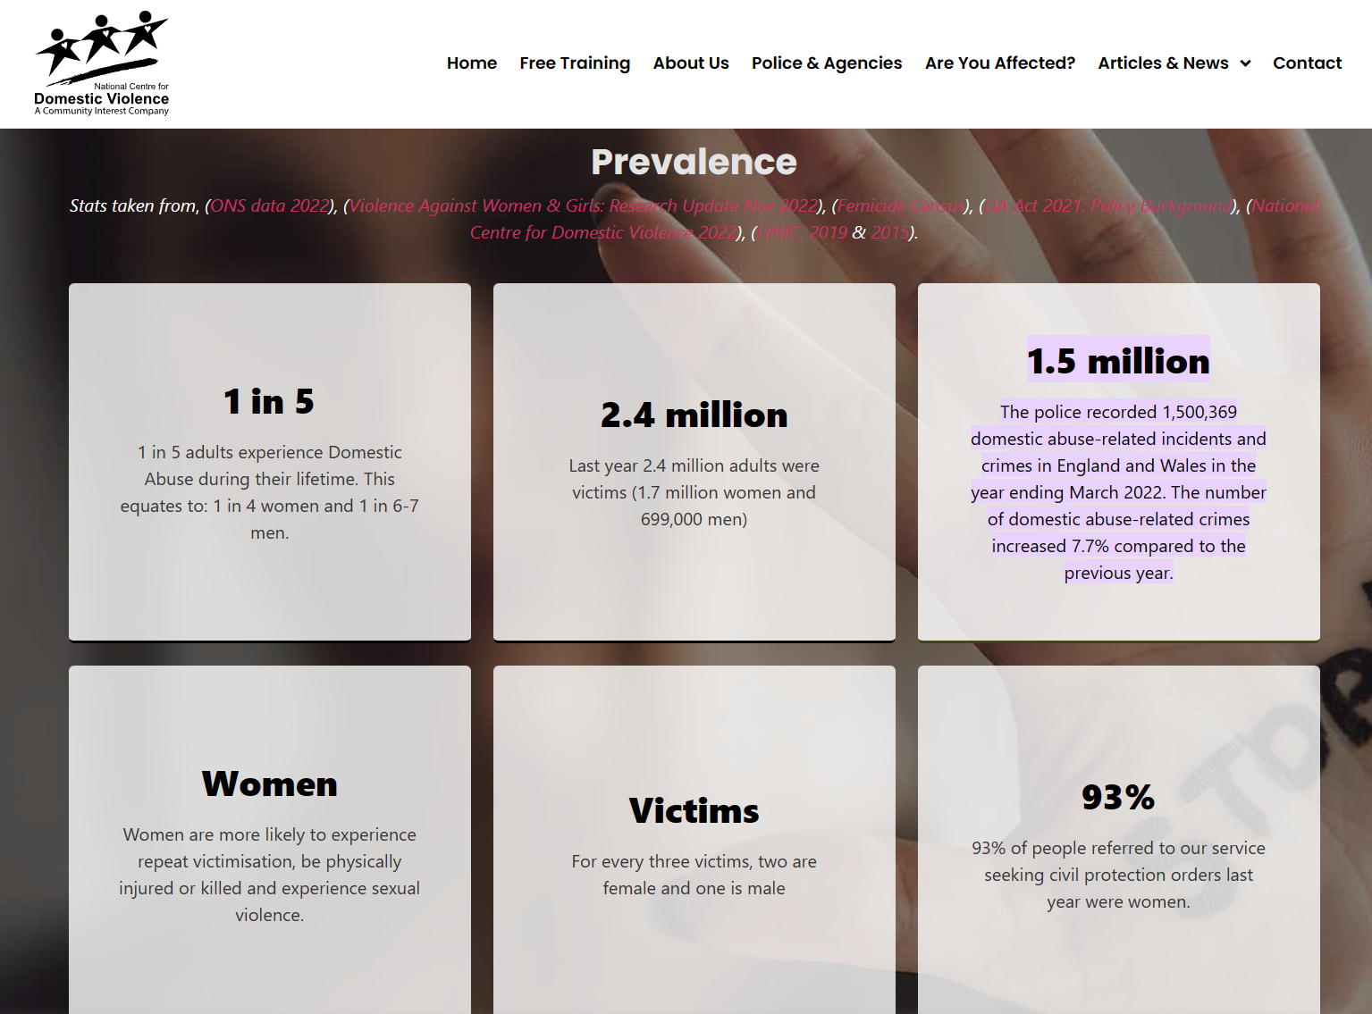

There are many other stats but nothing exactly related to the value of my project. I have a network of work colleagues who specialise in this area and I will have to send out a questionnaire to those to get the stats that I need.
Question: What percentage of offenders repeat their behaviour after a restraining order?

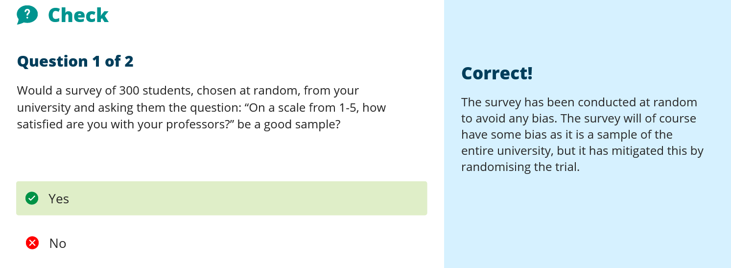

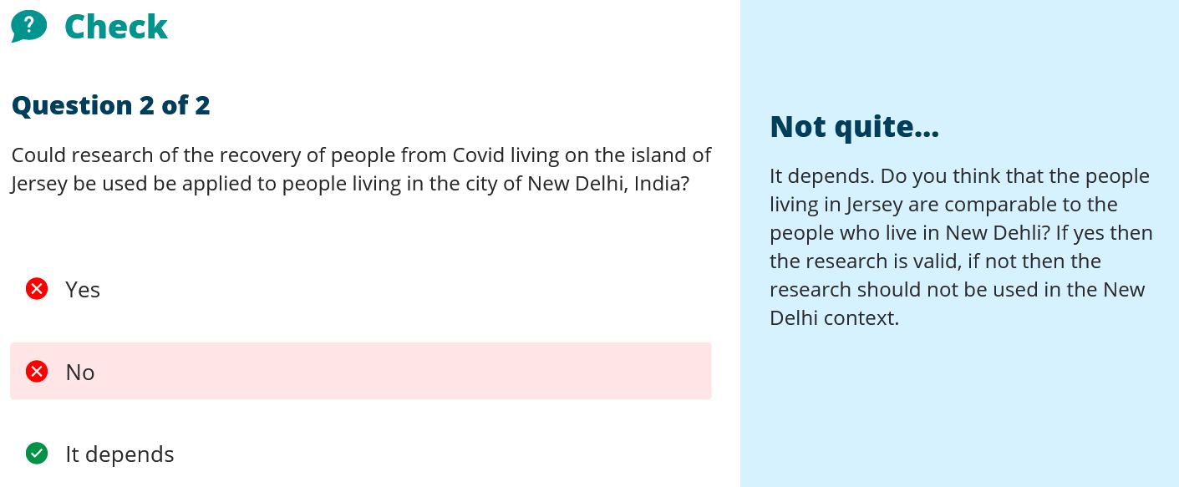
The question here does not quite make sense it states
‘… Jersey be used be applied to people…’
this does not make sense. The keywords of ‘be applied to’ when mentioning research of people from Jersey to the people of New Delhi, would absolutely not be the right thing to do. The answer then mentions ‘are the two people comparable’ which is not in the question. If the research is to compare between the two then of course. But that isn’t what the answer is saying either. I cannot think of how research of people living in Jersey can be applied to people in New Delhi. Different genetics, geography, society, religion, health service, density of population to name a few basics would mean that the data cannot be ‘applied’ against the other population. If the question is supposed to read ‘be used’ it would have to continue ‘… to …’ do something. It could be applied to a study into the similarities or differences between the two, but you can’t apply the research of one demographic to another. That would instantly negate the value of the research.

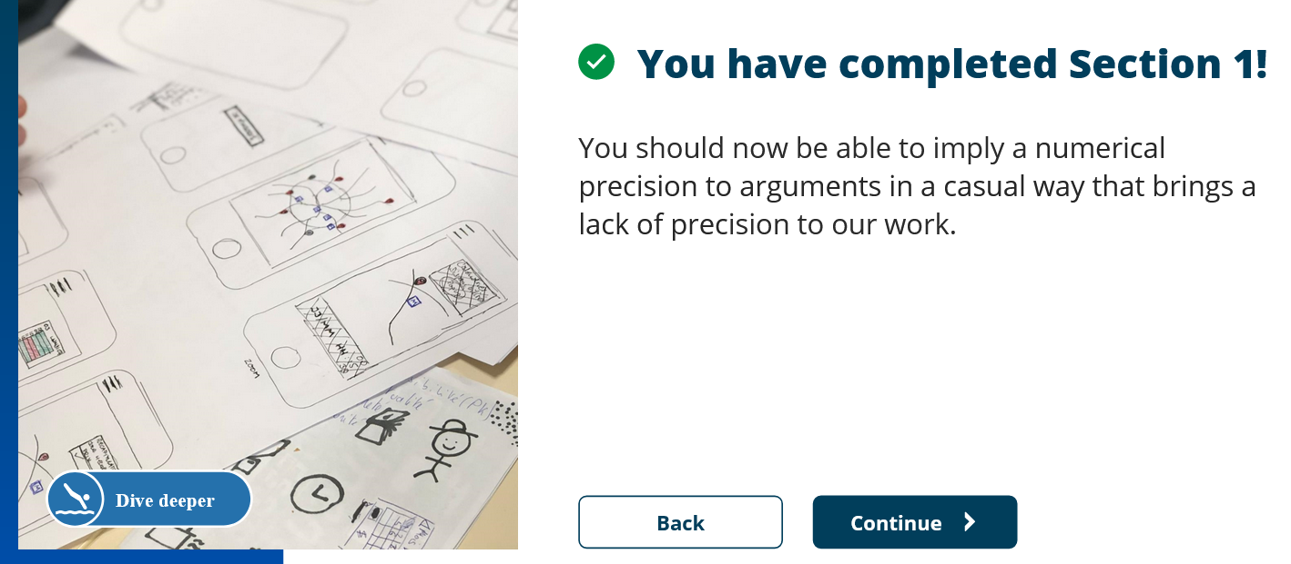

Correlation between two sets of results is best described with a scattergraph.

For my research superimposed bar chart to provide figures for repeat offending at same address.
Andrew Abela provides the following guide to which chart to use:

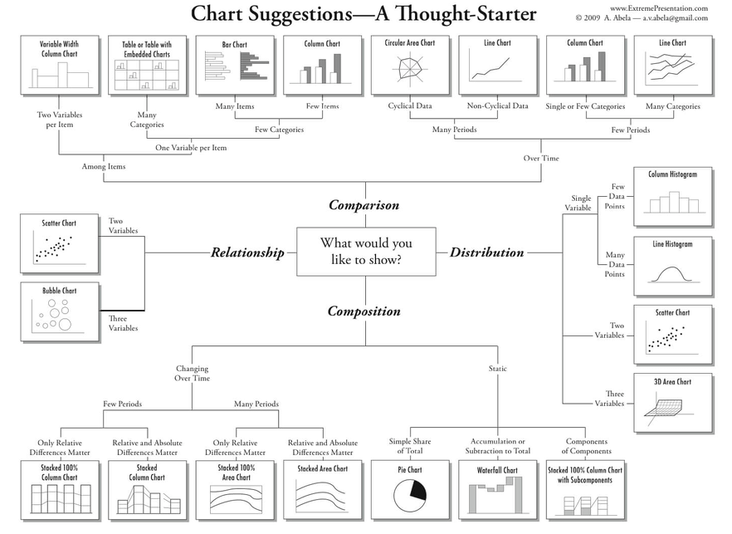
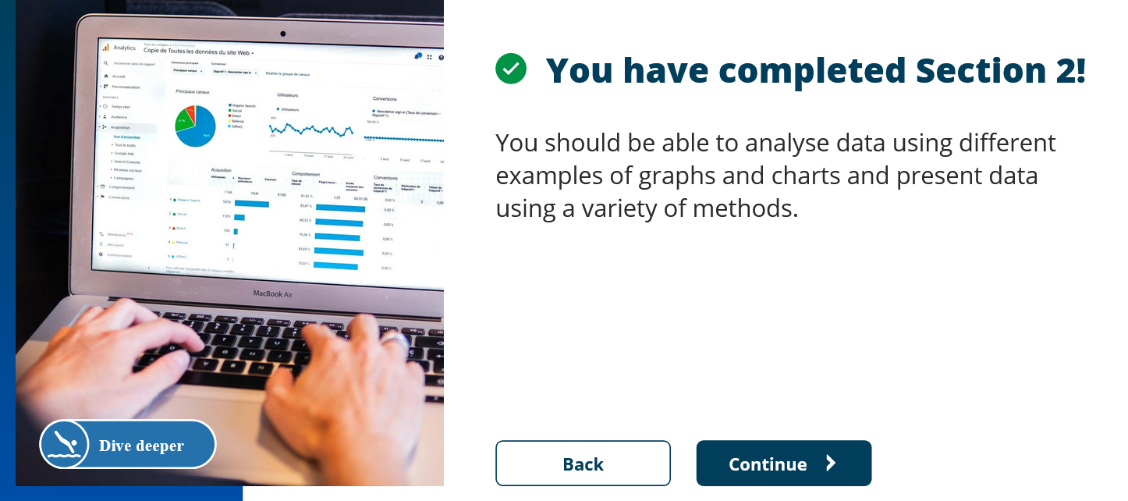

Unit 4 Section 3

Aristotle saying ‘The aim of art is to represent not the outward appearance of things, but their inward significance.’
I think it has to be said that it may depend on the art. Still life artwork of a bowl of fruit for example probably does represent the outward appearance of things if painted in a straightforward way, but if for example it was painted in the style of Picasso then how the viewer appreciates that artwork can only be internal or have internal significance. So then, there is still the internalisation of all experience. We cannot really say how we all view the world around us. How does one person see the artwork named ‘My Bed’ by Tracey Emin for the Tate Gallery in 1999, for example, compared to another. Or the Tate Bricks by Carl Andre is another example of art installations which have radically different reactions by different people. Those may be extreme examples but on a simpler level, one person’s green may differ from another. Some people may experience the still life through the eyes of the artist, thinking about how the artist felt whilst painting. Some people see sounds in colours if they have sound-colour synesthesia, so their perception of a still life could be radically different. Therefore, overall I think it has to be said that everything has inward significance, and art uses that to great effect, however, sometimes it is just a bowl of fruit.
The charts are aesthetically pleasing, and so in some ways can be considered works of art, there is absolutely no reason why not. The fact that not only are they informative but are wonderful to look at does not necessarily mean that they convey more meaning, but I would say that they probably hold people’s attention more. This means they may digest that information more thoroughly and possibly make more psychological links to the meanings of the information being provided. So they could possibly convey more meaning by proxy. This could be linked to the fact that when viewing artwork, people’s brains are placed in a mode to appreciate the aesthetics and so they may be more susceptible to ‘open’ thinking which may help realise further meanings from the chart.
Chart for research of DV re-offending? But what would that show? The project is to try and protect the vulnerable. How much safer would a victim feel with this new tech in place? Very subjective, not quantitative.

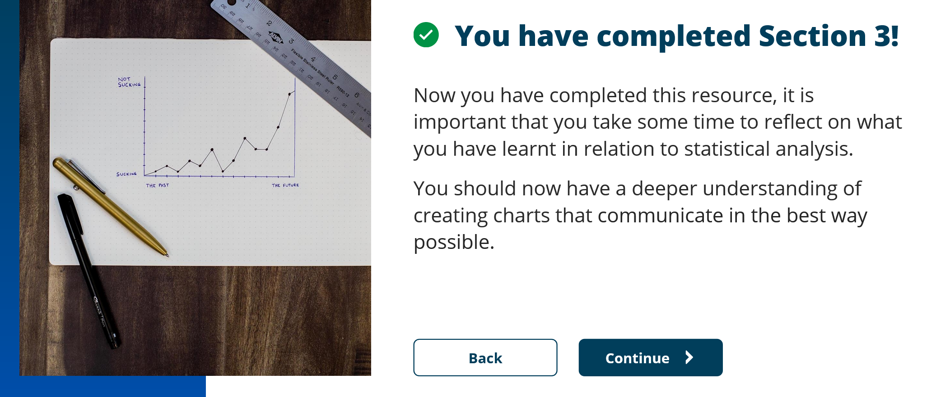

Unit 4 Topic 2 Qualitative data
Qualitative research can be considered more human-centric, about understanding, behaviours and possibly will have an experience attached to the project being researched. The benefits are that the research deals with real experiences of people, rather than a numerical indicator.
There is probably some element of every project that can have a qualitative element placed against it. Even if it is the GUI of a produced piece of software. That interaction would be researched qualitatively.
The disadvantages are that often consistency of description and/or lived experience differs between each individual involved in the research, therefore it can be difficult to arrive at specific end points as they may be different for each person.

My data would be organised in the following way:
Folders for:
Project Plan
Plan for the whole project, including a Gantt chart or similar that provides the timescales for each section of the project.
Data Management Plan
Rules for Creating, Documenting and accessing data.
Ethical considerations
Data Protection Act 2018 aspects that need to be adhered to.
Research of individuals involved:
Questionnaire for Welfare Officers – Dealing with frequencies of restraining order breaches, the likelihood of the offender having their phone with them, whether other technologies such as ‘Ring’ -style doorbells could be used, is there a need for extra access points to be setup to widen the capture area, do the officers have the ability to respond if the alarm is raised, should the alarm be covert or overt? This research would mostly be qualitative with the view to determine the value of the project and its viability.
Questionnaire for victims – anonymous, dealing with the behaviour of their attacker, likelihood of carrying mobile device, access to router previously given, how would they feel about this tech being implemented, would it help their mental health, would they feel safer, it would not be the only tech used but one of a suite of protection technologies. Would they want the alarm covert or overt? Ie would they rather the offender be caught or warned off. How do they feel about other tech such as ‘Ring’ style doorbells and would they want access points at the perimeter to provide a wider capture or just within their home confines. If extended there is a chance that their network would be picked up more readily by other individuals, although this may be masked. This would form the quantitative data that would be relevant to the project and to evaluate its worth as a project to the survivors.
Some of the questions are similar between the two which would provide some experience based qualitative data against the numerical officer based data that checks each other but the same question almost has a different meaning. For example an Officer may want the alarm to be covert so that the offender can be caught, but the victim may just want them warned away so that they do not have to deal with the offender in any way. And each answer is correct, but that may mean that it becomes a configurable part of the system.
Funding Research
Who can be approached for funding – what forms do they need completing to apply.
Application forms
Hardware Research
What hardware is required for the project,
Have other similar projects been created and is there a solution that can be tailored to this need.
Have software libraries been created to control the hardware and can they be utilised? At what cost?
What are the limitations of the hardware and can it still provide the functionality required.
What communication with the outside world is required. Local warning, remote warning, use of mobile network. Connections to authorities allowed?
Software Research
What libraries are available for the hardware or will those routines need to be written also. If so, is there good documentation for the hardware to be able to write the controlling software itself.
What is the best language to write the software in? This may be linked to the libraries already written or use a hybrid approach.
What communication with the outside world is required. Local warning, remote warning, use of mobile network. Connections to authorities allowed?
All of the above folders would be stored in the cloud but with locally accessible copies on USB or local machine storage. Therefore, there is the local working copy, synched to a cloud account and a backup USB for a third copy that makes for a reliable robust safeguarding of data against loss. Policies can be devised for how often data is backed up to the USB but the cloud would remain the first point of backup as it is quite readily available and as long as an internet connection is available then your data is available. However, there are times when this is not immediately available, which is where the backup USB is useful. Unfortunately, data breaches, malware and other attacks can make that data vulnerable. Obviously, the local machine should be encrypted, as should the USB backup storage and strong passwords used for access across all devices and accounts.



Unit 4 Topic 2 Section 2 Patterns and Themes
We are all pattern recognition creatures to some degree. Some superstitions and behaviours people display can come from pattern recognition, sometimes people are consciously aware and other times not. We see traffic patterns on our commute to work, we hear speech patterns of our colleagues and friends. Themes are probably more about a subject whereas a pattern maybe a little more distinct or nuanced. So maybe the theme of getting to work is to use as little time as possible (or as much as possible depending on the driving factor), whereas the pattern might be leave 10 minutes earlier on a Thursday because the binmen slow the traffic that day. So the pattern of behaviour is different on a Thursday but the theme is the same each day.

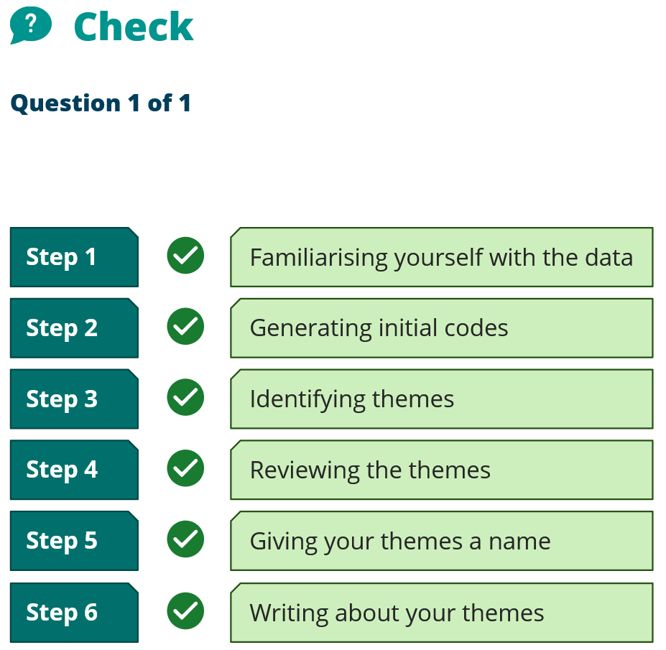


Unit 4 Topic 2 Section 3 Qualitative software
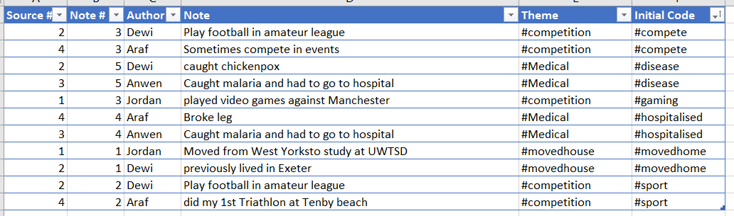


Unit 4 Topic 3 Section 1 – Succeed or fail.
Failure is the inability to perform a task to my best ability. I almost have a compulsion to do things under pressure, when they have to be done. Spreading a task over a long period of time is difficult to manage for me as I continually react to whatever is in front of me. This has some great advantages as I am great under pressure, can react dynamically to any situation and if an unexpected issue arises I am usually the one to rectify it quickly and to the best it can be at that time. But most of my failures within any projects have been down to not having the time to concentrate solely on those projects and do them as I wish. Generally, most of the projects I have worked on within my employment have been successful, and it is lack of resource, distractions and my lack of time to organise effectively that have lead to any failures.

Unit 4 Topic 3 Section 2 – Success and wellbeing
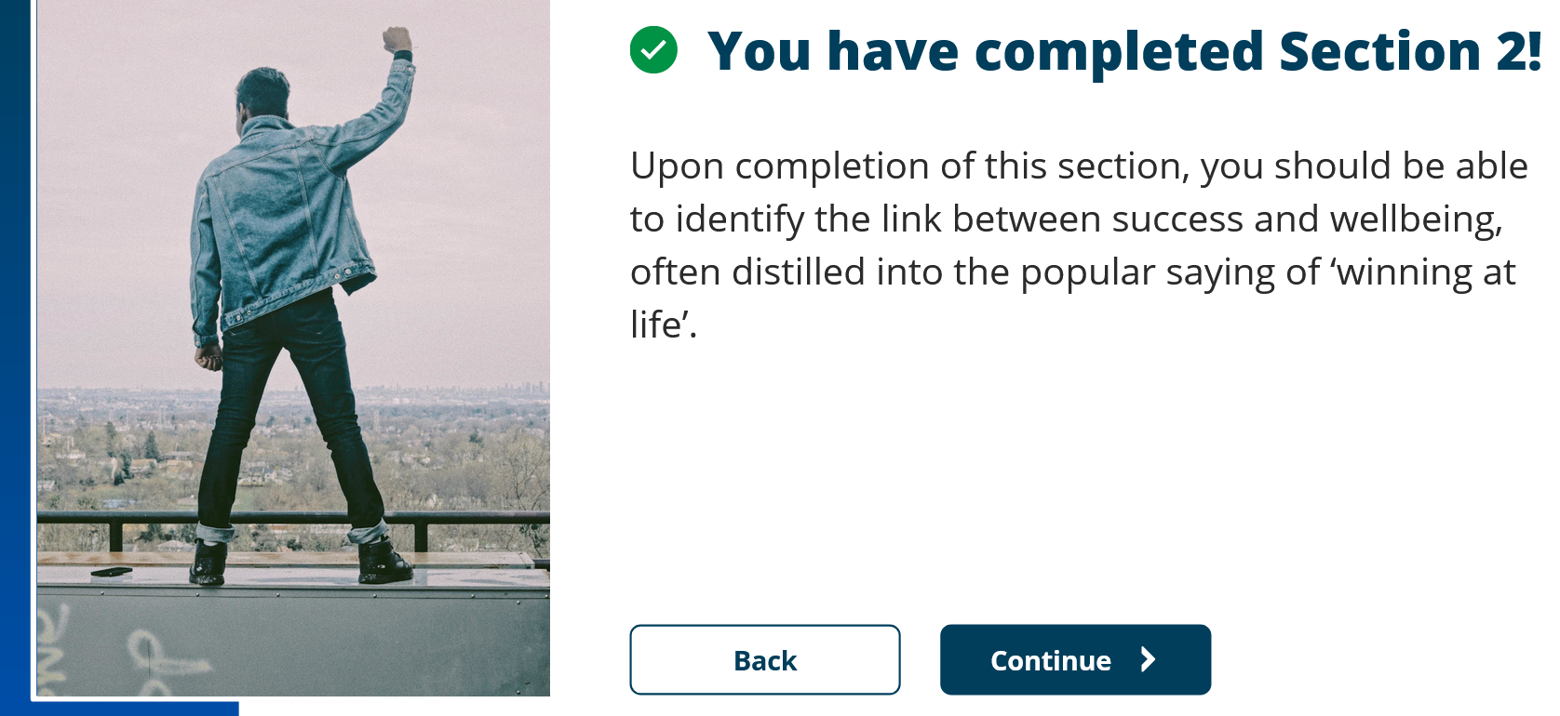

Unit 4 Topic 3 Section 3 – Success from failure
Can’t think of anyone particularly successful who hasn’t worked for it. Not really interested in famous people to know if some have been lucky, mostly you hear stories that they worked their way through the ranks to get to being famous. I’m not sure of who has been plucked from obscurity randomly.
My manager is successful as they work tirelessly towards a goal, they have a big picture mentality and continually strive to out-perform themselves. Their success is recognised by the management above them, as projects get completed and figures move in the right direction. They use psychological means to get their desires realised. There is a single mindedness about their targets and where they want to get to. Fame holds no meaning to them, they are self-centred and drive their world into the shape they want. My choice is borne out of respect of being that single-minded and not doing anything that does not interest them. They may not have achieved fame as that is not something that they crave. If they did crave fame then they would have achieved it.
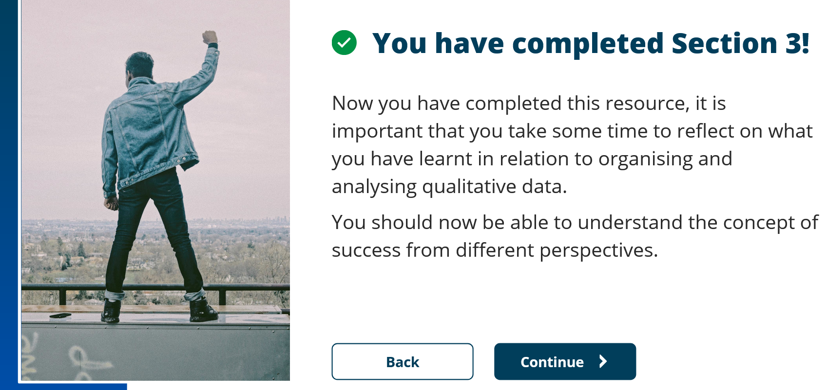

Unit 4 Topic 4 Section 1 – Applying learning
To become better, as a person and as a programmer and to develop the basic skills I have as a programmer and create innovative software that will help people achieve tasks easier in the future. In one word Develop.
Hindsight Bias – look back and see it as predictable. Once learnt anyone else should know it,
Context – Situation or context you are making project
Problem statement
Variables that govern the situation (time, equipment etc)
The complications or complexity in the project as seen.
Alternatives that were seriously considered and why not chosen
A paragraph explaining the range of outcomes
A paragraph explaining what you expect to happen with reasoning and actual probabilities assigned to each projected outcome. Degree of confidence.
Time of day making decision how feel physically and mentally.
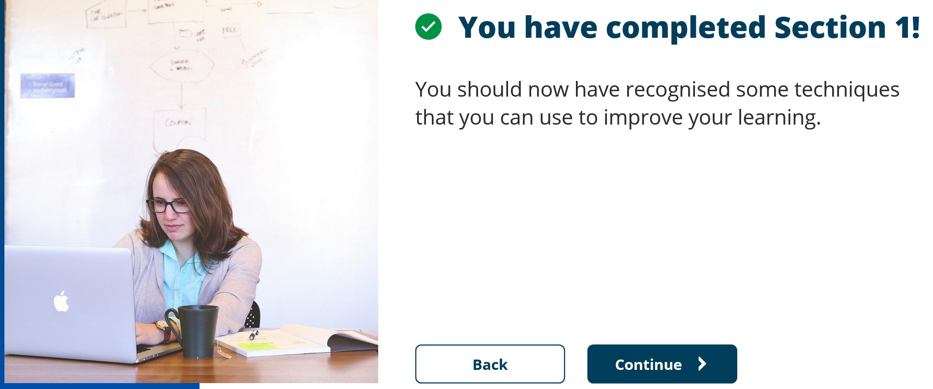
Unit 4 Topic 4 Section 2 – Develop approach
Create Mind map


Unit 4 Topic 4 Section 3 – Implement approach
Title of poster – short draws interest
UWTSD logo in poster professional looking photo of self.
Words 300-800 advice is <150
List people and references
Template consistent fonts and colour palette. Do not get fussy.
Powerpoint can be used for a poster.
Background, Questions, Methods, Results, Conclusions References and acks small at bottom.


