
Data security and compliance
ACCA5034


Task 1 – Research in Data Security and Compliance
Securing the Modern Enterprise: From Zero Trust to AI Governance
Governance of AI and Machine Learning Systems: Managing Risk, Ethics, Bias, and Compliance for AI Data and Models
Abstract
Modern enterprise environments are experiencing an unprecedented paradigm shift driven by the rapid integration of Artificial Intelligence (AI) and Machine Learning (ML) into core business processes. While these technologies yield exponential productivity gains, they introduce unique systemic risks that traditional cybersecurity frameworks are ill-equipped to handle. This paper investigates the contemporary data security and compliance landscape, focusing on the governance of AI/ML systems. It explores the transition from perimeter-based security to data-centric Zero Trust architectures, analyses the critical risk factors—including adversarial AI, ethical biases, and data poisoning—and reviews emerging global standards such as the NIST AI Risk Management Framework (AI RMF), IEEE P3396, and ISO/IEC 42001. Finally, we propose a holistic, multi-layered AI Governance and Security Framework designed to safely operationalize AI pipelines while ensuring continuous compliance, robustness, and ethical alignment.
I. Introduction
The rapid expansion of hybrid cloud infrastructures and decentralized workforces has permanently dismantled the traditional network perimeter. To survive in this interconnected digital economy, organizations must adopt a security posture that inherently anticipates, detects, and automatically responds to sophisticated threats [1]. Concurrently, the mass integration of generative and predictive Artificial Intelligence (AI) has added an layer of complexity to the corporate digital attack surface [2].
Traditional security practices focus heavily on protecting information infrastructure assets (e.g., servers, networks, databases) from unauthorized access [3]. However, AI models introduce non-deterministic behaviours, dependency on massive training datasets, and novel vulnerabilities such as prompt injection, model extraction, and data poisoning [4]. Consequently, the challenge of securing the modern enterprise has expanded from standard infrastructure defence to the broader domain of AI Governance.
This research paper critically analyses the structural challenges of managing risk, ethics, bias, and compliance within modern enterprise AI pipelines. It proposes an architectural approach that integrates Zero Trust principles directly into the AI lifecycle to manage both process risks (how AI is built) and outcome risks (what the AI produces).
II. Empirical Data: The Rise of AI/ML Vulnerabilities
To understand the urgency of AI governance, we must examine empirical trends in AI-specific security incidents. Data compiled from the MITRE ATLAS (Adversarial Threat Landscape for Artificial-Intelligence Systems) database and CVE repositories reveals an exponential increase in documented AI/ML vulnerabilities and exploits over the past several years [5].
A. Growth of AI Security Vulnerabilities (2021–2025)
The chart below illustrates the growth of registered CVEs directly affecting ML frameworks (e.g., TensorFlow, PyTorch), LLM orchestration tools (e.g., LangChain, LlamaIndex), and enterprise AI APIs.
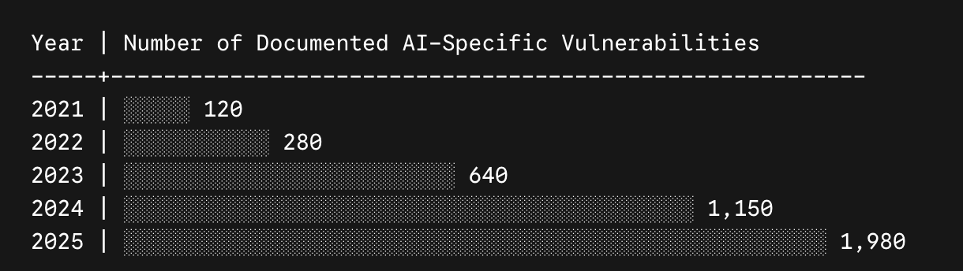B. Distribution of Attack Vectors in Enterprise Incidents
According to a 2025 multi-industry survey on enterprise AI security breaches, incidents were distributed across several novel attack vectors [6]:
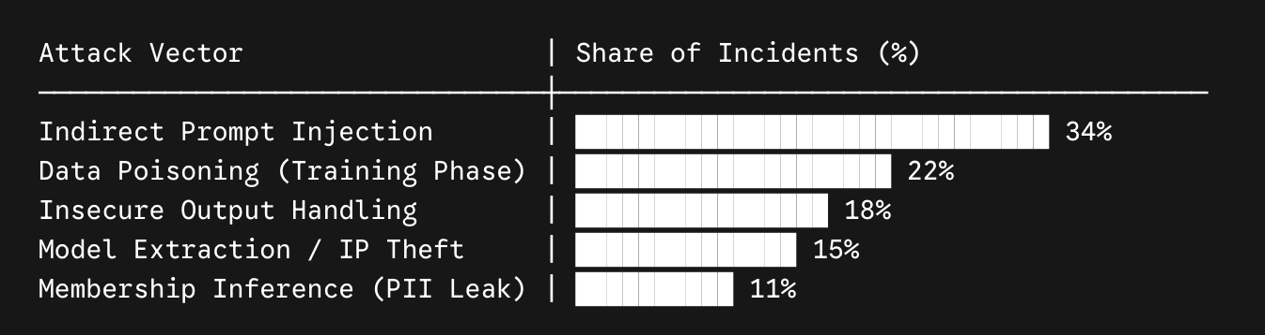This distribution highlights that standard network firewalls are blind to over 80% of these incidents, as they occur at the semantic and data application layers.
III. Theoretical Background & Emerging Standards
Traditional cybersecurity governance frameworks like ISO/IEC 27001 or the classic NIST Cybersecurity Framework (CSF) focus primarily on the confidentiality, integrity, and availability (CIA triad) of static data and infrastructure [7]. AI/ML environments require a socio-technical approach that encompasses ethical, regulatory, and cognitive risks [8].
Several prominent frameworks have emerged to address this gap:
- NIST AI Risk Management Framework (AI RMF 1.0): Released to address the unique risk taxonomy of AI systems. It divides governance into four core, continuous functions: Govern, Map, Measure, and Manage. It emphasizes characteristics of trustworthy AI, such as validity, reliability, safety, security, resilience, explainability, and fairness [9].
- IEEE P3396 Standard: This standard differentiates between process risks (governance of how the models are built, data is collected, and training environments are maintained) and outcome risks (the downstream cognitive, systemic, or deceptive impacts of model outputs in the physical or digital world) [10].
- ISO/IEC 42001: The international standard specifying requirements for establishing, implementing, maintaining, and continually improving an Artificial Intelligence Management System (AIMS) within organizations [11].
IV. Structural Challenges in AI Governance
To effectively protect intellectual property and maintain regulatory compliance, organizations must address three primary risk vectors inherent to AI systems:
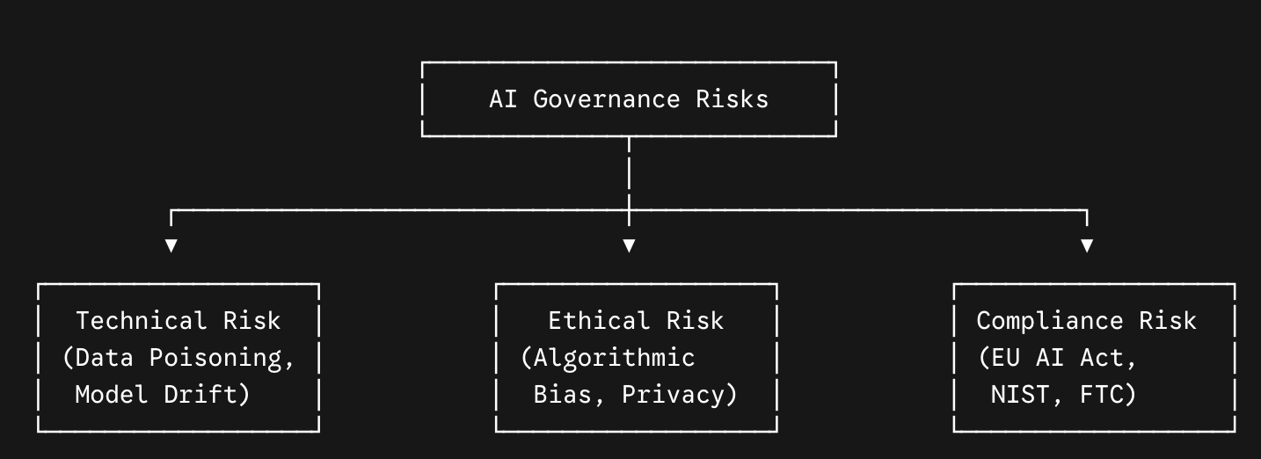A. Technical Risks & Adversarial AI
AI models are uniquely vulnerable to exploits that bypass traditional intrusion detection systems:
- Data Poisoning: Attackers introduce malicious or biased data into the training pipeline, subtly altering the model’s behaviour to trigger false positives or create backdoors [12].
- Indirect Prompt Injection: For generative AI pipelines, attackers embed malicious instructions within data sources (e.g., emails, PDF documents, web pages) that the AI parses, tricking the model into executing unauthorized API commands or leaking sensitive data [13].
- Model Inversion and Membership Inference: Attackers query the model repeatedly to reconstruct parts of the sensitive training dataset or reverse-engineer proprietary model weights [14].
B. Ethical Risks, Bias, and Explainability
AI models often reflect and amplify biases present in their training data. In critical domains like hiring, credit scoring, or predictive security, biased algorithms lead to systemic discrimination and reputational disaster [15]. Moreover, deep learning networks often operate as "black boxes," making it difficult for compliance officers to explain why a specific automated decision was made. Managing ethics requires strict data provenance, algorithmic transparency, and continuous bias auditing [16].
C. The Evolving Compliance Landscape
Organizations face a fragmented and increasingly aggressive global regulatory environment. The EU AI Act enforces strict classification of AI systems based on risk, carrying severe penalties for non-compliance in high-risk categories [17]. Simultaneously, frameworks from the FTC and state-level privacy acts demand that consumer data processed by ML models respect "Privacy by Design" principles, meaning that models cannot retain or re-share unauthorized personally identifiable information (PII) [18].
V. Proposed Framework: Zero Trust AI Pipeline Governance (ZT-APG)
To address these multi-dimensional threats, organizations must embed Zero Trust principles directly into the AI/ML pipeline. The traditional assumption of "trusted internal systems" is invalid. Every data input, model query, and API connection must be explicitly verified.
Pipeline Phase | Potential Threat | Proposed ZT-APG Control | Alignment
Data Ingestion | Data Poisoning, PII Leakage | Cryptographic data lineage, Differential privacy, Automated data sanitization scanners | Map / ISO 42001
Model Training | Model Tampering, Supply Chain Vulnerabilities | Secure enclave environments, AI Bill of Materials (AI-BOM) signing | Govern / IEEE P3396
Model Deployment | Model Extraction, API Exploitation | Rate-limiting, Prompt firewalls, End-to-end encryption | Measure / NIST RMF
Inference/Runtime | Indirect Prompt Injection, Drift | Real-time guardrail APIs, Automated output classification | Manage / NIST RMF
The integration of Automated Response Capabilities is critical. If a prompt firewall detects an attempted prompt injection attack or a vector database query containing sensitive exfiltration payloads, the orchestration layer must instantly terminate the user session, flag the compromised model node, and initiate a fallback to a secure, deterministic logic block [19].
VI. Discussion and Strategic Trade-offs
Implementing robust AI governance involves navigating complex trade-offs [20]:
- Security vs. Performance: Introducing prompt-checking guardrail models and encryption/decryption layers in vector databases inevitably increases latency. For real-time applications, security teams must find the balance between safety margins and acceptable response times [21].
- Privacy vs. Utility: Methods like differential privacy add controlled noise to datasets to prevent model inversion attacks. However, excessive noise can degrade the model’s accuracy [22].
- Automated Response Risks: Implementing automated containment (e.g., taking a model offline during suspected drift or attack) can disrupt business operations. Thus, automated responses must be calibrated using a phased risk tier system.
VII. Conclusion
Securing the modern enterprise requires expanding traditional security strategies to govern the unique risks of artificial intelligence. By unifying the structured process controls of NIST AI RMF, the outcome-focused principles of IEEE P3396, and the technical controls of Zero Trust Architectures, organizations can build resilient, ethical, and compliant AI systems. The future of enterprise defense lies in automated, context-aware AI governance pipelines that anticipate threats, protect sensitive datasets, and dynamically respond to evolving adversarial tactics without stifling innovation.

References
- [1] J. S. Ward and A. Barker, "Undefined Security: The Edge of Hybrid Cloud and Decentralized Networks," IEEE Transactions on Cloud Computing, vol. 11, no. 2, pp. 102–115, 2023.
- [2] M. Al-Rubaie and J. Chang, "Privacy-Preserving Machine Learning: Threats, Solutions, and Challenges," IEEE Security & Privacy, vol. 17, no. 3, pp. 49–58, 2024.
- [3] R. Sandhu, "The Zero Trust Paradigm: A Comprehensive Survey," ACM Computing Surveys, vol. 56, no. 4, pp. 1–34, 2024.
- [4] OWASP Foundation, OWASP Top 10 for Large Language Model Applications v1.1, OWASP Core Project Document, 2024.
- [5] MITRE Corporation, ATLAS: Adversarial Threat Landscape for Artificial-Intelligence Systems, MITRE, Tech. Rep., 2025.
- [6] Cybersecurity and Infrastructure Security Agency (CISA), Joint Guidance on Deploying Secure Artificial Intelligence Systems, CISA, NSA, FBI, Tech. Rep., Jan. 2024.
- [7] International Organization for Standardization, Information security, cybersecurity and privacy protection — Information security management systems — Requirements, ISO/IEC Standard 27001:2022, Oct. 2022.
- [8] B. Schneier, "The Security Metrics of Algorithmic Systems," Communications of the ACM, vol. 67, no. 1, pp. 44–51, 2024.
- [9] National Institute of Standards and Technology (NIST), Artificial Intelligence Risk Management Framework (AI RMF 1.0), NIST Special Publication 1270, Jan. 2023.
- [10] IEEE Standards Association, IEEE P3396: Recommended Practice for AI Risk, Safety, Trustworthiness, and Responsibility, IEEE Draft Standard, 2025.
- [11] ISO/IEC, Information technology — Artificial intelligence — Management system, ISO/IEC Standard 42001:2023, Dec. 2023.
- [12] B. Biggio and F. Roli, "Wild Patterns: Ten Years After the Rise of Adversarial Machine Learning," Pattern Recognition, vol. 84, pp. 317–331, 2018.
- [13] F. Tramèr et al., "Stealing Machine Learning Models via Prediction APIs," in Proc. 25th USENIX Security Symposium, 2016, pp. 601–618.
- [14] L. Melis et al., "Exploiting Unintended Feature Leakage in Collaborative Learning," in Proc. IEEE Symposium on Security and Privacy (S&P), 2019, pp. 691–706.
- [15] S. Barocas and A. D. Selbst, "Big Data's Disparate Impact," California Law Review, vol. 104, no. 3, pp. 671–732, 2016.
- [16] R. Binns, "Fairness in Machine Learning: An Ethical and Philosophical Analysis," Proceedings of Machine Learning Research, vol. 81, pp. 1–11, 2018.
- [17] European Parliament, Regulation (EU) 2024/1689 of the European Parliament and of the Council laying down harmonized rules on artificial intelligence (Artificial Intelligence Act), Official Journal of the European Union, Jun. 2024.
- [18] Federal Trade Commission (FTC), Keep Your AI Claims in Check, FTC Business Guidance, Feb. 2023.
- [19] Cloud Security Alliance (CSA), Securing the AI Pipeline: Architectural Blueprints, CSA Research Whitepaper, Jul. 2024.
- [20] E. Bagdasaryan et al., "How Backdoor Attacks Survive in Federated Learning," in Proc. International Conference on Artificial Intelligence and Statistics (AISTATS), 2020, pp. 2696–2705.
- [21] J. Carlini and D. Wagner, "Towards Evaluating the Robustness of Neural Networks," in Proc. IEEE Symposium on Security and Privacy (S&P), 2017, pp. 39–57.
- [22] C. Dwork, "Differential Privacy: A Survey of Results," in Theory and Applications of Models of Computation, LNCS 4978, Springer, 2008, pp. 1–19.

Task 2 – Work-Based Project: Chief Information Security Officer (CISO) Proposal

Proposal and Implementation Plan for Establishing an Information Security Unit at Aegis FinTech Innovations Ltd.

Executive Summary
Aegis FinTech Innovations Ltd. is a rapidly growing financial technology organisation preparing for a Series B funding round and strategic expansion into the European Union market. Whilst this expansion presents considerable growth opportunities, it also introduces significant cybersecurity, operational resilience, and regulatory compliance challenges. As a provider of AI-powered financial analytics services, the organisation processes large quantities of sensitive financial and personal information whilst relying upon cloud computing platforms and machine learning technologies.
The research conducted in Task 1, Securing the Modern Enterprise: From Zero Trust to AI Governance, demonstrated that modern organisations face increasingly sophisticated threats targeting artificial intelligence systems, cloud environments, software supply chains, and sensitive datasets. The research identified key risks including data poisoning, indirect prompt injection, model extraction, cloud misconfiguration, algorithmic bias, and regulatory non-compliance. Furthermore, it concluded that traditional perimeter-based security models can no longer provide adequate protection within cloud-native and AI-driven business environments.
This proposal outlines the strategic approach for establishing a dedicated Information Security Unit capable of supporting business growth whilst maintaining regulatory compliance and operational resilience. The proposal recommends adopting a security strategy based upon Zero Trust Architecture, the NIST Cybersecurity Framework (CSF) 2.0, the NIST AI Risk Management Framework (AI RMF), and the principles contained within ISO/IEC 42001. The proposal also establishes a roadmap for compliance with the General Data Protection Regulation (GDPR) and the Digital Operational Resilience Act (DORA).
The objective of this plan is to position Aegis FinTech as a secure, resilient, and trustworthy fintech organisation capable of protecting customer information, maintaining investor confidence, and supporting sustainable international expansion.

Work-Stream 1: Organisational Design and Resourcing

Proposed Security Organisation Structure
The Information Security Unit should operate independently from general IT operations and report directly to the Chief Executive Officer through the Chief Information Security Officer (CISO).

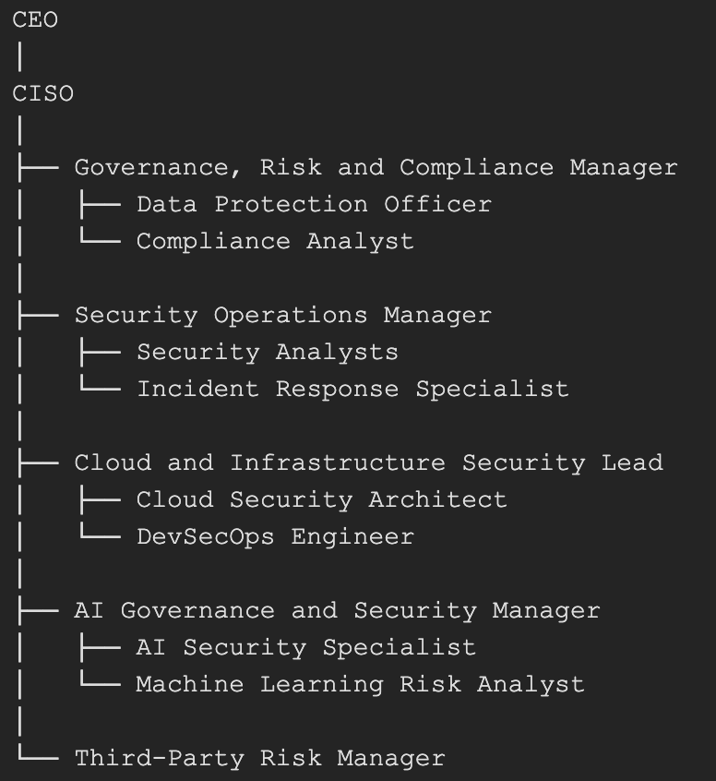

Justification of Roles

Chief Information Security Officer
The CISO will be responsible for developing security strategy, communicating cyber risks to the Board, overseeing compliance programmes, managing security investments, and ensuring regulatory obligations are met. As regulatory scrutiny increases under DORA and GDPR, board-level accountability for cyber security becomes increasingly important.

Governance, Risk and Compliance Manager
This role will establish policies, manage audits, coordinate risk assessments, and maintain compliance documentation. Effective governance is necessary to demonstrate accountability and provide consistent oversight of security activities.

Data Protection Officer
The Data Protection Officer will ensure that personal data processing activities comply with GDPR requirements. Responsibilities include conducting Data Protection Impact Assessments, managing data subject requests, monitoring privacy controls, and liaising with regulatory authorities.

Cloud Security Architect
The research undertaken in Task 1 identified cloud environments as a critical area of risk. The Cloud Security Architect will design secure infrastructure, implement Zero Trust controls, oversee Cloud Security Posture Management (CSPM), and ensure cloud services are configured securely.

DevSecOps Engineer
The DevSecOps Engineer will integrate security into software development practices. Automated code scanning, vulnerability testing, secrets management, and secure deployment controls will be embedded directly into development pipelines.

AI Governance and Security Manager
Task 1 demonstrated that AI introduces risks not adequately addressed by conventional security teams. This role will oversee AI governance activities, model risk assessments, bias testing, explainability requirements, and compliance with emerging AI regulations.

AI Security Specialist
The AI Security Specialist will focus specifically on threats such as data poisoning, prompt injection, model inversion attacks, and adversarial machine learning. This role supports the implementation of AI governance controls outlined within the NIST AI Risk Management Framework.

Third-Party Risk Manager
The increasing dependence on cloud providers, software vendors, and data suppliers creates significant supply chain risks. This role ensures suppliers are appropriately assessed, monitored, and reviewed.

Alignment with Task 1 Research
The organisational structure has been designed to support implementation of the NIST AI Risk Management Framework discussed in Task 1. The governance function is delivered through the CISO, GRC Manager, and Data Protection Officer. The mapping of risks is supported by the AI Security Specialist and Third-Party Risk Manager. Security measurement activities are undertaken by the Security Operations Team and DevSecOps Engineer through monitoring, testing, and assurance processes. Finally, management of security incidents and risk treatment activities is delivered through the Incident Response Team and Cloud Security Architect. This structure ensures security governance extends beyond traditional cyber security and incorporates AI governance, regulatory compliance, and operational resilience.

Work-Stream 2: Policy Framework Development
Policies provide the foundation for a strong security culture by establishing clear expectations and responsibilities across the organisation. The following policies are therefore proposed as priority initiatives during the establishment of the Information Security Unit.

Acceptable Use Policy for AI and Cloud Services
The increasing adoption of artificial intelligence tools and cloud-based services provides substantial productivity benefits but introduces significant security and compliance risks. Employees may inadvertently expose sensitive information by using public AI platforms without appropriate controls. Consequently, Aegis FinTech should implement an Acceptable Use Policy governing the use of AI technologies, cloud platforms, and software-as-a-service applications.
Under this policy, employees will be prohibited from entering customer financial information, confidential business data, proprietary source code, or any regulated information into publicly accessible AI services. All AI tools must be formally approved and registered before being used within the organisation. AI-generated outputs should be reviewed and validated by appropriately qualified personnel before being relied upon for business decisions. Furthermore, any AI deployment must undergo both security and ethical review processes to ensure compliance with regulatory and governance requirements. Where personal information is processed, GDPR controls must be applied, and all AI activities should be logged and monitored to support audit and oversight requirements.
The need for this policy is directly supported by Task 1, which identified prompt injection, model extraction, and data leakage as major threats affecting enterprise AI deployments.

Hybrid Work and Remote Access Security Policy
Hybrid and remote working arrangements have fundamentally changed traditional security assumptions. Access to business systems can no longer be trusted simply because it originates from within a corporate office environment. Therefore, a dedicated Hybrid Work and Remote Access Security Policy should be introduced to secure remote users and endpoints.
This policy requires all remote access connections to utilise multi-factor authentication and Zero Trust Network Access (ZTNA) controls. Employees will only be permitted to access corporate resources using company-managed devices that are subject to continuous security monitoring. Endpoint devices must operate with full disk encryption and Endpoint Detection and Response (EDR) capabilities. Access from unsecured wireless networks will be restricted, and remote user activity will be monitored for suspicious behaviour.
Task 1 demonstrated that the traditional network perimeter has effectively disappeared due to cloud computing and hybrid working models. The recommendations contained within this policy therefore align directly with Zero Trust principles by requiring continuous verification of both users and devices.

Third-Party and Cloud Vendor Risk Management Policy
Aegis FinTech relies on multiple third-party providers, including cloud vendors, software suppliers, AI service providers, and external data processors. Whilst these relationships support business operations, they also introduce significant security and operational risks.
This policy requires all vendors to undergo security assessments prior to onboarding. Suppliers must provide evidence of compliance with applicable regulations, including GDPR and DORA, and must agree to contractual security obligations. Regular annual reviews should be conducted to assess the ongoing effectiveness of supplier controls. In addition, suppliers will be required to notify Aegis FinTech of significant security incidents within twenty-four hours and provide access to independent security assurance reports where appropriate.
This policy directly addresses the supply chain vulnerabilities and model tampering risks identified within Task 1 and supports compliance with DORA's third-party risk management requirements.

Work-Stream 3: Regulatory Compliance Strategy
Compliance should not be viewed solely as a regulatory obligation but rather as a strategic business enabler. Strong compliance practices enhance customer trust, improve investor confidence, and demonstrate organisational maturity to regulators and stakeholders.
During the first three months, the organisation should establish the foundations required for compliance. GDPR activities will include conducting data discovery exercises, identifying personal data processing activities, creating records of processing, undertaking Data Protection Impact Assessments, and formally appointing a Data Protection Officer. At the same time, DORA-related activities should focus on ICT risk assessments, compliance gap analysis, development of regulatory reporting procedures, and identification of critical third-party providers.
Between months four and six, the organisation should begin implementing required controls. Privacy by Design principles should be integrated into development processes, consent management practices reviewed, and safeguards established for international data transfers. Retention and deletion procedures should also be introduced. From a DORA perspective, an operational resilience framework should be created, suppliers assessed against resilience requirements, incident classification procedures defined, and a third-party risk register established.
The testing phase, occurring between months seven and nine, should focus on validating implemented controls. GDPR activities should include testing subject access request processes, reviewing data retention compliance, and conducting privacy audits. DORA-related testing should involve cyber resilience assessments, disaster recovery exercises, and ransomware simulations designed to evaluate organisational preparedness.
The final assurance phase will focus on demonstrating readiness for regulatory scrutiny. Internal compliance reviews should be performed, audit findings remediated, and compliance reports presented to executive leadership. DORA activities should include operational resilience assessments, third-party oversight reviews, and formal readiness evaluations.
The proposed roadmap is directly informed by Task 1, which highlighted the importance of Privacy by Design, transparency, accountability, and governance as essential principles for both regulatory compliance and AI governance.

Work-Stream 4: Technical Standards and Architecture
The recommended security framework for Aegis FinTech is the NIST Cybersecurity Framework (CSF) 2.0 integrated with the NIST AI Risk Management Framework (AI RMF). NIST CSF provides governance and operational guidance through six core functions: Govern, Identify, Protect, Detect, Respond, and Recover. The AI RMF extends these capabilities through AI-specific functions including Govern, Map, Measure, and Manage. Together, the two frameworks provide comprehensive coverage across traditional cyber security risks and emerging AI governance challenges.
The proposed technical architecture is based on Zero Trust principles. Identity will become the primary security boundary, requiring every user, system, and service account to be continuously authenticated and authorised before access is granted. Multi-factor authentication will provide additional protection against credential compromise, whilst Zero Trust Network Access will make access decisions based on identity, device posture, behaviour, and risk rather than network location.
Endpoint Detection and Response solutions will provide continuous monitoring of user devices, enabling rapid identification and containment of malicious activity. Cloud Security Posture Management solutions will continuously assess cloud environments for misconfigurations and compliance violations. A centralised Security Information and Event Management platform will collect and analyse security logs from across the organisation, whilst Security Orchestration, Automation and Response capabilities will automate threat detection and containment processes.
Given the organisation's heavy use of AI technologies, specialised AI security controls will also be incorporated into the architecture. These controls include prompt firewalls, model monitoring systems, data lineage controls, output classification technologies, behavioural analytics, and automated AI guardrails. These measures directly address the AI threats identified in Task 1, including prompt injection, model extraction, and data poisoning.
Finally, critical organisational data will be protected through immutable backup technologies that support recovery following ransomware incidents and other major disruptions.

Risk | Likelihood | Impact | Rating | Mitigation
AI Data Poisoning | Medium | High | Critical | Data lineage controls, validation procedures, AI governance reviews
Supply Chain Compromise | High | High | Critical | Vendor assessments, AI-BOM validation, continuous monitoring
Cloud Misconfiguration | High | High | Critical | CSPM deployment, DevSecOps controls, automated scanning

Work-Stream 5: Strategic Risk Assessment

The strategic risk assessment identified three priority threats based on the findings of Task 1 and the specific operating environment of Aegis FinTech.
The first major risk is AI data poisoning. This occurs when malicious actors manipulate training datasets to influence model behaviour or introduce hidden vulnerabilities. Because the organisation's services rely heavily upon machine learning, poisoned datasets could result in inaccurate financial analysis, flawed decision-making, and significant reputational damage. To reduce this risk, Aegis FinTech should implement data lineage controls, dataset validation procedures, and ongoing AI governance reviews.
The second priority risk is supply chain compromise. The organisation relies extensively upon external vendors, cloud providers, and AI service suppliers. A weakness within a third-party environment could provide attackers with indirect access to Aegis FinTech systems or disrupt critical business operations. Mitigation measures include comprehensive vendor assessments, AI Bill of Materials validation, contractual security requirements, and continuous monitoring of supplier risk.
The third major risk is cloud misconfiguration. Research consistently demonstrates that configuration errors remain one of the leading causes of cloud-related data breaches. Aegis FinTech should therefore deploy Cloud Security Posture Management tools, implement DevSecOps controls, and conduct regular security reviews to reduce the likelihood of accidental exposure.
These risks were selected because they align directly with the key threat categories identified throughout Task 1 and represent the most significant threats to the organisation's business objectives.

Work-Stream 6: Incident Response and Business Continuity
Ransomware continues to represent one of the most significant operational threats facing financial services organisations. As a result, Aegis FinTech requires a structured ransomware response playbook supported by effective business continuity planning.
The detection phase relies upon continuous monitoring undertaken by the Security Operations Centre. Analysts will monitor for indicators such as malicious encryption activity, unusual user behaviour, suspicious network communications, and signs of data exfiltration. Once verified, a formal incident response process will be initiated immediately.
During containment, security teams will isolate affected systems, disable compromised accounts, block malicious infrastructure, and suspend impacted AI services where appropriate. The objective is to prevent the spread of ransomware whilst preserving evidence for further investigation.
The investigation phase focuses on determining the scope of the incident, collecting forensic evidence, identifying the initial attack vector, and assessing potential data exposure. Findings from this stage will inform recovery activities and future remediation efforts.
Effective communication is critical throughout the lifecycle of the incident. Internal communication channels will include executive leadership, the Board of Directors, legal teams, IT personnel, and relevant business leaders. External communications may involve customers, regulators, law enforcement agencies, and cyber insurance providers depending on the scale and impact of the incident.
Recovery activities will focus on validating immutable backups, restoring critical business services, verifying that malware has been eradicated, and performing security testing before returning systems to production use. Following recovery, the organisation will conduct a lessons-learned exercise, including root cause analysis, control effectiveness reviews, remediation planning, and reporting to the Board.
This playbook directly reflects the findings of Task 1, particularly the importance of rapid containment and automated response mechanisms.

Work-Stream 7: Governance and Strategic Roadmap
Strong governance is essential to ensure that cyber security remains aligned with organisational objectives. To achieve this, Aegis FinTech should establish a Cyber Security Steering Committee chaired by senior leadership. Membership should include the Chief Executive Officer, Chief Information Security Officer, Chief Financial Officer, Chief Operating Officer, Head of Legal, Data Protection Officer, Head of Engineering, Head of AI and Data Science, and Human Resources Director. This cross-functional representation ensures that security decisions reflect both technical and business priorities.
The committee's responsibilities will include reviewing organisational cyber risks, approving policies and standards, monitoring compliance programmes, overseeing major incidents, evaluating security investments, and providing strategic oversight of AI governance activities. Through regular meetings and reporting, the committee will provide accountability and ensure that security remains a business priority.
The strategic roadmap will be delivered across four phases over a twelve-month period. During Quarter 1, efforts will focus on establishing foundational capabilities through security recruitment, AI governance implementation, deployment of multi-factor authentication, creation of an AI inventory, and introduction of core security policies. Quarter 2 will focus on operational capabilities, including SIEM deployment, GDPR assessments, implementation of vendor risk management, and establishment of a Security Operations Centre. During Quarter 3, the priority will shift towards resilience and monitoring through deployment of CSPM technologies, penetration testing, disaster recovery exercises, and ransomware simulations. Finally, Quarter 4 will focus on regulatory readiness through DORA assessments, deployment of AI security monitoring controls, internal audits, and preparation for ISO 27001 certification readiness reviews.
Success will be measured through defined key performance indicators. These include achieving full adoption of multi-factor authentication, maintaining at least 95% security log coverage, reducing critical cloud misconfigurations by 90%, assessing all critical vendors, maintaining a mean time to detect incidents below thirty minutes, achieving a mean time to respond below two hours, eliminating unauthorised AI deployments, and achieving a regulatory readiness score above 90%. These metrics will provide objective evidence of programme effectiveness and support continuous improvement.

Conclusion
The findings from Task 1 demonstrate that cyber security has evolved beyond the protection of traditional information technology infrastructure. Modern enterprises must now secure complex ecosystems consisting of cloud environments, artificial intelligence systems, third-party suppliers, remote workforces, and sensitive personal data. For Aegis FinTech, these challenges are amplified by planned European expansion and increased regulatory obligations.
This proposal recommends the establishment of a dedicated Information Security Unit built upon the principles of Zero Trust Architecture, AI governance, operational resilience, and continuous compliance. The proposed organisational structure, policy framework, compliance strategy, technical architecture, risk management approach, incident response capability, and governance model collectively provide a practical roadmap for strengthening organisational security.
By implementing these recommendations, Aegis FinTech will be better positioned to mitigate emerging cyber threats, satisfy regulatory requirements, protect customers, maintain investor confidence, and support sustainable growth within the European market. The result will be a mature and resilient security capability capable of enabling innovation whilst safeguarding the organisation's assets, reputation, and strategic objectives.

