STRATEGIC CHANGE AND ORGNISATIONS
Assignment: 1

Name of the Student: Ms. Mary Mena Dore-Okuoimose
Student’s ID: 1806652
Course Code: LCDB7005
Subject: Strategic Change and Organisations
Lecturer: Professor Amare Desta

Table of Contents
The overall strategy of Softbank and how this acquisition fall in line 3
1. History, background and merging of Softbank with ARM holdings 3
2. Background on ARM Holdings 3
3.Reasons behind merging of Softbank and ARM Holdings 4
4.The implications of acquisition on ARM Holdings by Softbank 6
5.Overall strategy of Softbank to fall in acquisition 7
6. Change implications from the viewpoints of ARM and Softbank and its advantages and disadvantages 8
7. Difference between work culture of both companies and effect of merger on the changes of organizational structure 10
8. How has ARM and Softbank fared since the acquisition? 13
9. Key performance indicators on merger change and findings on their effect 13
10. Data analysis and relevance with the essay 14
References 16
Appendix 18

The overall strategy of Softbank and how this acquisition fall in line with it?

History, background and merging of Softbank with ARM holdings
Softbank Group, one of the leading conglomerate companies around the globe was founded in the year 1981 as Softbank Corp, by Masayoshi Son. However, at the initial stages the company published magazines related to Sharp and NEC computers, named “Oh! PC” and “Oh! MZ”. Gradually the company became the largest computer related magazine publishing company by 1989 (www.softbank.jp, 2020). However, the company went through great changes and by 1996, the company created a joint venture program with Yahoo! and creating Yahoo! Japan in the process. In 1999, Softbank became a holding company and in the following year invested on a successful deal made with Alibaba, a rising Chinese company. What followed after were various acquisitions and successful mergers with a wide plethora of global companies.
At this point of time, the company is known as Softbank Group or Kabushiki Gaisha in native Japanese. The current headquarters of the company is located in the Tokoy Shiodome Building in the Minato-ku prefecture of Tokyo, Japan. Masayoshi Son is at present the owner and the CEO of the company and the vice chairperson is Ronald D. Fisher. The company deals with wide ranges of products and services like IOT, internet facilities, online payment services, A.I and robotics related products, services, and investment services. In the year 2016, the company bought the ARM Holdings Company of UK, which enabled them to expand further in the software designing services and semiconductor industry (www.softbank.jp, 2020).

Background on ARM Holdings
ARM holdings is one of the leading technology firm in the UK. ARM Holdings is originally based in Cambridge but not so well known among the global consumers though having its span through the processor of Smartphone in worldwide market (Arm.com. 2020). The microprocessors designed by ARM are widely used and recognized within the brand names of Samsung Electronics and Apple Inc. The ARM chip is mandatory part into the devices from the cheapest handset of Nokia or be the Apple Watch and i-Phone. Regarding the background of ARM, Acorn Computers was the earlier name of this brand that started the journey in 1978. Later on 1990, a spun off was done by ARM from Acorn and started joint-venture with Apple to develop the project of making chip for Apple’s personal digital guide planned in that time. Growing times and advanced merge in designs make opportunity for ARM to invest their thoughts in latest technologies. From microprocessor to light bulbs and car accessories, the imaging specialist have emerged their business in 2016 with a takeover by Japanese organisation Softbank Group. The vision of this Japanese firm was 5 years more progressive to take acquisition over the mobile processors company for growing the desired employee numbers extended to the outer countries than UK (Arm.com. 2020).

Reasons behind merging of Softbank and ARM Holdings
According to Sapkota (2019), merging and acquisition over any existing organisation keeps a huge challenge for the managerial authorities to set diversity in product range and improve the service quality and so on within the agenda to modify the business strategy. Regarding this case study of Softbank and merger with ARM holdings, various reasons have been identified behind this movement of the company. Both internal and external reasons would get discussed in this section
To gain competitive advantage: The Japanese Conglomerate industry and its leading organisation Softbank group is multinational company having its own stakes in the Softbank Corp., which is a group of multinational companies. Apparently, ARM Holdings provides design for the processors to run mobile devices within a global market. ARM chips keep huge demand in the market of technology, while Japanese stakeholders give high preferences to the business involved in technological industry. The competitive advantages of advanced technologies and its use in worldwide increased the chance to earn profit from the market in a desired amount (Farrell, 2018)
To extend the customer base: Regarding the past experience from loyal customer base and after understanding the present market trend the authority of Softbank group have decided to invest and take acquisition of ARM Holdings to merge their Conglomerate business opportunities by using the intellectual property of the purchased enterprise. ARM Holdings have a worldwide brand name for their software designs in processor chips and other IP technologies (Barkho, 2019).
To recover the financial crisis: As Kelnar (2016)opined that, when a leading organisation decides to merge with another industry who are interested to expand their business, the company which is taking over must have faced certain financial crisis and that they have thought to overcome with the supporting organisation. Researches behind this essay keeps highlight on the issue happened before the financial year 2016. The previous year’s reports have identified that ARM was facing certain loss regarding their previous investment and the outcomes of production, sales and marketing gain not expected profit in terms to compensate the earlier year’s loss. Thus, the managerial decisions tuned into give access to one of the biggest names in the Conglomerate industry to ensure their profit earnings with maintaining the fair business policies.
To explore opportunities: According to Barkho (2019), any new venture by joining of two existing organisations opens the way of huge scale opportunities to explore by following and modifying each other’s business strategies and policies. In business industry, this is considered as a friendly and prospectus practice to explore the new and updated opportunities trending in the market to make the business plans with merged companies’ profitable ideas and their applications in favour to comprehend with the market demand.
To solve brand issues: As Farrell (2018) stated that, brand issues are certain objectives that provide concern to any leading organisation in terms to deal with the market demand and finding the opportunities to improve the strategies to mitigate such problems harming the brand name. Following the case study on merging together of Softbank and ARM, opportunities have been found with inclusion to sheltering the products of ARM in the market of technology under the brand name of Softbank. This initiative is not only experimental but provides scope to identify the brand issues for both of the companies while merging and implement right strategies to mitigate those.
To solve location issues: Similarly, while discussing on the issues to deal with business locations, ARM is UK based organisation with great opportunities of their Intellectual Property in technological industry. Here, the Japanese company Softbank’s acquisition would give profitable scopes to utilise the required modifications in the organisational terms and policies (Kelnar, 2016).

The implications of acquisition on ARM Holdings by Softbank
As opined by Kelnar (2016), acquisition provides profound effect to set outlook for long-term achievement for the acquirer organisation. In context to this case study, Softbank completed acquisition on ARM Holdings in the year 2016, which was that time one of the most successful companies dealing in High Tech at Britain. Softbank set their acquisition policy from the very first day to utilise all of the beneficial aspects from ARM to accomplish their business target for upcoming years to reach the profound level in Conglomerate industry. The previous set market of High Tech. Processors and other electronics design provided aid to arrange the further business implications by Softbank.

It can transform the structure of acquiring company to achieve proposed business goals. The acquirer company, which is Softbank in this case, would definitely input their profitable business terms and policies to recover the previous loss faced by acquiring company ARM. This is practiced from years in the global business industry and regarding the issue to comprehend with economical backlogs of any acquiring organisation, this implication could make the managerial access an ease to deal with market burdens (www.softbank.jp, 2020).

Having required preparation to deal with the business risk in merged venture is a prospering implication to accomplish the success rate yet decreasing the risk factors as well. Similarly, it could be discussed like this way while considering the case of merge between Softbank and ARM Holdings. Both of the companies are merging in an individual business and the right implement of strategic combinations decrease the risk factors for both of the organisations while they have to adjust for getting success result at a lower rate as well. In a greater perspective, this is a right implication to deal with the market risk and achieve the desired success in slow but positive way (Lee, 2017).

Buying rival organisation to cut-off the competition is a most old practice in strategy followed by successful business organisation. There could be certain change advised in this implication that, following the case study it have been noticed that the Japanese Conglomerate organisation taken acquisition on a high-tech company. It could be more satisfactory and prospectus for the acquirer company to merge with other enterprises dealing in the same industry. This would definite their market competition rate comparatively lower position to access business with an ease (Kelnar, 2016).

Paying both companies’ existing employees is highly against profitability. As someone opined that, the practice of merging and acquisition promotes the tradition to cut-off employee rate from the process to enhance business improvement with increased profitability. Although, terminating the least skilled or below productivity quality ones are required, the acquiring organisation should be careful to apply the workforce management in order to deal with business assets. Whenever a reputed organisation such as Softbank is emerging their business aspect with a growing company like ARM Holdings, they nourish the desire to double the business size with use of both companies’ assets that is the valuable workforce along with monetary investment (Lee, 2017).

The Overall strategy of Softbank acquisition
According to (Kelnar, 2016), the comprehensive plan, which provides aid to identify and describe the approach for acquisition, is defined as Acquisition strategy. The acquirer organisation would follow in the Program management to manage the risks in organisational program and meet the business objectives. Here would be a discussion with list and explanations on such strategy to determine the growth and development of the organisation.
The growth/development strategy of Softbank acquisition
Low-cost strategy: To accomplish the business goals with certain prosperity, the strategy to implement at first stage is lower the cost. Dealing in global market and emerging business with respective organisation, the lower-cost implementation on the products is a tactful strategy to deal with the market competition. In this case study, as Softbank acquired on the ARM Holdings, the managerial policies and implementation should be in favour of determining the final pricing of the designs produced on basis of Intellectual property. The present market dealing in the same industry would face a tough and sure competition for implementing the low-cost strategy by Softbank authority on the designs and services of ARM Holdings (Singh et al., 2018).
Diversification strategy: As opined by Rothaermel (2016), that organisation could adopt the strategy of diversification in order to develop the business while, this type of strategy involves the aspect of widening opportunities in any business enterprise to diverse the products and service range depending on the market segment. ARM Holdings deals to create designs in technologies by using the Intellectual properties and those designs provide support to the manufacturers of electronic devices. In this context, the acquiring institution Softbank could diversify the price range according to the quality sold through the Conglomerate channels of them to ensure reach among diversified consumers.
Strategy of Market-window: The strategic window defines a particular time within which the strategy is required to do work in favour of acquisition. The market success and the objectives in between merging or acquisition play the role to ensure growth or development equally to fit in the critical factors and the competencies, which are distinctive. The main impact of this strategy is to cope up with the market favour and optimal required fulfilling the means of acquisition (Singh et al., 2018).
Geographic Expansion strategy: This strategy involves such physical activities and contribution by exploring the new geographic location to expand the business with acquisition of existing company. In this case study, the Japanese organisation Softbank is emerging their business with UK based ARM Holdings. This promotes the geographic visit and expansion of the acquirer company to a different location for the new joint venture. In this strategy, they would involve the most trustworthy and dependable field managers to examine the acquiring organisations business span, employee attitude, work culture and many more aspects. The practical references and communications give an ease to both of the companies from diverse geographical location to understand each other’s requirement on workforce capability, skill and managerial behaviour (Rothaermel, 2016).
Lastly, product supplementation keeps a huge importance to set the ideal strategy of the acquiring organisation while dealing with any type of market crisis. According to Singh et al. (2018), any successful organisation holds the practice of implementing a strategy, which is in favour to make ready supplementation of the proposed product. During any unfortunate market crisis, the acquiring organisation provides huge support to the overall business by keeping healthy supply of these supplement products.

The change implications Of the Acquisition from the viewpoints of ARM and Softbank Will have its Advantages and Disadvantages
The merger of Softbank and ARM holdings is one of largest technological acquisitions and the merger will create opportunities as well as challenges for the company because of their good track record in some of the following ways.
The merger will be good for workforce working from UK, as the merger will help in further innovation (Hegde, 2016). After acquiring ARM holdings, Softbank has announced to invest huge amount for research and development and this will help employees working in ARM to create innovation.
The management of Softbank is highly successful in taking right strategy and management in ARM can be able to copy management strategy of Softbank (Farrell, 2018). On the other hand, management of ARM holdings is not highly successful and effective strategy of Softbank will be beneficial in revitalizing it.
As opined by Hegde (2016), as Softbank is an active conglomerate, the market position of ARM holdings has developed due to merger. There is increased growth in royalty revenue of ARM.
The organisational culture of ARM will be changed due to merger with Softbank and organisation culture of Softbank is distinct from the culture type of ARM (Farrell, 2018).
The merger of ARM holdings with Softbank helps to reduce huge amount of debt owed by ARM holdings in the market and this help to gain confidence of investors in the market (Techcrunch.com, 2018).
Employee psychology can be affected due to the acquisition due to job security, fear of losing their jobs or former roles and fear of the unknown changes that will take place due to the merger.
In the opinion of Hegde (2016), Softbank after merging with ARM holdings could investment huge amount in improving the performance of ARM holdings and this may help to enhance business operation of ARM holdings.
The acquisition could further create opportunity to tap into the loT (internet of things) market, making it easy for interrelated computer devices for the company due to the merger, both companies can now share and have access easily to data.
There are also areas where these acquisition and merger will affect ARM holdings and Softbanks.
After occurrence of merger, the organisational structure of ARM holdings will be changed and hybrid structure of Softbank will be adopted (Techcrunch.com, 2018). This will create difficulties for the employees, as they are already accustomed with the flat structure.
There can be problem of communication between staffs working in ARM holdings and management of Softbank. The employees working in ARM holdings may face problems in understanding decisions and instructions given by top management and this lay lead to increasing confusion among employees.
According to Hegde (2016), the productivity of employees may reduce due to degrade morale of employees working in ARM holdings. The decisions of merger give rise to insecurity and dissatisfaction with jobs among employees Workers previously working in ARM holdings may feel that their employment would be taken away by the new management.
As mentioned by Farrell (2018), employees working in ARM holdings may face problems in adopting new organisational culture, work culture, management style and employment policy. After merger of Softbank and ARM holdings, the organisational policy would be changed by the new management and most of previous style would be replaced by new one. The employees would find it difficult to adopt new changes.
As opined by Kelnar (2016), the entire organisational structure would be changed after occurrence of merger by Softbank. This would increase internal problems related with management of ARM holdings.
There would be change in organisational policy of ARM holdings and the new managerial style of ARM holdings would create conflicts among previous management groups and new management groups (Segan, 2016).

The Difference between work culture of both companies and effect of merger on the changes of organizational structure
Work culture of Softbank
The work culture of Softbank is mainly related with promoting inclusiveness among the employees (SoftBank, 2019). Softbank aims to create work culture that helps to develop a shared ambition among the entire workers associated with the organisation. The inclusive work culture developed by Softbank tries to indulge common objectives to every employee and to enable them to work as per the set objectives. According to the point of view of Barkho (2019), employees are selected carefully the Softbank and all employees are provided good opportunities for explore their potentiality and capabilities.
Work culture of ARM holdings
On the other hand, the work culture of ARM is mainly focus on improving skills and competencies of employees (Arm.com, 2020). The ARM holdings tries to give employees a worldwide network of eminent technologist and the management of ARM consider this is as an essential factor. Only focusing on the connecting network is effective for enhancing performance of employees. Along with linking with leading technologists, it is important to provide workers other facilities for self-development (Arm.com, 2020). The work culture of ARM compared to the Softbank lacks in providing proper motivation to the employees. In the opinion of Barkho (2019), as the work, culture of Softbank is related with developing inclusiveness among employees and this is effective in creating good work culture among the employees. However, the focus of work culture in ARM is not related with individual benefits of employees rather on over all achievement of the organisation.
The Organisational structure of Softbank
The organisational structure of Softbank is mainly hybrid structure as it includes more than one organisational structure. With help of hybrid organisational structure, Softbank is able to incorporate more flexibility in dividing tasks and monitoring various departments (The Official Board, 2018). At the top of organisational structure of Softbank are the CEO and broad of director. The broad director includes many persons along with CEO and vice chair of the company. The broad of director takes various decisions regarding the entire organisation and decisions for separation of different tasks are executed by the broad of director. In the next layer, there is chairperson of subsidiaries and departments, CFO, chief operating officers and directors for various individual department and chief legal officer (The Official Board, 2018). In the third tier, there are various departments such as accounting, portfolio performance, finance and more.
The Organisational structure of ARM holdings
On the other hand, the Organisational structure of ARM is mainly based on the functional structure of the organisation. As opined by Närman et al. (2016), organisational structure based on functions mainly aims to divide various functions of the organisations. The organisational structure of ARM holdings separates various functions on different departments and all tasks are executed in the individual department (The Org, 2019). ARM holdings divides various departments such as marketing department, sales department; finance departments and these departments are placed in the second layer of the organisation structure. All these departments are headed by CEO of the company.
Comparison of organisational structure of Softbank and ARM holdings
The organisational structure of these two organisations are different as Softbank's organisations structure is matrix or hybrid form while, the ARM holdings have functional Organisational structure (Närman et al. 2016). After merger of these two companies, Softbank introduce matrix or hybrid organisational structure to ARM holdings. Though there is an overall change in the organisational structure of ARM is transferred to hybrid structure, the third layer of the organisational structure includes various departments. Thus, the effect of merger will be moderate on the organisational structure of ARM holdings.
The effect of the merger of Softbank and ARM holdings
In the opinion of Farrell (2018), the merger of Softbank and ARM holdings has helped the ARM holdings to reduce the amount of debt.
The merger gives boost to the internet of things services provided by Softbank as micro cheap production become easy.
As mentioned by Hegde (2016), the employees of ARM holdings are able to learn good techniques from the advanced techniques applied by Softbank.
As opined by Farrell (2018), the organisational structure of ARM holdings would be changed and this could create problems and disappointment among employees.
According to Hegde (2016), the work culture of ARM would be more inclusive as Softbank follows inclusive work culture. This will be beneficial for employees working in ARM holdings to explore their talents and potentialities.
How they have fared since the acquisition- ARM and Softbank

The Key performance indicators on merger change and findings on their effect
Failure is not an option for the merger of Softbank and ARM holding as failure will lead to very huge loss financially more on the part of Softbank than ARM holding, not only the financial implication to the companies but to the lives of its employees who will lose their jobs if the merger fail to work . There are varied ranges of Key Performance Indicators or KPIs, with the aid of which different effects created following the acquisition of ARM Holdings, a software designing company by the global conglomerate Softbank Group. It has to be noted that after the merger of the former organisation with the latter they are often regarded as a same corporate entity, therefore, the KPIs will be discussed in that basis (Jackson and Weaver, 2020). The first major KPI is the amount of Profit made by the conglomerate company after the merger. With the aid of the official reports of Softbank Group, it can be witnessed that the company made greater amount of profit in the years after the merger. Furthermore, this links with another KPI, which discusses about the Sales, and in the case of Softbank Group, the sales improved post merger.
These two KPIs are linked with the performance indicators such as Customer Satisfaction, Retention of old Customers and Increase of the Total Number of Customers. These three indicators are also highlighted in the official reports published by Softbank Group after the merger with ARM holdings, and there have been significant rise in each case. Furthermore, there is a KP indicator regarding the process of Providing Support to the Customers in order to solve their issues, and for this case as well, there has been an increase in the competency of the group (Softbank Group, 2020). Moreover, there is another pair of KPIs that have to be discussed along with the ones mentioned above. The first one is the Rate of Employee Turnover, which has reduced drastically after the merger of the both companies. The second one, which is linked with the one elucidated in the4 line prior, is the Satisfaction Rates of the Employees. It has been pointed by the organisational report published jointly by the management of both companies, that various benefits provided under the policies of Softbank Group has ensured greater satisfaction levels among the employees.

Data analysis of the Changes brought by the Merger
The collected and synthesised data aids to evaluate the condition of Softbank Group following the merger with the ARM Holdings in 2016 (www.softbank.jp, 2020). When considered carefully post the acquisition of the UK based software designing company ARM Holdings, by the global conglomerate Softbank Group of Japan, it can be witnessed that their joint sales and income grew to a great deal.
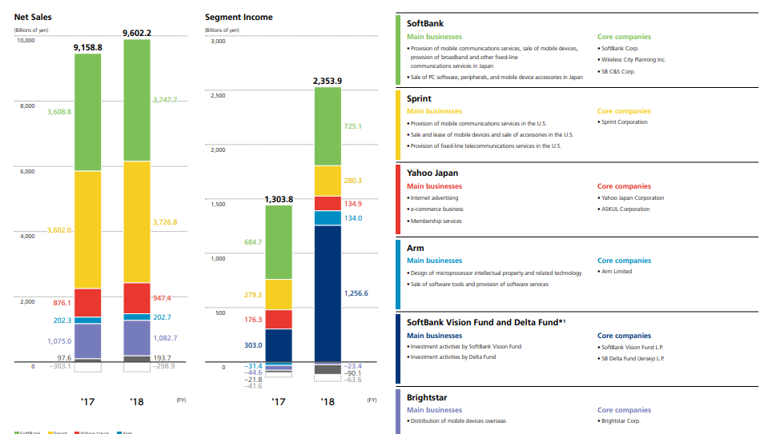
Figure 1: Net Sales and Segment Income of Softbank post acquisition of ARM Holdings
(Source: Softbank Group, 2020)
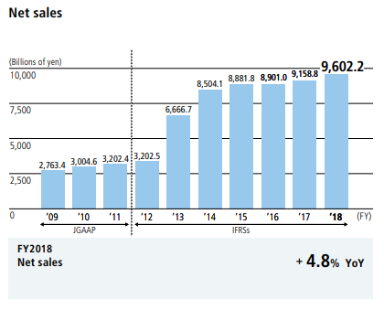
Figure 2: 10 years of Net Sales of Softbank
(Source: Softbank Group, 2020)
In 2017, the Group was able to collect an increased net sale of 202.3 billion yen and in the year following it went up to 202.7 billion yen with the help of the operations of ARM Holdings, thus highlighting their joint growth. In addition to that, the overall net sales of the group skyrocketed to a staggering 9602.2 billion yens on a global scale by the end of 2018, suggesting the boost it got from the global operations by the company ARM Holdings (Softbank Group, 2020). This clearly points to the fact that, the merger created a beneficial condition for both organisations.

References
Arm.com. 2020. Arm.Com. [online] Available at: <https://www.arm.com/company/careers/culture> [Accessed 31 March 2020].
Barkho, G., 2019. Softbank Vision Fund’S Exposed Toxic Work Culture Reflects Its Frenzied Investments. [online] Observer. Available at: <https://observer.com/2019/12/softbank-vision-fund-toxic-work-culture-frenzied-investments/> [Accessed 31 March 2020].
Farrell, S., 2018. ARM Holdings To Be Sold To Japan's Softbank For £24Bn. [online] the Guardian. Available at: <https://www.theguardian.com/business/2016/jul/18/arm-holdings-to-be-sold-to-japans-softbank-for-234bn-reports-say> [Accessed 31 March 2020].
Hegde, Z., 2016. Three Iot Lessons From The Softbank Acquisition Of ARM - Iot Now - How To Run An Iot Enabled Business. [online] IoT Now - How to run an IoT enabled business. Available at: <https://www.iot-now.com/2016/07/29/50466-three-iot-lessons-from-the-softbank-acquisition-of-arm/> [Accessed 31 March 2020].
Jackson, T. and Weaver, J., 2020. 18 Key Performance Indicator (KPI) Examples Defined. [online] ClearPoint Strategy. Available at: <https://www.clearpointstrategy.com/18-key-performance-indicators/> [Accessed 29 March 2020].
Kelnar, D., 2016. Quick Take: Implications Of ARM’S Acquisition By Softbank. [online] Medium. Available at: <https://medium.com/mmc-writes/quick-take-implications-of-arms-acquisition-by-softbank-bbe44b8ecaa6> [Accessed 31 March 2020].
Lee, J., 2017. Three Essays about Market Competition Effects on Firm Behavior, Performance and Risk (Doctoral dissertation, Northeastern University).
Närman, P., Johnson, P. and Gingnell, L., 2016. Using enterprise architecture to analyse how organisational structure impact motivation and learning. Enterprise Information Systems, 10(5), pp.523-562.
Rothaermel, F.T., 2016. Strategic management: concepts (Vol. 2). McGraw-Hill Education.
Sapkota, R., 2019. Issues and Analysis of leadership, strategy, behaviour, and accounting of mergers and acquisitions: A Case Study Of a Merger Of two Mega-Corporations. International Journal of Organisational Innovation (Online), 12(2), pp.180-191.
Segan, S., 2016. Softbank Buying ARM Is A Bad Idea For Everyone. [online] PCMag India. Available at: <https://in.pcmag.com/chipsets-processors/105387/softbank-buying-arm-is-a-bad-idea-for-everyone> [Accessed 31 March 2020].
Singh, V., Vaibhav, S. and Sharma, S.K., 2018. Using structural equation modelling to assess the sustainable competitive advantages provided by the low-cost carrier model. Journal of Indian Business Research.
Softbank Group, 2020. [online] Group.softbank. Available at: <https://group.softbank/system/files/pdf/ir/financials/annual_reports/pdf_01_en.pdf> [Accessed 29 March 2020].
SoftBank. 2019. Softbank. [online] Available at: <https://www.softbank.jp/en/corp/hr/personnel/> [Accessed 31 March 2020].
Techcrunch.com. 2018. Techcrunch.Com. [online] Available at: <https://techcrunch.com/2016/09/05/softbank-has-completed-its-24b-cash-acquisition-of-arm-holdings/> [Accessed 31 March 2020].
The Official Board. 2018. The Official Board. [online] Available at: <https://www.theofficialboard.com/org-chart/softbank-group-corp> [Accessed 31 March 2020].
THE ORG. 2019. The Org. [online] Available at: <https://theorg.com/org/arm> [Accessed 31 March 2020].
theofficilaboard.com, 2020. Org Chart Softbank Group Corp. [online] The Official Board. Available at: <https://www.theofficialboard.com/org-chart/softbank-group-corp> [Accessed 31 March 2020].
www.softbank.jp, 2020. About Us | Softbank. [online] SoftBank. Available at: <https://www.softbank.jp/en/corp/> [Accessed 29 March 2020].

Appendix

Figure 1: Net Sales and Segment Income of Softbank post acquisition of ARM Holdings
(Source: Softbank Group, 2020)

Figure 2: 10 years of Net Sales of Softbank
(Source: Softbank Group, 2020)
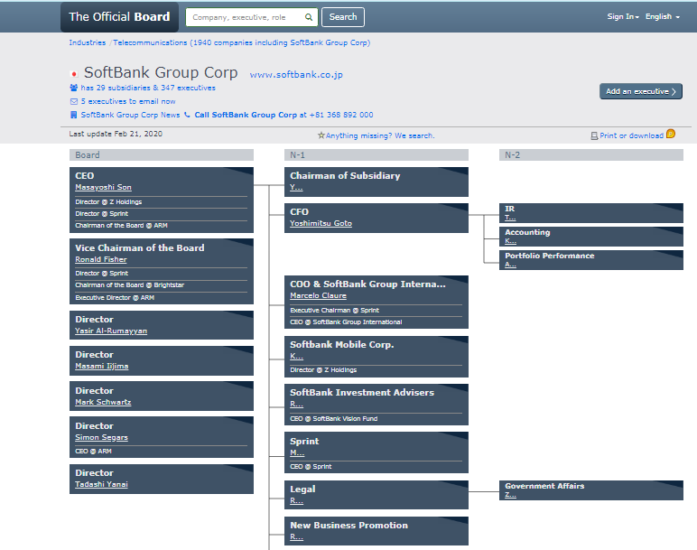
Figure 3: Organisational Structure of Softbank
(Source: theofficialboard.com, 2020)

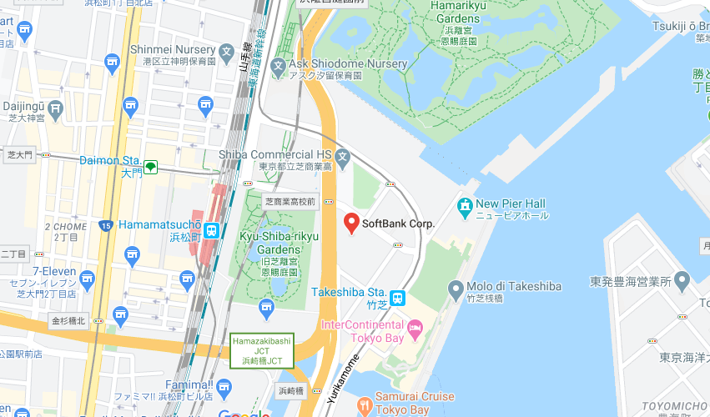
Figure 4: Location of Softbank Group Head Office
(Source: Softbank Group, 2020)

