Name: Kiril Baldev

Number: 2024776
Tutor’s Name: Lloyd Beharry
EFFECTIVE TEAMWORK AND COMMUNICATION ASSESSMENT 1

Introduction
Extensive research has been done to understand the communication process and different models of communication developed to explain the communication process. Understanding these models can help in improving the communication process in an effective manner. This report will focus of these models representing the Linear, Circular and Transactional Models.

Models of Communication

Shannon and Weaver Linear Models
These models are based on the idea that communication moves in one single direction and happens in a linear manner. The Shannon and Weaver Model, developed by an engineer and a scientist in 1945 is a model that shows that communication talks place when a person (Sender) sends a Message through a Channel to another person (Receiver). Shannon and Weaver noted that the communication could be affected by Noise, such as physical noise in a telephone line or noise around sender or receiver. (REF) In the case study ‘Maria and Pedro, Pedro misunderstood Maria because of the noise on the building site where he was working and thought she meant kitchen and not chicken.

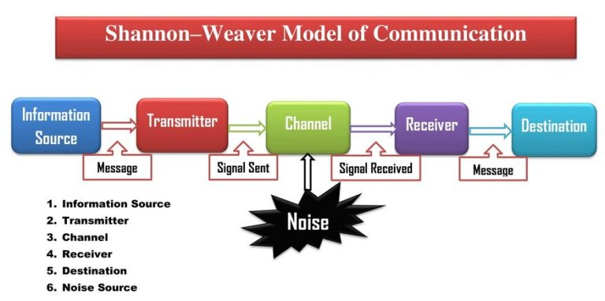
https://newsmoor.com/shannon-and-weaver-model-of-communication-explanation-examples/

Schramm’s Model
Wilbur Schramm’s model (1954) was based on Shannon and Weaver model but was not linear but circular. Schramm said that communication was not complete unless the receiver contacted the sender to confirm the message. This feedback would complete the communication. In the case study ‘Maria and Pedro’ Pedro should have contacted Maria to make sure that she meant kitchen. Another example is if my boss phones to say there is a meeting tomorrow and noise affects the message, so I didn’t hear what time, I should phone him and ask what time. According to Schramm, only in this way can communication be completed.

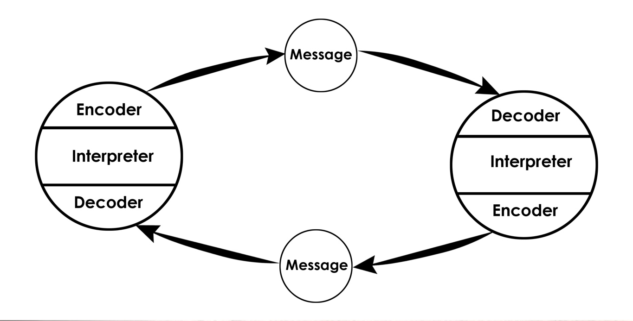

https://www.communicationtheory.org/osgood-schramm-model-of-communication/
Berlo’s SMCR Model (1964)
The communication model presented by Berlo, explains the communication process in four components which are source, message, channel and receiver. This model considers the emotional aspects related to the communication process. The source represents the person that is sending the message and it can have an impact on the overall communication.
Berlo said that many things can affect communication such as different communication skills between sender and receiver, different language, culture and education.
In the case study ‘The Professor and the Village People’ the professor tried to get the Village people to help him because his house was on fire, but because he was using big words, they could not understand him, and his house burnt down. It is like speaking a different language.
Communication Skills
Communication requires the use of different skills in order to happen in an effective manner. The understanding of these communication skills can help an individual in improving their communication with others (Chan, 2021). Some of the key skills required for effective communication are Verbal, Non- Verbal and Listening skills.
Verbal Skills
These are skills that use words in speaking and writing. First, the language you choose should be appropriate to the person you are speaking to. For example, in the case study the professor and the Village People.
Second, it must be clear. The clear communication involves careful articulation of the message and the proper selection of the words so that the receiver of message may understand it more clearly (Muyeen, 2017).
Third, the volume of a person voice during communication is also critical. If the volume is too high the other person may perceive this as shouting and get offended. While the low volume may create a problem for another person in understanding the message properly.
Last, friendliness is a necessary skill for having better communication at workplace. A person who is seemed unfriendly cannot communicate with others effectively as others will try to avoid that person and hinder the communication process (Muyeen, 2017).
Non-verbal Skills
Body language is also important, and this include eye-contact, expressions of the face and signals from the body.
Listening
The active listening is one of the most important skills required in order to communicate effective with others. The actively listening involves giving attention to others in order to the empathy is the skills to understand the other people truly by putting them in other person shoes. The empathy helps in developing perspective of other individual which helps in developing better communication.
The selection of right mode of communication is another very important skills. Face to face communication, email messages, text messages and voice mail etc. are some of the modes of communication that are available. The key is to adopt the right method of communication can make the other person understand their message effectively.
The selection of right mode of communication is another very important skills. Face to face communication, email messages, text messages and voice mail etc. are some of the modes of communication that are available. The key is to adopt the right method of communication.
The miscommunication at workplace is a common thing and that is why ensuring that proper communication takes place is a must for any business organisation. The miscommunication can cause very troubles both for an individual and an organisation. The choice of right communication method is also very important for communication at workplace. The incident happened at the workplace of one of my friends. An individual was having discussion with his boss and during the conversation the boss asked the employee to investigate the query of a particular customer as they are very important to the company. The employee perceived that the supervisor wants to make him informed about the case and deal with the customer in future. The employee decided to work on that customer query first thing in the morning. Next day, the boss asked the employee about the resolution of the customer query upon which the employee replied that he will investigate the case today. The boss became unhappy and said that he should not put urgent cases on hold, and this is very careless on behalf of the employee. The employee also was unhappy as he thought the behaviour of the supervisor is not good and employees should not be treated like that.

Advantages and Disadvantages of Communication Technology

Advantages
1 - New methods of communication
ICTs have opened a wide range of new methods of communication that allow you to connect with others for less money and greater distances than before. Text messaging, instant messaging, and preference technologies allow users to interact with people around the world for a nominal price, a concept that can be mixed before a computer video.
2 - New industries
In addition to promoting existing industries such as manufacturing and shipping, the strong adoption of ICT has created its own industries. Programmers, systems analysts and web designers owe their work to ICT, as well as people involved in secondary industries such as technology training and employment.
3 - Increasing participation in organizational processes
At the work level, each employee will have a specific task to complete, and all this can be monitored remotely by the manager. Therefore, all parties will be active, as their work is simplified through easy communication. Employees who are shy to seek advice and help will use tools such as emails or instant text messaging services to seek help from their co-workers in the
organization, they can also use the same means of communication to participate in creating creative design solutions and challenges.
4 - Reduces stereotypical classifications
According to the city dictionary, "stereotyping" is a term used to define all people with a certain faith in the category, mostly negative, which can give only selected by some of the one-time demographics. With the technology of information and communication of all this decreases because there is no face-to-face communication. Stereotypical employees often lead to poor performance and protection of lack of self-esteem.
5- Give a voice
Personal communication is difficult for some people, so the use of information and communication technologies will help them communicate effectively in both social and work environments.
Disadvantages
1 - Loss of some jobs
Increased efficiency and automation caused by ICT can lead to job losses, especially in manual functions and in the manufacturing sector.
2 - Loss of body language
Communication by voice memos or instant messages does not consider body language. Non-verbal cues are a vital part of the way people communicate, as it is estimated that 55% of the content of a message related to feelings and attitudes is presented only with facial expressions. As such, there is a greater chance that your message will be misunderstood if you are not engaged in a face-to-face dialogue with the person you are talking to.
3- Security issues
ICTs provide various ways for fraudsters to gain access to individuals' personal data, which can lead to the loss of money and the reputation of you or your business. Technologies like online banking mean that with the right security information, a third party can impersonate you and access your finances remotely. This is in stark contrast to the pre-ICT era, when fraudsters would have to convince another person (such as a banker or telephone operator) of their identity to have access to money.
4 - Difficult training of employees
If an organization introduces a new communication technology system, it will have to pay an additional training fee to the organization's employees so that they can use this technology effectively. Some employees learn first from others, which can lead to job losses.
5 - Costs
It can be very expensive to install a new communication technology system, both for a house and for a very large organization. In addition to creating a database, you need to buy technological devices and invest in the effective training of these people.
Suggestions to improve
The above incident is a clear example of poor communication at workplace. Many times, the error in communication leads to the problem and no single party is responsible for the issues which have occurred. In the above case scenario, the supervisor is suggested to improve the word selection in communication. The clarity in communication is essential and helps in getting the message understood in a better manner (Coffelt, Grauman and Smith, 2019). He should clearly inform others about the tasks that are to be informed and the expectation which the supervisor has from the subordinate. The subordinate should also be using the feedback in the communication to improve the communication. The feedback response can help in improving the understanding of the communication (Banwart, 2020). If the subordinate has communicated his understanding about the task, the misunderstanding may have been avoided. Another suggestion is that the supervisor may adopt another channel for formal communication. Having certain pre-defined mode of communication helps in understanding the nature of message to the recipient (Pollak, 2020). By mutually agreeing to send the urgent tasks on a selected model e.g., email may help both the sender and receiver in understanding the nature of the communication.

Conclusion

The communication is a very important aspect of human life and especially the effective communication is the necessity of the modern-day workplace environment. There are different communicating models which attempt to explain the communication process. The linear model explains the communication as a one-way process. The interactive model discusses the exchange that happens between the sender and receiver during the communication. While the transaction models discuss the communication as a continuous interaction between the senders and receivers form different aspects. There are also different communication skills which can help an individual in better communication such as active listening, empathy, friendliness, feedback and selection of right communication method. There can arise many challenges in the workplace due to poor communicating and adopting the right communication techniques can help in improving the communication.

Referencing List
Ban wart, M., 2020. Communication Studies: Effective Communication Leads to Effective Leadership. New Directions for Student Leadership, 2020(165), pp.87-97.
Chan, C., 2021. Helping university students discover their workplace communication needs: An eclectic and interdisciplinary approach to facilitating on-the-job learning of workplace communication. English for Specific Purposes, 64, pp.55-71.
Coffelt, T., Grauman, D. and Smith, F., 2019. Employers’ Perspectives on Workplace Communication Skills: The Meaning of Communication Skills. Business and Professional Communication Quarterly, 82(4), pp.418-439.
Harvey, N., 2017. Effective communication. 5th ed. Dublin: Gill & Macmillan.
Hartley, P., 2019. Business Communication. 2nd ed. London: Taylor and Francis.
Ramadanty, S. and Martinus, H., 2016. Organizational Communication: Communication and Motivation in The Workplace. Humaniora, 7(1), p.77.
Pollak, K., 2020. Teaching effective communication by modeling effective communication: Experiences of a communication coach for clinicians. Patient Education and Counseling, 103(2), pp.423-427.
Muyeen, S., 2017. Communication. Stevenage, Herfordshire, UNKNOWN: The Institution of Engineering and Technology.

