Counselling Theory & Approaches (ECPS5013)

Component TWO: Produce a qualitative research report based on the provided transcript – 2000 words.
Carry out a thematic analysis of the provided interview transcript which explores the following research question: How do counsellors understand and experience professional boundaries in their counselling practice?

AI acknowledgement:
I confirm that I have not used any AI tools in the research and creation of this
assignment. I confirm that I have not presented any AI-generated materials as my own
work. I confirm I have copies of my drafts, notes, and other resources I used, which I
may be asked to provide in evidence.

Abstract:
This study explores how a counsellor understands and experiences professional boundaries in their counselling practice. A semi-structured interview with a humanistic-integrative counsellor took place. Chris, the counsellor, was analysed using thematic analysis following Braun and Clarke's (2021) guidelines. The analysis generated three principal themes: Boundaries surrounding ethical and legal considerations, Counsellors' understanding of boundaries and boundaries as a tool for client safety and maintaining the therapeutic relationship. Each theme contained subthemes that captured the complex and dynamic nature of boundaries within counselling practice. Findings emphasise that boundaries are not fixed rules, but rather adaptive, relational expertise that support therapeutic complexity, reduce anxiety, and promote safe and ethical conduct. The report discusses implications faced by counsellors when creating boundaries, for instance, difficulties with supervision and boundary challenges, implying that boundary work involves constant reflexivity, cultural sensitivity and an integrative understanding of both ethical and relational factors.
Introduction:
Counsellors understand and experience professional boundaries as a fundamental component of ethical and effective counselling practice. They provide structure that allows the therapeutic relationship to progress safely and consistently. Ethical practice involves adherence to decision-making models and integration with individuals' culture and background (Kress et al., 2013). Boundaries help distinguish the limits of the counsellor’s role, confidentiality, and outline expectations around contact and closeness (Webb et al., 1997). According to Amis et al. (2017), Boundaries are seen as dynamic and context-dependent, with the involvement of clear clarification and contracting with clients to establish the limits surrounding misconduct, confidentiality, consent and the therapeutic relationship between the client and counsellor. Boundaries help protect both the client and the counsellor from harm and exploitation. Professional codes of ethics support boundaries; however, their understanding and application to counselling practice can differ based on the counsellor's personal values and counselling experiences (Evans et al., 2017). Boundaries are not fixed rules: they are contextual, relational and continuously negotiated within therapeutic practice between the client and the counsellor (Hermansson, 1997). Yonatan-Leus et al. (2025) state that counsellors can face various challenges in maintaining professional boundaries during counselling practices, which can be caused by ethical, contextual and interpersonal factors. For example, the counsellor feeling overly responsible for the client's well-being, providing additional support outside the counselling practice and self-disclosure dilemmas, for instance, the client asking personal questions.
This research report aims to explore the question: How do counsellors understand and experience professional boundaries in their counselling practice? To address this question, a qualitative approach is most applicable as it allows researchers to identify, describe and interpret key themes within qualitative data, which can provide insight into participants' perspectives. Qualitative methods are specifically useful when exploring complex phenomena where recognising subjective meanings is valuable (DeJonckheere et al., 2024). Specifically, this report follows the extensively used six-phase
framework proposed by Braun and Clarke (2021). This report aims to highlight how counsellors interpret professional boundaries, how they navigate boundary challenges and how experiences influence their idea of professionalism and therapeutic relationships.
Method:
Design:
A qualitative design was used to explore the counsellors' understanding and personal experiences with boundaries within counselling practice. Thematic analysis (Braun and Clarke, 2021) was chosen as it is a flexible method and emphasises researcher interpretation. This approach acknowledges that themes are generated by engagement with data.
Participants:
One counsellor participated; they were referred to as Chris, which was a pseudonym to protect their identity. The participant is a 46-year-old white British humanistic integrative counsellor based in Wales. They primarily work in independent practice and agency work.
Data collection:
A semi-structured interview was conducted, which explored the participant’s understanding and experience of professional boundaries in counselling practice, boundary challenges and philosophical perspectives. Appendix 1 contains a copy of the anonymised transcript with a list of the questions for the interview schedule at the end.
Procedure:
The analysis followed Braun and Clarke’s six phases:
- Familiarise with data, rereading the data multiple times
- Generating initial codes, finding data relating to boundary understanding and experience
- Organising codes into initial themes and subthemes
- Review themes
- Define and name themes and subthemes
- Produce the report
Ethical considerations:
Informed consent was obtained, and confidentiality was maintained throughout. The participant was referred to by a pseudonym, so their real identity was protected. Data was securely stored following institutional ethical guidelines.
Findings:
Thematic analysis produced three main themes that capture how Chris understands and experiences professional boundaries in their counselling practice. These themes reflect boundaries as ethical frameworks, relational concepts, and therapeutic tools. Appendix 3 contains a table which shows how I refined the themes.
Theme 1: Boundaries surrounding Ethical and Legal considerations
This theme reflects the routine, ethical and legal elements of boundaries that reinforce safety and accountability in counselling practice. Chris emphasised that ethical boundaries consist of confidentiality, dual-relationship management, recordkeeping, fees, digital communication limits and contracting. These boundaries form the structure that protects both the client and counsellor.
Subtheme 1: Contracting and confidentiality limits
Chris described contracting as a collaborative but essential process which provides clients with the understanding of confidentiality and its limits, communication expectations and crisis pathways. They saw these ethical measures as part of developing trust instead of organisational barriers, explaining that “clear limits expand freedom…without them, the ground feels wobbly”
They approached contracting with transparency, ensuring the client understands entirely how confidentiality works legally and ethically, including mandatory reporting. They accentuated the importance of explaining recordkeeping and supervision. Chris explained this as “Supervision protects the clients and me”, showing that the clients know they are protected.
Subtheme 2: Polices around fees, cancellations and money
Money, fees, and cancellations were discussed by Chris with equal clarity. Chris regarded financial boundaries as part of ethical transparency instead of an awkward requirement: “money is relational, too”. They enclosed their cancellation policy as part of maintaining a reasonable, safe and sustainable therapeutic frame “My cancellation policy is 48 hours; outside that window, the fee is usually due, with direction for emergency”
Subtheme 3: Relationship and community ethic boundaries
Chris highlighted the difficulty of avoiding dual relationships, specifically while living in a small Welsh community. Chris stated that they have previously bumped into clients outside the practice before, and they addressed these situations ethically through anticipation and transparency “I’ll take your lead if we see each other out” When potential conflicts of interest arose, Chris relied on ethical reflection, and referral was used if needed. This shows a strong awareness of ethical and legal considerations regarding confidentiality and professionalism.
Subtheme 4: Digital boundaries
Chris explained how ethical boundaries are present in their method of digital communication. They sustained strict limits, keeping contact to email only, avoiding WhatsApp and social media, and social media accounts are kept private. These practices show ethical consideration to safety, privacy and professionalism.
Theme 2: counsellors' understanding of boundaries
This theme demonstrates Chris’s conceptual understanding of boundaries as relational, flexible and embedded in their humanistic-integrative thinking. Chris views boundaries as interpersonal processes influenced by therapeutic intention, congruence, and cultural understanding.
Subtheme 1: Boundaries are part of the humanistic conditions
Chris outlined boundaries as an integral component of the humanistic “conditions”, stating that they are “part of the frame that lets trust and depth develop” Chris explained that boundaries were not recognised as limits but as relational structures, allowing attunement, authenticity and psychological safety.
Subtheme 2: Boundaries are shaped by cultural context and the client's needs
Chris accentuated the importance of assessing individuals' cultural and contextual needs. They established that norms around touch, openness and emotional expression can vary across culture and an individual's past, “I try not to universalise my own norms”. Chris would alter a disciplinary model of boundaries to suit the client’s needs.
Subtheme 3: Self-disclosure as a boundary practice
Self-disclosure was also outlined as boundary practice by Chris and is intention-led and used sparingly; they would assess whether disclosure would be beneficial to the client and would explore its impact, showing their understanding of boundaries as dynamic relational tools.
Theme 3: Boundaries as a tool for client safety and maintaining therapeutic relationships.
This theme demonstrates how boundaries operate within counselling to support emotional regulation, relational repair trauma trauma-informed practice and therapeutic containment.
Subtheme 1: boundaries enabling emotional safety
Chris explained how consistency and clarity within therapeutic practice can reduce anxiety and allow clients to explore their emotions on a deeper level. They also expressed that predictability and consistency enable clients to relax and open up. They explained that when clients know what to expect, for instance, the session length, the structure of the session, availability, and confidentiality limits, their anxiety is reduced. “If clients know what to expect… it lowers anxiety”. “With a secure frame, clients take more risks to be authentic.” This highlights boundaries as conditions for emotional openness rather than barriers to it. Chris expressed the therapeutic frame as constant and reliable, offering clients a “holding environment” where emotion can occur without the worry of instability. Chris stated, “I invoice the same day every month, so it's predictable” This shows routine for the clients, so they are aware of what’s happening, resulting in anxiety being reduced.
Subtheme 2: Time boundaries as repairable relational edges
Chris used time boundaries to organise sessions and expand the therapeutic process. When clients expressed distress at session endings or endings causing attachment anxiety, Chris used these moments for exploration. Chris stayed consistent with predictable endings and signalling time, which enables clients to build tolerance to relational separations and develop new emotional patterns. They showed that the boundary “Stopped being a rejection and became part of therapy” Chris showed that they would explore the distress surrounding endings and would expand on the feeling caused by endings and what they meant “Instead of shaming or rescuing, we became curious. What did endings evoke? For the ending meant abandonment”.
Subtheme 3: Self-care as a safety boundary
Chris emphasised self-care as a professional safety boundary essential for ethical and effective counselling. They expressed that “I hold my own boundary not to respond to emails when I’m away” allows them to be fully present in counselling sessions, and allowing themselves breaks allows them to offer grounded presence. They demonstrated that self-care boundaries consist of protecting breaks, limiting availability, taking time off without responding to emails and the use of supervision for emotional responses. Christ stated that “My clients benefit from a steady counsellor more than from an always available one,” outlining self-care as an ethical obligation to the safety of clients. Chris explained that by regulating their own emotions, they can maintain a stable therapeutic environment, emphasising that the counsellor's well-being plays a part in clients' safety boundaries.

Discussion
The findings of this study highlight the complex and relational nature of professional boundaries in counselling practice. The three themes generated were boundaries surrounding ethical and legal considerations, counsellors' understanding of boundaries and boundaries as a tool for client safety and maintenance. These themes demonstrate how boundaries are used for both a structural and relational framework for counselling practice.
The first theme, boundaries surrounding ethics and legal considerations, displays the necessity of transparent procedural frameworks which protect both the client and the counsellor. The first theme coincides with literature from Amis et al. (2017), who imply that ethical and legal boundaries provide a framework for safe therapeutic practice and reduce the risk of harm or confusion within the therapeutic relationship. Specifically, Chris conceptualised these boundaries not as rigid obligations, but alternatively as commitments that produce reliability and professional honesty. In addition, Chris reflects on dual relationships in small communities, explaining the importance of contextual ethical decision-making. Chris emphasised the importance of clear boundaries and using practical approaches to balance personal and professional roles effectively, reinforcing DeCino et al.'s (2023) findings that it is significant for counsellors to recognise the fundamental difficulties in avoiding dual relationships and navigating these situations while applying ethical standards. Similarly to Chris, the literature also stated that Strategies to manage these relationships consist of clear boundaries and applying practical methods to maintain the professional relationship.
The second theme, counsellors' understanding of boundaries, focuses on Chris’s humanistic-integrative understanding of boundaries as fluid, negotiated and relational in the therapeutic practice. Chris showed their understanding of boundaries as part of the “conditions” which accentuate humanistic principles of safety and congruence. This coincides with Wilkins. (2000) idea that counsellors should balance the expression of unconditional positive regard with congruence, which involves the counsellor being authentic and transparent. Cultural sensitivity appeared as a principal to this theme, Chris discussed that norms around touch, directness and proximity can vary based on context and culture. They stated that self-awareness is significant when dealing with cultural needs and that they will reflect on their own cultural biases, as these can influence their perceptions of boundaries. This is reinforced by Evans et al. (2017) that counsellors can manage boundary difficulties in relation to culture by self-awareness and reflection, allowing an ethical practice and maintaining professional boundaries.
The third theme, boundaries as a tool for client safety and maintaining the therapeutic relationship, demonstrates how boundaries function within the counselling practice. Chris described time boundaries, session structure and emotional pacing as key principles for helping with regulation. Chris showed how boundaries become therapeutic interventions and how predictable endings allow opportunities to explore fears of abandonment, and, in addition, applying between-session message limits, which enable clients to develop self-regulation. This supports Campos-Ramos et al.'s (2016) research that time boundaries serve as a structure to counselling practice and allow focus, flexibility and ethical practice. Supervision and self-care were framed as significant boundaries, enabling counsellors to regulate and ethically ground themselves. Similarly, Chris also expressed how the use of self-care protects both themselves and the client as it prevents emotional overinvestment and burnout, allowing Chris to be fully present as a counsellor.
Overall, the findings suggest that boundaries work simultaneously as ethical standards, relational and therapeutic tools. In conclusion, Chris showed their understanding of boundaries being dynamic processes which allow trust to be developed, support to be provided and safety for the client, allowing them to maintain a professional therapeutic relationship with the client. This outlines the significance of incorporating ethical clarity with relational flexibility in counselling practices. As well as emphasising the necessity for boundary frameworks which allow reflection of diverse therapeutic contexts.
Reference list:
Amis, K. (2017). Boundaries, Power and Ethical Responsibility in Counselling and Psychotherapy (1st edition). SAGE Publications. https://doi.org/10.4135/9781473919976
Braun, V., & Clarke, V. (2001). Using Thematic Analysis in Psychology. Qualitative Research in Psychology, 3(2), 77–101. https://doi.org/10.1191/1478088706qp063oa
Campos-Ramos, M. A. (2016). Seasoned licensed clinical therapists’ perceptions of boundary setting with mental health clients. ProQuest Dissertations & Theses.
DeCino, D. A., Waalkes, P. L., & Iverson, V. (2023). Rural School Counselors’ Experiences with Dual Relationships. Journal of Child and Adolescent Counseling, 9(3), 1–15. https://doi.org/10.1080/23727810.2023.2195229
DeJonckheere, M., Vaughn, L. M., James, T. G., & Schondelmeyer, A. C. (2024). Qualitative Thematic Analysis in a Mixed Methods Study: Guidelines and Considerations for Integration. Journal of Mixed Methods Research, 18(3), 258–269. https://doi.org/10.1177/15586898241257546
Evans, R., Johnson, V. R. F., & Sommers-Flanagan, J. (2017). Counseling and psychotherapy ethics: self-awareness, competence, and boundaries [Video recording]. Microtraining Associates.
Hermansson, G. (1997). Boundaries and boundary management in counselling: The never-ending story. British Journal of Guidance & Counselling, 25(2), 133–146. https://doi.org/10.1080/03069889708253797
Hole, L. (2024). Handle with care: considerations of Braun and Clarke's approach to thematic analysis. Qualitative Research Journal, 24(4), 371-383. https://doi.org/10.1108/QRJ-08-2023-0132
Kress, V. E., Hoffman, R. M., Adamson, N., & Eriksen, K. (2013). Informed Consent, Confidentiality, and Diagnosing: Ethical Guidelines for Counselor Practice. Journal of Mental Health Counseling, 35(1), 15-28. https://www.proquest.com/scholarly-journals/informed-consent-confidentiality-diagnosing/docview/1269701497/se-2
Webb, S. B. (1997). Training for maintaining appropriate boundaries in counselling. British Journal of Guidance & Counselling, 25(2), 175–188. https://doi-org.ezproxy.uwtsd.ac.uk/10.1080/03069889708253800
Wilkins, P. (2000). Unconditional positive regard reconsidered. British Journal of Guidance & Counselling, 28(1), 23-36. https://doi.org/10.1080/030698800109592
Yonatan-Leus, R., & Shefler, G. (2025). The complexities of research ethics when therapists become research subjects: power, privacy, and professional boundaries in psychotherapy research. Psychotherapy Research, 1–8. https://doi.org/10.1080/10503307.2025.2569828

Appendices:
Appendix 1: Annotated transcript 1 – coding the data

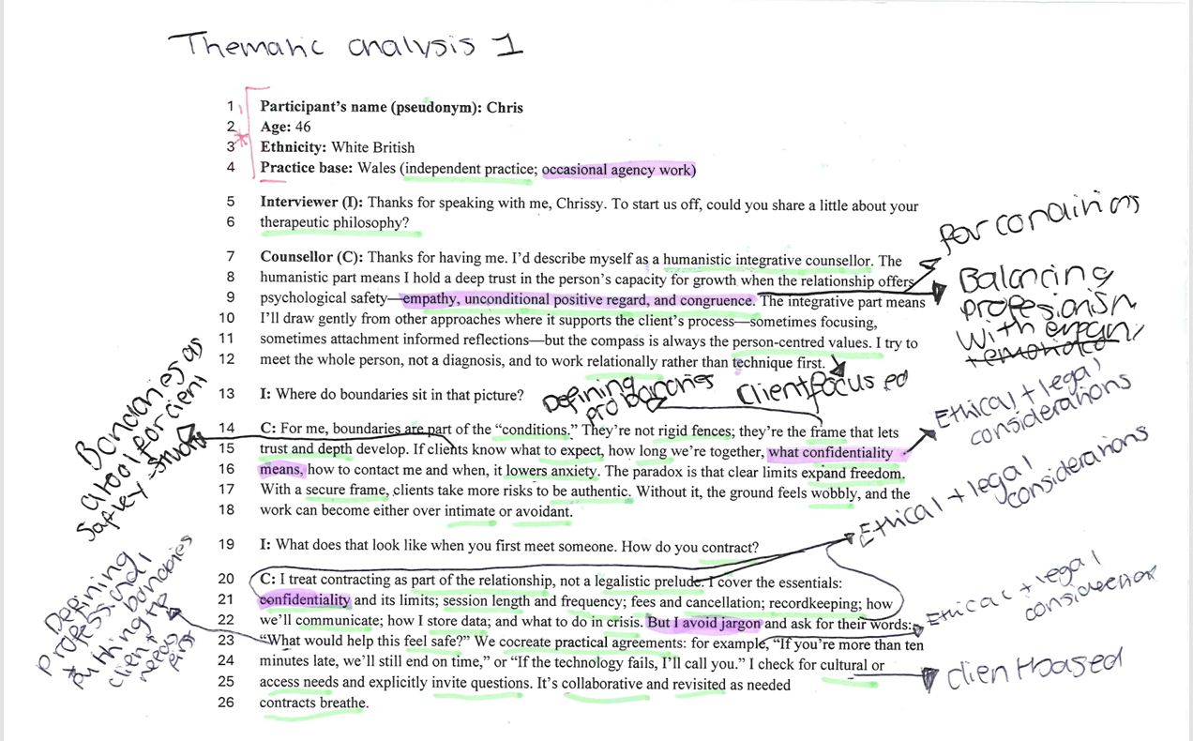

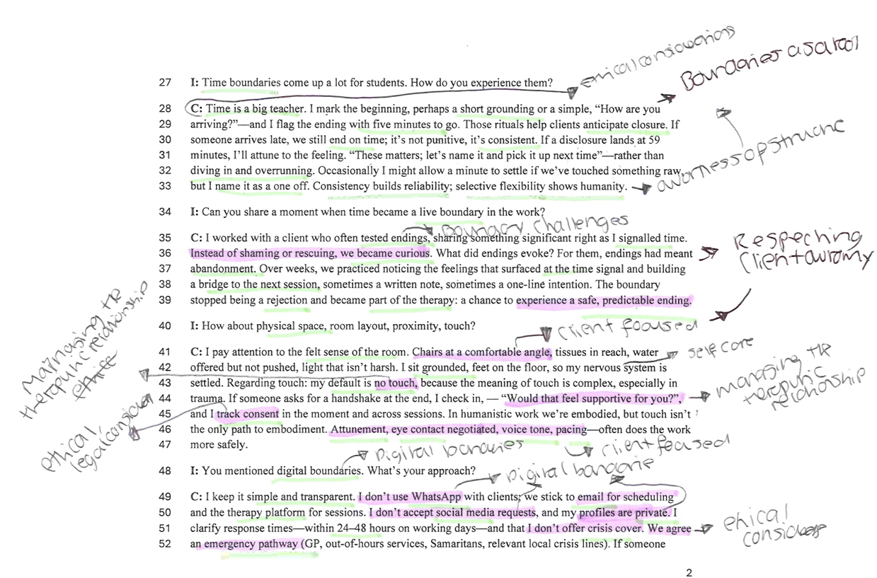

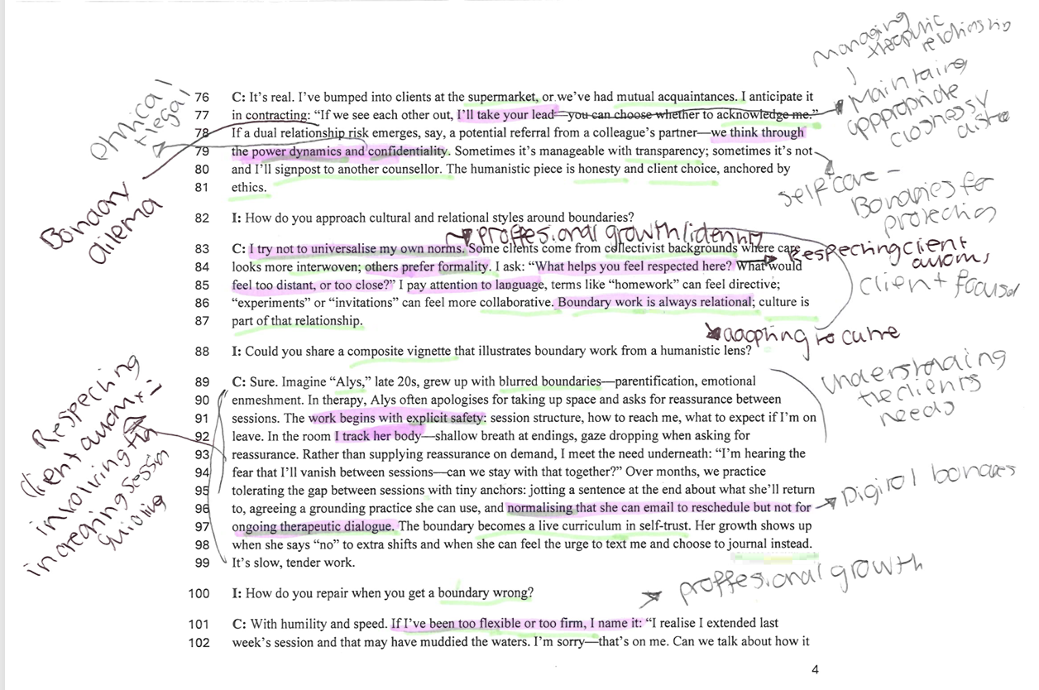
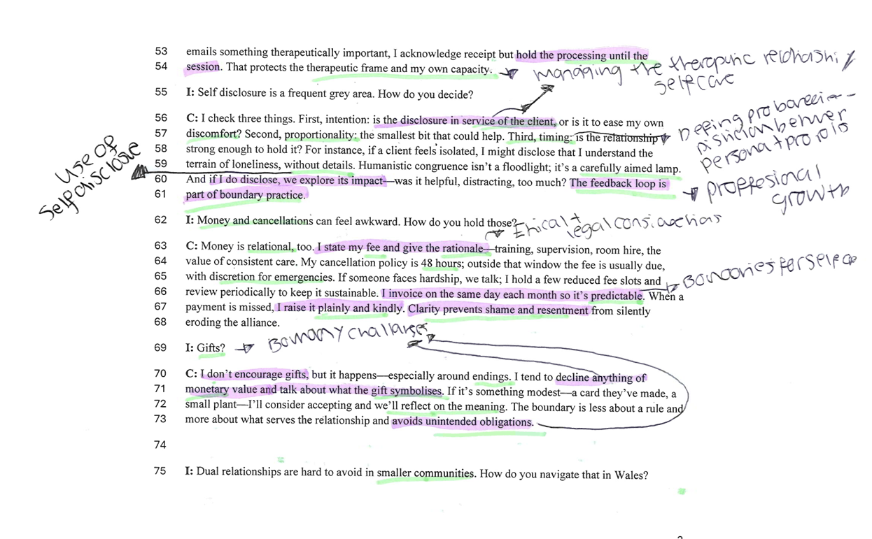
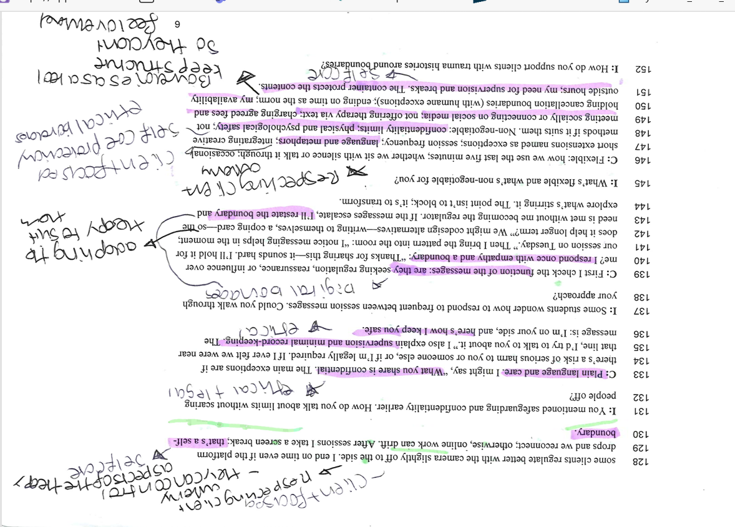
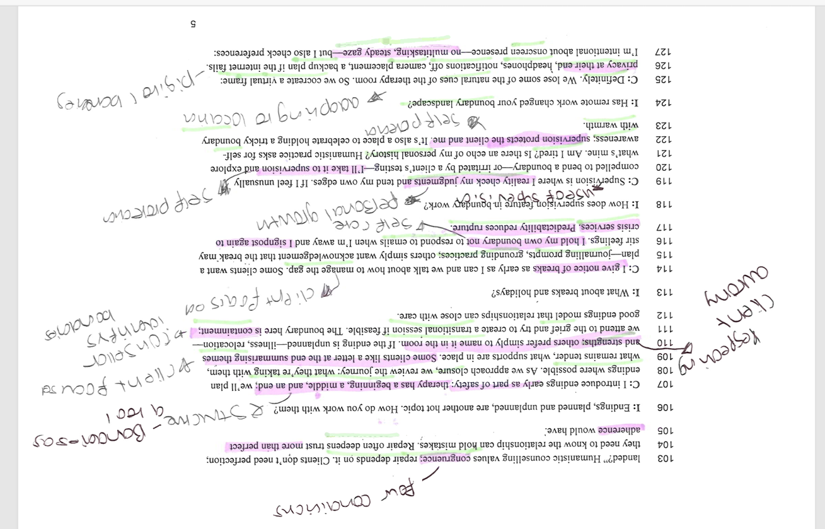
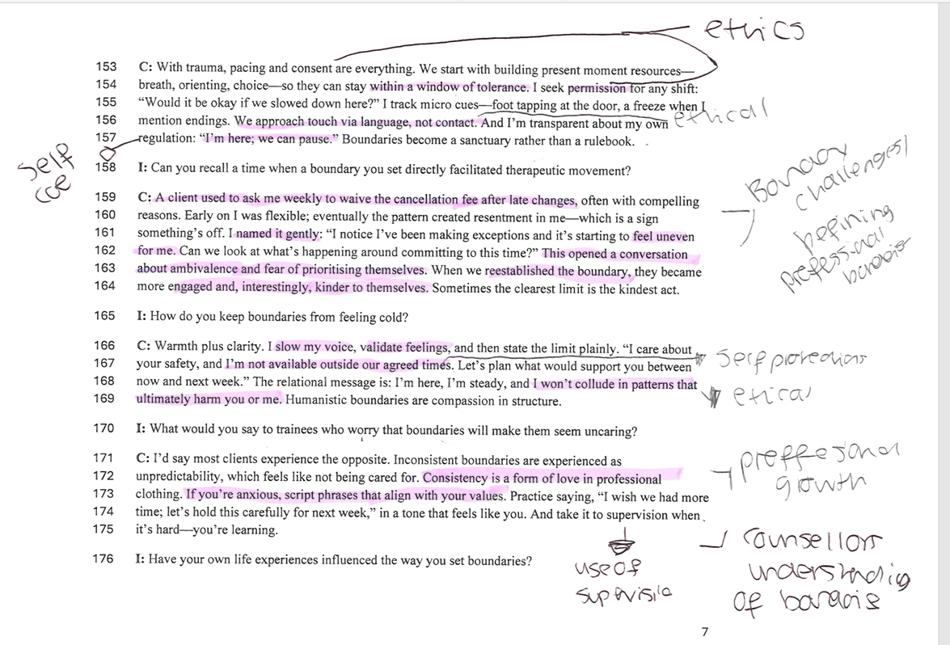
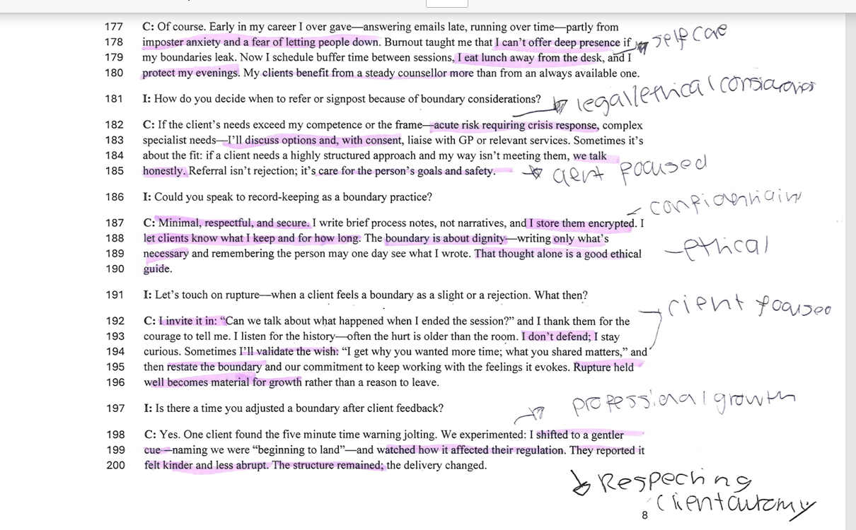
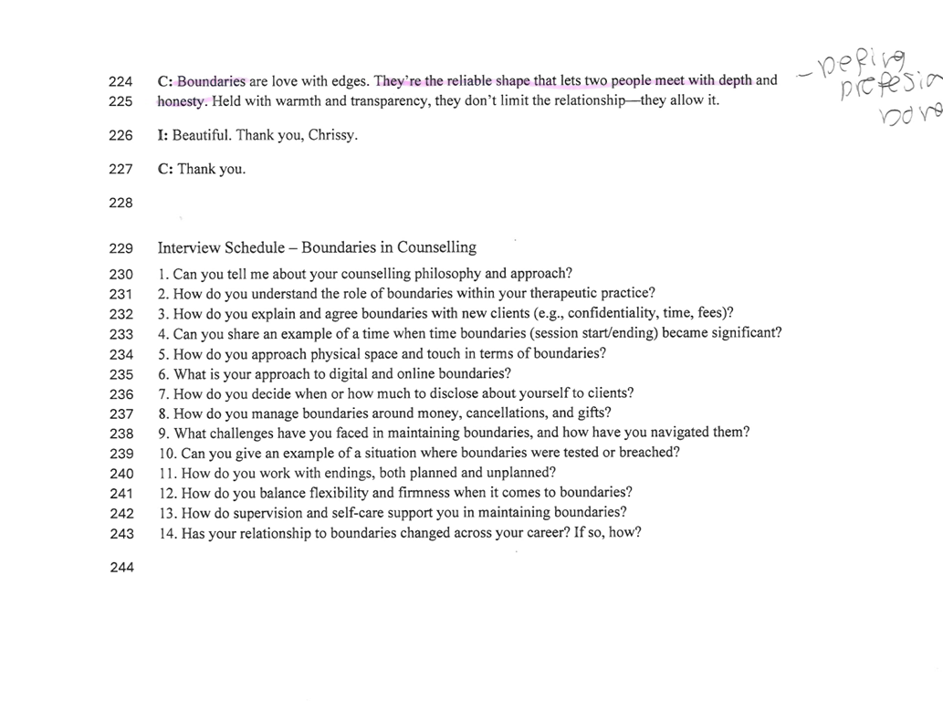
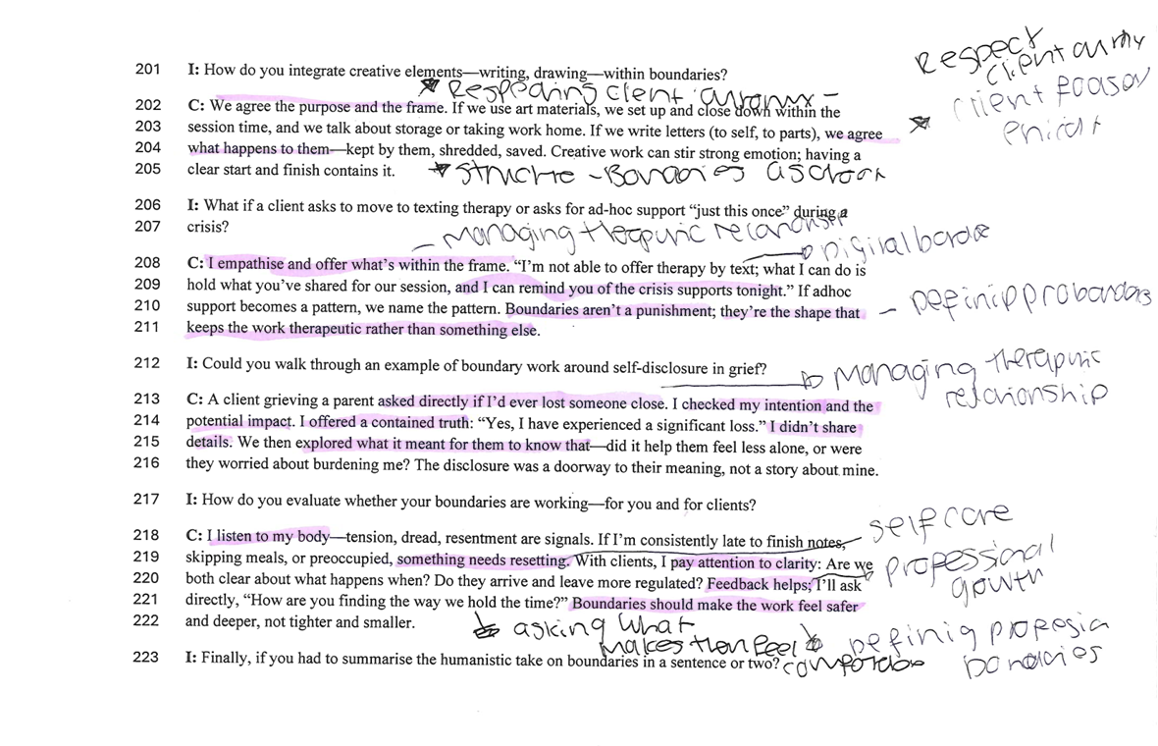

Appendix 2: Thematic analysis 2 – generating the initial themes
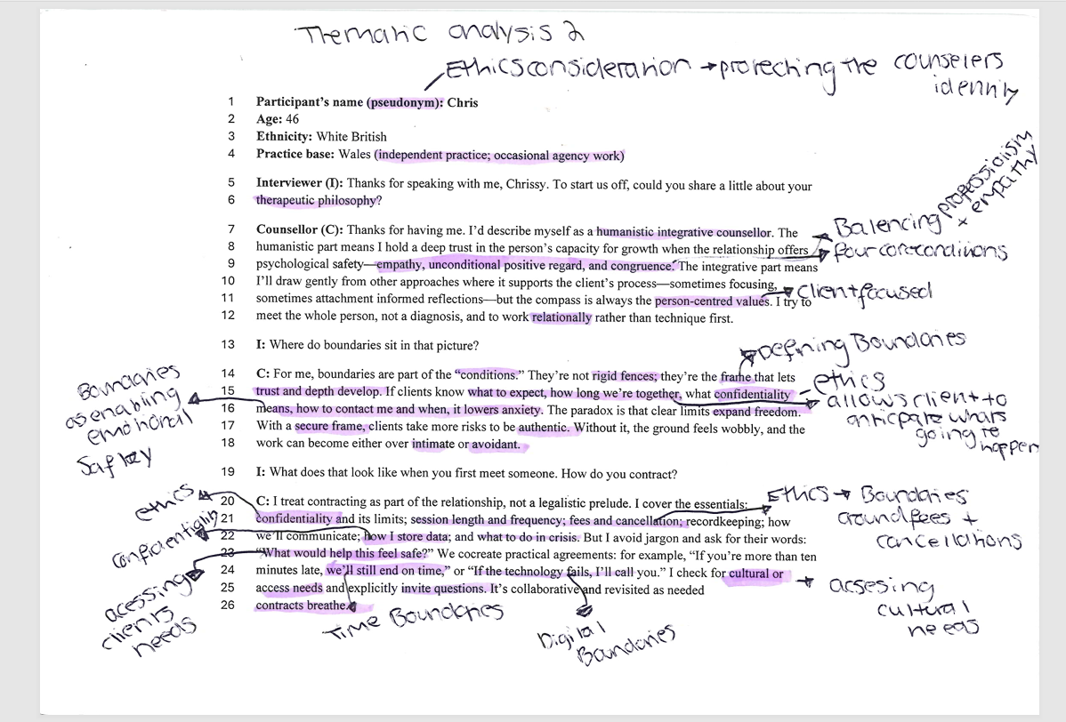

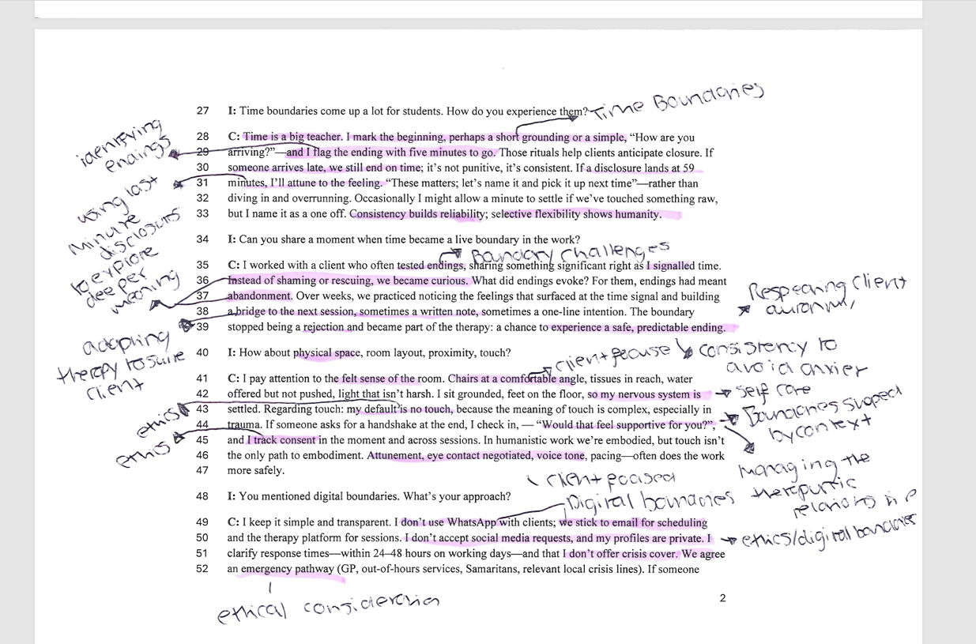
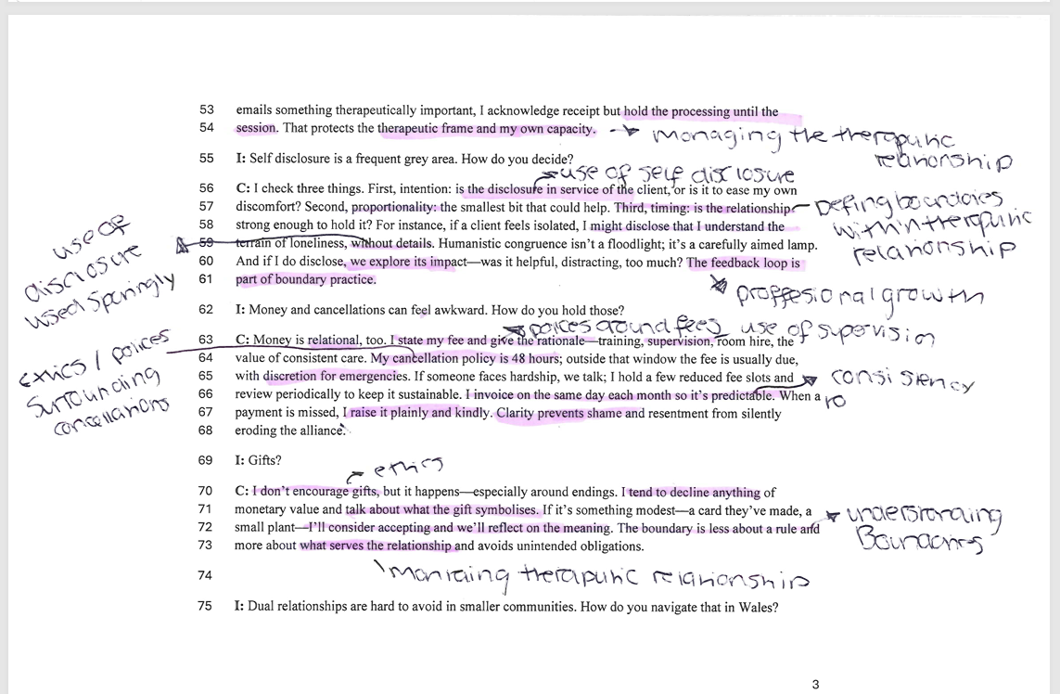

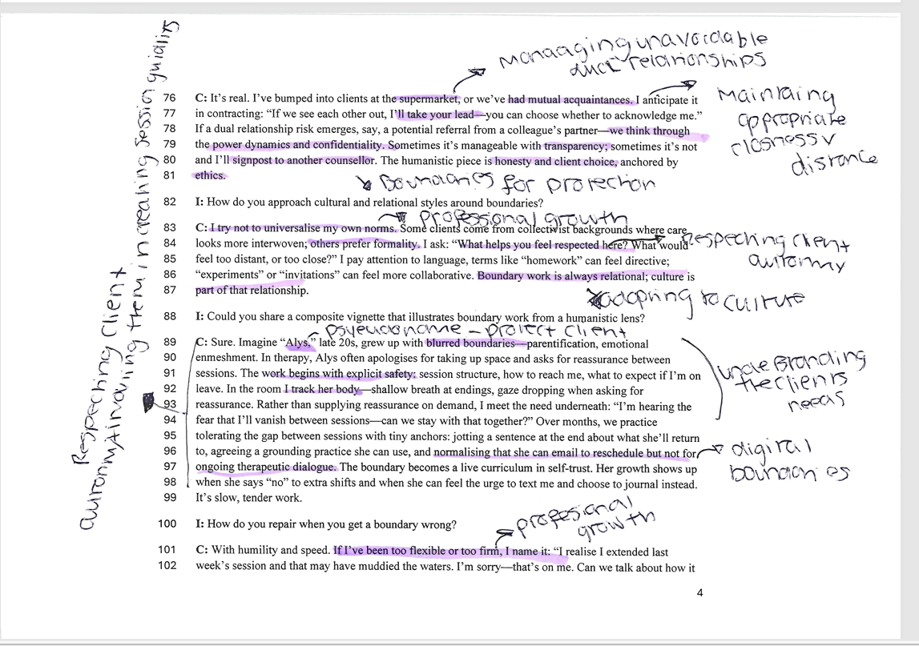

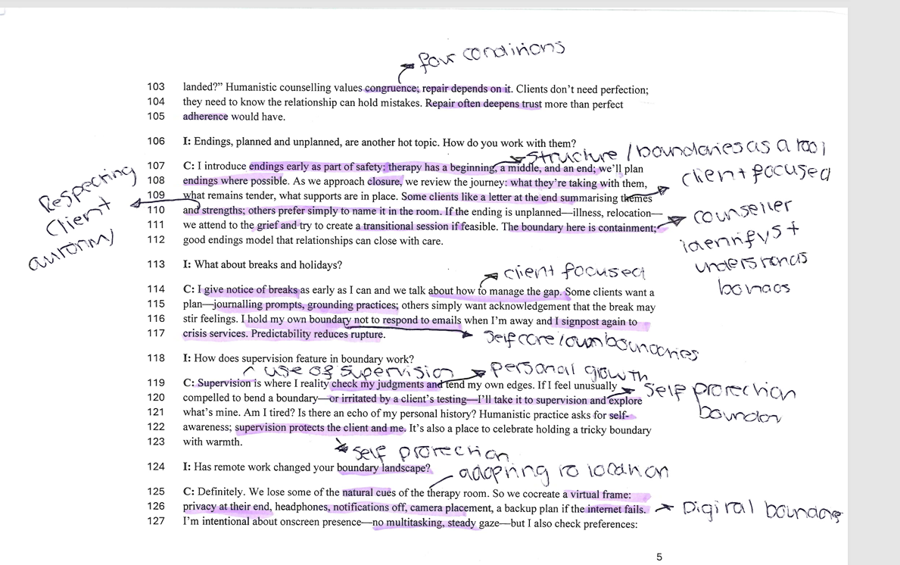

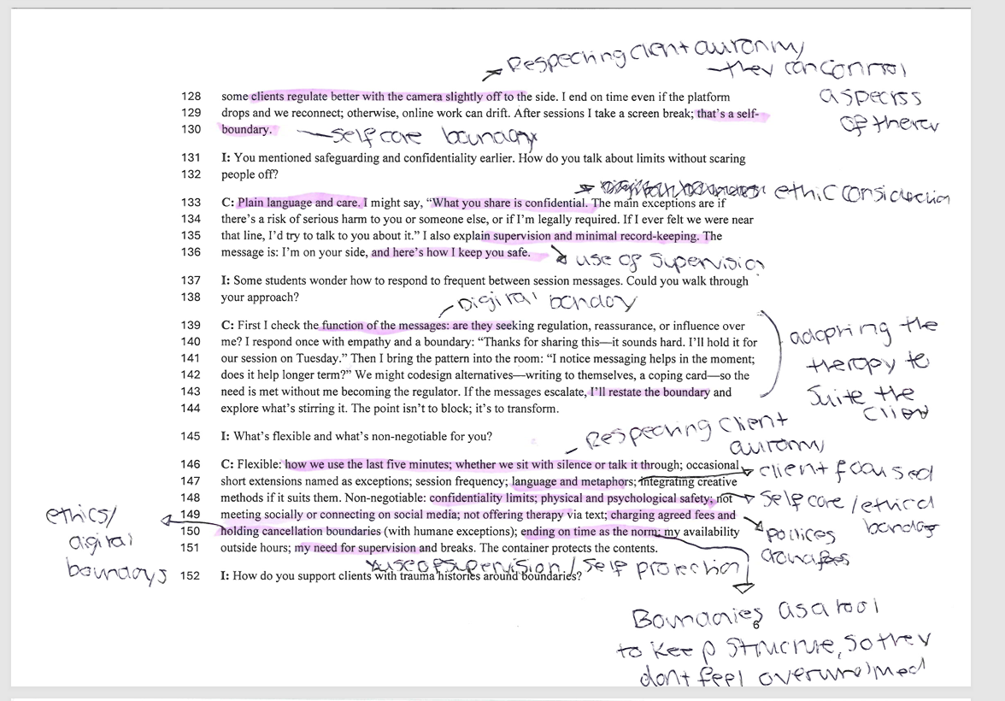

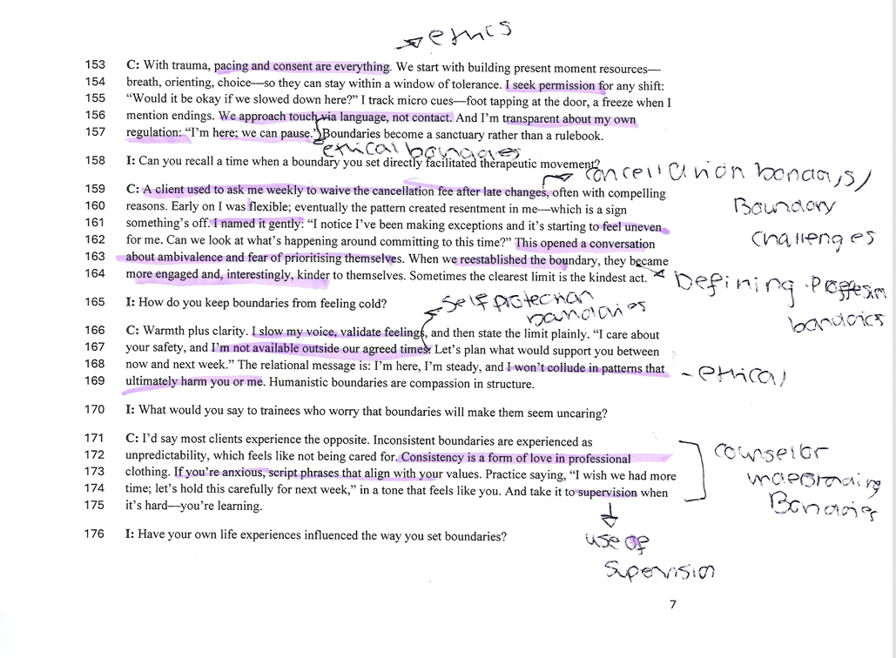

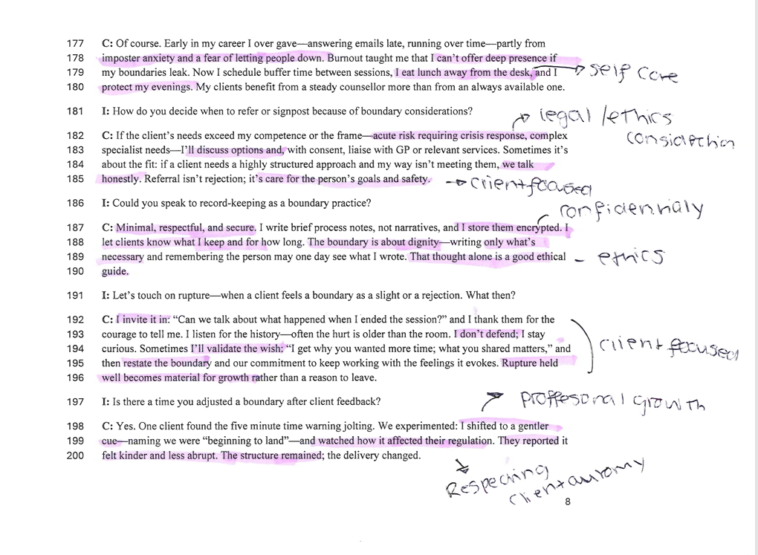

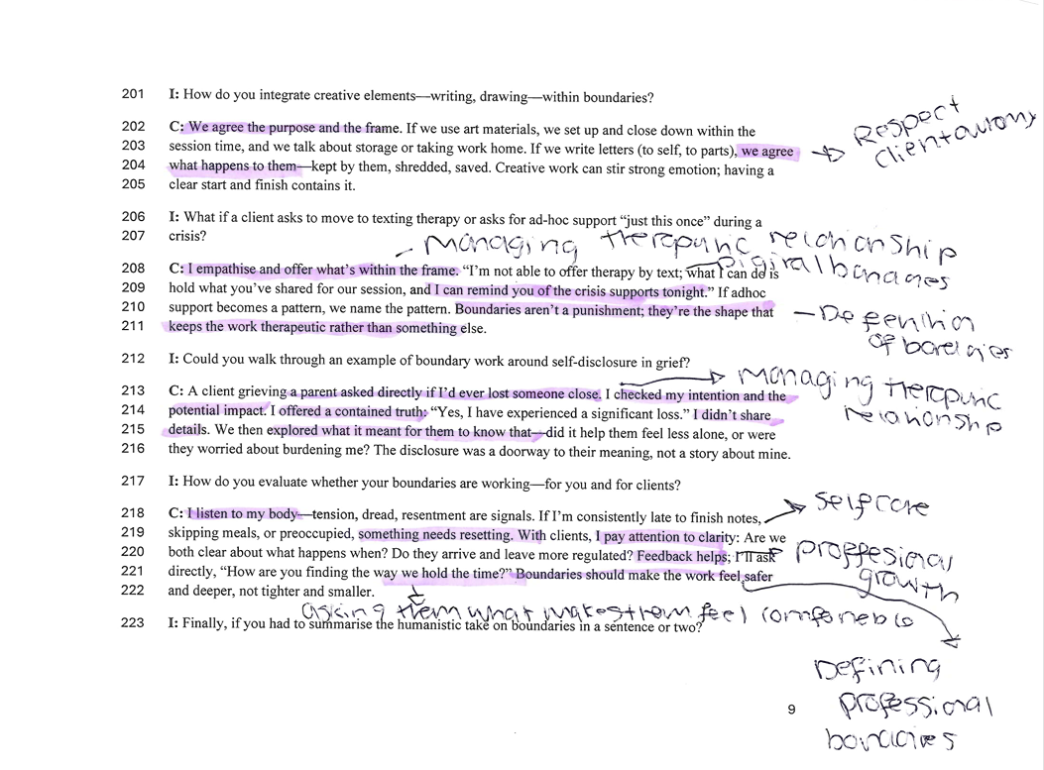

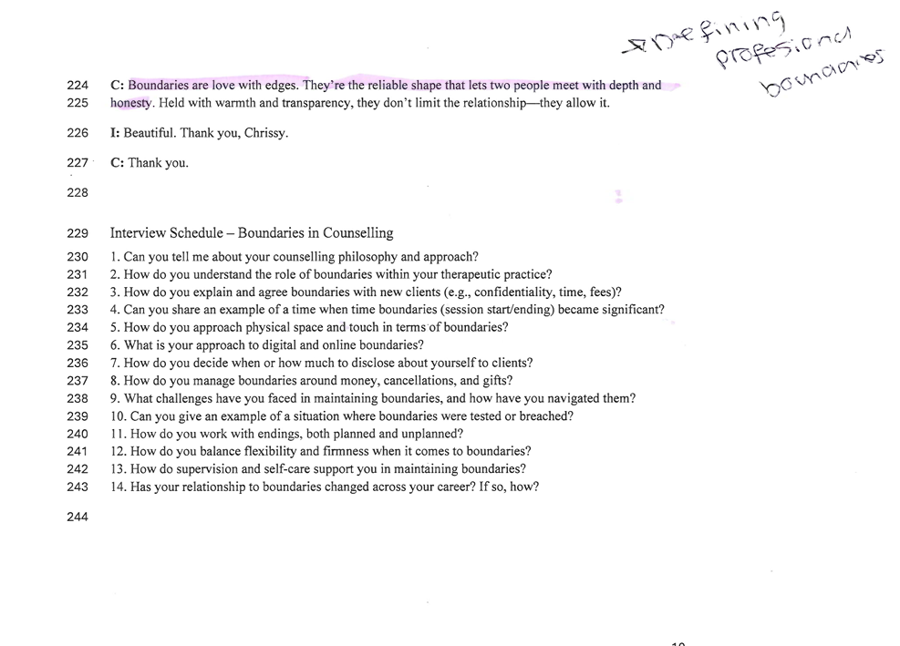

Appendix 3: Thematic analysis table
Theme | Subthemes | Line number |  | Description |  | Examples from the transcript
Boundaries surrounding ethical and legal considerations | - Contracting and confidentiality limits |  | 15 – 16  21-22  45  133  174  122 |  | Chris discusses confidentiality, consent, data storage, and the use of supervision, clearly explaining how ethical and legal considerations are communicated to the client. |  | “If the client knows what to expect, how long were we together, what  confidentiality means”  “I track consent in the moment and across sessions.”  “What you share is confidential”  “Take it to supervision when it's hard”  “Supervision protects the clients and me”
 | - Polices around fees, cancellations and money |  | 21  64 |  | Ethical handling of fees and non-negotiable cancellation boundaries that protect the professional frame. |  | “I cover the essentials – fees and cancellations”  “My cancellation period is 48 hours”
 | 3. Relationship and community ethic boundaries |  | 76-79 |  | Managing unavoidable dual relationships ethically in small communities like Wales |  | “If a dual relationship risk emerges, say, a potential referral from a colleague's partner, we think through the power dynamics and confidentiality”
 | - Digital boundaries |  | 49-50  139  149 |  | Ethical limitations around communication on social media platforms, only use email for contact, and social media accounts are private |  | “I don’t use WhatsApp”  “We stick to email for scheduling” “I don’t accept social media requests”  “My profiles are private”  “I check the function of the message”  “Not offering therapy via text”
Counsellors' understanding of boundaries | - Boundaries are part of the humanistic conditions |  | 14-15 |  | Chris views boundaries as part of the frame that allows trust and depth to develop (Empathy, unconditional positive regard, and congruence) |  | “For me, boundaries are part of the conditions.” “They’re the frame that lets trust and depth develop”
 | - Boundaries are shaped by cultural context and the client's needs |  | 24-25  43-44 |  | Chris highlights cultural differences, expectations around touch, and communication style |  | “I check for cultural or access needs”  “If someone asks for a handshake at the end, I check in” “Would that feel supportive for you?”
 | - Self-disclosure as a boundary practice |  | 56-57 |  | Self-disclosure is intention-led and used sparingly and is always explored afterwards. |  | “Is the disclosure in service of the client, or is it to ease my own discomfort?”
Boundaries as a tool for client safety and maintaining the therapeutic relationship | - boundaries enabling emotional safety |  | 29  66 |  | Consistency and clarity can reduce anxiety and allow clients to explore their emotions more deeply |  | “I flag the ending with 5 minutes to go; those rituals help anticipate closure”  “I invoice the same day every month, so it's predictable” . “If clients know what to expect… it lowers anxiety. With a secure frame, clients take more risks to be authentic.”
 | - Time boundaries as repairable relational edges |  | 28-30  35-37  107 |  | Endings, late arrivals and last-minute disclosures are used to explore abandonment fears and attachment patterns |  | “Time is a big teacher. I mark beginnings” “if someone arrives late, we still end on time”  “Instead of shaming or rescuing, we became curious. What did endings evoke? For the ending meant abandonment”  “I introduce endings early as part of safety”
 | - Self-care as a safety boundary |  | 116  120  179 |  | Chris uses self-care to protect both themselves and the client. This prevents emotional overinvestment and burnout. They also use supervision to process emotional reactions and help maintain safe and ethical boundaries. |  | “I hold my own boundary not to respond to emails when I’m away”  “Supervision protects me and the client”  “I eat my lunch away from the desk”

