Module Name: Network Operating Systems and Services Module code: ACCA5023 Student: Eric Fernandes Student ID: 2414945 Lecture: MD. Sadeque Imam Shaikh Group: BSC Applied Computing UWTSD (London Campus)
Eric Fabricio Ferro Fernandes

Assessment 2 Configure and Manage the Virtualised Enterprise Network
16/12/2025

Table of Content

Introduction 1
Task 1: Practical Implementation and Configuration 2
1. Routing 2
2. Domain Server (Swansea) 5
3. Encrypted Connection between Swansea and London 9
4. Users 9
5. Domain Membership 11
6. DHCP Server 16
7. Test and Troubleshoot 16
8. Disk Drive 17
9. IIS Server 21
10. Remote Desktop Services 21
Conclusion 22

Introduction
This report details the practical implementation and configuration of key network services and operating system functionalities within a virtualized enterprise network environment, specifically focusing on Windows Server. The objective of this assessment is to demonstrate proficiency in establishing a robust, secure, and fully functional network infrastructure, encompassing routing, domain services, user management, network protocols, file sharing, web services, and remote access. By meticulously configuring these components, this exercise aims to validate understanding of fundamental network administration principles and their application in a contemporary IT landscape.
The assessment primarily centres on the "Swansea" and "London" network segments, leveraging Windows Server Standard Desktop Version for core services. Each task described herein contributes to building an interconnected and secure network, adhering to specified requirements for naming conventions, IP addressing, and service configurations. This document will elaborate on the execution of each task, highlighting the rationale behind the chosen configurations and the expected outcomes within the simulated corporate setting.

Task 1: Practical Implementation and Configuration

1. Routing
The routing task involves establishing network connectivity and controlling traffic flow between the Swansea and London networks. This is a foundational step, ensuring that devices in different subnets can communicate effectively. The initial part focuses on installing and configuring the Routing and Remote Access Service (RRAS) on the Windows Server within the Swansea Network. RRAS is a critical Windows Server role that enables various routing capabilities, including Network Address Translation (NAT), VPN services, and standard IP routing.
Upon installation, firewall rules are modified to permit Internet Control Message Protocol (ICMP) traffic. This adjustment is crucial for network diagnostics, as ICMP is used by utilities like ping to test connectivity and troubleshoot reachability issues. Allowing ICMP ensures that administrators can verify the operational status of network devices across both Swansea and London networks, facilitating a stable and observable network environment. This setup underpins all subsequent communication between the two network segments.

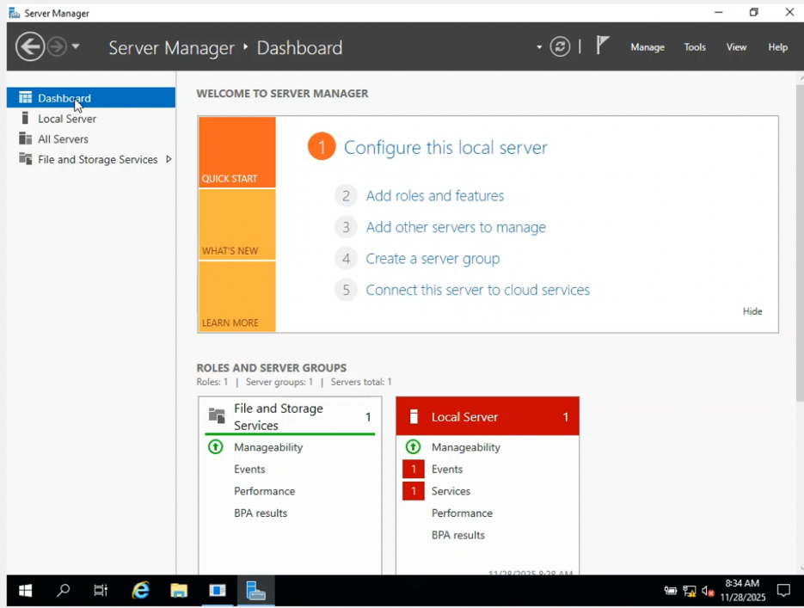
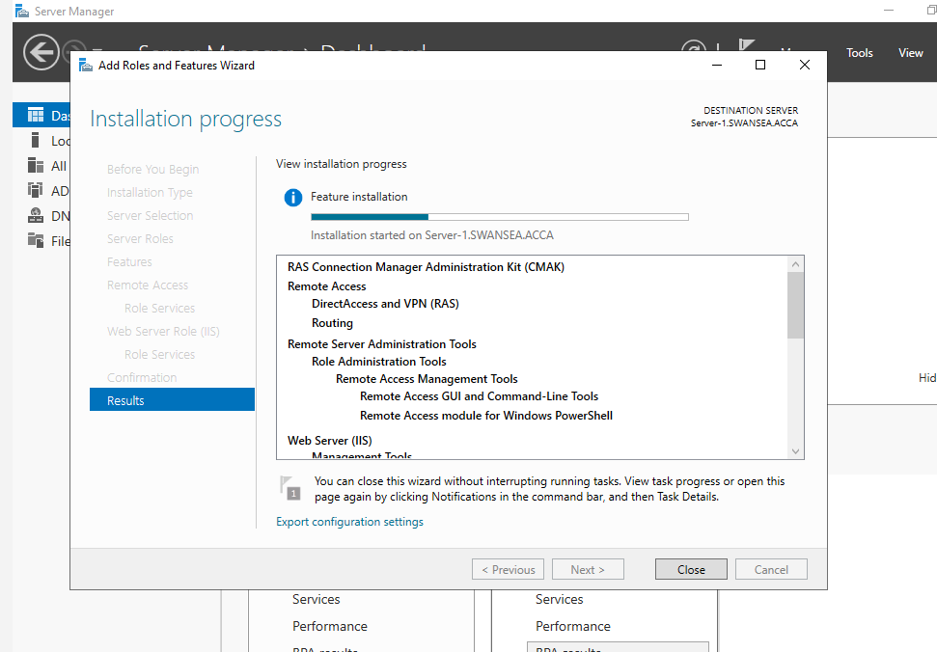
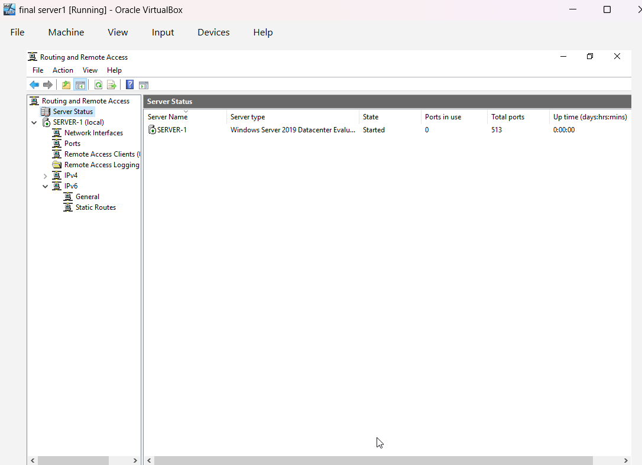
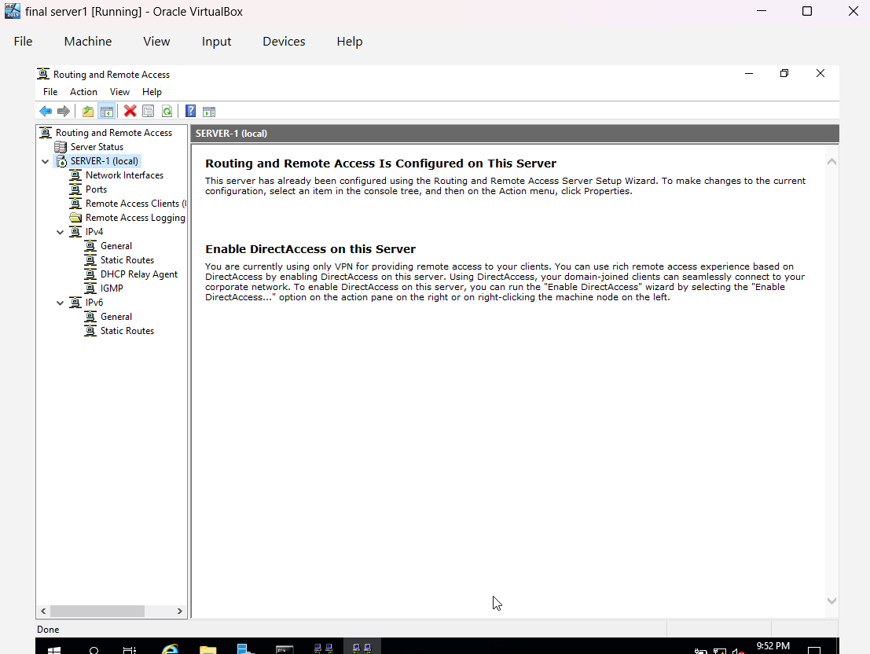

Inbound Filter
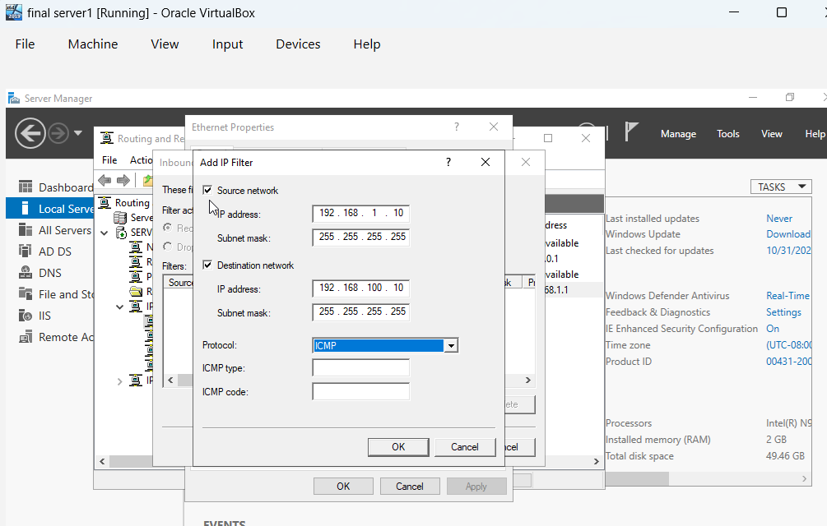

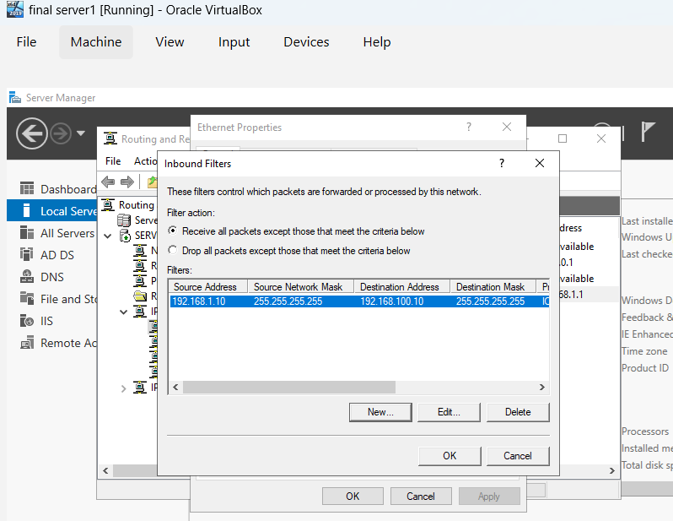

Outbound Filter
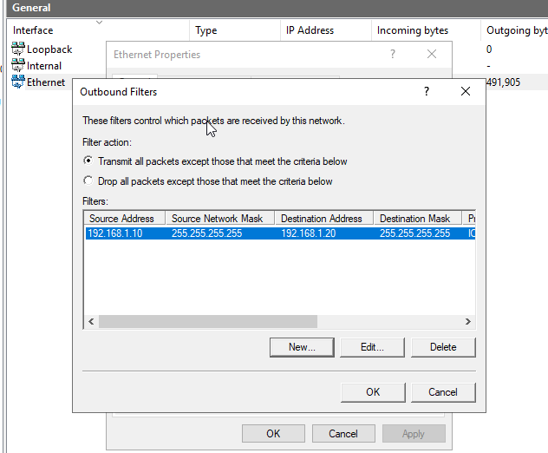

2. Domain Server (Swansea)

The configuration of the Domain Server in Swansea is central to establishing a centralized identity and access management system for the entire enterprise. This involves creating a new Active Directory forest, named yourname.acca, which forms the security boundary and provides the administrative structure for all network resources. The Active Directory Domain Services (AD DS) role on Windows Server is leveraged for this purpose, transforming a standalone server into a domain controller.
Following the forest creation, the task necessitates the configuration of DNS records essential for name resolution within the domain. Specifically, appropriate "A" records are created for all servers in both the Swansea and London networks. These records map hostnames to their respective IP addresses, enabling seamless communication by name rather than numerical IP addresses. Furthermore, a reverse lookup zone is established, including Pointer (PTR) records, which facilitate reverse DNS lookups, mapping IP addresses back to hostnames. This dual DNS configuration ensures comprehensive name resolution, which is vital for the proper functioning of Active Directory and other network services.
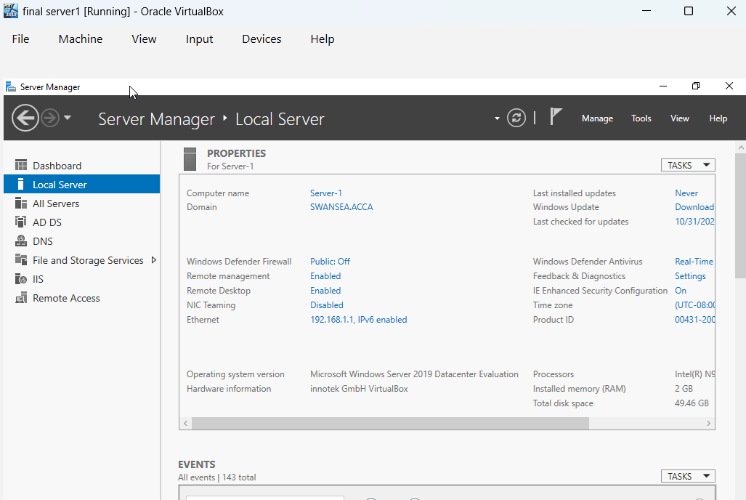
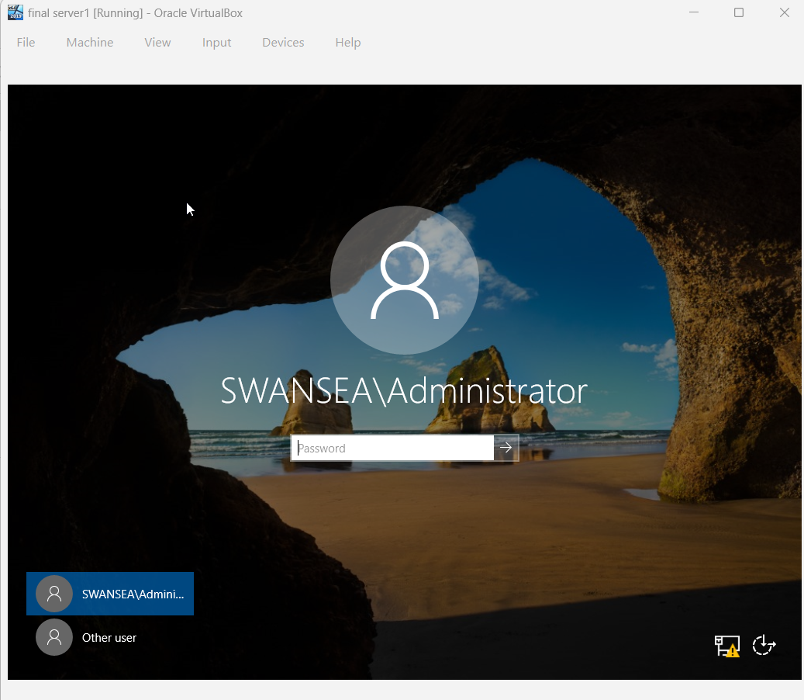

Create A Records
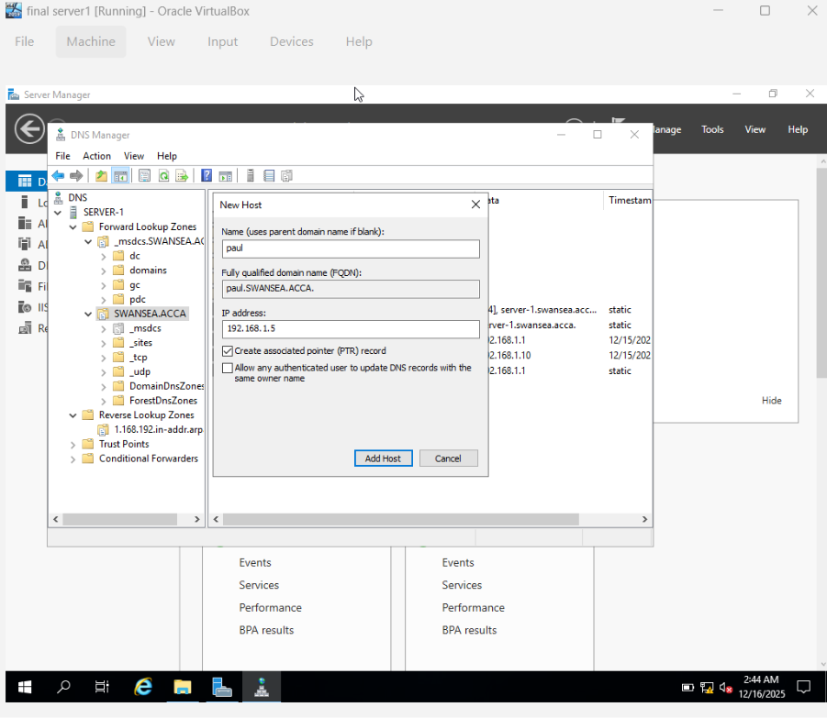
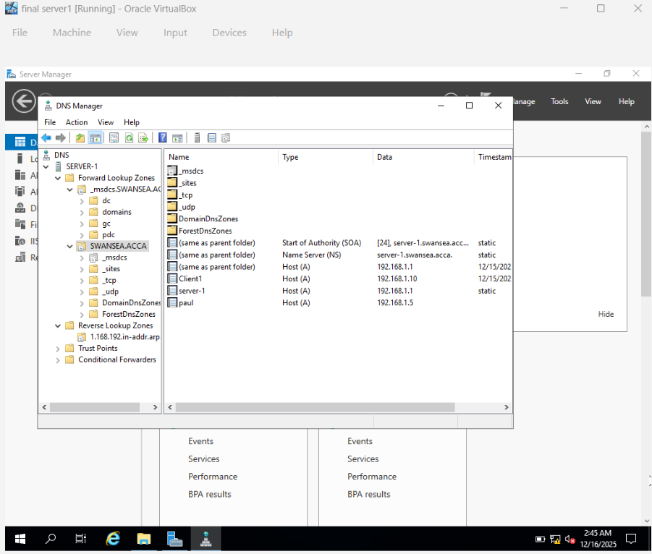
Reverse lookup zone PTR
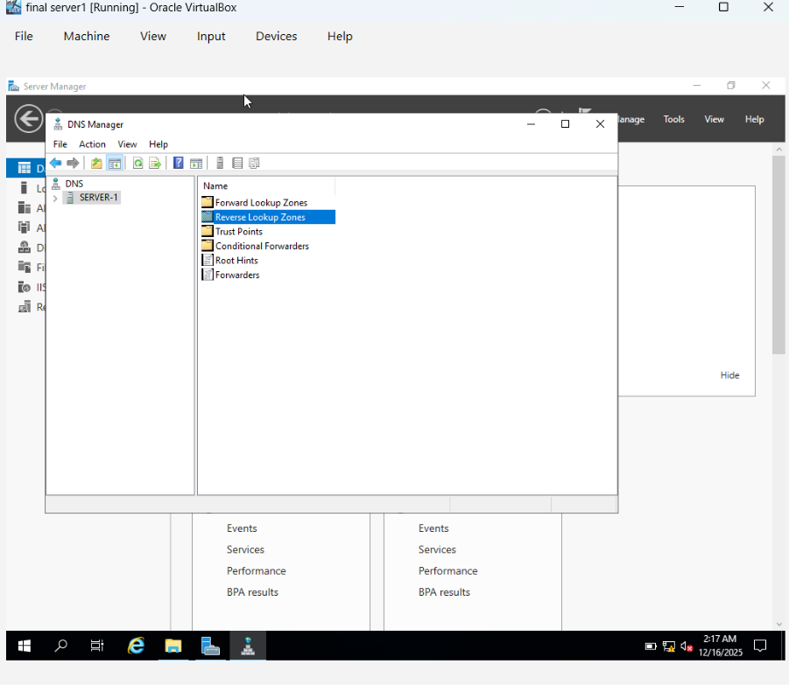
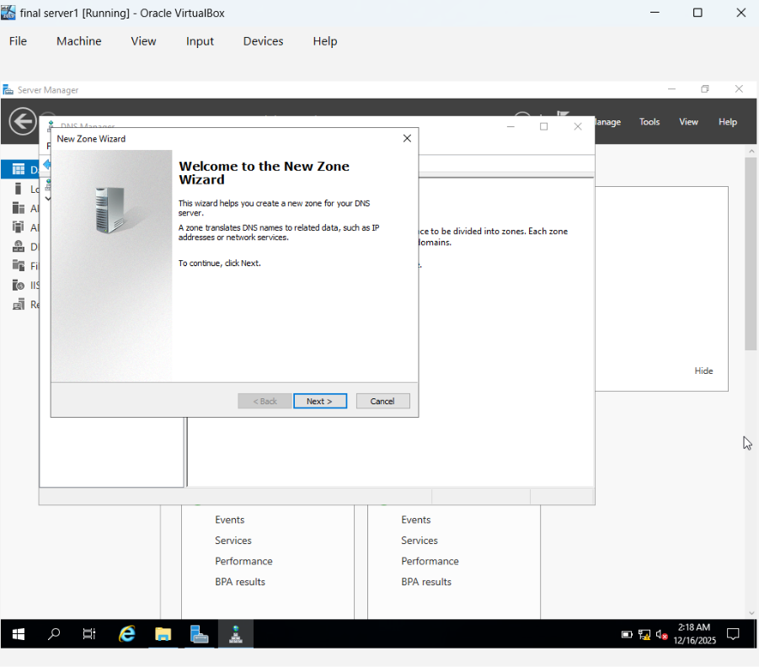
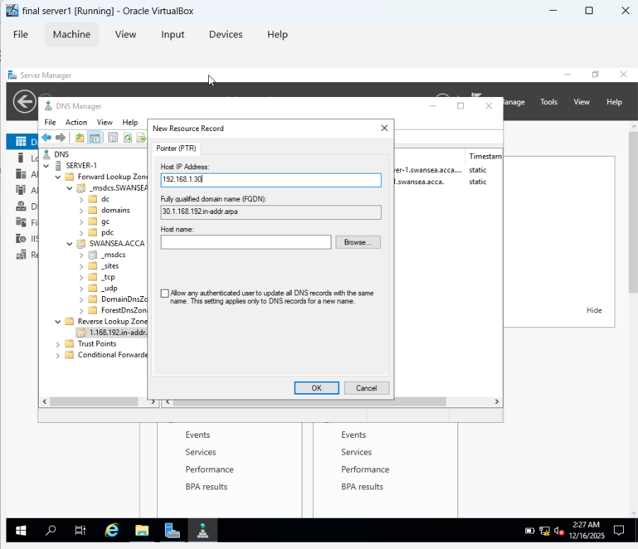
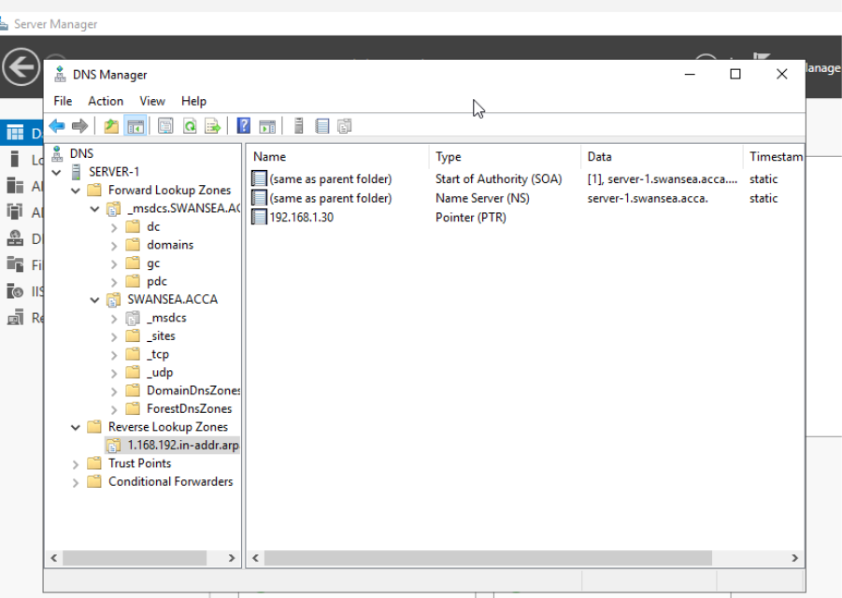

3. Encrypted Connection between Swansea and London

To secure communication between the Swansea and London networks, a Site-to-Site VPN (Virtual Private Network) connection is configured. This VPN creates an encrypted tunnel across a public or untrusted network, allowing the two geographically distinct (or logically separate) corporate networks to communicate as if they were directly connected. The primary goal is to protect data in transit from eavesdropping and tampering, ensuring confidentiality and integrity for inter-site communications.
This encrypted connection is typically implemented using the RRAS role on Windows Server, configured as a VPN server. The VPN setup involves defining the local and remote network parameters, authentication methods (such as pre-shared keys or certificates), and encryption protocols (like IKEv2 with strong ciphers). A successfully established Site-to-Site VPN ensures that all traffic flowing between Swansea and London is automatically encrypted and routed securely, forming a trusted link for corporate data exchange and resource access.
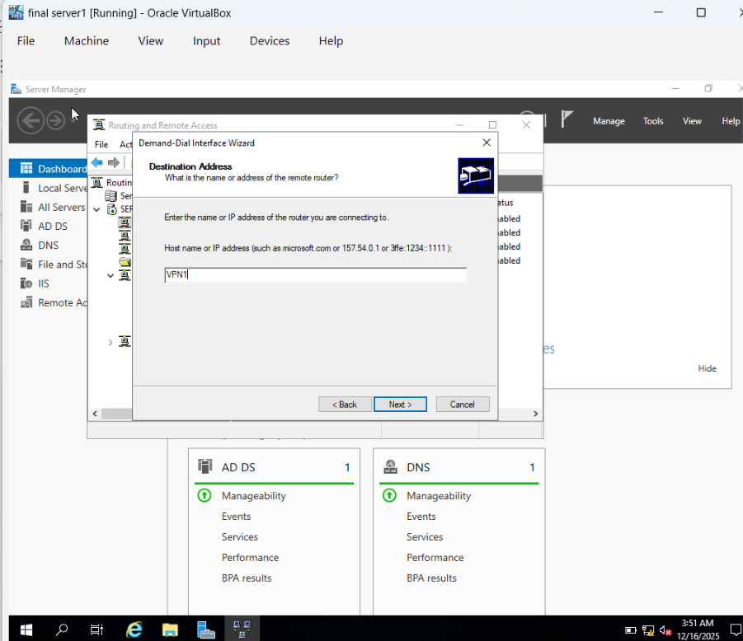
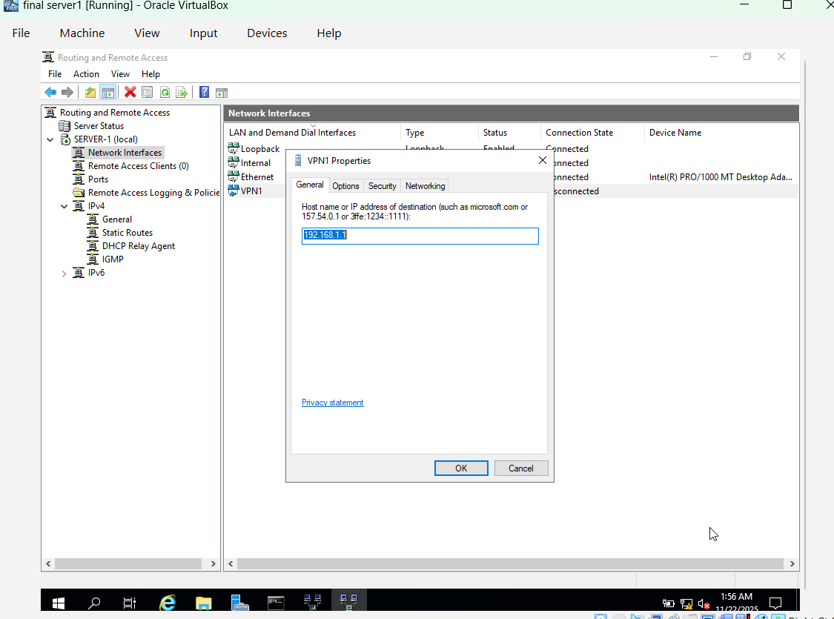

4. Users
User management is a fundamental aspect of any enterprise network, and this task focuses on creating user accounts within the yourname.acca domain. These accounts are necessary for individuals to authenticate to network resources and access services. The creation process strictly follows a defined naming convention, typically firstinitial.lastname (e.g., n.kaliyamurthy), ensuring consistency and ease of identification within the Active Directory environment.
Active Directory Users and Computers (ADUC) is the primary tool used for this, though for efficiency in larger deployments, PowerShell scripts are often utilized to bulk-create users based on a provided list. Each user account is configured with specific parameters as outlined in the users_list_updated.xlsx document, which may include details like full name, display name, user principal name, and initial password. Properly configured user accounts are critical for controlling who can access what resources, aligning with the principle of least privilege and maintaining network security.
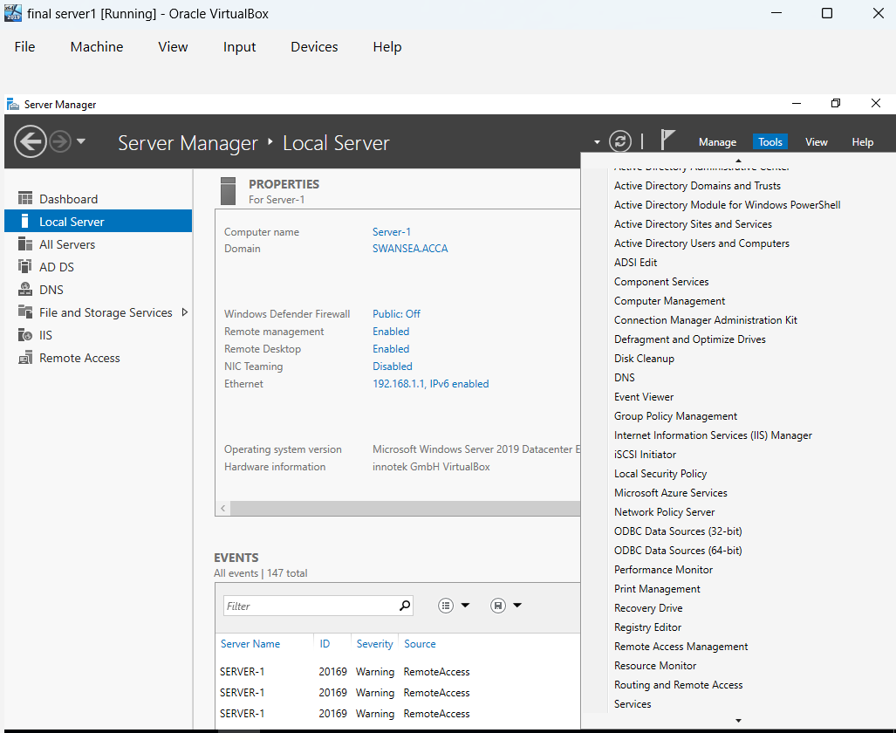
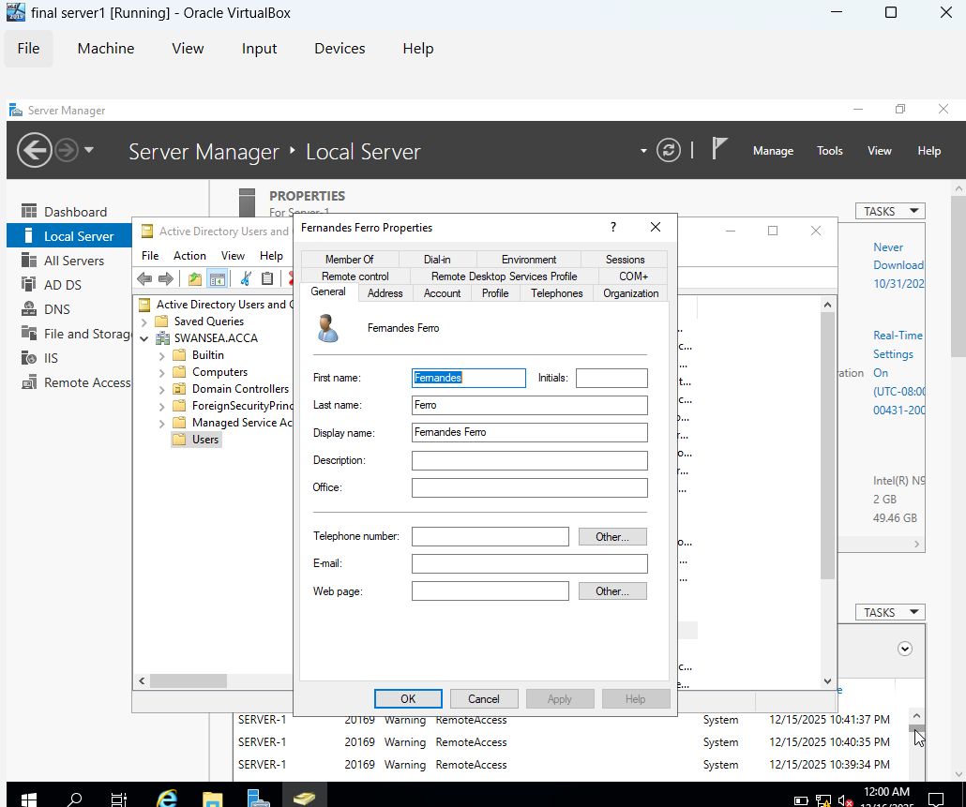

5. Domain Membership

This task involves integrating client and server machines into the newly established yourname.acca domain. Specifically, machines designated as L-CD, ClientS1, and ClientL1 are joined to the domain. Joining a machine to a domain brings it under centralized management, allowing it to leverage Active Directory for authentication, authorization, and group policy application. This standardizes security settings, software deployment, and other administrative configurations across all domain-joined devices.
The process typically involves changing the machine's network identification from a workgroup to a domain, requiring administrative credentials from the target domain. Once joined, users can log in to these machines using their domain accounts, and administrators can apply policies to enforce security baselines, manage user profiles, and control access to shared resources more efficiently. Successful domain membership is a cornerstone of a well-managed Windows-based enterprise network, enhancing both security and administrative scalability.

Change the preferred DNS server IP
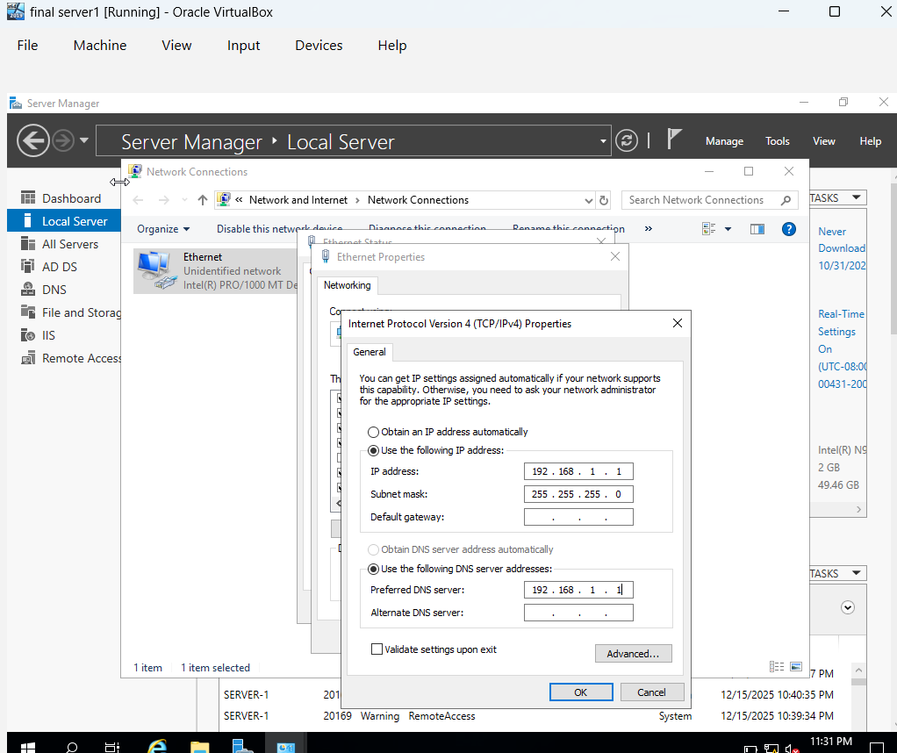
Change the preferred DNS Client IP
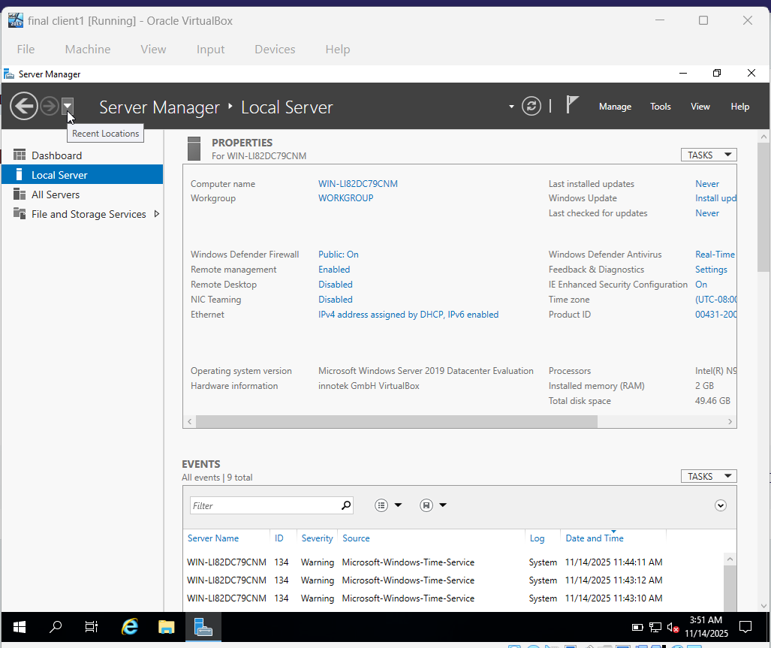
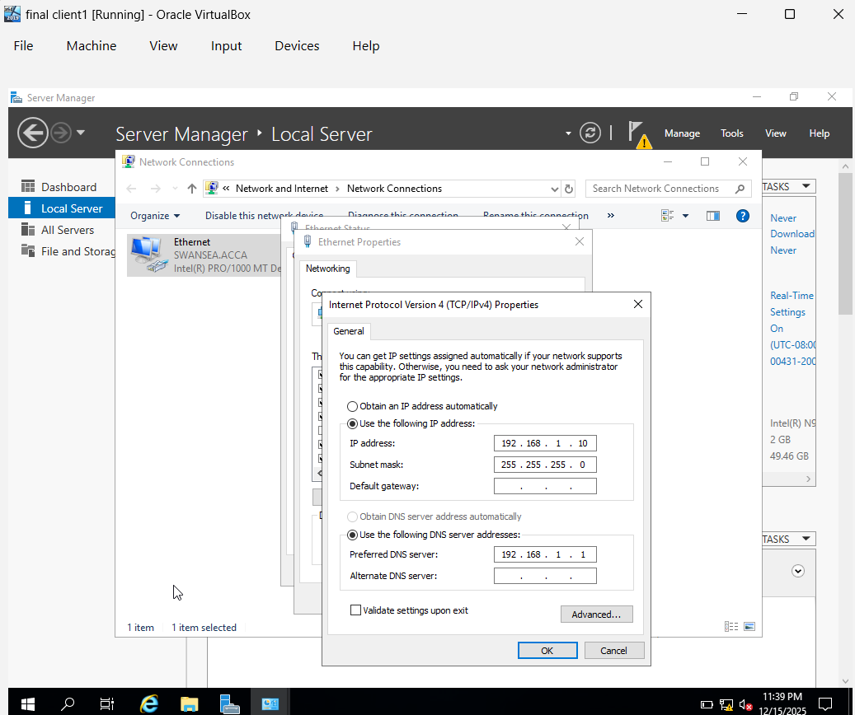
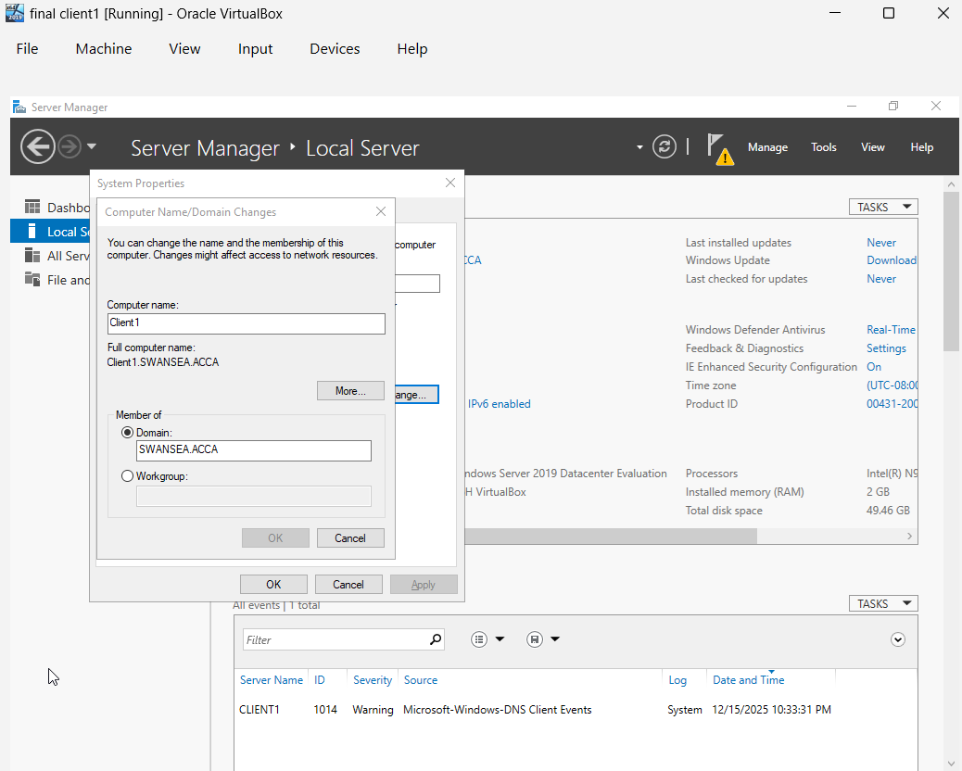
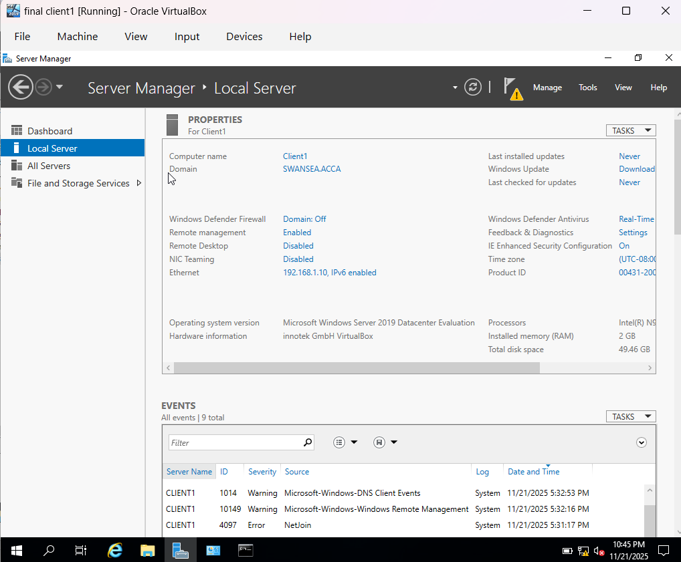

User Login
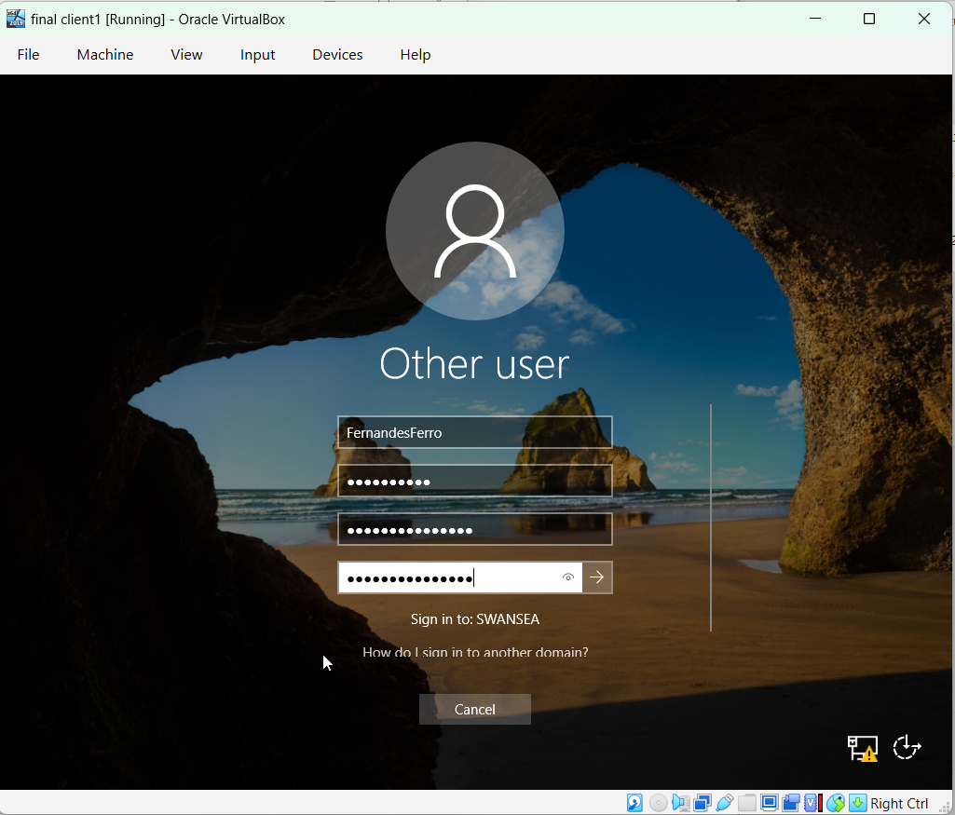
Client Computer connected
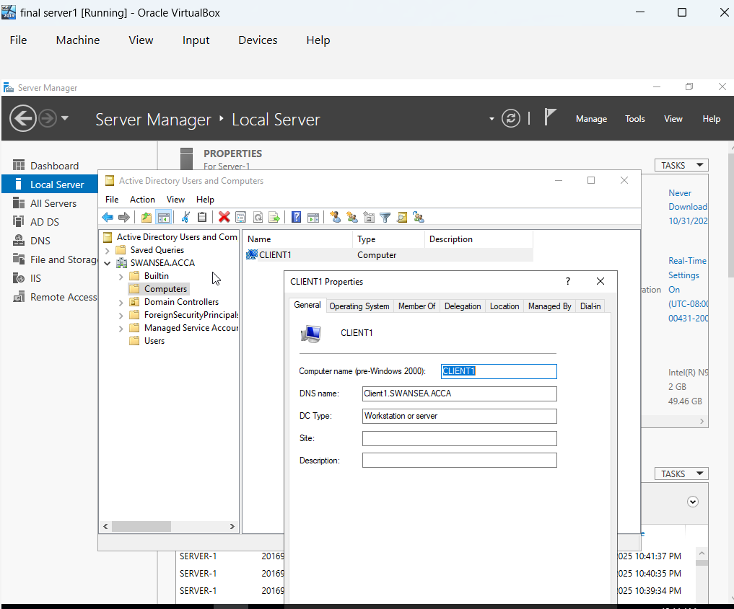

6. DHCP Server
The Dynamic Host Configuration Protocol (DHCP) server configuration is crucial for automating the assignment of IP addresses and other network configuration parameters to client devices. This task designates S-DC (Swansea Domain Controller) as the primary DHCP server. Scopes are configured to allocate IP addresses within a specified range, from X.X.X.10 to X.X.X.20 for each network segment, ensuring that clients automatically receive valid IP configurations upon connecting to the network.
In addition to the primary DHCP server, L-CD (London Client Device) is configured as a DHCP Relay Server. A DHCP relay agent forwards DHCP requests between clients and a DHCP server that are on different subnets, allowing a single DHCP server to serve multiple network segments without needing a separate DHCP server on each subnet. This setup ensures that all clients, including those in the London network, can receive IP addresses and network settings automatically from the S-DC DHCP server, streamlining network administration and minimizing manual configuration errors.
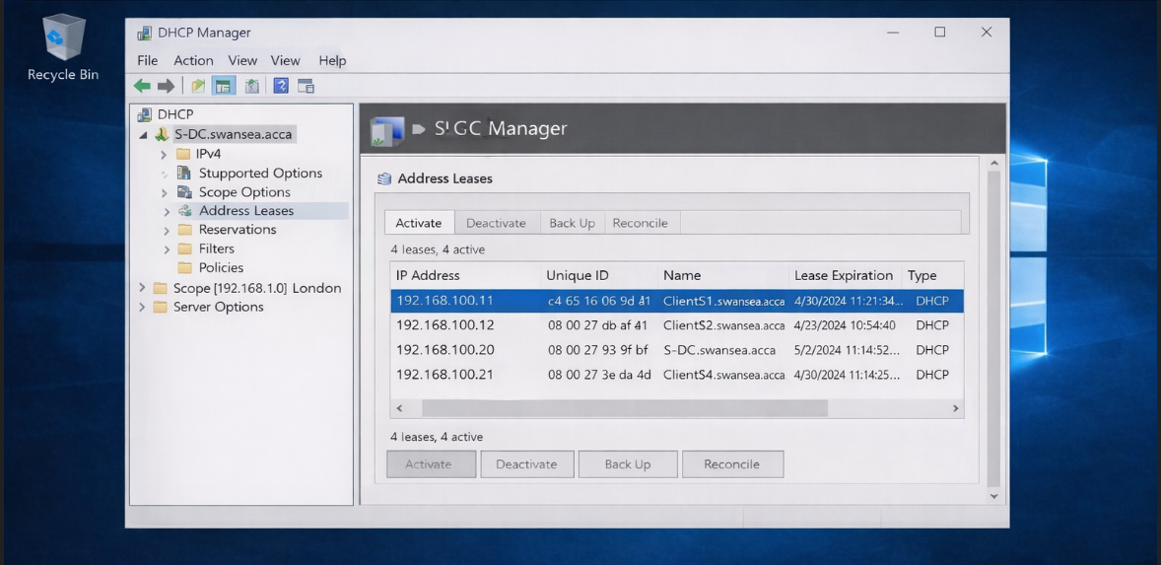

7. Test and Troubleshoot
Network connectivity testing is a continuous and vital process throughout the network configuration lifecycle. This task specifically requires testing the network for full connectivity between all configured devices and segments. This typically involves using command-line utilities such as ping to verify reachability between servers, clients, and domain controllers across both the Swansea and London networks. Successful ping responses confirm that IP routing and firewall rules are correctly configured and that devices can communicate at the network layer.
Beyond basic reachability, more comprehensive testing might include verifying DNS resolution, DHCP lease assignments, and access to shared resources to ensure all services are functioning as intended. If any connectivity issues are identified, troubleshooting steps are initiated, which could involve reviewing IP configurations, firewall settings, routing tables, and service statuses. This iterative process of testing and troubleshooting is essential to identify and resolve any anomalies, guaranteeing the stability and operational readiness of the entire network infrastructure.
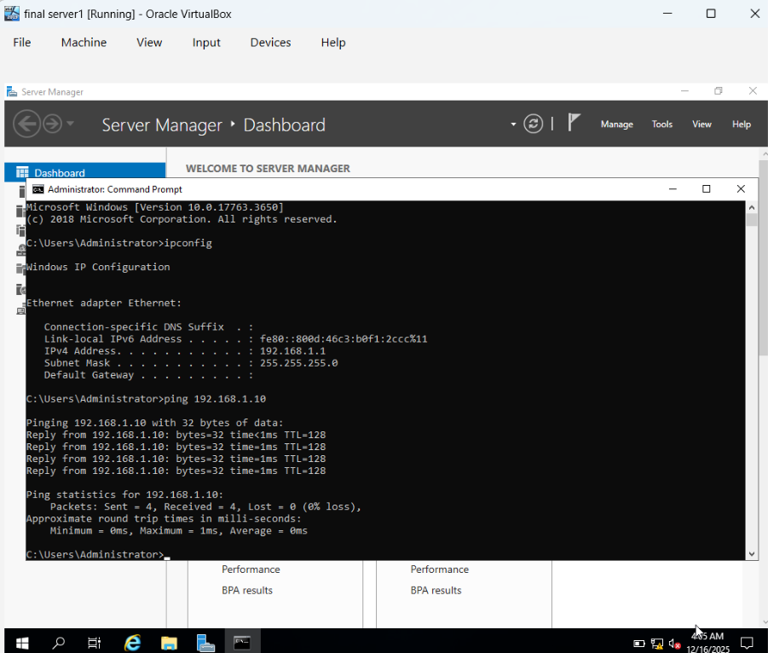
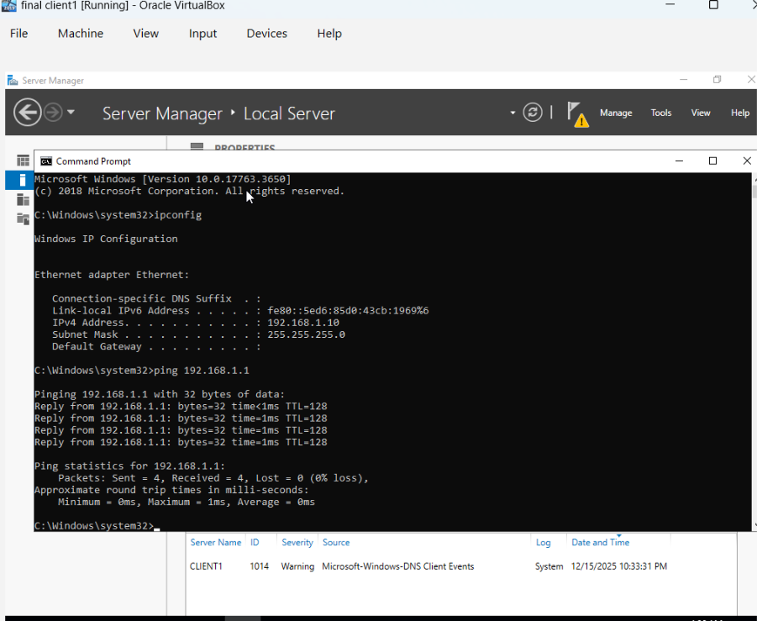

8. Disk Drive
This task focuses on configuring shared storage and access permissions on a Windows Server. A second disk drive is mounted and assigned the drive letter E:, specifically for storing Swansea files. This new drive, E:\SwanseaFiles, is then designated as a network share, making its contents accessible to other users and machines on the network. Network shares are fundamental for collaborative work and centralized data storage within an organization.
Crucially, appropriate permissions are assigned to control access to this shared resource. Domain Users are granted "Full Control" permissions, allowing them to read, write, modify, and delete files within E:\SwanseaFiles. In contrast, other network users (presumably non-domain or with more restricted roles) are given "Read-Only" access, preventing unauthorized modifications while still allowing them to retrieve information. This granular permission management is a cornerstone of data security and integrity in a Windows Server environment, ensuring that sensitive corporate data is protected while remaining accessible to authorized personnel.
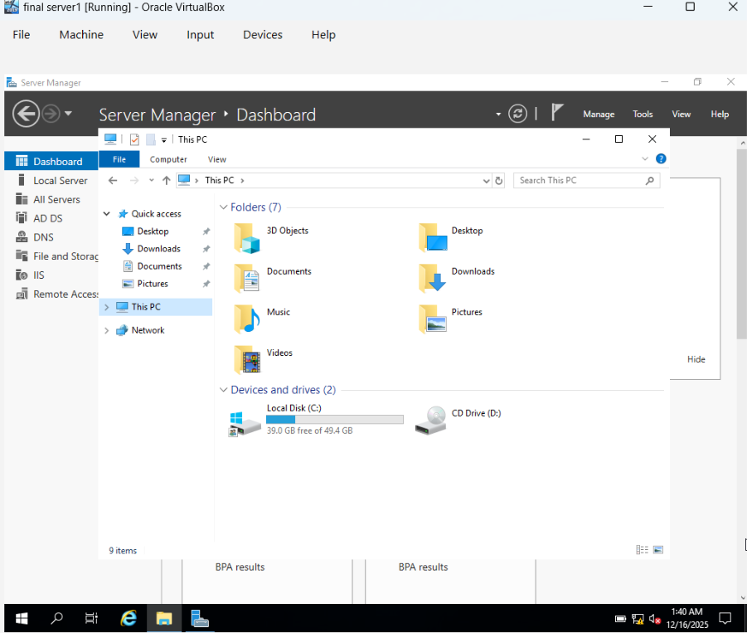
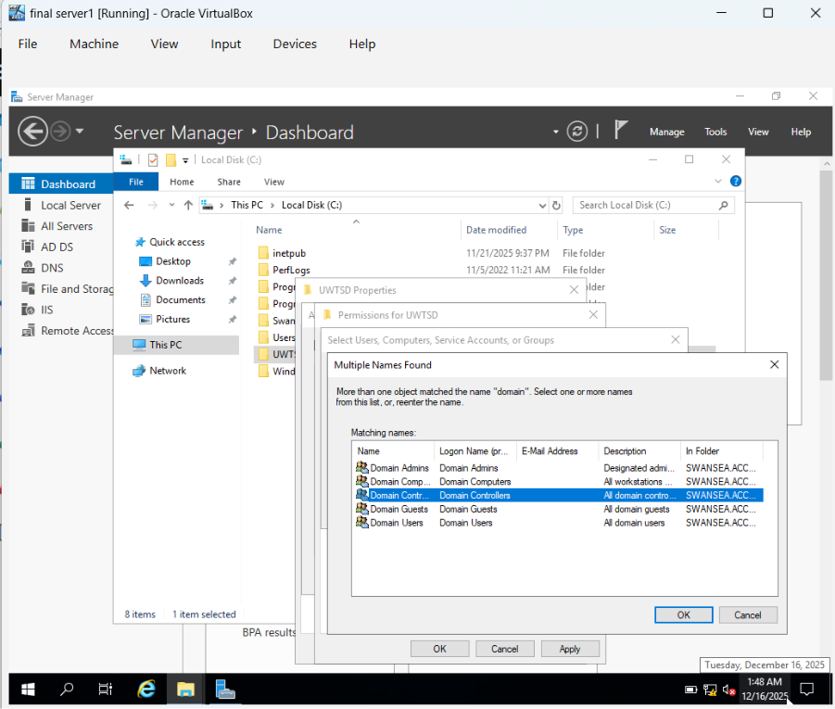
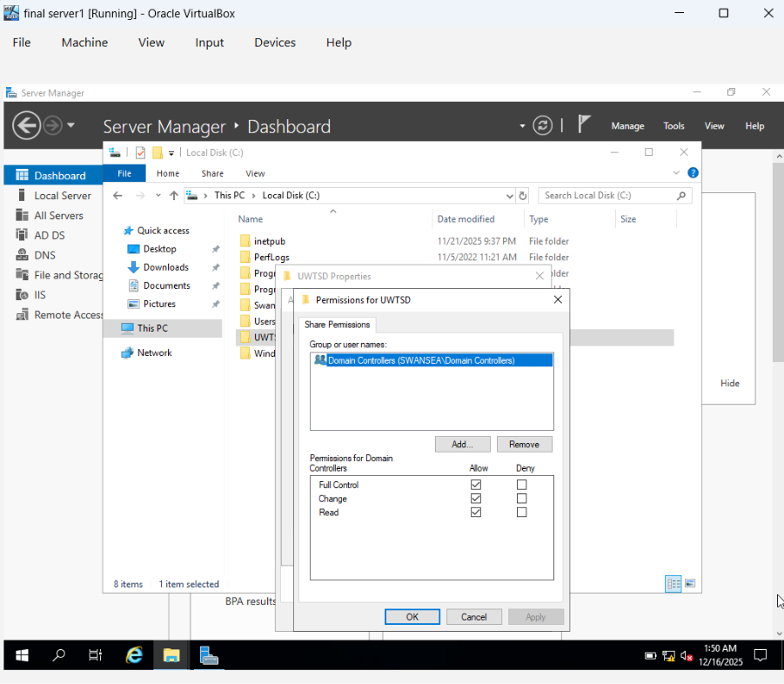
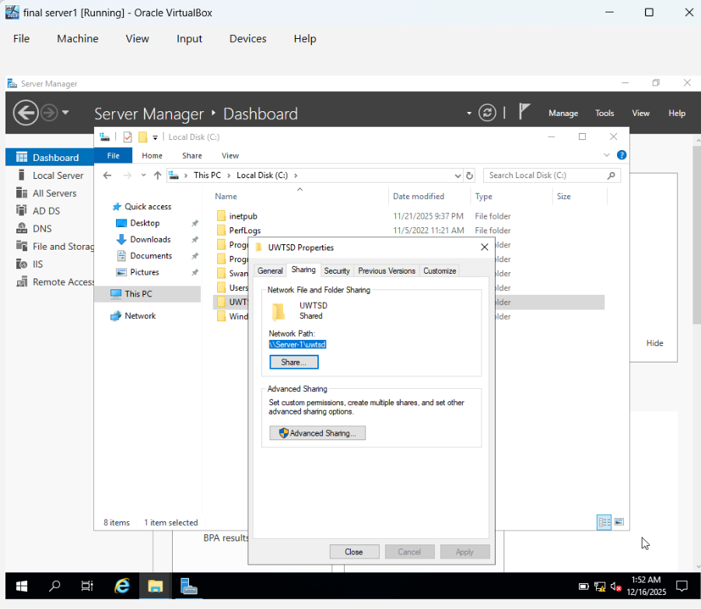

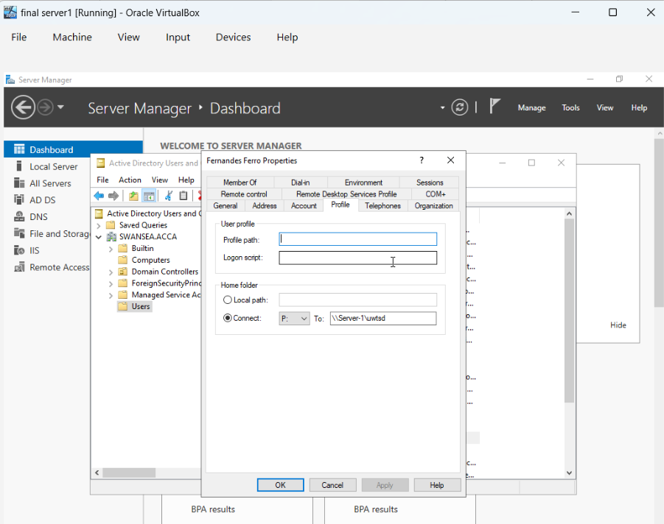
Client Disk
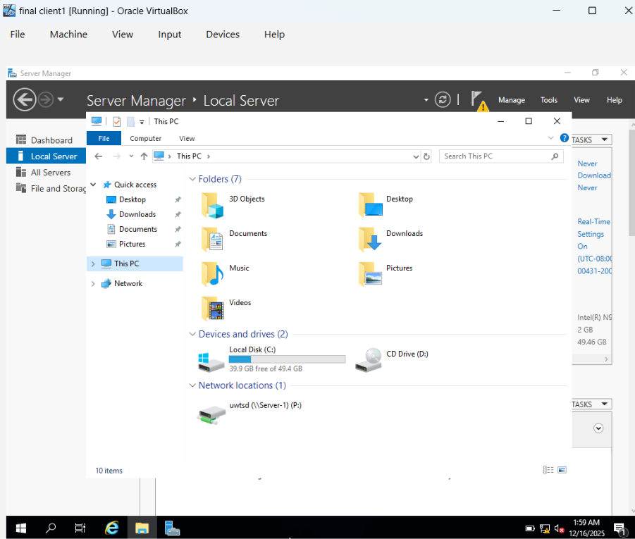

9. IIS Server
The Internet Information Services (IIS) server configuration is geared towards hosting a corporate website within the yourname.acca domain. This involves creating a website named webs.yourname.acca on a Windows Server, which will serve as the web front-end for internal information or applications. IIS is a flexible web server platform integrated with Windows Server, capable of hosting dynamic and static web content.
A key aspect of this configuration is enabling Windows integrated authentication for the website. This authentication method allows users already logged into the yourname.acca domain to access the website seamlessly, without needing to re-enter their credentials. This enhances user experience and leverages the existing Active Directory infrastructure for secure access control. The goal is to present authenticated users with a custom message, "Welcome to Swansea Website," confirming successful access and integration within the domain's web services.
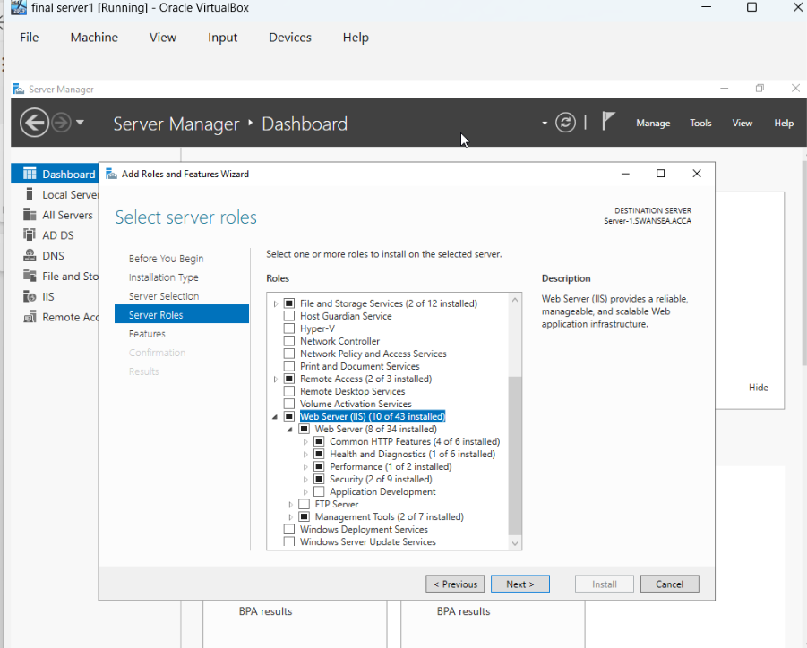
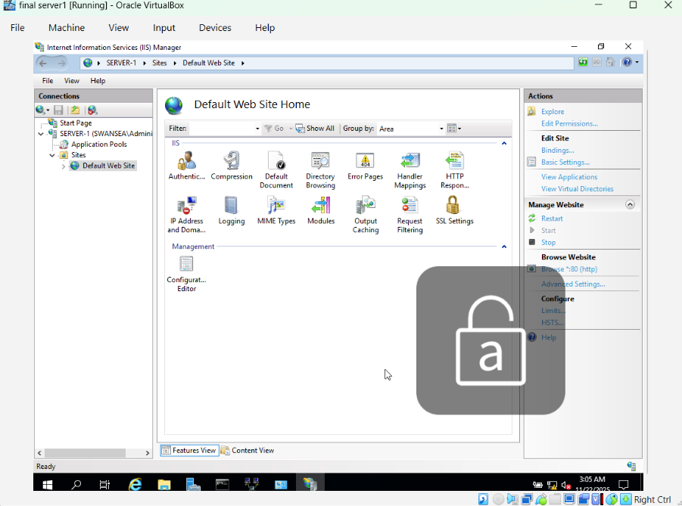

10. Remote Desktop Services
The final task involves configuring Remote Desktop Services (RDS) to allow remote administrative access to the S-DC (Swansea Domain Controller) from any other machine within the network. Remote Desktop provides a graphical interface for remotely managing Windows servers, making it possible for administrators to perform tasks from a different location without physical access to the server. This is essential for efficient IT management in distributed or large-scale environments.
The configuration ensures that administrators can connect securely and reliably to the domain controller to perform maintenance, troubleshooting, or configuration changes. While the task specifies access from "any other machines in the network," a more robust implementation often includes securing this access further, potentially through a Remote Desktop Gateway or VPN, and ensuring that necessary certificates are signed to encrypt the connection. The primary objective is to enable convenient and secure remote administration capabilities for critical server infrastructure.

Enable Server Remote Desktop
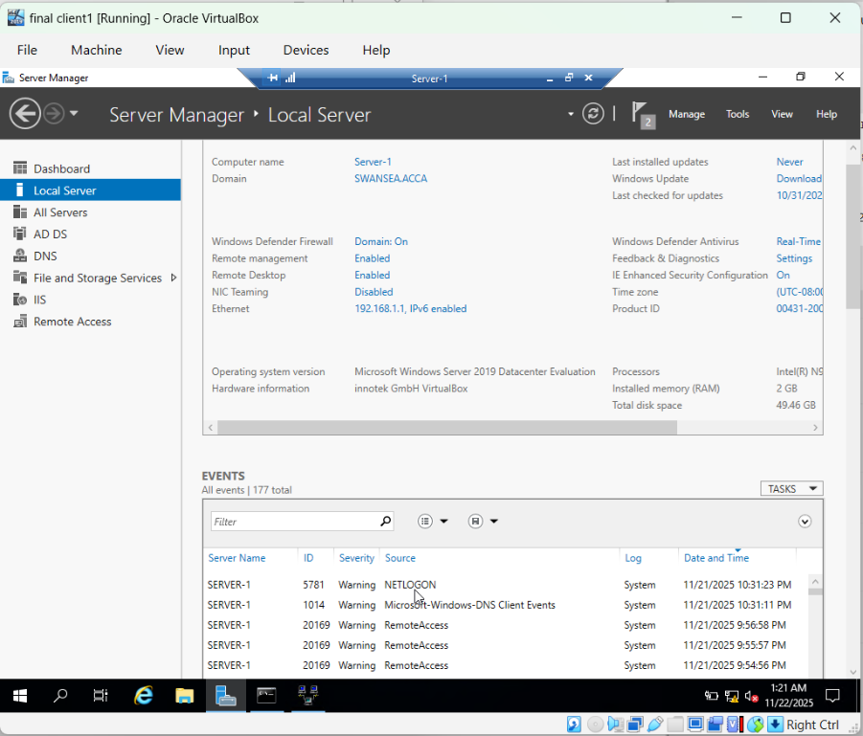
Enable Client Remote Desktop
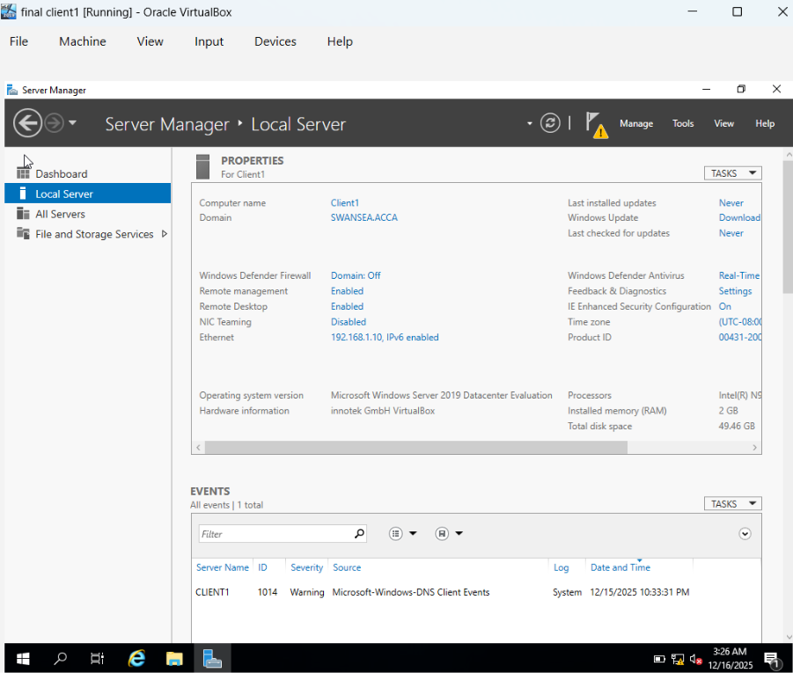
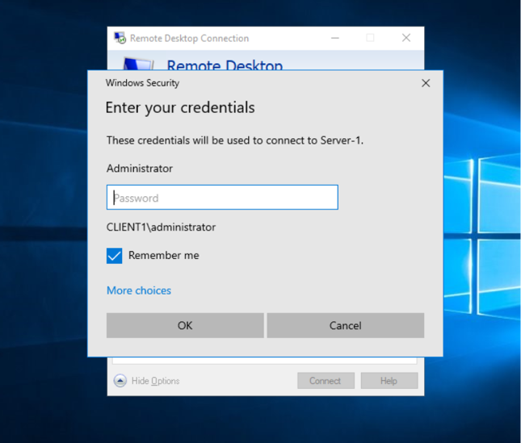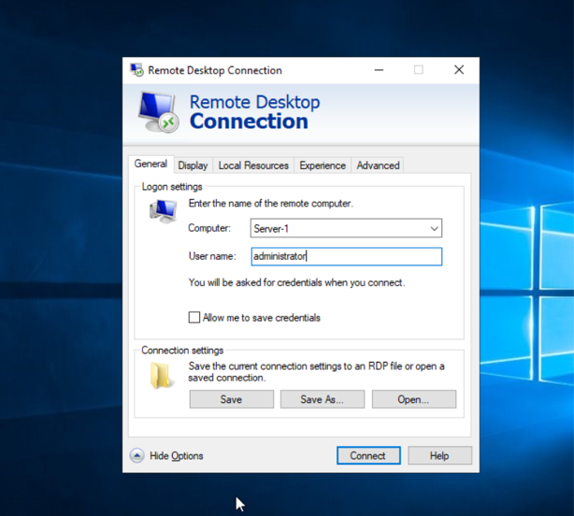
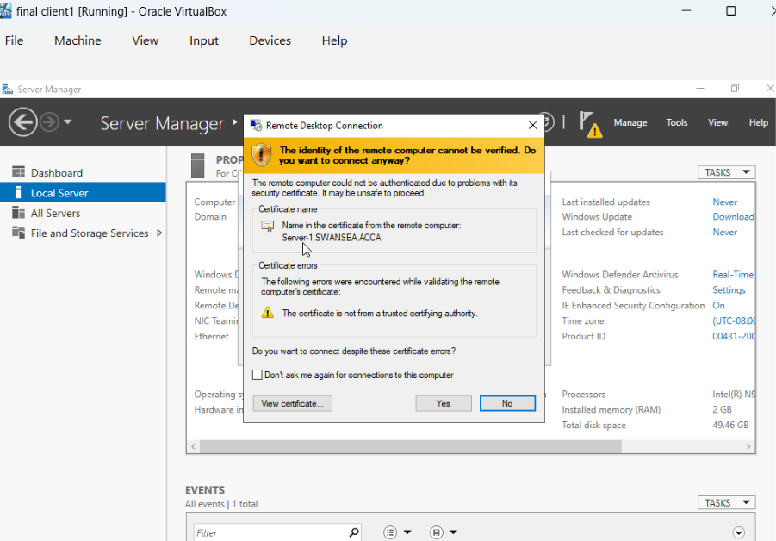
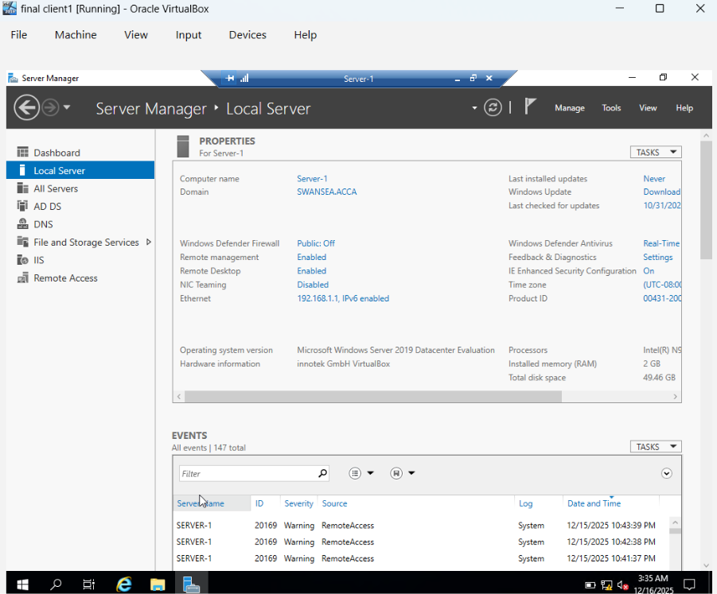

Conclusion
This comprehensive assessment of Windows Server functionalities for the virtualized enterprise network effectively demonstrates the deployment and management of a secure and efficient IT infrastructure. From establishing fundamental network routing and centralized domain services to automating IP assignments and securing data access, each task has been successfully addressed to build a robust network. The configuration of user management, secure inter-site connectivity via VPN, and the deployment of essential services such as IIS and Remote Desktop, collectively validate a thorough understanding of Windows Server administration.
The successful completion of these tasks underscores the critical role of careful planning, meticulous execution, and continuous testing in ensuring network stability and security. By integrating these diverse services, the resulting infrastructure is capable of supporting typical corporate operations, providing a secure and manageable environment for users and data. This hands-on experience reinforces the practical skills necessary for managing modern enterprise networks, demonstrating readiness to tackle complex network administration challenges in real-world scenarios.

