Name. Marie doody
Student number. 2406919
Module code. BMHP5014
Module. Change makers
Assignment title. Component 2

Introduction
Domestic abuse is a very serious and widespread issue within the UK in the year ending march 2025 an estimate of 3.8billion people 16+ suffered domestic abuse , sadly that effects multiple people including the abused the communities and families all across all types of people weather social cultural and all types of backgrounds, ( NSPCC,2023) it can include different types of abuse like financial, emotional, physical and sexual, and it can therefore have a long lasting effect of both the victim and their families.(home office,2022) Sadly, although there is allot of support out there for help with domestic abuse many victims still are hesitant to speak out in case of retaliation from their abuser and also could be for fear and people knowing what is going on, or even just lack of awareness about support that is out there to help them.
Getting help early is very important in being able to protect the victim and therefore protecting them from further harm, which will also then reduce long term impact on their health and their wellbeing, and helping their family stability Aswell. My assignment helps with solutions aimed at improving awareness of domestic abuse and increasing access to full support. The main goal here is to ensure that victims can find help and support easily and safely, and without any fear of judgement while also showing multiagency working between different health care providers social care, local authorities and charities.

Improving domestic abuse awareness and access to support in the UK
The problem is
- Their are many victims that do not reach out for help while being abused
- Many things including fear, judgement stigma and embarrassment stops them reaching out
- Services might be difficult to find and not easily accessed
- Many abuse victims also face finance abuse

Why this matters
- Domestic abuse also effects children and families involved
- Can escalate greatly if early intervention is not involved
- Domestic abuse doesn’t just effect victims physically but also can have a huge effect mentally
- Domestic abuse usually is a repeating cycle

My solution
Community awareness campaign, create a way for victims to be able to use an emergency way to exit a site quickly, i recommend safe link which would offer key features to help with any barriers that victims will face when trying to get help, these will include multiple features for example having a 24/7 live chat function, which will help the users communicate with professions that are fully trained without needing it to be a phone call, which would be very useful for individuals who are monitored by their abusers (women’s aid 2023). This platform would also include a safety feature quick exit that will allow users to leave the site instantly if they feel unsafe. Along side this platform a community awareness campaign would be available that will promote safe link and get out and educate the public about it and domestic abuse and let people know that there is help out there and do not be afraid. Safe link aims to empower victims to seek out help sooner and safely and to reduce harm to domestic abuse victims (refuge, 2023). Safe link will give victims back some power to get to the right services earlier and get away from the domestic abuse for good

Who is involved on this project
- UK Charites
- Refuges
- NHS
- Social services
- Local councils (e.g. Leeds city council )

What are the benefits
- Getting quicker and safer support and help
- Protection for children and the family
- Getting help early
- Mental health support

Some challenges faced
- Getting the right funding
- Some digital concerns
- Awareness of the platform

The problems faced
Many domestic abuse victims do not report their abuse so allot of this goes under reported as many victims feel trapped and feel they cannot reach out for help, things like fearing their abuser not having trust in services that are provided and not having enough information about what kind of support is out there for them.
(National society for the prevention of cruelty to children. 2023).

Also victims may also struggle to find a safe and confident way of reaching out for the help and support, as for some victims phone and or in person support may not be something that they can do use in case this is something their abuser may monitor, so this actually highlights that there may need to be different discreet ways for victims to reach out for help and support. Victims of abuse may also suffer with mental health issues and physical injuries due to the abuse also including being isolated from everyone, it is also proven that children that live in and see domestic abuse are at a greater risk of emotional harm and from development harm from being around abuse and can have a higher chance of them in future also being in an abusive surrounding.

Helpful solutions
Including a confidential digital platform for abusers to be able to easily access, combining this with a national awareness campaign, to help improve access for abuse victims. Making access to easier information regarding were to get help and support from different agencies and servicers, making all help available quickly and being able to safeguard victims while trying to them the correct support quickly.

This platform would then
- Be able to offer quick links to local services that can help give advice and support
- Possibly include an emergency exit feature for victims to exit quickly if needed
- Provide anonymous support for them to talk about their issues
- Be accessible on mobile devices
This would also work alongside the UK charities and NHS that all information is up to date at all times and to make sure all information is accurate for people that are needing the support

How this will improve health and social care
This solution will support early intervention which is very important in health and social care, by providing victims easy access to support they will then be able to get help before a situation gets out of hand quickly. The platform also includes multi-agency working as many different services are involved for example health carers, social workers and charities ( department for education 2023).
Improving access to support can also then reduce the pressure on emergency services which will also improve the outcomes for the victims. This will also help children that are affected by domestic abuse get all the support they need also as children that have grown up around domestic abuse are much more likely to attracted that kind of environment when they grow up, resulting in a never-ending cycle.

Some of the benefits
- It will improve safety for victims
- Will lead to better communication between all the services involved
- Brings greater knowledge on domestic abuse
- Will increase the accessibility to allot of support services that are needed
- A better multi-agency working approach
This also blends with safeguarding and supports steps that are aimed at protecting
Victims and their families.

Although these are some challenges that could be faced That need to be considered also
- Being able to reach out to people that may possibly not have any access to technology
- Findings ways to help people that may not be able to be alone from their abusrrs for very long
- Raising funds
- Making sure things can stay confidential
But these challenges can be faced by multiple ways for example making careful plans involving multiple agencies when needed and making sure ongoing support is available to the victims at all times and done safely. Also making a clear plan and steps to be taken to get the victim out of the situation that they are in and get the right support group to help them also in the long run, which is also why multi-agency working is also important in a domestic case as different services can all come together to make a plan and will get a better outcome.

My conclusion is that
Sadly domestic abuse is such a serious issue that will require effective support and accessibility needs to be made available safely, men women and even children can all be victims of domestic abuse, this assignment outlines practical and innovative solutions to improve awareness and access to support services through many different ways including digital platform and awareness campaign. There are multiple agencies out there that can help provide support to people that need it, although victims need to make that first step to getting help and which a large amount are scared to do, once victims make the first step their then halfway there to get the help they need to get free from this abuse. Reach out to any agencies that are available to start getting your life back and get free from abuse. Also improving access to domestic abuse services will not only protect individuals and children but strengthen families and communities all across the UK. Don’t stay silent you are not alone help is available out there safely, take the first steps to getting your life back

My poster about domestic abuse
There are many reasons why people that are suffering from domestic abuse do not come forward including fear of what may happen if they tell including facing what they think will be embarrassment, others may feel afraid to tell their loved ones in case of judgement for staying. Other will feel like they need to stay for their children and feel its best for them to have a two-parent household. While some may be afraid of being single and doing it alone.
Do not be afraid to speak out and stop the cycle of abuse

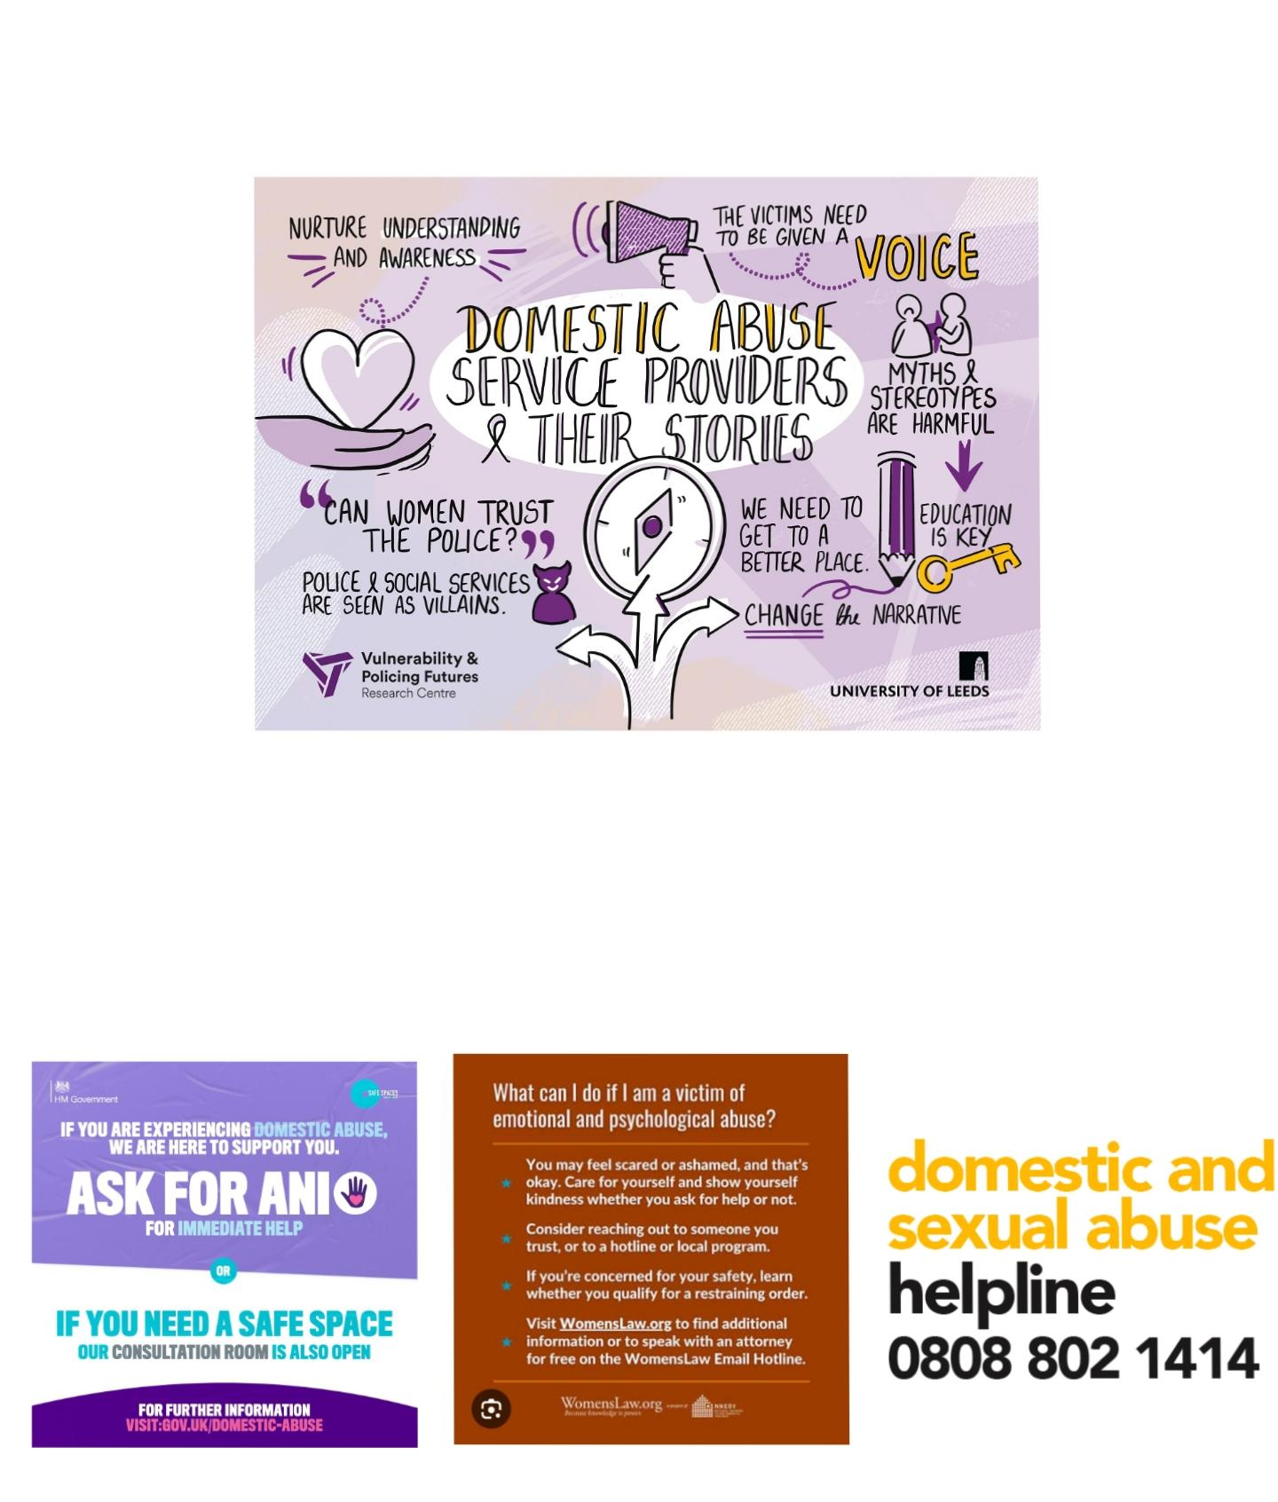

3.2 billion people 16+ have suffered with some kind of domestic abuse
23% being of men
61% being women
Victims of strangulation are 7times more likely to die
Don't be another statistic
Being able to find the right services can help abuse victims make that step to get free from the abuse
Having clear advice and support will encourage others to seek help you do not have to suffer alone there is help there waiting
Also having clear steps on what abuse victims can do to get support early will help children and families that are also involved. Safe link is a digital platform that allows abuse victims to seek out help and advice safety,
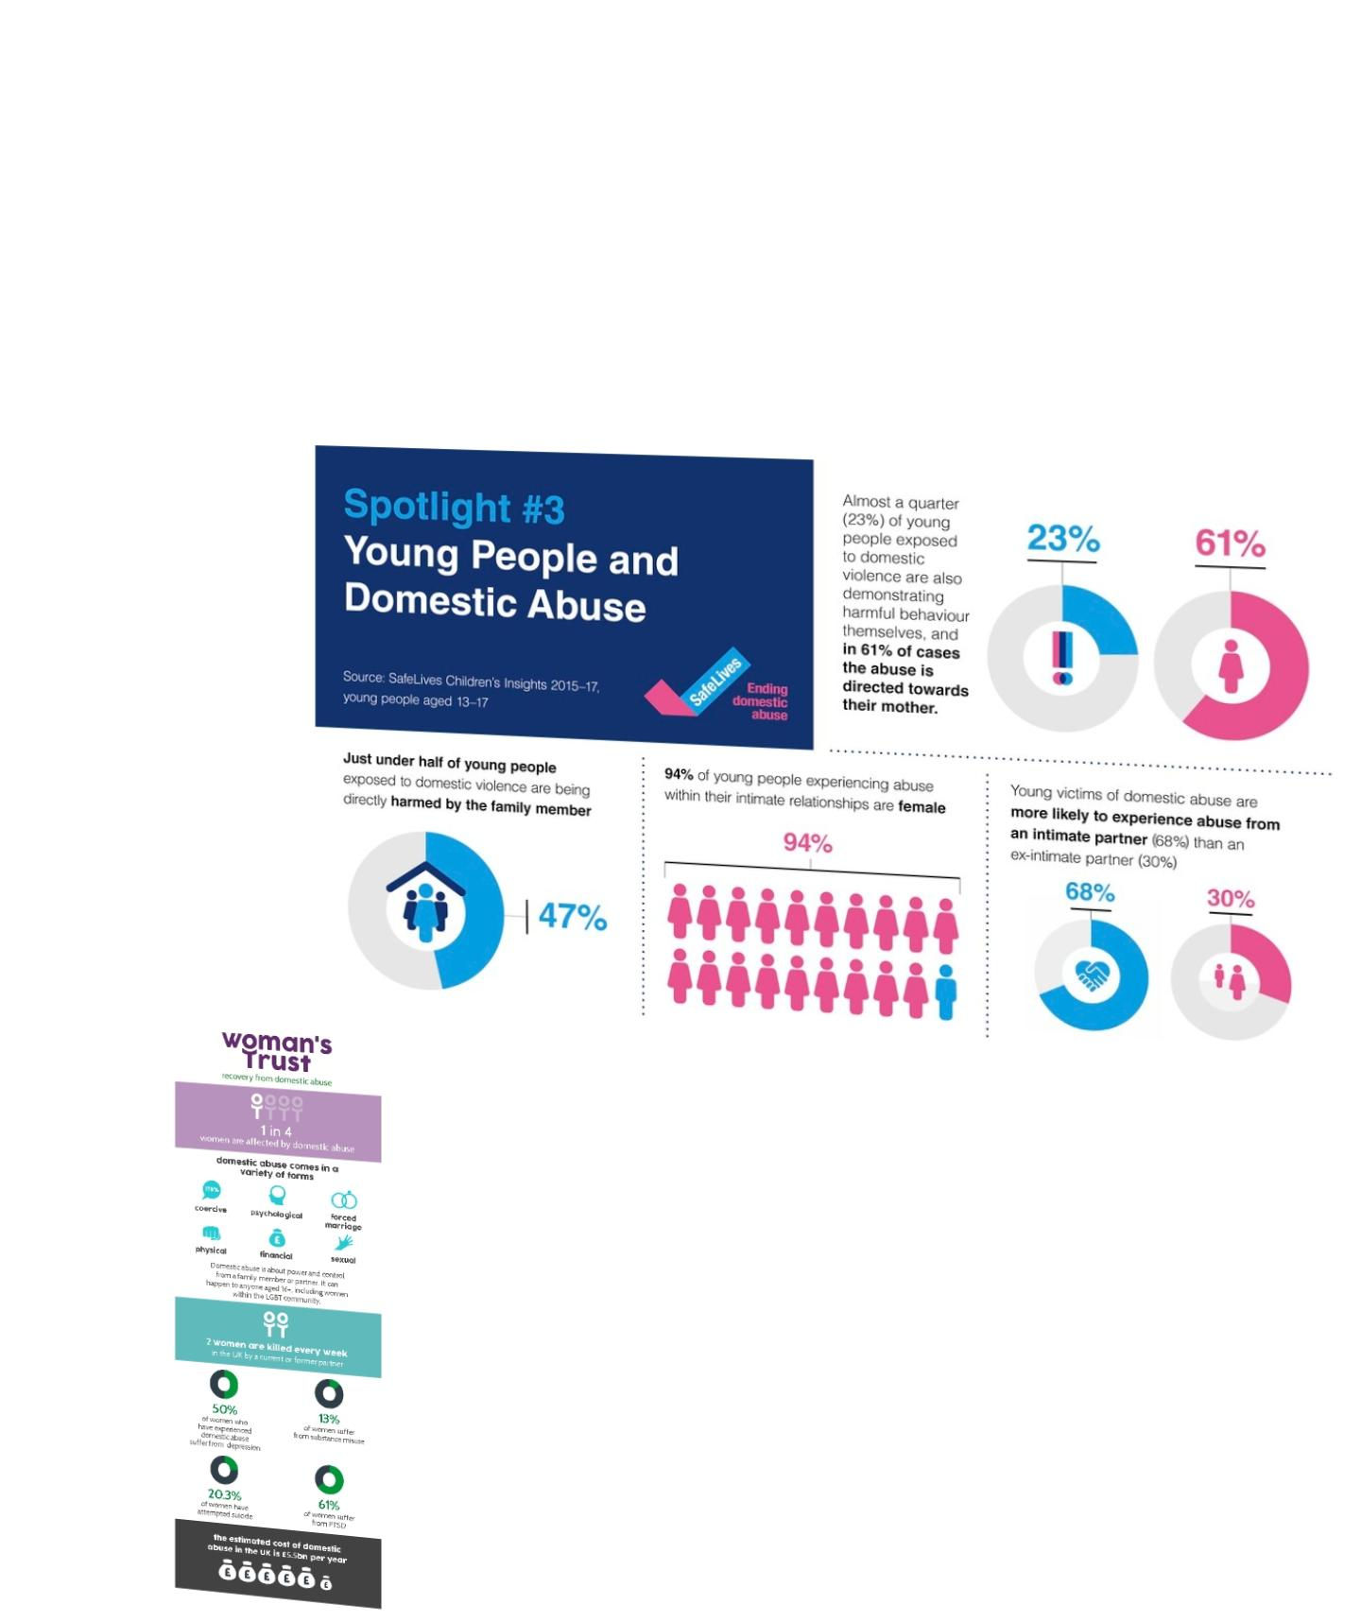
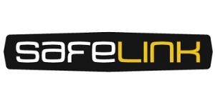

References
NHS (2023) Domestic abuse: how to get help. (Accessed 19 March 2026).
Leeds city council (2024) Domestic abuse support services (Accessed 19 March 2026).
Department of Education (2023) working together to safeguard children. (Accessed 20 March 2026).
Women’s aid (2023) the domestic abuse report: trends and insights. (Accessed 18 March 2026).
NSPCC (2023) Domestic abuse and its impact on children. (Accessed 18 March 2026).
Refuge (2023) About domestic abuse and its support services. (Accessed 18 March 2026).
Leicestershire county council (2024) Early help and safeguarding. (Accessed 18 March 2026).
Home office (2022) Domestic abuse: how to get help. (Accessed 18 March 2026).

