
Figure 1
Belton Chris | l4 OME | November 22, 2023

L4 GROUP PROJECT

Contents
Table of Figures 4
Introduction 5
Team roles and responsibilities 5
Chris Belton 5
Liam Stephenson 5
Tom Diaper-Fox 5
Hayden Gibbs 5
Luke Reidy 5
Display brief 6
Systems Engineering 6
Stake holder analysis 6
Requirements 6
Statistics 7
Previous incidents 8
26/10/2023 RTA 8
26/09/2023 Qaraqosh Wedding Accident 8
Colectiv nightclub Accident 9
Display design 9
Market research 9
Music choice 9
Simulation 10
Firework selection 10
Weather 11
Location 12
Shell Calc 13
Environmental considerations 13
Licensing 14
Health and safety 14
Hazard identification 14
Risk assessment process 15
Hierarchy of control 16
Firework Trial 18
Aim 18
Results 18
Executing the display 18
Management of change 19
Equipment details 19
Emergency plan 19
Personal Protective Equipment 20
Assigned roles 20
Design review 21
Presentation 21
Practice 21
Reflection on presentation 21
Reflection on the process 22
Conclusion 23
References 24

Table of Figures
Figure 1 0
Figure 2- Requirement list 7
Figure 3- Canadian road traffic accident [10] 8
Figure 4- Qaraqosh wedding aftermath [11] 8
Figure 5- Colective nightclub accident reconstruction [12] 9
Figure 6- FWSIM Simulation 10
Figure 7- Firework bill of materials 11
Figure 8- Long range weather forecast 11
Figure 9- Short range weather forecast 11
Figure 10- Northern wind 12
Figure 11- North-westerly wind 12
Figure 12- 8inch shell calc 13
Figure 13- Environmental clean-up net [13] 13
Figure 14- Hazard identification check list 14
Figure 15- Trials risk assesment example 15
Figure 16- UWTSD display risk assesmsent example 16
Figure 17- Hierachy of Control [8] 16
Figure 18- UWTSD Firework trial 18
Figure 19- Fireworks tested 18
Figure 20- Emergency contact details 20
Figure 21- PPE requirements 20
Figure 22- Presentation marking card [10] 22

Introduction
This report amalgamates the large quantity of work undertaken by all team members in order to present one, forty minute presentation on the outcomes of the firework display preparation. Key details will be focused on such as the roles within the team, techniques used, critical issues and health & safety. Two design review meetings prior to the presentation allowed for difficult conversations to take place on progress. This allowed for focus to be shifted from all the preparation work onto producing the presentation and practicing. The examiners scored the presentation 82/ 100. This falls within the excellent (1st/ Distinction) category which is between 70-84%. The company UWTSD chose to conduct the display is called The Fireworks Company (TFC).

Team roles and responsibilities

Chris Belton
Chris took on the safety and trial elements for the display. This required a large amount of research and knowledge to produce risk assessments for the trial and display and the trials plan for the trial and display. However a large apart of this required input from other work streams. Chris collated a large amount of information and data to produce one coherent presentation and display.

Liam Stephenson
Liam focused on the firework choice and display. This required a variety of skills including creativity and project management skills to manage the budget. Liam ensured that the team met the required specification provided by the University of Wales Trinity St David (UWTSD).

Tom Diaper-Fox
Tom focused on the legislation and the laws that the display musy abide by. This included the storage legislation for the fireworks both before and during the display, the transportation/ logistics plan and what we could or could not transport. Tom spotted one thing a number of companies often forget when conducting public displays. Music copyright. The correct license was obtained from PPL PRS to play the song for the display.

Hayden Gibbs
Hayden focused on the location choice and environmental consideration for the display. This included producing the clean-up plan, assessment of the environmental impact and choosing the display location. Choosing the display location required calculating safety areas and danger templates for different weather conditions.

Luke Reidy
Luke focused on taking a systems thinking approach. This included carrying out the requirements capture, assessing the requirements and considering the impact of legislation throughout the systems engineering (SE) process.

Display brief
The display brief has been provided by the university. This is what the group has been working to and must be met in order for the display to be a success. All team members required to view, process and understand the display brief. This would allow for constructive criticism on other work if deemed to not be meeting the design brief. The group stuck to the display brief throughout the process meeting the customer requirements.
- A centrepiece firework display is required for the graduation of the first OME Level 4 Apprentices.
- The display theme needs to represent OME, the university and education.
- They are to be fired from the quayside near the IQ building (Plans provided).
- The audience will be located in and around the IQ campus. (Safety trace to be calculated)
- A duration of at least 30 seconds is required (excluding any time to effect) though up to two minutes is desirable
- The materials budget for the fireworks display is £2000 per minute of display or a max of £10000
- The display shall not break any legal limitations/regulations
- ‘Fall-Out’ (airborne display debris) shall be assessed and any associated safety issues addressed
- Logistics and safety plans will be required
- Environmental effects are to be considered and documented (disposal, site contamination, air pollution, etc.)

Systems Engineering

Stake holder analysis
The stakeholders must be considered through each step of the process, engagement is often required from multiple stakeholders. Stakeholders include University of Wales Trinity St David, Swansea Council, the spectators and the company conducting the display (The Firework Company).

Requirements
The requirement list has been extracted from the design brief given by the university/ customer. Different types of requirement exist such as expressed, delight, basic and assumed.
The expressed requirement is a requirement that is clearly stated by the customer. The more expressed requirements provided reduces the number of both basic and assumed requirements. These provide the customer with high levels of excitement and satisfaction. An example of this is the display must represent OME and the university. The delight requirements are those that the customer has not stated as they did not know they wanted them/ they were a possibility. These are often a surprise to the customer so also come with high customer excitement and satisfaction as you have gone above and beyond. This is not over engineering or over design. It should be common practice where possible. One example of this is Challenger 2 Main Battle Tank center design piece. The basic requirements are often unspoken. These are so obvious that they will not be stated. This can cause issues if they are missed and result in low customer satisfaction. An example of this is that the firework display must not injure members of the audience. The assumed requirement is very similar to the basic requirement. The customer will have very low satisfaction if these are not provided. These are often taken for granted and missed by both parties involved.
Figure 2- Requirement list

Statistics
Injuries from both home and professional firework displays remain a big concern for both the emergency services and the National Health Service (NHS). This concern is heightened around firework night which takes place annually on the 5th November. There has been an increase of fake fireworks that do not conform to manufacturing standards being sold around the UK. These are often cheaper than regular fireworks but considerably more unreliable and dangerous. Improvised fireworks are also common, this type of firework is often made at home and contains improvised pyrotechnic produced by someone from online reading or videos. It is of the utmost importance that professional firework companies use the correct fireworks that meet the regulations. If this was not the case it could cause severe reputational damage.
“This comes after latest data shows that in 2020/21, there were more than 100 hospital admissions of people injured by fireworks. Some 21 of the 116 admissions involved children aged 14 or under, with nine aged between one and four.” [1] Ten people both employees, customers and emergency service personnel have died in UK firework accidents since 2000. [2]

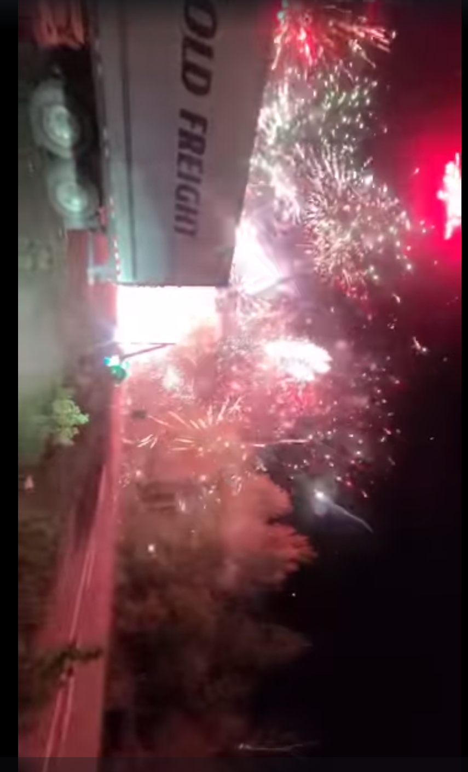
Previous incidents

26/10/2023 RTA
This incident involved an articulated lorry carrying a large quantity of fireworks crashing on a Canadian highway. This resulted in an hour long firework show as the cargo ignited. Luckily this incident resulted in 0 deaths and only 1 injury, the driver. This did however cause significant disruption to the local area and tie up emergency services. Due to how recent this incident was the full report is yet to be released.
Figure 3- Canadian road traffic accident [10]

26/09/2023 Qaraqosh Wedding Accident
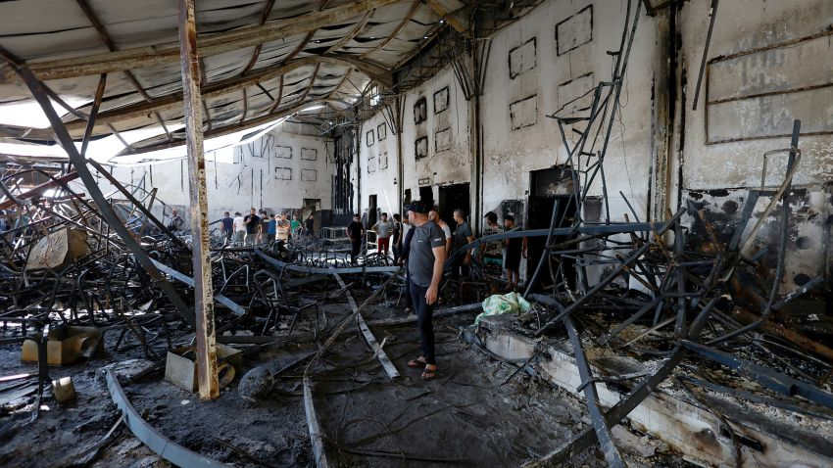
This accident took place at the Al- Haitham Hall which was large venue often used for weddings in the town of Qaraqosh, Iraq. A total of 107 people were killed when a fire ripped through the venue. It is thought that a firework hit the roof of the venue which had been lined with fabric for cosmetic reasons. Due to the fabrics high flammability the fire spread at great speed throughout the venue. The fabric then also dropped onto the floor further spreading the fire. A further 82 people are believed to have been injured, most of which are burns. Lack of emergency exits and over population of the venue contributed to the number of deaths and injuries. 5 Iraqi officials have also been sacked for grave negligence.
Figure 4- Qaraqosh wedding aftermath [11]

Colectiv nightclub Accident
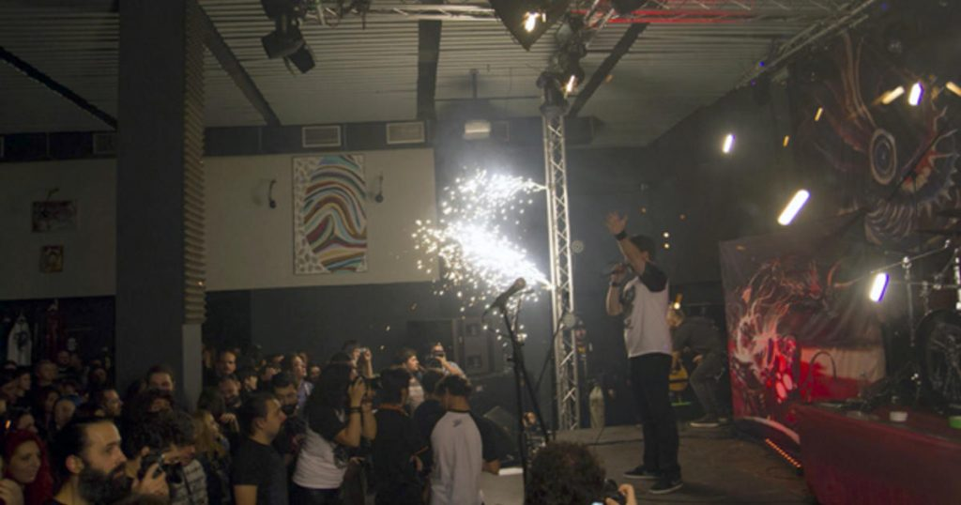
This accident took place at the Colectiv Nightclub in Bucharest, Romania. A total of 64 people were killed when a fire ripped through the venue. A further 146 people were injured, many of which serious burns and crush injuries due to the number of people trying to escape the inferno. The fire was caused by a pyro technic sparkler ignited a piece of acoustic foam which then spread. 13 people have now been imprisoned for a variety of negligence charges with the longest sentence being 12 years and 8 months handed to the firework company owner. During the investigation it was identified that failings such as lack of medical facilities, security deficiencies and corruption contributed to the deaths.
Figure 5- Colective nightclub accident reconstruction [12]

Display design

Market research
As a market leading display company it is common practice to complete market research on other companies. This allows for assessment of the competition to ensure that the service provided is deemed above and beyond. “Data has transformed the way companies approach future-proofing. Employing the right tools to collect valuable insights is crucial for businesses seeking long-term viability and brand success.” [3] Utilising modern techniques to achieve this improves efficiency.
Using the latest equipment, highest quality fireworks on the market and high quality song choice ensures that the display is not only eye catching but leaves a lasting memory with the audience. This had a link to the trials work being completed as test and evaluation of the latest fireworks and equipment would allow for the limitations to be tested in real life in comparison to the manufacture’s stated specification.

Music choice
The song chosen by the group was Toy Dolls- Nellie the Elephant (We’re Mad, Sunderland 1984). This song allowed for what seemed like a slow build up but then as the beats per minute built so did the number of fireworks with a very impressive finale. The length of the song also suited the budget constraints provided by the customer. This links into the firework selection completed by Liam. The timing of the firework linked with song chosen was vital in achieving customer satisfaction.

Simulation
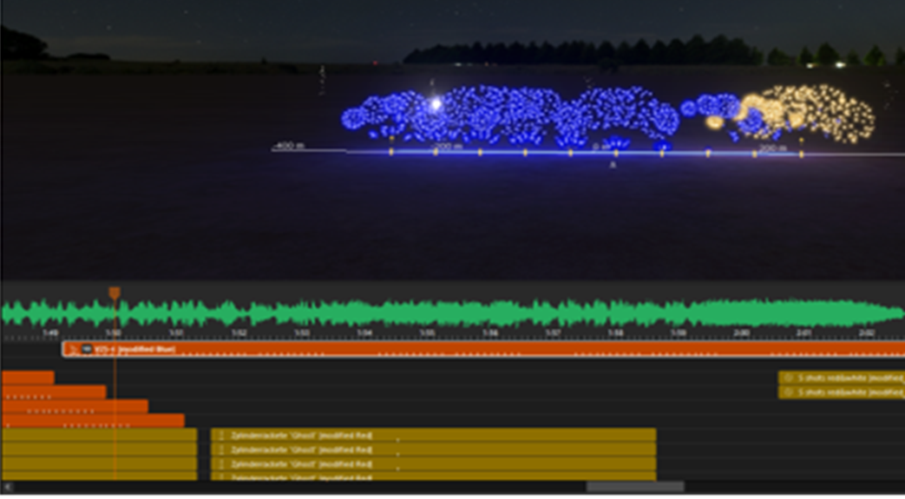
As the display had been designed from the start this required using simulation software to plan and simulate the display in a virtual environment. This was done after the song had been chosen. The song had been chosen in the software along with the desired length of the display. Each firework has different characteristics, this could be different flight time, colour and sound. Based on these characteristics the firework that was deemed most appropriate was chosen. A variety of set ups could also be chosen depending on the size of the firing area. The software used was called Fwsim. The website claims that “FWsim is one of the best 3D simulation tools of the fireworks industry, used and acclaimed by professionals and fireworks enthusiasts all over the world. After 10 years of success, and with more than 30.000 fireworks shows designed.” On reflection the software was very capable, completing what we required with ease. The software is more than capable of conducting complex displays involving buildings and large quantities of fireworks.
Figure 6- FWSIM Simulation

Firework selection
Limited by song choice and budget constraints the fireworks selected provided the audience with the wow factor stipulated in the design brief. The Net Explosive Quantity for the fireworks totalled 144.07Kg. This equated to £3,213, meeting the budget requirements. This heavily links in with the trials plan. Knowing what fireworks would be included in the display allowed for a selection to be chosen to be trialled. Trialling all fireworks was deemed to not be cost effective. In addition to the trial the fireworks used in the display is of critical importance. Small changes such as a change from 1.3G fireworks to a 1.1G fireworks would cause a number changes to be made to the trials plan, storage requirements and the location. This was stressed to Liam who undertook the firework selection piece of work due to the high importance.
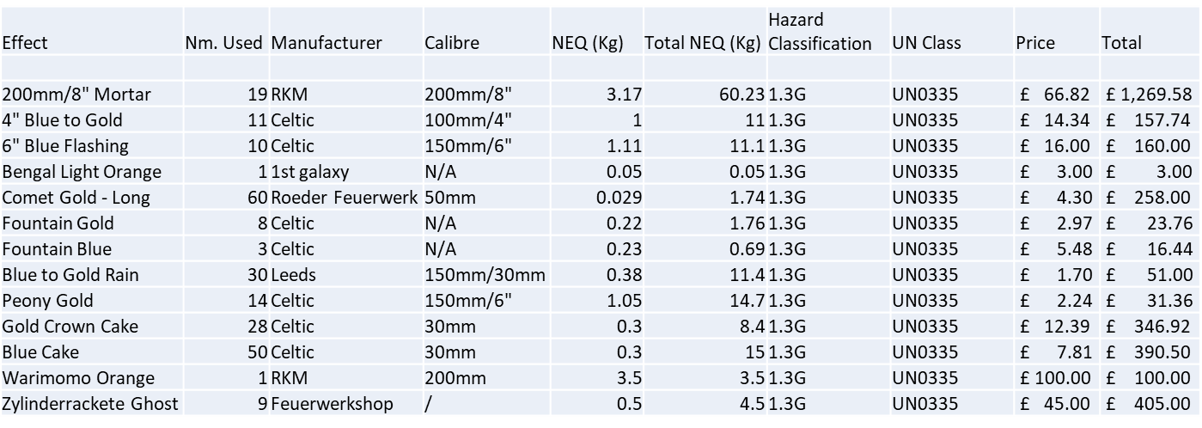
Figure 7- Firework bill of materials

Weather
Foul weather is always disappointing for the audience. What the audience often do not realise is the safety implications if the display was to go ahead. Meteorological data must be observed using the long range forecast. As the display gets closer to the display the daily forecasts should be used. These are likely to be more accurate. Local MET stations should be used in the vicinity of the firing area to gain valuable local MET data and allows for early notification of wind direction changes for example. This is included heavily links in with the trials plan and the risk assessment building the safe system of work. Considerations include precipitation, cloud cover, cloud height, sunset, wind direction and wind speed. Weather is an important safety consideration so had to be thoroughly considered throughout the planning stages and on the actual day of the display.
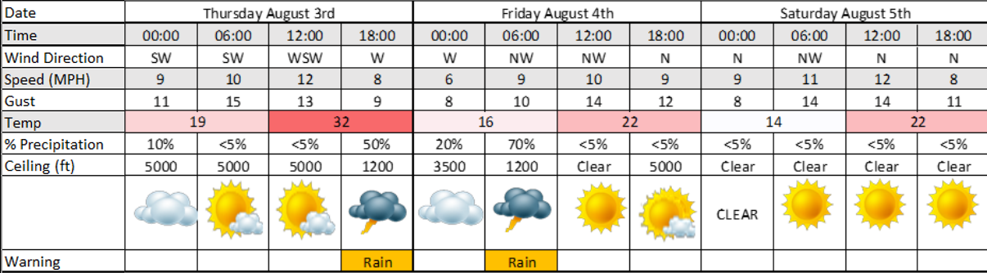
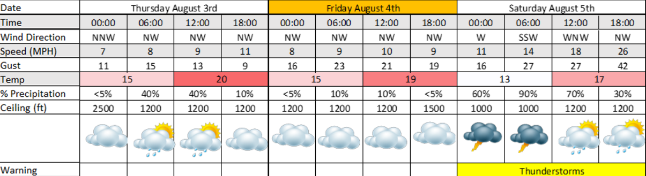
Figure 8- Long range weather forecast
Figure 9- Short range weather forecast

Location
Location is a key factor when considering the safety and practicalities of a firework display. Considerations such as firing area, safety area, spectator area, fall out area, emergency exits and buildings must be thoroughly thought through. General rules of thumb exist such as one metre of safety distance per millimetre of shell calibre. The larges shell used in this display was 8” this requires the audience to be a minimum of 200 metres from the audience. Based on the weather the location could also change. It is best practice to have more than one option in the event that a last minute change is required. Location details and safety templates allowed for Chris to fully understand the hazards and the risk this posed to the audience and team members. Without this link Chris would be completing the risk assessment without the required information.

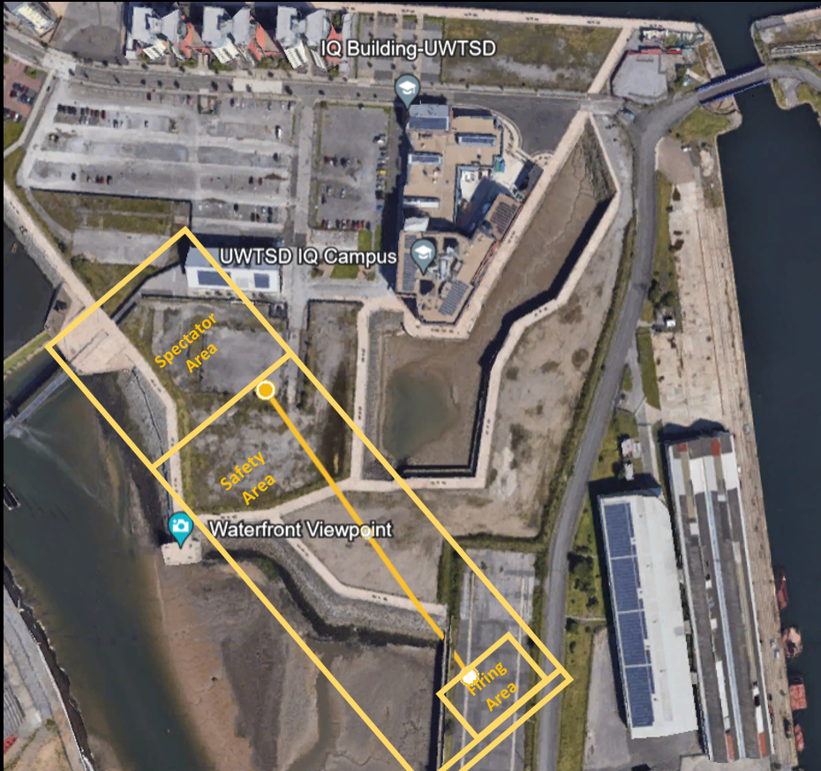
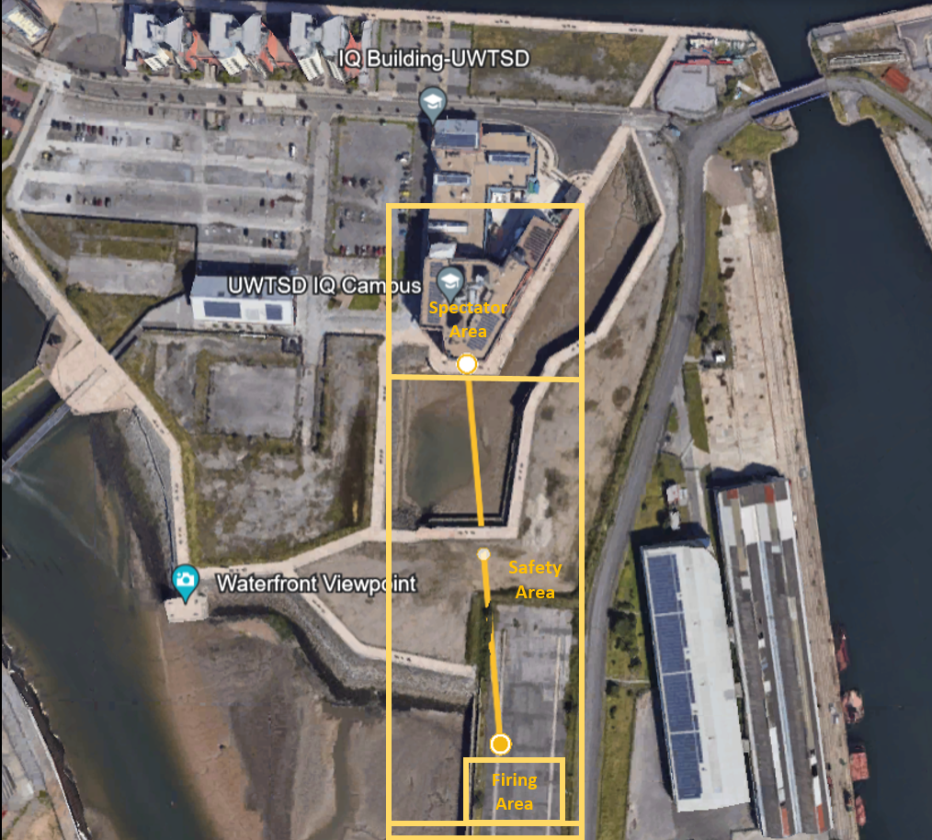
Figure 10- Northern wind
Figure 11- North-westerly wind

Shell Calc
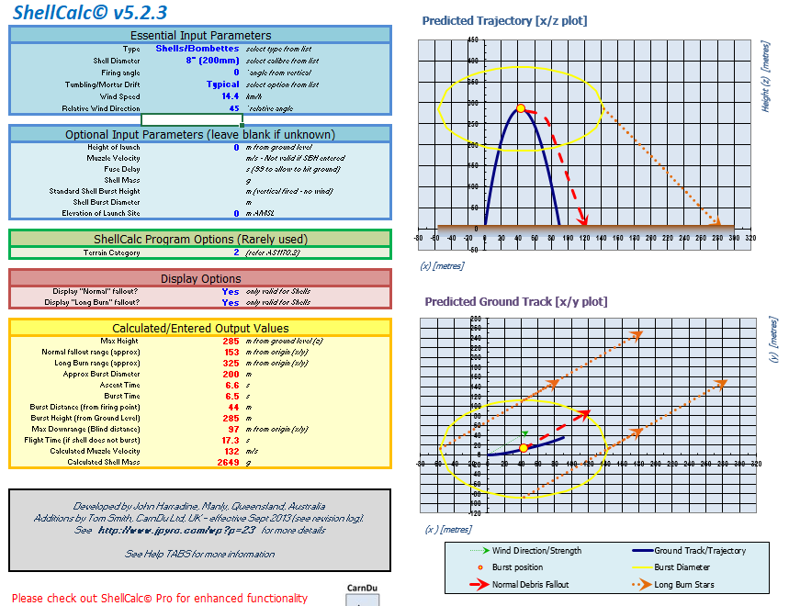
The shellcalc V5.2.3 software allows for data to be entered and results in a graphical representation for the predicted trajectory and ground track. The information entered is based on the long range weather forecast as this provides the MET data required along with the maximum shell diameter. The maximum shell diameter is used as a worst case scenario. The resulted in critical display decisions being made and contingencies considered such possible change in firing location. The link between the shell calculations and safety allowed for the appropriate safety templates and risk assessment to be applied for the display. This was checked by Chris as any errors would have had a big impact on the display.
Figure 12- 8inch shell calc

Environmental considerations
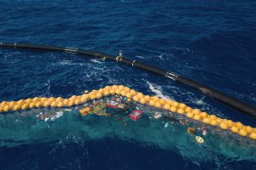
Firework displays inherently cause a large amount of waste both from the fireworks themselves and the audience. A full environmental clean-up plan must be produced for the display to ensure that the location is left in a safe state. Consideration include fumes/ smoke caused by the fireworks, full foreign object debris search of the area to ensure no spent fireworks remain and use of a net to catch firework debris in the water. This was particularly important for this display due to the location of the firing area and wind direction being so close to the sea. Fireworks not only have an impact on the immediate impact but could also be contributing to global warming. “The temporary enjoyment of fireworks releases a host of contaminants that affect air quality and can contribute to climate change, including carbon dioxide, carbon monoxide, nitrogen, sulphur dioxide, and particulate matter.” [4]
Figure 13- Environmental clean-up net [13]

Licensing
Each council enforce a number of different rules and regulation surrounding events. Swansea council require a temporary event notice to be in place for firework displays. This limits the attendance to 499 people including staff. It is also mandated that the event must finish before 2300 hours. “A temporary event notice (TEN) can be used to allow a licensable activity at a small scale one off event.” [5]
Swansea council also require an explosive storage license to be acquired. Exemptions to this include storing 5kg NEQ equivalent to 20kg gross or 100kg NEQ hazard type 3 provided that they are stored no longer than 3 days in their place of intended use; or 50kg NEQ hazard type 4 provided that they are stored for no longer than 21 days and are not for sale or for use at work. This type of exemption allows for small quantities of fireworks to be stored at home or for hazard type 3 stored at the display site for no longer than 3 days. This links in with the trials plan as licensing and storage requirements. Specific licensing had to wait until the fireworks had been chosen due to certain exemptions and limitations.

Health and safety

Hazard identification
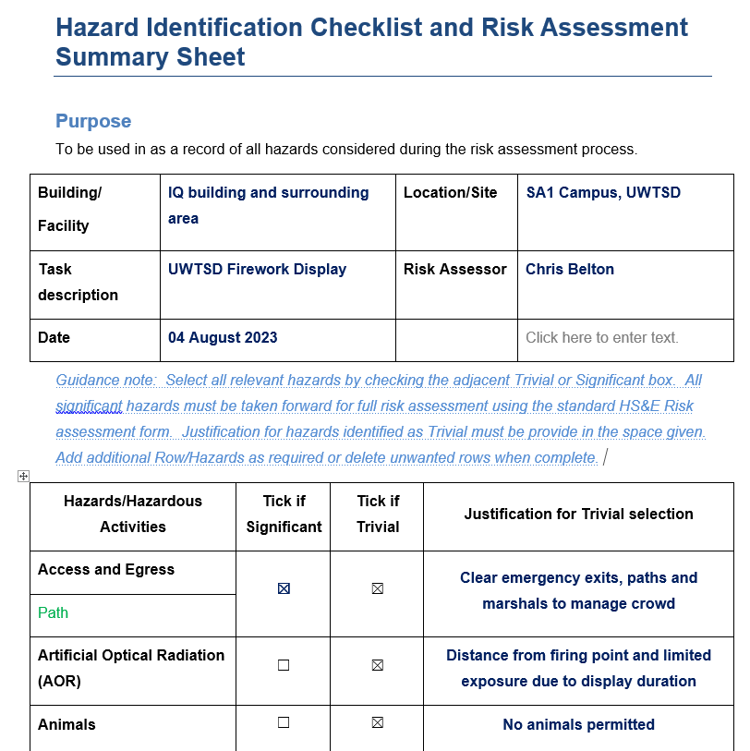
Correct hazard identification allows for the appropriate mitigations to be implemented. One must not assume the risk remains the same even when the task is similar. This is often the case when conducting a firework display. Many companies use generic risk assessments which do not adequately evaluate the risk. Hazards identified included explosives, electricity, fire, manual handling, poor housekeeping leading to a slip/trip and fall, crushing, pinching, weather, water and crowd. The hazard identification checklist is used to record this process. This also allows for hazards deemed trivial not to be included in the risk assessment but ensures the risk has been considered.
The Civil Aviation Authority released a report listing a number of hazards that aircraft are vulnerable to. “Firework displays can vary from the small-scale garden event to a major commercial or ceremonial occasion; they have the potential to distract and confuse aircrews or damage aircraft during flight operations. A feature of fireworks displays is that solid objects are physically launched into the air to create the full visual effect. Many fireworks associated with large-scale events can dispense canisters several hundred feet into the air. Whilst the risk of collision with aircraft is small, the existence of such projectiles needs to be borne in mind when carrying out an assessment for firework displays in the vicinity of aerodromes.” [3] Thorough research on the local area must be conducted to minimise this risk.
Figure 14- Hazard identification check list

Risk assessment process
Using the hazard identification checklist above two different risk assessment were produced focusing on the firework trial and then the display. Many of the risks remained the same between the two different risk assessments. Once the risk has been accessed, the next stage is to assess the risk. How likely is it that someone could be harmed and if so how serious? This focuses on human life but also includes the environment. The risk must be appropriately controlled using the as low as reasonably practicable principles. Possible controls include redesigning the task, replacement of materials and the use of personal protective equipment. Balancing the level of risk against the measures that would need to be enforced to eliminate the risk completely must be done. This could be in terms of financial commitment and the time required to achieve the solution. Spending one million pounds and 10 years’ worth of work to reduce the chances of someone having a paper cut would not be deemed reasonably practicable. Recording your findings and the constant review of processes and risk assessments must be conducted. [4]
The risk assessment process links in with a number of other areas including the trials plan, legislation, weather and location. Constant discussion between all involved was required to ensure that nothing got missed. This involved regular meeting and design reviews.
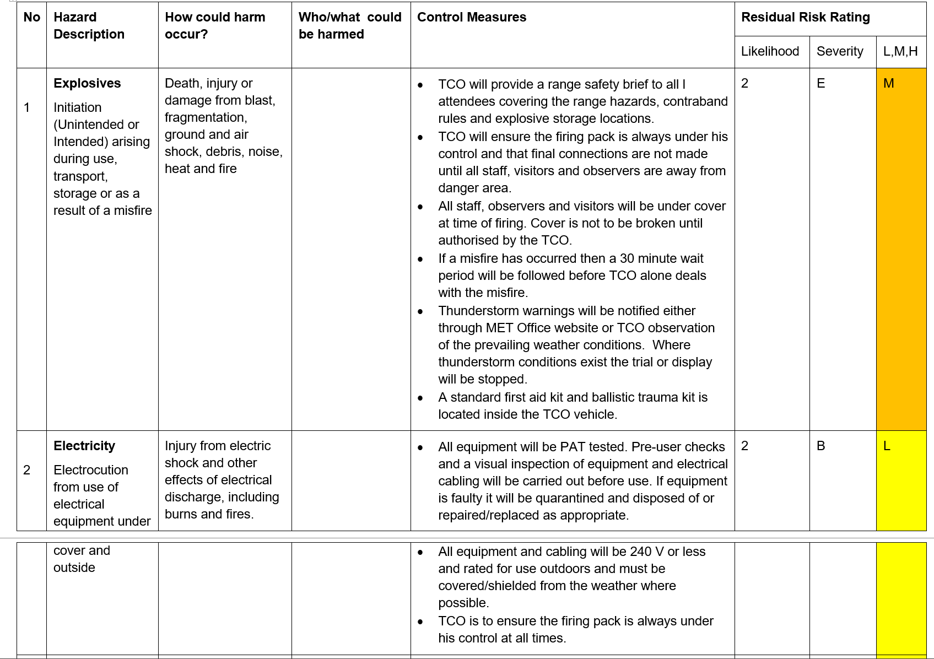
Figure 15- Trials risk assesment example
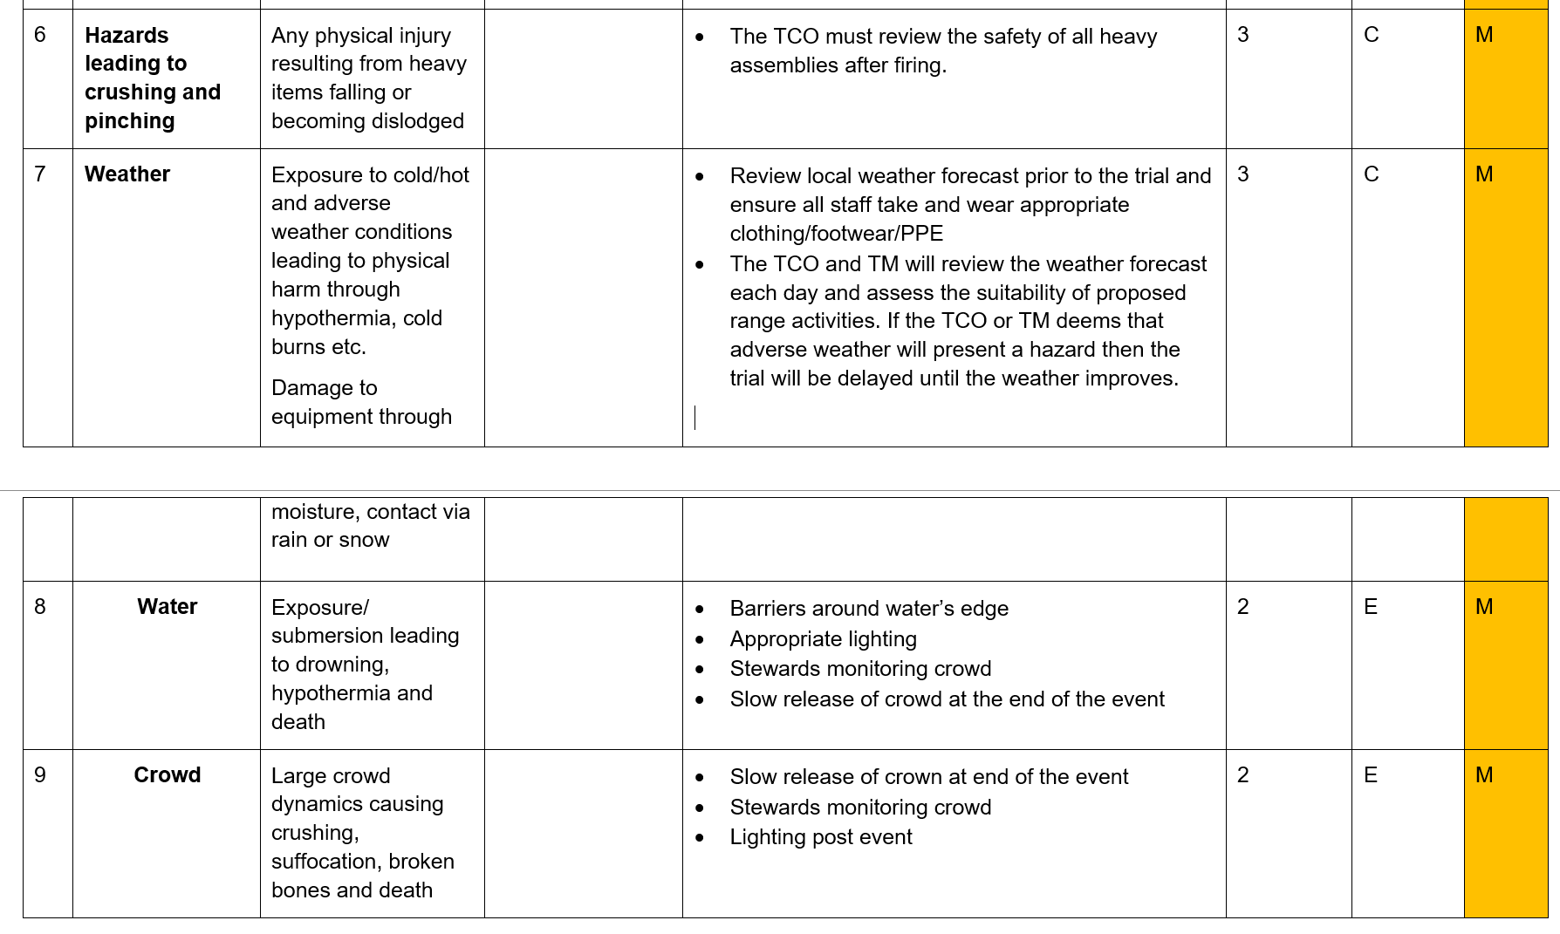
Figure 16- UWTSD display risk assesmsent example

Hierarchy of control
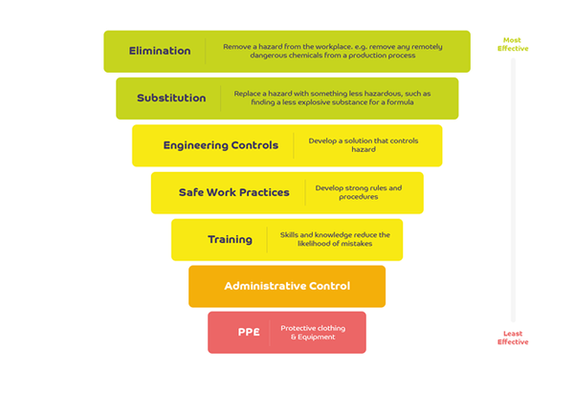
Figure 17- Hierachy of Control [8]
The hierarchy of control is used in the order listed in figure 17 to appropriately manage and control the risk. This links in with a number of other areas such as the trials plan, risk assessment and the choice of location completed by Hayden.
Elimination is the ultimate control measure if this is possible for the specific task. For example removing a process worker from an explosives area to operate machinery remotely eliminates the risk to the individual. There will still be a risk to the facility and environment but this is far more tolerable than human life. This would also be following the as low as reasonably practicable (ALARP) principles.
Substitution should be used when elimination is not possible or not deemed reasonably practicable. For example substitute the traditional non insensitive munition (IM) main explosive fill such as trinitrotoluene (TNT) for another explosive fill that is classified as an insensitive munition explosive such as 2,4-dinitroanisole (DNAN), nitrotriazolone (NTO), and nitroguanidine (NQ) (IMX-101).
Engineering controls should be used when elimination and substitution is not possible. This could be a large array of things. Interlocking guards, detection systems and fall arrest system are just 3 common examples. When remotely cutting a propellant sample the door to the machine must be closed. This door has an interlock which will disable the machine from operating until this engineering control measure is achieved.
Safe working practices should be used in conjunction with the other control measures. This involves developing strong safe systems of work that have been rigorously tested. These can also be linked with other control documentation such as risk assessments, method statements and operating procedures.
Training should be undertaken on a regular basis in conditions that closely resemble the work. One example of this is first aid training. The training should be conducted initially but then refreshed on a regular basis in the environment you will be working. Small changes such as being away from running water could have a big impact if you need to irrigate a chemical burn or flush an eye.
Administrative controls link in with safe working practices. These would often be stipulated in the safe systems of work. These include mandatory signage, effective leadership and appropriate selection of personnel to undertake the work. One example where all 3 examples above work together is when a team leader, using a management system which takes into account training and availability, selects an appropriate individual for the task. This individual then complies with the mandatory ear defence sign on the outside of the building. This then links with PPE.
Personal protective equipment (PPE) this is final control measure in the hierarchy of control as PPE is deemed the least effective solution. This does not mean that PPE is not needed. With the correct mitigations discussed above PPE can be utilised as an additional safety measure when it is not possible to eliminate, substitute, build an engineering control, fully develop a safe working practice, reduce through training and the use of administrative controls. Items such as ear defence, steel toe cap shoes and respiratory protection would be classed as PPE. PPE must meet vigorous British Standards and replaced if damaged.

Firework Trial

Aim
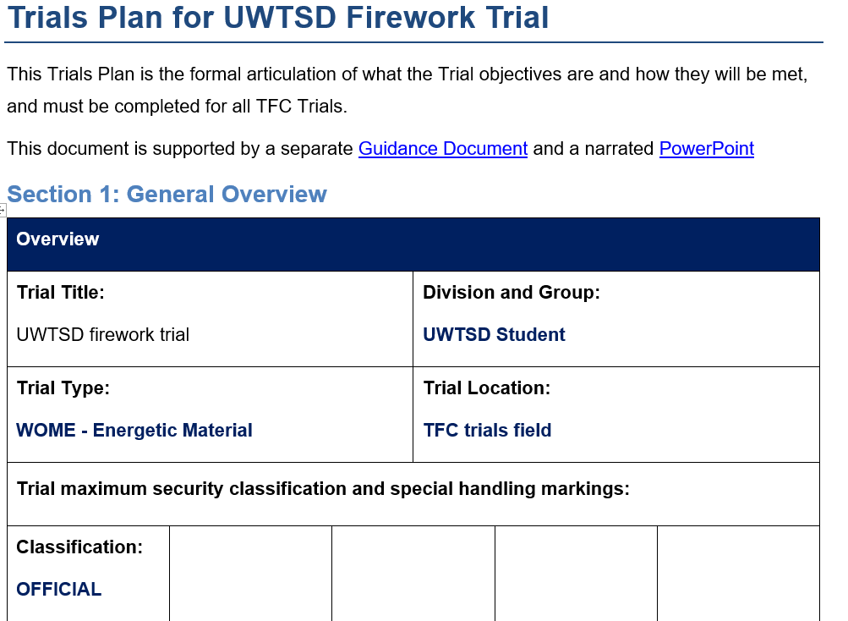
The aim of the trial was to access the accuracy of stated firework characteristics focusing on but not limited to the following factors;
- Comparison between 3 blue fireworks from the list from different manufacturers to see if it is actually blue or closer to green
- Sound volume
- Type of sound
- Colour
- Brightness
- Size/ spread
- Velocity
Figure 18- UWTSD Firework trial
Fireworks tested included;

Figure 19- Fireworks tested

Results
The results from this trial informed the design choices for the final display. Three of each firework type were tested to ensure enough data could be gathered to make a sound evidence based judgment on the factors listed above. CELTIC fireworks appeared to have a stronger blue colour compared to LEEDS. This is based on the opinion of the team members on the trial. These results were then communicated across the team to inform other team member’s choices and decisions that needed to be made. The firework trial was a critical part of designing the display. This allowed for the specific fireworks to be purchased for the display. Contingencies included the organisation of an additional trial to test further fireworks. This would have likely caused a delay due to the procurement and planning process.

Executing the display
The display has been treated as a trial for planning purposes. A full trials plan has been completed to correctly plan, mitigate risk and execute a display that meets all customer requirements. The following sections were included in the trials plan as part of the safe system of work. Executing the display required working across the team with input from all team members. The trials plan incorporates all of the research and knowledge built up throughout the process culminating in the display. Contingencies included having two options for the location of the crowd whilst keeping a very similar firing area. This would allow for the correct safety template to be used based on different weather reporting. The local MET station was also used to analyse the weather at the firing point.

Management of change
All staff irrespective of role on a trial are authorised to stop any activity they consider to be unsafe or that will have a detrimental environmental impact. Where staff are unsure about the safety of an activity it must not be undertaken until the TM has been consulted. The trials plan contains a full section on the scope of change and the process in order to agree this change. This also includes the level of authorisation that is needed. This could be a decision on the ground or one which requires consultation with the customer/ UWTSD. All team members are aware of this requirement.

Equipment details
Equipment lists reduce the chances of vital bit of equipment being forgotten. This also allows for de-confliction between different trials or displays taking place at the same time. Thorough research led to the purchase of the FireOne XL4 firing module. [6] This provides a greatly enhanced capability. This following list is not exhaustive but includes a number of important items.
- 144.07kg NEQ fireworks
- Firing module (FireOne XL4)
- Firing rack
- Camera for still photos
- Camera for videography
- Diesel generator
- XL2 Sound meter
- MET station

Emergency plan
First aid was provided by TFC team members alongside UWTSD staff. The major trauma kit was held in the TFC trials manager vehicle. Emergency exit from area was clear at all times. Policed by TFC and stewarding staff. This again is building on the safe system of work discussed previously.
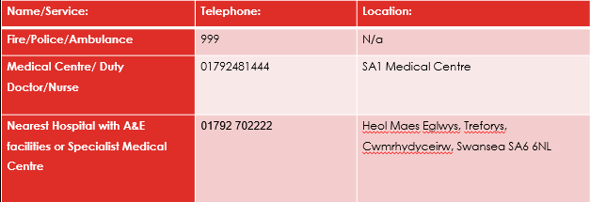
Figure 20- Emergency contact details

Personal Protective Equipment
PPE is the last section in the hierarchy of control. This does not mean it is not required. PPE in addition to the previous sections of the hierarchy of control allow for a safe system of work to be produced. PPE must be serviceable, in date and conform to the required standards. This links in with the firework choice as a change in firework type could dictate a change in the PPE requirements.
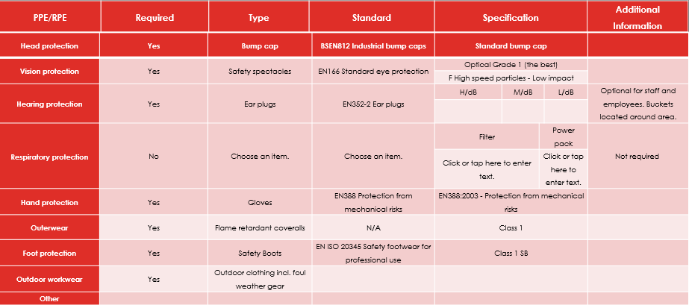
Figure 21- PPE requirements

Assigned roles
Having assigned roles allows for all team members to have a clear direction on their roles and responsibilities. This again, is all part of building the safe system of work. Knowing who to go to in the event of an emergency and one single point of contact if anything needs to be escalated. Roles included;
- Display Operator
- Marshall
- First Aid Trained
- Transport and Storage Manager
- Safety Operator
- TFC Team Leader

Design review
Two planned design reviews had been booked in. Unfortunately due to technical issues the group was unable to share the work that had been completed to date. This raised concerns over the amount of work that had been completed. To alieve concerns another design review was booked in one week later. The final design review was a success. The group was able to share the screen through utilising another Microsoft team’s account. The group went through the presentation and the feedback was that there was too much information included, some of which should be added to the report. Based on this feedback the group re worked the presentation a number of times cutting out information that was not needed. This was a gradual process and all team members were in agreement when information had been removed. This information did not get deleted but put in a separate reference file and used to answer any questions posed after the presentation. The design review incorporated all team members work so there was a strong link between all work streams.

Presentation

Practice
Practicing the presentation before allowed for a number of changes to be made to ensure that the highest score could be achieved. The order in which the slides were presented changed a number of times as the presentation evolved making best use of the different skill sets within the team. Timing each section ensured that the time constraints given could be met. The end goal of the presentation was to show or present the conclusions from all the research, trials and pre work that had been completed. This reports shows how we achieved that conclusion. There had to be a clear line between the information that went into the presentation and the report.

Reflection on presentation
Reflecting on previous work allows for improvement to be made in the future. Self-reflection is important but having independent scrutiny on your work is also of great importance. Two examiners who were subject matter experts in the explosive field provided both verbal and written feedback. As this presentation was marked against a marking scheme an overall grade has also been provided in figure 22.

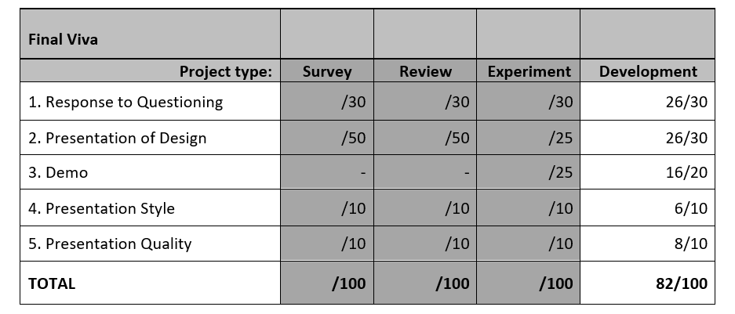
The link between the different roles has been important throughout the process but culminated with the final presentation. This involved not only presenting the work completed individually but showing where this linked into the other team members. For example the risk assessment could not be completed until the firing area had been chosen.
Figure 22- Presentation marking card [10]

Reflection on the process
The process proved challenging due to a number of reasons, one of the most important was communication. Poor communication between team members resulted in certain aspects of work being repeated and missed. If this was not identified at the time this could have had a detrimental effect on the presentation and display. This also meant the plan put in place at the start of the project did not get followed. Due to availability of team members, in person meetings proved difficult to organise with only two being attended by the complete team at the same time. This also added pressure to meet the required deadlines such as key design review meetings.
Under pressure to complete the work the team pulled together to produce a quality product that had a large amount of thought and research to back up the decisions made. Evidence based decision making was one highlight of the process. Although the initial plan did not get followed all point did get covered in the research and presentation. This was commented on by the independent examiner.

Conclusion
In conclusion the presentation to the customer was a success. This was as a result of hard work and determination in the lead up to the presentation. Early deadlines had been missed due to work commitments limiting time available. The design review meeting allowed for a formal situation report to allow for progress to be made before the next meeting. Each team member played a role in the preparation work and their section of the presentation. The presentation practice was evident in the presentation to the customer, this was also noticed by the examiner. It was identified early on that each section and role was critically important to one another resulting in work not being able to be completed until previous preparation work had been completed. This was communicated to one another at the earliest opportunity.
Treating the main display as a trial allowed for the appropriate preparation work and safe system of work to be implemented. This included the risk assessment. Additionally this allowed for a large amount of information to be collated in one single document. This acted as the single point of truth that other team members could use as a reference. Working with other team members was required throughout the process to ensure all the required info had been included.

References

[1] | National Health Service , “Top doc urges public to be safe this Bonfire Night and Diwali,” 04 November 2021. [Online]. Available: https://www.england.nhs.uk/2021/11/top-doc-urges-public-to-be-safe-this-bonfire-night-and-diwali/. [Accessed December 2023].
[2] | S. Wilkins, “Evidence for two safety questions posed by the fireworks inquiry,” UK Government, 2019.
[3] | R. Kelly, “Market Research: An Important Investment For Long-Term Viability,” June 2023. [Online]. Available: https://www.forbes.com/sites/forbestechcouncil/2023/06/01/market-research-an-important-investment-for-long-term-viability/?sh=51cd8301551b. [Accessed December 2023].
[4] | J. Han, “Crowd-Pleasing Fireworks Are Not So Pleasing to the Planet,” Earth.org, 19 April 2023. [Online]. Available: https://earth.org/environmental-impact-of-fireworks/#:~:text=The%20temporary%20enjoyment%20of%20fireworks,sulphur%20dioxide%2C%20and%20particulate%20matter.. [Accessed December 2023].
[5] | Swansea Council, “Temporary event notices,” 07 February 2023. [Online]. Available: https://www.swansea.gov.uk/article/4527/Temporary-event-notices. [Accessed December 2023].
[6] | Civil Aviation Authority, “Operation of Directed Light, Fireworks, Toy,” TSO (The Stationery Office) , Norwich, 2011.
[7] | Health and Safety Executive, “Managing risks and risk assessment at work,” [Online]. Available: https://www.hse.gov.uk/simple-health-safety/risk/steps-needed-to-manage-risk.htm#_Control_the_risks. [Accessed December 2023].
[8] | BCarm, “What is the hierarchy of controls?,” [Online]. Available: https://www.bcarm.co.uk/insights-and-news/health-and-safety/what-is-the-hierarchy-of-controls/. [Accessed December 2023].
[9] | FireOne, “FIREONE XL4+,” 2023. [Online]. Available: https://www.fireone.com/products-firing-system-hardware/control-panel-automatic-xl4/. [Accessed November 2023].
[10] | D. Holley, “HNC Group Project Marking Sheet group 3,” 2023.
[11] | BBC, “Car crash leads to fireworks show on Canadian motorway,” 02 November 2023. [Online]. Available: https://www.bbc.co.uk/news/av/world-us-canada-67303123. [Accessed December 2023].
[12] | CNN, “‘Wedding became a graveyard.’ At least 100 killed as fire rips through party in Iraq,” 27 September 2023. [Online]. Available: https://edition.cnn.com/2023/09/26/world/iraq-wedding-fire-intl/index.html. [Accessed December 2023].
[13] | Working With Crowds, “Colectiv Nightclub Fire,” 2023. [Online]. Available: https://www.workingwithcrowds.com/colectiv-nightclub-fire/. [Accessed December 2023].
[14] | E. Fernandes, “Marine Debris Collection Equipment Market Size, Forecasting Share and Scope for 2023-2030,” 2023.

