Student name: | OOI Nicholas Tyan Chyi | Student ID number: | 2031098
Programme: | DBA
Module: | Approaches to Research and Academic Communication
Module code: | HKBM7000 | Contribution to Overall Module Assessment (%): | 60%
Lecturer: | Dr. Luk Chung Leung | Internal Verifier:
Assignment Title: | Research Proposal | Word count (or equivalent): | 4,781 words
Submission deadline: | 6 September 2021 | Return date of provisional marks & written feedback: | 5 October 2021

Title: The Internal Factors that Affect the Survival of Social Enterprises During the COVID-19 Pandemic in Hong Kong

Abstract: Since the outbreak of the COVID-19 pandemic in Feb 2020, social enterprises in Hong Kong had adopted many new ways to fight for their survival. Due to the different factors that have affected the operation of the Social Enterprises, it is crucial for us to understand which forces might play an essential role in the survival of the social enterprises during the pandemic. In this research proposal, I would share the research questions, research objectives and methodology for my studies. COVID-19 pandemic has had an extensive effect on global society, especially on the business sectors. And currently, there aren't not many social enterprises related articles in Hong Kong that mentioned about the effect of the COVID-19 pandemic. Other than the existing external factors, it is important for us to study the internal forces through Strategy Map Balance Scorecard include operation management process, customer management process, innovation process, regulatory social process. The mentioned process could shape the social enterprises to survive their business operation.

Keywords: social enterprises; COVID-19 pandemic; Porter five Forces Model; strategy map balance scorecard; Hong Kong; survival; operations.

- Research Problem and Introduction

  - Social Enterprises in Hong Kong

A "social enterprise" is an organization that solves social problems through a market-driven approach and is characterized as a hybrid organization that combines both for-profit and nonprofit approaches with a social mission (Social Enterprise Alliance, 2018). The concept of social enterprises uses entrepreneurial strategy for the benefit of society while earning profit to sustain the office. The organization must find a balance also to create social value. Operate a social enterprise involves a high level of complexity. Most founders and co-founders fight for their survival for long-term sustainability because they must achieve commercial and social objectives (Moizer and Travey, 2010).

In one of their papers, Gandhi and Raina (2018) discussed that social entrepreneurship has different genres. They also mentioned that social entrepreneurship stressed solving social issues and produce progressive externalities. In Hong Kong, the total revenue generated by the Social Enterprises was equal to 0.056% of Hong Kong's total GDP, which is also equivalent to HKD1.3 billion (Kee et. al., 2016). Kee and his team (2016) also mentioned that there are three stages of Social Enterprise development. The first stage is marketisation, which suggests that social entrepreneurs use the least financial resources to create social value. The second stage is Actualization that suggest social entrepreneurs to demonstrate the social impacts generated by the social enterprise. The third stage is called Diffusion, in which the founder and co-founders extend their influence and build the eco-system outside of the Social Enterprise sector, and then scale up the social impact. According to Kee and his team, most of the Social Enterprises in Hong Kong is currently past the first two stages.

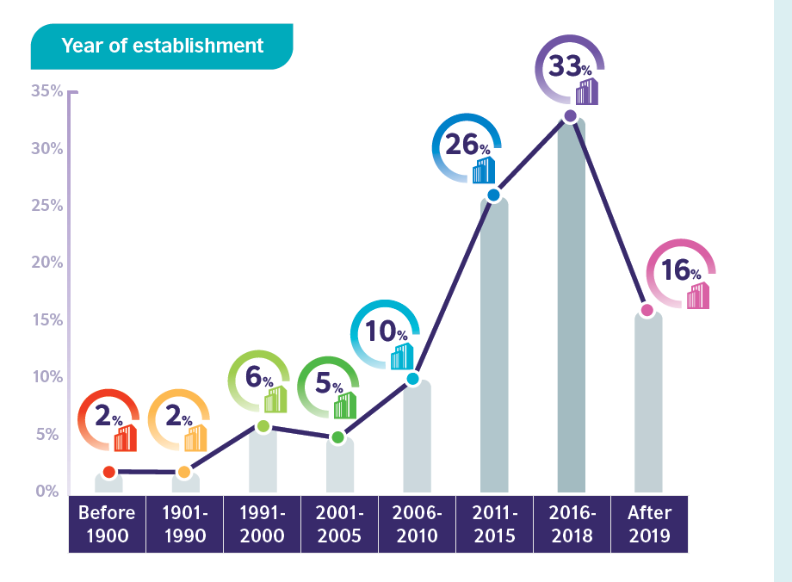
Figure 1: Year of Establishment for Social Enterprises in Hong Kong (British Council, 2020)

As we could understand from the graph above (Figure 1) by British Council (2020), out of 146 respondents, most of the social enterprises in Hong Kong have been founded in the past few years and have decreased in year 2019 and after. Almost 59% of the social enterprises were found in the year 2011-2018. Due to the social unrest in Hong Kong from Jun 2019 and the COVID-19 pandemic from Feb 2020, there is a significant decrease in social enterprise start-up. It is surprising that social enterprise already exists in Hong Kong before 1900.

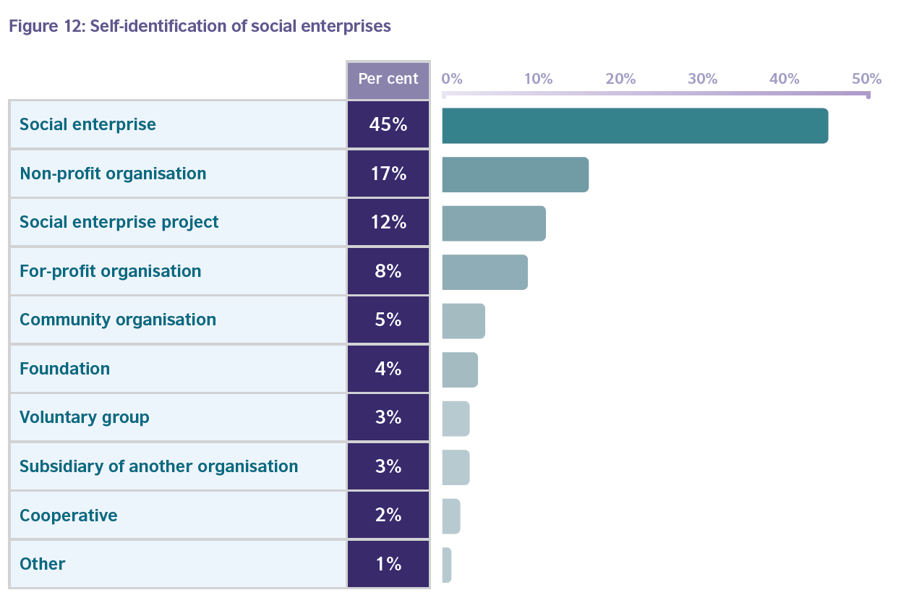
Figure 2: Self-Identification of Social Enterprises in Hong Kong (British Council, 2020)

Currently, Hong Kong does not have a standard legal form and registration for social enterprises; it does not have a formal definition of social enterprise. So, it is flexible for organizations and companies to distinguish themselves as one. As we can see from the graph (Figure 2) provided by the British Council (2020), out of 146 respondents, 17% of the non-profit organization, 12% of the social enterprise project, and 8% for-profit organizations also self-identify their organization as a social enterprise. The self-identification is only specific to Hong Kong because large organizations like NGOs and Charities often spin-off multiple social enterprise projects. For instance, Yan Oi Tong Limited has three social enterprises under its big umbrella: Greenhome that promotes sustainable development and responsible consumption. The Rivulet employs the disadvantaged group to provide massage services, and Healthy Living Shop for seniors to improve the quality of life for elderly citizens.

Social enterprises usually depend heavily on donations and funding from donors and the government, especially in the start-up or incubation stage (Luke, 2016). Currently, in Hong Kong, there are three government funding schemes, they are provided by the Efficiency Office of Innovation and Technology Bureau, the Social Innovation and Entrepreneurship Development Fund, provided by the Social Welfare Department, the Enhancing Employment of People with Disabilities through Small Enterprise fund, and provided by the Home Affairs Department, the Enhancing Self-Reliance through District Partnership Program. Currently, during the outbreak of COVID-19, the government implemented the Anti-epidemic Fund to allow social entrepreneurs to apply for the Employment Support Scheme (ESS). In a study done by Sidney Leung and his team (2019), the funding sources, investment objectives, and enterprises governance matter to the sustainability of social enterprises in Hong Kong. It is essential for social enterprises invest on long-term sustainability with an operation horizon of 3-5 years (S. Leung et. al., 2019). The good use of funding could be a critical move for founders and co-founders of social enterprises to ensure the sustainability of their organization.

  - Definition of Problems

The outbreak of the COVID-19 pandemic is having a harmful effect on social enterprises in Hong Kong. An entrepreneurial understanding is required since the change of a lifestyle and needs to all individuals after the hit of the COVID-19 pandemic (Vannesa, 2020). A recent study by the Chamber of Social Enterprises Hong Kong (2021) shows that out of 222 founders and co-founders of social enterprises, 111 of them mentioned the profit of an organization in Nov 2020 had dropped more than 50% compared to Dec 2019. In addition, the study also noted 68% of them were not optimistic about the sales in the coming three months as of Jan 2021, and 51% of them were very pessimistic about the sales for the whole year of 2021. These statistics are concerning and suggest the devastating effect on social enterprises in Hong Kong during the COVID-19 pandemic. In the same study, 73% of the founders and co-founders mentioned that in Jan 2021, the effect of the sales dropped was affected by the cancellation of orders or services, which rank the first. Among the orders and services cancellation, 95% from the services sector, 80% from retail, and 75% from catering and restaurants. The customers' reduction was ranked second with 59%, out of it 85% from retail, 73 from the health and nursing industry, and 62% from catering and restaurants. 49% of the founders and co-founders mentioned that most consumers had declined their consumption desire, which mainly affects the services industry, also the health and nursing industry. The causes, as mentioned earlier, could highly affect the operational cost and profit for social enterprises owners to sustain their company.

Since it is hard to forecast for such a crisis, and the pandemic is foreseen to continue for an unknown period (He and Harris, 2020), this situation is getting harder for companies to plan for future development. World Health Organization (2020) also mentioned that the COVID-19 pandemic does not have a specific duration, unlike other previous crises. This crisis has brought adverse reactions, especially to the financial situation. It is essential for an organization to survive during this situation; they should either treat this as a threat or an opportunity (Alon, Farrell, and Li 2020). Since Feb 2020, there were several waves of COVID-19 outbreaks in Hong Kong. During each wave of the COVID-19 pandemic outbreak in Hong Kong, there are different social distancing measurements, which could make it hard for social enterprises to cope with the fast-changing regulations. Each measure reduced social activities that primarily affect consumer intention to shop and purchase products and services. In addition, from the previous study by the Chamber of Social Enterprises Hong Kong (2021), 50% of the social enterprises said they could survive for another year if the COVID-19 pandemic continues. To survive, it is not simple, and it is crucial to understand which internal factors cause the most harm and which aspects would positively impact some social enterprises in Hong Kong.

It is essential to help social enterprises understand the factors and propose few ways in which organizations' founders and co-founders can control and successfully manage their business operation during the outbreak. COVID-19 pandemic also changed consumer behavior. The New Normal approach also means changing an individual's lifestyle and purchase behavior during the COVID-19 pandemic online and offline, which would affect the social enterprises to adjust their business model according to the new needs (Vannesa, 2020). It is impossible to become a successful entrepreneur without risk, and it is essential to know when and where to take risks (Pittz and Liguori, 2020). According to the study by the Chamber of Social Enterprises Hong Kong (2021), 59% of the founders and co-founders of social enterprises mentioned that up till Jun 2021, it is not possible for them to shut down their businesses. In my research, I would learn more about the risks the founder or co-founders have taken for their company survival. The rapid evolution of technologies could create more entrepreneurship opportunities, especially during the pandemic (Kuckertz et al., 2020). It is also interesting to understand what innovative approach the entrepreneurs have taken to survive during this critical moment.

  - Literature Review

In my literature review, I will provide different perspectives of the impact of COVID-19 pandemic to the social enterprises. In which, I will frame my research questions around the statements I’ve found. The specific themes of the literature review include: i) The status of COVID-19 pandemic to the social enterprises; ii) The influence of global economics; iii) The effect of COVID-19 pandemic to the social enterprises in Hong Kong; and iv) The factors of driving business change of social enterprises.

Beginning of March 2020, World Health Organization (2020) declared a global pandemic for the COVID-19 Coronavirus outbreak. Since then, most countries have implemented different measurements to control social distancing and reduce social activities. Up till now, there are not many articles about the impact of the COVID-19 pandemic on the and social enterprises sector. There is limited literature to draw on about the challenges faced by these companies in Hong Kong. However, some research has been done by Kuckertz and his team (2020) to discuss with bricolage theory which discover the financial challenges that faced by these companies during the critical time. In addition, there are also some research and data from the non-government organizations and corporate companies that I could draw from.

Andreas Kuckertz and his team (2020) also mentioned in one of the recent studies that during the initial phase of the pandemic in the United States, many businesses and communities had been affected because it was a standstill for the economy. Many studies focused on health rather than the COVID-19 pandemic impact on business operation. The COVID-19 pandemic is a global crisis; like any other crisis that could affect human's health, it would then affect international economics (Ahani and Nilashi, 2020). Most countries put much effort to contain the virus, which led to economic shutdowns around the world. A study conducted in 2006 focused on the role of entrepreneurship during different disasters, which found out that other than death, it can also fracture the socioeconomic structure of affected cities or countries (Galbraith and stiles, 2006).

It is more complicated in countries or cities with emerging economies. Since the pandemic is "dramatically worsening the economic outlook for emerging economies" (Herrero, 2020) like Singapore, Brazil, Turkey, and Mexico experienced few waves of the pandemic (Kawamorita et. al., 2020), which could cause significant damages if social enterprises took the wrong business action. Take Hong Kong as an example; the government has priorities improving public health capacities and would have tighter mobility restrictions. Most resources would just be invested in basic needs for their citizens (Ojha and Shubha, 2020).

On the 28 January 2021, SCMP (2020) reported that the Hong Kong government announced the first work-from-home implementation and applied border control to reduce traffic from Mainland China. At the beginning of the pandemic, a study also mentioned that social distancing and behavioural change like online education and mask-wearing will likely play an essential part until the end of March (Cowling et. al., 2020). On 29 March 2020, the Hong Kong government News.gov.hk (2020) announced it is prohibited for more than four people to gather in the public area. On 1 April 2020, karaoke, mahjong parlors and bars were forced to close. The closure of business operations has caused companies and organizations to find it hard to sustain their business. Only a healthier city with controlled COVID-19 cases could go back to operation. Samuel and his team (2020) figured in their study that wearing face masks have played a critical role in controlling the spread of the virus. In addition, they also mentioned high-volume testing for suspected cases, border control, and social distancing are crucial ways to handle the situation. Since the COVID-19 pandemic in Hong Kong, the government has implemented the Prevention and Control of Disease Ordinance (Cap. 599) by the Chief Executive of Hong Kong since 29 March 2020. With the updated version from 5 August 2021, more than four people group gathering is prohibited in this ordinance. While some may be exempted, like group gathering for performing any governmental function, at the workplace for work purposes, the person living in the same house, or even during a tour organised by licensee of no more than 30 participants (Legislation of HKSAR, 2021). Before that, the Cap. 599 has been changed many times during different waves of the COVID-19 outbreak in Hong Kong. The constant changing of the ordinance makes it hard for entrepreneurs to predict the government next move to make the correct business decision.

From that onwards, many enterprises had to shut down for more than a few months. However, occasionally when the situation got control before the next wave, the government would announce the resume of business operation. Some social enterprises have found it challenging to resume operation, leading to a high risk of permanent shutdown. Social enterprises and small firms are more likely to have the most significant impact due to their high dependence on government subsidies, low on preparation, increased vulnerability, and would have a higher financial impact on their founders and co-founders (Runyan, 2006). One of the TechCrunch reports suggests the start-ups and social enterprises prepare for the worse and cut down the cost because consumers are more likely to ask for a lower price. Some venture capital fund and fundraising organizations also suggested that the enterprises get ready to cut costs or downsize the company (TechCrunch, 2020). According to a survey by Peking University about SMEs in Feb 2020, about 20% of the founders and co-founders said that they could not last for a month on a cash flow basis, while 60% of them could not survive beyond a quarter (Rouchen et. al., 2020). Davidsson and Gordon (2016) also argued in one of their studies that due to the lack of will to initiate start-up activities, many companies had closed operations after the global crisis. They also questioned the entrepreneurs' persistence in business development. There is currently no effective cure for COVID-19, so it is hard for someone to estimate the timeline. Therefore, we would foresee the challenges and issues will only grow bigger if entrepreneurs do not take immediate action or take an innovative approach to solve the current problem.

On the other hand, the social distancing implementation has also created many business opportunities. For instance, Eggers (2020) has conducted a literature review and summarized that some social enterprises have tried to solve a series of challenges and find out many opportunities during the crisis. Eric and Thomas (2020) suggested that the perspective is very important in this extreme time, as entrepreneurs could see their business model as new opportunities to be created, rather than a threat that could destroy the company. It is understood that entrepreneurs find it hard to find new opportunities when the companies are facing the loss of profits, loss of employees and even loss of customers. However, many social enterprises owners have taken another route to promote their products and services online. Technological transformation has become essential when virtual businesses have become a trend due to the social distancing implementation and rather a convenient way to shop.

As a start-ups and social enterprises incubator, I have recruited 32 start-up teams from Jun 2020 till Jul 2021. Among 32 of them, almost 70% of the teams sell their services and products online either on an online marketplace or social media platforms. One study pointed out that during the COVID-19 pandemic, experts' opinions and media reports influence people's intention to purchase clothes online. And people rely on information from media reports and experts rather than family and friends (Julia et. al., 2020). Therefore, social distancing would increase people's intention to shop online because working-from-home increases the chances of going on the internet. The COVID-19 pandemic could affect human's health which could then affect global economics (Ahani and Nilashi, 2020). Still, consumers know that online shopping could vastly reduce the infection risk because virtual shopping will minimize the direct contact of people. And so, we can see that online shopping has become an opportunity for social enterprises during this crisis time.
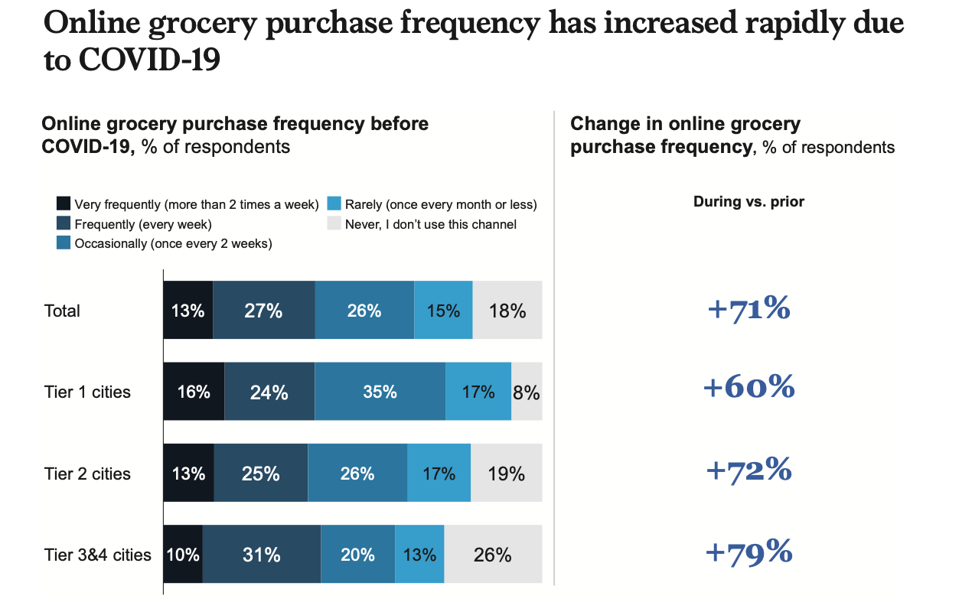
Figure 3: McKinsey COVID-19 Mobile Survey (Julien et. al., 2020)

In one of McKinsey reports, Julien and his team (2020) discover that about 55% of the consumer, out of 611 samples, mentioned that they are more likely to purchase groceries online even after the outbreak. And, according to the COVID-19 pandemic Mobile Survey, they found out that 74% of the Chinese consumer increase their online grocery visit frequency during the pandemic. Recently, online grocery retail in China has been growing almost 30% annually. More than 50% of Chinese consumers already buy packaged food virtually, which led to the rapid growth of the "stay-at-home economy" (McKinsey, 2021). We could understand from the data that the drastic increase in online and virtual purchases could be a new trend contributing to the "new normal" era. The fast connectivity enables close interaction between organizations and people virtually to facilitate various activities like teaching and learning, purchasing, meeting, discussion and more. It is not surprising in a continent when you found almost 70% of the population prefer to use mobile payment as one of their favourite payment methods (The Economist, 2013). This innovative approach could facilitate business transformation for social enterprises to retain their customers.

  - Research Questions

Since the literature review does not reveal much about what has caused social enterprises to survive, it is essential to discover the potential causes in my research. My study's main overall research question is: What are the internal forces that affect the survival of the social enterprises in Hong Kong, especially during the COVID-19 pandemic. The previous main question raises the sub-questions about the good cases we could learn from during the COVID-19 pandemic and how other social enterprises are fighting for their survival. In my research, I could develop appropriate interventions and validate the result when discovering some crucial factors. The research questions are as below:

- RQ1: Which internal factors affect the survival of the social enterprises in Hong Kong?
  - This question aims to discover the potential factors that affect the survival of the social enterprises during the COVID-19 pandemic. The Strategy Map Balance Scorecard will include the operation management process, customer management process, innovation process, and social regulatory process to design the sub-questions.

- RQ2: Which internal factor affect the social enterprises the most?
In this question, I would like to determine which factor would affect social enterprises the most while fighting for their survival.

- RQ3: Which internal environmental forces that affect the survival of the social enterprises in Hong Kong?
This question would aim to discover how the internal environmental forces would play an important role to ensure social enterprises survival during the COVID-19 pandemic. Social factors are often the essential parameters to analyze the business environment because they involve contexts like business activities that have taken place and all interpersonal actions (Thomas, 1974). Therefore, I would explore this part with the Porter five factors: supplier power, the threat of substitution, buyer power, the threat of new entrants, and competitive rivalry.

- RQ4: Which internal environmental force that affect the social enterprises the most?
In this question, I would like to determine which environmental force would affect social enterprises the most while fighting for their survival.

- RQ5: Which field of the social enterprises affect the most?
  - This question would discover which field of the social enterprises was affected the most during the COVID-19 pandemic in Hong Kong. The area includes education, business development services, elderly services, youth services, culture and heritage, medical services, retail, environmental protection, food and nutrition, manufacturing, and more.

  - Research Objectives and Hypothesis

In this research, I would like to achieve three objectives; i) To explore which internal factors that affect the social enterprises the most during the pandemic, ii) To explore which internal environmental forces that affect the social enterprises the most during the pandemic, iii) To discover whether the pandemic is the most extensive caused of business failure, and iv) To propose innovative ways for social enterprise to improve their survival if a situation like this occurs in future.

Firstly, my hypothesis for this study is that the COVID-19 pandemic could be the most significant cause of business failure. In one survey from Peking University about SMEs released in Feb 2020, about 20% of the founders and co-founders said they could not last for a month on a cash flow basis. Rouchen and his team (2020) also discovered that 60% of the social enterprises could not survive beyond a quarter (Rouchen et. al., 2020). My second hypothesis is that social enterprises should implement innovative ways to strive for their business survival. Davidsson and Gordon (2016) argued in their research that due to the lack of will to initiate start-up activities, many companies had closed operations after the global crisis.

My third hypothesis suggests that internal factors caused by the COVID-19 pandemic are the top cause of business failure and good business management and planning are essential for business survival. An organization needs to survive during this situation; the founders and co-founders of the social enterprises should treat this as a threat or an opportunity (Alon, Farrell, and Li 2020). I would discover if those who treat this as an opportunity survived or sustain their business operation. Luke (2016) mentioned that social enterprises usually depend heavily on donations and funding from donors and the government, especially in the start-up or incubation stage. While Johnson (2000) also argued that public funding becomes insufficient and social enterprise should develop an innovative approach to dealing with different complex social needs.

- Research Design and Methods

The research in my doctoral dissertation will be divided into two parts according to (Figure 4). The two parts would be both the explorative part and the hypothesis testing part. In Study 1, for RQ1 and RQ3, I aim to understand how and which internal factors and internal environmental forces influence the social enterprises' operation through correlation methods such as a survey method for data collection. While during Study 2, RQ2 and RQ4, I aim to interview as case studies to learn about the potential and specific force or factor that influences the social enterprise's survival.

I will later use the data provided in Study 1 and Study 2 to conduct Study 3 and Study 4, which specifically focus on hypothesis testing. In my final study, Study 5, I will use the collected data to analyse the comparative evaluation to discover the field that has been most affected during the COVID-19 pandemic. In total, I will conduct five studies, as shown in Figure 4 below.

Research Method | Research Question | Explorative | Hypothesis Testing
Quantitative – Survey (Corelation Methods) | RQ1 & RQ3 | Study 1 | Study 3
Qualitative – Case Study (Semi-structured interview) | RQ2 & RQ4 | Study 2 | Study 4
Quantitative – Survey  (Comparative Evaluation) | RQ5 | Study 5
Figure 4 Studies in My Doctoral Research

  - Quantitative – Correlation Method

For the data collection in the qualitative part, I would use the correlation method, which is also the survey method. For the survey, it will provide data for Study 1, 3 and 5. In addition, the survey will give both results for the explorative part and the hypothesis testing part in Study 1, 2, 3 and 4. According to Social Enterprise Business Centre (2020), there are currently 666 social enterprises in Hong Kong in their Social Enterprise Directory. And so, there are two strategies to collect the data: i) I would send out the survey to all social enterprises in Hong Kong (N=666). I would estimate to have a 15% successful rate and probably get back 100 replies, ii) there were some start-ups of the social enterprises that are still in their incubation stage at different universities that I collaborate with, with the estimation of N=50.

After collected data for Study 1, I will use an extensive questionnaire for explorative studies to understand the influence of the internal factors. In Study 3, I will use Study 1 to analyse which factors would affect the social enterprise the most during the COVID-19 pandemic, including factors such as influence from operation management process, customer management process, innovation process, or regulatory, social process. In my research, I could also use study 1 for Study 5 to understand which field most affected to fight for their survival during the COVID-19 pandemic.

  - Qualitative – Semi-structured Interview

The semi-structured interview provides a degree of flexibility for participants to voice their opinions and give them opportunities to describe their feelings and perceptions. Later, I would use the collected data from the semi-structured interview to process a cross-case analysis which could help my research to compare with different cases. In the literature review, there was also some research regarding social enterprises that adopt semi-structured interviews in their studies (Spear, 2006; Seanor & Meaton, 2007). Some specific questions were designed to understand information from individuals to teams and organizations. Some questions were open-ended and in simple sentences, which allow the participants to get the point quickly.

I aim to interview 20 small and medium-size social enterprises (with around 2 – 10 full-time employees) from different fields include education, business development services, elderly services, youth services, culture and heritage, medical services, retail, environmental protection, food and nutrition, and manufacturing, to collect the data needed. For early preparation, the questionnaire will be revealed to the interviewee together for better preparation. Especially to study RQ2 & RQ4, my research will discuss some objectives, confidentiality and outline before the interview. The recording will be made after the consent from the interviewee. If the interviewees are using Chinese, it would later be translated to English, and the transcript will be attached in the appendix. Later, I will use the collected data from the interview to analyse.

- Limitation and Conclusion

The COVID-19 pandemic is unpredictable and social enterprises would expect to spend more time and resources to secure the business operation. A fundamental limitation of this paper is that I am only able to collect only limited social enterprises to analyze the effect of internal factors that affect their organization; the number of the unit is relatively low. The sample size I aimed to send was about N=666. If only 15% of them replied, I only get N=100 sample size, which could be quite relatively low. My study was not sufficient, and it does not imply to all social enterprises in Hong Kong. Although there are many articles and literature about the effect of the COVID-19 pandemic on small-medium enterprises globally, there are not many journals and articles about the effect of the COVID-19 pandemic on social enterprises, especially in Hong Kong. My study could fill the research gap, but more case studies need to be carried out. Since I analyze with only the internal factors, I could not fully understand the external factors of the survival of social enterprises during the pandemic. Future research needs to address more on the external factors that affect the survival of social enterprises.
Reference:

Alon, I., M. Farrell, and S. Li. (2020). "Regime Type and COVID-19 Response." FIIB Business
Review 1–9. doi:10.1177/2319714520928884.

Ahani, A., and M. Nilashi. (2020). "Coronavirus Outbreak and Its Impacts on Global Economy: The Role of Social Network Sites." Journal of Soft Computing and Decision Support Systems 7 (2): 19–22.

Akpan, I. J., D. Soopramanien, and D. H. A. Kwak. (2020). “Cutting-Edge Technologies for
Small Business and Innovation in the Era of COVID-19 Global Health Pandemic." Journal of Small Business & Entrepreneurship, 1–11. doi:10.1080/08276331.2020.1799294.

Brisith Council. (2020). "The state of social enterprise in Hong Kong" Retrieved: https://www.britishcouncil.org/sites/default/files/british_council_hong_kong_social_enterprise_web_final.pdf

Chamber of Social Enterprises Hong Kong (2021) "Survey on the Operating Conditions of the Social Enterprise under the Pandemic (Third Quarter)", P1-3
Retrieve: https://sechamber.hk/wp-content/uploads/2021/01/新冠疫情下社企業界營運狀況調查-新聞稿_20210128.pdf

Cowling, Benjamin; Ali, Sheikh Taslim; Ng, Tiffany; Tsang, Tim; Li, Julian; Fong, Min Whui; et al. (2020). "Impact assessment of non-pharmaceutical interventions against coronavirus disease 2019 and influenza in Hong Kong: an observational study". The Lancet. 5 (5): e279–e288. doi:10.1016/S2468-2667(20)30090-6.

Davidsson, P., and S. R. Gordon. (2016). “Much Ado about Nothing? The Surprising Persistence of Nascent Entrepreneurs through Macroeconomic Crisis”. Entrepreneurship Theory and Practice 40 (4): 915–941.

Eggers, F. 2020. "Masters of Disasters? Challenges and Opportunities for SMEs in Times of
Crisis." Journal of Business Research 116: 199–208.

Eric W. Liguori and Thomas G. Pittz. (2020) “JOURNAL OF THE INTERNATIONAL COUNCIL FOR SMALL BUSINESS” VOL. 1, NO. 2, 106–110
DOI: https://doi.org/10.1080/26437015.2020.1779538

Galbraith, C. S., & Stiles, C. H. (2006). “Disasters and entrepreneurship: A short review”. International Research in the Business Disciplines, 5, 147-166.

Gandhi, T., & Raina, R. (2018). “Social entrepreneurship: the need, relevance, facets and
constraints. Journal of Global Entrepreneurship Research”, 8(1), 9.

He, H., and L. Harris (2020) "The Impact of Covid-19 Pandemic on Corporate Social Responsibility and Marketing Philosophy." Journal of Business Research 116: 176–182.

Herrero, A. G. 2020. “El Covid-19 en Las Econom_ıas Emergentes.” Pol_ıtica Exterior 34 (195): 116–125.

Heung, Vincent C. S. & Qu, Hailin (1998). “Tourism Shopping and its Contribution to Hong Kong, Tourism Management”, 19(4), 383–386.

Johnson, S. (2000). Literature review on social entrepreneurship. Canadian Centre for Social
Entrepreneurship, 16, 23.

Julia Koch, Britta Frommeyer and Gerhard Schewe. (2020) "Online Shopping Motives during the COVID-19 Pandemic—Lessons from the Crisis" Sustainability 2020, 12, 10247; doi:10.3390/su122410247

Julien Boudet, Jonathan Gordon, Brian Gregg, Jesko Perrey, and Kelsey Robinson. (2020) “How marketing leaders can both manage the coronavirus crisis and plan for the future”, McKinsey, April 2020.

Kawamorita, H., A. Salamzadeh, K. Demiryurek, and M. Ghajarzadeh. (2020). "Entrepreneurial Universities in Times of Crisis: Case of Covid-19 Pandemic." Journal of Entrepreneurship, Business and Economics 8 (1): 77–88.

Kee Chi Hing, Kwan Chi Hong, and Kan Chung Kan Clara. (2016). “Comparing the Key Performance Indicators of the Social Enterprise Sectors among Hong Kong, United Kingdom, and Korea”. Fullness Social Enterprises Society Limited

Kuckertz, A., L. Br€andle, A. Gaudig, S. Hinderer, C. A. Morales Reyes, A. Prochotta, K. M.
Steinbrink, and E. S. C. Berger (2020). "Startups in Times of Crisis – A Rapid Response to the COVID-19 Pandemic." Journal of Business Venturing Insights 13: e00169.

Legislation of HKSAR. (2020). “Prevention and Control of Disease (Prohibition on Group Gathering) Regulation”. 29 March 2020
Retrieve: https://www.elegislation.gov.hk/hk/cap599G?pmc=0&m=0&pm=1

Luke, B., (2016). “Measuring and reporting on social performance: from numbers and narratives to a useful reporting framework for social enterprises”. Soc. Environ. Account. J. 36 (2), 103–123.

McKinsey & Company. (2021). “China Consumer Report 2021 - Understanding Chinese Consumers: Growth Engine of the World Special edition”: 16-33

Moizer, J., Tracey, P., (2010). “Strategy making in social enterprises: the role of resource allocation and its effects on organizational sustainability”. Syst. Res. Behav. Sci. 27, 252–266.

News.gov.hk. (2020). “Group gathering ban gazetted”. Mar. 28. Available: www.news.gov.hk/eng/2020/03/20200328/20200328_110413_745.html (accessed 2020 Apr. 2)

Ojha, S., and M. Shubha. 2020. "COVID-19: Anticipating a Dramatic Collapse and a
Recessionary Phase in the World Economy." Archives of Business Research 8 (5): 1-7.

Pittz, T. G., and Liguori, E. W. (2020). “The entrepreneur's guide to risk and decisions: Building successful early stage ventures”. Emerald Publishing.

Rouchen Dai , Junpeng Hu and Xiaobo Zhang. (2020) “The Impact of Coronavirus on China's SMEs: Findings from the Enterprise Survey for Innovation and Entrepreneurship in China”, Center for Global Development, February 28, 2020, Retrieved: https://www.cgdev.org/publication/impact-coronavirus-chinas-smes-findings-from-esiec.

Runyan, R. C. (2006). “Small business in the face of crisis: Identifying barriers to recovery from a natural disaster”. Journal of Contingencies and Crisis Management, 14(1), 12–26. Retrieved: https://doi.org/10.1111/j.1468-5973.2006.00477.x

Samuel Y.S. Wong, Kin On Kwok and Francis K.L. Chan. (2020). "What can countries learn from Hong Kong's response to the COVID-19 pandemic?" CMAJ May 11, 2020 192 (19) E511-E515; DOI: https://doi.org/10.1503/cmaj.200563

Seanor, P. & Meaton, J. (2007). Making sense of social enterprise. Social Enterprise Journal,
3(1), 90-100.

Sidney Leung, Phyllis Mo, Howard Ling, Yanto Chandra, So Sum Ho. (2019). "Enhancing the competitiveness and sustainability of social enterprises in Hong Kong: A three-dimensional analysis". China Journal of Accounting Research 12 (2019) 157–176

Social Enterprise Alliance, (2018). “What is Social Enterprise?” Retrieved: <https://socialenterprise.us/ about/social-enterprise/>.

Social Enterprise Business Centre (2020). “Social Enterprise Directory 2020-21” Retrieved: https://www.hkcss.org.hk/upload/sebc/SE%20Directory%202020-21.pdf

South China Morning Post, SCMP (2020). “China coronavirus: Hong Kong scrambles to roll out containment plan stopping short of total closure, with cuts on cross-border travel and reduced transport services with mainland”
Retrieved: https://www.scmp.com/news/hong-kong/health-environment/article/3047907/china-coronavirus-hong-kong-government-deny-entry

Spear, R. (2006). Social entrepreneurship: a different model. International Journal of Social
Economics, 33(5/6), 399-410.

TechCrunch. (2020). "Investors Tell Indian Startups to 'Prepare for the Worst' as COVID-19
Uncertainty Continues." Last accessed 2 April 2020. Retrieved: https://techcrunch.com/2020/03/31/investors-tell-indian-startups-to-prepare-for-the-worst-as-covid-19-uncertainty-continues/

The Economist. (2013). “Electronic payments in Africa: Cash be cowed”. September 14 Retrieved from https://www.economist.com/finance-and-economics/2013/09/14/cash-be-cowed

UNWTO (2020), “World Tourism Barometer, Covid - 19 related travel restrictions a global review for tourism second report” as of 28 April, Madrid.

Vannessa Ratten (2020): “Coronavirus (covid-19) and entrepreneurship: changing
life and work landscape”, Journal of Small Business and Entrepreneurship, Vol. 32, No. 5, 503–516

World Health Organisation (2020). “WHO, Coronavirus Disease (COVID-19) outbreak”.
Retrieve: https:www.who.int/emergencies/diseases/novel-coronavirus-2019

