Finding full-text information using IHS
Firstly, you will need to go through the Library’s website to gain access to the full-text information in IHS. To do this, type UWTSD or http://www.uwtsd.ac.uk/ into your internet explorer. Select Quick Links, then Swansea Library and Learning Resources. Select Online Library from the left-hand side of the screen. Then select Swansea Online Library. Then under the heading A-Z Listings of Online Resources, click on the box Databases A-Z. If you hover your cursor over each title, you can view descriptions of the databases.
Select IHS from the Databases A-Z list. The search box is on the bottom left of the screen. In the search box, type in keywords to describe the topic you are looking for and select search:
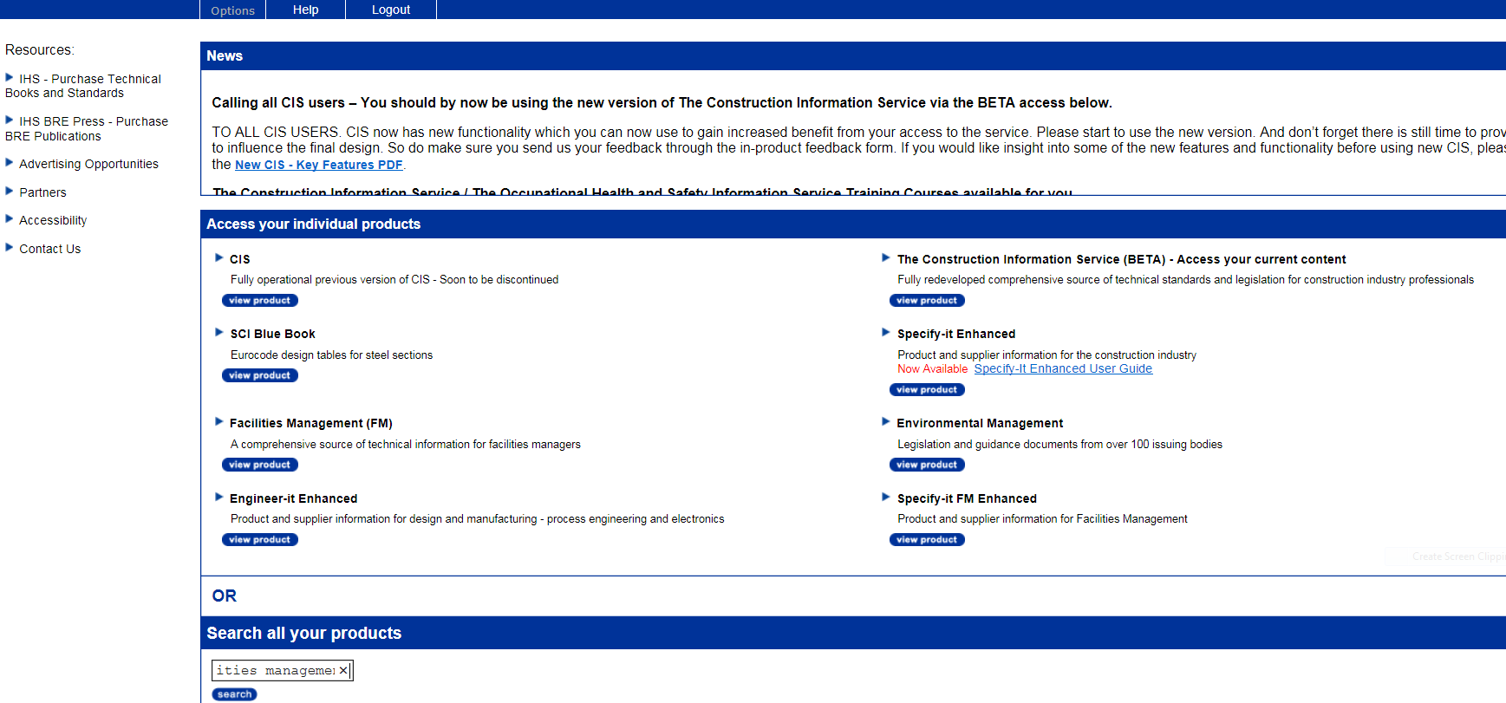
You’ll be taken to a new screen:
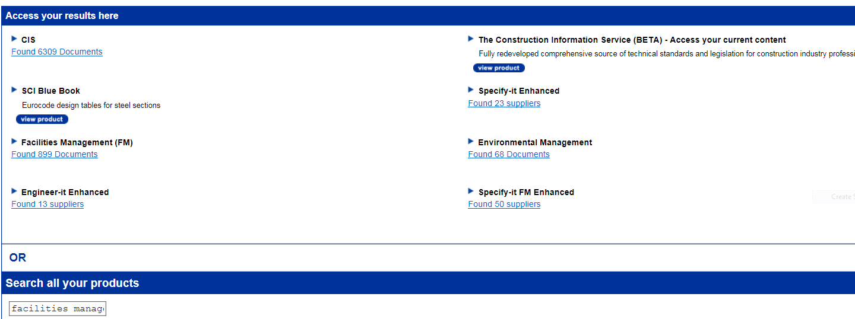

By selecting the documents found in CIS, you will be presented with results from the Construction Information Service database. Here you’ll find documents from the British Standards Institution, CIRIA, BRE and NBS Building Regulations, amongst others.

You may want to refine your results. To do this you could select the Source or Publication Year.

You can download the document from this page.
However, if you select the title of the document you’ll be taken through to a page with more information.
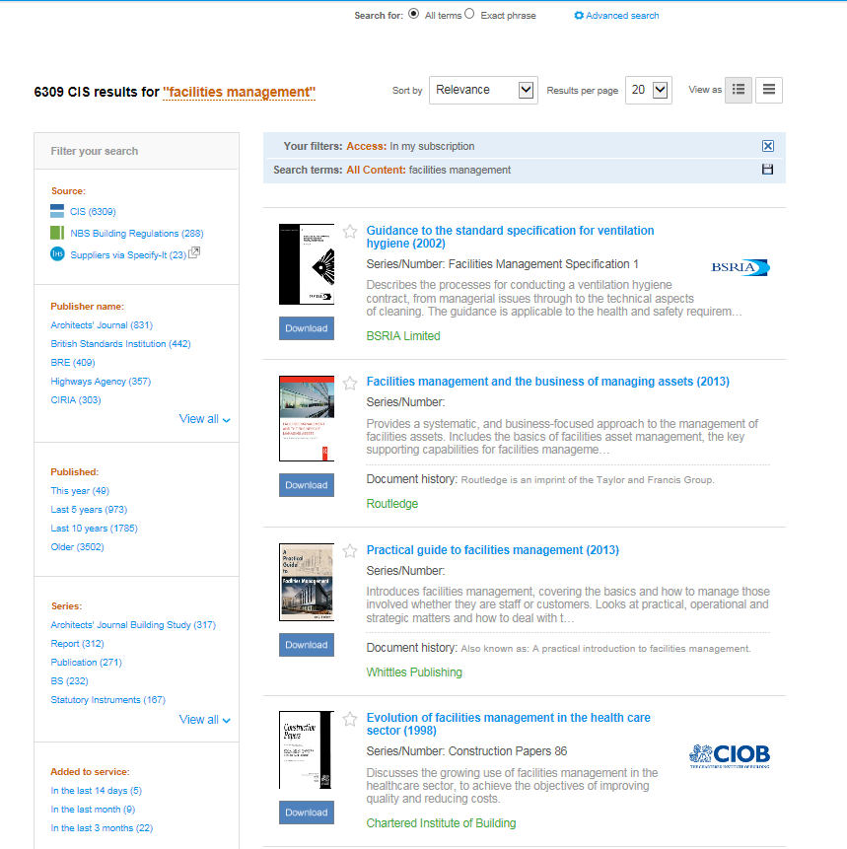

You’ll be taken to a screen which looks like this. You can download the document from this page and see items other users have viewed.
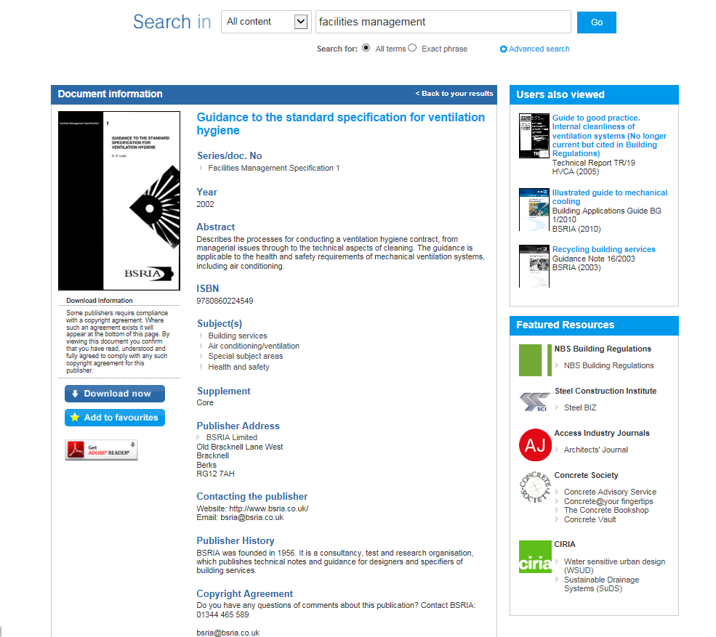

If you go back to the original search screen, you’ll find other search results you may want to explore:
You may want to select Facilities Management documents ….
or …
Environmental Management documents

Facilities Management
Select Year and again the newest results will display first. You can also refine your results on this page.
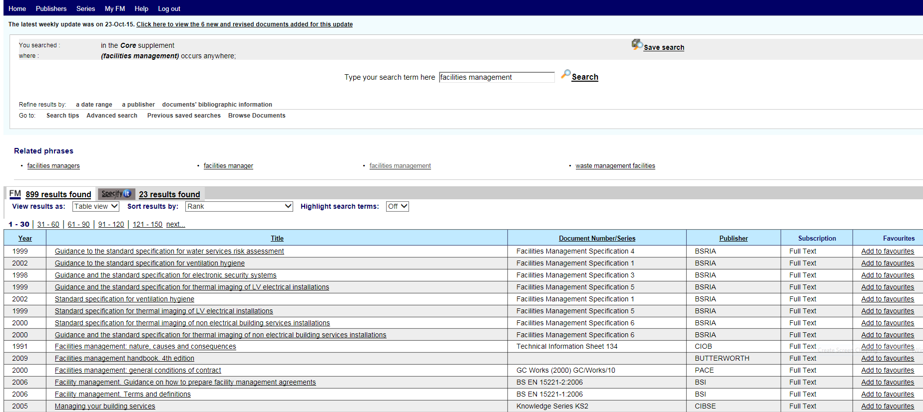
Environmental Management
Click on the Published tab and the newest document will be presented first.
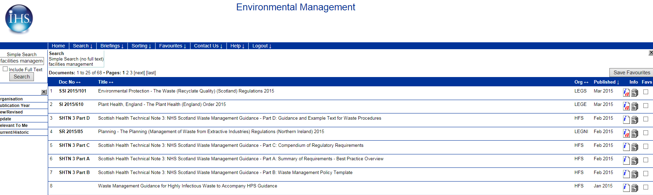
Please note, IHS will be changing its interface by the end of 2015.

Please contact me if you would like help finding information for your assignments. Ask for me at counter in the Owen Library, phone (01792 481141), or email suzanne.taylor@uwtsd.ac.uk
Suzanne Taylor (Subject Librarian)

