Assignment2
Applied Quantitative Business Research

JUNQIAN DAI
2005928

Content

Introduction 4
The rationale for choice of articles 6
Discussion of methodology and research design 9
Conclusion and Recommendations. 15
Bibliography 17
Appendices 22

Abstract

The publication of an academic paper is subject to strict scrutiny. The academic committee is required to pay attention to the connection between the paper and existing theories, as well as the reliability and validity of the methods used and the final data. This report analyses two articles published in the Journal of Business Strategy and the Journal of Destination Marketing & Management.

The first is about international expansion. In particular, some small and medium-sized enterprises hope to get more opportunities. These SMEs will face the challenge of limited resources after entering the global market. So, entering new markets or conservative growth? It needs to be evaluated. The article uses a questionnaire to measure some of the primary conditions for company expansion. The second paper is about whether tourists will revisit the image of tourist destinations and the role of e-word-of-mouth. The research data for the article was collected from Iranian tourists in Kashan (a UNESCO Heritage city). This study uses a mixed method and employs a quantitative method and a self-administered questionnaire to collect data.

The first section of this paper is a review of the academic contribution and status of the two works in the literature. Then, the second part evaluates the applicability and potential shortcomings of the selected approaches (sampling methods, usage of quantitative models, analytical tools) and attempts to find better ways to improve the results of the two papers.

Introduction
I choose these two articles to belong to 1* magazines. Their low assessment scores mean they do not meet international standards academically.

The first article is an analysis of whether small businesses need to expand globally. The article begins by suggesting that the time between SME and international enterprise is the rate of expansion of a firm (Musteen et al.). Such a definition is early and does not fit the current situation. Zhao et al. (2020) believe that such a defined method ignores the company's first expansion speed, and the change of different businesses will change over time. Therefore, Zhao et al. (2020) think that the speed of expansion and networking of a company are important factors affecting the growth of a company. They took the form of a questionnaire to a random sample of 3,000 small and medium enterprises (2,000 in Australia and 1,000 in New Zealand). And then, a simple inverted U-shaped graph (Figure 1) is presented for analysis.
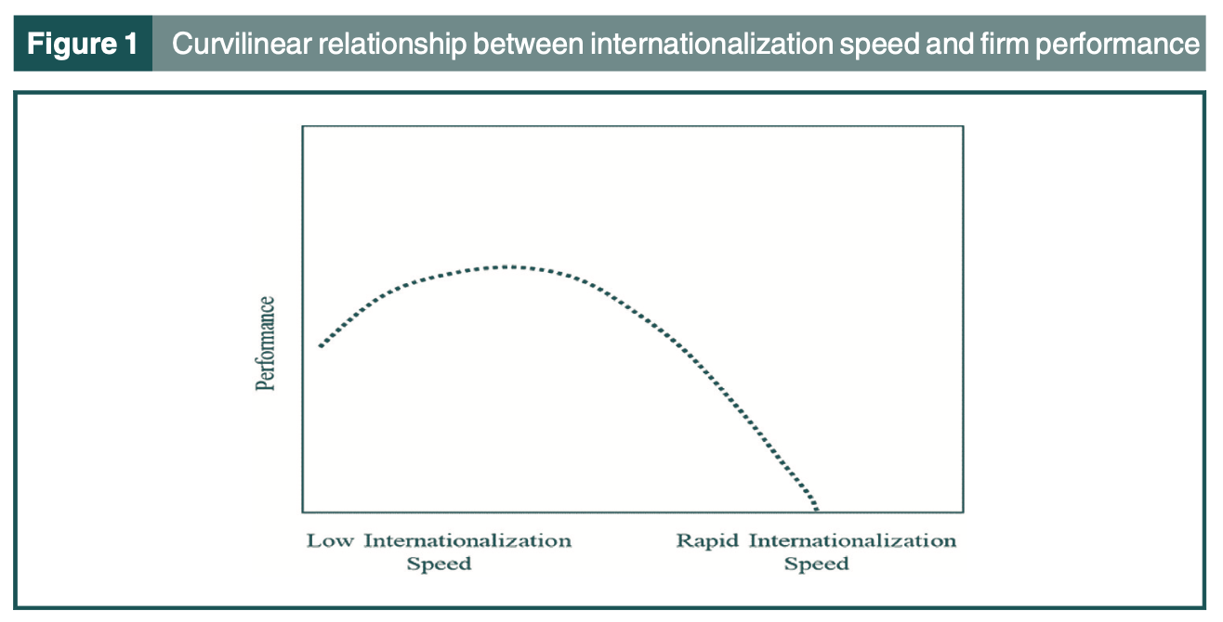
Zhao et al. (2020) show in figure1 that when the value reaches its peak, it indicates that the enterprise gains the best benefits from entering the global market. At the beginning of internationalisation, companies cannot increase in foreign markets. Developing such capabilities takes knowledge and time. Under moderate expansion, the enterprise is able to start a new ability effectively. However, this ability decreases with increasing speed. This is consistent with the theory of a non-linear relationship between international expansion speed and performance (Mohr and Batsakis, 2017). The paper praised this finding as a direct and effective way to explain the contradictions in the existing internationalisation theories. In my opinion, this research is inadequate and sufficient. And the models used are not well valid. The validity and reliability of the data are also not mentioned.

The second article is about the behavioural intention of tourists. The author believes that the tourist experience of heritage sites is not well described in the existing literature. And the understanding of the potential influence of Memorable Tourism Experiences in the context of heritage tourism is limited. Therefore, in this article, the author has carried out extensive research on the tourism experience of tourists in heritage sites. And for the heritage Tourism environment and Memorable Tourism Experiences, have a deeper understanding. For this blank part, the author uses a new model in data analysis. And the author uses a hybrid approach. He used both quantitative questionnaire surveys and qualitative interview data collection. The questionnaire for quantitative methods is developed on the basis of previous research. Therefore, on the whole article, the validity and reliability of the data are better than those in the previous paper. Because this paper used two methods in the investigation, it is a little bit of work. The quantitative data analysis software used in this paper is WarpPLS 7.0 software. This software is I did not use. Therefore, I cannot give better advice. And then, I will use SPSS software on the basis of this paper to try to find out which method is better.

The rationale for choice of articles
First article: Going global, fast or slow? Networking decisions for smaller firms

As mentioned above, it is important that international expansion to the development of enterprises. Such influence can bring more opportunities for enterprises. Further expansion is necessary for small and medium-sized enterprises to obtain more opportunities and development (Oecd.org. 2000). However, there may be difficulties in the expansion. This is because these SMEs have limited resources and an insufficient capital chain (Oecd.org. 2009). As a result, the expansion speed is too fast, which is easy to lead to enterprise failure (John, 2012.). However, it is also possible to use the contacts, resources, and capital during the expansion to make the enterprise grow quickly (Oecd.org. 2015). Therefore, the expansion mode and speed of SMEs will have an important position on the success or failure of enterprises.

On the other hand, there are two ways to think about the pace of expansion. First of all, what is the speed at which a SMEs company seeks to expand its own business through expansion? Second, if the company has started to operate overseas, the number of countries served, the size of local companies and the overall proportion of total sales of the company can be compared together to understand the speed of overseas expansion (McKinsey, 2015). And many companies to expand overseas market research mainly focused on the first thinking. As a result, the previous article mainly studied why domestic enterprises go overseas. The speed is considered the time between establishing a company and its international sales (Musteen et al., 2010). Zhao et al. (2020) believe that this definition ignores the expansion rate of the company after the first international sale (Prashantham and Young, 2011) and ignores the different forms that may exist in global expansion. For example, the model of entering the local market, investment in the local area and gross income from overseas sales. These can change over time. These two neglected aspects have an important impact on the company's performance.

Therefore, I chose the first article. The author used a dynamic capability perspective to examine the role of enterprises' networking to see how SMEs expand overseas markets through networking. The authors choose networking because they believe that networking affects the expansion speed of enterprises. This has not been mentioned in the previous literature. At present, the existing research shows that the international expansion speed of enterprises can have a positive or negative impact on enterprise performance. This study has not taken into account the networking of the company (Dwivedi et al., 2021). Zhao et al. (2020) think that the rapid expansion of enterprises will benefit those companies that are most capable of developing and using networking. Conversely, the rapid expansion of the enterprise will hurt those companies with low networking. Therefore, Zhao et al. (2020) took SMEs engaged in international trade as samples to study whether networking can prove that there is a close relationship between the growth rate of enterprises in the international market and their own performance.

Second article: Understanding memorable tourism experiences and behavioural intentions of heritage tourists

As mentioned above, this article discusses the influence of tourists' participation in tourism experience, authenticity, and destination image on tourists' willingness to revisit heritage sites and electronic word-of-mouth. However, the memorable travel experience of tourists is the intermediate role of promoting their willingness to return to the old place and e-WOM. Cultural heritage tourism is a very important part of the tourism market (Mahamudul & Jobaid, 2014). The United Nations World Tourism Organisation (UNWTO) (2015) estimates that four over ten tourists choose destinations based on cultural heritage. Studies show that the demand for cultural tourism has changed in recent years. What started as pure cultural tourism has become a "cultural experience" (Richards, 2018). Therefore, the memory of cultural heritage tourism will become a part of tourists' memory (Lee, 2015). Cultural heritage tourism offers experiences such as visiting or participating in "real past" story scenarios. Many of the sites are unique tourist experiences that combine culture, education and entertainment (HAMIMI OMAR. 2013).

However, heritage tourism has not received much attention as part of the " memorable tourism experiences " (Siamak et al., 2019). Many existing kinds of literature do not thoroughly discuss the experience and structure of heritage tourists (Nowacki, 2021). In order to fill the gaps in this literature, Rasoolimanesh et al. (2021) developed and empirically tested a comprehensive model in this study about whether tourists are willing to go to tourist destinations because of the image of the destination. In addition, the article tests the role of mediation memorable tourism experiences (MTE) in this interrelationship as heritage tourism is experiential in nature (Richards, 2018), whether tourists are willing to create unforgettable experiences in heritage destinations. This article attempts to identify MTE as the mediator of enhancing tourists' behavioural intention. Mixed methods were used in this study, which combined quantitative methods of questionnaire survey and qualitative analysis of interviews to obtain data collection. The authors believe that the choice of this mixed form is not for future comparison results but to be able to use complementary transformation data in this study to understand the impact of heritage tourism on MTE.

Discussion of methodology and research design
Creswell (1994) pointed out that quantitative research is a research method that "explains phenomena by collecting numerical data and analysing them with mathematical methods (especially statistics)". Quantitative research usually focuses on the determination of facts. Quantitative research is finding research in a problem that can be quantified using numerical forms. Because quantitative research is objective, it is strict in data collection and analysis. Thus, quantitative research is essentially collecting data to explain a particular phenomenon. In quantitative analysis, there are four types of quantitative research: 1) survey research, 2) correlational research, 3) experimental research and 4) causal-comparative research（Suphat，2021）. Through comparison, I found that the two articles chosen used the questionnaire method in quantitative research, also known as survey research. Survey research uses scientific sampling and questionnaire design to obtain data and thus obtain research results (Ponto, 2015). A survey is a complex communication process, and the interaction between researchers and respondents results in a data result (Petra Lietz, 2010).

In the first article: Going global, fast or slow? Networking decisions for smaller firms.

This article uses the questionnaire as a quantitative analysis method. An online questionnaire was used to sample a random sample of 3,000 SMEs (2,000 from Australia and 1,000 from New Zealand). Through this data collection, it is found that the source of data is not very reliable. Data needs to be selected with some justification and an explanation of why they were chosen over others. Why there are more Australia than New Zealand is not explained by the author. Such data surveys are unreliable. After that, the author did not give relevant data collation but only emphasised the variables concerned in the study. In addition, the derivation was carried out directly without the support of relevant data. In addition, some interviewees may be hesitant to give answers that are not consistent with the truth (Balnaves and Caputi, 2014). And because the study was collected online, it meant that there was no monitor. The validity and reliability of the data cannot be well measured (Zohrabi, 2013). These are all things that need to be taken into account before the study, but the authors seem to ignore them. In the end, the author does not discuss the research methods used but only makes a detailed analysis of the results (Jonathan and Keith, 2013.). They simply ignore possible errors, limitations and uncertainties in the study. They simply assumed that the data was perfect, and no other factors were taken into account. Also, whether there is a better alternative is not discussed in this article. Whether an enterprise needs to expand and at what speed will result in different results for various reasons. This article only focuses on one point and completes the overall study in the case of unreliable data. Therefore, after reading the article as a whole, people will still have doubts about the data used, which is not convincing.

In the second article: Understanding memorable tourism experiences and behavioural intentions of heritage tourists

In the second article used mixed methods, in which qualitative analysis interview method and quantitative analysis questionnaire form were used to collect data. And the authors explain that the use of such a hybrid method is not for comparison but to make the data more comprehensive. In this comparison, it is found that the second article is better than the first one in terms of research methods.

In the second article, the author puts forward a hypothesis for qualitative analysis. Then, hypotheses are proposed for each intention, and some impacts on tourists are found through analysis. The author divides the influence into positive influence and negative influence. Furthermore, a conceptual framework for the study is also presented (figure1).

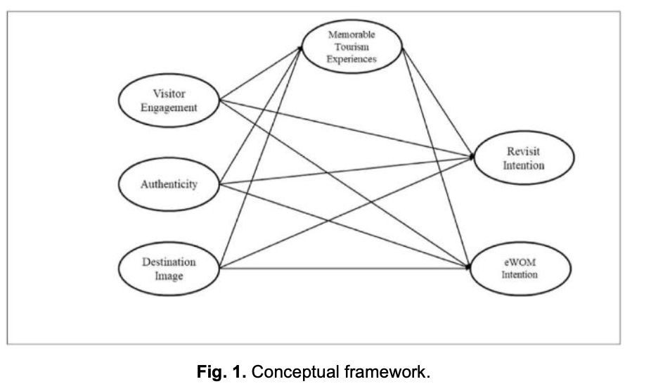

The above steps are more detailed. Let me feel very clear. After that, the authors began to use quantitative analysis. The author is through the past research on the basis of processing again. The authors state that this study was developed by considering visitor participation and reflection after MTE was assessed. Since this study involves four reflection structures and two reflections form second-order structures. Therefore, in a more complex situation, the author chooses the targeted sampling collection.

When distributing the questionnaire, the author also carried out data pertinence well. They distribute to visitors to Kashan sites and explain the purpose of the study to those surveyed. This is a good way to avoid visitors who do not want to fill in the questionnaire or other circumstances. They also do a good job of avoiding the ethical issues involved. After collecting the data, they also conducted a full screening and determined that 350 were usable. That's good for the validity of the data. Age, sex and education were identified in the questionnaire. All these factors have different influences on heritage tourism. The partial least squares structural equation model (PLS-SEM) was used in this study. WarpPLS 7.0 software package was used to analyse the quantitative data and evaluate the measurement model and structural model. The software package and the model I haven't studied, so I cannot judge it. After studying the data, the author made corresponding checks. In the first stage, Fornell-Larcker standard and HTMT methods were used to conduct validity discrimination within the acceptable range for all data (Table 2 and Table 3). This means that through testing, these data are valid and reliable in subsequent studies.

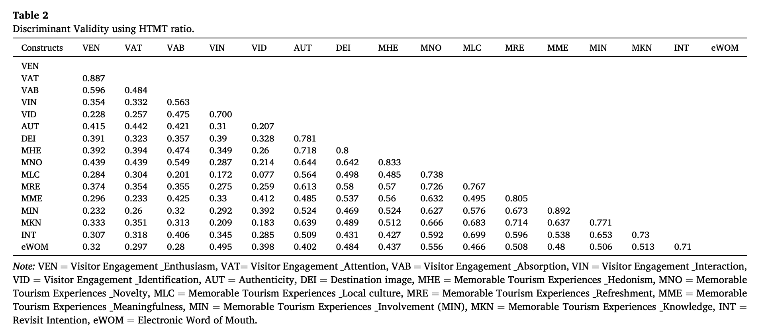

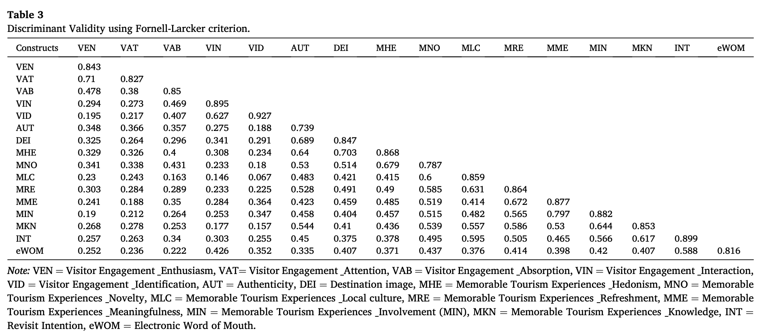

In the second stage, the authors also evaluated the reflective formation (compound) structure (visitor participation and MTE) of the 2 S stage, and multicollinearity, through variance inflation factor (VIF) should be less than 5, and the external weight of the related items should be significant. The validity of the data was confirmed by the detection that the collinear VIF was all lower than 3.3.

Finally, the authors suggest that the study is still limited. For example, respondents were not given enough time to think during the questionnaire survey. Secondly, the study only investigated the positive factors of MTE, not the negative factors of MTE. Finally, due to the impact of COVID-19, there is uncertainty about the true intentions of visitors. Further evaluation is therefore required in this area.

In the second article, I think the author has done a good job in data collection, analysis and final summary. Each part makes sense and has data to back it up. Therefore, as far as my current ability is concerned, I have not seen why the star rating of this paper is not enough. Perhaps it was the journal ratings they submitted that caused their papers to be downgraded. That's my guess.

Parametric or Non-parametric

Because of the articles I chose, SPSS software was not used in the two articles. Therefore, further analysis is required on Parametric or Non-parametric analysis. What is Parametric?

Parametric statistics assumes that sample data comes from data that can be adequately modelled from a probability distribution with a fixed set of parameters. In contrast, non-parametric models do not assume any structure or misalignment. In non-parametric models, these assumptions about the form of distribution are usually few, but there are strong assumptions about independence (Tanya， 2021).

Therefore, parametric tests assume that data exists in a statistical distribution. Then this must satisfy several valid conditions for the parameter test to be reliable. However, the non-parametric test does not depend on any distribution. Therefore, they can be applied even if the parameter conditions for validity are not met.

According to the above analysis and the results of the first article, it can be judged that the expansion speed of the enterprise in the first article is non-parametric. This is because the expansion rate in the enterprise is related to various factors and cannot be effectively distributed in the structure. The second article is about memorable tourism experiences，which is parametric. This is because the data used is already reliably distributed in the statistics in the second article. In addition, the author also carried out the corresponding detection.

Conclusion and Recommendations.
The above two articles use the questionnaire method in quantitative analysis. However, the data quality of the questionnaire will be affected by the research tools. For example, the second article uses WarpPLS 7.0 software Package. And what we learned was SPSS. Both kinds of software, though, analyse data. However, the results presented were wildly different. The final measure of whether a quantitative study is feasible should be measured by the following five indicators: 1) Input Cost Measures; 2) Collection Output Measures; 3) Effectiveness Measures and Indicators; 4) Domain Measures; 5) Cost-effectiveness Indicators (Goertzen, 2017). In addition, due to the large data set collected by general quantitative methods, the data need to be easily tested from various angles (Goertzen, 2017). With the help of data analysis software such as SPSS, the overall data set and retrieval can be quickly located, and the results can be quickly presented (Ghuman and Aswathappa, 2010). However, due to the gradient between data sets, there is a great difference. Therefore, the scale will have errors in the detection of samples. This aspect needs to be improved. The article about MTE makes a detailed description of the research methods. The other one did not. This means that the research methods and data in this article need to be greatly improved in the study of enterprise expansion speed. So that's why this article has a low star rating.

On the other hand, the research methods and design of the two articles are of a reference value. Especially the second (MTE) article. In MTE, the conceptual framework and questionnaire were completed on the basis of previous studies. Therefore, the advantages of the article are easy to be highlighted. Thus, it also reminds me that a large number of references are needed to support a relatively complete study in future research. First of all, the first article about the expansion rate of enterprises needs to further refine their data analysis. And try to use data analysis software to help them do their job better. Although, in the theoretical analysis, there is a very detailed process. However, due to insufficient data support, people are not very convincing. It also makes people question their conclusions. In the second article about MTE, the author obtained reliable and effective data for theoretical support through repeated testing of data. However, there are still problems. For example it is easy to happen that the real thoughts of interviewees are not reflected in the questionnaire. The change in people's attitudes towards MTE in the context of COVID-19 was also not taken into account. Finally, there are positive and negative effects of each intention in the text. However, no negative effects were mentioned in the questionnaire. These are all areas that need further improvement. Quantitative research itself is data analysis, which is more inclined to use tools to solve problems. This complicates quantitative research and makes it difficult for learners to use. That's why I decided to use a hybrid approach in my research. These two articles almost use mixed methods to complete data collection and analysis. This can reduce the amount of work and make the research more reliable.

Bibliography
Balnaves, M. and Caputi, P. (2014) Introduction to Quantitative Research Methods. USA: SAGE Publications Ltd.

Creswell, J.W. 1994, Research Design: Qualitative & Quantitative Approaches, London: SAGE Publications.

Dwivedi, Y., Ismagilova, E., Hughes, D., Carlson, J., Filieri, R., Jacobson, J., Jain, V., Karjaluoto, H., Kefi, H., Krishen, A., Kumar, V., Rahman, M., Raman, R., Rauschnabel, P., Rowley, J., Salo, J., Tran, G. and Wang, Y., 2021. Setting the future of digital and social media marketing research: Perspectives and research propositions. Available at: https://www.sciencedirect.com/science/article/pii/S0268401220308082 [Accessed 20 November 2021].

Ghuman, K. and Aswathappa, K. (2010) Management: Concepts, Practice & Cases. New Delhi: Tata McGraw Hill.

Goertzen, M.J. (2017) ‘Introduction to Quantitative Research and Data. (Chapter 3)’, Library technology reports, 53(4), p. 12–17.

HAMIMI OMAR. 2013. THE DEVELOPMENT OF SUSTAINABLE CULTURAL HERITAGE TOURISM IN MALAYSIA: IMPLICATION FOR PLANNING AND MANAGEMENT, Available at: https://core.ac.uk/download/pdf/268139454.pdf [Accessed 20 November 2021].

Jonathan Rougier and Keith Beven, 2013. Model and data limitations: the
sources and implications of epistemic uncertainty, Available at: http://www.bris.ac.uk/cabot/media/documents/jonty-chapter3.pdf [Accessed 20 November 2021].

John P. Kotter, 2012. Accelerate! Harvard Business Review. Available at: https://hbr.org/2012/11/accelerate [Accessed 20 November 2021].

Lee, Y. J. (2015). Creating memorable experiences in a reuse heritage site. Annals of Tourism Research, 55, pp. 155–170.

Oecd.org. 2000. Small and Medium-sized Enterprises: Local Strength, Global Reach, Available at: https://www.oecd.org/cfe/leed/1918307.pdf [Accessed 20 November 2021].

Oecd.org. 2009. The Impact of the Global Crisis on SME and Entrepreneurship Financing and Policy Responses, Available at: https://www.oecd.org/industry/smes/49316499.pdf [Accessed 20 November 2021].

Oecd.org. 2015. New Approaches to SME and Entrepreneurship Financing: Broadening the Range of Instruments, Available at: https://www.oecd.org/cfe/smes/New-Approaches-SME-full-report.pdf [Accessed 20 November 2021].

Petra Lietz, 2010. Research into Questionnaire Design: A Summary of the Literature. SAGE Journals. Available at: https://journals.sagepub.com/doi/10.2501/S147078530920120X [Accessed 20 November 2021].

Mahamudul Hasan, Md. Imrul Jobaid. 2014. Heritage Tourism Marketing: Status, Prospects and Barriers, Journal of Business and Management. Available at: https://iosrjournals.org/iosr-jbm/papers/Vol16-issue5/Version-4/F016544048.pdf [Accessed 20 November 2021].

McKinsey on Marketing & Sales, 2015. Marketing & Sales Big Data, Analytics, and the Future of Marketing & Sales. Available at: https://www.mckinsey.com/~/media/McKinsey/Business%20Functions/Marketing%20and%20Sales/Our%20Insights/EBook%20Big%20data%20analytics%20and%20the%20future%20of%20marketing%20sales/Big-Data-eBook.ashx [Accessed 20 November 2021].

Mohr, A. and Batsakis, G. (2017), “Internationalisation speed and firm performance: a study of the market-seeking expansion of retail MNEs”, Management International Review, Vol. 57 No. 2, pp. 153-177.

Musteen, M., Francis, J. and Datta, D.K. (2010), “The influence of international networks on internationalisation speed and performance: a study of czech SMEs”, Journal of World Business, 45（3）, pp. 197-205.

Musteen, M., Francis, J. and Datta, D.K. (2010), “The influence of international networks on internationalisation speed and performance: a study of czech SMEs”, Journal of World Business, Vol. 45 No. 3, pp. 197-205.

Nowacki, M., 2021. Heritage Interpretation and Sustainable Development: A Systematic Literature Review. Sustainability. Available at: https://www.mdpi.com/2071-1050/13/8/4383/htm [Accessed 20 November 2021]

Ponto, J., 2015. Understanding and Evaluating Survey Research. [online] PubMed Central (PMC). Available at: https://www.ncbi.nlm.nih.gov/pmc/articles/PMC4601897/ [Accessed 20 November 2021].

Prashantham, S. and Young, S. (2011), “Post-entry speed of international new ventures”, Entrepreneurship Theory and Practice, 35（2）, pp. 275-292.

Rasoolimanesh, S. M. et al. (2021) Understanding memorable tourism experiences and behavioural intentions of heritage tourists. Journal of destination marketing & management. [Online] 21100621–.

Richards, G. (2018). Cultural tourism: A review of recent research and trends. Journal of Hospitality and Tourism Management, 36, pp. 12–21.

Siamak Seyfi, Colin Michael Hall and S. Mostafa Rasoolimanesh. 2019. Exploring memorable cultural tourism experiences. Available at: https://www.researchgate.net/publication/334193047_Exploring_Memorable_Cultural_Tourism_Experiences [Accessed 20 November 2021].

Suphat Sukamolson，2021. Fundamentals of quantitative research，Available at: https://www.iicseonline.org/Quantitative_MethodsII.pdf [Accessed 21 November 2021].

Tanya Hoskin，2021. Parametric and Non-parametric: Demystifying the Terms. the Mayo Clinic CTSA BERD Resource. Available at: https://www.mayo.edu/research/documents/parametric-and-nonparametric-demystifying-the-terms/doc-20408960 [Accessed 20 November 2021].

Zhao, C. et al. (2020) Going global, fast or slow? Networking decisions for smaller firms. The Journal of business strategy. [Online] 41 (3), 11–19.

Zohrabi, M. (2013) ‘Mixed Method Research: Instruments, Validity, Reliability and Reporting Findings’, Theory and practice in language studies, 3(2), p. 254–. doi:10.4304/tpls.3.2.254-262.

Appendices
Journal of Destination Marketing & Management:
https://browzine.com/libraries/1422/journals/66962/issues/current

Rasoolimanesh, S. M. et al. (2021) Understanding memorable tourism experiences and behavioural intentions of heritage tourists. Journal of destination marketing & management. [Online] 21100621–. https://www.sciencedirect.com/science/article/pii/S2212571X2100069X?via%3Dihub

Journal of Business Strategy
https://browzine.com/libraries/1422/journals/10060/issues/335167321

Zhao, C. et al. (2020) Going global, fast or slow? Networking decisions for smaller firms. The Journal of business strategy. [Online] 41 (3), 11–19.
https://www.proquest.com/docview/2533806881?accountid=130472

