Name: Nikole Atkinson
Student I.D.: 1910236
Module code: BMHP5014
Assignment Title: E-Portfolio
Lecturer: Azura Hurd

Introduction
I will be creating a mind map based around the NHS and Technology based around the concepts that I learned in Unit 1, through using my resources I came to find that in society a lot of children and young adults suffer with mental health which does not have substantial amount of awareness using my creative mind I have materialised An invention based around the impact of society triggering mental health, and the advanced levels of technology which as already migrated within the NHS, constituting an online based platform were doctors, other health professions and individuals can access their own health records, combining the two together to decrease mental health and the strain on the NHs introduces a virtual stimulation app for children and young adults suffering with mental health.
I will also be creating a blog outlining how I generated my idea, surrounding the ideas of a changemakers which helped evolve my idea, using the concepts that was outlined in unit 2 such as creating value, entrepreneurship, using attributes and problem solving.

Health care(children) and Technology

- NHS
- Electronical Medical Record
- Electronic health record
- Society and the influence in the younger generation
- Technology development

Mind map
A mind map is a tool generated for the brain created to collect your thought that are going around in your head, mind mapping allows you to think more openly and freely, generating your knowledge, creating it around a central concept or subject through imagery.

Mind map
- NHS
2. EMR

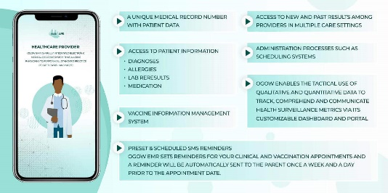

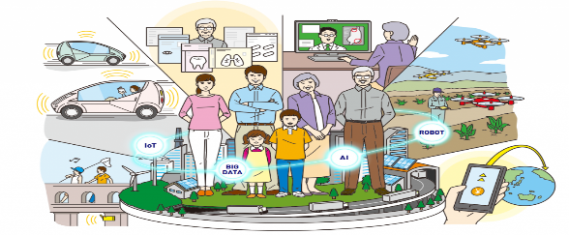
(Gu, 2019)

4. Society and its influence

5.Technology development

3. EHR


1.NHS
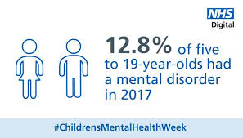
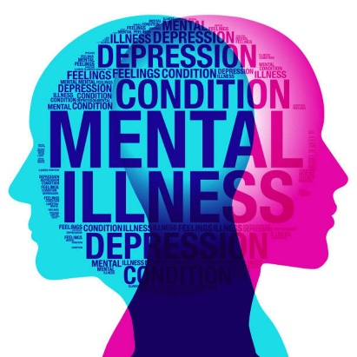

The Conversation. (2010)
( The Kim Foundation, (2018)
Southoxheysurgery (2006)

Mental health is a serious condition that is now becoming vast in society, getting more awareness for mental health has been a common focus with the male gender and children being the centre of misfortune. The NHS is the for frontal of copying with the strain of mental health, the primary care service is the first place of contact then hospitals being the second, doctors offer referrals to counselling sessions they suggest NHs, (2018) “Talking therapies, or psychological therapies, are effective and confidential treatments delivered by fully trained and accredited NHS practitioners” this is one of the solutions that help tackle mental health. Mental health is overall a large spectrum.
They can help with common mental health problems like stress, anxiety and depression. This is one of the limited services that are offered.

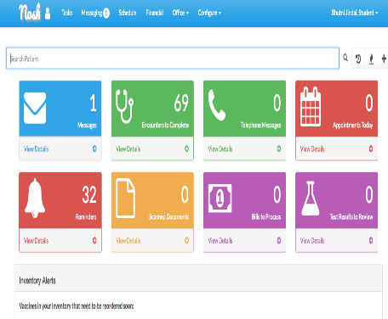
2.Electronical Medical Records
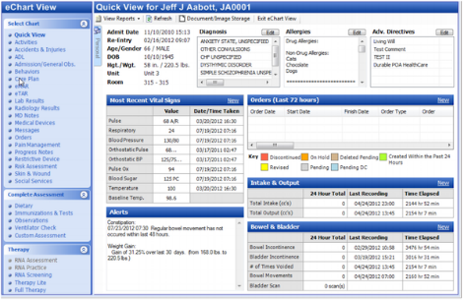

(Mu, 2018)
Software advice , (2021)

“A change maker one who desires change in the world”, using different tools gathering knowledge through research and resources all in contribution in making change happen. L. weed shaped the NHS by introducing The EMR system this holds Patient information such as Health history E.G allergies, any underlying conditions, he focused his Attributes on the whole scale of the NHS to improve quality of care and leadership L.Weed formed a complicated system and made It to a simpler form were health professionals can access records, being able to access patients records in a timely manner, find a solution to a patient’s problem, and information being accessed by third parties such as therapist has given the NHS more flexibility.


3. Electronical health record (EHR)
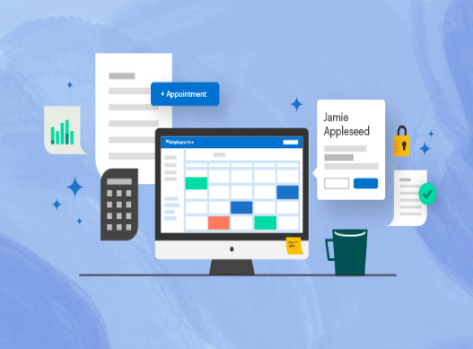
EHRintelligence (2021)
Zumwalt, D.,( 2020)

Electronical health records help us to keep on track with our health, with the help of technology you can gain access and book appointments with your GP, you can also go through your health history and keep up to date with what is mentally and physically happening with your body, HealthIT, (2021) “More complete patient information available from EHRs enables providers to make well-informed care decisions quickly” this helps to improve care and reduce safety risks within the NHS system, using these types of technological based system as an olive branch to work in partnership with other department areas so patients can see other areas of their health such as their therapy sessions would allow it to be more manageable as patients can track their progress and also be engaged in online session.

3.Society
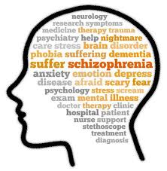
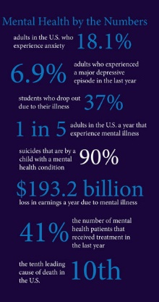
Acharya, (2021)
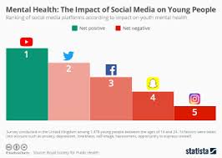
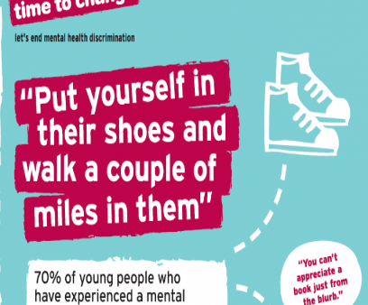
Time to change, (2021)
In society Humans have the biggest influence on each other if a trend sets social groups are usually the ones to follow, it is even higher in the younger community, social apps such as Facebook and twitter are big social influences, most commonly has a negative, and domino effect on individuals. Every individual wants to be valued so being part of a social group as a young adult or child holds value to them, but also can influence online bullying and lead to causes of mental health such as depression.
MERCK, H., (2017)


4.Technology

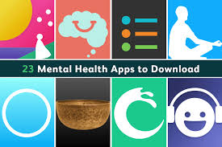
Boyall, (2020)
Harman, (2019)
(Bianco, 2016)
TECHNOLOGY has a huge impact on society, especially in the younger generation, Mark an it also improves the quality of life ranging from machinery to software data, technology also opens up opportunities it has given easy access to information, in relation to software data there are a whole range of apps especially communication apps, which the younger generation engage in, they have the highest rate in adapting to the fast-growing rate of technology, “Mark Zuckerberg is a co-founder of an social networking website called Facebook, started in his college dorm room” which I now one of the most biggest social media networking site, his innovation has had a impact on society based on communication, instant The era that we are living in is now entering 5.0 technology enhances and interlinks our current innovations, this allows us to have more advance software and better quality of life.

Type here:
Technology & Mental health
Within the Healthcare system

User name: Nikole Atkinson
Student number: 1910236

BLOG

What inspired me to create my idea was that there is an exceedingly small area’s that targets an active solution for young people to cope with their mental health day by day, having values such as integrity, responsibility, health and dependability also created a wider vision to target this chosen area, working with younger adults for majority of my career out shined a massive issue with mental health in young adults, finding the triggers to mental health and the way young adults engaged resulted the decision making of my idea.

There are change makers that have shaped the NHS to help support those with mental health, such as GPS referring them to the right place or prescribing medication to make it more manageable, “Talking therapies are free, effective, confidential treatments. A GP can refer you to a service offering talking therapies, also known as IAPT services, or you can refer yourself directly”. This is one of the solutions offered by a mental health campaign offering brief solutions. GP’s and hospitals have a great deal of strain so third parties usually have that offer of support.
Creating this virtual app will still hold that same value and support from NHS but will help reduce the strain by creating a system that works through a systematic approach, all support and monitoring of mental health will be virtual and also accessible by the patients it will also be flagged through patient’s progression if they will relapse so the best possible advice will be there immediately.

The EMR system is a technological program where different professional bodies can access your records and offer you the right help and support., Larry Weed is one of the changemakers that used technology and replaced it with the old paper style records, Siegenthaler, (2021) “in the late 1960’s, Larry Weed presented the EMR concept to generate an electronic record to allow a third party to independently verify the diagnosis” Weed’s vision is based upon and focused around clinical data management. These systems were also known as hospital information systems. Displaying his competencies and thinking outside the box he created an automated intelligent data extraction software, this helped with time management taking away from transcription by reading paper document, which brings me to why involving these two types of system into my project ideas will help it be stable and consistent having online records for both patients to access it (EHR) and the (EMR) provides a manageable record base for everyone to have easy access to their health.



this inspired to the use values I felt that is based around mental health in the younger society also creating a vision bored of the positive and negative thing that effect younger adults and children in contribution towards mental health which lead me to the 4.0 use of technology bjbj



society and mental health the triggers of mental health is society in general, young people Impact of social media and screen-use on young people’s health, (2019) In 2015, the Office for National Statistics reported that, based on data from 2011 and 2012, “children who spent more than three hours on “social websites” on a normal school night were “more than twice as likely to show symptoms of mental ill-health”, society and technology has and huge influence on mental health in young people from these statistics mobilising my resources from different resources finding a positive solution,

Everyday technology is evolving we are in that era where we live and breathe Technology, there are a variety of apps for everything ranging from health to communication apps such as SnapChat, Twitter and Instagram, right no were are living in the generation on 4.0 transmitting into 5.0 Rossi, (2021) “4.0 moves towards Industry 5.0 when you allow customers to customise what they want” another researcher suggests ISA,( 2018) “4.0 is not enough. Because consumers want more” They want mass personalization, which can only be had when the human touch returns to manufacturing. This is what I call Industry 5.0” this gives an open opportunity to enhance a technology that is already in place to target that is at most disadvantage.

Introducing an virtual reality app that is connected to a system that is already created within the NHs to help tackle mental health within young adults and children will be beneficial for the reasons of that is society grows with technology, and the younger generation engages with technology so this would be something that they will be interested in but also helps their health and improves their health and quality of life with individuals having full access to but will also be easy accessed by GP’s and other professions through the linked EMR/HER system managing data from the patient.



REFRENCE

Acharya, A., (2021). Here’s How You Can Care for Someone With Schizophrenia. [online] femina.in. Available at: <https://www.femina.in/wellness/health/heres-how-you-can-care-someone-with-schizophrenia-172628.html> [Accessed 6 February 2021].

Bianco, S., (2016). Virtual App | What is a Virtual App? | Parallels Blog. [online] Parallels Blog. Available at: <https://www.parallels.com/blogs/virtual-app/> [Accessed 9 February 2021].

Boyall, M., (2020). 5 ways COVID-19 has inspired digital innovation | McGregor Boyall. [online] McGregor Boyall. Available at: <https://www.mcgregor-boyall.com/our-thinking-library/2020/05/5-ways-covid-19-has-inspired-digital-innovation/211> [Accessed 12 February 2021].

Gu, V., (2019). Society 5.0: Japan’s vision to live with robots | GovInsider. [online] GovInsider. Available at: <https://govinsider.asia/connected-gov/society-5-0-inside-japans-vision-to-live-with-robots/> [Accessed 4 February 2021].

Isajobs.isa.org. (2018). Factory Automation: Welcome to Industry 5.0 - ISA. [online] Available at: <https://isajobs.isa.org/intech/20180403/> [Accessed 10 February 2021].

Healthit.gov. (2021). Benefits of EHRs | HealthIT.gov. [online] Available at: <https://www.healthit.gov/topic/health-it-basics/benefits-ehrs> [Accessed 11 February 2021].

EHRIntelligence. (2021). Have EHRs Been a Burden or an Asset During the Coronavirus?. [online] Available at: <https://ehrintelligence.com/news/have-ehrs-been-a-burden-or-an-asset-during-the-coronavirus> [Accessed 12 February 2021].

MERCK, H., (2017). Breaking the stigma of mental illness - when it's OK not to be OK — Vision Media. [online] Vision Media. Available at: <http://ngu-vision.squarespace.com/newsfeed/2017/1/12/breaking-the-stigma-of-mental-illness-when-its-ok-not-to-be-ok> [Accessed 5 February 2021].
Mu, H., (2018). NOSH EMR: Free, Open source Health Charting System built by a doctor for doctors. [online] MeDEVEL.com. Available at: <https://medevel.com/nosh-emr-open-source/> [Accessed 6 February 2021].

nhs.uk. (2018). NHS talking therapies. [online] Available at: <https://www.nhs.uk/conditions/stress-anxiety-depression/free-therapy-or-counselling/?gclsrc=aw.ds> [Accessed 11 February 2021].

Harman, R., (2019). Virtual Reality Trends for 2019. [online] Medium. Available at: <https://towardsda0tascience.com/virtual-reality-trends-2019-64003e2667ef> [Accessed 6 February 2021].

Parliamentary copyright house of commons (2019). Impact of social media and screen-use on young people’s health. 14th ed. [ebook] house of commons, p.26. Available at: <https://publications.parliament.uk/pa/cm201719/cmselect/cmsctech/822/822.pdf> [Accessed 7 February 2021].

Rossi, B., (2021). Industry 5.0: what is it and what will it do for manufacturing?. [online] Raconteur. Available at: <https://www.raconteur.net/manufacturing/manufacturing-gets-personal-industry-5-0/> [Accessed 6 February 2021].

Siegenthaler, K., (2021). A Brief History of the EMR. [online] Extract Systems. Available at: <https://www.extractsystems.com/healthydata-blog/2016/9/30/a-brief-history-of-the-emr#:~:text=Weed%27s%20vision%20focused%20on%20clinical,advancement%20in%20healthcare%2Fmedical%20practice.> [Accessed 7 February 2021].

Softwareadvice.com. (2021). Optimus EMR Software - 2021 Reviews, Demo & Pricing. [online] Available at: <https://www.softwareadvice.com/long-term-care/optimus-emr-system-profile/> [Accessed 5 February 2021].

Southoxheysurgery.nhs.uk. (2006). - Information for new patients wishing to join the doctors surgery. [online] Available at: <https://www.southoxheysurgery.nhs.uk/new-patients.aspx> [Accessed 4 February 2021].

The Conversation. (2010). The UK doesn't spend enough on the mental health of young people – we found out why. [online] Available at: <https://theconversation.com/the-uk-doesnt-spend-enough-on-the-mental-health-of-young-people-we-found-out-why-124315> [Accessed 9 February 2021].

Zumwalt, D,( 2020). Moving to an EHR System: What You Need to Know - SimplePractice. [online] SimplePractice. Available at: <https://www.simplepractice.com/blog/ehr-system/> [Accessed 6 February 2021].

