8th August 2018
Strategic Analysis for an Urban Food Producer.

By Frank Bruce, Student no. 1602754

Contents

- Executive Summary………………………………………..…… 3
- Main Strategic Issues…..………………………..……………... 4
- SWAT analysis.…………………………………………….……. 8
- Evaluation of Corporate Strategic Decisions to date…...... 12
- Strategic Options for Global Competitiveness...…..…….... 15
- Frameworks to achieve global competitive positioning…. 17
- Implications for strategic management decision making.. 23
- Recommendations for a new strategic approach…………. 32
- References………………………………………………………… 34
- Appendices……………………………………………………….. 41

List of figures

Figure 1: Organic farm weeding robot. ……………………………… 5
Figure 2: The annual increase in sales of organic foods...……….. 6
Figure 3: The Price Premium paid for Organic foods …………….. 6
Figure 4: SWAT Analysis using director interviews……………..... 11
Figure 5: Segmentation of fresh food retail markets……………… 15
Figure 6: Porter’s Five Forces Model applied to UACA …………. 17
Figure 7: Centrality-Distinctiveness Map……………………………. 18
Figure 8: Bowman’s Strategic Clock…………………………………. 19
Figure 9: Adaptation of the Strategic Clock for small businesses. 19
Figure 10: Ansoff’s Growth matrix applied to UACA Organics….. 20
Figure 11: McKinsey applied to UACA……………………………….. 24
Figure 12: Kotter applied to UACA…………………………………… 24
Figure 13: The Change Kaleidoscope……………………………….. 25
Figure 14: The Change Kaleidoscope applied……………………... 25
Figure 15: Mendelow’s Matrix applied………………………………. 27
Figure 16 Reasons for failure of Change Management………….. 29
Figure 17: Differentiation of small business strategy making….. 30

- Executive Summary

UACA, an SME producing organic food and various services, is analysed to find that it has only a general strategic management process and, according to a survey of directors, a lack of focus and understanding in their perception of strategic risks and opportunities.

A variety of techniques are applied to establish global positioning for competitiveness including centrality-distinctiveness and Bowman, Porter and Ansoff, which suggest an aspirational niche market would yield greater profit than a hybrid, middle of the road branding currently deployed.

The company’s approach to strategic management could be developed by taking on Kotter’s model and moving with more focus towards change leadership. It is important to address differences in personality and leadership through Mendelow’s matrix, rather than risk failure through these matters which many SMEs are vulnerable to.

A summary of recommendations is given on pages 32-33.

2. Main Strategic Issues
UACA is a small urban agriculture limited company trading in the West Midlands of England. Business includes quality, organic food production in a local urban setting. Garden services are also provided through a store, café, and allotment management services by contract to the local government authority. Educational provision, solar generation and public events management are complementary spin offs. A board of directors make strategic decisions, accountable to shareholders through an annual report and meeting. As a business registered as a horticultural producer, the company has interests in a wide variety of different trades, making it a broad platform. It may be a challenge to provide focus, brand identity and efficiency savings in such a structure, although such diversification spreads risk.

ACCA (2015) explains the importance of developing strategic governance in SMEs, and the challenges of doing so in smaller enterprises where operating culture and personal, emotional concerns may hold heavy influence. It is a strategic challenge to obtain cost effective change management advice, to make informed decisions about change management modelling. Can be better achieved through external consultancy or in house, bearing in mind the level of expertise needed and cost constraint? Change management is currently only a vaguely structured process through focused on UACA’s Annual report to Shareholders (UACA, 2018). Making change a structured process brings with it the challenge to choose and apply suitable models appropriate for the size of business and user friendly for the current range of expertise of directors.

The Economist (2016) technology quarterly analyses in details trends in agriculture. Agriculture needs to become more like manufacturing. Increasing use of IT systems to monitor and control farming systems will favour large corporations, as are operating in the USA, which have the financial power to invest. These also provide security of supply. In the traditionally labour intensive organic sector, robots can now undertake many of the unattractive jobs such as weeding. For a small, urban producer this is a challenging environment to compete in, to raise capital to invest or to attract labour.
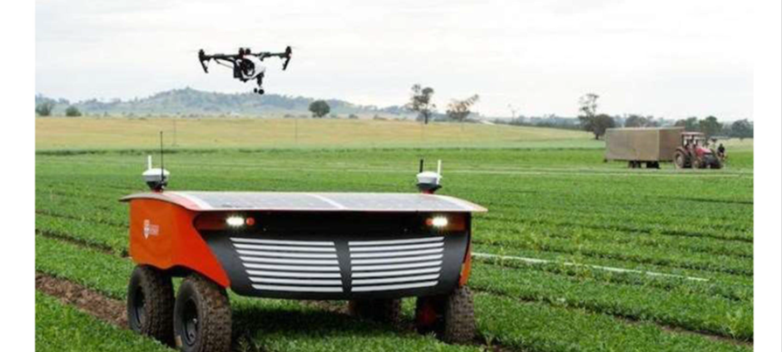
Figure 1: A high tech, solar-battery powered organic farm weeding robot. (Source: The Economist, 2016)
Cronin’s (2015) statistical research into the organic sector found that sales are still increasing, but at a lesser rate than 10 years ago (figure 2). However, a healthy profit margin can be enjoyed, which is increasing (figure 3) suggesting strong consumer value and perhaps loyalty to the organic cause. UACA’s strategic challenge is to position to maximise profit by appropriate pricing and attract new custom in a growing market which is likely to become more competitive as growth slows.

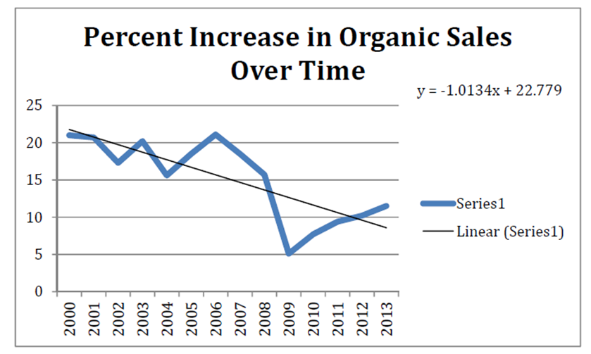
Figure 2: The annual increase in sales of organic foods (Source: Cronin, 2015)
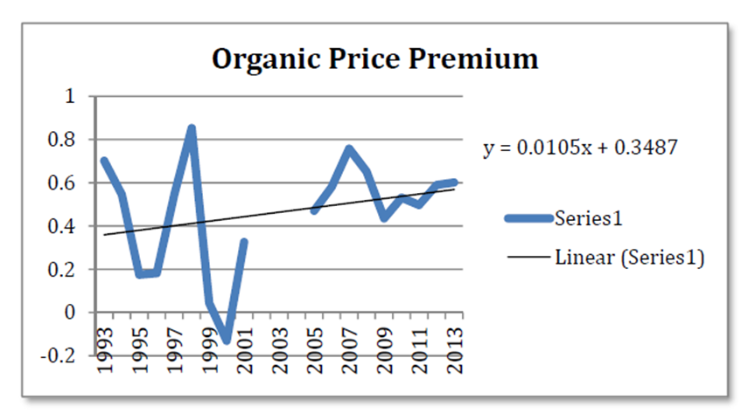
Figure 3: The Price Premium paid for Organic foods. (Source: Cronin, 2015)

Chang and Shuster (2015) found that vertical integration was a key trend in the organic farming industry. Whilst overall it is still relatively small, economies of scale are difficult to achieve. Other ways of lowering costs and achieving more efficient practice need to be found. Sources of supply can be unstable, and exposure to a niche market of consumers can be challenging. Vertical integration can help to address this by forging strategic alliances, long term partnerships and alliances. UACA need to make the most of this to ensure stability of operations and make logistics efficient – with an eye on competitor’s efforts to do likewise.

PWC (2018) analyses the UK economic outlook in which growth has slowed down considerably since the Brexit vote, making sales, particularly in organic – seen as something of a dispensable luxury by some – more challenging. The West Midlands region is forecast to receive a boost from the HS2 rail effect, with businesses relocating from London to Birmingham, but at the same time a slowdown in manufacturing, a traditionally strong area for the region, which might be hard hit by Brexit. UACA has some contracted service work with a local authority. Elkes (2013) problems of local authority contracts in Birmingham and the need for cutbacks in the cash trapped local government sector. So there may be pressure for cost savings here.

In the analysis below, reference will be made to Able and Cole and GrowUp Urban Foods for comparison. Both also compete in the organic food sector: Able and Cole supplying food boxes and products nationwide, on a larger scale than UACA; GrowUp Urban Foods a somewhat similar business based in a different geographical area. These two different comparable businesses may help to highlight issues and solutions in strategic management for the chosen company here.

3. SWAT Analysis
A SWAT analysis of the strategic position of the company and its strategic management decision making processes is made here. It could be argued that as a relatively young and enthusiastic small business, a SOAR analysis might be more appropriate. Morrison (2017) talks of SOAR as a positively reframed SWOT analysis. SOAR stands for Strengths, Opportunities, Aspirations and Results. However, this positive approach ignores weaknesses that can lead to opportunities. Hindle (2008) credits Albert Humphrey with the SWOT analysis in the 1960s, which since then has become the preeminent well known analysis, easily recognisable and understandable, and that in itself a great advantage when presenting plans to shareholders. SWAT is intended to analyse internal weaknesses: factors which may inhibit the organization from delivering its promise, more than externally who might outperform the company. Therefore SWAT is used here as a preferable tool for delving into the strategic management qualities of UACA.

In order to conduct the SWOT analysis, a series of interviews was conducted with directors of the company (appendix 1), visually displayed in figure 4. An estimation of the seriousness of each issue has been made according to the number of directors who identified it and the emphasis they gave (indicated by the stars in the appendix), reflected by the position of circle on the chart. Positioning near to the borderline between strengths and weaknesses is a reflection that the issue is marginally one way or the other; positioning high within strengths or low within weakness shows the issue is at the extreme end.

An analysis of the Company’s Annual Report to Shareholders, and relevant literature about the sector, was used to identify further strengths and weaknesses, opportunities and threats. UACA’s (2018) Annual Report to Shareholders describes existing strategic priorities to forge local partnerships; develop the educational services and expand store and café offer. An organic vegetable products offer remains core. Figure 4 shows that directors have identified many different areas of strength and weakness, bringing to the board their different experiences and perspectives, demonstrating the diversity and affiliative freedom which they themselves identify as strengths of the company. At the same time, also identified, is a lack of focus and competitive drive in prioritised areas.

In regards to the Urban Food sector, GrowUp Urban Foods, a similar outfit in London, identifies ethical issues and causes as an opportunity for marketing and a strength (EIT, 2015). A similar diverse range of products is available. Kate Hoffmann, founding entrepreneur, has taken care to avoid the weakness of New York based Urban food company Aqua Vita (Callie, 2015) which entered a crowded market and failed to sell enough products to succeed. So GrowUp first took the opportunity to pilot and sold the idea before launching the product on any scale (GrowUp Urban Farms, 2016). Building on strong ethical principles, orders were pre-negotiated with high end restaurants. Then, following a step by step strategic plan, GrowUp launched a new Fish range and developed their education and training offer. The stages of opportunity enabled them to always stay ahead of the curve of improvement (Power, 2014) and pre-empt threats from local stores moving into GrowUp’s market share. UACA could note the threat of competitors to Aqua VFita’s supply line and the opportunity for ethical marketing, modelling before scaling up and diversification into fresh fish from GrowUp.

Able and Cole did not foresee the importance of competitive positioning in their rocky past decade, before the threat of takeover became reality (Benjamin, 2013). Now restructured, every part of their supply line is focused to add value. Expertise is driven from parent company Jackson Food Group, who have the resources to input management expertise in house and invest in technology for marketing and logistics. UACA should note the threat of takeover, should they fail to exploit their position effectively.

Figure 4 SWAT analysis using Directors interviews
Strengths  Training services  Ethical principles  Financial consult-ancy  Niche market  Stakeholder involve-ment  Shareholder account-ability  Affiliative leadership  Diversity  Action plan cycle  Local govern-ment  Lack of focus | Opportunities  Quality product  New lines  Local partners  Invest-ment  Focus/ Prioriti-sation  Cafe  Flexibility  Store sales
Weaknesses  Reactivity  Local partners  Innova-tion  Invest-ment  Marketing  Business know-ledge  Recruit-ment  Personnel issues | Threats  Regula-tion  Competition  Supplier volatility  Shareholder engagement  Recruit-ment  Super-markets

4. Evaluation of Corporate Strategic Decisions to date
Do UACA make any strategic decisions? The question could be posed given the breadth of comment in figure 4. According to Alfred Chandler: “strategic planning involves the articulation of long-term goals and the allocation of the resources necessary to achieve those goals,” (The Economist, 2007). Igor Ansoff (The Economist, 2008) pointed out the difference between strategic planning and what he called strategic management, which turns plans into reality, and manages resistance to change. Porter distinguishes between steps and strategy: many companies mistake the steps they take, such as to internationalise, with the strategy itself, which should be to gain competitive advantage (Porter, 2010). A detailed strategic plan broken down in this way is not present for UACA. Reeves (2014) suggests that strategy takes 3 months to create and then is obsolete within a month, so perhaps for a small business in a fast changing market there is no need to set out a strategic plan. But this does not mean no strategy. “Strategy is more important than ever, but we need to adapt the right approach to the right situation.”

Mintzberg accepts there is no agreed definition of strategy and to some it is just a corporate level approach leading to a culture of success (Mintzberg, Ahlstrand and Lampel, 2009). Mintzberg defines the 5Ps of strategic planning: plan; ploy; pattern; position and perspective. Frank Bruce considers the 5Ps applied to UACA (Bruce 2018, 1) and is critical of the extent to which they are present in the company. It is not that they don’t exist or that the company is failing: the nuts and bolts of finances are strong. But the strategic management process to define and analyse these parts is lacking. UACA may be missing meaningful analysis which could bring future growth.

The company took advice from financial consultants as well as a business research exercise from the University of Aston. A consultant was contracted, experienced in business enterprise start-ups and ‘green’ and ethical projects. The Economist (2005) concludes: “firms do need to spend as much time thinking about the consequences of outsourcing as they do about where their business is going. You cannot outsource strategy.” Regenwetter (2018) emphasises the importance of getting value for money: consultants are not cheap. But given the concern about lack of business experience (figure 4), external advice on strategy was a sensible move. Bruce (2018, 3) considers that even with unknown uncertainties, consultants chosen with care, who know the values of a business, can add valuable experience which would otherwise take time and much more expense to develop in house.

Stakeholder involvement is a strength; but personnel issues a threat; this and the many different views in figure 4 suggest that the valued affiliative leadership giving everyone a say is resulting in a lack of focus and drive. Bruce (2018, 4) considers this company to have robust governance through shareholder scrutiny. This favours the Porter cost leadership and cost focus, and a Resources based approach (RBV). It can be a deterrent towards long term vision; shareholders are not so familiar with the daily processes and work patterns that stakeholder governance would bring out. Short term financial return approach is not necessarily the best focus for strategic long term planning.

Ferris and Treadway (2012) explain that economics based theories have become preeminent over sociology based theories in strategic planning. Resource based review (RBV) is rooted in economics and Knowledge based review (KBV) in sociological perspectives. RBV is better for evolutionary development whereas KBV focuses on less tangible skills and knowledge. The two theories can complement each other and help an organisation see the full picture and value all of its parts. Overall, UACA addresses shareholders using RBV information but directors have a bias of interests towards KBV. This inconsistency needs addressing. The company is based around ethical production which customers choose partly for quality and partly out of belief in the system it supports. Ferris and Treadway (2012) argue that KBV is favourable for firms wishing to gain competitive advantage and differentiation, whereas RBV may produce a race to the bottom, so the less tangible KBV approach is the right one for this company.

5. Strategic Options for Global Competitiveness
Considering the current state of food markets (CBI, 2016), global competitiveness for UACA would be best achieved in a niche. A broad brush approach or a mass, low price appeal would be very difficult to achieve against larger competitors. As an SME, UACA should therefore concentrate on its quality, organic, ethical niche.
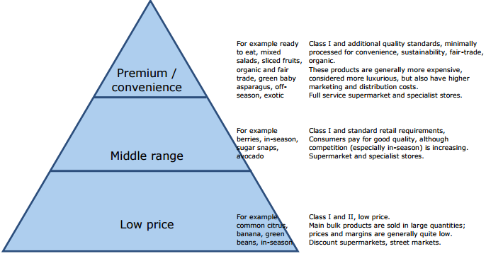
Figure 5: Segmentation of fresh food retail markets (CBI, 2016)

In a similar enterprise in London, GrowUp Urban farms have used involvement with environmental outreach projects and social media, interviews, attendance at conferences to promote the brand, differentiating their position against larger, cheaper rivals (Austen, 2016). Abel and Cole use a “digital trident” (Holt, 2015) to corner online organic sales. Blythman (2017) shows how in the UK, Lidl and Aldi have provided cut price organic produce for the mass market. As the novelty wears off and organic foods become mainstream, local suppliers who could previously charge a premium might be squeezed. Winkless (2016) finds that many Urban farmers are doing so more for social and educational reasons than profit as overheads are higher in terms of energy use and paying for land, it is difficult to compete with large scale rural farming. Nevertheless, urban farmers may be futureproofed by more innovative, controlled farming environments from climate change, drought and flood, as identified by the Food and Agriculture Organization of the United Nations (2017).

KelloggInsight (2018) discussed the current trend towards vertical integration. Uncertainty about which layers of business might generate value in the future make contracts uncertain. Amanda Starc comments that if it is too difficult to write a clear contract because of this, then that’s the time to vertically integrate instead. In the organic food industry, many customers believe traceability is essential and will pay a premium for products such as organic infant nutrition where they feel secure about that. In the small company Herba Ingredients they see vertical integration as a positive for supplying this confidence to the consumer (Herba Ingredients, 2018). Chang and Shuster (2015) found vertical integration a trend in the organic food industry with similar benefits. In UACA, figure 4 shows local partners identified as both a weakness and an opportunity. Local supplies for the store have been put in place, perhaps due to convenience rather than strategy (UACA, 2018). A strategic plan to form closer vertically integrated supply lines might yield more reliability and help shield the business from disruption or in times of critical incident.

6. Frameworks to achieve global competitive positioning
Porter’s Value Chain model works when a firm is able to focus on making each part of its value chain simpler and cheaper, thereby undercutting competitors. Each part of the chain, including primary activities such as operations, logistics and marketing; and support activities should add more value than their cost. Bajpai (2017) argues it is relevant for major corporations aiming to keep market share and squeeze out start-ups. Industry trends suggest consolidation into larger farms with cost cutting efficiency (The Economist, 2016). For a small, organic start-up, Porter’s value chain cannot be ignored but may not be the best approach. Figure 6 shows UACA has a reasonable position but does not necessarily focus the company in the most profit making niche market direction.

Figure 6: Porter’s Five Forces Model applied to UACA organic Vegetable sales
Rivalry | Threat of substitutes | Buyer Power | Barriers to entry | Supplier Power
Few local Urban Farm competitors  Strong competition from organic producers supplying directly (Able & Cole) or to Supermarkets | Less likely due to being a niche in the local area; possibility with growth in this sector although growth is declining. Changes in shopping habits to online could mean substitutes are able to grow more quickly. | Loyalty built up with consumers who value organic range for ethical reasons and are prepared to differentiate on those grounds more than price, so pay a premium | Local market secured but barriers to wider geographical market include logistical issues and advertising, particularly as an SME with a loyal local following and less well known/ unknown outside the local area | Increasing for products not grown in house, depending on the supplier:  Local – less power, good relations  Exotic suppliers – considerable power as they can sell large quantities more easily elsewhere
(Based on Porter’s Competitive Strategy, Porter: 1980)

Dawar and Baggar (2015) propose a C-D Centrality Distinctiveness map to help visually display brand positioning. Brands are mapped according to four quadrants: aspirational, mainstream, unconventional and peripheral. Instead of narrowly focusing on organic, companies can compare many different products and make decisions about appropriate pricing and profitability according to how distinctive a product is. Figure 7 shows that UACA may not have sufficiently differentiated their organic range. The company does not price as highly as Able and Cole, online competitor, and may be regarded as unconventional for the ethical, green standards, but not so much aspirational, for the higher pricing and mark up benefit, so fails to take advantage of the organic foods premium (figure 3).

Figure 7: Centrality-Distinctiveness Map for food retailing in West Midlands

Food Sales Volumes, estimated |  | <----------Distinctiveness---------> | Food Pricing, estimated
Unconventional  Able & Cole  Pak Markets  Asda | Aspirational  Waitrose  Sainsbury  Tesco | <----------Distinctiveness---------> | Unconventional  UACA | Aspirational  Tesco  Able & Cole  Waitrose  Sainsbury
Locals  Morrison  UACA  Peripheral | Mainstream | <----------Distinctiveness---------> | Locals  Asda  Pak Markets  Peripheral | Morrison  Mainstream
<Centrality–how representative brand is> |  | <----------Distinctiveness---------> | <-----------------Centrality--------------------->

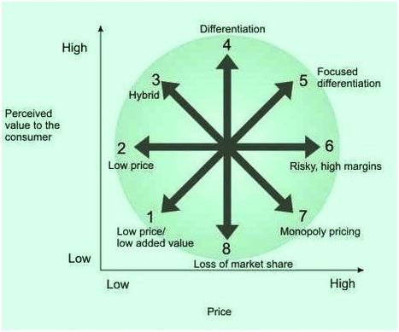

Figure 8: Bowman’s Strategic Clock. Source: Bowman and Faulkner (1997)

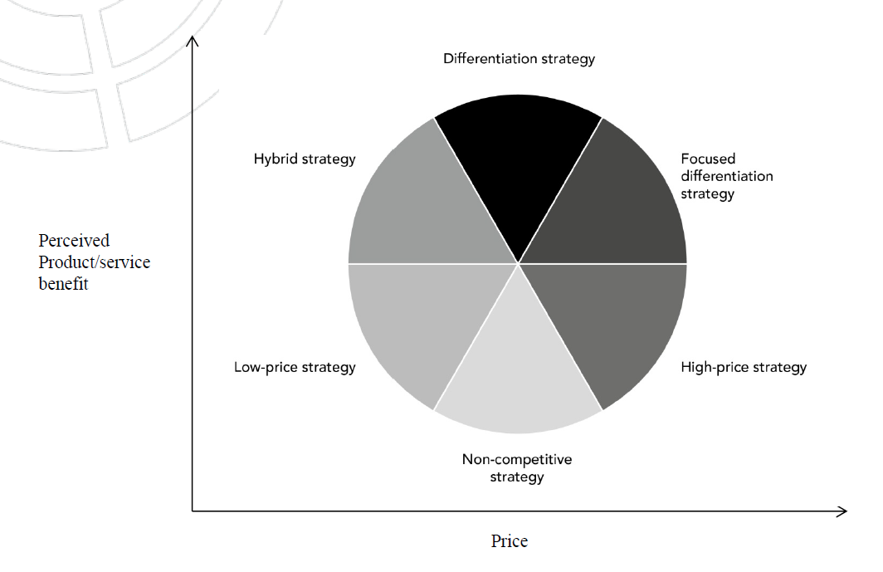
Figure 9: Adaptation of the Strategic Clock for small businesses
Source: Haselwanter, Muskat and Zehrer (2016).

Bowman’s strategy clock is another tool for competitive positioning. This simple, visual tool is helpful for UACA especially as adapted in figure 9, appropriate for an SME. Bruce (2018, 7) advises a shift from the current hybrid strategy of the company evaluated here, to more differentiation and move further clockwise in strategy so that focused products emerge to take advantage of the quality organic niche. Consistency across the diverse range of products and a move towards focused differentiation pricing might better position the company more clearly away from lower cost rivals.

Figure 10: Ansoff’s Growth matrix applied to UACA Organics

Market Penetration of existing products  Strategic:  Increase market share of local organic consumers, targeting share of sales currently taken by Lidl, Sainsbury and Able and Cole  Administrative:  Requires marketing and promotion amongst customers which the company has little exposure to  Operational:  Nudge into the competitive supply market for supermarkets with just in time guaranteed product production | New Product development  Strategic:  Develop new ranges including organic cosmetics and ready meals to increase average order by existing customers  Administrative:  Marketing alongside existing deliveries/ sales; new supply lines and operational production  Operational:  Existing supply operations but new product production lines need to be set up  Risk >
Market development of existing products into new markets  Strategic:  Define geographical area for targeting, set goals and research competition  Administrative:  Copy over operations to new area; organise partners and administration  Operational:  Logistics of supply and upscale existing operation lines | New product diversification in new markets  Strategic:  Develop new ranges including organic cosmetics and ready meals sell online or through new local retail partners  Administrative:  Set up new web presence and organise structures and contracts of partnerships with new sales outlets  Operational:  Set up whole new lines for product production

Ansoff produced a growth matrix as a tool for market penetration and planning. Dawes (2018) questions how logical Ansoff’s matrix is. Can organic vegetable products really be ‘new’ to UACA? If really ‘new’ this automatically implies an unfamiliar market and the diversification square is unnecessary. However, new products in the existing organic specialism may not really be perceived or differentiated as all that ‘new’ by consumers. Hindle (2008) criticises Ansoff for over-elaboration, slowing down the process, but with flexible application, this matrix can be very useful for UACA to focus on developing the organic range and spreading the geographical as well as consumer sectors of their market, as advised in figure 10. Ansoff’s division of planning into strategic, administrative and operational is a practical guide to section and chunk development in a manageable way for companies and has been widely adopted (The Economist, 2018).

An alternative to Porter’s Five Forces is the Blue Ocean Thinking model. Five Forces is about competition: how to become the most competitive in class. It can involve cut throat efficiency driving, rather than innovating new products. Blue Ocean is about innovation to create new markets. But doesn’t that inevitably lead to the need to follow five forces once those new markets become crowded? Burke et al (2010), in their analysis of Dutch retail, found that Blue Ocean techniques grew the market for all entrants over a 10 year period, not just some at the expense of others. However, as Lee Mullins discusses, Blue Ocean does not necessarily lead to truly innovative products being developed, and can be time consuming and laborious as a process (Mullins, 2018). For this reason UACA might not be in a position or have the expertise to steer through Blue Ocean at this point in its development, but could consider it for developing innovative products 2-3 years down the line. Another model is the 7 step staircase for growth Baghai et al (2000). Some of the same principles of Ansoff are applied in steps building in complexity. This may produce a simple, linear approach of advantage to an SME, but with a diverse range of activities at UACA the approach cannot be linear (Bruce, 2018, 6).

7. Implications for strategic management decision making
Two of the main change management models used today are the McKinsey 7-S model and Kotter’s 8 step Change Model. A third, old model proposed by Kurt Lewin model has not been considered here. This suggests it is necessary to unfreeze staff, change then refreeze into a new stable state (Lynch, 2015). However, given the dynamic and continually changing world business now faces, and the complexities to be negotiated, the more detailed steps outlined by Kotter and McKinsey are used here for more guidance. An application to UACA is shown in figures 11 and 12 below.

Going through a process such as this might help structure strategy making, although with both strategies the time taken in working through might slow change down. Since change is not urgently, the company evaluated here might do well to follow one of them. McKinsey might be easier to fit into as it is cohesive and allows all staff to become involved in the formation of shared values (Monahan, Murphy and Johnson, 2016) – in keeping with practice at UACA. However, Kotter might have the edge in facilitating a clearer vision and promoting a path towards leading from the front whilst bring staff along the way. Though UACA might be less comfortable with this initially it is advised that this would be a good stepping stone towards change leadership and faster, more focused change which this SME would benefit from.

Figure 11: McKinsey applied to UACA.
McKinsey 7-S Model –  7 factors | Strengths | Weaknesses
Hard elements:  Strategy | Broad agreement and encompassing of many different interests/ lines | Organic growth; not well defined in steps/ stages
Structure | Relatively flat structure, not a top down approach; suits small size of company | Does not promote specialism in change management
Systems | Shareholder accountability cycle / discipline | Copy-paste structure – may not be so appropriate for SME
Soft elements:  Shared Values | Consensus around organic products, ethical working | These values are not always emphasised or pre-eminent – in the background
Style | New chair has affiliative style popular amongst staff | Lack of leadership management; lack of focus
Staff | Opportunity for best minds to be critical and involved in suggestions for strategic planning | Turnover/ recruitment issues; not up to speed with company changes/ involved until established in company
Skills | Breadth of experience represented at strategic planning | Directors experience lacking of business models for strategic improvement

Figure 12: Kotter applied to UACA.
Kotter’s 8 Step Change Model | Strengths | Weaknesses
1. Increase the urgency for change | Annual cycle including report to shareholders creates time discipline | Since sales are reasonable there is no pressing sense of immediate need for change
2. Build a team dedicated to change | Dedication to the principles around which the company is based | Personal power issues dividing directors
3. Create the vision for change | Strong ethical commitment and local vision for growth and partnership | Weak articulation of that vision
4. Communicate the need for change | Number of consultation events occur | ‘Need’ is not the main focus
5. Empower staff with the ability to change | Training available; suggestions welcomed | Staff turnover, recruitment and training an issue for commitment
6. Create short term goals | Within annual cycle financially driven targets | Steps for developing important strategic plans not in place
7. Stay persistent | Directors have strong views they are committed to, persistently | Lack of focus for persistence
8. Make the change permanent | Relatively stable company position in which change can be embedded | Multiple foci effecting business overall make permanence difficult

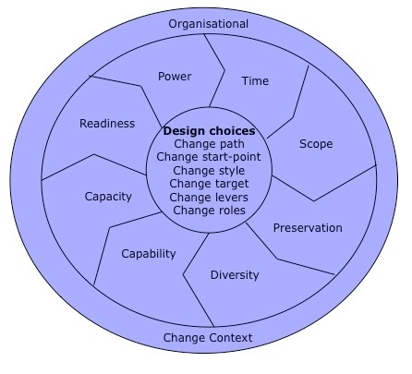
Figure 13: The Change Kaleidoscope. Source: Balogun et al. (2008)

Figure 14: The Change Kaleidoscope applied to a shift
to a focus differentiated strategy
Time | Important longer term shift building on current success and avoiding threat of competitors eating into margins at current positioning of quality products
Scope | Scope involves developing branding across organisation and particularly with the organic food range. Although focus will be more on marketing since logistics with local suppliers is satisfactory (though may be targeted to become more vertically integrated for other reasons)
Preservation | The ethical and organic character of products; strength of listening to employees and involving them in strategic planning
Diversity | Staff are, if anything, too diverse with too many different interests, not focused on strategic leadership but contentedly involved in strategic management
Capability | Whilst there is a range of business expertise amongst the directorate, more support, perhaps through external consultancy, is needed; particularly to work through the differences between different leaders
Capacity | Finances secure; staffing OK but insecure in some ways due to turnover and recruitment issues. Limits to the amount of time available given the wide range of activities the business supports which need to continue alongside.
Readiness for change | Vague awareness of the need to change but not the importance or urgency of it. Vision not articulated clearly.
Power | There is vested interested against change by the previous Chair and allies within the organisation

The Change Kaleidoscope represents a full model for strategic management. Could this provide the extra guidance and structure needed for an SME? Within the outer ring of context, the inner ring provides options, analysed here as a table. Here this is further focused on one particular issue, following on from Bowman’s strategic clock analysis to move from hybrid towards a more focus-differentiated strategy. Figure 14 shows the Change Kaleidoscope applied to a change to a focus differentiated strategy. The Change Kaleidoscope might help build capacity for strategic management within the organisation and help directors work through aspects in detail, though it could be criticised for being too complicated to manage, taking too much time for an SME with limited capacity.

ACCA (2015) advises building capacity and expertise in small businesses with professional advisers, about implementation of governance. Corporate governance frameworks and implementation were developed for large businesses and this can be a barrier to their effective implementation in SMEs. Frameworks need to be applied flexibly. It may be that this company has imposed the shareholder structure governance more suited to a larger enterprise and has this has nudged the company towards Porter- style strategy, focused on best value, rather than niche marketing and innovation.

Behind the SWAT analysis based on director’s interviews, displayed in figure 4, lies some conflicting interested as identified in the raw data from those interviews summarised in appendix 1. Mendelow’s matrix is a tool which might help to understand the different demands of stakeholders by helping to establish political priorities. Kaplan (2012) explains that the process involves deciding the balance between the power and interest of the stakeholder and is normally applied with regards to a particular strategy. The purpose is to assess whether stakeholder resistance is likely to inhibit the success of the strategy and what policies may ease the acceptance of the strategy.
 |  | Level of Interest
 |  | Low | High
Power | Low | Box A  Customers | Box B  Chair, Board of Directors – gentle, has affiliative style, does not lead from the front  Environmental groups  Committed workforce  Need to convince to keep on board, committed, or they could try to gain power and disrupt  Chair needs to assert power and displace previous Chair in Box D
Power | High | Box C  Local government due to various contracts and legal land ownership rights  Need to be kept satisfied, reassured; strategy as effects them explained | Box D  Consultant, former Chair – pulls the strings with other stakeholders; back seat driver; blocker of some changes  Shareholders; keen interest in management accountability; could stop management if not satisfied. Management needs to communicate plans and discuss implementation.

Figure 15: Mendelow’s Matrix applied

Bruce (2018, 5) considers the power of the former chair to be an issue for the future strategic direction of the company. Ideally interest may remain high but not power. An examination of a particular issue and positions taken, rather than personalities, could be a way forward for the company, using Mendelow’s matrix. This could help to work through the positions taken and enable people to find a structure to resolve issues for the strategic good of the company, rather than fight out personal power plays.

The power play issue suggests the company should consider the cultural web of factors which control the environment within which strategic planning takes place. Control systems, symbols, rituals, routines, stories and organisational structures all play a part. The best leaders are expert and referent, according to French and Raven’s Five forms of power (Aiello et al, 2017). Bruce (2018, 5) considers it important for the Chair of Directors to be more assertive. Currently respected as an expert holding quiet skills and knowledge, her perceived power needs to be enhanced so that she can operate as a referent. In exercising strategic leadership it may be that too much has been done to listen, but not enough to move on from that and lead.

Eisenhardt (2016) argues that Corporate Social Responsibility (CSR) has had its day. The focus on corporate large businesses is limited whereas most businesses like this company are smaller. Human social responsibility (HSR) is a new term which is all encompassing and more applicable. Those committed to the ethical and environmental values of the company are likely to agree with HSR, helping workforce satisfaction and therefore well-being and productivity. This is also a good advert for consumers who choose organic because they believe in responsibility. By involving workforce in consultations for strategic direction, a more holistic approach is created at UACA.

Figure 16 Reasons for failure of Change Management
Monahan, Murphy and Johnson (2016)

- research shows 70% of large-scale change initiatives fail to meet long-term goals
- employees experience change fatigue
- many executives recognize the need to change management, but still recommend traditional techniques, like pay-for-performance, which reinforce old ways
- Power dynamics, contextual considerations, and resistance to change are underestimated
- emotional and office politics preoccupy real people in organizations and are overlooked
- organizational change means changing human behaviour which is difficult
- since the 2008 financial crisis, change has focused on efficiencies not growth – so the focus is on cuts and restructures which can be negative and wearing

Monahan, Murphy and Johnson (2016), writing for Deloitte Review, comment that: “research shows that most large change management efforts fail. Why? Something’s been left out of the equation: the human element.” Some CEOs lead from the front without getting vital leaders in their organisation committed. On the other hand, some organisations operate “change management” rather than “change leadership”, lacking a clear, focused plan and taking too long to follow through mechanical steps of process without taking strident steps to disrupt current practices to create new value. Key reasons for failure are summarised in figures 16 and 17. In this assignment, the company is at risk of failure through “change management” and lack of focus amidst issues regarding different personalities, particularly present and former Chair. Following a change management model could yield considerable benefits in bringing key personalities together and on board. By contrast, The Economist Intelligence Unit (2008) in a survey of major firms found that only 18% labelled employee resistance as a major factor in the failure of change management. Lack of clearly defined and/or achievable milestones and objectives to measure progress was the most significant factor. Change management models could help to address this also.

Figure 17: Reasons for differentiation of small business strategy making
Source: Haselwanter, Muskat and Zehrer (2016).

- Prominent role of the owner-manager in decision-making
- No separation of ownership & management
- Entrepreneurial orientation and intuition
- Emotions, personality, prior experiences, skills & competencies
- Structural and size-related factors of micro firms • Limited financial & human resources
- Smaller market share
- Operation orientation of micro firms •
- Rather daily business oriented
- Not aware of strategic competitive advantages
- Lack of market knowledge

Arnold (2016) argues for firms having their own change management departments, permanently part of the firm for an on-going process of change, exercised more flexibly than Kotter’s rigid stages. The concept of organisational change management (OCM) and constant change is becoming more prevalent. UACA may not be large enough for an in house department. But a continuous process has two advantages: it would avoid the resistance to change building up at the time of change in key leaders, and it would embed change within what is anyway a changing marketplace, normalising the process for employees. OCM could be organised using the main principles from Kotter of McKinsey. Kotter believes that combatted with: “Get ‘em out of the way” (Kotter, 2011). But Monahan et al (2016) argue that there has been a failure to recognise the psychological effects. Resistance to change could come from Kotter’s model ineffectively applied. Constructive criticism by some of the best brains in an organisation can lead to innovation: these are valuable staff to be retained. Therefore the company would be wise not to take Kotter too literally Bruce (2018, 9).

Which strategic management practices are applicable to small businesses such as UACA? Most research has focused on larger firms whereas small and micro businesses are a rather new area of research (Kelliher & Reinl, 2009). It has been shown that methodical strategic planning in small businesses reduces failure rates, and is vital for long term success (Pe’er, Vertinsky & Keil, 2014). Haselwanter, Muskat and Zehrer (2016) identify the factors, shown in figure 6, as necessitating adaptation of strategic management approaches. Applied to the Strategic clock, this existing strategy is seen as easy to use and appropriate. Figure 7 above shows an adaptation of this which removes the no frills and monopoly pricing sectors leaving simplified sector terminology, easier to apply by small business directors themselves. Adaptation and flexibility are key to success.

8. Summary of recommendations for a new strategic approach
The main recommendations contained in the above texts are summarised here, in order of priority:
- beware of the personality issues which lead to failure of change management in many SMEs in particular, and work through these using Mendelow (page 30)
- with some urgency, focus on Mendelow’s matrix to resolve personality disputes behind lack of focus amongst directors, as a process for developing understanding and bringing directors on board (page 27-8)
- be aware much change management fails due to failure to articulate clear goals and work on expressing and communicating them for UACA (page 29)
- deploy Kotter as a stepping stone to draw directors and employees into a more formalised change management process (rather than Mintzberg which is too drawn out given the already loose processes of UACA) and move on towards change leadership, with clearer, focused sharing of the vision (page 23)
- make products more distinctive according to the Centrality Distinctiveness index to profit from the premium consumers will pay for aspirational, distinctive organic products (page 18)
- turn from hybrid to focus differentiation according to Bowman’s strategy clock (page 19)
- promote HSR (rather than CSR) as it is in keeping with the company’s values (page 28)
- balance the current emphasis on Porter/RBV (in reporting to shareholders) with more emphasis on KBV, which better suits the company’s ethical values and interests (page 17)
- if considering Ansoff, apply it flexibly so as not to delay pressing change through drawn out change management process (page 20)
- consider Blue Ocean for Innovation after 2 years. In the short term more focus is needed to build capacity and urgency for change (page 21)
- consider using the change kaleidoscope for a particular area, such as the moved to focus differentiation for product competitive positioning, but adapt it for simplicity given the size of this SME (page 26)

9. References
ACCA (2015) Governance for all: the implementation challenge for SMEs. Available online at: https://www.accaglobal.com/content/dam/acca/global/PDF-technical/small-business/ea-governance-for-all.pdf [Accessed 30/07/2018]
Aiello, A., Tesi, A., Pratto, F. & Pierro, A. (2017) Social dominance and interpersonal power: Asymmetrical relationships within hierarchy‐enhancing and hierarchy‐attenuating work environments. Journal of Applied Social Psychology 48:1 pp.35-45 Available online at: https://onlinelibrary.wiley.com/doi/10.1111/jasp.12488 [Accessed 02/06/2018]
Arnold, P. (2016) The evolution of change: why things need to be done differently. Chartered Management Institute 08/02/2016. Available online at: https://www.managers.org.uk/insights/news/2016/march/the-evolution-of-change-why-things-need-to-be-done-differently [Accessed 15/07/2018]
Austen, N. (2016) The socially conscious shopper: trends changing the way we choose, buy and consume food. Foodbev Media 11/01/2016. Available online at: http://www.foodbev.com/news/the-socially-conscious-shopper-trends-changing-the-way-we-choose-buy-and-consume-food/ [05/07/2018]
Baghai, M. et al (2000) The Alchemy of Growth: Practical Insights for Building the Enduring Enterprise. McKinsey USA.
Bajpai, P. (2017) Starbucks as an example of the value chain model. Investopedia 09/04/2017. Available online at: https://www.investopedia.com/articles/investing/103114/starbucks-example-value-chain-model.asp [Accessed 21/06/2018]
Balogun, J., Hailey, V., Johnson, G., & Scholes, K. (2008) Exploring Strategic Change. FT Prentice Hall.
Balogun, J. & Hailey, V. H. (2014) Landing transformational change. CIPD. Available online at https://www.cipd.co.uk/Images/landing-transformational-change_2014_tcm18-16180.pdf [Accessed 10/072018].
Benjamin, K. (2013) Abel & Cole delivers at last as demand for vegetable and fruit boxes soars. Campaign 13/02/2013. Available online at: http://www.campaignlive.co.uk/article/groceries-abel-cole-delivers-last-demand-vegetable-fruit-boxes-soars/1170428 [Accessed 06/07/2018]
Blythman, J. (2017) How to surf the organic food boom on the cheap. The Guardian 20/02/2017. Available online at: https://www.theguardian.com/lifeandstyle/shortcuts/2017/feb/20/how-to-surf-the-organic-food-boom-on-the-cheap [Accessed 07/07/2018]
Bowman, C. & Faulkner, D. (1997) Competitive and Corporate Strategy, Irwin, London
Bruce, F. (2018, 1) Is there one "best" definition of strategy? Forum message to Week 1, Activity 2, 05/2018
Bruce, F. (2018, 2) Blue Ocean Thinking. Forum message to Week 2, Activity 3, 05/2018
Bruce, F. (2018, 3) Take Risk to manage uncertainty. Forum message to Week 2, Activity 5, 05/2018
Bruce, F. (2018, 4) Overview of strategic purpose. Forum message to Week 4, Activity 1, 06/2018
Bruce, F. (2018, 5) French and Raven’s Five Basis of Social Power. Forum message to Week 4, Activity 3, 06/2018
Bruce, F. (2018, 6) What about organisations interested in a growth strategy? Forum message to Week 5, Activity 3, 06/2018
Bruce, F. (2018, 7) Bowman’s Strategy Clock. Forum message to Week 5, Activity 4, 06/2018
Bruce, F. (2018, 8) McKinsey: Twelve Questions Every New Director Should Ask. Forum message to Week 6, Activity 4, 06/2018
Bruce, F. (2018, 9) John Kotter: Resistance to change. Forum message to Week 7, Activity 5, 06/2018
Burke, A., Stel, A., & Thurik, R. (2010) Blue Ocean vs. Five Forces. Harvard Business Review 05/2010. Available online at: https://hbr.org/2010/05/blue-ocean-vs-five-forces [Accessed 27/05/2018]
Callie (2015) London’s First Commercial Aquaponic Farm. Garden Culture Magazine 17/04/2015. Available online at: http://gardenculturemagazine.com/ [Accessed 01/07/2018]
CBI (2016) CBI Market Channels and Segments: Fresh Fruit and Vegetables in Europe. Available online at: https://www.cbi.eu/sites/default/files/market_information/researches/market-channels-segments-europe-fresh-fruit-vegetables-2016.pdf [Accessed 12/06/2018]
Chang, M. & Shuster, E. (2015) Understanding the Organic Foods Supply Chain: Challenges and Opportunities from Farm Gate to End Consumer. Available online at: https://www.researchgate.net/profile/Edmund_Schuster/publication/228869478_Understanding_the_Organic_Foods_Supply_Chain_Challenges_and_Opportunities_from_Farm_Gate_to_End_Consumer/links/54f876680cf28d6deca29716/Understanding-the-Organic-Foods-Supply-Chain-Challenges-and-Opportunities-from-Farm-Gate-to-End-Consumer.pdf?origin=publication_detail [Accessed 03/07/2018]
Cronin, C. (2015) The Organic Food Industry: An Analysis of Supply and Demand via Aggregate Prices. Available online at: https://repository.upenn.edu/cgi/viewcontent.cgi?referer=https://www.google.co.uk/&httpsredir=1&article=1000&context=spur [Accessed 03/07/2018]
Dawar, N. & Baggar, C. (2015) A Better Way to Map Brand Strategy. Harvard Business Review 06/2015. Available online at: https://hbr.org/2015/06/a-better-way-to-map-brand-strategy [Accessed 02/06/2018]
Dawes, J. (2018) The Ansoff Matrix: A Legendary Tool, But with Two Logical Problems. SSRN 27/02/2018. Available online at: https://ssrn.com/abstract=3130530 or http://dx.doi.org/10.2139/ssrn.3130530 [Accessed 23/07/2018]
Deloitte (2013) Global Business Driven HR Transformation. Available online at: https://www2.deloitte.com/content/dam/Deloitte/global/Documents/HumanCapital/dttl-hc-hrtransformation-8092013.pdf [Accessed 15/07/2018]
Denning, S. (2017). Moving to blue ocean strategy: A five step process to make the shift. Forbes Available online at: https://www.forbes.com/sites/stevedenning/2017/09/24/moving-to-blue-ocean-strategy-a-five-step-process-to-make-the-shift/#6fbef5157f11
Eisenhardt, K. (2016) Replacing CSR with Human Social Responsibility: People First. CSR Wire 21/10/2016. Available online at: http://www.csrwire.com/blog/posts/1768-replacing-csr-with-human-social-responsibility-people-first [Accessed 02/06/2018]

EIT (2013) Kate Hofman - Interview - Climate-KIC, EIT CH.A.N.G.E. Award 2013 Winner. Available online at: https://www.youtube.com/watch?v=YoW_tykd5hk [Accessed 16/06/2018]

EIT (2015) Interview with Katie Hofman – EIT Change Award Winner 2013. Available online at: https://eit.europa.eu/ [Accessed 18/06/2018]
EIU (2008) A change for the better Steps for successful business Transformation. A report from the Economist Intelligence Unit. Available online at: http://viewswire.eiu.com/report_dl.asp?mode=fi&fi=1003398485.PDF [Accessed 15/07/2018]
Elkes, N. (2013) Birmingham may axe £120m in services contracts. Birmingham Mail 16/12/2013. Available online at: https://www.birminghammail.co.uk/news/local-news/birmingham-axe-120m-services-contracts-6407131 [Accessed 22/07/2018]
Ferris, G.R. & Treadway, D.C. (2012) Politics in Organizations: Theory and Research Considerations. Routledge
Food and Agriculture Organization of the United Nations (2017) The future of food and agriculture – Trends and challenges. Rome. Available online at: http://www.fao.org/3/a-i6583e.pdf [Accessed 07/07/2018]

Gedeon, S. (2010). What is entrepreneurship?' Entrepreneurial Practice Review 1.3
Gluck et al (1980) Strategic Management for Competitive Advantage. Harvard Business Review. Available online at: https://hbr.org/1980/07/strategic-management-for-competitive-advantage [Accessed 01/07/2018]
Gopalan, M. (2015) Volvo Buses eyes next growth phase in India. The Hindu Business Line 27/08/2015. Available online at: https://www.thehindubusinessline.com/specials/auto-focus/volvo-buses-eyes-next-growth-phase-in-india/article7587175.ece {Accessed 01/07/2018]
Gordon, S. (2014) Virgin group: Brand it like Branson. Financial Times 05/11/2014. Available online at: https://www.ft.com/content/4d4fb05e-64cd-11e4-bb43-00144feabdc0 [Accessed 02/07/2018]

Grow Up Urban Farms (2016) Our Story. Available online at: http://growup.org.uk/ourstory/ [Accessed 18/06/2018]
Haselwanter, S., Muskat, B. & Zehrer, A. (2016). Strategic Planning in micro businesses – Adapting the strategic clock for micro firms. EURAM 2016, Manageable Cooperation? Paris, France, 1–4 June 2016. Available online at: https://www.researchgate.net/profile/Birgit_Muskat/publication/320741276_Strategic_Planning_in_Micro_Businesses_Adapting_the_Strategic_Clock_for_Micro_Firms/links/59f8fd60aca272607e2f66e4 [Accessed 22/07/2018]
Herba Ingredients (2018) Vertical integration in organic food industry. Available online at: http://www.herbaingredients.com/upstream-downstream-innovation [Accessed 03/07/2018]
Hindle, T. (2008) Guide to management Ideas and Gurus. The Economist.
Holt, M. (2015) The Digital Trident: Marketing’s New Weapon of Choice. Sell or else 09/02/2015. Available online at: https://sellorelse.ogilvy.com/2015/02/09/the-digital-trident-marketings-new-weapon-of-choice/ [Accessed 22/07/2018]
Johnson, G., Whittington, R., Scholes, K., Angwin, D. & Regnér P. (2017) Exploring Strategy: Text and cases. 10th edition. Pearson.
Kaplan (2012) Mendelow’s Matrix. Available online at: http://kfknowledgebank.kaplan.co.uk/KFKB/Wiki%20Pages/Mendelow%27s%20matrix.aspx [Accessed 20/06/2018]
Kelliher, F. & Reinl, L. (2009) A resource-based view of micro-firm management practice. Journal of Small Business and Enterprise Development 16:3 pp. 521–532.
KelloggInsight (2018) What’s Behind the Current Wave of Vertical Integration? KellogInsight 05/01/2018. Available online at: https://insight.kellogg.northwestern.edu/article/whats-behind-the-current-wave-of-vertical-integration
Kenny, G (2014) A List of Goals Is Not a Strategy. Harvard Business Review 19/11/2014. Available online at: https://hbr.org/2014/11/a-list-of-goals-is-not-a-strategy [Accessed 12/05/18]
Kotter, J. (2011) Resistance to change. YouTube. Available online at: https://www.youtube.com/watch?v=Wdroj6F3VlQ [Accessed 15/07/2018]
Laja, P. (2017) Purchase Decisions: 9 Things to Know About Influencing Customers. CXL 2017. Available online at: https://conversionxl.com/9-things-to-know-about-influencing-purchasing-decisions/ [Accessed 18/06/2018]

Lincoln, J. (2011) Entrepreneurial DNA. New York: McGraw Hill.
Love, D. et al (2012) Commercial aquaponics production and profitability: Findings from an international survey. Aquaculture 435, 01/01/2015, p. 67-74 Available online at: http://www.sciencedirect.com/science/article/pii/S0044848614004724 [Accessed 12/06/2018]
Lynch, R. (2015) Strategic Management 7th ed. Pearson.
MBA Knowledge Base (no date) Bowman’s Strategy Clock. https://www.mbaknol.com/strategic-management/bowmans-strategy-clock/ [Accessed 22/07/2018]
Merchant, N. (2012) Why Porter’s Model No Longer Works. Harvard Business Review. Available online at: https://hbr.org/2012/02/why-porters-model-no-longer-wo [Accessed 20/06/2018].
Meyer, P. (2017) Apple Inc. Organizational Culture: Features & Implications. Panmore Institute 29/01/2017. Available online at: http://panmore.com/apple-inc-organizational-culture-features-implications [Accessed 22/06/2018]
Mind Tools (no date) McKinsey's Seven Degrees of Freedom for Growth. Available online at: https://www.mindtools.com/pages/article/seven-degrees.htm [Accessed 01/07/2018]
Mindtools (2018) The Cultural Web: Aligning Your Organization's Culture With Strategy. Available online at: https://www.mindtools.com/pages/article/newSTR_90.htm [Accessed 23/06/2018]
Mintzberg, H., Ahlstrand, B. & Lampel, J. (2009) Strategy Safari: Your complete guide through the wilds of strategic management. FT Prentice Hall.
Monahan, K., Murphy, T., & Johnson, M. (2016) Humanizing Change. Deloitte Review 19:2016. Available online at: https://www2.deloitte.com/content/dam/insights/us/articles/developing-more-effective-change-management-strategies/DR19_HumanizingStrategy.pdf [Accessed 04/07/2018]
Morrison, M. (2017) SWOT or SOAR? – Strategy and tools in business. RapidBi 26/06/2017. Available online at: https://rapidbi.com/swot-or-soar-strategy-and-tools-in-business/ [Accessed 22/06/2018]
Mullins, L. (2018) Blue Ocean Thinking. Forum message to Week 2, Activity 3, 05/2018
Olenski, S. (2017) 13 Marketing Trends For 2017 That B2B Marketers Need To Understand. Forbes 20/01/2017. Available online at: https://www.forbes.com/sites/steveolenski/2017/01/20/13-marketing-trends-for-2017-that-b2b-marketers-need-to-understand/#7bf72eac1516 [Accessed 12/06/2018]
Open Tuition (2017) ACCA P3 Chapter 20 Change Management. YouTube. Available online at https://www.youtube.com/watch?v=h3aE-qx1xQ4 [Accessed 10/07/2018].
Pe'er, A., Vertinsky, I. & Keil, T. (2014) Growth and survival: The moderating effects of local agglomeration and local market structure. Strategic Management Journal 37:3 08/2014.
Pinpointer (2017) Able and Cole. Available online at: http://www.pinpointer.uk/customer-stories/abel-cole/ [Accessed 22/07/2018]
Plantagon (2017) Strategy. Available online at: http://www.plantagon.com/about/brand/strategy/ [accessed 07/07/2018]
Porter, M. (1980) The Competitive Strategy: Techniques for Analyzing Industries and Competitors. Free Press, New York.
Porter, M. (2010) What Strategy is? Youtube. Available online at: https://www.youtube.com/watch?time_continue=2&v=0BgMQkKMKaE [Accessed 09/05/2018].
Porter, M. (2013) Lecture 24: Michael Porter – Strategy. Youtube. Available online at: https://www.youtube.com/watch?v=KvYwKM5bY0s [Accessed 10/05/2018]

Power, D. (2014) The Curve Ahead: Discovering the Path to Unlimited Growth. New York: St. Martin’s Press.
PWC (2018) UK Economic Outlook. Available online at: https://www.pwc.co.uk/services/economics-policy/insights/uk-economic-outlook.html#dataexplorer [Accessed 30/07/2018]
Reeves, M. (2014) Your strategy needs a strategy. Ted. Available online at: https://www.ted.com/talks/martin_reeves_your_strategy_needs_a_strategy [Accessed 17/05/2018].
Regenwetter, P. (2018) Take Risk to manage uncertainty. Forum message to Week 2, Activity 5, 05/2018
Sage S. (no date) The Three Levels of Strategy. Available online at: https://onstrategyhq.com/resources/the-three-levels-of-strategy/ [Accessed 25/05/2018]
Salvado, V.L. (2005) Competitive advantage and strategy formulation: The key role of dynamic capabilities. Management Decision 43:5, pp.661-669. Available online at: https://doi.org/10.1108/00251740510597699 [Accessed 20/06/2018]
Scholes, K. (2009) The Strategy Clock. YouTube. Available online at: https://www.youtube.com/watch?v=qJjbBH-gvbo&feature=youtu.be [Accessed 01/07/2018].
Schmidt, S. (2015) Competition Heats Up Among Organic Food Retailers. Market Research and Business Intelligence 10/11/2015. Available online at: http://blog.marketresearch.com/competition-heats-up-among-organic-food-retailers [Accessed 07/07/2018]
Shukla, G. (2012) Going Places. Business Today 08/07/2012. Available online at: https://www.businesstoday.in/magazine/case-study/why-volvo-makes-for-good-case-study/story/185477.html [Accessed 01/07/2018]
The Economist (2005) Outsourcing intelligently. The Economist 16/12/2005. Available online at: https://www.economist.com/node/5325095 [Accessed 28/05/2018]
The Economist (2007) Alfred Chandler. The Economist 17/05/2007. Available online at: https://www.economist.com/obituary/2007/05/17/alfred-chandler [Accessed 02/07/2018]
The Economist (2008) Igor Ansoff. The Economist 18/07/2008. Available online at: https://www.economist.com/node/11701586 [Accessed 22/05/2018]
The Economist (2009) Change Management. The Economist 12/01/2009. Available online at: https://www.economist.com/news/2009/01/12/change-management [Accessed 04/07/2018]
The Economist (2009) Strategic planning. The Economist 16/03/2009. Available online at: https://www.economist.com/news/2009/03/16/strategic-planning [Accessed 02/07/2018]
The Economist (2009) Value Chain. The Economist 19/11/2009. Available online at: https://www.economist.com/news/2009/11/19/value-chain [Accessed 20/06/2018]
The Economist (2016) The future of agriculture. The Economist technology Quartley 09/06/2016. Available online at: https://www.economist.com/technology-quarterly/2016-06-09/factory-fresh [Accessed 03/07/2018]
UACA (2018) Annual Report.
University of Cambridge (2016) Mintzberg's five Ps for strategy. Available online at: https://www.ifm.eng.cam.ac.uk/research/dstools/mintzbergs-5-ps-for-strategy [Accessed 22/05/2018]
Winkless, L. (2016) Urban Farming: Fad or Futureproof? Forbes 09/03/2016. Available online at: https://www.forbes.com/sites/lauriewinkless/2016/03/09/urban-farming-fad-or-futureproof/#3a4acfdf472b [Accessed 07/07/2018]

10. Appendices

Appendix 1: Summary of Interviews with Directors

Director | Strategic Priorities and Issues | Strength | Weakness | Oppor-  -tunity | Threat
A | Local government contracts | **
 | Recruitment |  | ***
 | Quality store sales |  |  | ***
 | Café range |  |  | ***
 | Shareholder engagement | ** |  |  | **
B | Organic quality |  |  | ****
 | Niche market | ***
 | Shareholder interest |  |  | ***
 | Regulation |  |  |  | *
 | Local government |  |  |  | **
C | Supermarket competition |  |  |  | ***
 | Shareholder accountability | ***
 | Investment |  | **
 | Local partnerships | ** | * | ****
 | Personnel issues |  |  |  | **
D | Involvement of all stakeholders in action planning | ** |  | ****
 | Reaction to market conditions rather than forward planning |  | **
 | Volatility amongst suppliers |  |  |  | **
 | Difficulty in calibre recruitment |  |  |  | ***
 | Education and training services | *** |  | ****
E | Flexibility to pursue different lines of business | *** |  | ***
 | Investment in strategic operations/ new technologies |  |  | ***
 | Strong financial consultancy | *** |  | ***
 | Affiliative leadership style | *
 | Robust shareholder accountability | **
F | Innovation |  | *
 | Annual cycle of strategic planning | *
 | Competition |  |  |  | *
 | Local government |  |  |  | *
 | Business modelling knowledge |  | ***
G | Strong ethical principles | ****
 | Marketing |  | **
 | New business lines |  |  | ***
 | Specialist business expertise |  | **
 | Focus and prioritisation |  | ** | ****

Appendix 2: Discussion Forum Industry Analysis

Applying this to an Urban Organic Food company and looking at the organic food sector in general:

Board roles and relationships
There is considerable Director experience from within the sector and more generally as accounting, director and Managing director experience from other prior employments

What will be your level of engagement and contribution to board dynamics?
High – as a member of the board myself and Company Secretary with organisational role but I attempt to ensure I’m not just organiser but also contributor to strategic policy planning as well as realistic moderator and legal advisor to some ideas mooted by other members of the board

Does the CEO hold the board at arm’s length or actively solicit the board’s guidance?
Actively seeks the boards guidance perhaps too much because there are competing interests and personalities; these need to be kept in check and focused otherwise internal competition becomes unfocused division

Do directors regularly challenge management’s point of view?
Robustly. However there is sometimes a tension between director’s emphasis on financial return and management’s long term strategic aims.

How much time does the average director spend on board matters and do they feel it is sufficient?
Varies. Directors have commitments as directors elsewhere too, some in partner/ supplier organisations which helps smooth functioning.

How will you proactively shape key relationships?
There are personal and professional relationships between the ‘old guard’ around the former chair, no longer a member of the board but continues to offer consultancy, and has influence, and the new Chair, who is attempting to exert her influence. I will proactively support the new Chair and attempt to reason with competing views.

Industry and company context
How is the competitive context evolving?
Competitors such as Able and Cole are gaining loyalty, have strong marketing, and now as part of William Jackson Food Group a degree of vertical integration with their supply and marketing divisions. We can’t match them but can create more distinctive niche.

Where are the priority opportunities for the company?
Higher quality products through existing channels.
Educational services and consultancy. (including new and existing products expanded to wider geographic market)

Which uncertainties could cause disruptions or opportunities for the company?
Changes to market with other competitors
Recession or equivalent causing a decline in the quality market
Regional uncertainties
BREXIT disrupting supply chains

Strategic Direction
Does everyone have a consistent understanding of the corporate strategy?
No. The division between past and new Chair is taking time to work through and this has an affect on peoples understanding of corporate strategy – however I believe new Chair wants to get people on board with some listening and persuasion first so when she does say that’s it, people will be less likely to disrupt

Are resources dynamically aligned with opportunities?
More or less although there are resources to play with and if the board chose to be bolder they could secure more financial backing to make bolder initiatives into new markets

Organisational Health
Is the board’s dashboard value-driven and does it cover non-financial metrics?
Provided externally through partners/ consultancy – yes but not always scrutinised enough by directors

I have commented above about some of the personalities/ delicacies with change of Chair.

The context of the organic industry is that it has ‘grown up’ to some extent. The quality end, Able and Cole and the like, have tried to forge out their distinctive boxes and worked hard on loyalty of customers but are being eaten away by the mass market discounters like Lidl who stock some organics at half the price. Whilst some firms are going for vertical integration to ensure traceability to satisfy demands, our experience of close links with suppliers of similar values works easier but it means that at strategic policy level directors must ensure they are well informed about them.

Source: Bruce (2018, 8)

MASTERS DEGREE ASSIGNMENT SPECIFICATION

Student name: | Frank Bruce | Student number: | 1602754
Programme: | eMBA
Module: | Strategic Management | Module Level: | 7
Module code: | SBMA71032D | Contribution to Overall  Module Assessment (%):
Lecturer: |  | Internal Verifier:
Assignment Title: | Strategic Management | Assignment No (1 of 1): | 1 of 1
Hand Out Date: | February 2018 | Submission deadline:  Feedback deadline: | 10/08/2018

Referencing: | In the main body of your submission you must give credit to authors on whose research your work is based. Append to your submission a reference list that indicates the books, articles, etc. that you have read or quoted in order to complete this assignment (e.g. for books: surname of author and initials, year of publication, title of book, edition, publisher: place of publication).
Disclosure: | I declare that this assignment is all my own work and that I have acknowledged all materials used from the published or unpublished works of other people. All references have been duly cited.
Student’s Signature: |  | Date: | 08/08/2018

