Design Patterns in  Web Development | Layered Architecture  ORM with Repository and Unit of Work Pattern  MSc. Software Engineering Web Development  ACCA7004  Gomathi Shivakumar 1809705

Table of Contents
Design Patterns 2
Introduction 2
Layered Architecture 2
Concept of Isolation 2
Evaluation 3
Object Relational Mapping (ORM) 3
Redundant Data problem 4
Impedance Mismatch Problem (IMP) 4
Advantages 4
Disadvantages 4
Repository 5
Benefits 5
Unit of Work (UoW) 6
Conclusion 7
References 7
Appendix 8
An example Repository and Unit of Work 8

Introduction

Design Patterns

Software architectural patterns enable developers to arrive at solutions to problems in a tried and tested manner thus reducing costs and risks. In a research conducted by Mohamad Kassab and et.al, only 1% of the participants did not use any design patterns in their project[1]. Empirical literature research indicate that quality concerns such as testability, maintainability and reusability are the main factors for developer’s choice of a design pattern[2].
It is critical to determine the right pattern that addresses the most desired qualities of the software being developed. Design patterns are categorised as structural and behavioural. This report focuses on two structural patterns Layered architecture and ORM with Repository and Unit of Work pattern.

Layered Architecture

Layered architecture is a structural architecture pattern focusing on abstraction and is the most commonly used in several software systems.

Concept of Isolation

Software is grouped into several loosely coupled layers that communicate with one another through shared interfaces. It works on the concept of isolation whereby the layers are grouped by responsibilities or concerns independent of other layers[3]. In most applications, there are three major components[4],

The User interface domain (UI)
The Application Layer – Business Logic(BL) The Data layer (DL)

Layered pattern places these three into different layers, communicating from the top to bottom. Additional layers such as Security, Network and Communication layers could also exist.

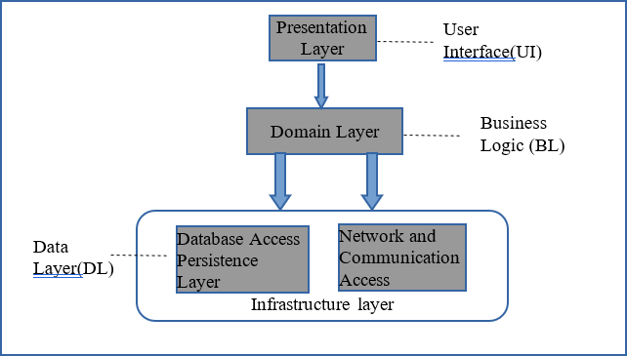

Figure 1:Layered pattern in common use

A layered architecture is considered as “foundational patterns” since it is recommended for most large systems [5]. The UI deals with user interaction functionalities. The Application layer, often combines the Business Logic incorporating manipulation of data to deliver business logic outcomes. The Data layer forms part of the infrastructure layer. Data stores and access to data by the BL is handled in the data layer.

Each layer has its own responsibility and serves as a service to the layer above it. In a component based layered architecture, components that satisfy the single responsibility rule are placed together into a layer. Thus, a network component could be grouped within the infrastructure layer with the data store. A perfect example is the Open system network and the TCP/IP model which uses 7 layers to transmit data as packets between systems.

Fowler states that the layers are logical and can be placed together or in multiple locations physically (tiers)[6]. Thus, an UL can be in the client and the BL can be in either the client or the server. The DL is always in the server. Placing the BL in the client can increase performance with relation to speed, especially in smaller systems. In larger systems with large volumes of data, it is efficient to place the BL in the server.

Evaluation

The successful implementation of a layered architecture relies on the following criteria being met [8]

- clearly defined context
- appropriate and well-defined functional layers
- modularity
- an appropriate level of abstraction
- hiding of unnecessary implementation details

Layers are generally closed. Each layer has its own controls and is accessible only to the immediate neighbour[4]. They are not concerned on the implementations of the other layers and has knowledge of a layer just above it. Such an abstraction provides for ease of scalability and refactoring of framework or infrastructure. It is easier to replace the upper layers without any changes to the lower layers[7].

Clarity on the layer’s structure would result in loosely coupled product with reduced maintenance[8]. The designers of the application layer need not concern about how the data is stored and data security and the data layer need not worry about how the data is acquired.

A layered architecture’s performance and stability can be improved with a combination of design patterns[8]. For instance, the use of observer design pattern to provide the communication between the layers results in loose coupling and scalability[9]. Modularity facilitates reimplementing any layer differently without affecting the functionality of other layers.
The very nature of modularity lends to platform independence, testing, debugging and facilitates, distributed development in large teams[10].

However, strict layering could result in antipatterns such as over abstraction. Too many layers increase complexity, more often resulting in intermediary interfaces and any changes to code could have a rippling effect. Layers can invoke only the lower layers in strict layering. This results in the traversal through each of the layers and slows performance[3]. This also calls for measures
to make sure data is not lost. This is increasingly a waste of resources in cases where a layer is not required access by all but one and can be left open.

Flexible hierarchy allows for direct communication between non-adjacent successive layers[7].

In a comparative study conducted by Anubha Sharma and et.al, a layered architecture evaluation is as follows[3].

Quality attributes | Performance
Complexity | Low
Functionality | High
Maintainability | High
Efficiency | High
Portability | Medium
Reliability | High
Scalability | Medium
Table 1:Performance of a layered architecture

Object Relational Mapping (ORM)

Object oriented programming (OOP) as we know works with objects that reflect real world. Web enterprise applications often deal with massive amount of data, sometimes the data being served from external sources. Persistence of data used or generated in any software is required at some level for operations to be performed to deliver the required output. The data layer must communicate with the business layer and the application layer for data persistence and data retrieval. This is often achieved through the data access layer interfaces through complex queries that are executed often repetitively[11]. Database query languages are restricted to the type of data models used and knowledge of such languages.

A framework that is independent of the way that data is structured and stored and allows querying using the language in which the software is being developed would enhance efficiency in development. Object relational mapping allows for such flexibility and converts the data in an object model to the structured or semi structured model in which the data is persisted within the database[12].

In an ORM framework, database records are mapped into objects by providing a conceptual abstraction and is the most popular data management technology in OO development [12]. This separates the concern of how the data is stored from the business logic.

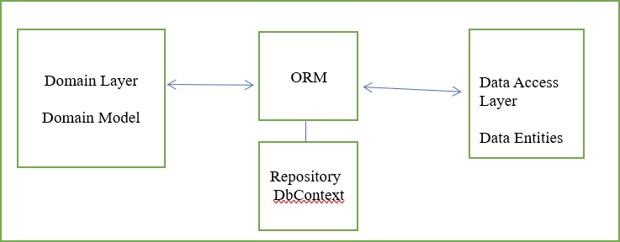
Figure 2:Intermediary ORM layer with Repository

The mapping of objects and table relationships are specified, and the SQL code is generated by the ORM. The mapping is done either by the domain object as an active record or a separate layer of Data Mapper. The framework is not aware of the utilisation of the data in the business logic though.

There are two issues in ORM frameworks.

- Redundant data problem
- Impedance Mismatch problem

Redundant Data problem:
When only certain columns are to be updated in the database, all columns in a table are updated. Read models acquire all columns including from the child table using joins in an eager load. This results in excessive data if the other columns are not required by the BL and severely impacts on the performance and memory, especially when there are large number of fields in the tables[12].
In contrast, a lazy load brings in just enough data but with repetitive calls. Almost all ORMs including Hibernate and Entity framework have this issue[12]. To increase performance, data is queried in batches to keep database calls to minimum.

Impedance Mismatch Problem (IMP):

Object models contain data, their behaviour and state. Relational data bases contain data and their relationships. The differences in paradigms make these two incompatible technically. The mapping of data that could possibly have inheritance in OOP to a database with primary and foreign keys, many
- to many relationships and no inheritance concept results in an IMP[11].

An object-oriented Database would eliminate the need for mapping and hence IMP is averted. Although this increases performance it is not popular. Relational databases being the most commonly used, it is imperative to have mapping to avoid IMP.
The availability of ORMS in various platforms makes it easier to implement rather than creating one’s own mapper. However, it is imperative to arrive at a balance while having to make compromises to resolve IMP, considering design priorities such as normalisation in database design against OOP concepts such as cohesion and coupling.

Advantages
  - A Domain model incorporates Plain old Java objects (POJO) to capture the data from the domain logic. A complex domain logic with several inheritance and strategies calls for complex mapping with the relational database. A data mapper with an ORM makes it simpler to map to a sophisticated data model. If the domain is simple an active record is enough.
  - Data Mapper provides complete isolation of layer.
  - Knowledge of query in the native language of the software is enough.
  - Provides for changes in the database provider without affecting the application layer and business layer.

Disadvantages

  - The burden is on the application code that becomes more complex with the data manipulation logic in the

application code rather than within the database.
  - ORMs must deal with bidirectional mapping and it gets complex with large databases. Translating the object model to the data model and vice versa will reduce performance of the application as it is doing all the heavy lifting. It is not as complex in a read model. The more the object is relational it is easier.

Repository

The flexibility provided by a layered architecture by way of abstraction of the persistent layer from the application domain can be optimised by use of an intermediate layer that would map the data using an ORM tool. A repository is an interface that provides for the abstraction layer that hides the query code and holds an in-memory collection of the domain object. Entity framework is one such tool that provides this facility [6].

The application code specifies a selection criterion independent of query language, which is stored in the repository. This then invokes the data mapper, that returns the object matching the criteria. The simplicity of a repository lies in the fact that, the objects held there are mapped from an extensive data layer and not stored in the repository. The user is only exposed to the domain object and not to the implementation and complexities of the data layer[6].
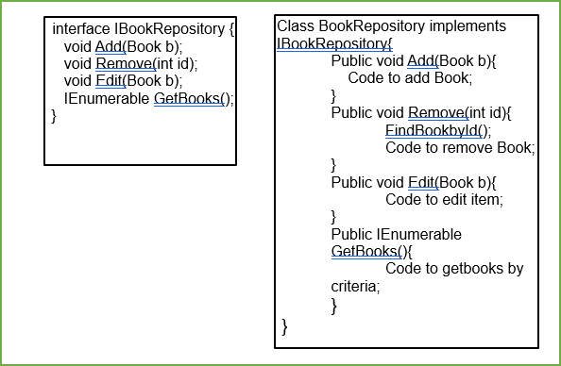
Figure 3:Concrete class implementing a repository

Benefits

Strict layering in a domain driven design (DDD) could result in dependency issues and tightly coupled layers. A repository interface allows for loose coupling through dependency injection.

When the business object is composed of aggregates that are required to be treated as a single object, especially in a DDD, access to the object should be whole although they may have been persisted across several tables. However, to maintain transactional consistency, it is important to have only one repository for the whole aggregate object and not one per entity table[13]. This is significant since a transaction is incomplete until all parts of the aggregate root that constitute the transaction has completed. A repository is very useful to achieve abstraction in this instance. It handles all the query calls to the database, stores in in-memory and returns the object that satisfies the criteria as a whole.
Persistence layer is projected in a more object-oriented view providing clean and distinctive layer separation with code clarity. Equally effective with unstructured non-Sql databases.

The open-close principle allowing for extension to the interface, facilitates the BL to access any database. The stability of the interface is maintained by the closed for modification which enhances independency thus improving maintainability[14]. The domain and the data layer exhibit one-way dependency.

Reusability

Reusability of design patterns can be reusing the idea or the code. Reusing the idea is better when developing a component from scratch. Refactoring the query code is possible without any impact on the client calls to the repository. In large enterprise applications with multiple querying, it cuts down repetitive SQL code.

Testability

Once the data access is abstracted, the in- memory data structures such as hash tables can point to the objects impersonating the database. This facilitates working with mocks and stubs of data for testing purposes, thus

increasing testing performance[13]. In- memory store of the domain objects collection eliminates the need for a database for unit testing.

Antipatterns

In simple systems where domain objects imitate the data structure in the data layer, as in the case of simple read, write, delete(CRUD) operations, a repository might be an unwanted overhead.

Generic repositories are over generalisation. Although a meaningful contract could be achieved with specialised repositories implementing them, this could result in an antipattern as all of these specialised repositories should have the implementations, resulting in wet code [15]. This is an unnecessary abstraction in ORM, as the DBContext is the generic repository. Returning IQueryable rather than the object, the query manipulation will be scattered into the upper UI logic. This violates the Dont repeat yourself(DRY) rule. Returning IEnumerable is faster and averts any query leak[13].
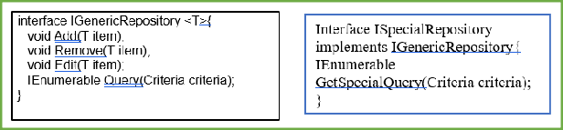
Figure 4:A specialised repository implementing a generic repository

Unit of Work (UoW)
Unit of work refers to the atomicity principle of transactions on database. In an application with heavy transactional operations, it often requires more than one CRUD operation on multiple tables. This would involve multiple calls to the database that would be very slow and any failures to an operation on one table would result in consistency and concurrency issues. The UoW aids the conformance of the ACID properties of the database[13].

The focus is on the behaviour of the objects with regards to the state of the database. The UoW tracks all modifications to all in-memory objects and then writes to the database. It ensures that a transaction is committed to the persistence layer only when all

operations relating to that transaction is successful[6].

Any change on an object is registered with the UoW registry. Completed changes are committed and incomplete changes are rolled back. The registration can be initiated either by the caller or by the object, implemented as a method in the object. In a caller register method, the object is flagged as dirty when it is registered. In the object registry method, it is flagged as clean when it is read from the database and dirty when updated. When there is a commit, all dirty objects are identified and written to the database[6].

As Fowler suggests, the UOW acts as a controller to the mapping. In Entity framework, repositories have a DBContext of their own acting as the controller. A UOW is implemented when they instead share a single DBContext.
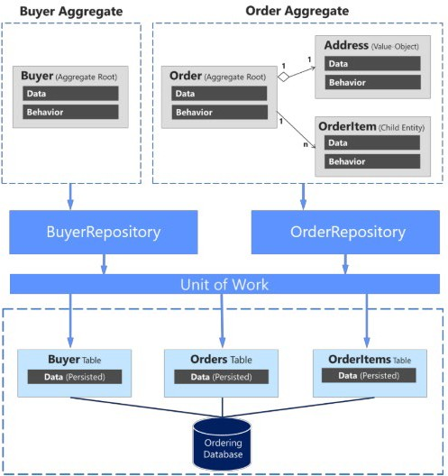
Figure 5:Repository and Unit of Work in a Domain Model[13]

The key operations that a UoW address are:

- Multiple Database calls
- Batch updates
- Referential Integrity
- Deadlocks

Two issues that are of concern with transactions on databases are referential integrity and deadlock. Foreign key dependencies determine the order in which multiple tables are required to be updated to avert these situations. Foreign key dependencies determine the order in which multiple tables are required to be updated to avert these situations. Maintaining a sequence

list of the tables required to be updated in the UoW maintains referential integrity and avoids deadlocks[6]. Batch updates are completed as a single call upon commit. Multiple single SQL statements can also be combined as a single statement and applications such as java database connectivity, JDBC facilitate this feature [12] .

Combine this with the repository pattern, the domain object resides in the repository and is registered with the UoW. Upon completion of changes, a call is invoked to the UoW to commit. The repository is not aware of the internal implementations of the data persistence. A single repository per aggregate root as mentioned above facilitates the registry with the UoW.

However, Repository and Unit of Work is inherently implemented by ORMs like Entity framework and coding them would be an additional abstraction resulting in the leaking of implementations from the PL to the BL.

An example of a non-Generic repository implementing the repository and UoW is shown in the appendix. The Borrower and Borrow repository are served by the UnitofWork class sharing the same DB context. Both calls to update borrower and the borrowing to the data layer are executed as a single call, thereby succeeding or failing together. This ensures that the data state is consistent across the two entities in the database.

Conclusion

Design patterns impact the scalability, maintainability, flexibility and portability of a system. Layered architectural style is based on design principles such as abstraction, reusability, clearly defined functional layers, loose coupling, high cohesiveness and encapsulation[10]

Repositories hold all SQL query code and the Unit of Work controls all the work that a repository does. Repository and Unit of Work increases performance by reducing communication. Maintains the current state of the system and provides for recovery when transaction fails. This is also useful in testing and debugging. Provides for easy
maintenance and replacement of components[16].

References

- M. Kassab, M. Mazzara, J. Lee, and G. Succi, “Software architectural patterns in practice: an empirical study,” Innov. Syst. Softw. Eng., vol. 14, no. 4, pp. 263–271, Dec. 2018.
- N. B. Harrison and P. Avgeriou, “Leveraging Architecture Patterns to Satisfy Quality Attributes,” in Software Architecture, 2007, pp. 263–270.
- A. Sharma, M. Kumar, and S. Agarwal, “A Complete Survey on Software Architectural Styles and Patterns,” Procedia Comput. Sci., vol. 70, pp. 16–28, 2015.
- M. Richards, “Software architecture patterns - O’Reilly Media,” O’Reilly. 2015.
- H. Hakeem, “Layered software patterns for data analysis in big data environment,” Int. J. Autom. Comput., vol. 14, no. 6, pp. 650–660, 2017.
- M. Fowler, Patterns of enterprise application architecture (Паттерны корпоративных приложений). 2003.
- H. Gomaa, Software Modeling and Design: . Cambridge University Press - M.U.A, 2010.
- C. Liyan, “Application research of using design pattern to improve layered architecture,” Proc. - 2009 IITA Int. Conf. Control. Autom. Syst. Eng. CASE 2009, pp. 303– 306, 2009.
- B. Dayyani, “Software architecture design and development of multi-layer highly modular platform using intelligent components for dynamic big data analytics,” 2016 4th Int. Symp. Comput. Bus. Intell. ISCBI 2016, pp. 45–53, 2016.
- P. U. Chavan, M. Murugan, and P. P. Chavan, “A review on software architecture styles with layered robotic software architecture,” Proc. - 1st Int. Conf. Comput. Commun. Control Autom. ICCUBEA 2015, pp. 827– 831, 2015.
- A. Torres, R. Galante, M. S. Pimenta, and A. J. B. Martins, “Twenty years of object-relational mapping: A survey on patterns, solutions, and their implications on application design,” Inf. Softw. Technol., vol. 82, pp. 1– 18, 2017.
- P. Flora, Z. M. Jiang, M. Nasser, A. E. Hassan, T.-H. Chen, and W. Shang, “Finding and Evaluating the Performance Impact of Redundant Data Access for Applications that are Developed Using Object- Relational Mapping Frameworks,” IEEE Trans. Softw. Eng., vol. 42, no. 12, pp. 1148–1161, 2016.
- M. Pope, “i DOWNLOAD available at : https://aka.ms/microservicesebook Co-Authors : Editors : Participants and reviewers :,” 2018.
- Z. Li, X. Li, and M. Xia, “Design and implementation of data access layer based on design pattern,” ICCASM 2010 - 2010 Int. Conf. Comput. Appl. Syst. Model. Proc., vol. 14, no. Iccasm, pp. V14-98-V14- 100, 2010.
- Kanjilal, “Design Patterns that I often avoid,”
Infoworld.com, 2016. .
- P. Lalanda, “Shared repository pattern,” Proc. 5th Pattern Lang. Programs Conf. (PLoP 1998), p. 10, 1998.

Appendix

An example Repository and Unit of Work

}
public class BorrowRepository {
private Entities _records;
public BorrowRepository(Entities records) {
_records = records;
}
public void Add(Borrow borrow) {
_records.Borrow.Add(borrow);
}
public void Delete(Borrow borrow) {
_records.Borrow.Delete(borrow);
}
public void Save(Borrow borrow) {
_records.Borrow.Save(borrow);
}
}
public class BorrowerRepository {
private Entities _records = new Entities(); public BorrowerRepository(Entities
records) {
_records = records;
}
public void Add(Borrower borrower) {
_records.Borrower.Add(borrower);
}
public void Delete(Borrower borrower) {
_records.Borrower.Delete(borrower);
}
public void Save(Borrower borrower) {
_records.Borrower.Save(borrower);
}
}
class Controller {
public Controller() {
UnitofWork _uow = new UnitofWork(new Entities());
_uow.BorrowerRepo.Add(new Borrower("Fred"));
_uow.Borrow.Add(new Borrow
{ borrowid = 100 });
_uow.Save();
}
namespace Repository_and_Unit_of_work {
interface UnitofWork { public class UnitofWork {
private Entities _records;
private BorrowerRepository _borrowerRepo; private BorrowRepository _borrowRepo;
public UnitofWork(Entities record) {
_records = record;
}
public BorrowerRepository borrowerRepo { get {
if (_borrowerRepo == null)
_borrowerRepo = new borrowerRepository(_records);
}
return _borrowerRepo;
}
}
public BorrowRepository borrowRepo { get {
if (_borrowReop == null) {
_borrowRepo = new borrowRepository(_records);
}
return _borrowRepo;
}

marking criteria and Student FEEDBACK

This section details the extent to which the assessment criteria are demonstrated by you, which in turn determines your mark. The marks available for each category of skill are shown. Lecturers will use the space provided to comment on the achievement of the task(s), including those areas in which you have performed well and areas that would benefit from development/improvement.

Common Assessment Criteria Applied (Assignment 1) | Marks available | Marks  awarded
1. Engagement with Literature Skills

An excellent range of appropriate literature has been consulted and referenced in the work and the review and discussion of the literature is of a very good standard. (Grade mark: 86.67%) | 15 | 13
2. Knowledge and Understanding Skills

An excellent discussion of the layered architectural pattern with some very good examples of some of the issues with the use of the pattern. An excellent review of ORM and the repository and unit of work patterns, clearly identifying the over-abstraction of combining these two patterns with ORM frameworks and some of the criticisms concerning their use with ORM. Very good code examples have been provided, one or two concepts are briefly introduced and it would have been nice to see a bit more detail. (Grade mark: 85.33%) | 75 | 64
3. Cognitive and Intellectual Skills

4. Practical Application Skills

5. Transferable Skills for Life and Professional Practice

The report is well-written and presented. (Grade mark: 80.00%) | 10 | 8

Assignment Mark (Assessment marks are subject to ratification at the Exam Board. These comments and marks are to give feedback on module work and are for guidance only until they are confirmed. ) | Late Submission Penalties (tick if appropriate) |  | 85%
 | Up to 1 week late (40% Max) |  | 85%
 | Over 1 week late (0%) |  | 85%

