
Module Name: Software solutions for Business
Module Code: ACCA4026

Student Name: Imran Sharif
Student ID:2538385
Group:1

Lecturer’s Name: Rajeev Nath

Table of Contents
Introduction 1
Task 1. e-Commerce Website builders/software solutions 1
Introduction of the task 1 1
1.1 Google site 1
1.2 Shopify 3
Task 2. Mind-map of contemporary software applications 4
2.1 Mind mapping and its benefits 4
2.2 Mind map of contemporary software applications 6
Task 3. Office Applications 8
3.1 Four office software solutions for business operations 8
Ms Word 8
Ms Excel 10
Ms PowerPoint 12
Ms Access 14
3.2 Test any two features 16
Statement 18
Task 4. Communication and Collaboration applications 18
4.1 One contemporary Communication and one Online Collaboration 18
Gmail 19
Zoom 20
4.2 Test one feature of a freely available Communication (1) and one feature of a Collaboration (1) application 22
Gmail 22
Zoom 29
Conclusion 39
References 40

Introduction

The study of software to result in successful business performance the task opens with a comparison among two different software; Google Sites and Shopify. The subject makes or chooses a mind map for visual ordering (Task 2) after comparison. After this, the assignment performs analysis of Microsoft Office and lists applications of Excel. The analysis in task 4 includes functions of both Gmail and Zoom.

Task 1. e-Commerce Website builders/software solutions

Introduction of the task 1
Company suffers from negative impact of choosing wrong e-commerce software. The comparison between free e-commerce of Google sites and scalable enterprise software of Shopify.
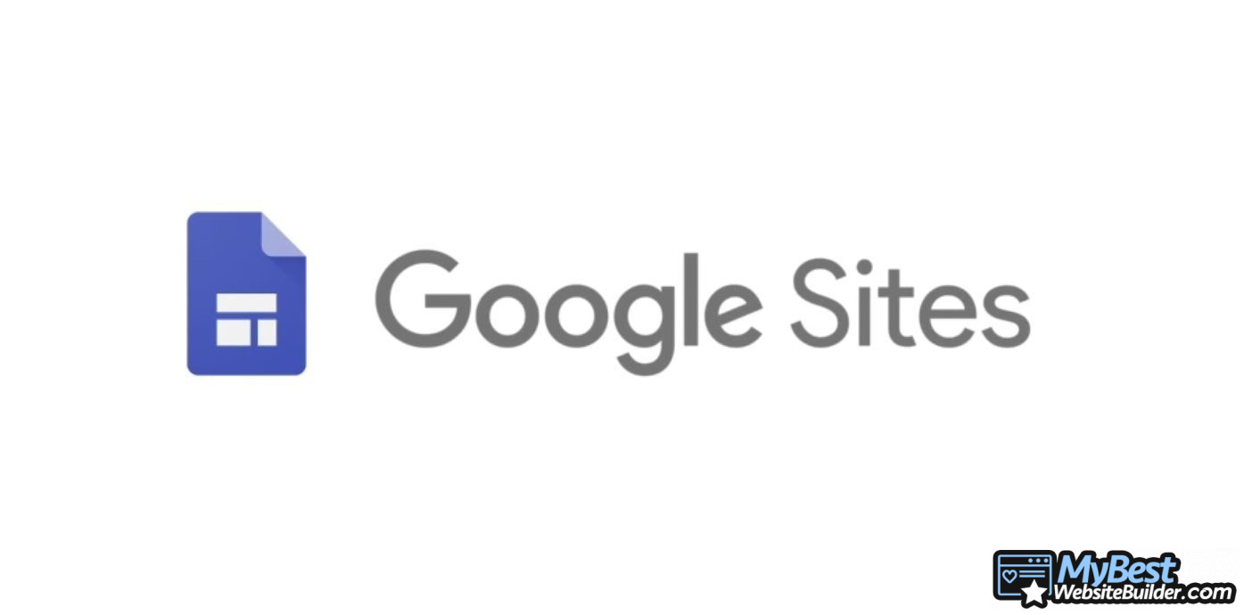
[1]

1.1 Google site
Google site is a free, drag and drop website designer which requires little to no coding experience. Some things google sites is known for is google sites usability, internal information sharing and collaboration with other colleagues. It is arguably the perfect general purpose website maker but fails in its inability to function as an E-commerce platform [1]. Some of the Capabilities: usability, Google Site, it is also arguably, very friendly for those new to website building.
It fully integrates with google apps, e.g. Google drive, google Docs and google Calendars. It features a drag and drops site builder along with limited, simple templates. It is also quite effective at managing sites intended for internal project collaboration, wikis and internal team hubs. The big caveat, however, is that it will not enable you to use your site for a real online store - rather a purchase link must lead to an outer site - effectively, taking traffic away from yours.
This said for the very small business owner selling just a hand full of items for absolutely nothing, this zero-maintenance e-commerce alternative could be an obvious consideration, albeit in an obviously limited way.

The biggest drawback of Google Site is clearly it lack commerce support, but its ease of use, and rock-solid speed and up time could also be some of the main draws of the product along with, of course, no monthly fees. Google is a reliable company so up time will be consistent, and fast speed makes this builder very appealing, for a quick , cost-free and reliable website there's really very little to lose. Of course, this is not always about having the most capable system , but more often how easy it will be to use and test concepts or run an exceedingly small business with nothing but google site and it is free price.
[3]
Figure 1 shows a small-scale business that was created using google site

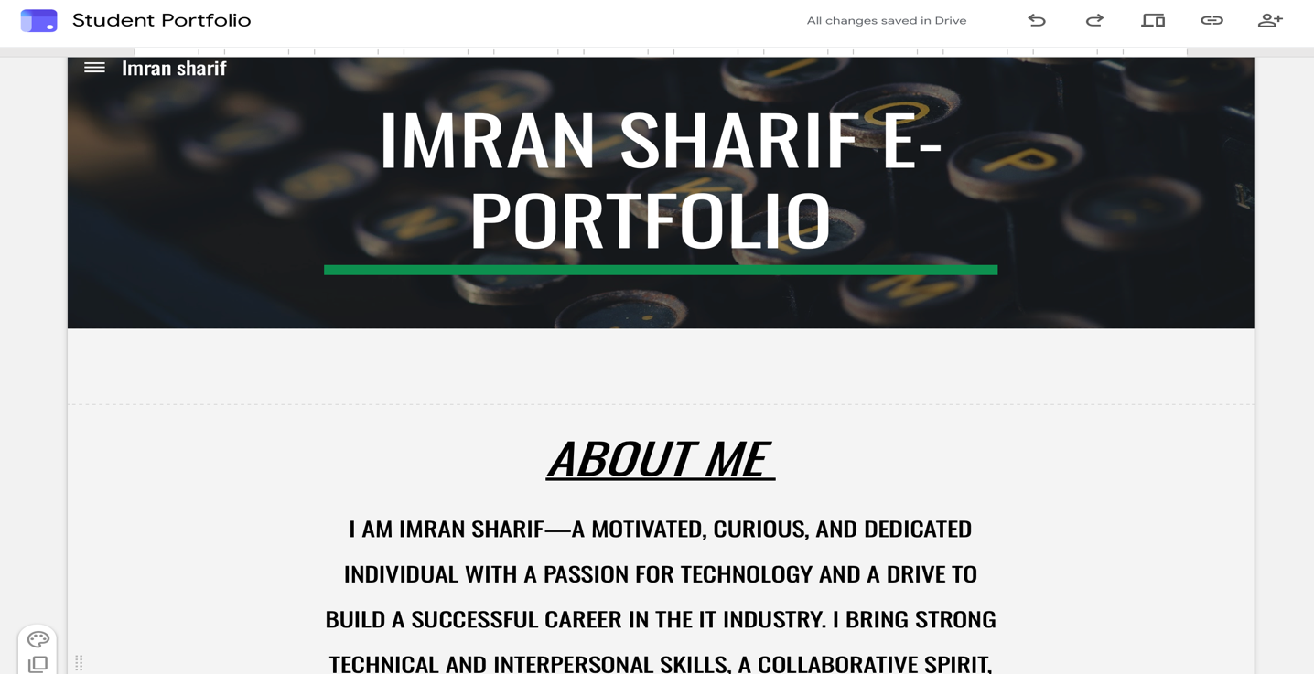
Figure 2 is a screenshot of my E-portfolio that I created using google site.


[3]

1.2 Shopify
Shopify, instead, is a ready-built e-commerce platform for businesses all around the globe that run a myriad of online stores. In a ready to go and hosted set up, merchants can establish a store, put up products, manage the inventory, make online sales, carry out a calculation of delivery costs and the total due tax all in one interface [2]. Merchants can take their pick from among one of more than a hundred and one ready-made designs-fully customizable in terms of look with HTML and CSS codes and fully ready to go even on a mobile device. The real features are usually not seen but the user. The Shopify app Store features tens of thousands of add-ons and modules for drop shipping, marketing, sales, management of bookkeeping services, and a many of additional functions to ensure a business expands seamlessly with minimal additional expense. Among Shopify’s integrated tools, merchants can find a feature rich content section designed to enable blogs be published to stores, optimize Search engine visibility (SEO) for both content and products, manage discount codes to entice visitors, recover abandonment sales, and support selling across multiple channels including social sites like Facebook or Amazon and eBay marketplaces. It begins around £29/ month for the basic plan however it also includes transaction processing charges except in cases of using Shopify Payment. Although considerably much more expensive to acquire and more difficult to determine as an asset it is an e-Commerce store that may be scale able from a start-up that is part-time in the endeavour as a source of passive revenue to an organisation sized business. Shopify Plus will enable the company to continue expand until it’s well beyond where it can operate a tiny home store.
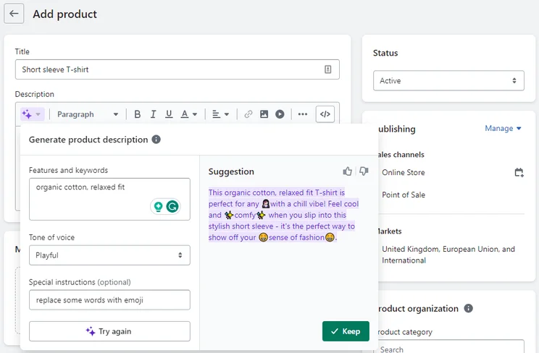

[5]
This figure shows the feature of Shopify magic. This utilizes the technology of Shopify Magic, which responds to your Prompt Special Instruction. Moreover, adjusting Tone of Voice is also possible.

Task 2. Mind-map of contemporary software applications
 [5]

2.1 Mind mapping and its benefits
A visual strategy to organize information around a concept-how the brain naturally works-mind mapping eschews linear notes for a radiant structure. A central idea occupies the middle space, surrounded by major branches curving outwards like sunbeams labelled with single keywords. Secondary branches fill in details, and colour, images, and symbols enhance retention and memorization. Popularized in the 1970s by Tony Buzan [3], mind mapping dates back centuries, appearing in diagram form in the notebooks of thinkers such as Leonardo da Vinci. In use today with the aid of software such as mind Meister, XMind, and Miro, mind mapping is now a collaborative tool with multimedia options that provides one big picture while detailing fine points.
To mind map, create a core topic, then sprout off primary keywords in branching forms. Follow with sub-branches, layering in further details as connections and associations flow. Digital versions allow for the re-shaping of elements, creation of hyperlinks, and multimedia uploads to provide richer context. There’s no need for a specific sequence of actions-just create with your mind as the muse. As a result of these differences, mind mapping offers several compelling advantages: Increased Creativity. A strict format can constrain the mind. Freedom from sequential thought-and the addition of images and colour that can stimulate the right brain-can unleash unexpected ideas, enabling you to connect seemingly disparate thoughts to brainstorm and troubleshoot new solutions. As these links occur, new possibilities can arise out of the chaos. Enhanced Learning and Recall. The visual elements of mind mapping-the structure, colours, and keywords-create strong anchors for your memory. Research conducted on medical students showed the mind mapping technique greatly improves recall of factual material compared with conventional lecture notetaking [4]. When you revisit the mind map, you recall not just information, but also where it sits in the context of the big picture, creating more durable memory traces. Clearer Understanding. A mind map visually defines the components of any subject, displaying central issues, their relationship, and tangential points in one frame. You gain an at-a-glance understanding of complex projects, an organizational essay, or a strategic business plan. The big-picture perspective exposes any gaps or logic flaws long before you begin to drill down. It deconstructs the imposing into the manageable. Greater Productivity and Focus. Using a single keyword per branch forces you to extract essence from thought, a focus that often carries over into the real world. When you’re listening to someone speak, either in a meeting or at a lecture, you’ll naturally record what’s essential first, then expand upon points as associations occur. This engagement keeps you sharp. Revision work is reduced when you work from one comprehensive overview. Better Collaboration. Most digital mind map software permits team members to work on a single map in real time. All contributions are immediately integrated into a visual framework that serves as a common understanding. It brings people together, streamlining communication and collaboration in meetings and group projects [5].Universal Application. Mind mapping can be applied in nearly any endeavour. Students use it to summarize book chapters or develop essay outlines, businesspeople use it to plan agendas or analyse their SWOTs, and individuals use it to brainstorm goal strategies or outline projects. Regardless of the context, the core practice-transforming the invisible landscape of thought into a vibrant visual schematic-offers compelling clarity.In short, mind mapping is a powerful cognition tool. It taps into our brains’ natural way of connecting things by giving us permission to explore beyond rigid lines, producing insights while building more robust memories within the framework of one central idea. It is a time-honoured technique that, when combined with the latest technologies, continues to prove valuable in classroom and conference room alike.
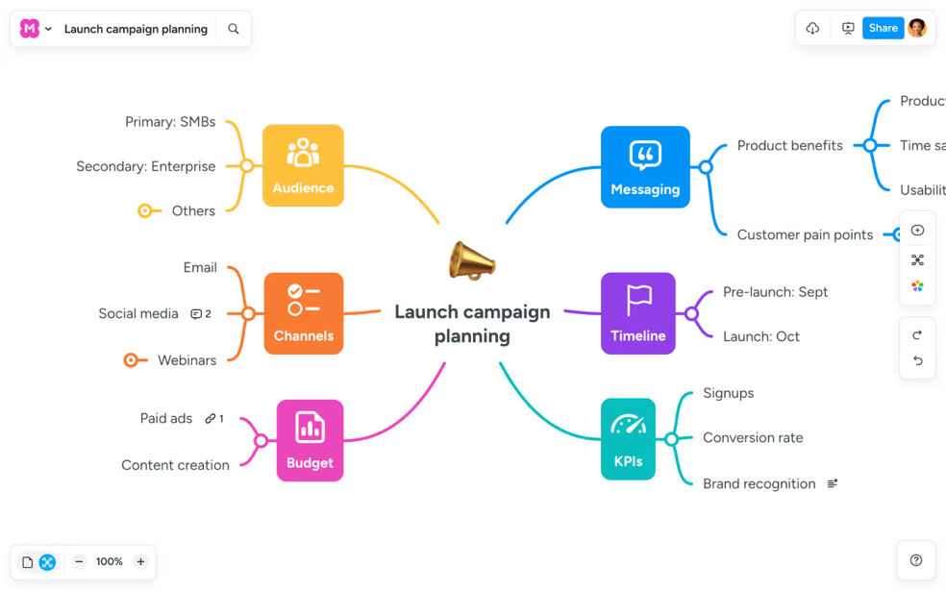 [10]
This figure shows Mind Meister in action. This feature is called mind mapping.

2.2 Mind map of contemporary software applications
Link https://mm.tt/map/4034011194?t=WV3wYNVjMQ
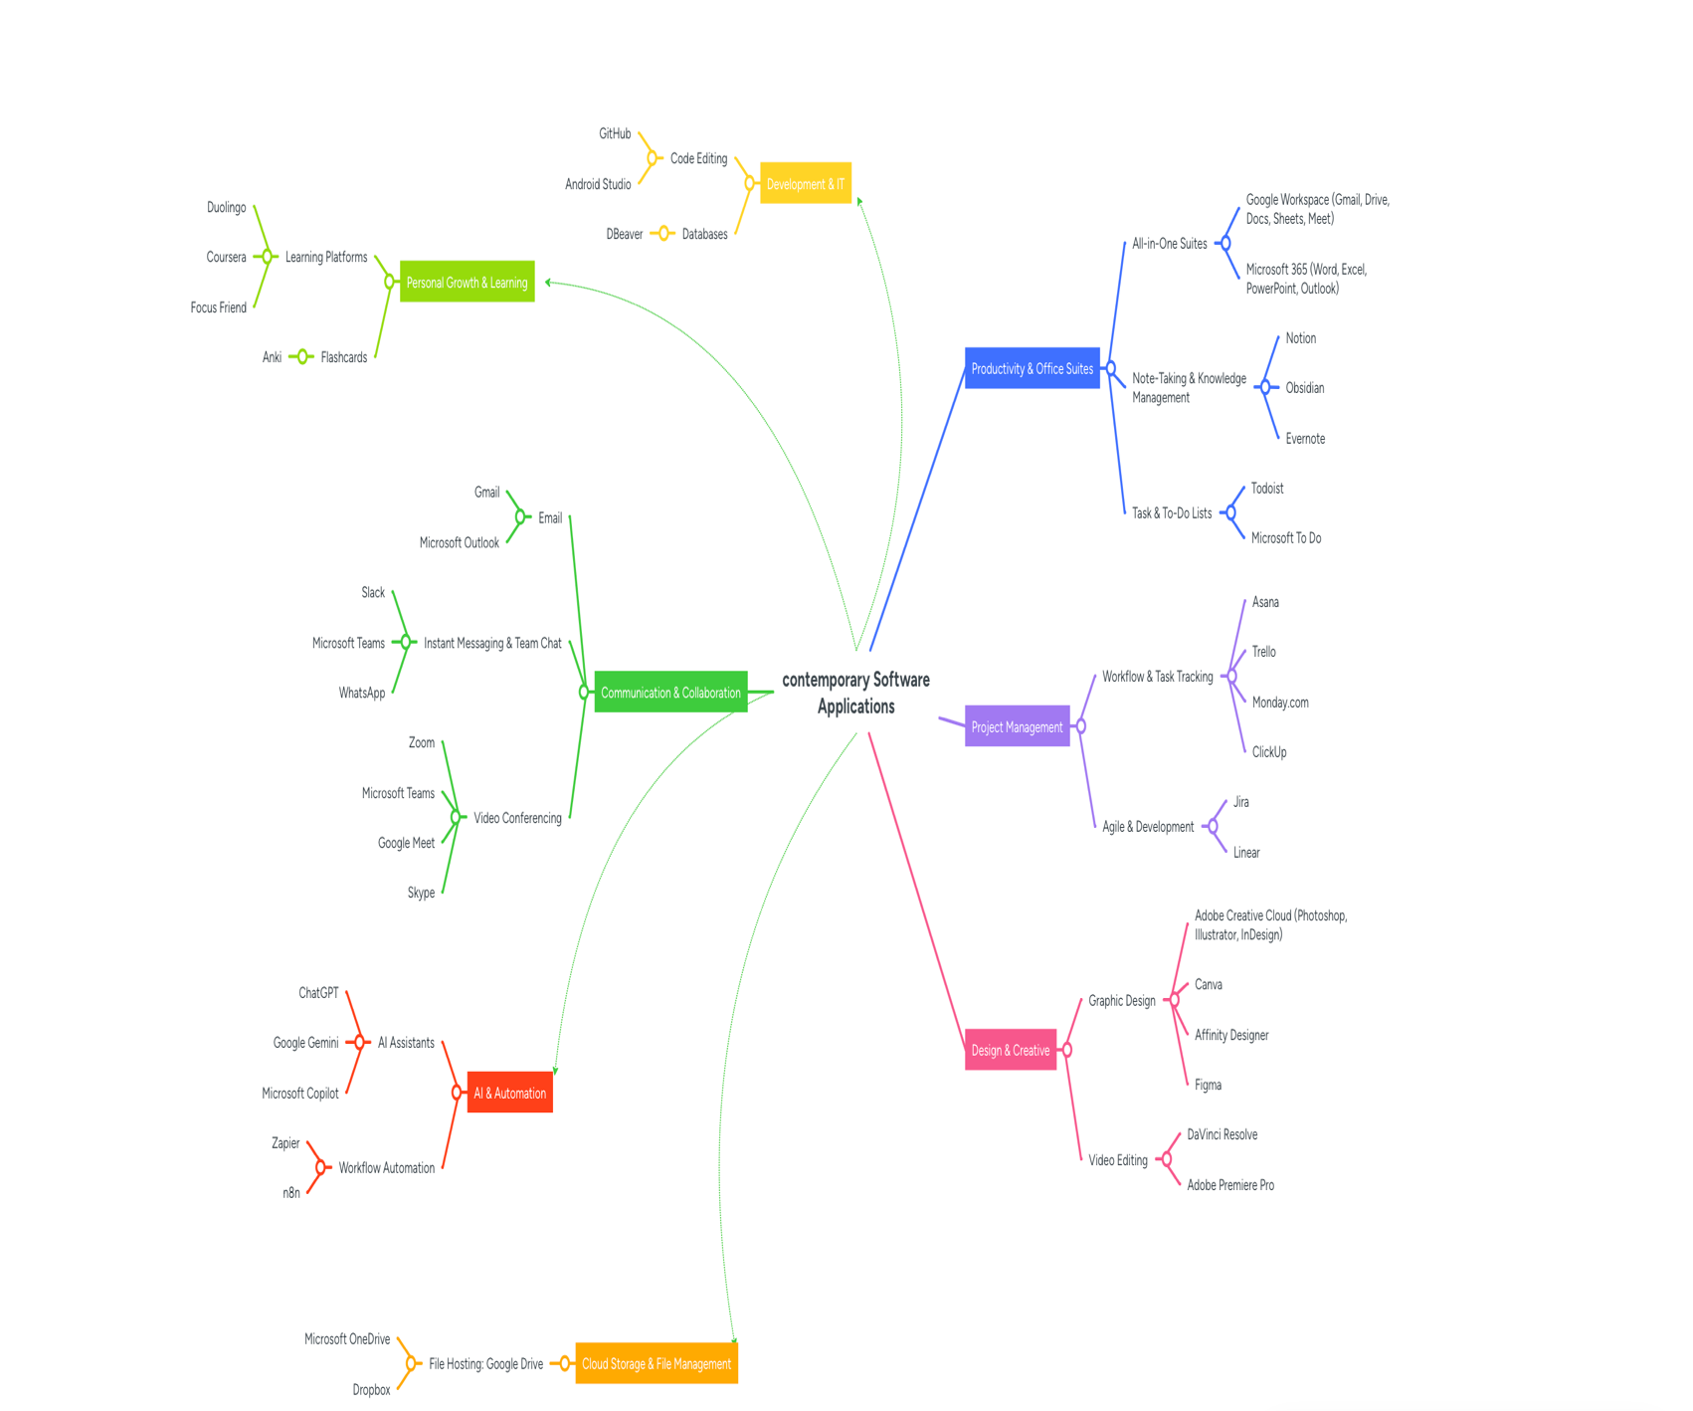

Task 3. Office Applications

3.1 Four office software solutions for business operations
Microsoft Office is a suite of robust software tools that several businesses use to create documents, perform analysis, present information and manage information. 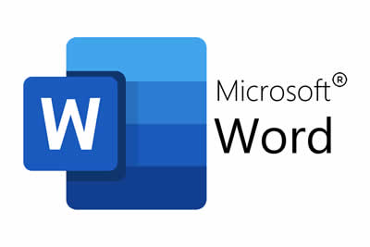 [9]

Ms Word
Microsoft Word is a convenient app for making, editing, formatting and saving documents. Corporate organisations use Microsoft word for letters reports contracts policies proposals minutes manuals invoices and academic reports [6]. Written communication is an application office which is one of the most common as it is required to most organisations.
Key Features
The primary function of Microsoft Word is to ensure document formatting. Using the software, users are allowed to change the font style, size, margins, spacing and alignment. Besides, we can modify page border, page header, footer, and page number as well. Word provides a variety of styles for heading 1, heading 2 and normal text. Styles create consistent formatting for long documents [7]. Users can also add an automatic table of contents.
One more important ability track changes and comments. This enables multiple people to view a document and propose changes. A report manager’s comment can be made on the report only which can be accepted or rejected. Besides the features, Word supplies a spelling and grammar checking tool which helps you in spotting the mistakes you commit while typing and helps in improving the overall quality of writing.
Word also provides a mail merge feature. It connects the document with a data source which is excel data. This tool allows the organization to generate letters, labels or emails addressed to a lot of customers at once. The other features are templates, tables, SmartArt, diagrams, citations and references, PDF export. Accessibility checking. 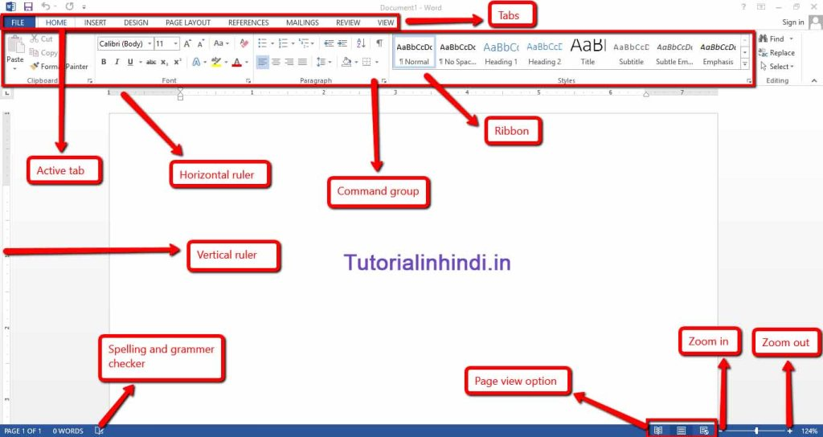 [14] This figure shows the features of Ms word.
Advantages.
Through Microsoft Word, different business documents can be created professionally and within the time limit. By using templates, your work becomes a lot easier since you do not have to re-design every document. Consistency is encouraged in reports and formal writing through styles.
It helps you to work together. If the Word file is saved in OneDrive or SharePoint, several people can work simultaneously on the file. You can create reports, business plan, and policy documents with it. This will create a clear edit record of your edit while using Track Changes.
The word is regularly used in schools and offices. Most of the users must have used DOCX file format. In addition, documents can share to customers in PDF. Thus, it makes Word ideal for internal and external communications.
negative side or advertence.
Word can handle documents, but it is not something you should use to perform complex calculations or analyse large data sets. Excel works better than others in calculating numbers. The word program can incorporate tables but does not apply in case of some advanced formulas or large data for a document.
Formatting problems are the other limitation. Layout alterations may occur when moving a document between versions of Word or opening it in other word processors. As before, images in large documents may slow your edits down. Word is unable to hold a large quantity of database records because it is not a database.

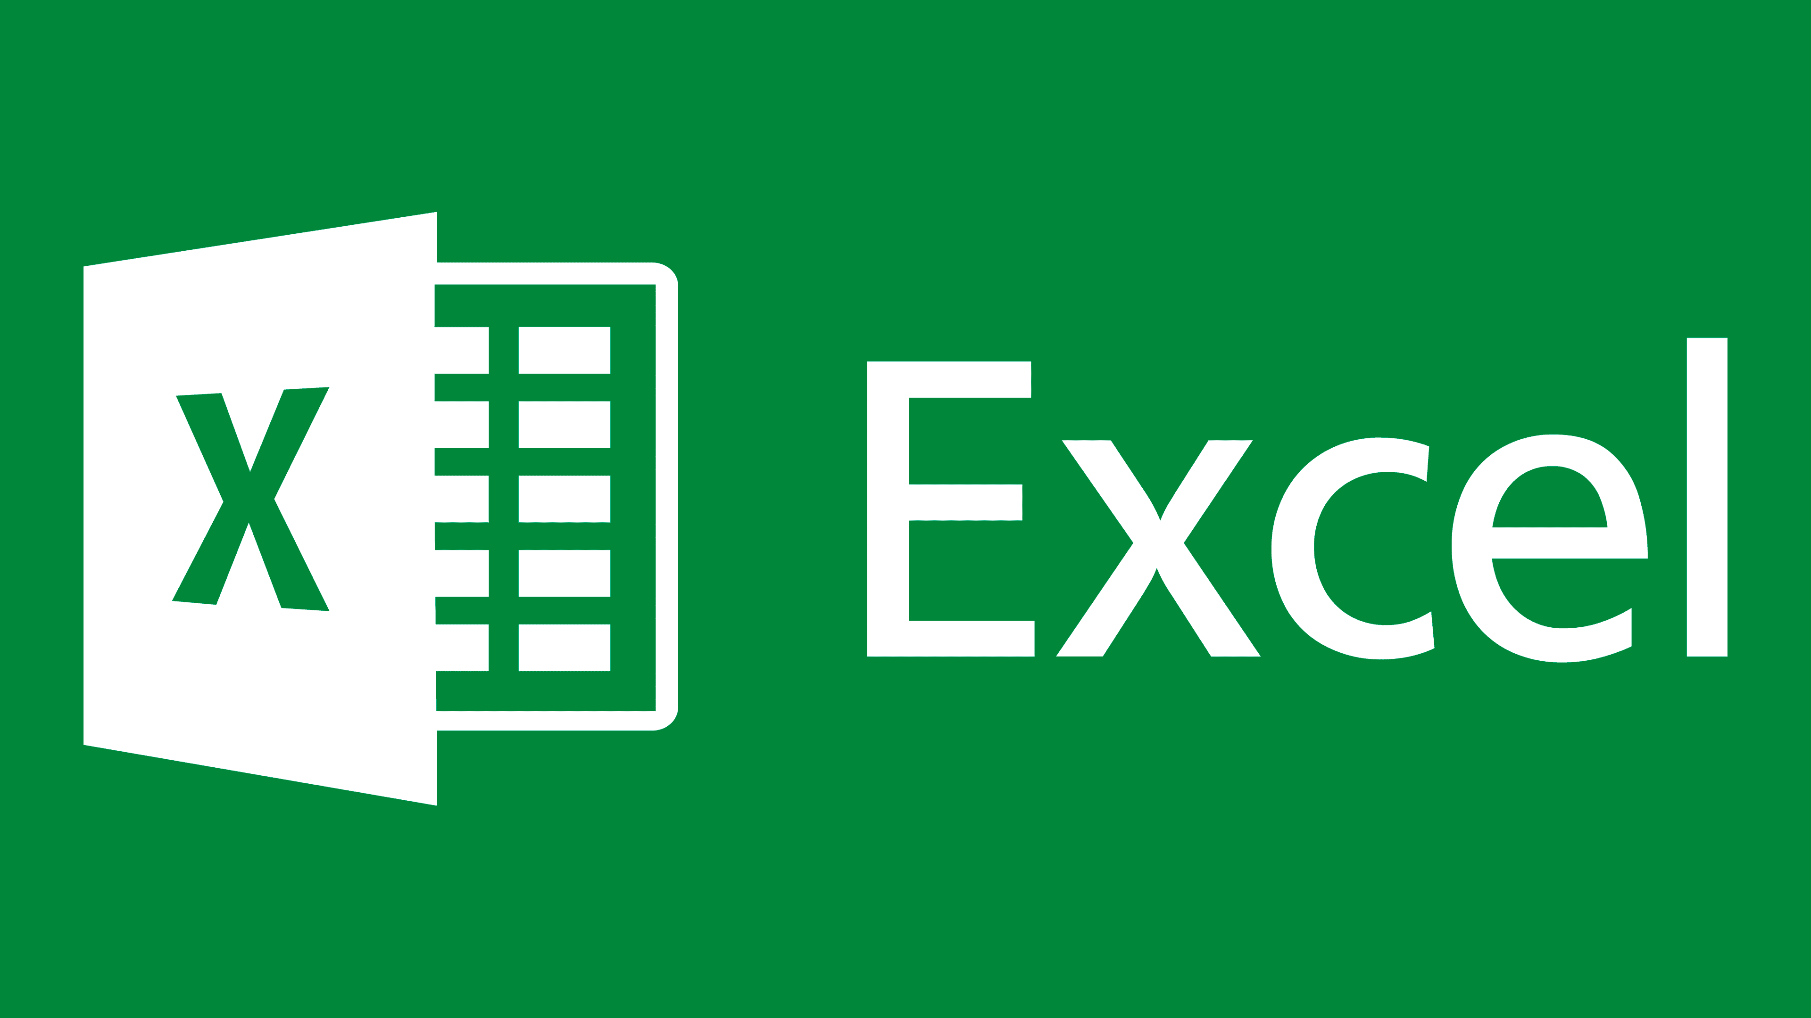
[12]

Ms Excel
Microsoft excel is the application which creates computerized spreadsheet to store, calculate and Analyse data. Using rows, columns and cells, data is arranged [8]. Excel can be used for several things including budgeting payroll sales forecasting stock control performance reports and customer lists.
Key Features
The most important Excel feature: The use of Formula and Function. A function is a pre-defined calculation in Excel while a formula is a user-defined calculation. Functions including SUM, AVERAGE, IF, COUNTIF, VLOOKUP, MIN, and MAX. These functions assist users in finding, comparing, and adding data.
You can make many different types of charts and graphs on excel. For example, bar charts, line graphs, pie charts and scatter plots. Users can visualize data with these. A sales manager might use a line graph, for example, to show monthly sales.
Another Key Feature is PivotTables. PivotTables make summarizing vast data easy without requiring it to be done using formulas. A company can use a PivotTable to total sales by product, region or by month. The tools provided excel including sorting and filtering conditional formatting and data validation. 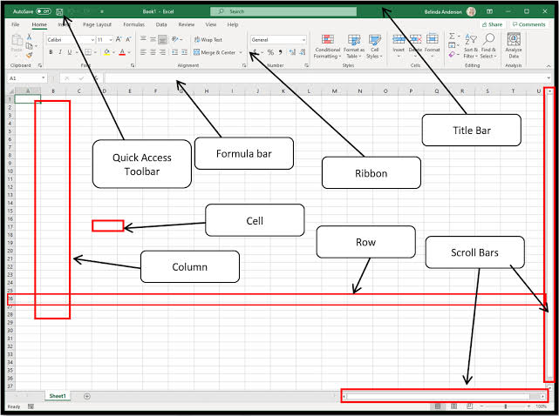
[17] This figure shows the feature of Ms Excel.
Positive points.
Organizations benefit greatly from Excel as it provides vital business information that they can use. After a formula is created, it will recalculate automatically when the data changes. It helps you create all kinds of forecast spreadsheets like budgets.
It assists firms in making superior choices. When data checks, relationships and performances become visual, they become easier to understand [9]. Conditional formatting can highlight key values such as overdue payments and stock levels below the requirements.
Will give accommodation flexibility to you. You can use Excel to create lists, budgets and complex data models. It may additionally interface with other Microsoft office applications. Presentations created in Power Point and Word may contain Excel graphs as an example.
Boundaries.
An obstacle with excel is that it can give false results if invalid formulas are fed to the sheets. The entire spreadsheet will be rendered ineffective if incorrect data is entered into any cell. As a result, there could be misreporting or business decisions.
Excel is not suitable for unique databases which are very large. While it can carry lots of data, a Microsoft Access (or some database) is better suited for having structure to the records and relationships between tables. There is one more limitation- versioning. When many users are editing a spreadsheet, it may be difficult to know which one is the right one.
Expertise is also needed for Excel advanced functions. It can be difficult to use PivotTables, Power Query and other macros.

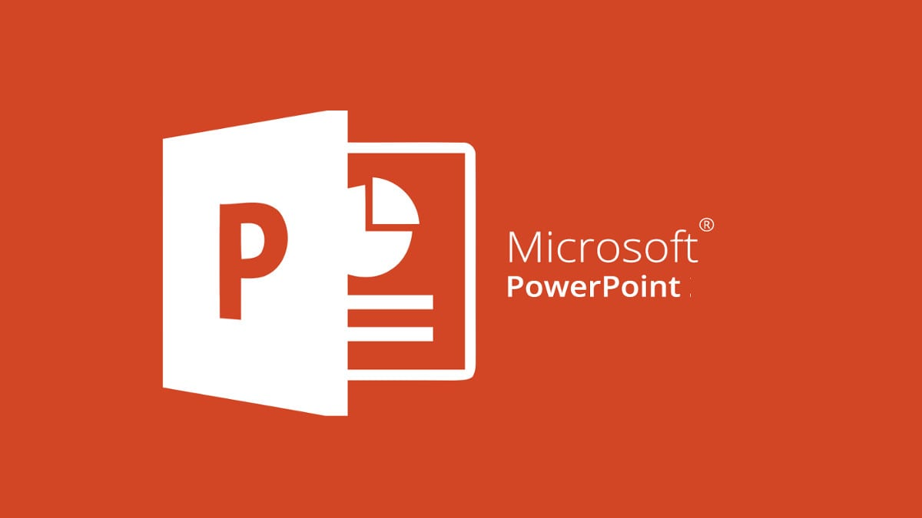
[15]

Ms PowerPoint
Microsoft PowerPoint is used to create a slideshow presentation of the topics. Business meetings and presentations use PowerPoint program for sale pitches, project updates or staff briefing [10]. The PowerPoint software allows for the presentation of text and pictures, graphs and videos and animations.
Trait of a good manager.
PowerPoint is used to design and layout slides.
Users can choose from pre-designed themes. PowerPoint offers one more tool named the Slide Master. Through Slide Master, you can control repeating design uniformity. In addition, it is simple to copy-paste the same design in multiple slides. It makes the presentations look formal and uniform.
PowerPoint enables you to use media as well. Users are allowed to add tables, charts, videos, audio, and other objects to their work. Animations and transitions allow us to control the appearance of things on the screen. It can easily assist in animating the slides.
Afterwards, through Skip and Presenter View, the presenter views notes, the current slide, the next slide, and the timer which only audiences see the slideshow. PowerPoint slideshows can export to PDF, notes or video. 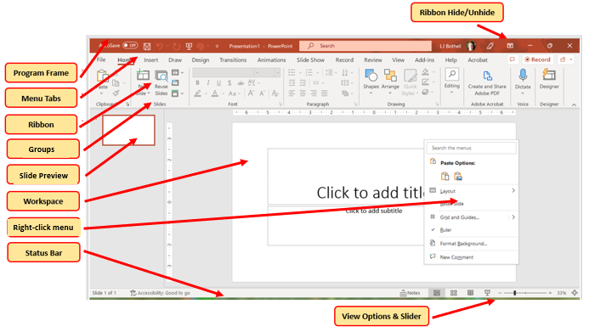
[21] This figure shows the feature of Ms PowerPoint.
Advantages of it.
One of the best features of PowerPoint is that it enables companies to showcase information visually.
Visuals are often easier to understand than text. Charts, diagrams and images make things clear.
Professionals use PowerPoint to present. A sales presentation, an employee update presentation, and a project update presentation are a few examples of the types of professional presentation design we could work on together. Such meetings are useful whether physical or virtual [11].
An added advantageous feature is integration with Word and Excel. For instance, the PowerPoint application can contain an Excel graph. It is useful during business reporting and financial presentation. Your training will benefit from PowerPoint as you can share and reuse it with your staff afterwards.
Constraints.
One disadvantage of PowerPoint is that presentations that are overloaded with text may not work as expected. Some customers read the slides but do not elaborate on anything in the slides. Your presentation is going to be dull and complicated.
The design quality depends on the user's ability and skill. Your slides may look unprofessional if the applied backgrounds and colours do not blend well. This is also connected with big presentations that contain many videos or images of big size.
This is not best tool for writing long documents or doing calculations. As Word is less cluttered and more formal, Document Formatting and analysis is possible.
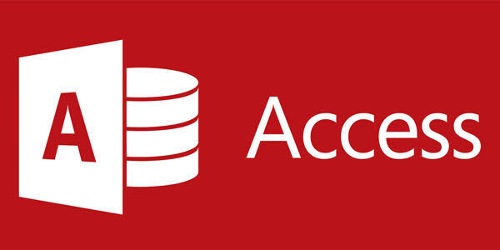
[18]

Ms Access
Microsoft Access is helpful for managing, organizing, and searching various types of structured data and information [12]. This pertains to the databases of small and medium enterprises. Business may use Access for different purposes, including customer records, stock systems, employee records, booking systems, order tracking and membership databases.
key traits
The relational database is the essential component of Access. Tables organize the information, and a relationship connects these tables. The tables of customer, order, and product are from company database. These tables can link up, so that each order is linked to the right customer.
It lets us run queries on the data for specific filtering, calculating and summary. Using a query, you can see all opened invoices or products at reorder level and more.
Another thing that is worth noting is forms. Using forms to input and view data is easier than entering directly into a table [13]. A user can print/ export various kinds of reports like professional summary, invoice, customer list, stock report, etc. Using macros and Visual Basic for Applications allows users to automate functions in Access.
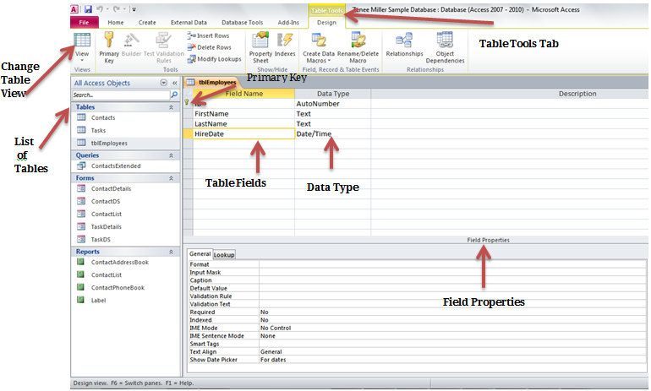
[26] This figure shows the feature of Ms Access.
Advantages.
A well-structured organization of data can help businesses. It eliminates redundancy when identical details can be added to distinct tables connected by a relationship. It enhances data reliability.
Another advantage is Access can create a form Workers can enter data using buttons, drop down lists and validators. When errors are reduced, the system is easier to use.
Having access makes report writing helpful. By using real-time data, managers easily generate managerial reports for decision making. If a business needs to manage customer orders, payments and related records and documents, it is better than an Excel spreadsheet.
Boundaries
Access may not be ideal for large enterprises; among its many disadvantages, this one stands out. Larger companies that need a more expansive database may consider using Microsoft SQL or Oracle or cloud database.
Beginners struggle with access database design, queries, relationships, and tables (13 words). A problem with the database design is the cause of confusion, erroneous and duplicate data.
The other limitation is performance with multiple users. Though it can share on a local area network, Access cannot cope with so many simultaneous users as well as an enterprise database can. Next to cloud DB tools compatibility may not be assured as the software is quite dependent on Microsoft Windows.
In summary, Microsoft Word, Excel, PowerPoint and Access help businesses in many ways and are expert tools. Microsoft Word is the best software for an official document and written communication. Excel is best for making calculations, analysis and financial work. PowerPoint is best for visual presentations and training. Databases and record management access is quite structured.
By working together, productivity and accuracy improve. All apps have their shortcomings If the formulas are wrong, you jeopardize the Excel file [14]. If poorly designed, PowerPoint Doesn’t Work "Access is unsuitable for extremely large enterprise database." Word is not a practical option for advanced calculations. The right office application for a job is one that a business should pick.

3.2 Test any two features
I went with the If function and the VLOOKUP
IF FUNCTION =IF(I2>1000, "Eligible", "Not Eligible")

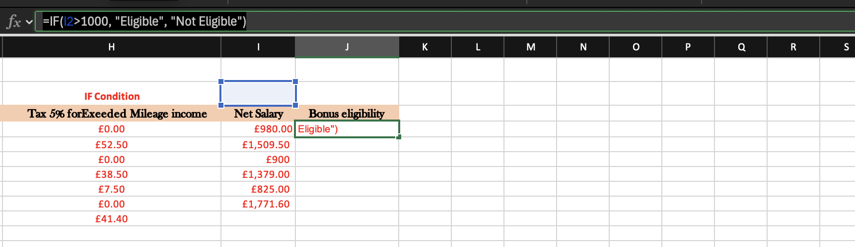
I made a new section call it bonus eligibility and used the formula
Screenshot 1 Raw data
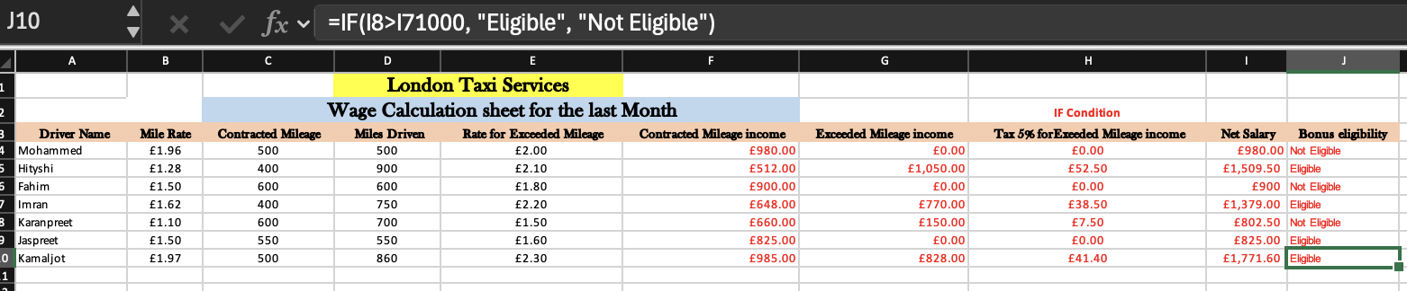
Screenshot 2 IF FUNCTION FOR ELIGIBLE CHECK

For the second screenshot It show that the formula works correctly because Kamaljot net salary is £1771.60 should show eligible while Jaspreet net salary £825 should show Not eligible. This proves that the IF function is working correctly.
VLOOKUP
For the VLOOKUP I went over to the course fees to add a column and called it Driver net salary. After that I proceeded to enter the formula
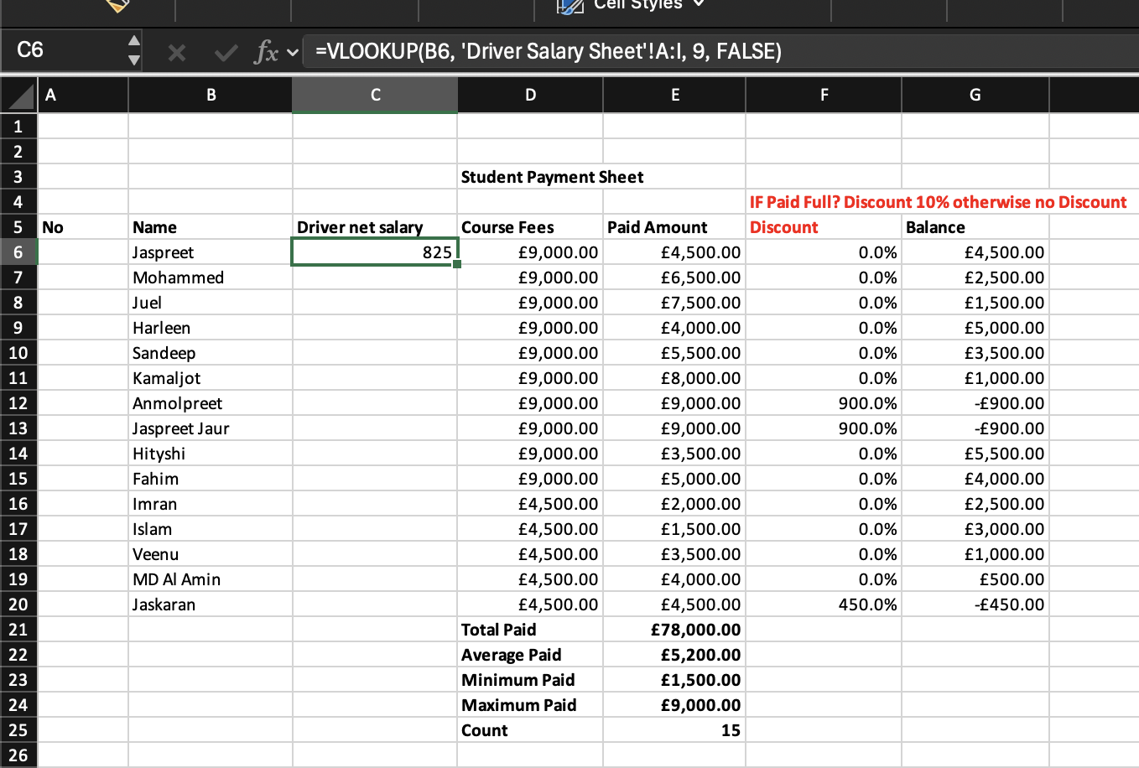
=VLOOKUP(B2, 'Driver Salary Sheet'!A:I, 9, FALSE)
Screenshot 3 VLOOKUP for student payment/driver salary
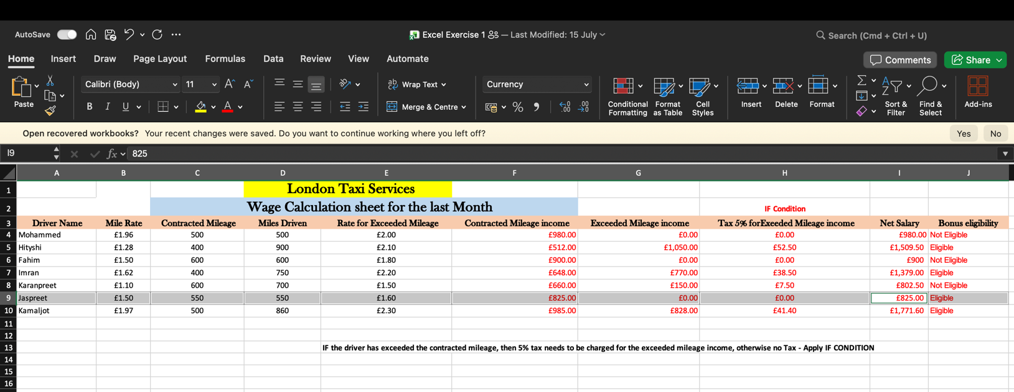
Screenshot 4 It looked up Jaspreet’s net salary in the driver salary sheet, and got his net salary,

Statement
As you can see, I have shown how to use IF function of Excel to automate business decisions like eligibility for bonus [15]. In addition, I demonstrated the use of the VLOOKUP Excel function to obtain data on excel [16].

Task 4. Communication and Collaboration applications

4.1 One contemporary Communication and one Online Collaboration
 [30]

Gmail
Google’s Gmail, a communication app is one of the most the most used contemporary popular communication apps that is being used a great deal for each business today. Since 2004, Gmail has evolved greatly in a few short years from a simple emailing system into a powerful one. Combine Google Calendar, Google Meet, Google Chat, Google Docs, Google Drive, and more as they’re all integrated with Google. Gmail Communication App - How it works in Modern Business? There are many communication app in modern day’s business that provides communication, mailing, and interactivity. But it comes to Communication for Business Gmail App is what and more than just a mail. What it comes to people it is a professional mail app with many business functions. Gmail’s Gemini AI has upgraded from merely becoming a mail into the personal AI of user and make the inbox of user proactive. The ‘Help me write’ feature pulls and utilizes the context of previous mails, a chat, a Drive file which makes an elaboration and writes an original customize new mail. The Experiential AI overview feature in Gmail's search allows users to communicate through natural language questions. In response to the question asked, the tool fetches answers from the conversations that are relevant to the question raised. For instance, the response of “This is what I got.” shows that a user can ask “What’s the latest status about the Acme deal.” as a direct answer synthesizes. Google provides secure business communication with Gmail and a professional app that not only has an inbuilt sophisticated AI relying on various algorithms but also provides protection to the accounts to prevent malware, spam, and phishing from entering the inbox but also affecting your important tasks. It has built-in security that is used to defend against over 99.93% of Spam and Malware [17]. Enterprise-grade encryption ensures that business users can communicate securely. They can send encrypted emails to any external email service provider. Gmail does not organize mailboxes in a traditional way that require files for organizing but rather it uses labels which helps in organizing of your mails in levels and also a user can make filtering settings that can send each thing for each individual person into right place of newly formed messages and that can save on average 45 minutes per day per user. Gmail's integration with a range of other business tools increases your efficiency and ability to collaborate. For example, business users can make Google Meet calls from within the Gmail page as well as schedule Google Calendar invitations and quickly view a document all without having to leave Gmail, making collaboration quick and effective [18]. The primary message space’s tabbed Inbox feature, where users can sort messages from friends and a range of promotions – Gmail Business Communication Benefits; Gmail boosts communication in several ways for business, by keeping the conversation formal, reducing the time of sent and received mails, as the AI aids, the employees save a lot of time in drafting messages, while, the mails have a high level security with benefit features. Due to the connections, the staff members will also be able to work effectively as they will not get stuck in switching between apps for getting a work done.
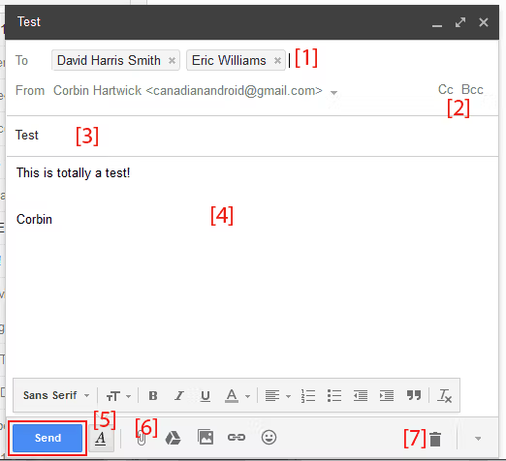
[33]

Zoom
 [34]

Zoom Video Comm. Inc. It provides a complete online collaboration tool that the world counts on [19]. The software giant started video conferencing with the video call software, traditionally speaking. However, this has been scaled to become Zoom Workplace – a fully-fledged AI-capable workspace that brings together video meeting, chat, phone, calendar, whiteboard and document sharing into a single app. On the meeting interface they have designed, the screen will only show the meeting, with the rest of the interface dark. The goal of the software is to make it easier to have face to face interaction where you feel as if you are present as a colleague or to chat and collaborate with team messages, phone calls or other tools that won’t interrupt the flow. The objective is to enable teams to more easily move from conversation to work completed, a team meeting or an internal conversation. With online collaboration through Zoom, you have access to the following important features: A stable, well-supported High-Definition video meeting capabilities, allowing you flexible view options, full Screen share and complex meeting features like Virtual Backgrounds, Touch Up My Appearance, and Immersive View for a seamless meeting and collaboration session . The AI Companion 3.0 tool can help to manage tasks between meetings. it turns conversation into action items, docs (could be an application in the future) before the meeting is over the tool provided will schedule calls to allow task completion to occur from conversation to work product. This is a very basic comprehension passage where it rests output at test 8 ap word. The video conference host can divide a meeting into anywhere from 2 to 50 breakout rooms. The most notable thing is that it facilitates automatic and manual assignment and participant choice. The user can also set timers and make changes to the subgroups. Various aspects of Zoom, such as Zoom team chat, the cloud phone system, and Zoom docs (where users can write, edit docs), allow the users to write, plan and share the document with others. They offer features that allow various users to work on the same thing at the same time. Several new features were unveiled by Zoom for its Zoom Mate AI Agents [20]. Described as Agentic AI, the idea is that these agents will aid in the transition from a dialogue to the completion of a workflow. This feature identifies action items and streamlines work operations for users. Being able to share screens and applications as well as the use of a shared Zoom Whiteboard makes it possible for multiple users to comment and contribute to shared docs, screens and whiteboards in real time. Numerous additional characteristics of the Zoom workplace application are
1)Chat: Within the single app boasts of powerful persistent chat is also a phenomenal feature where conversations can be continuous with the seamless transition from chat to video meeting and that is just part one is able to easily organize and find conversations, and effectively use the folks etiquette tools, and further send out mobile notifications to message strategically reach out to other good folks.
2) The Interactive whiteboards are used to annotate, draw, make changes together and contribute live by the participants on the interactive whiteboard express and sync ideas in asynchronous manner. Using Zoom Workplace enables a seamless work experience through a single integrated platform.
Should Use Skype. Someone must ensure that the team stays productive when there is communication issues faced in person.
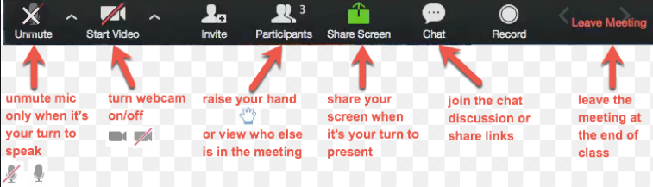
[37] This figure shows the feature of Zoom meeting in progress.

4.2 Test one feature of a freely available Communication (1) and one feature of a Collaboration (1) application

Gmail
Gmail - Email Filter and Label Creation
I have found G-mail Filter and Label quite interesting because it automatically sorts out incoming mail and I think it will be useful for running a business.
Step by step guid :
- Step 1 Access Settings: I went to my Gmail account, clicked the gear icon, and then selected “See all settings” by going to Settings.
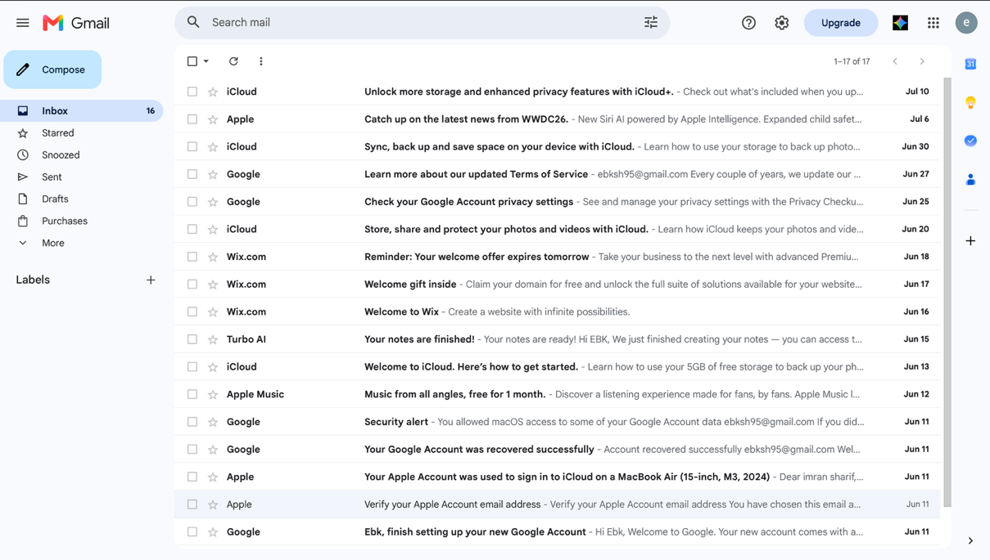

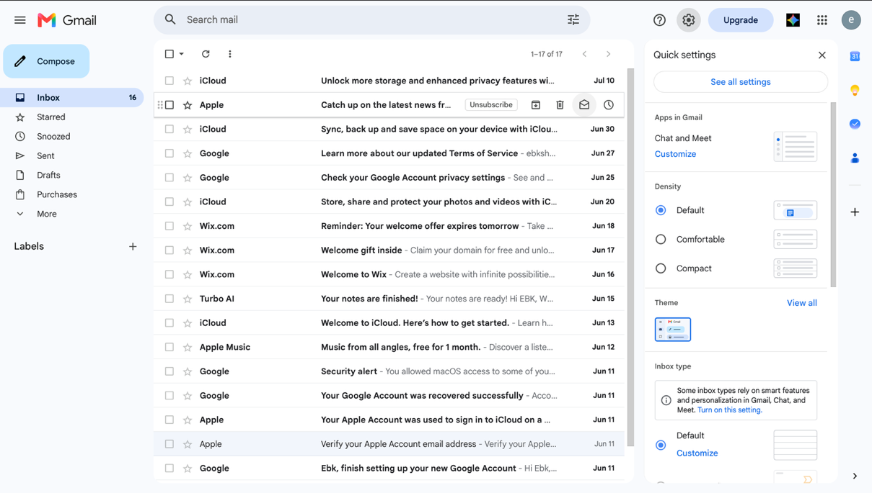
screenshot 1 Finding Setting

Screenshot 2 Clicking on “See All Settings”
2.Step 2 Create a New Label: Under the "Labels" tab, I scrolled down I went to the “Create New Label” option on the “Labels” tab to group up emails related to the Project. I called it ”Project Alpha – IMPORTANT!”.
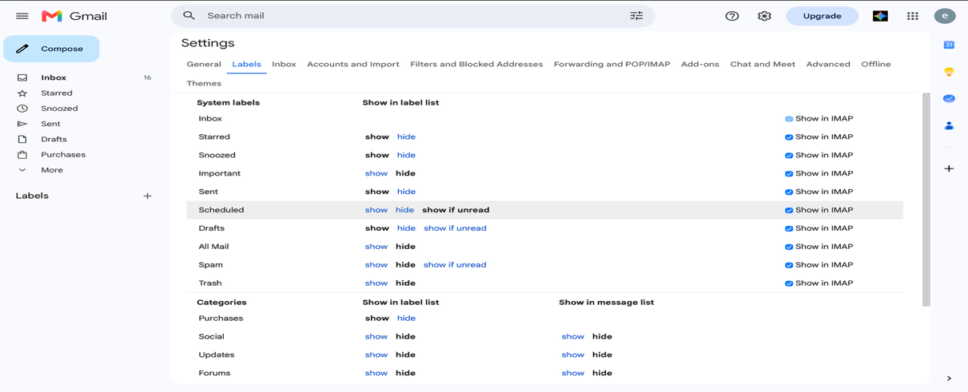

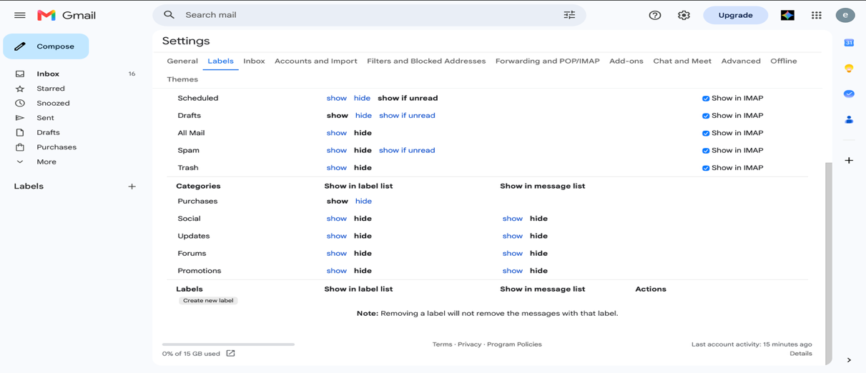

Screenshot 3 I’m on the label section

Screenshot 4 I clicked on “create new label”
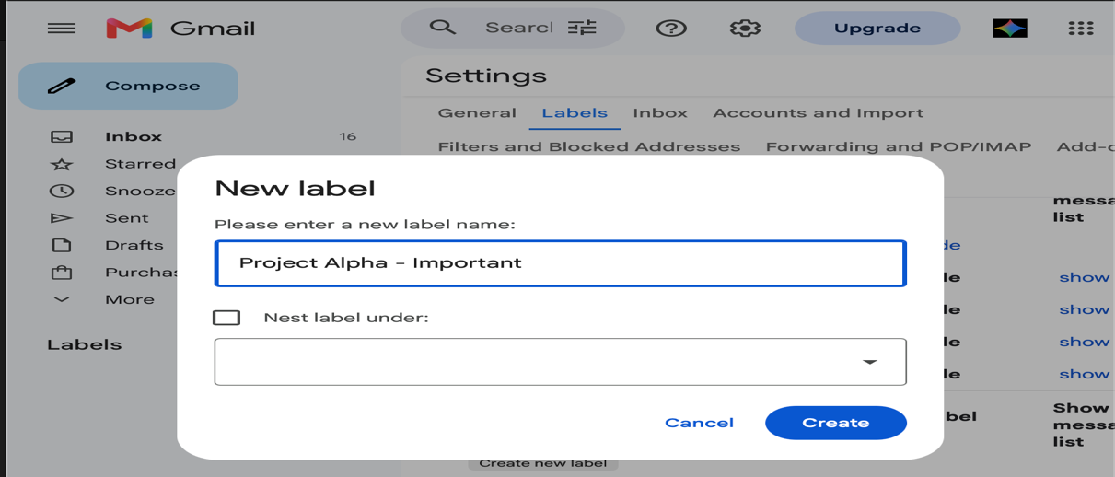

Screenshot 5 I named the label “Project Alpha-Important”
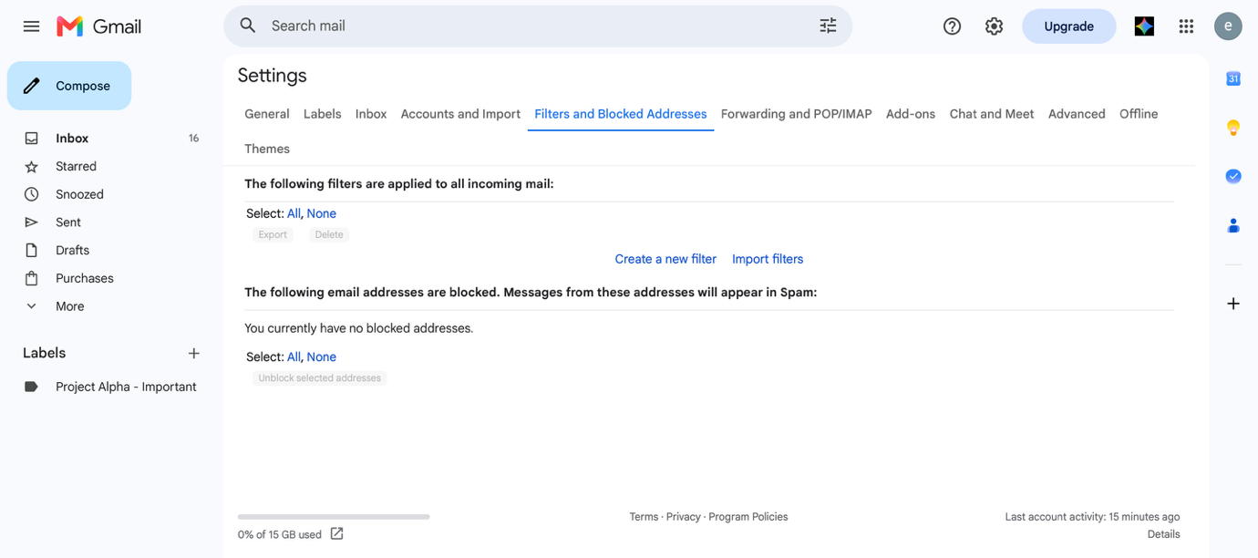
- Step 3 Creating a Filter: I went to my Google Account under “settings” filters and blocked addresses” and clicked “create new filter”.
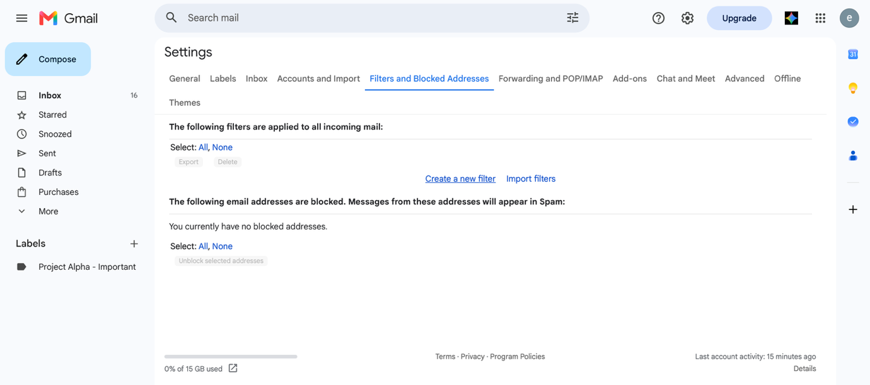
Screenshot 6 I went to “filters and blocked addresses”
Screenshot 7 I clicked on “create a new filter”

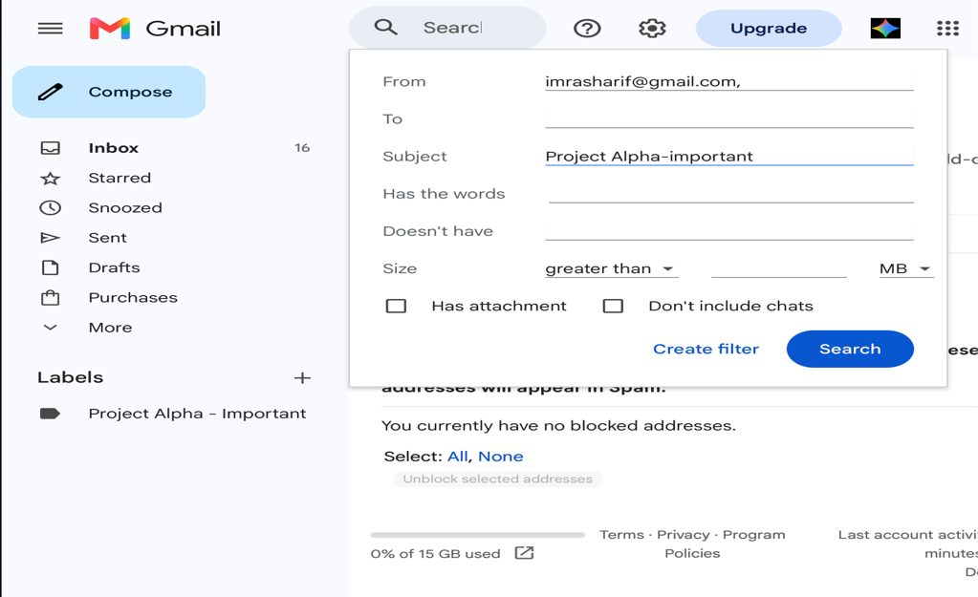
- Step 4 Define Filter Criteria: On the pop-up search results screen I searched for an email from a main project stakeholder in the ‘From’ box with the subject name of the message ‘Project Alpha’.

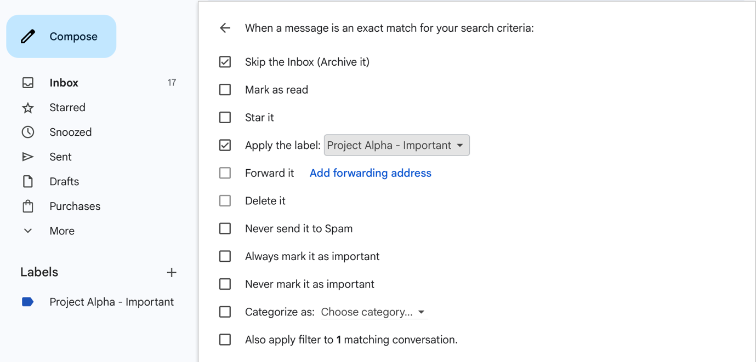
Screenshot 8 I put down the email I would like to filter. I made sure that subject had the same title as the labels.

Screenshot 9 after I clicked on create filter. A tick box option popped up, I ticked the “skip the inbox (archive it)”

- Step 5 Apply Action: I selected “Create filter”, and in the next window, I went for “Apply the label” and then chose the “Project Alpha – Important” label I had just created. I also marked “Skip the Inbox (Achieve it)” so that my primary inbox is clean.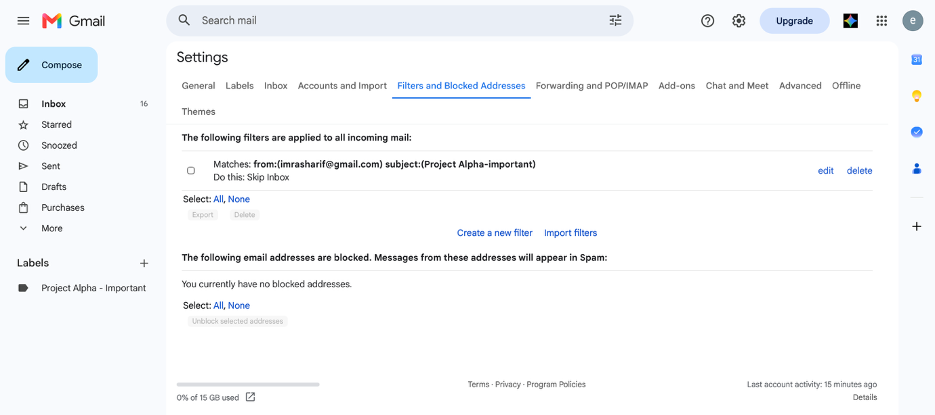
Screenshot 10 I created the filter
- Step 6 Test the Filter: Using the email address of the relevant stakeholder, I sent an email with the words “Project Alpha” on the subject line. The filter worked well because the email was auto archived and labelled “Project Alpha-Important”.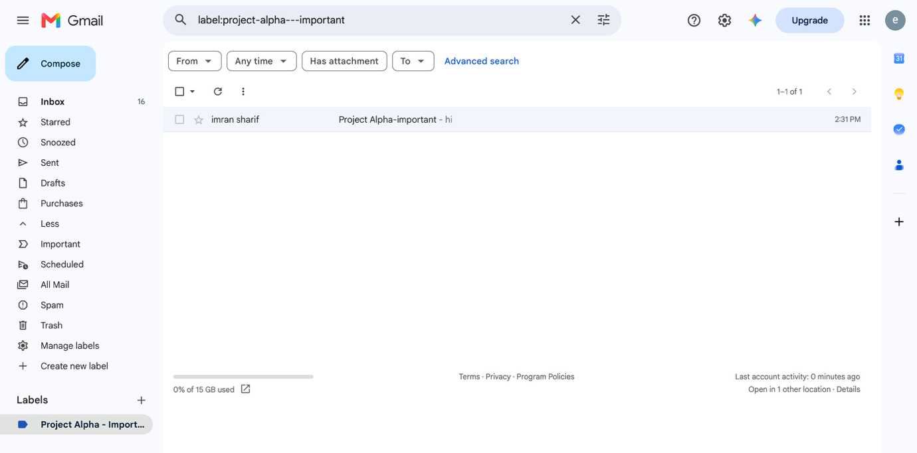
Screenshot 11 I tested the filter I created and worked the way I intended it to work

Practical Application: The email filtering function serves as a gain for business experts. Anyone who's received quite a few emails will understand how important it is to categorise emails for their business activity or their personal activity. This feature allows you to filter out irrelevant e-mails and focus on more important ones. So you don’t have to waste your time sorting the emails yourself. One example of a time where a decision can be made is when you are appointed project manager [38].

Zoom
Zoom - Breakout Rooms
In the first practical example, I checked Zoom Breakout Rooms, which allow for the meeting host, to split the zoom meetings participants into smaller groups [39]. This enabled them to discuss, workshop or train any session .
Step-by-Step guid:
- Step 1 Enable Breakout Rooms: I enabled Breakout Room in my Zoom account settings, prior to the meeting, as the host. I sign into the Zoom web portal to do this. I accessed Settings > In Meeting (Advanced) and enabled the Breakout Room feature.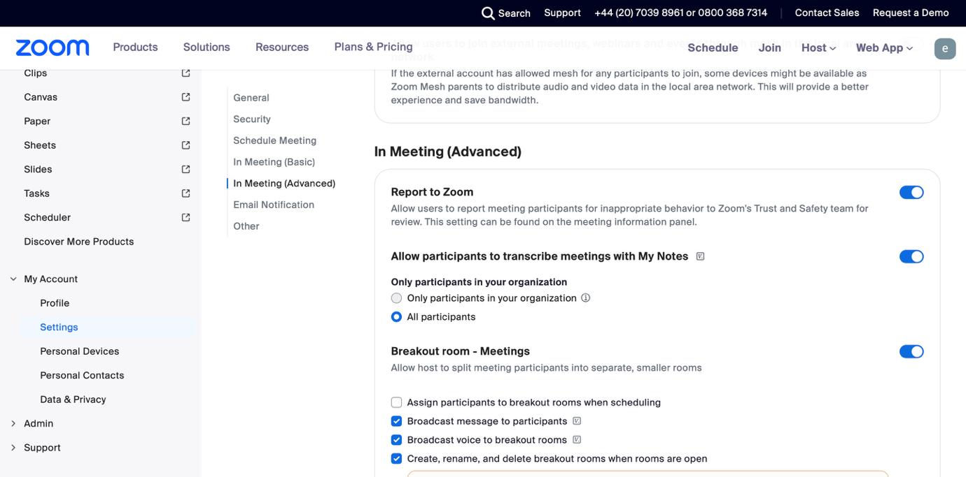
Screenshot 1 turning on Breakout Rooms in Zoom settings

Screenshot 2 I started a new Zoom meeting
- Step 2 creating the breakout tooms
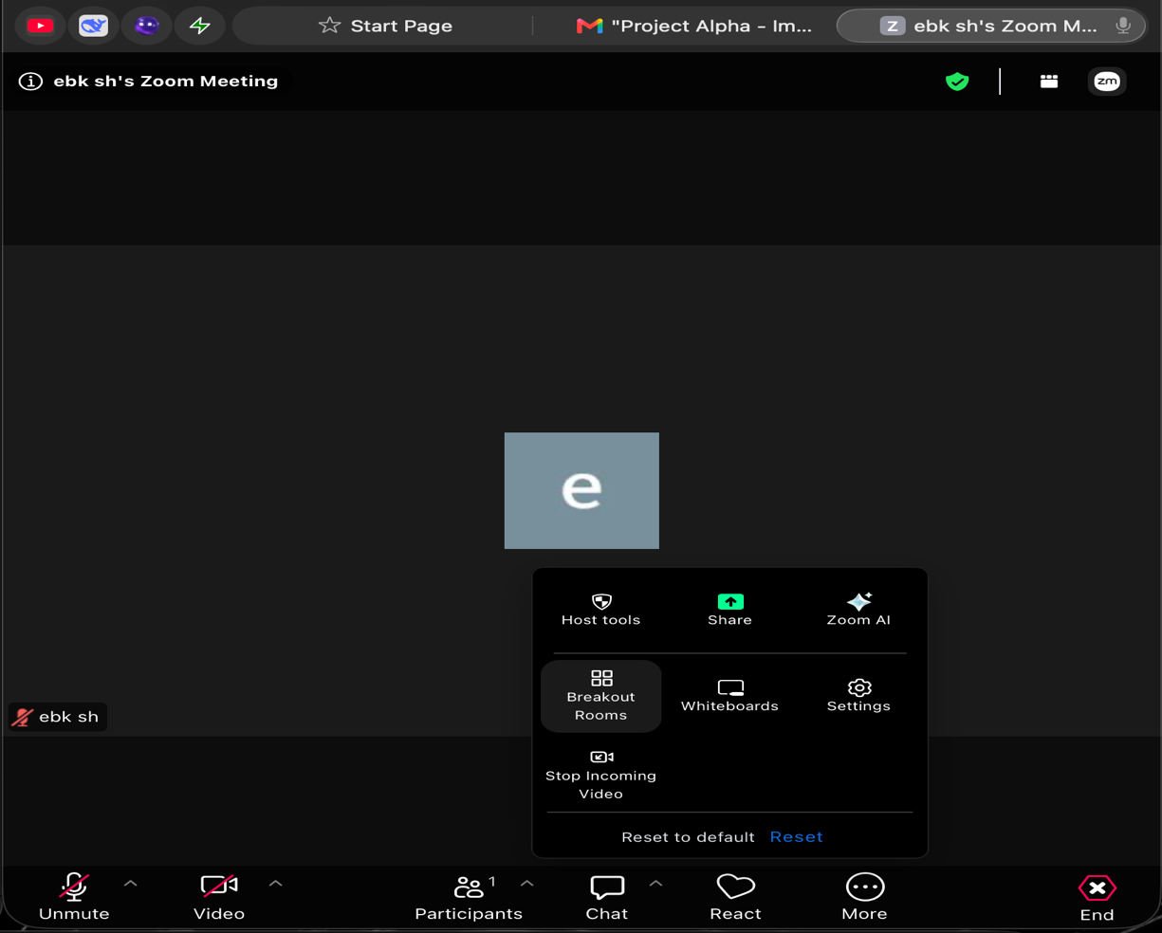
Screenshot 3 Breakout Rooms icon in Zoom meeting

- Step 3 Forming Rooms: On the pop-up window, I selected the number of rooms I wanted to make (like 3 rooms). I then selected for Automatically from the drop-down to evenly distribute the participants in their rooms by Zoom.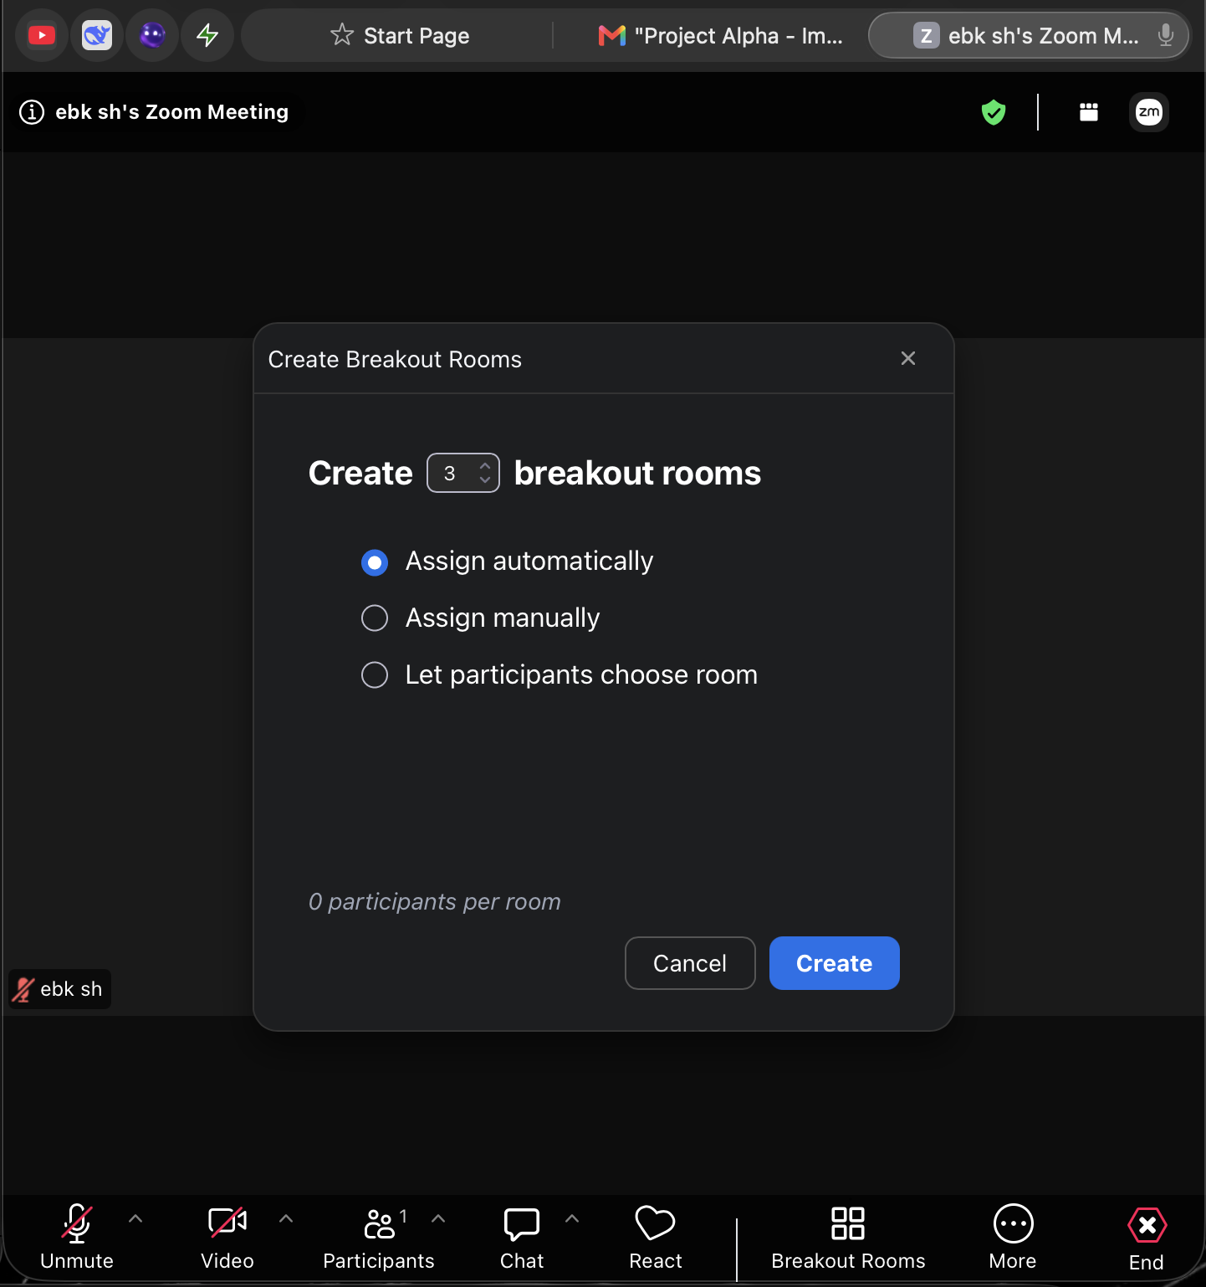
Screenshot 4 Forming Breakout Rooms

- Step 4 Setting up the room; Before setting up the rooms, I clicked the ‘Options’ button and selected the options I wanted for my breakout session. For instance, I let participants go to the main session at any time and I set a timer for the breakout session.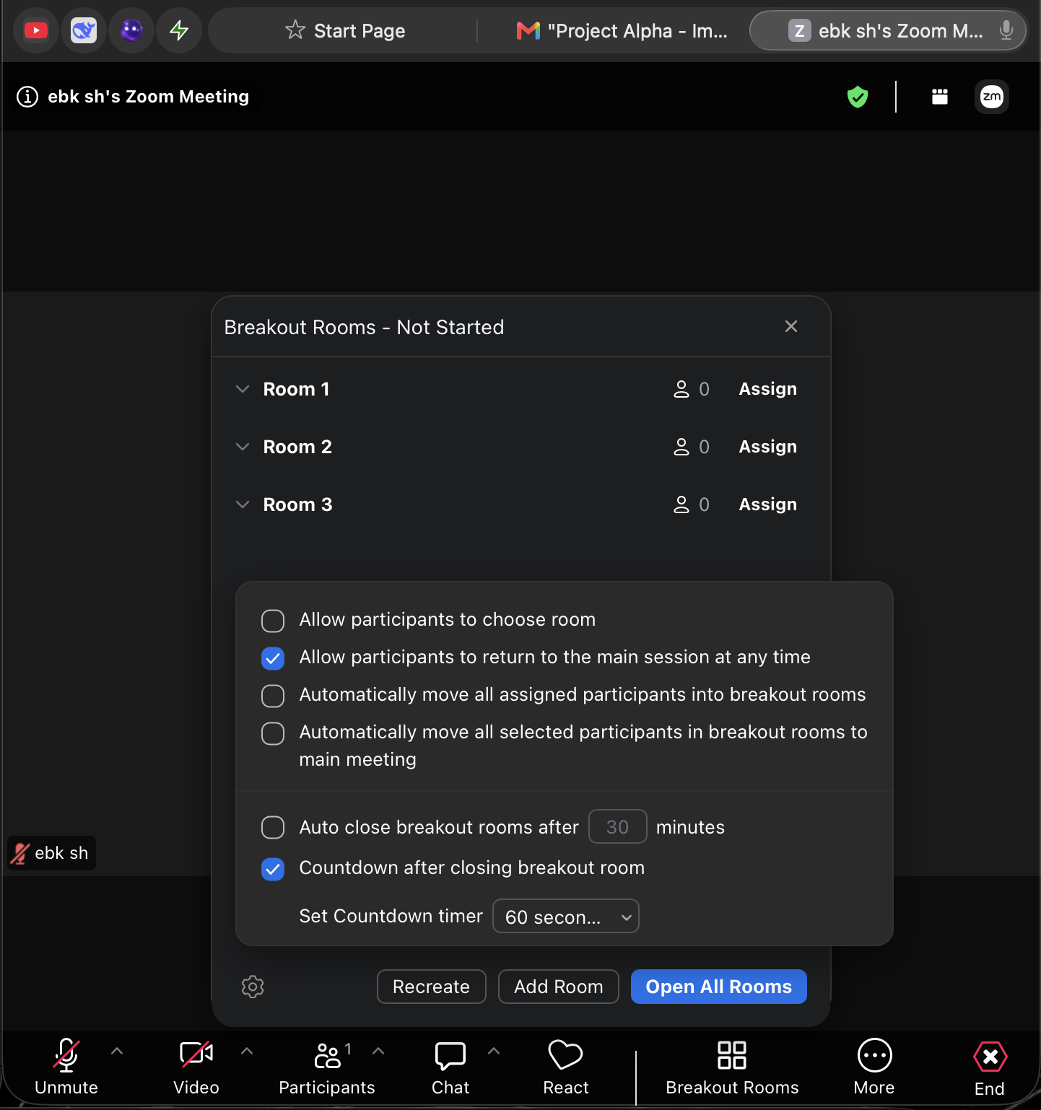
Screenshot 5 Setting up the Breakout Room options
- Step 5 Launching the Breakout Rooms: I pressed the “Create” button. Next is the option to open all the rooms. People joining my session got auto joined.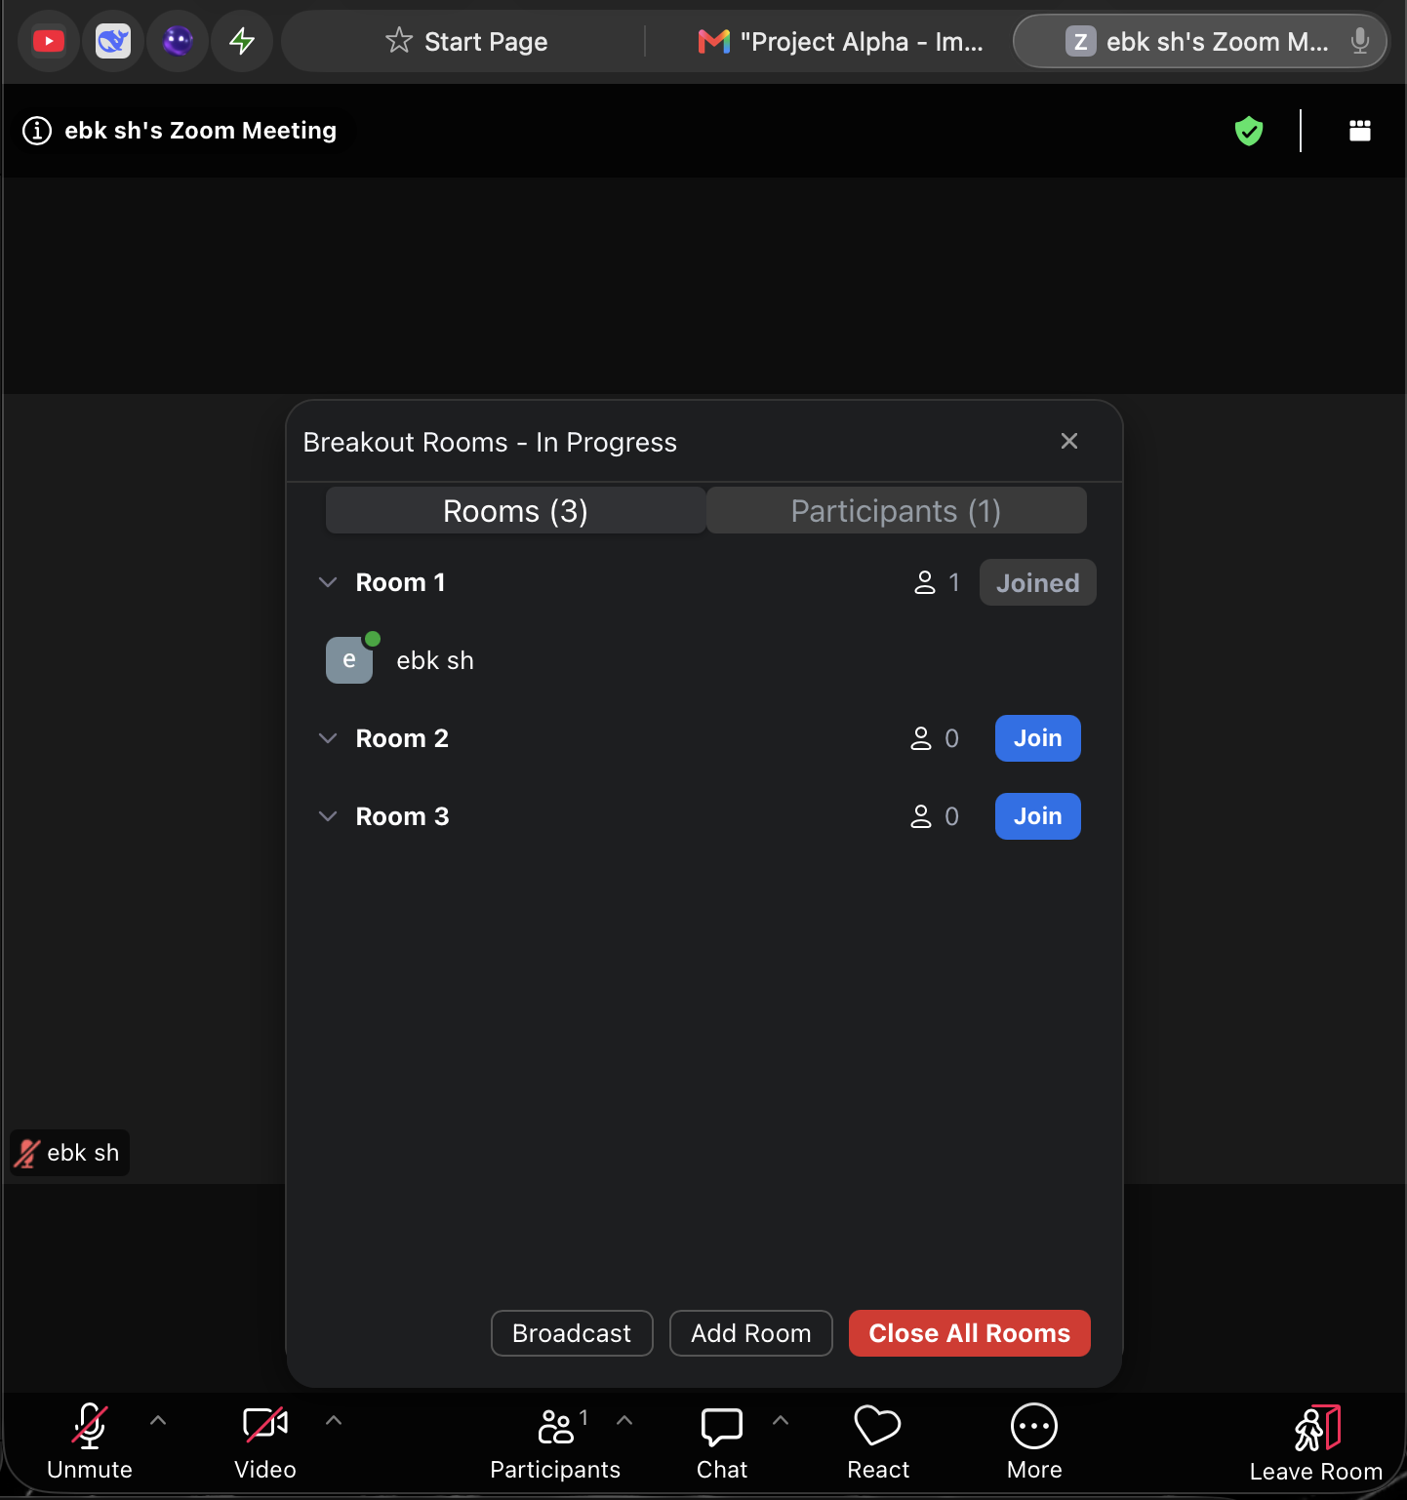
Screenshot 6 Launching the breakout rooms

- Step 6 Monitoring and Managing: As the host, I could send a message to all rooms, join any room to assist, and control the timer. The rooms closed when the session finished. The participants were sent back automatically to the main meeting.


Screenshot 7 I clicked on the 3 horizontal line to make sure if I’m broadcasting a message, everyone sees it
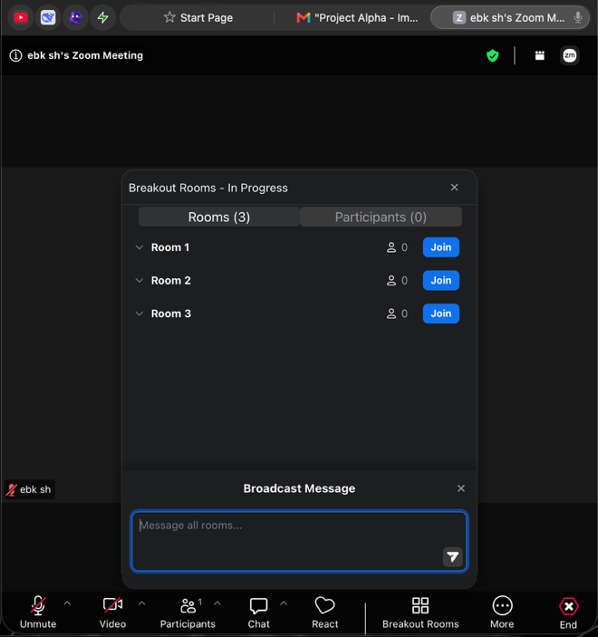
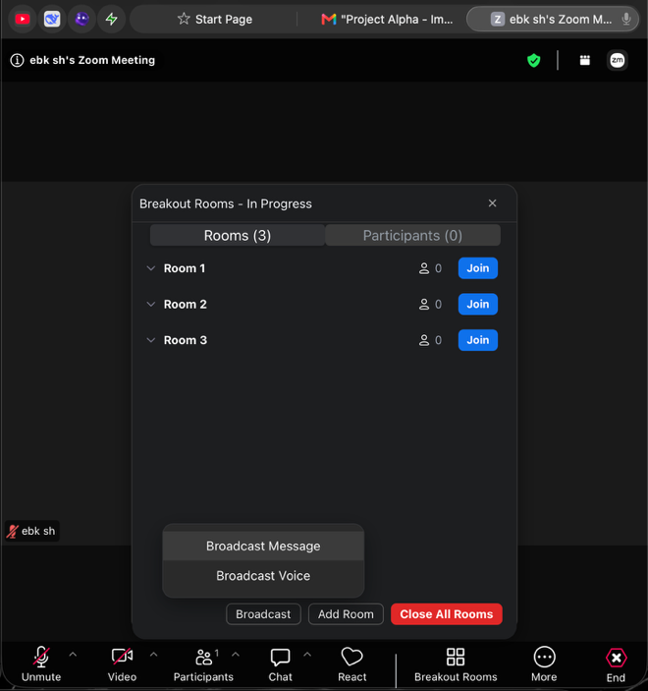
Screenshot 9 I am broadcasting a message to everyone
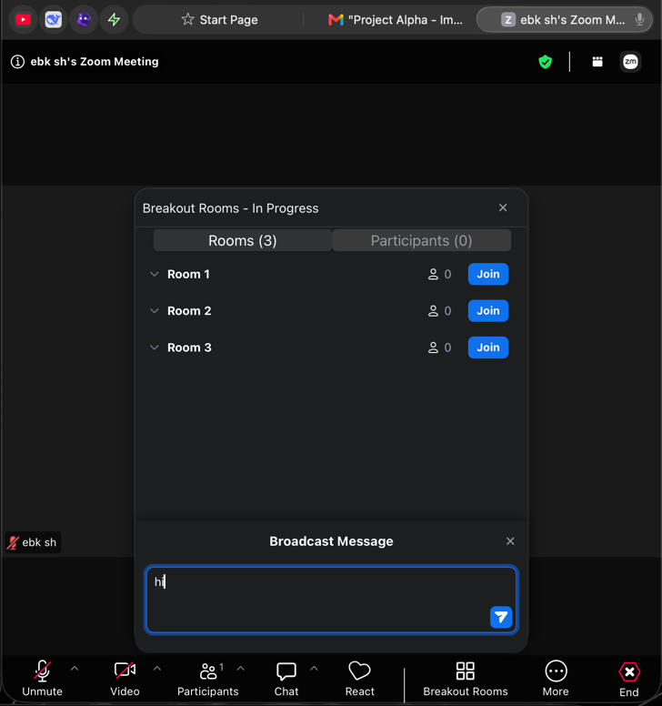
screenshot 8 broadcasting a message

Screenshot 10 finally testing the broadcast messaging feature

Practical Application: Many businesses use breakout rooms for various reasons while having meetings. In a strategies workshop, for instance, it is easy for the host to split people up into groups to come up with ideas on themes. In a training session, breakout rooms could also be used for a group exercise or case study. This enhances the communication among the members during the meetings [40].

Conclusion
Through this assignment, I got to know four software packages which are used by organisation. Google Sites and Shopify help organizations to have an online presence. Tools like a mind map serve to support visual communication. Microsoft Office Helps in Communication and Data Analysis with its Various Applications. Finally, Gmail and the Zoom software packages help gain internal and external communication. All in all, these applications help organizations facilitate their activities.

References
- [1] Ritoban TechRadar page 1https://www.techradar.com/reviews/new-google-sites
- [2] The e-commerce platform for business owner https://www.shopify.co.uk/(26/06/2026)
- [3] T. Buzan and B. Buzan, The Mind Map Book: How to Use Radiant Thinking to Maximize Your Brain’s Untapped Potential. New York, NY, USA: Plume, 1996.
- [4] MindMeister, “Mind Mapping for Business: Benefits and Use Cases,” Focus (blog), 2023. [Online]. Available: https://www.mindmeister.com/blog/mind-mapping-for-business/. [Accessed: Jun. 27, 2026].
- [5] P. Farrand, F. Hussain, and E. Hennessy, “The Efficacy of the ‘Mind Map’ Study Technique,” Medical Education, vol. 36, no. 5, pp. 426‑431, May 2002. doi: 10.1046/j.1365-2923.2002.01205.x.
- [6] Microsoft, “Word help & learning,” 2024. [Online]. Available: https://support.microsoft.com/en-us/word
- S. Lambert and C. Frye, Microsoft Office 2019 Step by Step. Redmond, WA, USA: Microsoft Press, 2019.
- Microsoft (2024c) Excel help & learning. Available at: https://support.microsoft.com/en-us/excel (Accessed: 28 June 2026).
- Microsoft (2024b) PowerPoint help & learning. Available at: https://support.microsoft.com/en-us/powerpoint (Accessed: 28 June 2026).
- Microsoft 365 Apps, Mar. 30, 2026. [Online]. Available: https://learn.microsoft.com[reference:7].
- J. Eckstein and B. R. Schultz, Introductory Relational Database Design for Business, with Microsoft Access
- Q. Yu, “The analysis of several commonly used Excel function in accounting practice,” in Proc. 2014 IEEE Workshop on Electronics, Computer and Applications, Beijing, China, 2014,
- Microsoft, “VLOOKUP function,” Microsoft Support. [Online]. Available: https://support.microsoft.com
- An Integrated AI-ML System for Email Management: Improving Productivity and Security through Classification and Multi-Layered Detection,” in Proc. 2025 IEEE Conference, Indore, India, Dec. 2025.
- B. Barnes, “More personalized and proactive assistance in Gmail coming to business customers,” Google Workspace Blog, Feb. 20, 2026. [Online]. Available: https://workspace.google.com/blog/product-announcements/more-personalized-and-proactive-assistance-in-gmail-coming-to-business-customers
- Zoom Communications, “New AI innovations for Zoom Workplace simplify and scale teamwork to cut through friction,” Zoom Newsroom, Mar. 10, 2026. [Online]. Available: https://news.zoom.com/ec26-zoom-workplace/
- Zoom Communications, “Zoom introduces AI agents as part of ZoomMate and Zoom AI On-Prem for regulated enterprises,” Zoom Newsroom, Jun. 22, 2026. [Online]. Available: https://news.zoom.com/zoom-introduces-ai-agents-as-part-of-zoommate-and-zoom-ai-on-prem-for-regulated-enterprises/
- Mike Evans, Aaron S my best website builder 26 mar 2026 https://www.mybestwebsitebuilder.com/google-sites-review Accessed 04 Aug 2026

- go digital now Google Sites Template for Online Stores (Ecommerce) 2026 https://godigitalnow.store/products/google-sites-template-for-online-stores-ecommerce Accessed 07 Aug 2026

- voucherify, voucherify 23 jun 2026 https://www.voucherify.io/integrations/shopify Accessed 04 Aug 2026

- websitebuilderexpert, Shopify Introduces New AI-Generated Product Descriptions 16 may 2023 https://www.websitebuilderexpert.com/news/shopify-magic/
Accessed 04 Aug 2026

- Mindmeister, Mindmeister 14 may 2026
https://www.mindmeister.com/pages/compare/lucidchart-alternative
Accessed 04 Aug 2026

- microsoft microsoft word 2026 https://www.microsoft.com/en/microsoft-365/word?market=im
Accessed 04 Aug 2026

- Get computer course What is ms word and its features? 2020
https://getcomputercourse.wordpress.com/2020/09/25/what-is-ms-word-and-its-features/
Accessed 04 Aug 2026

- microsoft microsoft excel 2026 https://www.microsoft.com/en-gb/microsoft-365/excel
Accessed 04 Aug 2026

- Anderson, Belinda Explore the Excel Interface 04 March 2026 https://www.thetraininglady.com/excel-window/
Accessed 04 Aug 2026

- microsoft microsoft PowerPoint 2026 https://powerpoint.cloud.microsoft/en-gb/
Accessed 04 Aug 2026

- open wa Chapter 9: Microsoft® PowerPoint® 2026 https://openwa.pressbooks.pub/bustechessentials/chapter/chapter-9-microsoft-powerpoint/
Accessed 04 Aug 2026

- microsoft microsoft accesss https://www.microsoft.com/en-gb/microsoft-365/access 2026
Accessed 04 Aug 2026

- ade, dayo Megatek ict academy Microsoft Access Databases: Still Popular? 22 jan 2022
https://ictacademy.com.ng/microsoft-access-databases-still-popular/d
Accessed 04 Aug 2026

- Hahn, Jennifer dezeen 07 oct 2020
https://www.dezeen.com/2020/10/07/gmail-logo-google-rebrand-workspace-design/
Accessed 04 Aug 2026

- Black, Steve Tech Life Unity 2022 https://techlifeunity.com
Accessed 04 Aug 2026

- CBS How can you use Zoom for your online teaching? 2026 https://teach.cbs.dk/tools-for-teaching/zoom/
Accessed 04 Aug 2026

- CSUSM How to Zoom What is Zoom and where do I start? 2023
https://www.csusm.edu/el/olli/howtozoom.html
Accessed 04 Aug 2026

