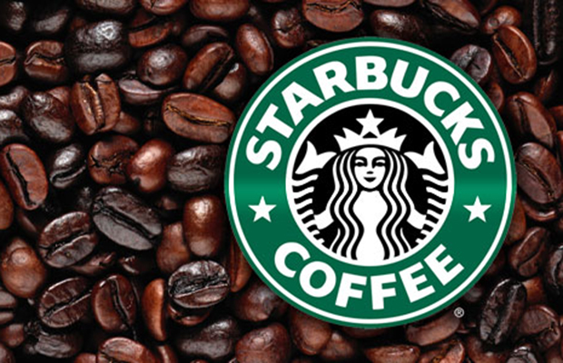
Strategic Management and Sustainability (M3X9111)
Sumitra Gurung (P148163)
STARBUCKS- Premier roaster and retailer of speciality coffee

University of Wales Trinity Saint David
2017
Table of Contents
1. Executive Summary 3
2. Introduction 4
2.1 Report Remit 4
2.2 Background of the organisation 4
2.3 Business environment 4
2.3 Definition of major concepts 6
3. Main Body 7
3.1 Implementation of the strategy 7
3.2 Advantages and disadvantages of the strategy 7
3.2.1 Advantages of Differentiation strategy 7
3.2.2 Disadvantages of Differentiation strategy 8
4. Conclusion 8
4.1 Recommendation 8
5. Bibliography 9

1. Executive Summary
This report will:
- Give a brief description about the organisation.
- Identify and analyse the strategy used by the Starbucks.
- Critically analyse the advantage and disadvantage of the strategy used
- Make a recommendation based on the finding.
The information for this report has been collected from various sources like book, articles and starbucks website. From the findings, it has been concluded that the Porter’s generic strategy that Starbucks has been using is differentiation.
Some of the advantage of using the differentiation strategy are:
- It gives the power to the organisation to be distinctive from its rivals.
- It creates market based advantage and creates value to add cost.
- It emphasises the reason for the customer on why they should buy from their company rather than from their rival competitors.
Some of the disadvantage of using the differentiation strategy are:
- There is a high risk of imitation by the rivals.
- It can be costly as more research, sources and ingredients are needed.
- It depends on the perception consumer to get acknowledge that the products or services are different to its competitors
The recommendation that were made after the evaluation of competitive strategy are:
- Expand their store in middle east.
- To introduce the new products in all Starbucks shops.

2. Introduction

2.1 Report Remit
The aim of this report is to critically evaluate the competitive strategy used by Starbucks. In this report, there will be a brief discussion on how Starbucks was formed and what changes it had to made in order to be one of the largest retail company. This report will be used to identify the strategy Starbucks has used in order to gain competitive advantage over its rivals. By critically evaluating the competitive strategy, this report will identify the advantages and disadvantages of strategy used by starbucks to gain competitive advantage.

2.2 Background of the organisation
Starbucks is one of the largest American global coffee shop who is specialised in beavering coffee and other cold and hot drinks. However, the journey of Starbucks was different to what it does know, it was established in 1971 at Seattle’s Pike Place Market where they were only selling whole beans and grounded coffee, tea and other spices (Starbucks, 2017). It was Howard Schultz, now also known as executive chairman of Starbucks who was able to discover the true value of the company. His vision was to bring the tradition of Italian coffee house to the United States. In order for that vision to come true different approach was carried to run the company and now, Starbucks has more than 24,000 stores in 70 countries (Starbucks, 2017). The mission statement of the Starbucks is “To inspire and nurture the human spirit – one person, one cup and one neighbourhood at a time” (Starbucks, 2017). And their value is to connect with everyone and to create a culture that welcomes everyone.

2.3 Business environment
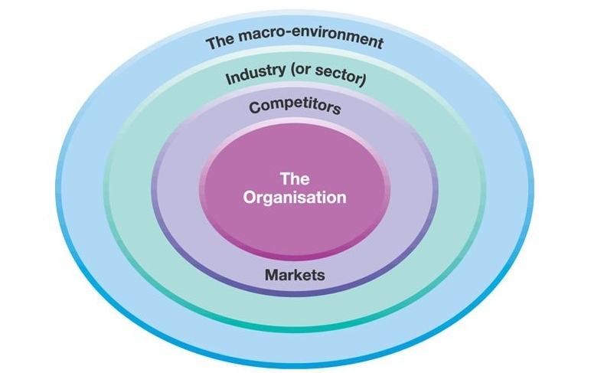

Fig. 1.1. Layers of business environment (D.Dunca, 2014).
The layers of the organisation have been organised into three layers and they are the macro-environment, industry and competitors and markets (Johnson, et al., 2008). The outer layer of the business environment is the macro-environment. Also, the first step of the strategic analysis for an organisation to look into the external environment in order to recognise opportunities and threats. The external environment consists of macro and micro environments which plays a vital role on the development and growth of the organisation. Micro-environment has direct impact whereas macro-environment has indirect impact on the organisation. Micro-environment consists the actor of the organisation which are the customers, suppliers, distributors and competitors. And the macro-environment helps to identify PESTEL framework which stands for political, economic, social, technical, environmental and legal (Johnson & others, 2013). These factors influence the success and failure of the strategies as they are the tools for analysing the key drivers, which helps to build and focus on what is important. The PEST analysis of Starbucks will help to analyse broad data to identify the key divers of change.
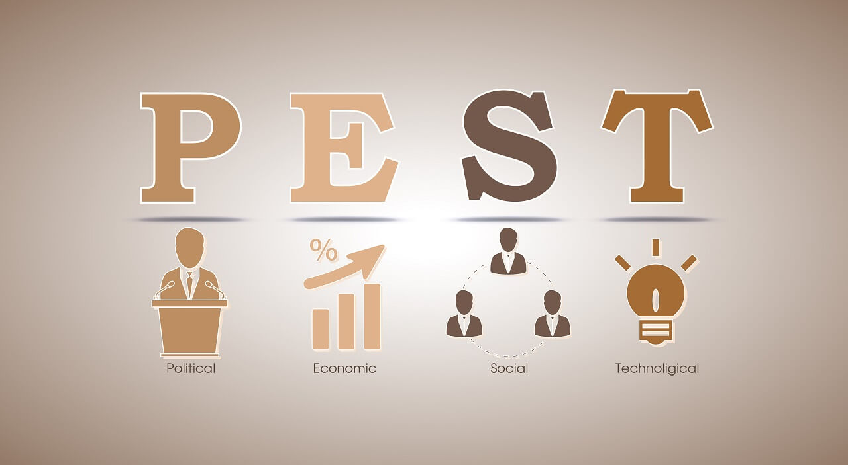

Fig.1.2. PEST analysis (Contributor, 2014)
“Politics emphasises the role of governments, legislation; Economics signifies to macro- economic factors such as exchange rates, economic growth rates around the world; Social influences include changing cultures and demographics, and Technological influences refer to innovations such as the internet or the rise of new composite materials” (Johnson, et al., 2008). Starbucks is a global organisation as it stores are located in 70 countries therefore, it is necessary to follow to rules and regulation set by the government by following fair trademark practice. The organisation should evaluate the employment laws and taxation policy in order for them to operate. The economic factors are affected by the buying behaviour of the consumer and the economic growth rate. During the time of Brexit, “Starbucks has reported a sharp fall in profits at its UK business, which it has blamed on a slowing economy” (Business, 2017). The economic problems can be dignified as the crisis on the profitability which led to change the focus of the consumers to cheaper alternatives. However, the establishment of Starbucks stores in different country has help to increase the opportunities of employment in the developing country.
The social-culture refers to adapting the culture or lifestyle of the consumers looking at the demographic. Being a global organisation Starbucks need to analyse the behaviour of the consumers before starting their business. For example; Japan is known for its historical building and tradition. Therefore, to keep up the tradition of Japan, Starbucks has introduced a traditional tea house with Japanese custom of seating on the floor. where the customers are asked to remove their shoes (Gajanan, 2017). Hence, understanding the tradition and culture of the community increases the loyalty towards the organisation. The technological factor refers to innovation of new technology for the development. Digital word has become one of the influencing factor which affects the growth of the organisation. Therefore, adapting to the changing society and bringing out new ideas to value the customers can help the organisation to stand out from the competitors. For example: to make the customer’ s life more convenient, starbucks has come out with the mobile app where they can place their order before coming in the store (Ryan, 2017). As a result, the consumer will find the organisation more reliable and trustworthy.

2.3 Definition of major concepts
Strategy is defined as, “the direction and scope of an organisation over the long term, which achieves advantage in a changing environment through its configuration of resources and competences with the aim of fulfilling stakeholder expectations” (Johnson & Scholes, 1999). Every organisation needs a strategy because it involves the innovation and creation of new ideas to attract the customer, and to meet the needs of the changing society. Likewise, Starbucks changed its strategy of only selling whole and grounded coffee beans to selling beverages which has made the company one of the largest retail coffee market. Strategy is about choosing on what to do and what not to. Therefore, the organisation needs to have a clear vision, mission and willingness to be flexible in order to make the choice.
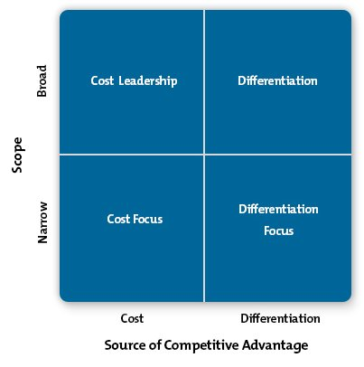
Business level strategies are actions that firms takes in order to gain advantage in a single market or industry (B.Barney & S.Hesterky, 2012). According to Porter (1985), “Competitive strategy is the search for a favourable competitive position in an industry. It aims to establish a profitable and sustainable positon against the forces that determine industry competition” (Hooley, et al., 2008). It is the ability of the organisation to stand against it rivals by adding more value for customers. Values can be added through improved products, satisfactory customer service or by bringing new and better ways of doing things. However, it can be difficult to satisfy all consumers due to which it is essential to sub group the people with identical behaviour and plan the strategies. Likewise, to sustain desirable loyalty or exchange of good relationship with customers; things like promotional offers or introducing new service should be introduced. Therefore, to keep the customers satisfied and loyal to the company, Starbucks has come out with substituting dairy with soy-milk, or almond-milk for the lactose intolerance people. Also, to make the organisation distinctive from its competitors; they have introduced seasonal drink like pumpkin spice latte during the time of Halloween which makes the customers to anticipate (Morris, 2017).

Fig 1.3: Porter’s model of generic strategy (Mindtools, 2007).
According to Porter, “strategies allow organisations to gain competitive advantage from three different bases which are also known as generic strategies and they are cost leadership, differentiation and focus” (Fred R. & Forest R., 2017). Cost leadership is when the company competes using lower costs than its rivals and also, against broad range of segments. Differentiation occurs when the company has the range of different products compared to the segments in the market and focus strategies occur when the company chooses a concentrated or only one or limited range of segment (Thompson & Martin, 2005). From these statements, it can be said that the strategy that Starbucks uses in order to gain competitive advantage is differentiation. This is due to having different ranges of products that are different from its competitors. For example: Starbucks has introduced seasonal drink which is a different type of product compared to its competitors like costa, pret-a-manager or other coffee shops.

3. Main Body
Differentiation is defined as “a business strategy whereby firms attempt to gain a competitive advantage by increasing the perceive value of their products or services related to the perceived value of the other firms’ product or services” (B.Barney & S.Hesterky, 2012). It is believed that it is the matter of customer perception in order to get acknowledge that the products or services are different to its competitors. The major advantage of differentiation strategy is that it creates market based advantage and also, emphasises the reason for the customer on why they should buy from their company rather than from their rival competitors.

3.1 Implementation of the strategy
Differentiation can be achieved through various application such as by changing the price, service, design, new products, etc. However, only potential differentiation strategy allows a firm to gain customer loyalty and charge a higher price for its product because consumers may become strongly attached to the differentiation factors. Similarly, Starbucks has introduced new approach to reach the customer which is by writing the name of the customers on the cup to make them feel more valued. The strategy of writing the name on the cup has played a vital role to promote the name of the company. As it has become to source of promotion for the organisation as the customer taking the picture of their name on the cup and posting it on the social media. As a result, they have created a win-win situation for company which is by keeping the customer satisfied and promoting themselves indirectly. Additionally, it has been said that the employees are misspelling the name of the customer on purpose as a part of their strategy in order to promote themselves for free (Wilkinson, 2016).
Differentiation is not just about being creative to be unique in order to stand out from its competitor however, it is also about understanding and analysing the needs of the consumer. So, to meets the needs and preference of the customer, Starbucks has designed their shops in a way where the customers can come to relax and enjoy their time in the shop. For instant, they have provided free Wi-Fi service and places to charge electronic devices in order to keep the customer engaged with the shop. Providing these types of service plays a significant role to keep the customer loyal. Additionally, starbucks has become one of the organisation who has adapted with the lasted technology to make the customers life easier and bring more satisfaction. They have introduced things like mobile payment service and a mobile app to place and pay for order before reaching to the store so, they can just pick their good without having to queue for the order (Rao, 2016).

3.2 Advantages and disadvantages of the strategy

3.2.1 Advantages of Differentiation strategy
Differentiation creates a reason to add cost which adds value to the customer for which they are willing to pay the premium quality product and services. The bargaining power of the buyers and supplier is low because of having premium quality products to which consumers are willing to pay the higher price. Apart from coffee starbucks has many other beverages and additionally, they have created different environment which are highly targeted to the younger adults (Dudovskiy, 2017). To conclude, keeping the younger adult as a loyal customer from their early age can result the company to have more loyal customers in future. The threat of substitutes is high for starbucks because it’s a coffee shop therefore, many beverage substitutes can be found in the market. However, starbucks has introduce unique flavour such as pumpkin spice latte and unicorn drink which make it more distinctive from its competitors and customers more loyal towards the company (Business, 2017).

3.2.2 Disadvantages of Differentiation strategy
Differentiation strategy can only be carried out only after a careful study of the buyer due to which more time, money and ideas are needed in order to come up new innovation and unique features. The disadvantage of this strategy is that there is a high possibility of the ideas to be imitated by the competitors and can become less important to the consumers. Therefore, the threat of new entrant is moderate as they can come up with more innovative ideas which may possibly attract the loyal consumers. Correspondingly, the risk of pursing the differentiation strategy is that some of the unique product introduce to the consumers might not get enough valued and may not agree to the higher price. The competitive rivalry is high because of there is a chance of customers switching towards to lower price alternatives as some consumer may not welling be the premium price of products.

4. Conclusion
Finally, to conclude the challenge of using generic strategy is that the organisation needs to be innovative and looks for means to keep the growth of the organisation. Starbucks have gained competitive advantage using the differentiation strategy of using unique ingredients, service and products over its rivals. Even though there are some limitation on what Starbucks can produce as they mainly sell coffee and other beverages, and some of which can be found in the market in lower price. However, it completely depends on the likes and dislike of the consumer. Starbucks gives value to its consumer due to which consumer are willing to pay the premium price for the product. Introducing system like writing the name on their cup so that they can feel valued. Also, the mobile app to pay and place the order has made the office worker’s life more convenient as they don’t have to wait in a long queue to order and pay for the product. To summarise, it can be said that the development of new innovation and ideas to make them stand out from the rivals has helped them to be one of the largest coffee shop.

4.1 Recommendation
Starbucks is one of the largest global retail organisation and has more than 24000 stores in 70 countries. However, the presence Starbucks still hasn’t reached in most of the part in middle east therefore, it can use the opportunity to expand the business. Also, starbucks should introduce its new invention of drinks to all the store it has rather than just choosing the certain store as some of the loyal customers may be anticipating for trying them as well.

5. Bibliography
B.Barney, J. & S.Hesterky, W., 2012. Strategic Management and Competitive Advantage: Concepts and cases. 4th ed. Hagerstown: Pearson Education.
Business, 2017. Starbucks joins 'unicorn food' craze with new drink. [Online]
Available at: http://www.bbc.co.uk/news/business-39641432
[Accessed 10 November 2017].
Business, 2017. Starbucks says Brexit vote hit UK profits. [Online]
Available at: http://www.bbc.co.uk/news/business-39586848
[Accessed 11 November 2017].
Contributor, P., 2014. What Is PEST Analysis and Why it’s Useful. [Online]
Available at: http://pestleanalysis.com/what-is-pest-analysis/
[Accessed 4 November 2017].
D.Dunca, C., 2014. Portfolio 3 – S1. [Online]
Available at: https://christiandunca.wordpress.com/2014/11/09/portfolio-3/
[Accessed 5 November 2017].
Dudovskiy, J., 2017. Starbucks Segmentation, Targeting and Positioning – Targeting Premium Customers with Quality Products and Service. [Online]
Available at: https://research-methodology.net/starbucks-segmentation-targeting-and-positioning-targeting-premium-customers-with-quality-products-and-service/
[Accessed 10 November 2017].
Fred R., D. & Forest R., D., 2017. Strategic Management: A competitive advantage approach, concets. 16th ed. Harlow: Parson Education Limited.
Gajanan, M., 2017. A Look Inside This Starbucks Modeled After a Japanese Teahouse. [Online]
Available at: http://time.com/4834814/starbucks-japan-teahouse-kyoto/
[Accessed 12 November 2017].
Hooley, G., F.Piercy, N. & Nicoulaud, B., 2008. Marketing Strategy and Competitive Positioning. 4th ed. Essex: Pearson Education Limited.
Johnson, G. & others, F., 2013. Exploring Strategy, Harlow: Pearson Education Limited,
Johnson, G. & Scholes, K., 1999. Exploring Corporate Strategy. 5th ed. Hertfordshire: Prentice Hall Europe.
Johnson, G., Scholes, K. & Whittington, R., 2008. Fundamentals of Strategy, Harlow: Pearson Education Limited.
Mindtools, 2007. Porter's Generic Strategies. [Online]
Available at: https://www.mindtools.com/pages/article/newSTR_82.htm
[Accessed 4 November 2017].
Morris, C., 2017. Brace Yourself. Starbucks' Pumpkin Spice Lattes Appear Imminent. [Online]
Available at: http://fortune.com/2017/08/31/starbucks-pumpkin-spice-latte-release-date/
[Accessed 10 November 2017].
Rao, L., 2016. Starbucks Is Going Even Bigger on Mobile Apps. [Online]
Available at: http://fortune.com/2016/06/08/starbucks-mobile-app-digital-strategy/
[Accessed 7 November 2017].
Ryan, T., 2017. Starbucks Mobile Ordering Is Working Too Well. [Online]
Available at: https://www.forbes.com/sites/retailwire/2017/04/12/starbucks-mobile-ordering-is-working-too-well/#751b0952ea28
[Accessed 11 November 2017].
Starbucks, 2017. Our mission. [Online]
Available at: https://www.starbucks.com/about-us/company-information/mission-statement
[Accessed 3 November 2017].
Starbucks, 2017. Starbucks Company Profile. [Online]
Available at: https://www.starbucks.com/about-us/company-information/starbucks-company-profile
[Accessed 4 November 2017].
Thompson, J. & Martin, F., 2005. Strategic Management: Awareness and change. 5th ed. Bedford : Thomson Learning.
Wilkinson, J., 2016. Do Starbucks workers spell your name wrong ON PURPOSE so you will share pictures of your cup on social media? Read more: http://www.dailymail.co.uk/news/article-4030698/Starbucks-employees-spell-wrong-cups-PURPOSE-share-pictures-social-media-conspiracy-theory-claims.html#ixzz4yVXyS7y2 Follow us: @MailOnline on Twitter | DailyMail on Facebook. [Online]
Available at: http://www.dailymail.co.uk/news/article-4030698/Starbucks-employees-spell-wrong-cups-PURPOSE-share-pictures-social-media-conspiracy-theory-claims.html
[Accessed 6 November 2017].

