
E-portfolio
Module: Changemakers – Creativity and Value Creation BMHP5014 Lecturer: Diola Bijlhout

Student: Tea Shchepanovich
Student Id: 2026173
University of Wales Trinity Saint David

Table of Contents

Introduction 2
Artefact 1 – Mind map 3
Artefact 2 – Blog 4
Conclusion 8
References 9

Introduction

In this E-portfolio, I will introduce a new campaign called ’Syndrome Awareness’.
Through artefact 1, which is a Mind-map, I will show how the idea come up and its development.
Artefact 2, which is a Blog, will be used for active communication and exchange of opinions, and creative ideas with the audience.

Artefact 1 – Mind map

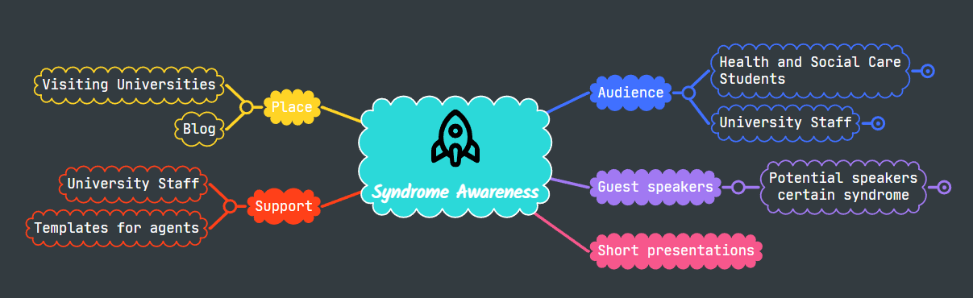(Shchepanovich, 2022)

I thought about how to enable students who are in the health sector to become better informed with the diseases and syndromes that exist. Unfortunately, that number is extremely high. The idea I got for raising awareness about the syndromes that surround us, how to recognize them, how to react and realize the needs of a disabled person in given situations. While I was working on e-learning for the Changemakers module, I came across a site for making mind maps, which gave me the opportunity to make my mind map in various colours and this encourages my further creativity. I chose the image of a rocket because it represents the launch of a completely new idea. This project will have great impact on public value – contributing to society trust and legitimacy, and service delivery quality (Bennington, 2010). The concept is that every month of the year we visit universities that offer a health course, and with the help of a blog we share and receive information from those who are interested in project. The connection point of place includes the visits to universities lasting 30-45 minutes, during which we will provide a short presentation on the cause/genesis of the syndrome, symptoms, and difficulties that they are facing. The largest part of the presentation will be devoted to students' questions and providing clear and concise answers from an expert and from a potential guest speaker. There is a possibility of a guest speaker, who is a person with a disability that we are talking about that month. There is a possibility of a guest speaker, who is a person with a disability that we are talking about that month. You are probably wondering why I wrote that there is a possibility of attendance. People with this type of disability have ’good’ days and ‘bad’ days; their tics can vary in type, frequency, or severity, it can depend on stress levels, tiredness, anxiety etc. Take Tourette's syndrome for example. Their tics and the sounds they make are not of the same intensity and duration every day. If a person has a ’bad’ day, he will not be able to attend the presentation due to his condition. The idea of ​​a guest speaker came from various social networks that I follow intensively, and where they are very active and want to raise awareness among their followers. At the end of each presentation, we will do a short questionnaire with the students to see the success of the project, and to find out which disability they would like to work on next. As I already wrote, the target audience are students, but also the academic staff of the university that is being visited, who can also come into contact with a person with a disability, whom they have not met before and are not sure about approach. Support for this type of project is needed from the staff of the university, the student union, which can also have a great influence on the success of the project, and we also leave space for the growth of the project.
In the following, I will use Artefact 2 – Blog, and present how the project would look like.

Artefact 2 – Blog

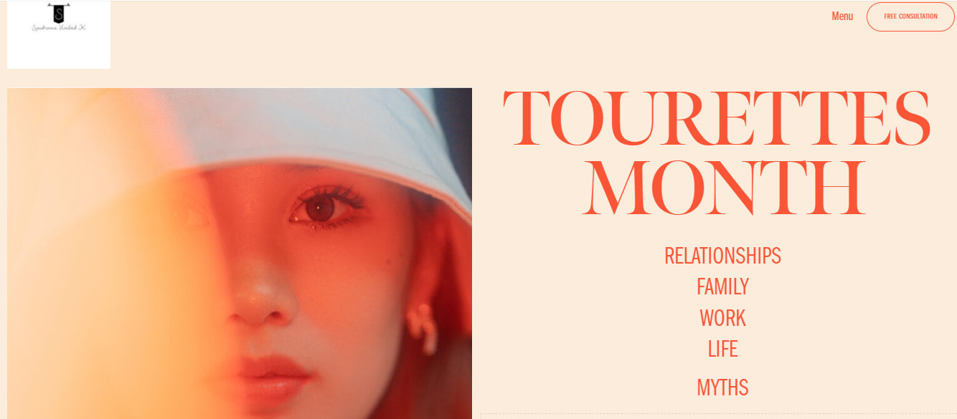
(Shchepanovich, 2022)
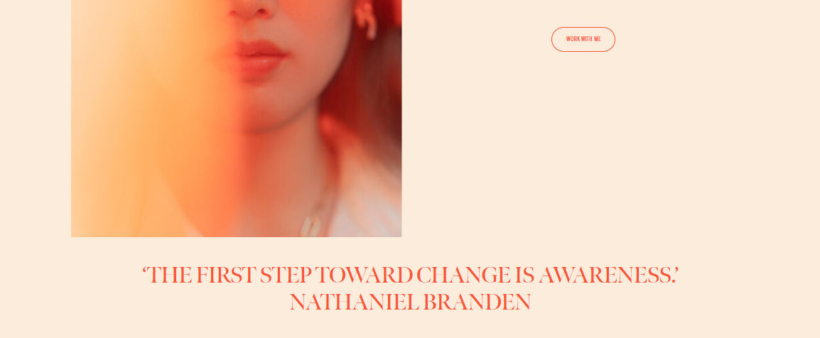
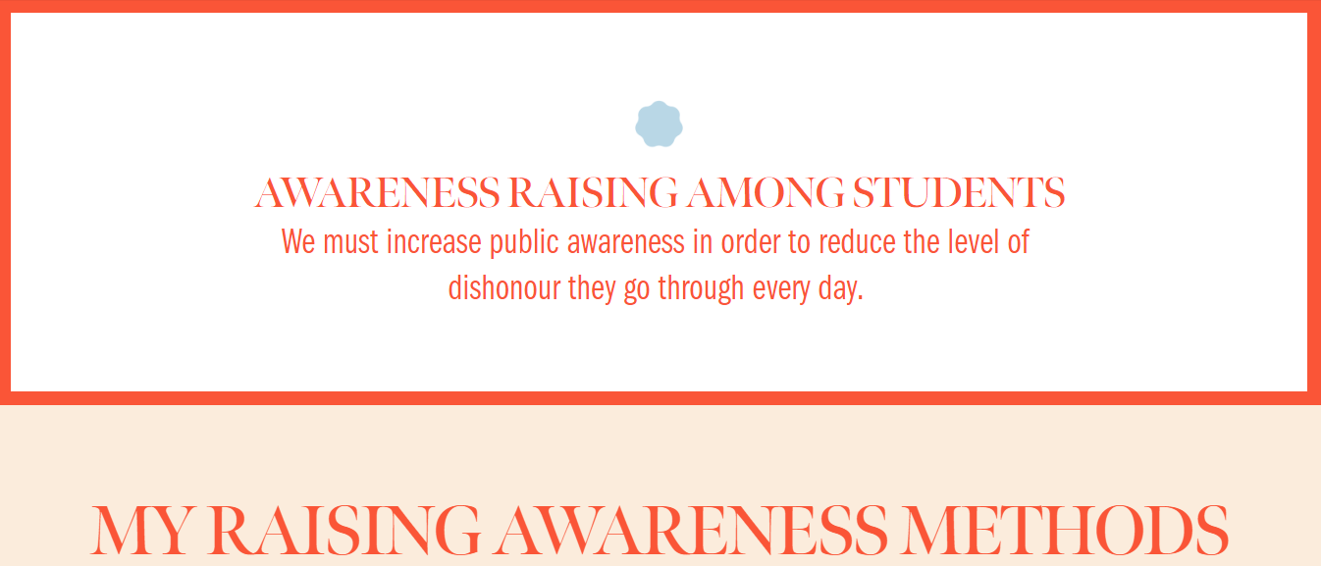
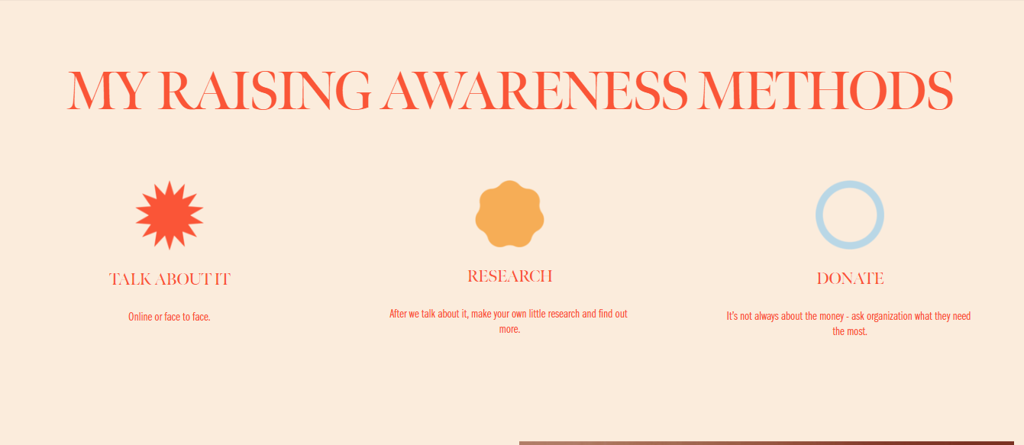
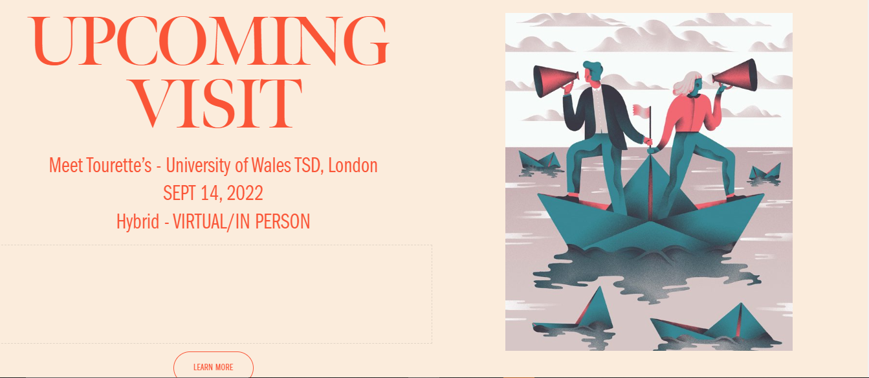

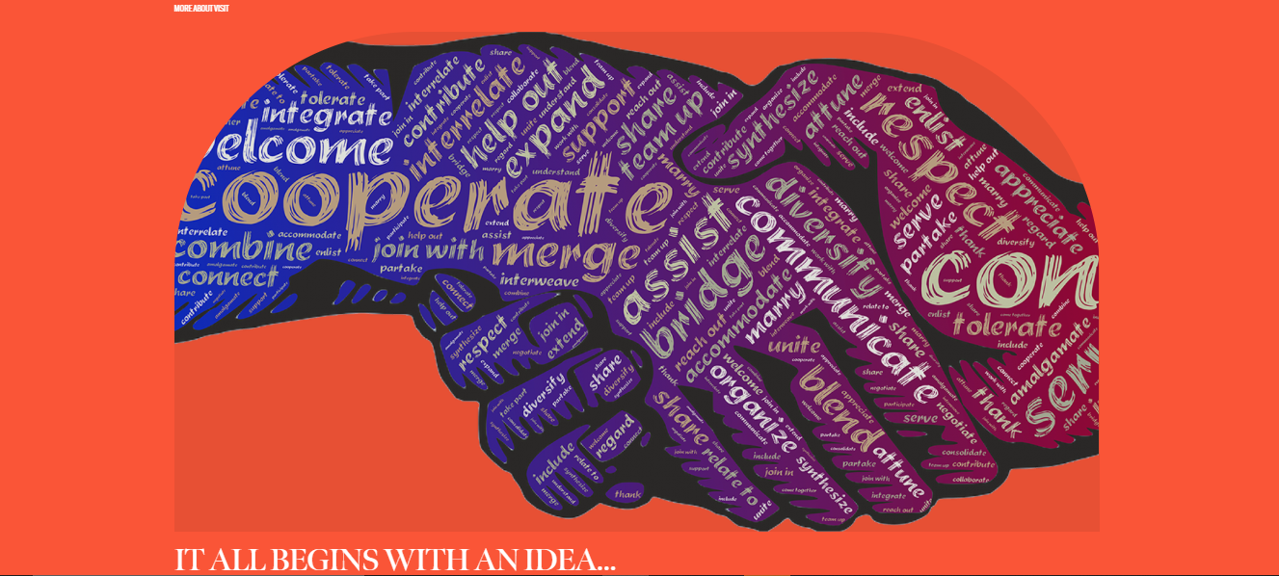
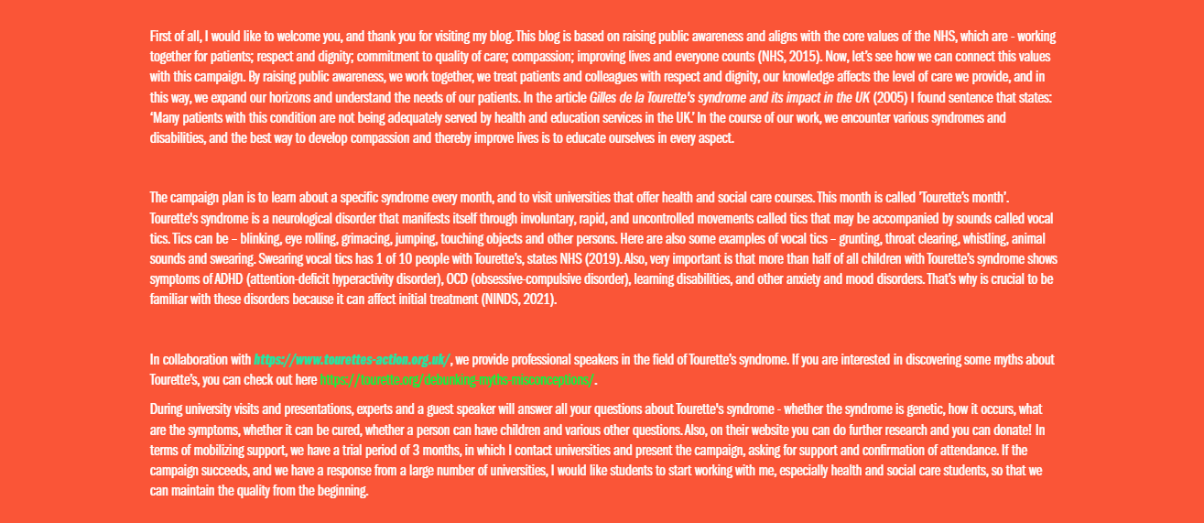
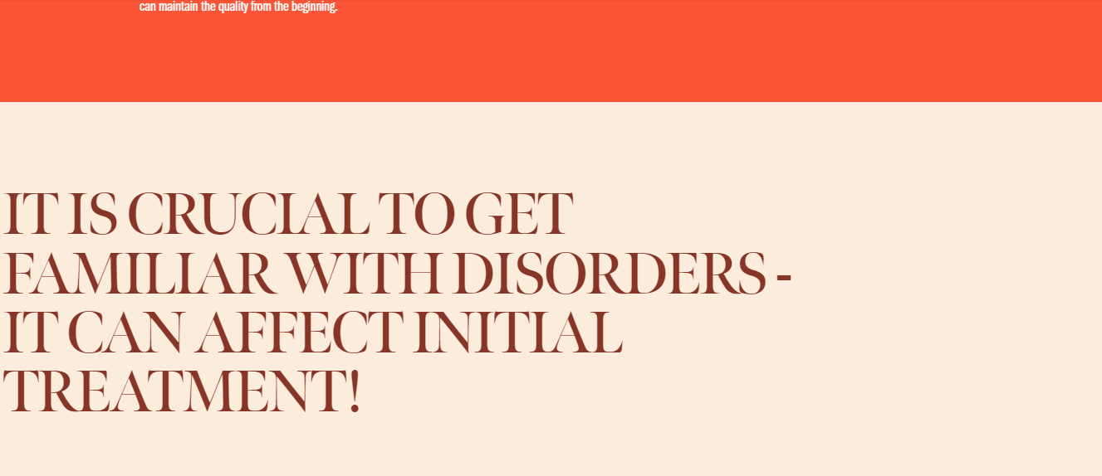
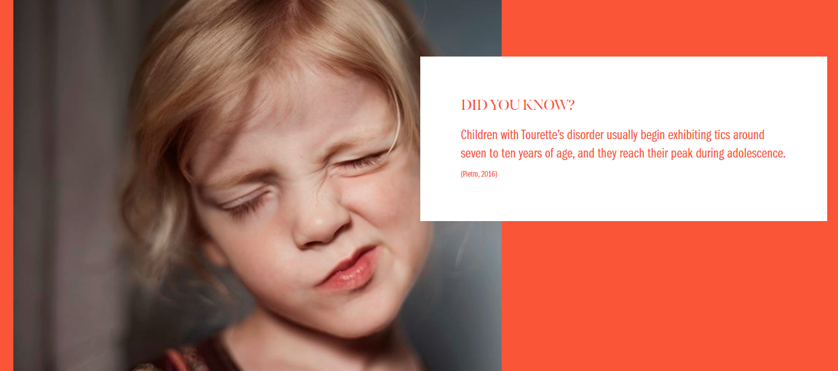
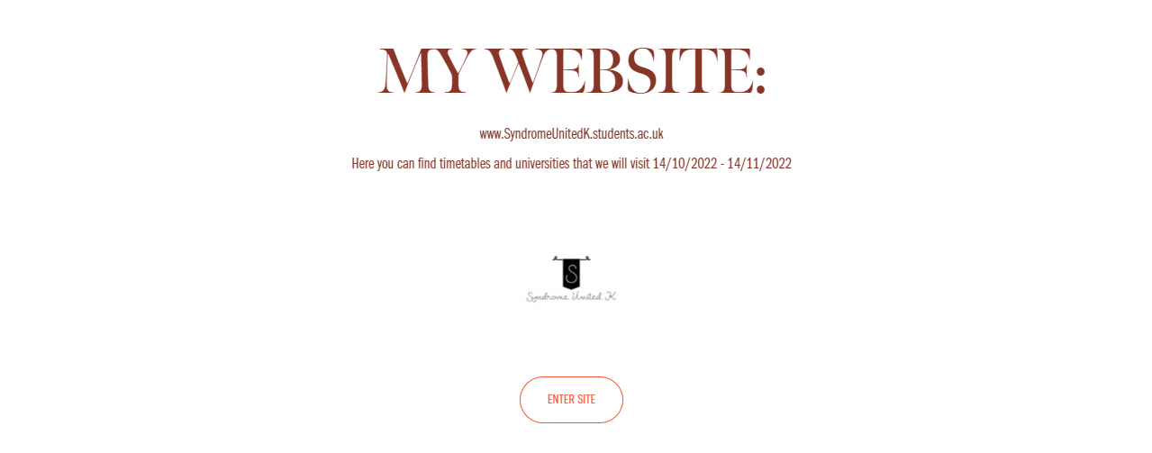
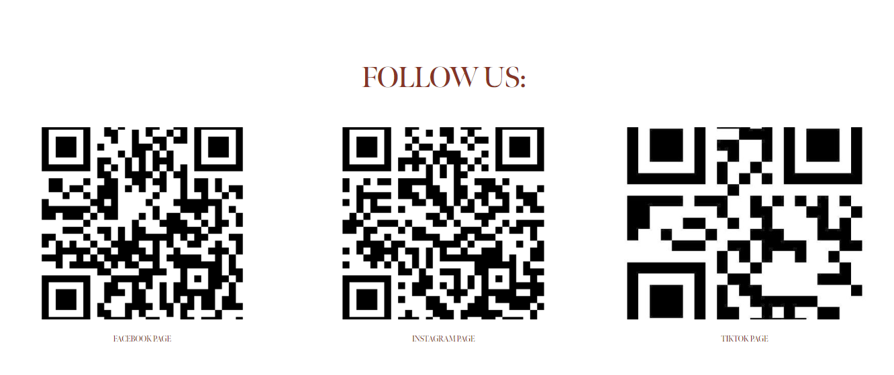


Conclusion

Artifact 1, which is a mind map, contains the most important steps in realizing the plan, and artifact 2, which is a blog, contains all the necessary information about the project. Through the blog, I can reach the audience, I can hear their opinion and ideas and spread information. The goal of this project is to raise awareness, but there is something more important - to learn how to properly provide person-centred care, how to make their daily life easier, how to support families, and respecting values – human rights, dignity, non-discrimination, access and equity, participation, and empowerment (WHO, 2013).

References

Benington, J. and Moore, M. (2010). Public Value: Theory and Practice. [online] Google Books. Bloomsbury Publishing. Available at: https://books.google.co.uk/books?hl=en&lr=&id=2ZhGEAAAQBAJ&oi=fnd&pg=PR2&dq=public+value+theory+practice&ots=_qdV7B5Yeb&sig=GWwSHdj1yoo1phrbJ3dhUXHtZXY#v=onepage&q=public%20value%20theory%20practice&f=false (Accessed 17/07/2022)
Gaze, C., Kepley, H.O. and Walkup, J.T. (2006). Co-occurring Psychiatric Disorders in Children and Adolescents with Tourette Syndrome. Journal of Child Neurology, 21(8), pp.657–664. doi:10.1177/08830738060210081301. (Accessed 15/07/2022)
Mayo Clinic (2018). Tourette syndrome - Symptoms and causes. [online] Mayo Clinic. Available at: https://www.mayoclinic.org/diseases-conditions/tourette-syndrome/symptoms-causes/syc-20350465. (Accessed 17/07/2022)
National Institute of Neurological Disorders and Stroke (2021). Tourette Syndrome Fact Sheet | National Institute of Neurological Disorders and Stroke. [online] Available at: https://www.ninds.nih.gov/health-information/patient-caregiver-education/fact-sheets/tourette-syndrome-fact-sheet. (Accessed 15/07/2022)
NHS (2015). Values of the NHS Constitution. [online] Health Careers. Available at: https://www.healthcareers.nhs.uk/working-health/working-nhs/nhs-constitution. (Accessed 15/07/2022)
NHS (2019). Tourette’s syndrome. [online] NHS. Available at: https://www.nhs.uk/conditions/tourettes-syndrome/. (Accessed 15/07/2022)
Pietro, S. (2016). Quick Facts on Tourette’s Disorder. [online] Child Mind Institute. Available at: https://childmind.org/article/quick-facts-on-tourettes-disorder/. (Accessed 15/07/2022)
Stern, J.S. (2005). Gilles de la Tourette’s syndrome and its impact in the UK. Postgraduate Medical Journal, 81(951), pp.12–19. doi:10.1136/pgmj.2004.023614. (Accessed 15/07/2022)
Storm (2019). Tourette’s Action. [online] Tourettes-action.org.uk. Available at: https://www.tourettes-action.org.uk/. (Accessed 15/07/2022)
Tourette Association of America (2016). Debunking Myths and Misconceptions - Tourette Association of America. [online] Tourette Association of America. Available at: https://tourette.org/debunking-myths-misconceptions/. (Accessed 15/07/2022)
World Health Organization (2013). People-centred health care: a policy framework. [online] www.who.int. Available at: https://www.who.int/publications/i/item/9789290613176. (Accessed 17/07/2022)

