Module Code: BMIH6007
Title: International Meetings

Topic: Management for the Hotel Industry

UK Chef Disability within MICE

Lecturer: Chris Wilkin
Student ID:2222623
Student Name: Zakaria Chowdhury

AI Declaration
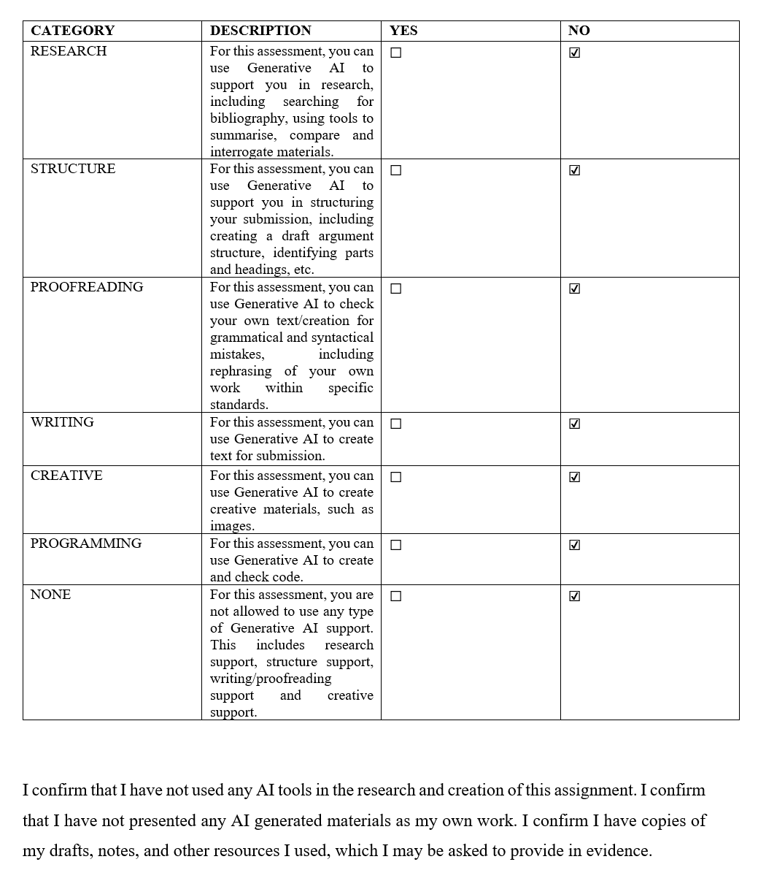

Contents
AI Declaration 2
Introduction 4
Event Content and Context (Background to the Event) 5
Market Factors 6
Market Factors (Cont….) 7
Operational Factors (Venue Availability and Suitability) 8
Operational Factors (Staffing Requirements and Resource Allocation) 9
Financial Factors 10
Financial Factors (Funding Sources and Revenue Strategy) 11
Conclusion and Recommendations 12
References 13

Introduction
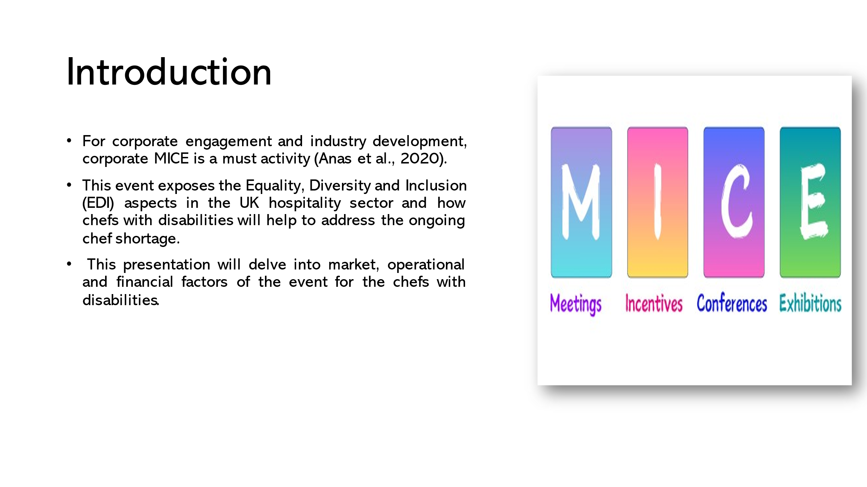

- For corporate engagement and industry development, corporate MICE is a must activity (Anas et al., 2020).
- This event exposes the Equality, Diversity and Inclusion (EDI) aspects in the UK hospitality sector and how chefs with disabilities will help to address the ongoing chef shortage.
- This presentation will delve into market, operational and financial factors of the event for the chefs with disabilities.

Event Content and Context (Background to the Event)
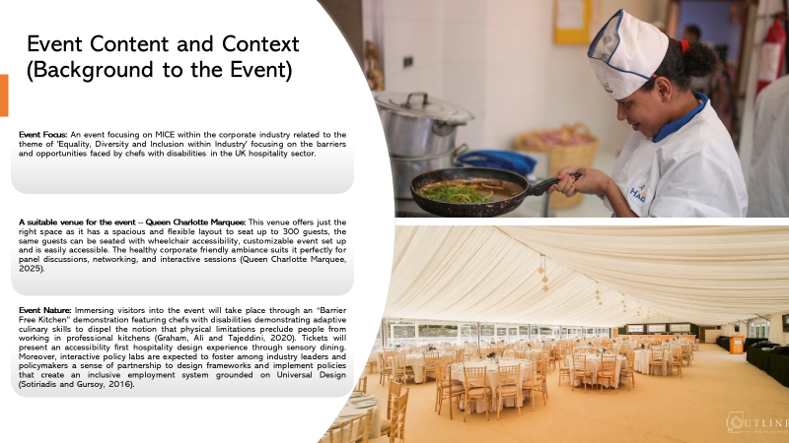

Event Focus: An event focusing on MICE within the corporate industry related to the theme of 'Equality, Diversity and Inclusion within Industry' focusing on the barriers and opportunities faced by chefs with disabilities in the UK hospitality sector.
A suitable venue for the event – Queen Charlotte Marquee: This venue offers just the right space as it has a spacious and flexible layout to seat up to 300 guests, the same guests can be seated with wheelchair accessibility, customizable event set up and is easily accessible. The healthy corporate friendly ambiance suits it perfectly for panel discussions, networking, and interactive sessions (Queen Charlotte Marquee, 2025).
Event Nature: Immersing visitors into the event will take place through an “Barrier Free Kitchen” demonstration featuring chefs with disabilities demonstrating adaptive culinary skills to dispel the notion that physical limitations preclude people from working in professional kitchens (Graham, Ali and Tajeddini, 2020). Tickets will present an accessibility first hospitality design experience through sensory dining. Moreover, interactive policy labs are expected to foster among industry leaders and policymakers a sense of partnership to design frameworks and implement policies that create an inclusive employment system grounded on Universal Design (Sotiriadis and Gursoy, 2016).

Market Factors
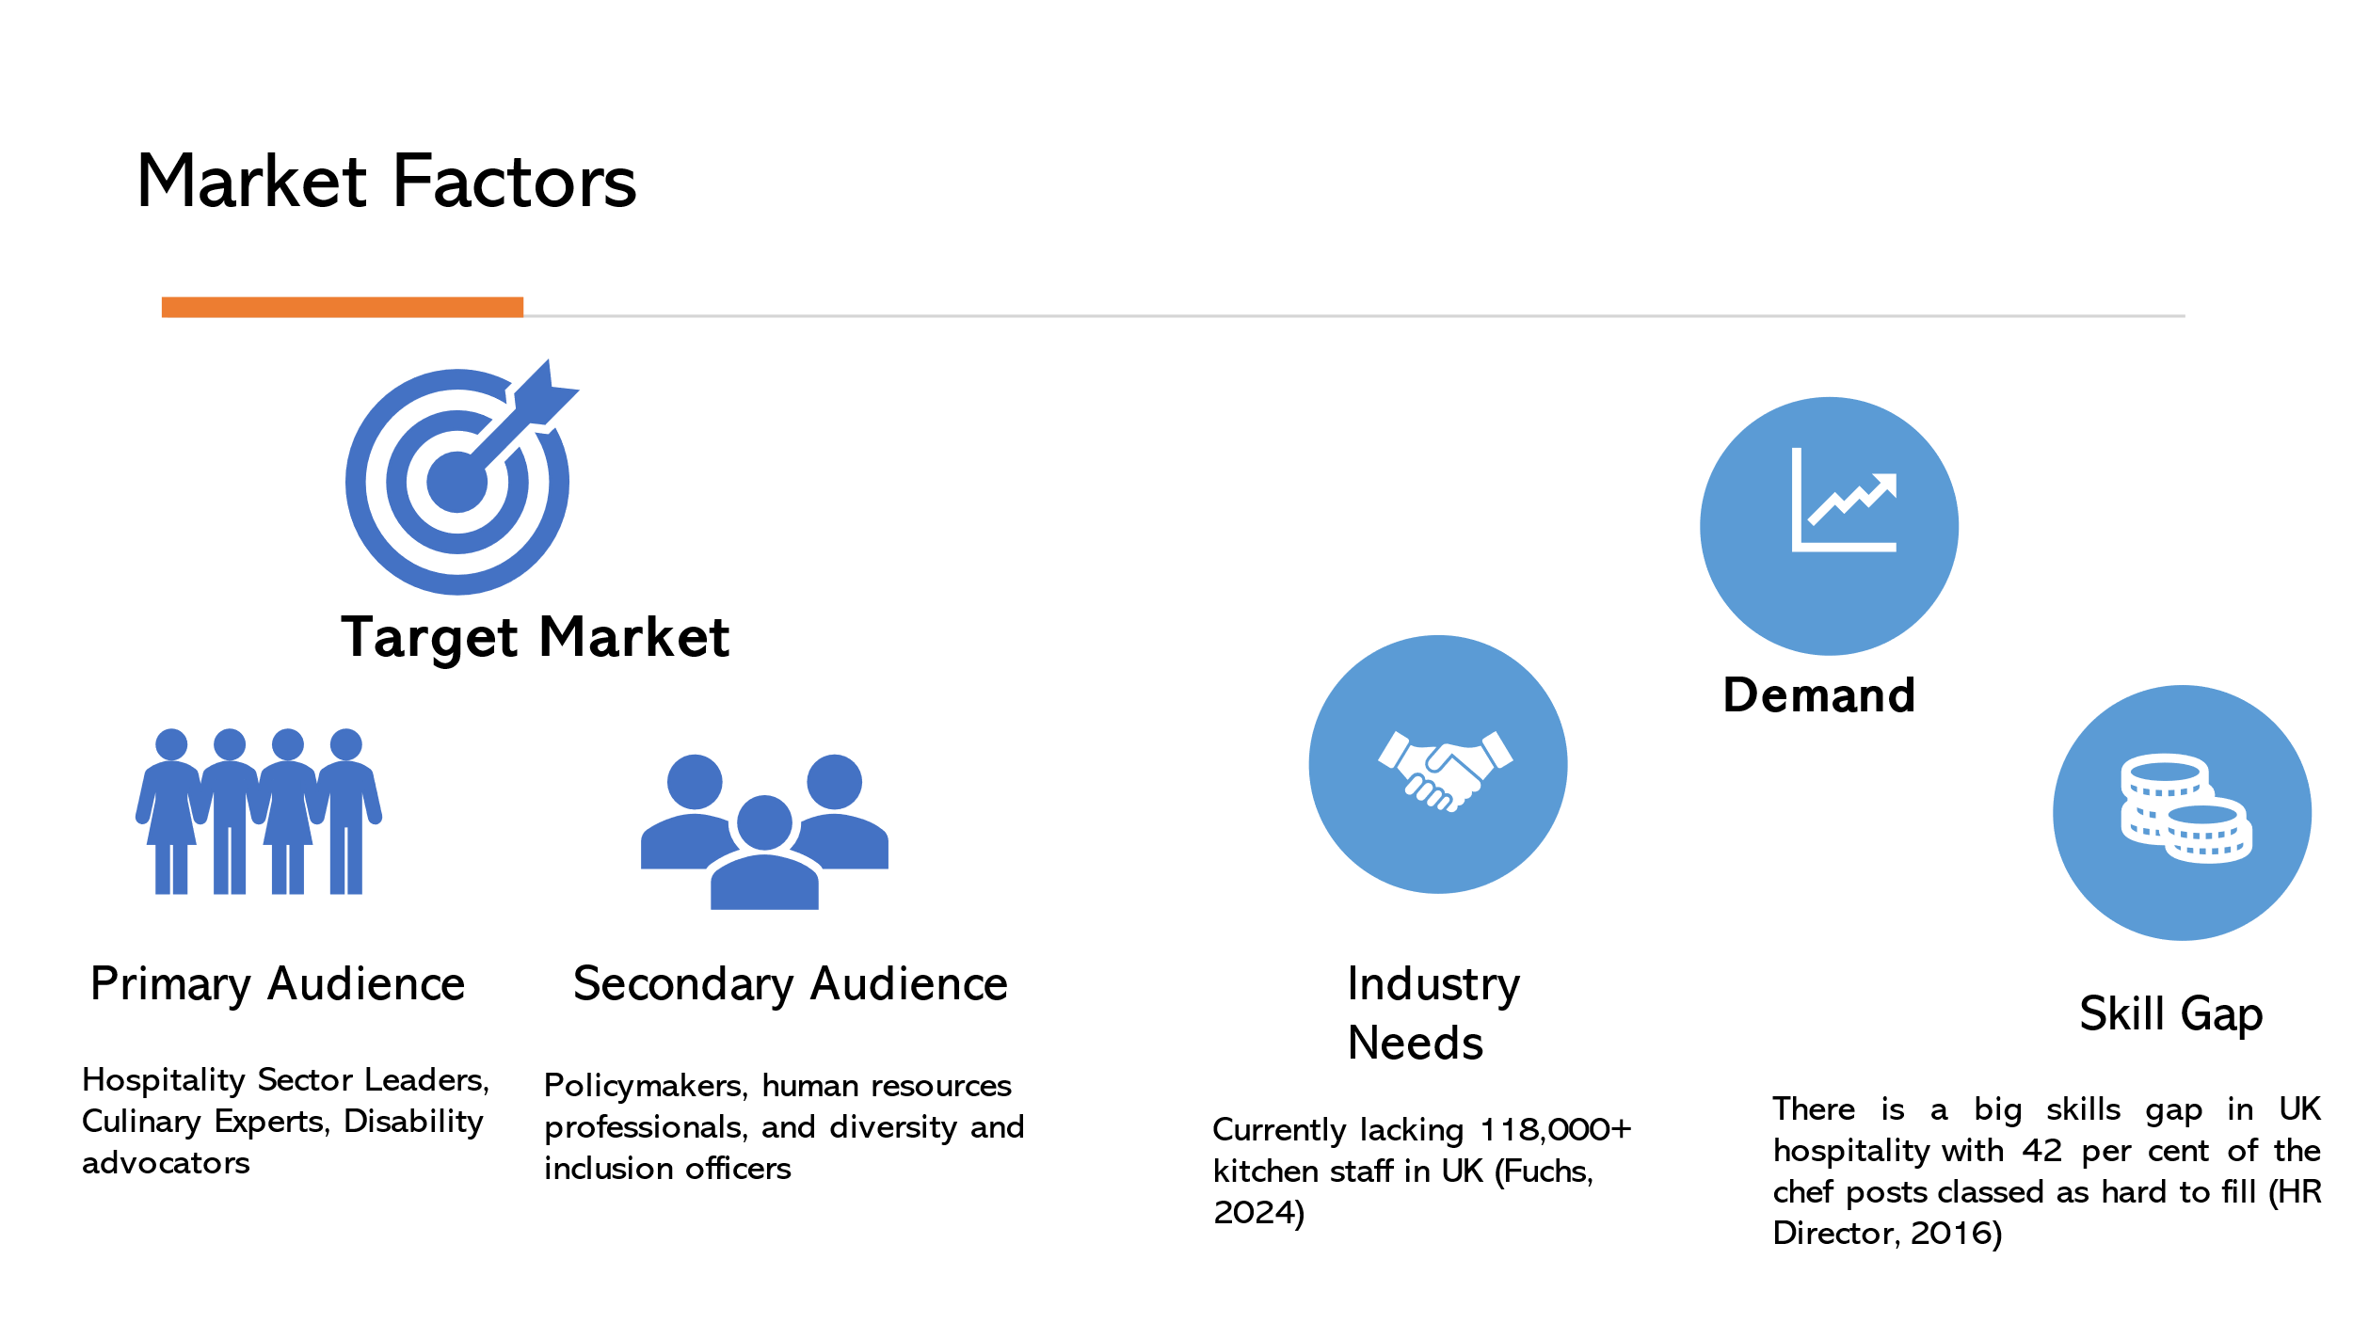

Target Market
Primary Audience: Hospitality Sector Leaders, Culinary Experts, Disability advocators
Secondary Audience: Policymakers, human resources professionals, and diversity and inclusion officers
Industry Needs: Currently lacking 118,000+ kitchen staff in UK (Fuchs, 2024)
Skill Gap: There is a big skills gap in UK hospitality with 42 per cent of the chef posts classed as hard to fill (HR Director, 2016)

Market Factors (Cont….)
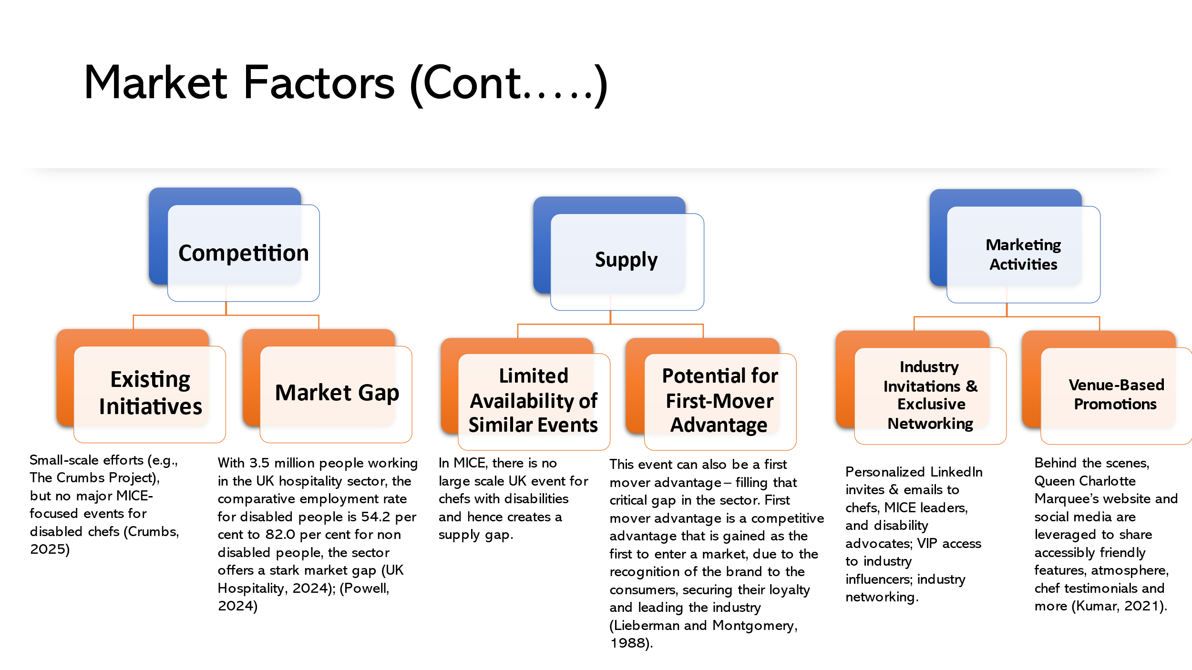
Competition
Existing Initiatives: Small-scale efforts (e.g., The Crumbs Project), but no major MICE-focused events for disabled chefs (Crumbs, 2025)
Market Gap: With 3.5 million people working in the UK hospitality sector, the comparative employment rate for disabled people is 54.2 per cent to 82.0 per cent for non disabled people, the sector offers a stark market gap (UK Hospitality, 2024); (Powell, 2024)
Supply:
Limited Availability of Similar Events: In MICE, there is no large scale UK event for chefs with disabilities and hence creates a supply gap.
Potential for First Mover Advantage: This event can also be a first mover advantage – filling that critical gap in the sector. First mover advantage is a competitive advantage that is gained as the first to enter a market, due to the recognition of the brand to the consumers, securing their loyalty and leading the industry (Lieberman and Montgomery, 1988).

Marketing Activities:
Industry Invitations and Exclusive Networking: Personalized LinkedIn invites & emails to chefs, MICE leaders, and disability advocates; VIP access to industry influencers; industry networking.
Venue Based Promotions: Behind the scenes, Queen Charlotte Marquee’s website and social media are leveraged to share accessibly friendly features, atmosphere, chef testimonials and more (Kumar, 2021).

Operational Factors (Venue Availability and Suitability)
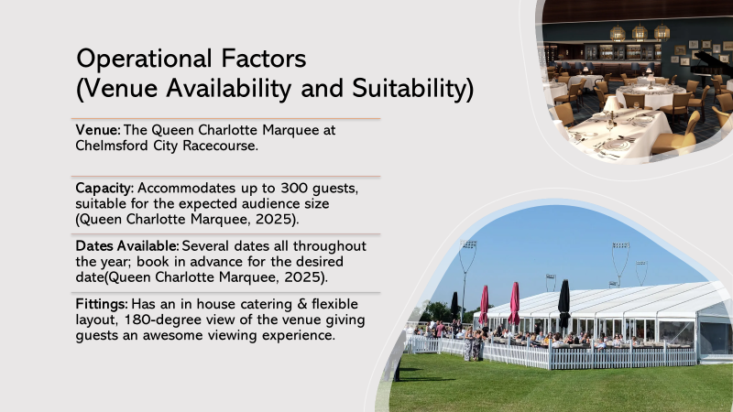
- Venue: The Queen Charlotte Marquee at Chelmsford City Racecourse.
- Capacity: Accommodates up to 300 guests, suitable for the expected audience size (Queen Charlotte Marquee, 2025).
- Dates Available: Several dates all throughout the year; book in advance for the desired date(Queen Charlotte Marquee, 2025).
- Fittings: Has an in house catering & flexible layout, 180-degree view of the venue giving guests an awesome viewing experience.

Operational Factors (Staffing Requirements and Resource Allocation)
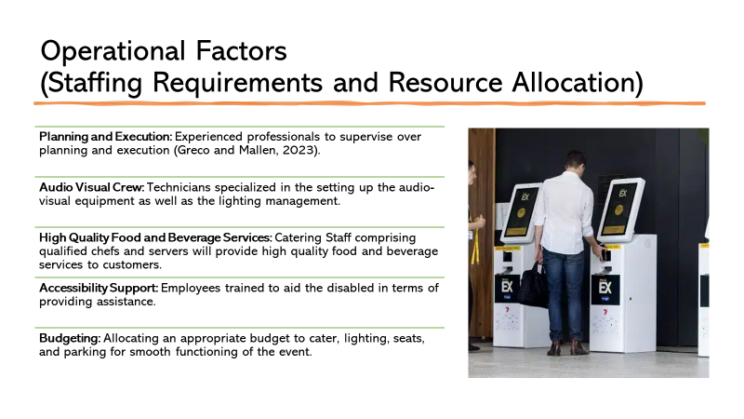
- Planning and Execution: Experienced professionals to supervise over planning and execution (Greco and Mallen, 2023).
- Audio Visual Crew: Technicians specialized in the setting up the audio-visual equipment as well as the lighting management.
- High Quality Food and Beverage Services: Catering Staff comprising qualified chefs and servers will provide high quality food and beverage services to customers.
- Accessibility Support: Employees trained to aid the disabled in terms of providing assistance.
- Budgeting: Allocating an appropriate budget to cater, lighting, seats, and parking for smooth functioning of the event.

Financial Factors
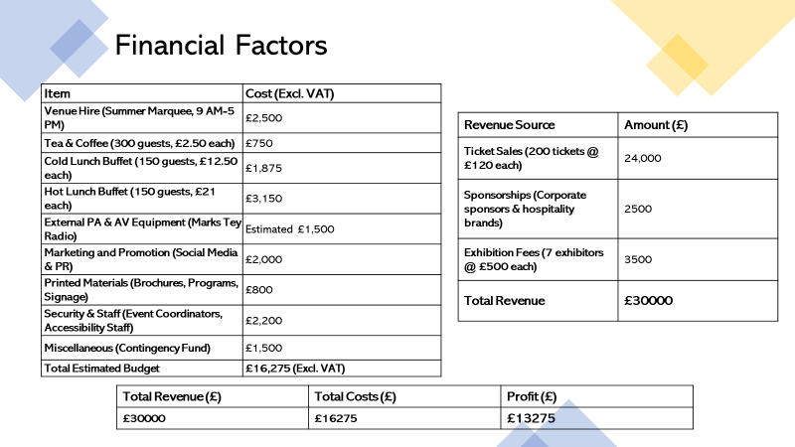

Item | Cost (Excl. VAT)
Venue Hire (Summer Marquee, 9 AM-5 PM) | £2,500
Tea & Coffee (300 guests, £2.50 each) | £750
Cold Lunch Buffet (150 guests, £12.50 each) | £1,875
Hot Lunch Buffet (150 guests, £21 each) | £3,150
External PA & AV Equipment (Marks Tey Radio) | Estimated £1,500
Marketing and Promotion (Social Media & PR) | £2,000
Printed Materials (Brochures, Programs, Signage) | £800
Security & Staff (Event Coordinators, Accessibility Staff) | £2,200
Miscellaneous (Contingency Fund) | £1,500
Total Estimated Budget | £16,275 (Excl. VAT)

Revenue Source | Amount (£)
Ticket Sales (200 tickets @ £120 each) | 24,000
Sponsorships (Corporate sponsors & hospitality brands) | 2500
Exhibition Fees (7 exhibitors @ £500 each) | 3500
Total Revenue | £30000

Total Revenue (£) | Total Costs (£) | Profit (£)
£30000 | £16275 | £13275

Financial Factors (Funding Sources and Revenue Strategy)
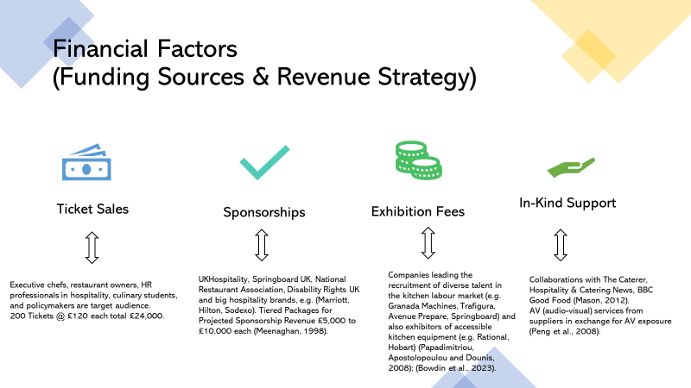
- Executive chefs, restaurant owners, HR professionals in hospitality, culinary students, and policymakers are target audience. 200 Tickets @ £120 each total £24,000.
UKHospitality, Springboard UK, National Restaurant Association, Disability Rights UK and big hospitality brands, e.g. (Marriott, Hilton, Sodexo). Tiered Packages for Projected Sponsorship Revenue £5,000 to £10,000 each (Meenaghan, 1998).
- Companies leading the recruitment of diverse talent in the kitchen labour market (e.g. Granada Machines, Trafigura, Avenue Prepare, Springboard) and also exhibitors of accessible kitchen equipment (e.g. Rational, Hobart) (Papadimitriou, Apostolopoulou and Dounis, 2008); (Bowdin et al., 2023).
- Collaborations with The Caterer, Hospitality & Catering News, BBC Good Food (Mason, 2012).
- AV (audio-visual) services from suppliers in exchange for AV exposure (Peng et al., 2008).

Conclusion and Recommendations
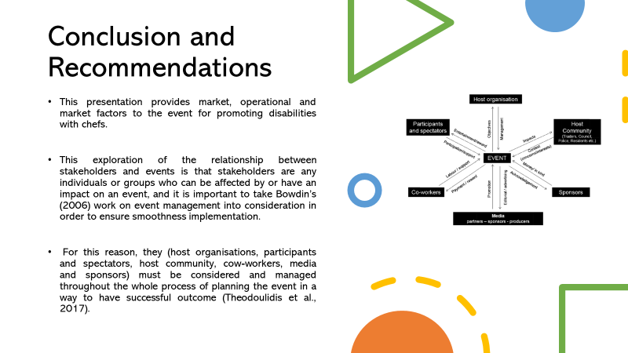

- This presentation provides market, operational and market factors to the event for promoting disabilities with chefs.
- This exploration of the relationship between stakeholders and events is that stakeholders are any individuals or groups who can be affected by or have an impact on an event, and it is important to take Bowdin’s (2006) work on event management into consideration in order to ensure smoothness implementation.
- For this reason, they (host organisations, participants and spectators, host community, cow-workers, media and sponsors) must be considered and managed throughout the whole process of planning the event in a way to have successful outcome (Theodoulidis et al., 2017).

References


