
Module | Complementary Therapy Assessment 1
Module Code | BMHP5001
Tutor | Joanna Walsh
Student | Nordia Patrice Baker
Student Number | 1813361

Content
Introduction
History of Reflexology
Use of Reflexology
Effectiveness of Reflexology
Is reflexology safe?
Comparison of Reflexology to Allopathic medicine
Statutory and Regulatory bodies
Conclusion
Slides from presentation
Reference

Introduction
I will give a timeline history of reflexology and its origins. Who used it and how it is still used today and its many uses. How effective it is as a treatment when compared to allopathic or more conventional medicine.
History of Reflexology
It is supposed that reflexology has been about since the times of the Egyptians. It also consigned with the times of the Chinese use in 2330 BC. Proof of this is the pictures that show the use of reflexology that is still present in the tomb of Ankmahor. It has also been said that the North American Indians also practised a type of foot therapy for hundreds of years. Reflexology has since been used and rebranded by different physicians, but the aims are still the same to relieve or cure pain and disease.
The chapter examining foot method written around 1000 BC bye the yellow emperor's classic of internal medicine was the start of the discussion in print about the connexion of life force and points and areas on the feet. It is alleged that Marco Polo translated A Chinese massage book into Italian in the 1300s. It Is said to be the introduction of massage and reflexology to Europe. A book called zone therapy was published in 1952, by Dr Adamus & Dr A’tatis. In 1917 William H. Fitzgerald MD wrote a book about the ten vertical zones that extended the body (Taking Charge of Your Health & Wellbeing. 2016). It linked the area of injury to the application of pressure and was said to help as pain relief when having minor surgery. Around this time he was hailed as the father of reflexology. Sometime after Dr Shelby Riley Expands upon Fitzgerald's theory by developing the mapping of the horizontal zones across the body. Eunice Ingham a physiotherapist who is another figure worked for doctor Shelby Riley; she researched zone therapy ‘s pressure points She is credited with finding that Feet were one of the most sensitive and responsive parts of the body. Eunice Ingham developed the Maps, and reflexology charts for foot therapy and these are still in use today she was also credited for introducing reflexology to the non-medical community in the 1930s. Reflexology is now a widely used theory with thousands of people using it every year.

Uses of Reflexology
Reflexology has many uses, and it can help with relaxation, brain function, nerves function as well as many other things. The reflexologist will apply pressure to the feet, head or ear. The right foot corresponds to the right half of your body, and the left foot corresponds to the left half of the body. A reflexologist will try to perform a healing response in the body, by touching various points which correspond to organs.
The application of pressure can also influence the body positively and allows it to ​
function at its best and allowing extra oxygen and nutrients to cells and enhances ​
waste removal. ​It can also improve symptoms, induce relaxation, reduce pain and lower blood pressure and help with anxiety
Reflexology can boost many of the body's internal systems, for example, the circulatory, respiratory and many more.

Advantages of Reflexology
There are many rewards when using reflexology, and when used correctly, it can improve or reduce symptoms from different ailments. Listed belong are the pros of using reflexology.
- By stimulating various pressure points, you can improve circulation and energy in the body.
- Relieves the effect of nausea, depression and other mental health disorders.
- Can relieve problems with the lung.
- Can help to relieve or alleviate stress.
- It is known to alleviate back neck shoulder and headache pain etc.
- It can help to remove cravings and balances appetite.
- It can improve skin problems and improve skin tone.
- It can reduce menstrual problems in women.
- It can also give the body relaxation.
Is reflexology safe?
There are known limitations when using reflexology, it can be harmful and may not heal the following conditions:
- Unfortunately, not enough research has been done to prove that reflexology can treat all symptoms of cancer.
- When pressure is applied to the feet, hand, head, etc. at the wrong point, it can cause an adverse reaction and make the problem worse.
- If you are pregnant, you should let your reflexologists know beforehand as pressing the wrong points can induce contractions and lead to premature Labour.
- It can reduce the problem for a short time but make them worse later.
- The person performing reflexology should be qualified when delivering a service like reflexology. As most complementary therapies are not Registered, regulated or monitored.
As indicated by (Taking Charge of Your Health & Wellbeing. 2016), there are a few contraindications when using reflexology examples are given. Foot injury, blood clotting and open wounds they would advise not to use this therapy as it can lead to the movement of blood clots, bones being move from correct positioning and healing process will be disrupted.
When looking for the services reflexologist, you must bear in mind that not all are professionals qualified. You should also seek professional advice from a General practitioner as the sickness or disease you have may be too advanced for the complementary therapy you are trying.
Comparison of Reflexology to Allopathic Medicine.
What I have found when I have looked into the research comparing reflexology to conventional medicine is it varies. The study has shown that reflexology is good at treating many illnesses and diseases and can have a long-lasting effect. Unfortunately, in some cases, for example, cancer depends on the stages the person is in as to whether it will work. Reflexology helps to relax the body and mind and doesn't require any other ingestible drugs. The effect of touch on pressure points can be enough to sort out a child with constipation or an adult with a digestive issue, unlike conventional methods where you would need to have a course of medication or use medication as the problem presents itself.

Statutory and Regulatory bodies
Many Regulatory bodies govern The complementary therapies. Unfortunately, you do not have to be regulated to perform many complementary therapies or even have qualifications. The regulatory agencies that are available for complementary therapies reflexology are:
- Association of Physical & Natural Therapists (APNT) (Reflexology | CNHC, 2020).
- Association of Reflexologists (AoR) (Reflexology | CNHC, 2020).
- British Reflexology Association (BRA) (Reflexology | CNHC, 2020).
- Complementary Health Professionals (CHP) (Reflexology | CNHC, 2020).
- Complementary Therapists' Association (CThA) (Reflexology | CNHC, 2020).
These bodies provide accredited specialist in reflexology who are registered and show the public they are capable of doing their job. These bodies ensure all therapist who is registered to them are regulated by having Standardised practise, for example, the education they received to be awarded a certificate for training, privacy and confidentiality for the client. They are also here to protect the public from harm as well as support the therapist.

Conclusion
Reflexology is a cost-effective treatment which has a good effect on the body. When used correctly administered, it has many benefits; for example, it can help relieve stress and improve body function. However, there are reasons not to use reflexology, and there is still much research that needs to be done and trailed on the effectiveness when used on cancer.

Slides from presentation

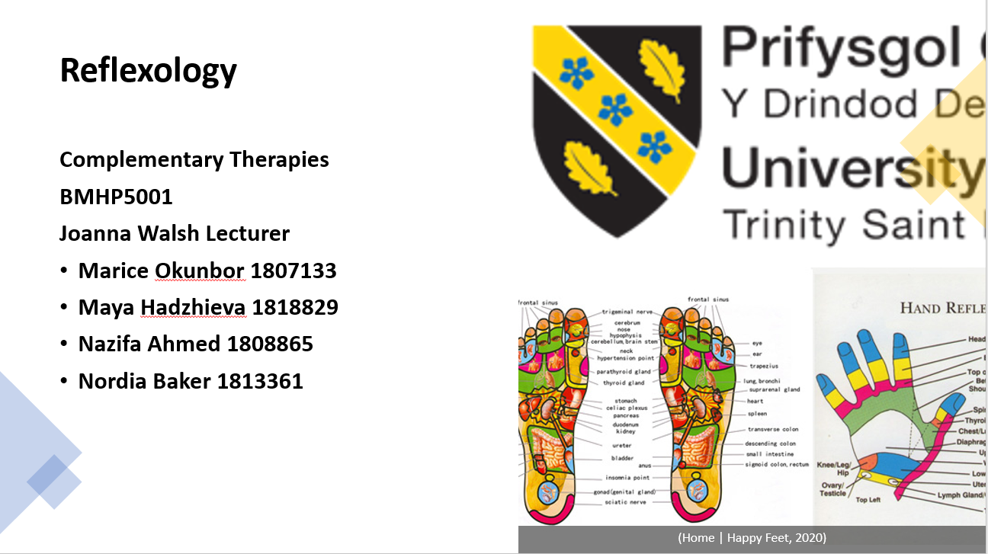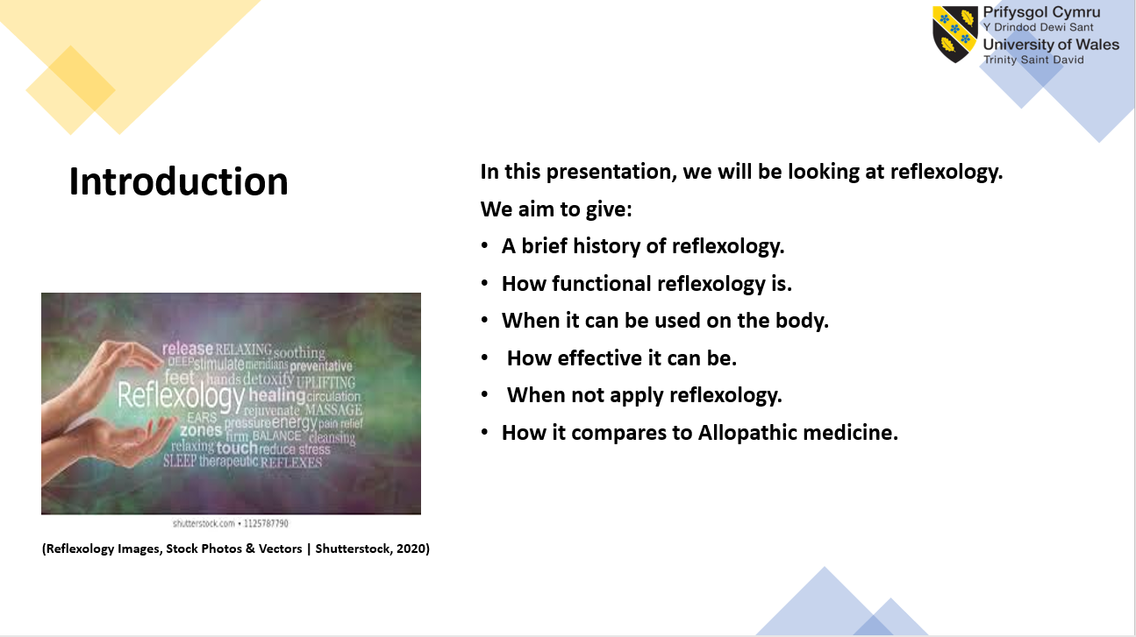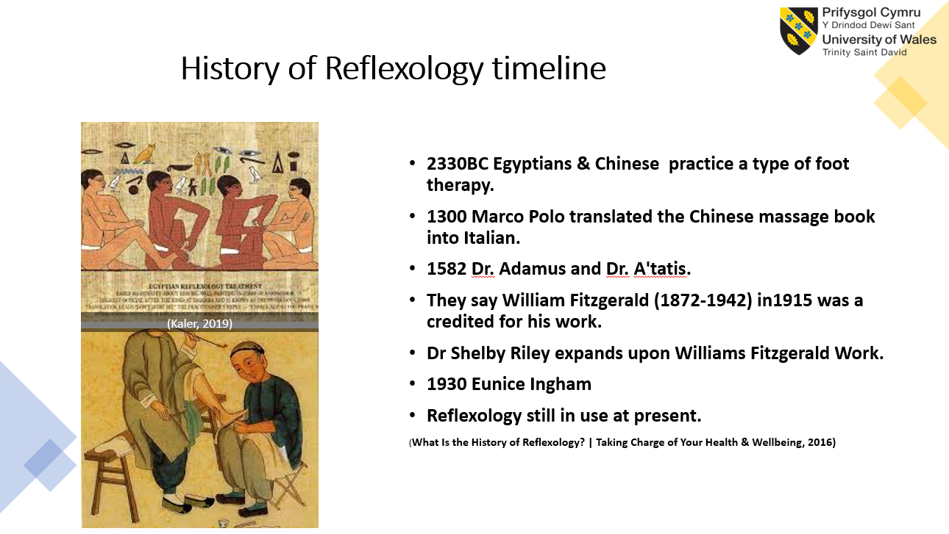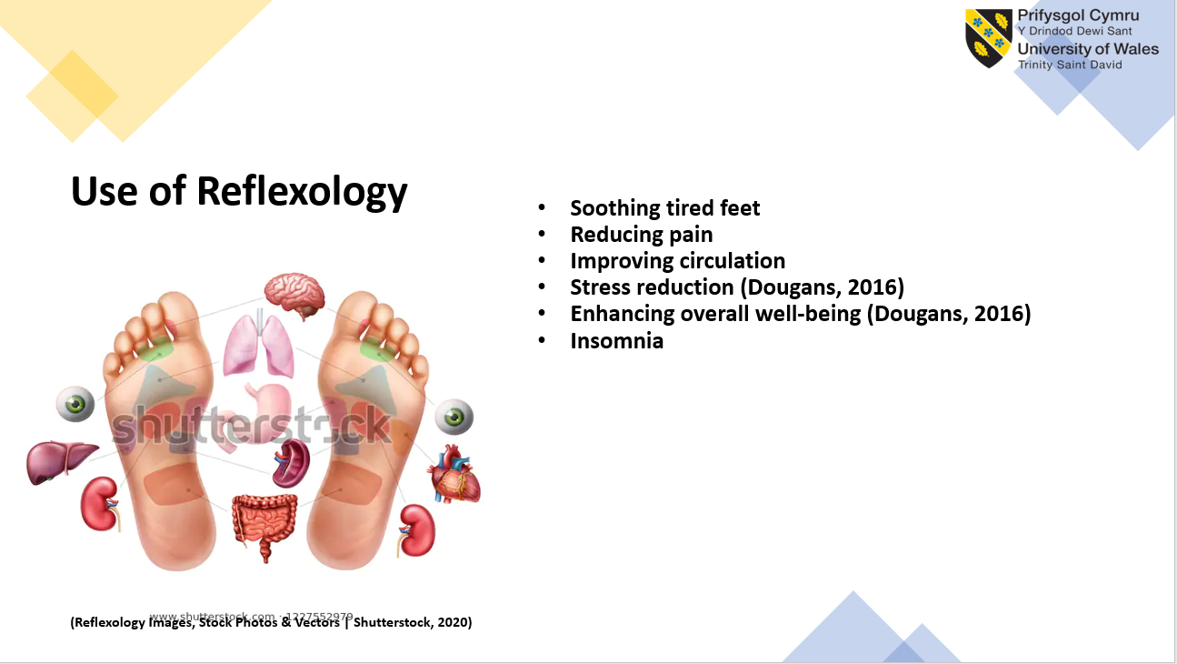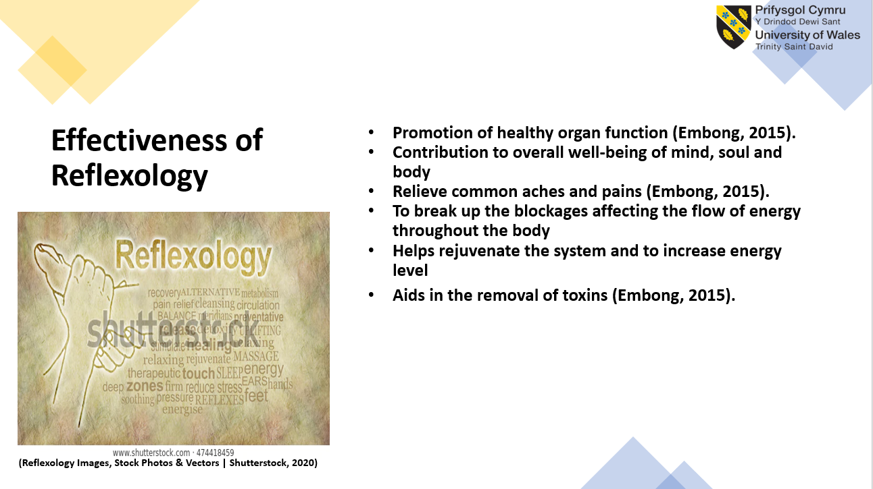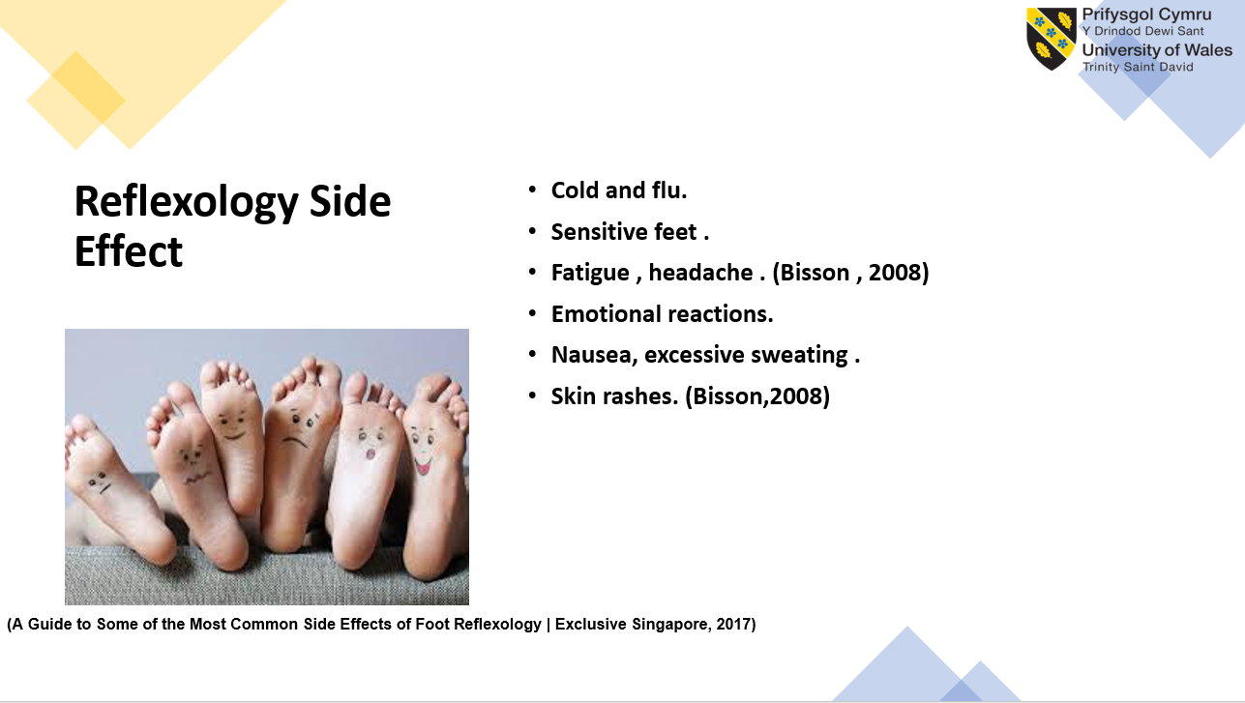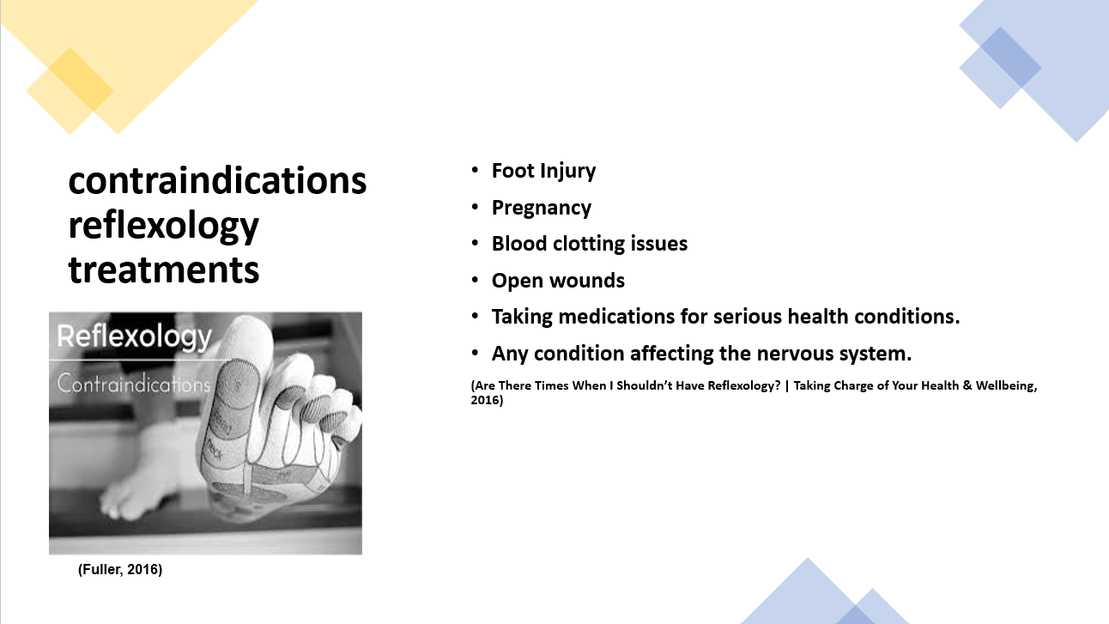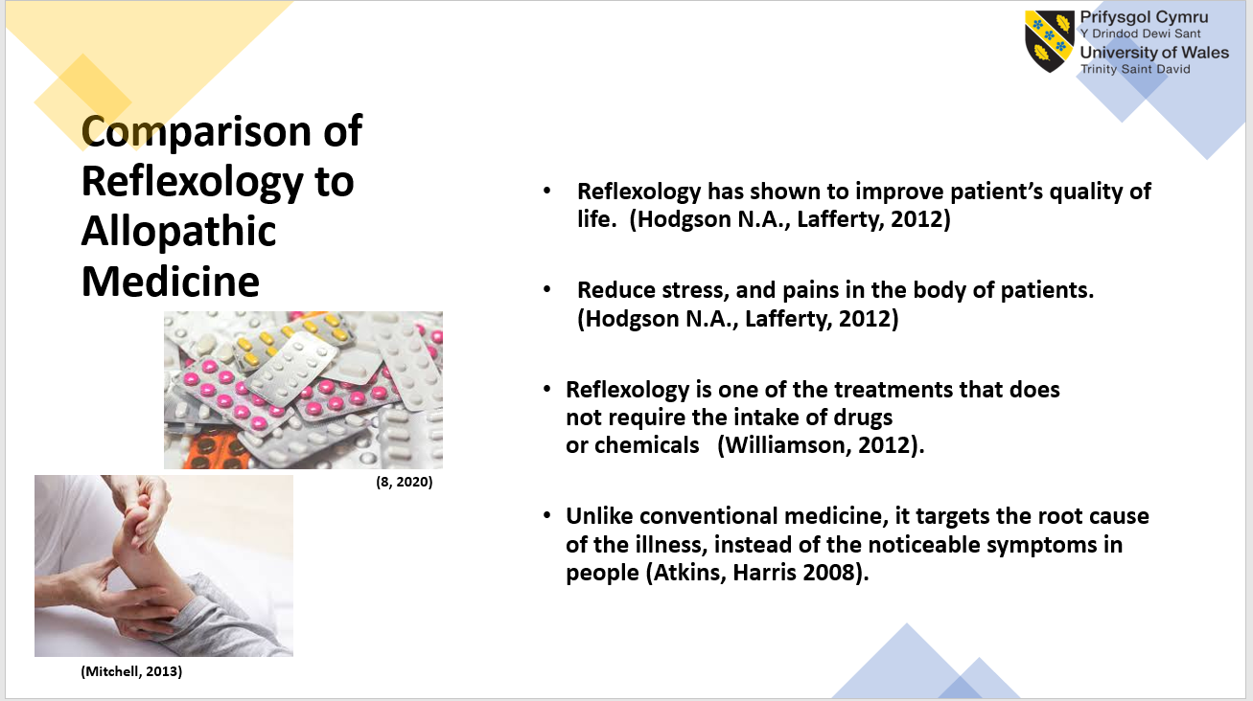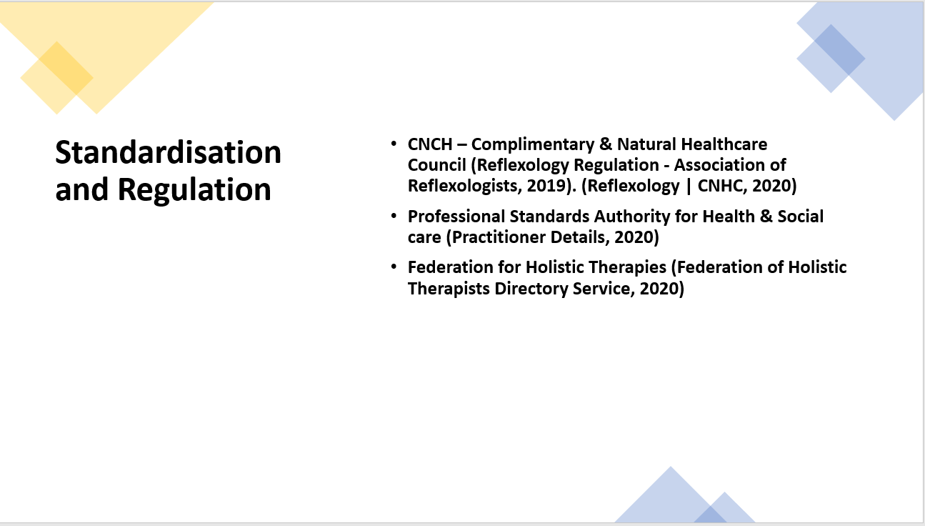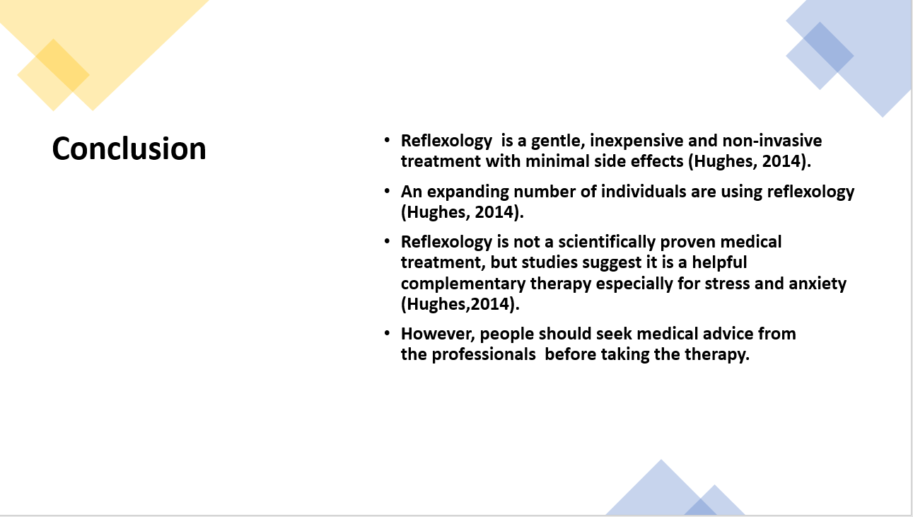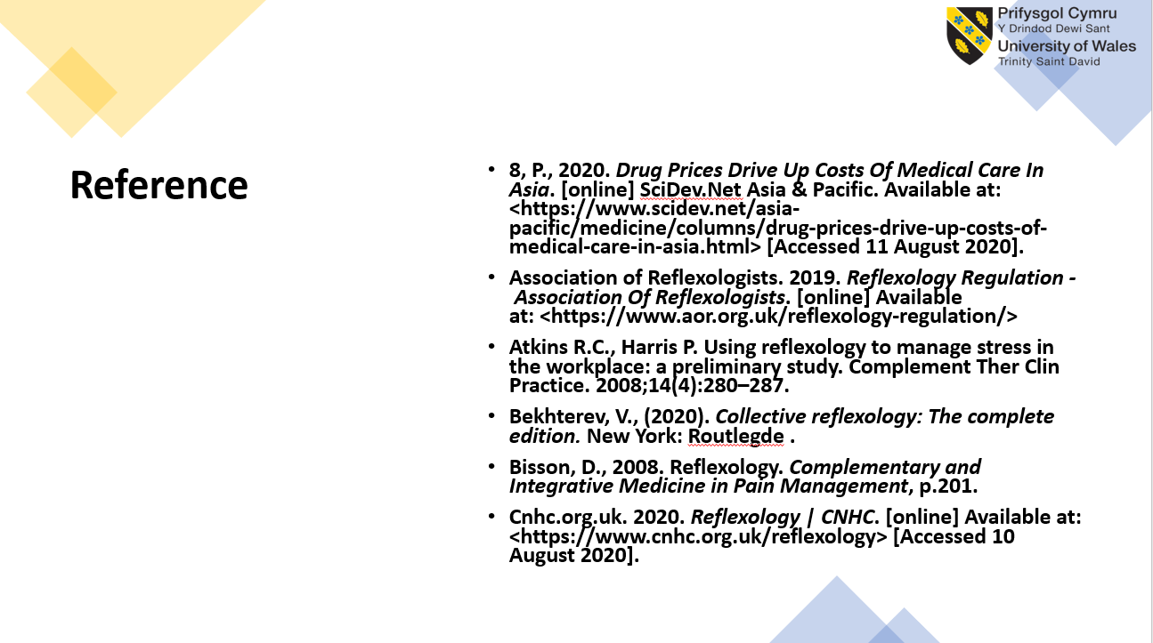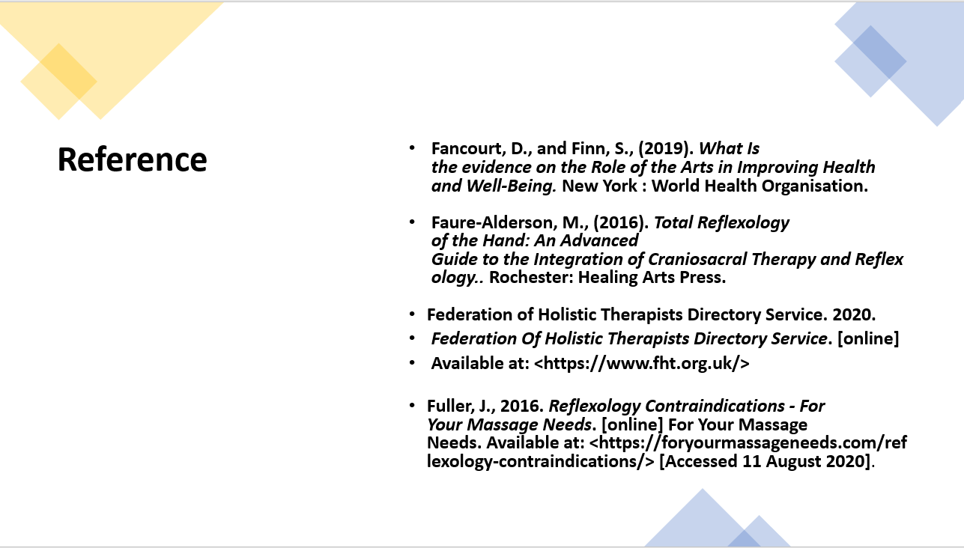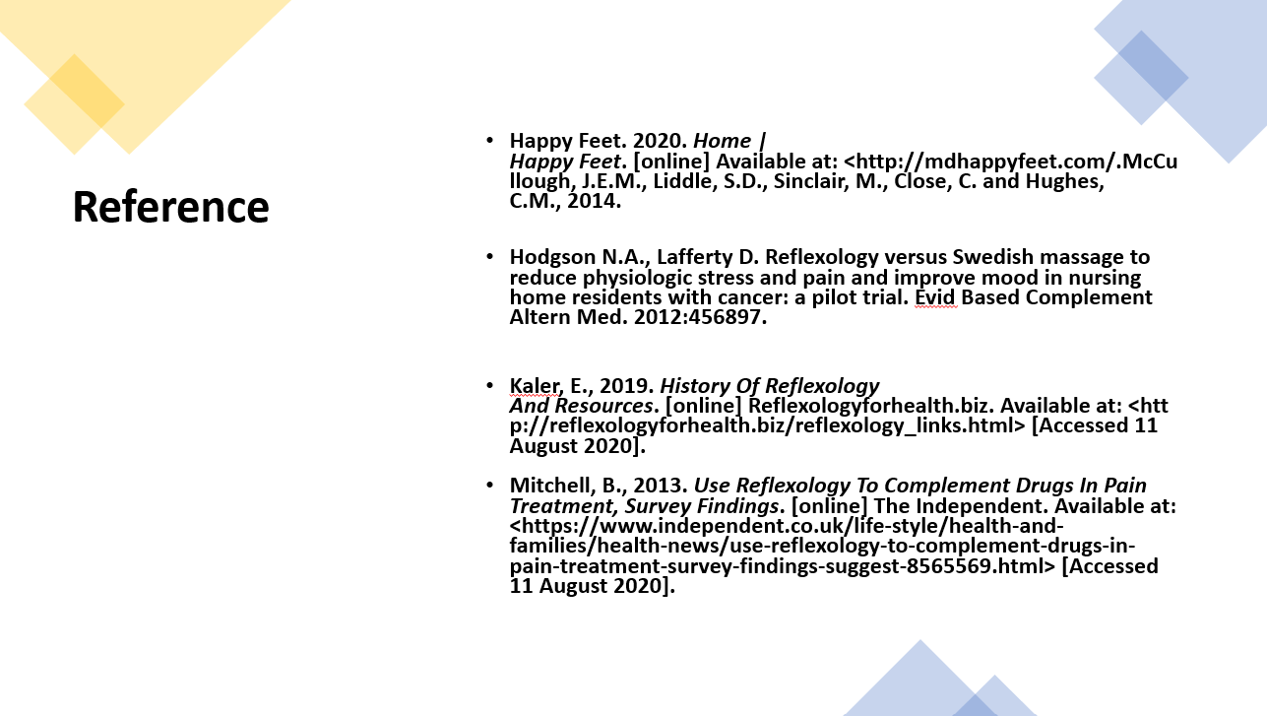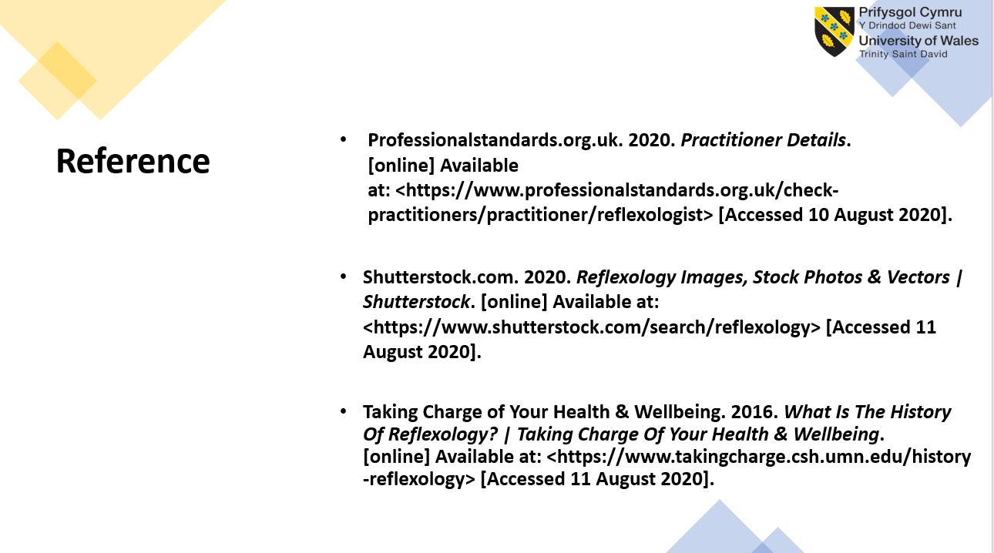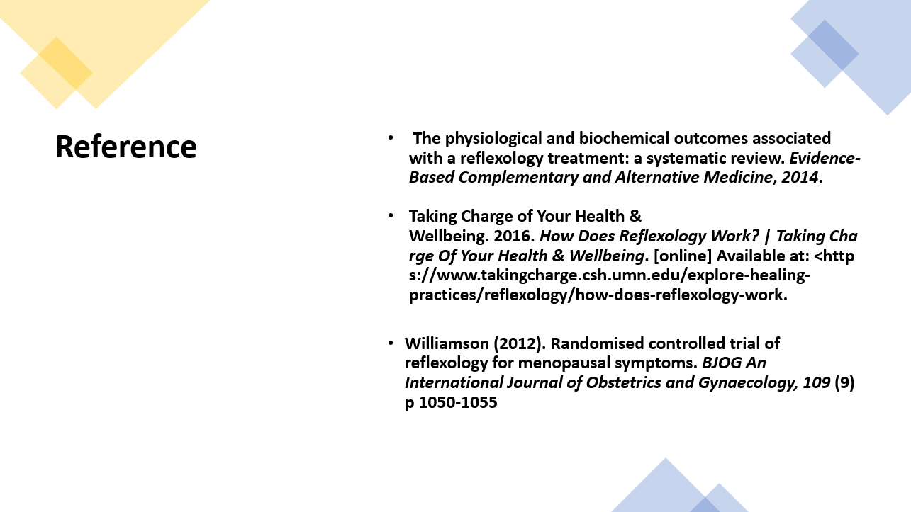

Reference
Barot, M., 2019. Reflexology: Benefits And Limitations By Mayur Barot | Knoxville Reflexology Group, Inc. [online] Knoxvillereflexology.com. Available at: <https://knoxvillereflexology.com/reflexology-benefits-and-limitations-by-mayur-barot/> [Accessed 31 July 2020].
BMCA, B., 2017. [online] Bcma.co.uk. Available at: <https://www.bcma.co.uk/> [Accessed 30 July 2020].
Federation of Holistic Therapists Directory Service. 2020.
Federation Of Holistic Therapists Directory Service. [online]
Available at: <https://www.fht.org.uk/>
Cnhc.org.uk. 2020. Reflexology | CNHC. [online] Available at: <https://www.cnhc.org.uk/reflexology> [Accessed 10 August 2020].
Teagarden, K., 2016. What Is The History Of Reflexology? | Taking Charge Of Your Health & Wellbeing. [online] Taking Charge of Your Health & Wellbeing. Available at: <https://www.takingcharge.csh.umn.edu/history-reflexology#:~:text=However%2C%20reflexology%20is%20thought%20to,in%20India%20and%20later%20China.> [Accessed 31 July 2020].
Taking Charge of Your Health & Wellbeing. 2016. How Does Reflexology Work? | Taking Charge Of Your Health & Wellbeing. [online] Available at: <https://www.takingcharge.csh.umn.edu/explore-healing-practices/reflexology/how-does-reflexology-work.
Professionalstandards.org.uk. 2020. Practitioner Details. [online] Available at: <https://www.professionalstandards.org.uk/check-practitioners/practitioner/reflexologist.
Quinn, f., Hughes, c. and Baxter, g., 2007. Reflexology In The Management Of Low Back Pain: A Pilot Randomised Controlled Trial. [online] sciencedirect.com. Available at: <https://pdf.sciencedirectassets.com/272589/1-s2.0-S0965229908X00020/1-s2.0-S0965229907000623/main.pdf?X-Amz-Security-Token=IQoJb3JpZ2luX2VjEFAaCXVzLWVhc3QtMSJGMEQCIGgLfhKbGgsPF7W8QrLB%2FGMN6Ruy0%2BPu6Mru6j6qBaFoAiAxR9%2BRG62N1nGsbEKjc2rPbC02lWtPY1RE6yCl5HNvdCq0AwgZEAMaDDA1OTAwMzU0Njg2NSIMV8Nzb89RP8k5mlo2KpEDhITh6KErgHVlUWsYAKXZsAdmaSd25WJVXD3Qk%2F2xeCof10lD%2B5%2BPZzFkhhHWYrOc5dFRDJvEb2cnVPLHZbuntDk99%2FSd9TrP22CN2b1L3ftQkMNyyITND%2B2mEVCMSvhSOw%2BQk%2B8s4jxOP4mrnEGMAUtPiviERwAA%2FU03Tycz1BEz9ZrijxJU2C8MZ2Ejik%2BG1mqOmSpxIhH2%2FAqt9y7hf49ObLT%2FcuuFMi1tv1P5A0TUkZfXz%2BK6Prd972yJ8RiYnDMae%2BtIOlHtUjyIGAxd2TmdXr0VmTcetB6m8azGv%2Bd%2FbYBb9DOYMmmzCMNjIR%2B0LTcXDfJxF3%2BLlKQM4mULeplBzMBGsYQfX%2F50qKRla8v4Po5Yj92azVXE1WKciv4T28PJb%2BbIGFuQ5q6m9MQQujjGkMbDa3g%2BckmqicoTD0BwoPhkX%2BLeF7IogwDtJ8GH83I9qZbQIrsRlA2w1iF07N1LffECCeaesiu9S93Jhw8HdJqbkepZ3sXK7Sy7T76YzKk9XCYLXj%2BpVhadOFkS6doww7WG%2BQU67AFSDZ3fIdL84shCMSOt5rRihQIbkKZvWv3mrB8Y8jMq2x6UxkdEF02HvsbMIcJslK77xfvPvtYmCKeJOWi7WhpaGvCitxm8qsptWJx4Nb6nln14%2F%2FxQrxL21zCU8kc6N0GkE9oWAtQTzC7uWB2UHvSWj2IzZA7tESADpCzuhhSnmy%2FpRuhMIXzsRAzD%2FHLC0278OgwQAN1RehLFJpBb7HvVNEz%2BxD4srPUsxCI1es6i6ff8HBXGgOBQk%2BM6RZFm3nRzRlULZAL0uZiO9%2BhywKfC2IqNFbahROK0Wutx97dS3V9XP2S0TGKu%2BQ%2F5iw%3D%3D&X-Amz-Algorithm=AWS4-HMAC-SHA256&X-Amz-Date=20200729T173625Z&X-Amz-SignedHeaders=host&X-Amz-Expires=300&X-Amz-Credential=ASIAQ3PHCVTYTLFFG5OI%2F20200729%2Fus-east-1%2Fs3%2Faws4_request&X-Amz-Signature=e5da7428c87b7671c80aa5cdd99f69a75e01092fcef3b480ac703636b> [Accessed 29 July 2020].
Wong, C., 2019. Reflexology And How It Differs From Massage. [online] Verywell Health. Available at: <https://www.verywellhealth.com/reflexology-what-you-need-to-know-89995> [Accessed 29 July 2020].

