Marketing Fundamentals

Assessment 1 Blogging to communicate

Table of Contents
Introduction 3
Blog Posts 4
Getting to net-zero 4
Segmentation strategy 5
Targeting strategy 5
Positioning strategy 6
Product strategy 6
Placing strategy 7
Pricing strategy 8
Promotional strategy 8
Conclusion 10
References 11

Introduction
British Petroleum (BP) is a UK based multinational oil and Gas Company that was established by William Knox D’Arcy. It was founded in 1909 which headquarters is in London, UK. More than 70000 employee’s works with the business (BP, 2021). The main two products of the business include gas and oil. 2020 was a bad year for BP because the sales of the business reduces along with its net profit. The net loss of the business in 2020 was $20.73 billion (BP Annual Report 2020, 2021). Marketing is an important function that can help the business. Blogging will be used to communicate the segmentation, positioning, targeting and marketing mix strategies.

Blog Posts

Getting to net-zero
This project has been launched by BP in February 2020. The ambition of the business is to become a zero-carbon emitter by 2050 to help to build a better world (Getting to net-zero | Sustainability | Home, 2021). There are 10 aims that have been developed by the business to become a zero-carbon company and five aims have been developed to make sure that the world will be a better place. This project has been developed by the business by considering Paris goals. Bernard Looney the CEO of BP said that the rate of carbon emission in the atmosphere is increasing and if it has not to be stopped then it will create a huge problem for the world (BP, 2021). Big companies like BP must have to step forward to solve this type of problem because without that ensuring the world a better place will not be possible. To change the world we have to be changed and the task which we are doing has to be changed as well.
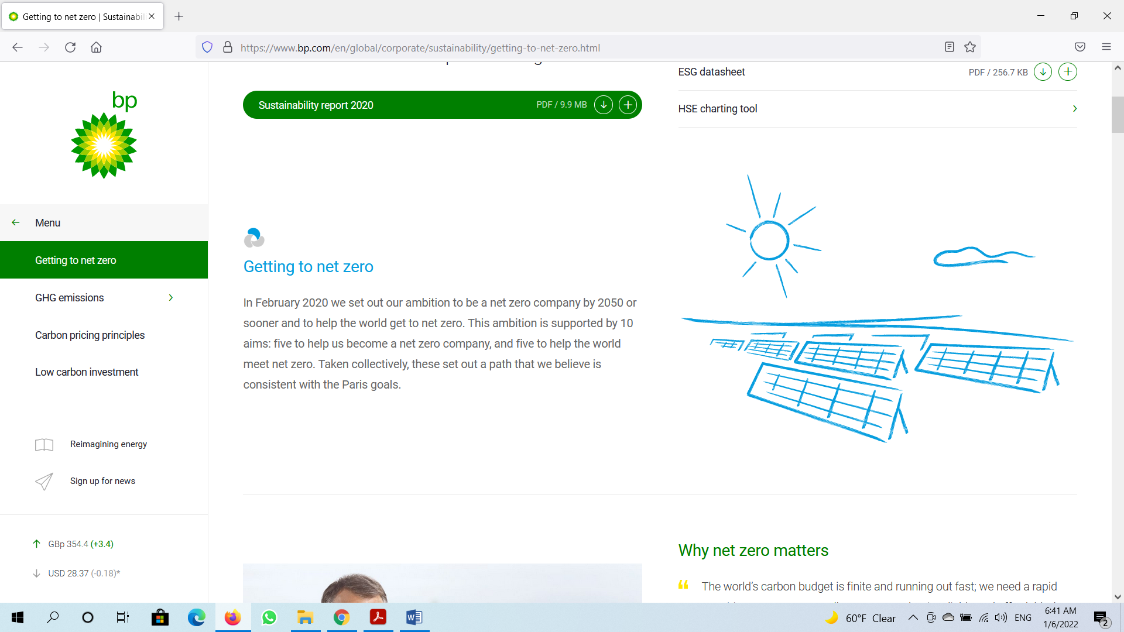
Figure: Getting to net-zero
Source: (Getting to net-zero | Sustainability | Home, 2021)
In BP, zero-carbon means achieving a balance between anthropogenic emissions and greenhouse gas removal which has been set in article 4.1 of the Paris agreement. The business will try to achieve zero carbon emission by 2050 and change in the climate condition is one of the most important reasons for which this decision has been taken. There are five aims related to this project of the business (BP Annual Report 2020, 2021). Those are net-zero operation by 2050, net-zero oil and gas, halving intensity, reducing methane and investing more money for new energy. All of these has been focused on making sure that the business is able to achieve zero carbon by 2050.

Segmentation strategy
The strategy which BP uses for organising the customers of the business is geographic segmentation (Kotler and Armstrong, 2017). This type of segmentation mainly focused on segmenting the market of the business based on state, country, community and international marketing. The types of operate which has been operated by BP, this type of segmentation is the most effective for the business. One of the most important aspects is that it will help the business to focus on international marketing and on the basis of that the business can ensure that its strategies have been developed. In the international market, focusing on CSR is important. Taking action to save the environment is an important part of the CSR process. The zero-carbon project which has been developed by BP was part of the international marketing process which has been developed as part of the segmentation strategy which been used by the business (Dykes, 2021). It will be helpful for the business to achieve sustainability in the market. Because in the international market customers want to relate with a business which thinks about the environment.

Targeting strategy
Differentiated targeting strategy has been used by BP to make sure that the business will have the chance to focus on the needs and wants of the customers in each of the markets (Riley, 2017). BP’s management knows that the needs and wants of the customers in each of the market are not the same or the same types of product has not to be proffered by customers. That means a homogeneous targeting strategy might not be effective for the business to make sure that the needs and wants of the customers of the business have been ensured. For that reason, this targeting strategy has been developed by BP’s management. This was effective for the business until COVID-19 hit the world. BP is still using this strategy but with some. For example, in every market, the business is now focusing to achieve sustainability by making sure that carbon emission has been reduced. This is helping the business to attract customers and for that, the sales of the business increased by 21% in the first three months of 2021 than in the first three months of 2020 (BP Annual Report 2020, 2021).

Positioning strategy
BP uses a value-based positioning strategy. This strategy has been developed by the business to focus mainly on the requirements of a specific group. This group is the customers of the business. After the pandemic hit the world, the perception of most people about the environment has been changed. These people were focused on making sure that they are buying oil and gas from a business that is trying to reduce carbon. Research which the business conducted in June 2021, demonstrate that 93% of the customers want to use alternative sources of energy is available and the business which will provide that type of energy will have sustainability (Reuters, 2021). Based on this value of the customers, BP is trying to make sure that the business position itself as a business that is focused on the interest of the customers. This will provide benefits to the business in the future as more and more customers will be attracted to the business.

Product strategy
Oil and gas are the two main products of BP right now. But the product strategy of the business has been changed and by 2050 there will be a huge change in the types of products and services which the business will offer because of the zero-carbon project of BP. The business focus on non-oil and gas products. This is part of increasing the product portfolio of the business. BP will try to make sure that low carbon electricity and energy has been offered to the customers, resilient and focused hydrocarbons (BP global, 2018). These are part of the plan which the business develops so that carbon emission in the atmosphere can be reduced. Other product-related strategies that the business is using includes developing an integrated energy system, partnering with countries and cities which will help the business to reduce carbon emission and use digital technology. The aim of focusing on these types of products is to make sure that the sustainability of the business has been ensured (Dykes, 2021). The changes have been made as part of the zero-carbon initiative which has been taken by the business.

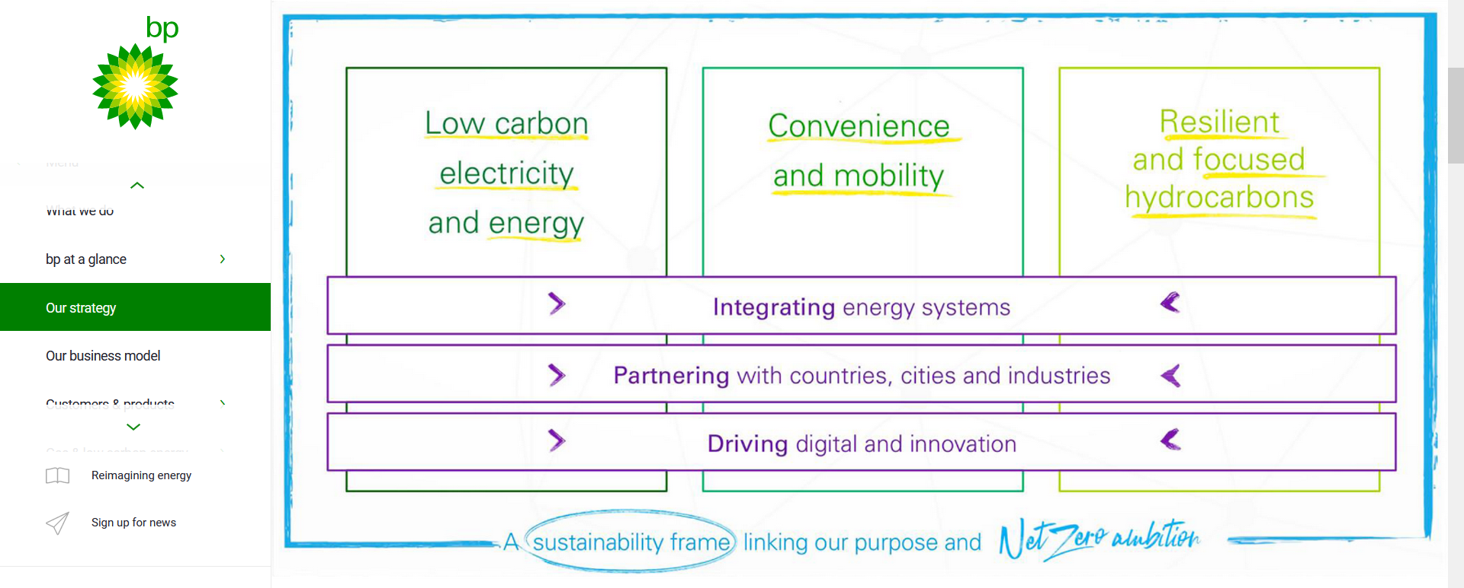
Figure: Strategy
Source: (BP, 2021)

Placing strategy
BP develops different steps for ensuring that the operation of the business has been conducted in an effective manner (Kotler and Armstrong, 2017). In 2020, one of the most important problems which BP faces was related to placing the product or distributing the products of the business. For that reason, the management of BP is trying to develop a sustainable supply chain. The lockdown initiative which was taken during the pandemic was the reason for that. That incident helps the business to realise that the current supply chain of the business might not be effective to deal with this type of pandemic situation. For that reason, the business has a plan to ensure that each region in which the business is operating as its own supply chain. This is also a part of the geographic segmentation process of the business. By this business is trying to make sure that it will have storage in each of the regions which will be helpful to meet the needs of that region. Bernard Looney in 2020 declared that the business will invest £3 billion to develop these facilities (BP global, 2018). This will help to reduce transportation costs and at the same time increase the ability to meet the regional need. Indirectly this initiative will be helpful to achieve the goal of zero carbon emission because the use of less transportation will reduce carbon emission. This is indicating that the placing strategy which BP is using is helpful to reach the customers of the business and at the same time, the sustainability strategy of the business will have implemented.

Pricing strategy
Like all the other types of business, BP does not have the ability to determine its product price based on the market or the quality of the product which the business is offering (Cateora and Graham, 2016). The reason behind that is the industry in which the business is operating. The companies in the gas and oil industry must have to focus on the government policy of a country and based on that determine the pricing policy of the business. In 2020, because of the pandemic, most of the countries governments initiate lockdown and for that, the movement of people and things from one place to another was very limited. Because of that reason, the demand for oil and gas was very low and this had a huge impact on the oil price. In 2020, on average BP had to sell a barrel of oil at $41.84 which is the lowest since 2004. But in 2021 the business was able to sell oil at a rate of $71.50 per barrel (BP Strategic Review, 2021). That means, price of the product which the sales in the market is not in the hand of the business.

Promotional strategy
This is the process by using which a business is trying to reach its selected customer's group. For that reason, it is important for the management of a business to make sure that the promotional strategy which the business is using has been effective. The PESTLE analysis of BP is showing that the trend in the energy market has been changed. The use of the traditional marketing process will not be effective for the business. BP spend 13% of its total revenue on marketing and from 2020 most of this money has been spent on digital marketing (BP global, 2018). The management of the business understood that the use of digital marketing tools like social media, SEO and email marketing is effective to reach the targeted customer group of business. The rate of customer conversion has been increased by 12%. In each of the promotional campaigns which the business developed, a zero-carbon project of the business is included to attract the customers.

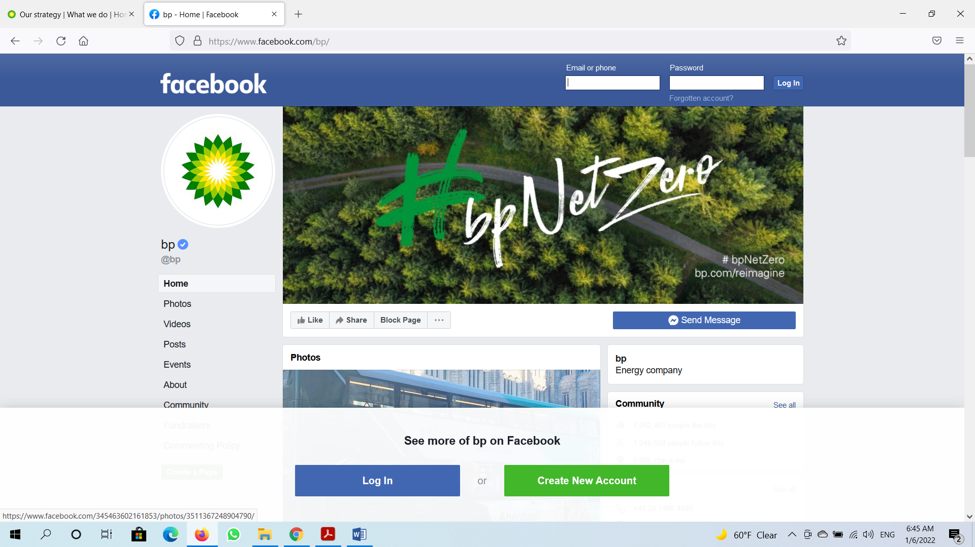
Figure: BP’s Facebook Page
Source: (BP Strategic Review, 2021)

Conclusion
The marketing process of BP is effective because it helps the business to reach the targeted customer group. Achieving zero carbon emission by 2050 is the project on which BP is focusing and that is an effective plan which will help the business to achieve sustainability. After developing the project in 2020, its impact can be seen in each of the marketing mix strategies which the business has. This was an effective decision for the business because it will help to attract customers to the business because the ability of the business to meet the needs and wants of the customers has been developed because of that.

References
BP (2021). Home. [online] BP global. Available at: https://www.bp.com/.
BP Annual Report 2020 (2021). BP Annual Report 2020. [online] BP.com. Available at: https://www.bp.com/content/dam/bp/business-sites/en/global/corporate/pdfs/investors/bp-fourth-quarter-2020-results.pdf.
BP global (2018). Our strategy | What we do | Home. [online] BP global. Available at: https://www.bp.com/en/global/corporate/what-we-do/our-strategy.html.
BP Strategic Review (2021). Oil | Energy economics | Home. [online] BP global. Available at: https://www.bp.com/en/global/corporate/energy-economics/statistical-review-of-world-energy/oil.html.
Cateora, P.R. and Graham, J.L. (2016). International marketing. New York, Ny Mcgrawhill Education.
Dykes (2021). BP picks two consortia for Net Zero Teesside FEED competition. [online] Energy Voice. Available at: https://www.energyvoice.com/renewables-energy-transition/372573/bp-picks-two-consortia-for-net-zero-teesside-feed/ [Accessed 6 Jan. 2022].
Getting to net zero | Sustainability | Home (2021). Getting to net zero | Sustainability | Home. [online] bp global. Available at: https://www.bp.com/en/global/corporate/sustainability/getting-to-net-zero.html.
Kotler, P. and Armstrong, G. (2017). Principles of marketing. 16th ed. Hoboken: Pearson Higher Education.
Reuters (2021). Azerbaijan’s SOCAR targets net zero emissions in extraction from own sites. Reuters. [online] 20 Dec. Available at: https://www.reuters.com/business/energy/azerbaijans-socar-targets-net-zero-emissions-extraction-own-sites-2021-12-20/ [Accessed 6 Jan. 2022].
Riley, T. (2017). Just 100 companies responsible for 71% of global emissions, study says. [online] The Guardian. Available at: https://www.theguardian.com/sustainable-business/2017/jul/10/100-fossil-fuel-companies-investors-responsible-71-global-emissions-cdp-study-climate-change.

